How to trigger initial deployment of zero-carbon technologies – Shipping briefing note

- CONTEXT: Shipping and carbon emissions
The shipping sector is a key enabler of international trade. Although lower-emissions than other freight transport modes in terms of CO2 emissions per tonne-kilometre, shipping represents about 3% of total global emissions from energy and industry today. These emissions are set to double as the shipping sector keeps growing in line with global economic growth.
  - The shipping sector accounts for 80% of global trade in physical units. Shipping activity is closely linked to gross domestic product growth. Both GDP and shipping activities have increased steadily, by 3.6% and 3.8% per year from 2000 to 2015 respectively.
  - From a global freight transport perspective, shipping is recognized as an energy-efficient means of transportation compared to road and air transport, due to its low fuel consumption per ton-kilometre.
  - Today, the global shipping sector emits 0.9Gt CO2, which is about 11% of total transport sector emissions and 2.8% of total global emissions from the energy and industrial systems. Under a business as usual scenario, these CO2 emissions could almost double and reach 1.7Gt by 2040 (IEA ETP 2017).
  - 87% of the shipping sector’s emissions derive from the combustion of marine bunker fuels by international freight traffic, specifically heavy fuel oils (currently 84% of the marine bunkers fuel mix). Containerships, bulk carriers, and oil, gas and chemical tankers account for 85% of total emissions, with RoPax and cruising accounting for most of the rest (see Exhibit 1). According to the IEA, the international shipping sector is currently responsible for about 5% of global oil demand, i.e. similar to the combined demand for oil from Germany, France and the United Kingdom.
  - Bunker fuels are residual fuel oils, which result from the cracking process of crude oil and is contaminated by many pollutants. They are cheaper, but dirtier than other types of fuel oils – producing significant amounts of NOx and SO2. Estimates suggest that ships are responsible for 15% of global NOX and 8% of global sulphur gas emissions.
  - Ships typically remain in the fleet for between 20 and 30 years before being scrapped. Considering the multi-year lead time for designing and building a vessel, achieving significant emissions reduction by 2050 requires imminent actions to both deploy zero-carbon vessels starting as well as to retrofit the existing fleet.
  - The fragmented nature of the shipping industry – multiple different arrangements for the division of responsibility between ship owners and ship operators, significant role for short-term charter contracts, fragmented nature of regulation through the flagging system – reduces the ability of and incentives for any one party to make investment decisions, even if they would in principle reduce costs. The international nature of the sector also limits the ability to regulate: shipping is not covered by the Paris Agreement and is governed by the International Maritime Organization (IMO), a UN agency with responsibility for the safety and security of shipping, in which major flags hold significant influence.
  - In April 2018, the IMO set the objective to reduce absolute GHG emissions from shipping by at least 50% by 2050 compared with a 2008 baseline, and attempt to eliminate them altogether thereafter. The strategy initially focuses on reducing the carbon intensity of international shipping (CO2 emissions per tonne kilometre) by at least 40% from the 2008 level by 2030 and to pursue efforts to reduce this carbon intensity by 70% by 2050.
  - Currently, the only IMO regulations in place to address GHG emissions from ships are the Energy Efficiency Design Index (EEDI), an efficiency standard for new ships, and Ship Energy Efficiency Management Plan (SEEMP), a management tool to assist shipowners in managing the energy efficiency of their ships. This mandate requires an annual energy efficiency improvement of the fleet of 1% on average between 2015 and 2025.

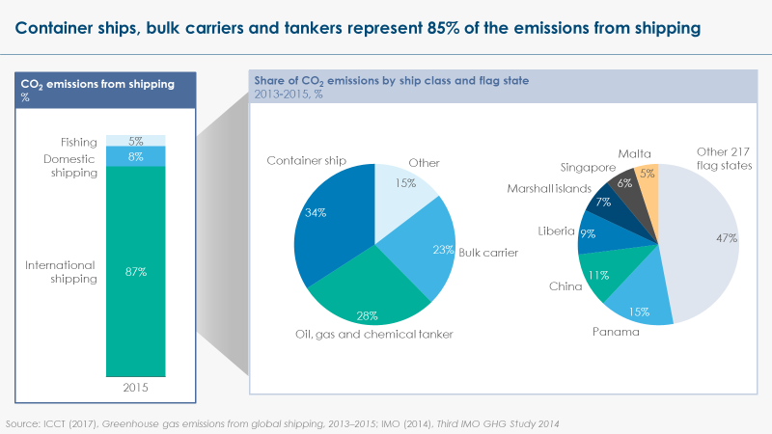
Exhibit 1

- PATHWAYS: How can shipping be decarbonised?
To achieve full decarbonisation, shipping will need to go beyond energy efficiency improvements and deploy zero-carbon fuels and propulsion technologies. Given the lifetime (20-30 years) of vessels, “drop-in fuels” that can be used in existing engines with limited retrofitting (biodiesel and ammonia) are likely to be the preferred decarbonisation options.
  - Shipping decarbonisation can be achieved through a combination of:
- Curbing total traffic volume. New economic trends, like the return of some industrial activities to developed economies or the expected decrease in international shipping of coal, oil and gas as the economic systems are decarbonised, might alter the growth trajectory of the shipping sector. However, this demand reduction could equally be replaced by growth in low-carbon fuels trade such as hydrogen and ammonia and new routes made possible by decreased Arctic Sea ice extent.

- Operational efficiency improvements. Operational efficiency improvement, in particular improvements in fleet management, better optimisation of voyages, and an optimal approach to ship speed, could enable a 5% reduction in carbon emissions within the fleets adopting these different measures. But, if applied to 75% of the global shipping traffic, it would only trigger a 4% reduction in carbon emissions for the sector as a whole.
- Energy efficiency improvements of existing ships and engines. While shipping compares favourably to other transport modes in terms of energy input per tonne-kilometre, there is still very significant potential to increase the energy efficiency of existing ships and engines even while continuing to use existing HFO-based propulsion. The potential is greater for shipping than for other transport modes because, until now, existing industry structures have created weaker incentives to optimize design and operation. For new ships, focus should be on improving hull shapes and materials, building larger ships, achieving drag reductions (reducing frictions between ship and water) and reducing non-propulsion energy requirements. Together with incremental improvements in the efficiency of existing engines and propulsion systems, these improvements could in principle deliver overall energy efficiency improvements of 30 to 55% for new built ships compared to the existing fleet. In addition, wind-sail assistance technologies could also very significantly reduce fuel use. Some of these technologies could be retrofitted on the existing fleet, which is particularly important given the long lifetime of ships. Overall retrofitting could improve the energy efficiency of the existing fleet by 15%, but the fragmented nature of the industry (see point 1.7) currently limits the realisation of this potential.
- Zero-carbon fuels and alternative propulsion technologies. To meet the IMO’s targets and ultimately fully decarbonise the sector, vessels using zero-GHG-emitting fuels need to start entering the international shipping fleet in the 2020s, while older vessels might need to be retrofitted. Several technology options are being considered by the industry (see Exhibits 2 & 3):
  - For riverine, coastal and short-haul RoPax / cruising, the most likely option is to use electric engines (either combined with batteries of with hydrogen fuel cells), given the higher energy efficiency of electric engines v. combustion engines.
  - For long-haul containerships, bulk carriers and cruising ships, options include biofuels, hydrogen (used either directly in combustion engines or used in fuel cells) or ammonia (with the same two options).
  - The debate on which option will prevail is not closed within the industry. The relative attractiveness of different options for each market segment will depend on (i) technical characteristics – in particular the weight/volume characteristics of the energy source and total energy efficiency, (ii) the ability to use existing assets, which is particularly important given the long lifetime of vessels, and (iii) the cost.
  - The long lifetime of ship engines creates a strong incentive to find a “drop-in” alternative to heavy fuel oil, which can be used in existing engines, in particular for long-distance container, bulk and tanker transport. Fortunately, ship engines are robust and versatile pieces of technology, which can use a wide range of alternative fuels with only moderate adaptation required. Analysis conducted by UMAS, therefore, narrows down the most likely routes to long-haul shipping decarbonisation to two options:
  - The use of biodiesel, although this option is likely to be limited by scarce sustainable supply of biomass, which is likely to drive prices up;
  - The use of ammonia, produced from zero-carbon hydrogen and used directly in combustion engines, which is likely to be preferred to direct hydrogen use due to higher volumetric density and greater ease of storage.
  - The potential use of ammonia as a fuel is currently a key area of focus for the industry. As a fuel, ammonia can in principle be used in internal combustion engines that use spark- or compression-ignition systems. Multiple uncertainties exist on the exact engineering of engines and tanks, which require further testing and demonstration, but constructors appear to be confident of their ability to solve these different questions, including those related to NOx emissions. Different points of view exist in the industry on whether ammonia can be considered as “drop in” fuel, but it is widely considered as a “retrofittable” fuel.

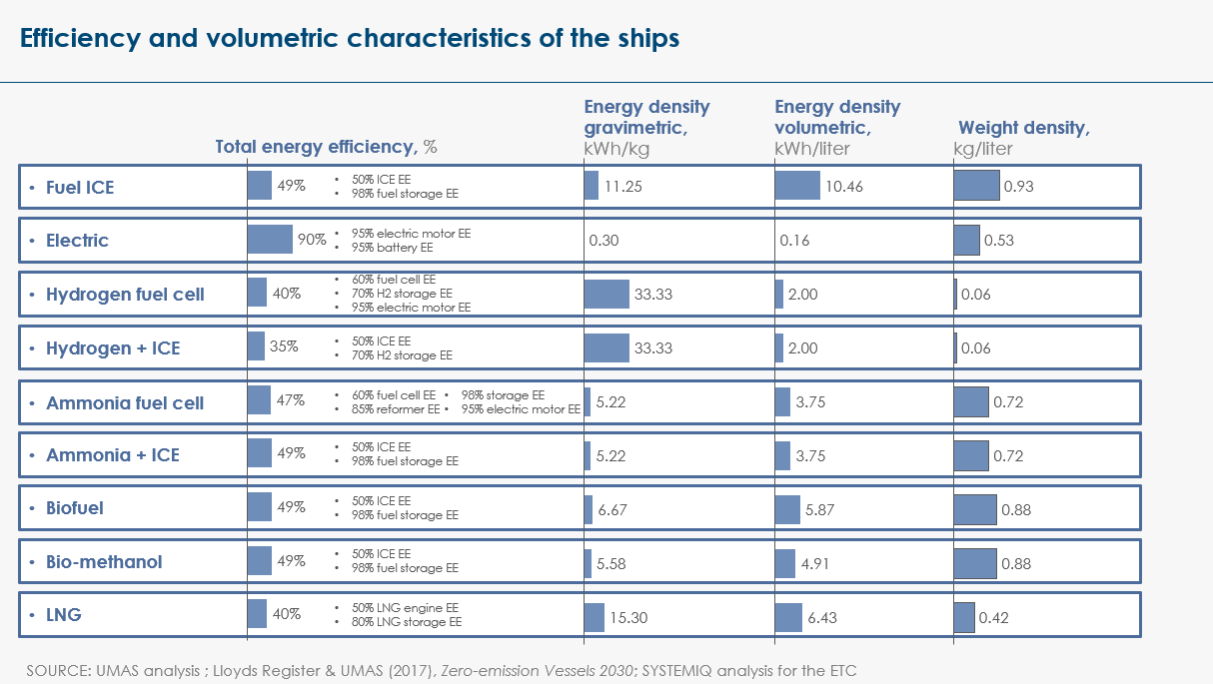
Exhibit 2

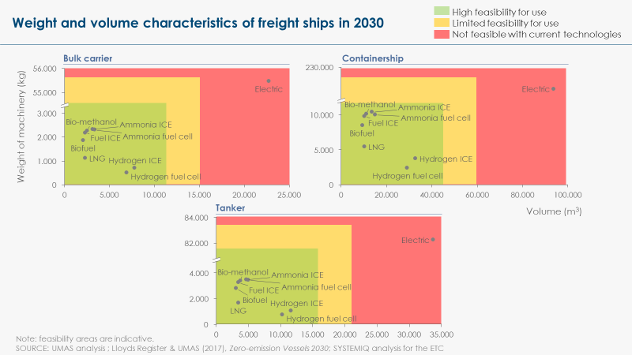
Exhibit 3

- STATUS: What is preventing the decarbonisation of shipping?
Three major barriers are currently preventing the deployment of zero-carbon fuels (i) the technology (especially for ammonia) has not yet been demonstrated at scale, (ii) the uptake of zero-carbon fuels would add significant costs in a highly competitive industry, (iii) the structure of the industry makes it more difficult to regulate than other sectors.
  - Although “drop-in fuels” can in principle be used in existing engines with limited retrofitting (new fuel tank still required, alongside minor retrofitting of the engine), it is not yet possible for the shipping industry to switch to these zero-carbon fuels at scale:
  - The use of hydrogen or ammonia to power shipping has not yet been demonstrated at scale and still raises safety concerns.
  - There is no large-scale production of biodiesel for shipping or of green ammonia (from SMR+CCS or from electrolysis of renewables) today. The scale-up of fuel provision will require at least a decade.
  - In the absence of a technological breakthrough, decarbonising shipping will have a significant cost implication. ETC and UMAS estimates suggest that achieving full decarbonization is likely to cost US$150-300 per tonne of CO2 saved, making shipping one of the most expensive sectors to decarbonize and adding significantly to total freight costs.
  - For example, at the business-to-business level, total operating costs for a typical bulk carrier could be increased by US$6-8 million per year, representing a +180-240% increase, if using zero-carbon fuels instead of conventional fuels.
  - The most important driver of this cost differential is fuel cost, as biofuels or green ammonia are currently much more expensive than heavy fuel oil. Other costs include cost of the engine, cost of the fuel tank and revenue lost from the increased space required for fuel storage, given lower volumetric density of ammonia – and even more so of hydrogen – compared to heavy fuel oil. See Exhibit 4.
  - If cheap renewable electricity (US$20/MWh) was available in favourable locations to produce green ammonia, the cost increase for bulk carriers could be brought down to US$2-3 million per year, representing a +60-90% increase. This, however, is unlikely to happen before the 2030s.
  - Despite high B2B costs, the impact on end consumer prices is likely to be limited. For instance, a 200% increase in international freight voyage costs would only translate in a price increase of US$0.55 (or less than 1%) on the cost of a pair of jeans priced US$60 and shipped from a production site in Southeast Asia to the US West Coast.
  - The major challenges to the decarbonisation of the shipping sector are therefore (i) how to drive uptake of technologies that would currently be cost-adding in a highly competitive industry where first movers could lose market shares and (ii) how to bring down the cost of alternative fuels rapidly.

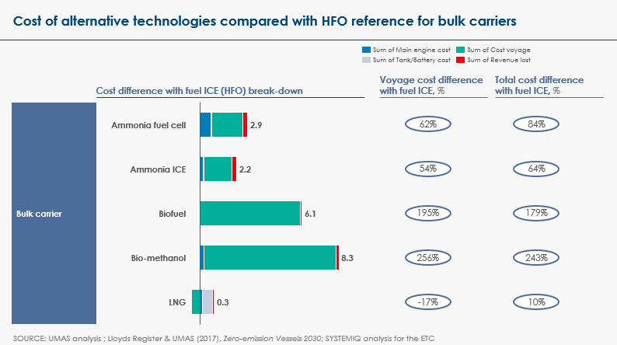
Exhibit 4

  - Finally, the structure of the shipping industry makes it more difficult to drive change. In particular, the multiple different arrangements for the division of responsibility between ship owners and ship operators, the fragmented nature of regulation through the flagging system, and the significant role for short-term charter contracts, reduces the ability of – and incentives for – any one party to make investment decisions in line with climate commitments.
  - This context favours the search for transitional solutions, which could be adopted at lower-cost in the 2020s, before a switch to truly zero-carbon options at a later point in time (late 2030s / 2040s) once the cost of electrolysis has been brought down.
  - Many players across the shipping industry are currently envisioning a switch to LNG as a transitional solution. The ETC’s view is that such a switch bears significant risks as (i) LNG is not significantly GHG-emissions reducing compared to heavy fuel oil once upstream methane leakages in the gas value chain are accounted for and (ii) LNG cannot constitute a long-term decarbonisation option, thus creating risks of either high-carbon lock-in or stranded assets in both engines and fuel provision infrastructure.
  - HFO-ammonia dual-fuel engines (initially using “brown” ammonia, derived from SMR without CCS) could offer an alternative transitional pathway. Dual-fuel engines are already commercially available.
  - The deployment of new engines and fuel provision infrastructure in ports that are conceived from the outset to be versatile, initially using HFO, LNG or biofuels, but enabling a switch to hydrogen or ammonia at low-cost by the 2030s, could be a sensible way forward.

- EMERGENCE: What is the critical minimum scale needed to shift the market?
The critical first step is to demonstrate the use of low-carbon fuels, in particular the use of ammonia in combustion engines, at scale. A minimum scale of alternative fuel demand then needs to be reached to trigger investment in the fuel provision value chain.
  - Building up confidence over the feasibility of technology pathways in real-world operation is essential to initiate uptake. This should be driven by a series of demonstration projects, with a particular focus on different uses of hydrogen and ammonia, and with the aim to (i) pilot and prove the technology at scale, (ii) resolve remaining questions related to storage and safety risks, (iii) refine the economic assessment of different technology options for different sub-segments of the fleet.
  - For reasons described in section 2 and 3, ammonia is likely to be the most scalable, zero-carbon option in the long term. Once the technology has been proven, a minimum scale of demand will be required to trigger investment in the production of ammonia at scale.
  - A small/mid-scale ammonia plant with a capacity of 350 tonnes of green ammonia per day (tpd) is approximately equivalent in energy terms to the daily fuel consumption of 2 post-Panamax scale containerships (i.e. ~5000-10,000 TEU v. 20,000 TEU for the biggest, most recent Ultra Large Container Vessels) or 2 large LNG carriers (i.e. ~150,000 m3). A large ammonia plant would have a capacity of 2,000 tpd or above, representing the consumption of ~12 medium-size containerships.

  - For comparison, the 5 world’s leading containership operators (APM-Maersk, Mediterranean Shipping, CMA CGM Group, Cosco, Hapag-Lloyd) own more than 900 ships (~51% of the market in terms of 20-foot equivalent units) and charter more than 1500 others. 8.6 million containerships enter The Port of Rotterdam every year.

- DIFFUSION: Where can this initial scale-up happen?
Fleet operators could capture value from a differentiated low-carbon offer in some sub-segments of the market which face higher pressures to reduce their carbon footprint: (i) cruising, (ii) fossil fuel, mining and metals trading, and (iii) logistics services for increasingly climate-conscious consumer product companies.
  - Ammonia carriers represent the most obvious initial candidate market segment to test and deploy the use of ammonia as a shipping fuel, given pre-existence of ammonia fuel storage equipment on board and coverage of the fleet by existing regulations for transporting ammonia as cargo. Ammonia producers (which are currently predominantly fertiliser producers) constitute a relatively concentrated market: the top 5 non-Chinese producers (CF, Yara, Nutrien, OCI, Ostchem) represent ~30% of global volumes. Demonstrating and scaling-up the use of ammonia as a shipping fuel could open a new, potentially significant and fast-growing market for the industry, beyond the existing fertiliser market, which should create incentives for early deployment.
  - Lifecycle carbon assessment tools which are currently used to assess the carbon footprint of corporates and goods largely estimate international shipping emissions using simplified emissions factors (so called ‘tank-to-wake’ emissions) owing to lack of specific emissions data. However, as public scrutiny increases on lifecycle carbon emissions of companies and products, buyers of shipping services are likely to start asking for more granular carbon emissions assessment from their ship operators, at the level of the ship or in aggregate terms at the level of the fleet. This movement should be encouraged. Carbon data availability and disclosure in the shipping industry could play a key role in creating a differentiated low-carbon shipping offer, for which buyers could be ready to accept a premium price.
  - In that context, the sub-segments of the market that are most likely to value a differentiated low-carbon offer are the following:
  - Cruising: Concerns about the sustainability of cruising has risen recently, driven initially by major touristic ports opposing the non-GHG pollutants associated with large cruise ships stationing in concentrated locations. In the same way as consumers are waking up to the carbon impact of aviation, it is not unlikely that consumers will also increasingly pay attention to emissions from cruising. Local regulations from ports / port cities as well as the possibility to offer an enhanced service to customers (by improving air quality on board and in ports) could drive the cruising industry to a faster switch to alternative fuels than other segments of the industry. Regulations at port-level are also easier to implement in cruising than in freight, given that the choice of port facilities is driven by touristic attractions rather than cost.

  - Fossil fuel, mining and metals: These high-emitting sectors are under increasing pressure from investors, buyers and governments to reduce their carbon emissions across Scope 1-3 (which includes transport emissions) and are exploring the opportunity to de-commoditise their products by offering a differentiated low-lifecycle-carbon offer. This is particularly true for metallurgical coal (given the limited potential to reduce emissions that are inherently related to the burning of the coal in blast furnaces), minerals like iron ore, bauxite or cobalt, or basic metals like steel and aluminium.
  - Logistics services: The demand for green logistics, especially in consumer-exposed sectors, is currently underserved by the shipping industry. Given the limited impact on end-consumer product prices of using low-carbon fuels (see point 3.2), it is possible to imagine that consumer product manufacturers and retailers would be able to absorb and pass on the additional cost of green shipping to customers. However, the structure of the sector – in which a given containership carries cargo for a range of different companies – does not enable a single buyer – or even a coalition of buyers – to easily regroup their cargo on one zero-carbon vessel. A differentiated green logistics offer would therefore likely have to be based on average carbon emissions of the fleet operated by any given ship operator.
  - Initial deployment of ammonia/hydrogen as a shipping fuel will be easier where ports can more easily scale-up the fuel provision value chain:
  - Where ports are linked with large industrial clusters that have on-site refineries or chemical facilities that already use and produce hydrogen (e.g. Rotterdam);
  - Where ports are located near gas extraction and carbon storage sites, which can enable low-carbon hydrogen production from SMR+CCS (e.g. Norway, UK);
  - Where low-cost renewable energy is available for electrolysis (e.g. San Francisco, Los Angeles, North Africa).

- RECONFIGURATION: What actions could be taken and by whom?
Leading global ports such as Shanghai, Rotterdam, Hamburg and Los Angeles need to play a central role in setting market signals for increasing uptake of low emissions vessels and a demand pull will also be required, which can be orchestrated through disclosure campaigns and/or buyers’ alliances. The world’s top 20 ports control 42% of global port throughput. Coordinated action among these could trigger real market change.
  - Several voluntary initiatives have already been setup to develop green shipping technologies. These include the Global Maritime Forum, the Sustainable Shipping Initiative (SSI), the Clean Cargo Working Group (CCWG), Green Marine, Green Ship of the Future, Shippingefficiency.org, and the Clean Shipping Project. States like the UK, Denmark or Norway, which are shipping nations, are traditionally involved in such groups, and could support greater alignment or consolidation of these groups.

  - IMO’s standards on both new ships and existing fleet are effective instruments to force investment decisions across the whole sector. A tightening of the existing energy efficiency standards for both new vessels and existing fleet, and an introduction of carbon emissions standards, would be ideal. Carbon emissions standards are indeed likely to be more powerful change drivers than an incentive/tax-based system, given how high these would have to be to trigger fuel switch. However, negotiations at IMO-level are generally a lengthy (5 years min.) process, creating a need for shorter-term action beyond the IMO.
  - In parallel, governments have the possibility to regulate domestic shipping, via fuel mandates, emissions standards or carbon taxes. However, these regulations would apply only to a small proportion of the fleet and of total emissions from the sector. Applying this type of regulation unilaterally on international traffic could also lead to re-routing.
  - Leading ports can help create the market signals for shipping decarbonisation through (i) setting long term environmental standard benchmarks and (ii) supporting the development of a local low-carbon fuel provision value chain.
  - Approximately 30 of the world’s top 100 ports, mostly within OECD member countries, already apply financial incentives to decarbonise maritime transport. Some of the smaller ports also deploy such instruments. By far the most common incentive is a green port fee, usually based on an index that indicates environmental performance of the ship calling the port. Other financial incentives, such as incentives to reduce speed, green berth-allocation, and local or regional carbon pricing mechanisms are rarer. However, most of these incentives remain marginal in relation to total operating costs of shipping companies.
  - Widening the differences in port fees for ships based on their environmental performance would further strengthen the impact. Port-based incentives have so far been voluntary for both shipowners and ports, but could win in effectiveness if made mandatory, harmonized internationally (at least across a coalition of ports like those participating in the World Ports Climate Action Program), and linked with mechanisms enabling both shippers and ports to communicate on the extent to which they are using or servicing environmentally friendly ships. As mentioned in point 5.3, higher fees could in particular be applied by touristic/cruising ports, in order to trigger early progress in this sub-segment of the industry.
  - Moreover, port authorities have started and should continue to work with regional and national governments, ship operators and energy providers to develop local low-carbon fuel provision hubs, liaising between energy providers and energy consumers to provide greater certainty on the scale of supply/demand and therefore reduce the risks associated with fuel switch. To be effective, such a strategy should ideally be put in place simultaneously by a small group of (3-5) highly interconnected ports, who would jointly ramp up availability of low-carbon fuels to enable ship operators to green specific freight corridors. The Asia-North America shipping corridor could be particularly promising for this type of coordination as the world’s busiest corridor and one where cheap ammonia production is conceivable from locations in central China and the US West Coast.
  - Some ship operators have taken bold climate commitments and are now encouraging their peers to follow through the Global Maritime Forum. These commitments are starting to galvanise industry coordination, as ship operators play a lead role in bringing together ship constructors and ports to enable them to deliver on their commitments. Initial discussions to create greater coordination on a few demonstration corridors is therefore under discussion under the auspices of Global Maritime Forum. This is still early stage, but should be encouraged.
  - But, given the higher cost of alternative, low-carbon fuels, a demand pull, absorbing the extra cost of green shipping, will be essential to drive scale-up.
  - In the cruising sector, an NGO-led public awareness campaign as well as continued regulatory pressure from touristic port cities could accelerate progress.
  - In the fossil fuels, mining and metals sectors, individual companies could commit to decarbonising their maritime freight as part of their broader climate-related commitments. This would require either greening of their own fleet or differentiated procurement practices.
  - In the broader logistics sector, a buyers’ alliance from a combination of consumer product companies (similar to the alliance of companies that have committed to 100% renewable energy through RE100 and 100% electric vehicles through EV100) in partnership with major logistics services providers (e.g. DHL, UPS and others) could, first, put pressure on the shipping industry to better disclose their real carbon emissions, then, develop procurement guidelines to discriminate against higher-carbon maritime freight providers, and, finally, commit to 100% zero-carbon shipping by a certain date (e.g. 2040).

https://unctadstat.unctad.org/wds/TableViewer/tableView.aspx?ReportId=109
https://data.worldbank.org/indicator/IS.SHP.GOOD.TU
IMO (2014), Third IMO study GHG study 2014
http://www.imo.org/en/MediaCentre/HotTopics/GHG/Pages/default.aspx
http://www.energy-transitions.org/sites/default/files/ETC%20sectoral%20focus%20-%20Shipping_final.pdf
https://rmi.org/wp-content/uploads/2017/06/RMI_Winning_the_Oil_Endgame_Book_2005.pdf
http://www.energy-transitions.org/sites/default/files/ETC%20sectoral%20focus%20-%20Shipping_final.pdf
https://www.lr.org/en-gb/insights/global-marine-trends-2030/zero-emission-vessels-2030/
http://www.energy-transitions.org/sites/default/files/ETC%20sectoral%20focus%20-%20Shipping_final.pdf
https://unctad.org/en/PublicationsLibrary/rmt2018_en.pdf
https://www.statista.com/statistics/197643/total-number-of-ships-of-worldwide-leading-container-ship-operators-in-2011/
https://www.portofrotterdam.com/sites/default/files/facts-and-figures-port-of-rotterdam.pdf
https://unctad.org/en/PublicationsLibrary/rmt2018_en.pdf# (Table 4.4)

