How to trigger initial deployment of zero-carbon technologies – Plastics briefing note

- CONTEXT: Carbon emissions from plastics production and use
Plastics constitute a major and fast-growing output of the chemicals industry. Current production processes already make plastics one of the highest emitting sectors of the global economy, but carbon is also embedded in the plastics itself, making end-of-life treatment a crucial issue and a potential time-bomb for climate.
  - Plastics constitute one of the main outputs of the chemicals industry. Exhibit 1 describes the key inputs and outputs of the chemicals industry, within which primarily fossil fuel-based feedstocks are transformed into end-use products. The single largest product category is N-fertilizers, with a global output of 275Mt per year, followed by thermoplastics at 222Mt per year, fibre and rubber products at 107Mt, and numerous other products accounting for the remaining 217Mt. The industry also produces a significant amount of by-products, some of which are reused as feedstock.

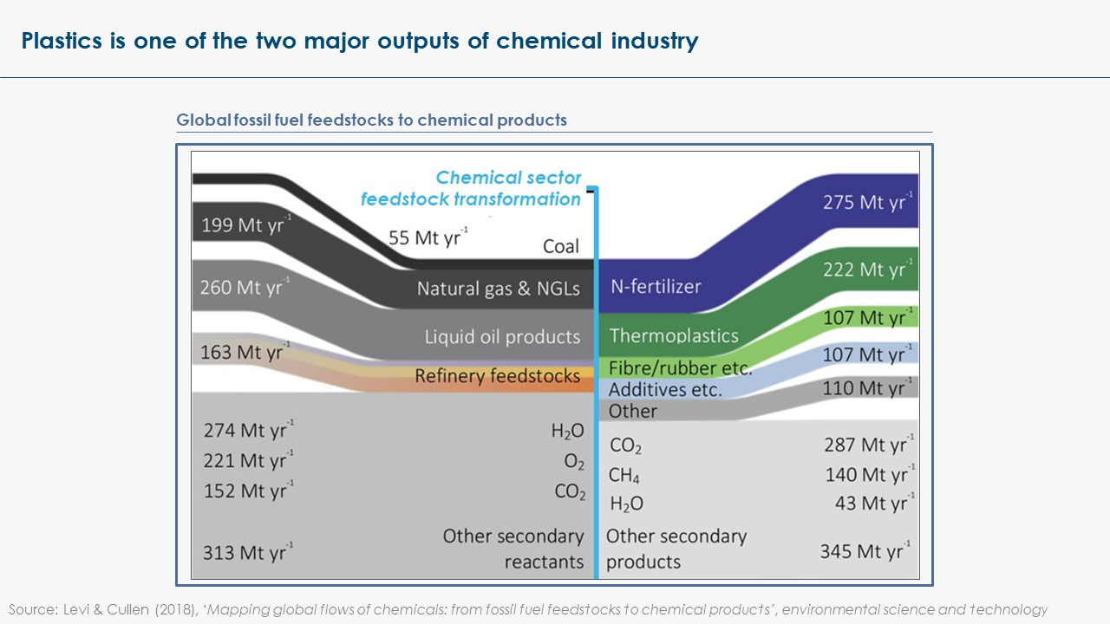
Exhibit 1

  - The production of plastics entails an extremely complex set of pathways with multiple feedstocks (varying from region to region) used to produce multiple intermediate products which are themselves transformed into multiple forms of plastics. The production of plastics begins with the distillation of fossil fuels (generally crude oil) in a refinery, allowing to isolate mixtures of hydrocarbon feedstocks, then used in the production of monomers – ethylene, propylene, plus the BTX aromatics (benzene, toluene and xylene) – which are the building blocks of plastics. Ethylene is the single largest high-value chemical produced globally. However, in the United States and the Middle East, ethane is the most common feedstock, for it is widely available as a by-product of wet- or shale-gas production.
  - More than 30 types of plastics are in common use, with different properties and applications in numerous sectors. They can be grouped into two main polymer families: thermoplastics (which soften on heating and then harden again on cooling) and thermosets (which never soften once they have been moulded). Fibres and rubber goods are also considered as part of the broader set of plastics (Exhibit 2).

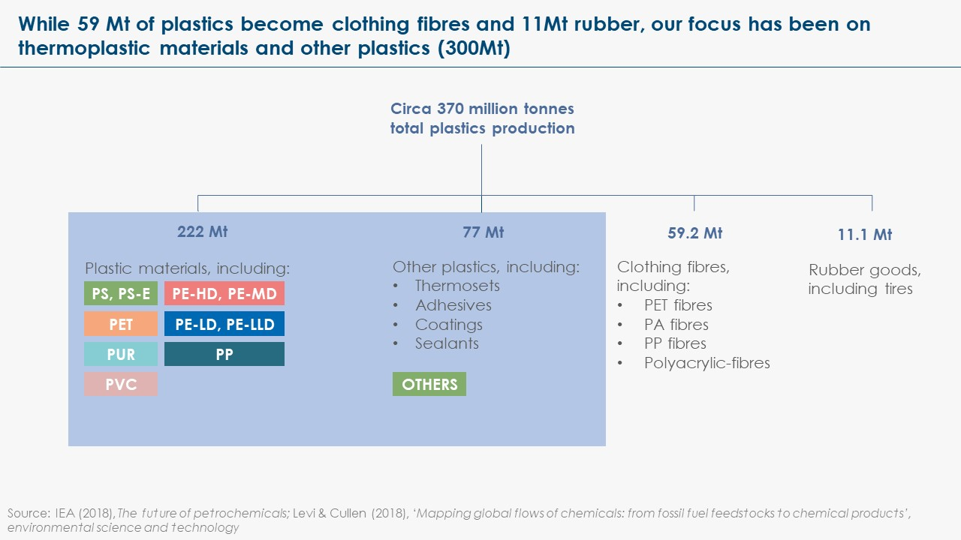
Exhibit 2

  - The plastics industry is quite concentrated and entertains close ties with the oil and gas industry. Top plastics and resin producers include Exxon Mobil, Dow Chemical, Lyondell Basell, SABIC, INeOS, BASF, ENI, LG Chem.
  - Plastics production is concentrated in major economies: 50% of the world plastics are produced in Asia (30% in China); the rest is split between Europe (19%), NAFTA (18%), and the rest of the world (<15%). Primary chemical production follows a similar geographical pattern.
  - More than one-third of global plastic polymers are used for packaging (36%). Building and construction, textiles, and consumer products each account for a share of 10-15% of plastics use. The use of plastics in the automotive industry is also growing, representing 7% of the global plastics demand today (9% in Europe).
  - Global plastics production has grown from trivial levels in the 1950s to reach over 320Mt today, of which 222Mt are thermoplastics. Thermoplastics production is forecasted to increase significantly to 800Mt per annum by 2050, and global demand could potentially grow to reach 1,350Mt per annum by the end of the century.
  - Plastics use is highly correlated with income. Europeans use about 100kg of plastics per person per annum, Americans 139kg, but consumption per capita is only 16kg in the Middle East and Africa and 36kg in Asia, excluding Japan. As a result, while demand in the developed economies may well now flatten out, demand is expected to grow greatly in emerging economies over the next decades (x2.5 in developing Asia, x3 in China, x6 in the Middle East and Africa), as a growing share of the population gains access to higher standards of living and a broader set of consumer goods.
  - Without profound changes in the plastics value chain, this growth in demand will entail a surge in carbon emissions from plastics, which could represent 2Gt per annum by mid-century, just accounting for emissions from the production process, and as much as 4.2Gt if accounting for end-of-life emissions.
  - Indeed, plastics entail two streams of CO₂ emissions: the production process produces on average 2.5 tonnes of CO₂ per tonne of plastics, while the decomposition of plastics at end-of-life produces about 2.7 tonnes of CO₂ per tonne of plastics. Decomposition and release of this embedded carbon might occur over decades or even centuries if plastics are left to disintegrate in nature, potentially constituting a time-bomb for climate. But this process is drastically accelerated if incineration is the preferred end-of-life treatment method.
  - The complexity of the plastics value chain makes it difficult to precisely assess carbon emissions from all stages of plastics production and use, and to pinpoint the greatest point sources. The IEA estimates that the production of petrochemicals (including fertilisers, plastics and related products) accounts for 1.5Gt of direct CO2 emissions per year, of which 1.3Gt are energy related (fuel combustion to generate heat) and 0.2Gt are process emissions (emissions from chemical reactions, corresponding to the difference in CO2 content between the feedstock and the product). Within that, CO2 emissions from plastics production currently represent 0.5-0.7Gt p.a.; but, by 2050, on a BAU basis, they could reach 2Gt p.a. for production only. Once accounting for end-of-life emissions, plastics could be responsible for as much as 4.2Gt p.a. by mid-century. In the plastics family, ethylene, propylene and aromatics production are the biggest emissions sources (Exhibit 3).
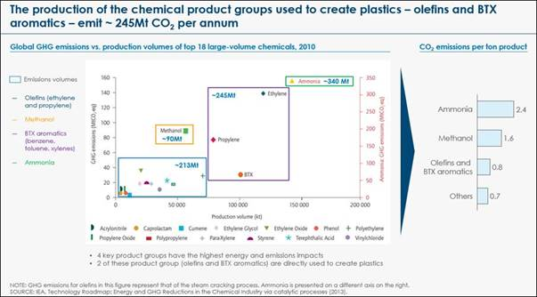
Exhibit 3

  - Fossil fuels demand from the chemicals industry – for both chemical feedstock and energy – represents 11% of total final global energy consumption today (14% of oil consumption and 8% of natural gas consumption).
  - Apart from CO₂ emissions, the end-of-life disposal of plastics can produce numerous other forms of environmental harm, including dangerous pollution of soils and oceans, with serious implications for biodiversity and human health. Much attention is currently given to these issues, in the public debate as well as in the research, policy and innovation spheres. One intricacy is that incineration might sometimes be suggested as a solution to environmental pollution with dramatic consequences in terms of CO₂.

- PATHWAYS: How can plastics be decarbonised?
Reaching net-zero emissions from plastics requires action at each step of the value chain. Increasing reuse and recycling represents a major opportunity, potentially cutting emissions from primary plastics production by more than half. In parallel, a range of technology options exist to eliminate emissions from production and shift from fossil fuels to renewable feedstock.
  - Demand-side levers are particularly important in the plastics sector, since reduced demand for primary plastics could reduce both the emissions generated in production and those which result from end-of-life disposal. They could cut CO₂ emissions from plastics by more than half globally (see Exhibit 3), and proportionally more in developed economies where the stock of plastics is higher and demand growth slower.

A. The first lever is to reduce end-use of plastics, either through:
- A net reduction in the use of plastics-based consumer products, in particular through bans of single-use plastics (a ban of 7 single-use plastics products, incl. PET bottles, cutlery and straws, could reduce plastics consumption by ~13%);
- Greater materials efficiency, i.e. a reduction in the plastic content of plastic-based products (e.g. limited overuse of packaging based on 3D printing) and a more intensive use of plastics-based products (e.g. product sharing practices);
- Materials substitution, e.g. by cellulose-based fibres, although the scale of opportunity is likely limited in the short term due to costs.
B. The second and most important lever is plastics recycling (either mechanical or chemical). Only 10% of end-of-life plastics are recycled in Europe today, with even lower percentages in the rest of the world. There are multiple opportunities to increase this percentage by better collecting and recycling the five most common forms of thermoplastics across key value chains like packaging and the automotive industry. Many of these opportunities are in principle cost-reducing (see Exhibit 4).
- Most of the recycled volumes are currently treated via mechanical recycling, entailing cleaning, re-melting and repurposing of plastic products. The inevitable contamination by additive products and quality downgrading along the process leads to downcycling: PET bottles and high-quality plastics are turned into lower-quality and lower-price plastics for clothes, carpets or flowerpots. There is a significant opportunity to maximise mechanical recycling through better coordination across the value chain that would increase both the quantity and the quality of plastics collected for recycling, enabling higher-quality and higher-value recycling.
- By contrast, in chemical recycling, plastic is broken down into smaller molecules from which new fuel (and eventually chemicals) could be produced. Today, this process is available at a pilot scale only, due to the high costs of the energy-intensive process. It could, however, offer a scalable solution to treat all forms of plastics that cannot be treated through mechanical recycling.
  - Incremental efficiency improvement in existing steam cracking processes could deliver positive net-present-value returns and reduce energy-related emissions. But with petrochemical plants already tightly managed to minimise energy costs, potential reductions from moving to best available technologies are unlikely to exceed 15 to 20% of monomer production emissions (and ~7% of total emissions including end-of-life).

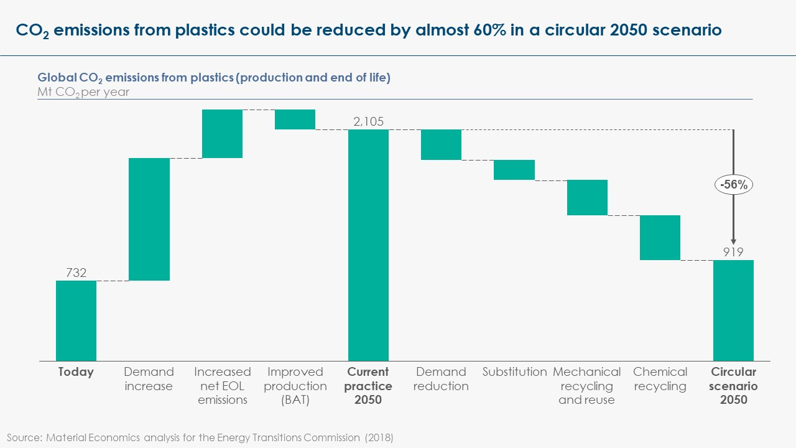
Exhibit 3

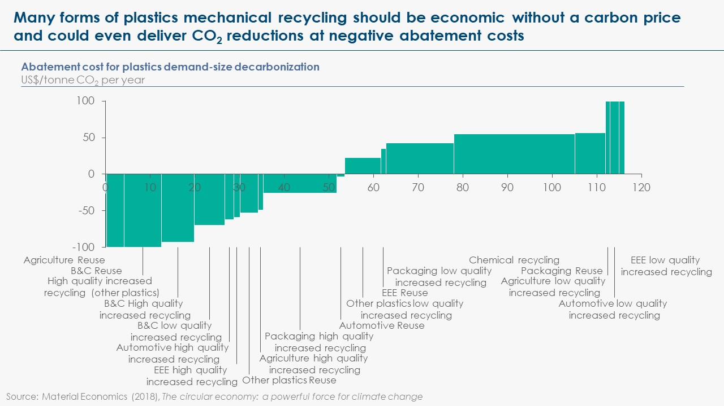
Exhibit 4

  - The decarbonisation of the primary plastics production process, in particular the monomer production process, can be achieved through 4 different routes, which are at different stages of technology development:

- A switch to low-carbon energy sources (e.g. sustainable biomass, sustainable biogas or zero-carbon hydrogen) would not require major retrofitting of existing installations, but the biomass and biogas routes are unlikely to be scalable given constraints on sustainable biomass supply.
- The direct electrification route is in theory also feasible, but, while high-temperature electric furnaces have been built in laboratories and other applications, they are not yet commercially available for ethylene cracking.
- Carbon capture could be applied to capture the exhaust gases from pyrolysis furnaces and the carbon then either be stored in underground storage or used in several applications, potentially within the chemical sector itself.
- In the long run, it is possible that plastics will be produced from entirely new zero-carbon electrochemical processes, if zero-carbon electricity is abundant and cheap enough.
  - The decarbonisation of plastics production combined with increased recycling at end-of-life could potentially bring the plastics sector close to net-zero emissions. However, it is highly improbable that 100% of end-of-life plastics can be collected and recycled. Residual emissions are likely from remaining incineration or natural disintegration. Compensating for these emissions would require a partial switch to renewable feedstock.
- Two types of renewable feedstocks could be considered: bio-feedstock (for which CO₂ absorption in the growth of biomass could in principle offset the end-of-life emissions) and synthetic feedstock (which would only be carbon-neutral if the CO₂ input to the synthetic feedstock came from direct air capture).
- The potential role of bio-based plastics will be limited by sustainability issues: if all plastics feedstock were made out of biomass, the demand for biomass for plastics feedstock only would already reach ~70EJ per year, which is the likely total sustainable supply of biomass for energy/feedstock use available across all sectors of the economy. However, the ETC has argued that some limited biomass use for plastics feedstock (at a scale that would just offset residual emissions from end-of-life plastics) could be considered as a high-priority use of biomass in the economy.
  - Alternative or complementary solutions to deal with residual end-of-life plastics include safe landfilling (which would in practice be a form of carbon storage) and carbon capture on the back of incineration plants.
  - Cost-benefit analysis suggest that circularity levers should be prioritised, as they offer the lowest (indeed often negative) abatement costs.
- Revenues arising from high-quality recycled plastics sales could in principle more than pay off recycling costs of mechanical recycling.
- Chemical recycling, which is more expensive than mechanical recycling, may impose an abatement cost of around US$50-US$60 per tonne, and thus will only occur if carbon taxes or regulation impose such costs on primary plastics production from fossil fuels with which it would compete.

- By contrast, on the production side, abatement costs could vary from US$80-400 per tonne of CO₂, depending on the chosen decarbonisation route and local electricity prices. The optimal solution will likely vary between different locations and over time, reflecting differences in carbon storage and transport costs and in renewable electricity costs. Renewable electricity costs are likely to continue to fall dramatically in locations with the most favourable wind and solar resources, with consequent dramatic falls in the cost of hydrogen production from electrolysis. This could enhance the cost-competitiveness of direct electrification, indirect electrification through hydrogen use, and, in time, use of synthetic feedstock.

- STATUS: What is preventing the decarbonisation of plastics?
The barriers to achieving a circular plastics economy are not technological, but rather related to split incentives across the value chain. By contrast, on the production side, most promising technologies are not yet market ready and high decarbonisation costs make it difficult for any player to move first in a competitive landscape. The complexity of the industry, with many different processes and plastics types to consider, also makes regulation more difficult.
  - On the demand side, the fundamental barriers to recycling plastics are not primarily technological, but arise from a combination of adverse policy, market and industry features throughout the value chain of plastics production and use:
- Price of raw materials: Primary plastics production from fossil fuel feedstock has historically not faced the taxes required to reflect either its climate impact or the other adverse environmental consequences of plastics use, making it more difficult for recycled feedstocks to compete on cost.
- Product design: Many plastic items are designed in ways which make recycling difficult or impossible, and producers do not face incentives to improve design, with insufficient coordination between the recycling industry and upstream producers of plastics products.
- Collection: Public policies and targets often focus on maximising collection rates, with a more limited focus on maximising the quality of the collected materials, which would facilitate the secondary production of high-quality plastics.
- End-of-life treatment: Product dismantling techniques often take little account of the implications for high-quality recycling e.g. shredding of cars results in mixed and contaminated plastic wastes which are difficult or impossible to recycle.
- Secondary material production: The recycling industry today is much too small to achieve economies of scale, with recycling processes and policies often locally managed and inconsistent between locations.
- Market for recycled material: Partly as a result, secondary plastics are perceived to be (and in many cases are) of low quality, trading at a significant price discount to primary production.

  - In summary, the fragmentation of the plastics value chain creates split incentives, as those stakeholders who would have to face the costs of shifting towards a more circular plastics economy (e.g. product manufacturers changing the design of products) are not those who would benefit from higher revenues (e.g. recyclers). Regulation – or new business models where profits are shared between players – are therefore needed to align incentives along the value chain.
  - On the supply side, chemical producers face the challenge of high decarbonisation costs in a competitive international market. Zero-emission primary plastics is likely to be technically feasible by the 2030s, as several decarbonisation routes are currently under development, but these will not be cost-competitive relative to conventional production.
- At the intermediate product level, the impact on the price of a tonne of ethylene could be as much as +50%, which translates into roughly +45% per tonne of plastics (from US$1000 to US$1450 per tonne). This could create serious competitive distortions between companies if policy requirements did not apply equally to all relevant domestic and international competitors.
- However, the impact on the cost of end consumer products is likely to be trivial (e.g. a maximal increase of 1% on the price of a bottle of soda). This, combined with the increasing public awareness of the other environmental impacts of plastics, could drive consumers to accept very small price increases to buy products made of zero-emissions plastics.
  - An additional hurdle comes from the high level of complexity of the plastics industry, with many different processes, types of plastics and value chains to consider.
- The many variations in feedstocks, industrial processes, types of plastics, etc. make it more challenging to deploy new technologies at scale rapidly, as different plants might require slightly different engineering solutions.
- Regulations appear to be a powerful tool to both (i) create incentives to recyclability and recycling for stakeholders across the plastics value chain and (ii) drive adoption of decarbonisation technologies in production (which would otherwise require high carbon prices). However, the ability of policymakers to regulate the sector is constrained by the inherent diversity and fragmentation of the plastics value chain.
  - Petrochemicals are rapidly becoming the largest driver of global oil consumption. This will accelerate with the electrification of transport. They are set to account for more than a third of the growth in oil demand to 2030, and nearly half to 2050, ahead of trucks, aviation and shipping. Oil companies are therefore increasingly pursuing integration along the petrochemical value chain. Against a backdrop of slower gasoline demand growth, robust growth prospects for chemical products, and attractive margins, oil and gas companies are further strengthening their links with petrochemical markets. This is likely to disincentivise any switch to renewable feedstock, but could, somehow counterintuitively, encourage the decarbonisation of production processes and the deployment of CCS. The oil and gas sector might indeed need to strengthen its licence to operate and could see a complementary revenue opportunity in carbon storage.

- EMERGENCE: What is the critical minimum scale needed to shift the market?
With regards to circularity, the question of minimum scale can be approached through two angles: quantitatively, recycling plants need to reach sufficient scale to unlock economics of scale; qualitatively, the quality of the collected end-of-life plastics must be of high enough quality to enable high-quality, high-value recycling. In parallel, low-emissions plastics production routes will need to operate on a similar scale as conventional plastics production routes today.
  - There is a chicken-and-egg dynamic at work, where a fragmented and small-scale recycling industry cannot produce the consistent quality and volumes required for large-scale use, while lack of demand for recycled products holds back the investment that would enable such production in the first place.
- Creating a large-scale recycling facility demands a harmonised collection system operating on a large enough geographical area. The fragmentation of recycling schemes at city or even neighbourhood level is an issue to reach that scale. The largest recycling plants built today have capacities of ~70,000 tonnes recycled plastics production per year. Large scale (>50,000 t/year) is crucial to cost efficiency in recycling. Such a scale represents about half of Paris’ annual plastics consumption, and an eighth of London’s. In less populated areas, the geographical scope of collection schemes would have to be even greater. Producing half of today’s plastics demand from recycled plastics would require a minimum of 1600 large-scale plants globally. 2500-3000 large-scale plants would be required to produce half of the plastics demand that can be expected by mid-century.
- Putting in place quality standards for end-of-life flows sent to recycling facilities (which would be enforced at collecting and sorting stage) as well as for secondary plastics would also contribute to breaking this vicious circle.
- But these standards might be difficult to meet if the design of plastics-based products is not improved to enable better dismantling and higher-quality recycling, which requires coordination upstream, with consumer good manufacturers.
  - In parallel, the development of low-carbon plastics production routes will need to achieve industrial scale. While ethylene crackers vary in levels of integration and scale, the typical EU cracker scale is 500 kt/year in an EU market of 22,000 kt/year. One average cracker covers roughly a quarter of the annual consumption of ethylene in the European automotive sector, or a tenth of the ethylene consumption of the EU building sector.

- DIFFUSION: Where can this initial scale-up happen?
Significant emissions reduction can be gained by focusing on five major types of plastics in three key product categories (packaging, automotive and buildings) which together represent a large proportion of total plastics consumption (e.g. 60% in the EU). Consumer pressure could drive adoption of lower-carbon plastics (either recycled plastics or lower-carbon primary plastics) if clarity is brought on the different dimensions of the plastics issue.
  - Much of the volume of plastics can be addressed by focussing on a limited number of large plastics flows (Exhibit 5). Focussing on these could, in particular, kickstart the development of an integrated recycling infrastructure, which could progressively be expanded to more complex and fragmented flows.
- Four main value chains account for three-quarters of EU plastics use: packaging (40%), buildings and construction (20%), automotive (9%) and electronics (6%).
- In addition, five major plastics types account for more than 70% of use, and can be recycled mechanically.

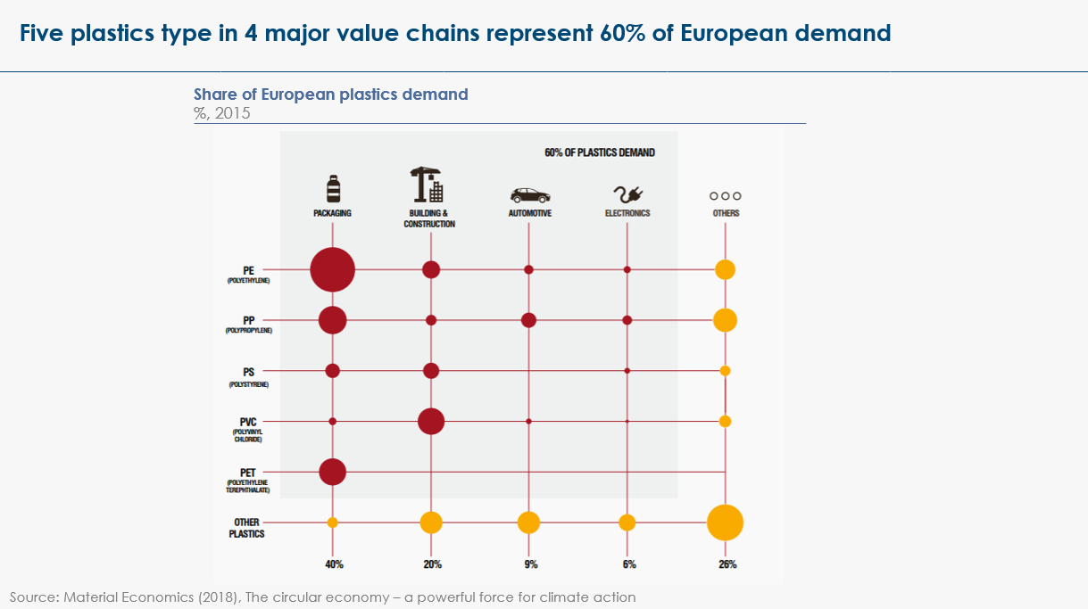
Exhibit 5

  - Downstream action at the level of plastics users in different value chains – rather than plastics producers – enables to circumvent international competitiveness issues:
- Regulations or voluntary commitments on the plastics content of products sold in a given market (e.g. Europe) or value chain (e.g. food industry) can create a demand for a differentiated low-carbon-emissions product. This market can then be seized by any plastics producer, regardless of geographical location.
- The packaging industry and, to a lower extent, the automotive industry are facing increased consumer pressure with regards to sustainability, which could provide a window of opportunity to offer such differentiated products at a (marginally higher) premium price.
  - To be effective, any (regulatory or voluntary) action related to plastics should ensure to cover three major dimensions – which often get confused in the public debate:
- Plastics should (i) not be overused, (ii) be lower-emissions (contrarily to a “recycled content” measure, a “carbon-intensity” measure would incentivise both use of recycled materials and emissions reduction for primary production), (iii) be truly recyclable (which implies changes in product design).
- Two additional dimensions are generally also mentioned in the public debate and can potentially blur focus on the dimensions outlined above: (i) production from bio-feedstocks – which appears to be less essential if recycling is developed, and which creates potential sustainability issue as per point 2.4 – and (ii) biodegradability – which can appear as a solution for plastics pollution, but actually triggers the release of carbon emissions.
  - In the packaging industry, three major steps could be taken:
- A joint voluntary commitment from the packaging industry to remove single-used plastics from market – or national bans as already enforced or announced in several countries;
- A joint voluntary commitment (or regulation) on the lifecycle carbon-intensity of plastics – this could take the form of a levy/price feeding a fund that could be reinvested in R&D in the plastics sector;
- The development of a coalition between packaging manufacturers, plastics waste collection schemes and recyclers to agree on guidelines with regards to best practices along the plastics value chain (from product design to collection and sorting) which would improve the quality of the end-of-life flow reaching recycling facilities only truly recyclable materials in packaging – this could be combined with pilot projects potentially co-funded by the levy mentioned above.
  - In the automotive and building industries:
- A prerequisite to voluntary commitments and regulations is to actually ensure traceability of materials input, with two potential indicators: a materials-intensity indicator (per automotive or per square meter) and a carbon-intensity of materials used indicator (per tonne of materials). Many materials substitution opportunities exist, which could plead in favour of a material-agnostic approach rather than a dedicated plastics/steel/aluminium/etc. approach.
- With regards to plastics use in particular, a similar collaborative approach to define guidelines on best practices along the value chain would be most appropriate. It would focus on re-designing plastic-based products for optimal function in use and for optimal processing in after-use systems.
- Such an approach would have to be developed by an independent international body with industry representation. In the buildings industry, the World Green Buildings Council could be the right anchor. In the automotive industry, the OICA would have the right representativity and geographical scope, but complex governance and tendency to fall back on the lowest common denominator could get in the way.

- RECONFIGURATION: What actions could be taken and by whom?
Key priorities to drive change at scale across the entire plastics value chain, while circumventing international competitiveness issues and the complexity and fragmentation of the sector include: (1) harmonisation/standardisation of collection processes and recycled products, (2) downstream carbon-intensity regulations on products made of plastics, (3) deployment of extended producer responsibility to new sectors, (4) public policy which treats incineration of plastics as a contributor to CO2 emissions and (5) continued innovation support for chemical recycling, low-carbon production processes and zero-carbon feedstocks.
  - Bans on certain forms of plastics, although useful for public awareness and to reduce other environmental impacts of plastics, would only have a limited impact in terms of CO2 emissions. Even dramatic reductions in some of the more discretionary single-use items could only reduce total carbon emissions from plastic by about 10%, with the biggest potential contribution coming from bottles and food containers.
  - Most importantly, the recycling industry needs to shift from a low-quality, low-price model to a high-quality, high-value model. The harmonisation of collection processes – or even their standardisation – would facilitate the scale-up of recycling facilities and ensure higher-quality flows reach the recycling industry. The standardisation of recycled products thereafter would enable potential buyers to have greater confidence in the quality of the recycled products, incentivising growth in a higher-value secondary market. Greater collaboration between local authorities, mandated by central governments or through voluntary schemes, would lead to large-scale public service contracts and with them trigger a significant scale-up of recycling.
  - In parallel, putting in place incentives related to the lifecycle carbon-intensity of plastics used in different product ranges would drive both the use of secondary materials and, where technical specificities do not allow for use of secondary materials, the reduction in carbon emissions from primary production. This could take the form of a carbon price on plastics-based products or of regulations on the lifecycle carbon-intensity of plastics. These measures would drive progress on both the supply-side and demand-side.
  - Many different measures can be taken at product design stage to increase the recyclability of products – using one of the five major types of plastics rather than specialised plastics, designing to facilitate dismantling and materials sorting, limiting mixing of materials, limiting use of additivities and advanced adhesives. Trying to regulate all of these different dimensions across a very large set of complex value chains is unlikely to be manageable. Expanding extended producer responsibility to as many value chains as possible, by contrast, would create incentives for producers to pursue these opportunities in order to reduce costs related to end-of-life treatment.
  - Incineration of plastics rapidly releases CO2 into the atmosphere, however, most assessments of greenhouse gas emissions ignore emissions from incineration. Public policy should treat plastics incineration as a net contributor to the industry’s total emissions, unless it is combined with carbon capture. Taxing incineration, in the same way as landfilling, would be key to incentivize greater recycling.
  - Public R&D funding programs dedicated to low-carbon energy should recognize that plastics decarbonization, including the development of recycling technologies, fits within the scope of their activities. This is the case, in particular, for individual country’s commitments to double R&D spending in clear energy as part of Mission Innovation. R&D should be allocated in priority to:
- Developing innovations which facilitate higher-quality and higher-volumes recycling (increasing recycling efficiency, making chemical recycling cost-efficient, designing products for recirculation);
- Building early-stage demonstration and first industrial-scale pilots for production decarbonisation techniques like carbon capture innovation on pyrolysis furnaces or the use of hydrogen or direct electrification to provide for industrial heat;
- Developing zero-carbon feedstocks (in particular synthetic feedstock whose deployment would go hand in hand with the deployment of electrochemistry).

Levi & Cullen (2018), Mapping Global Flows of Chemicals: From Fossil Fuel Feedstocks to Chemical Products
McKinsey & Company (2018), Decarbonisation of industrial sectors: the next frontier
Roland Geyer, Jenna R. Jambeck, Kara Lavender Law (2017), Production, use, and fate of all plastics ever made
Material Economics (2018), The circular economy – a powerful force for climate mitigation
Material Economics (2018), The circular economy – a powerful force for climate mitigation
STATISTA (2016), Per capita consumption of plastic materials worldwide in 2015 by region
Material Economics (2018), The circular economy – a powerful force for climate mitigation
Estimate from the Energy Transitions Commissions, based on 2.5 tonnes CO₂/tonne of plastic at production stage, 2.7 tonnes CO₂/tonne of plastic at end-of-life stage, and forecasted production volumes of 800 Mt per annum by 2050.
Material Economics (2018), The circular economy – a powerful force for climate mitigation
IEA (2018), The future of petrochemicals
IEA (2018), The future of petrochemicals
Energy Transitions Commission (2019), Mission Possible, Sectoral Focus, Plastics
SYSTEMIQ analysis for the Energy Transitions Commission (2018)
Material Economics analysis for the Energy Transitions Commission (2018)
McKinsey & Company (2018), Decarbonisation of industrial sectors: the next frontier
IEA (2017), Technology roadmap: Delivering Sustainable Bioenergy
Material Economics (2019), Industrial Transformation 2050, Pathways to Net-Zero Emissions from EU Heavy Industry
IEA (2017), Renewable energy for industry
Energy Transitions Commission (2019), Mission Possible, Sectoral Focus, Plastics
SYSTEMIQ for the Energy Transitions Commission (2019)
IEA, The Future of Petrochemicals (2018)
Material Economics for the Energy Transitions Commission (2018)
https://www.petrochemistry.eu/about-petrochemistry/petrochemicals-facts-and-figures/cracker-capacity/
Material Economics (2018), The circular economy – a powerful force for climate mitigation
Material Economics (2018), The circular economy – a powerful force for climate mitigation

