How to trigger initial deployment of zero-carbon technologies – Heavy-duty road transport briefing note

- CONTEXT: Heavy-duty road transport and carbon emissions
Heavy-duty road transport represents over half of all heavy-duty transport emissions (incl. shipping, aviation) and is set to grow under a BAU scenario.
  - Emissions from heavy road transport currently amount to circa 2.5Gt CO₂, accounting for 7% of total global emissions from the energy system, and more than half of the heavy-duty transport emissions. Under a business-as-usual scenario, heavy-duty road transport emissions would grow to 4.6Gt by 2050, representing 10.5% of global emissions.
  - Heavy duty road freight volumes, measured in tonnes-kilometre, are strongly driven by rising prosperity. Therefore, volumes are expected to triple by mid-century in a BAU scenario from circa 27k to circa 82k. The majority of this growth, and associated emissions, will be concentrated in major emerging economies such as India, China and South-East Asian countries – these would respectively represent growth of +0.8Gt, +0.5Gt and +0.3Gt by 2050 against total growth of +2.1Gt in a BAU scenario.
  - Heavy-duty road transport also contributes to non-CO₂ emissions. More than one-third of the transport-related NO_{X} emissions are produced by trucking.
  - The heavy-duty road transport sector can be further sub-divided into (i) different types of vehicles – light-duty truck, medium-duty truck, heavy-duty truck and city buses – and (ii) different route lengths – from urban haul (100km) to regional haul (200km) or long haul (500km).
  - In terms of manufacturing, the trucking market is highly concentrated in the US, Europe and India, with 3-4 major manufacturers per region representing more than 2/3 of the market. China appears to be, to some degree, an exception.
  - Low volumes of trucks are being exported between major markets (Europe, US, China, India). Even when exported, trucks are still likely to be designed and built for the target export region (in specific plants). Therefore, regulations in one region (e.g. EU) will not meaningfully impact trucks sold in other regions. However, countries within a given region (e.g. North America, South East Asia) certainly can influence each other especially given cross-border trade.
  - In terms of ownership and operations, however, the heavy-duty road transport industry is highly fragmented and inherently local. Ownership of truck fleets is split between major international logistics providers (e.g. DHL / UPS), smaller local logistics providers and corporate fleets (including those of major retailers).

- PATHWAYS: How can heavy road transport be decarbonised?
Electric drivetrains (BEV or FCEV) will become the lower-cost option for an increasingly wide range of buses and truck sizes and distances during the course of the 2020s and into the 2030s. BEV will likely dominate the short-haul segment, while FCEV would most likely serve the long-haul segment. Asset lives (c.15 years) allows rapid decarbonisation of fleets.
  - There is significant potential to reduce carbon emissions from trucking through modal shift and greater efficiency.
    - On the demand management side, a few measures carry potential to reduce 2050 BAU emissions by 28% (from 4.5Gt to 3.3Gt), namely:
- Modal shift to rail: in many countries there is potential to shift long-haul road freight to rail, which would trigger 85% reduction in carbon emissions on the shifted traffic. The potential will be dependent on local geographical specificities and on the existing of rail.
- Platform management: information and communications technologies make it increasingly possible for truck fleet operators to optimise routes. Further supply chain collaboration could also improve load factors. Energy savings of up to 15% could in principle be achieved through fleet optimisation and route management (e.g., eliminating backhauls and consolidating loads).
- Efficiency-based driver training: driver fuel-efficient training and maximum speed reduction has been shown in studies to achieve savings of up to 5%.
    - In terms of energy efficiency, there is possibly very considerable potential in trucking. Over the last 20 years European vans and passenger cars have achieved an average emission per kilometre reduction of 2% and 3% per annum respectively. Conversely, the trucking industry underwent a period of efficiency improvements until the 1990s, but stagnated in recent decades. This is due to the fact that trucks have not been subject to the same comprehensive regulatory regime as automobiles and vans. In May 2018, the European Commission presented a legislative proposal setting the first ever CO2 emissions standards for heavy-duty vehicles in the EU, which could re-start a search for energy efficiency. There is however a more limited opportunity for improvements in trucks v. cars, since light-weighting holds less potential given the dominant role of cargo weight v. vehicle weight in truck operations.
  - To reach net-zero emissions will require a shift to either alternative low-carbon fuels or an electric drivetrain (BEV or FCEV). Alternative fuels will not compete with electric drivetrains over the long-term, due to the higher efficiency of the electric motor. Electric drivetrains will be increasingly technically feasible and the lower-cost option (v. all other options incl. ICE) for an increasingly wide range of buses and trucks sizes and distances during the 2020s & early 2030s.
    - Electric drivetrains deliver energy efficiency of around 95% compared to at most 40% for ICE trucks. Hydrogen fuel cell trucks face the additional energy loss of H₂-to-electricity conversion, but can still achieve total efficiencies of ~60%.
    - Storage efficiency (weight and volume) and charging rates will determine where BEV will be the primary option vs. FCEV. BEV will likely dominate the short-haul segment while (unless there is a breakthrough in battery chemistry) FCEV will likely dominate the long-haul segment. There is greater uncertainty on which technology will prevail with regards to the medium-haul segment.
- The major challenge with BEV is the weight of batteries: 0.3kWh per kg for current lithium ion batteries. This will limit its applications for long haul.
- The second key concern with BEVs is charging rate. For a BEV, a 600-kWh battery, required to support a 700-km range, using a 400kW charge would take 90 mins for full recharge, which could only be operationally acceptable in conditions where trucks regularly return to depots overnight. Tesla claims their Semi has a 20-30 min full recharge, which could imply a 1600-kW charger (far beyond anything currently available) or there is speculation they have chosen to split the battery pack into 4 smaller packs that could be charged at the same time.
- Taking all considerations, for the shorter-haul vehicles involved in local delivery, with regular return to depots overnight, pure battery electric trucks are evidently already technically feasible. Considerations of storage weight and charging speed however may imply that – barring very significant technology improvements in battery densities and charging rates – the optimal solution for longer-range trucking will be FCEVs.

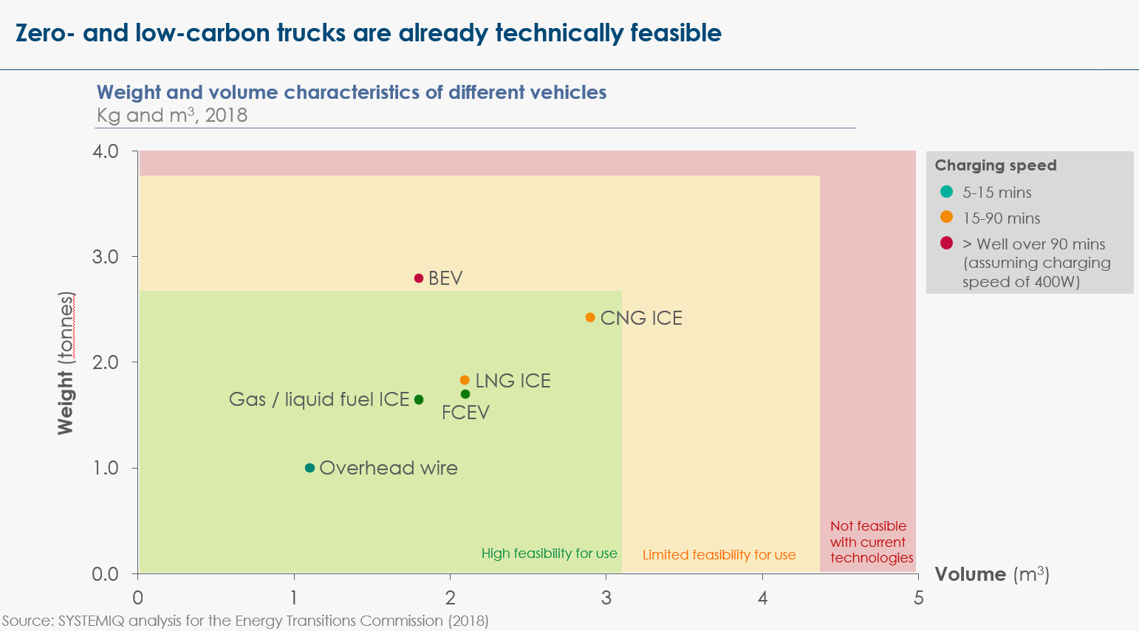
Exhibit 1

  - By 2030, trucks with electric drive trains will have a lower total cost of operation than diesel or gasoline trucks, even for long-distance trucking applications, with similar upfront capital costs and much lower operating costs. For light-duty trucks and buses, the cost advantage will likely be achieved much earlier. Exhibit 2 below illustrates the ETC cost model for a heavy-duty truck doing 150,000 km per year, excluding any tax effects.
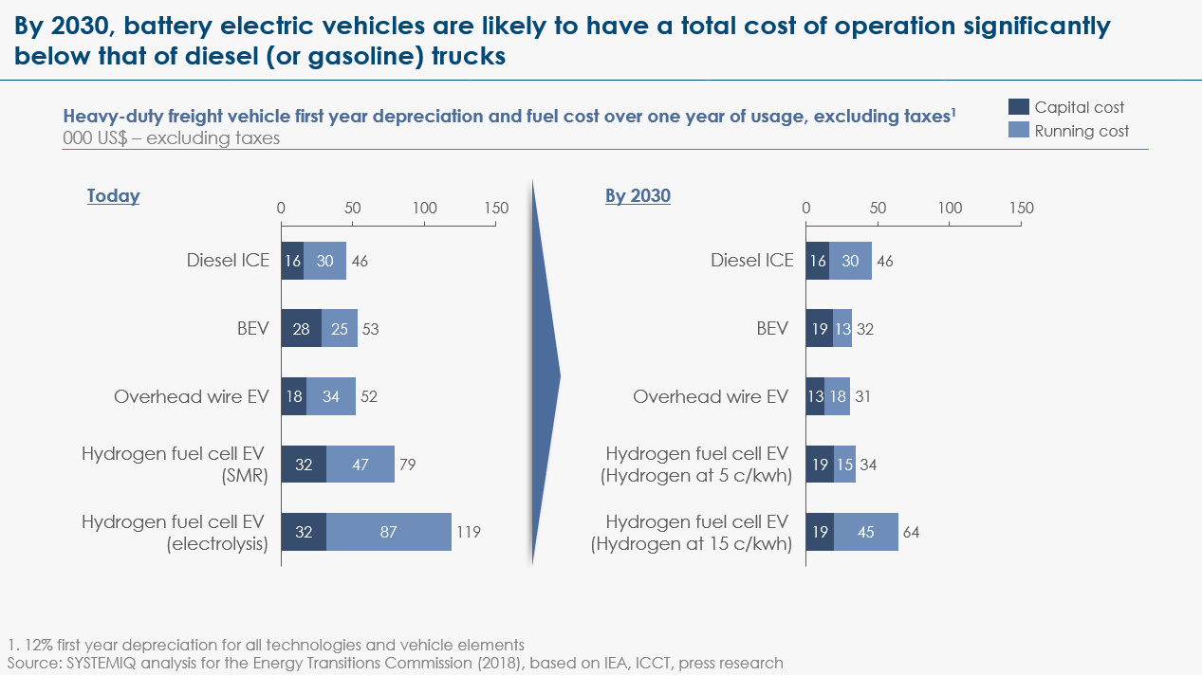
Exhibit 2

  - These conclusions are supported by a number of recent studies. McKinsey estimates that long-haul BEV trucks will become cost-competitive in Europe sometime between 2023 and 2031 and even in the US (with lower excise duties) by 2029 and 2031. Regional haul (200km) trucks and urban haul (100km) trucks and buses will enjoy a cost advantage much earlier, with the economics supporting large-scale deployment in the mid-2020s.
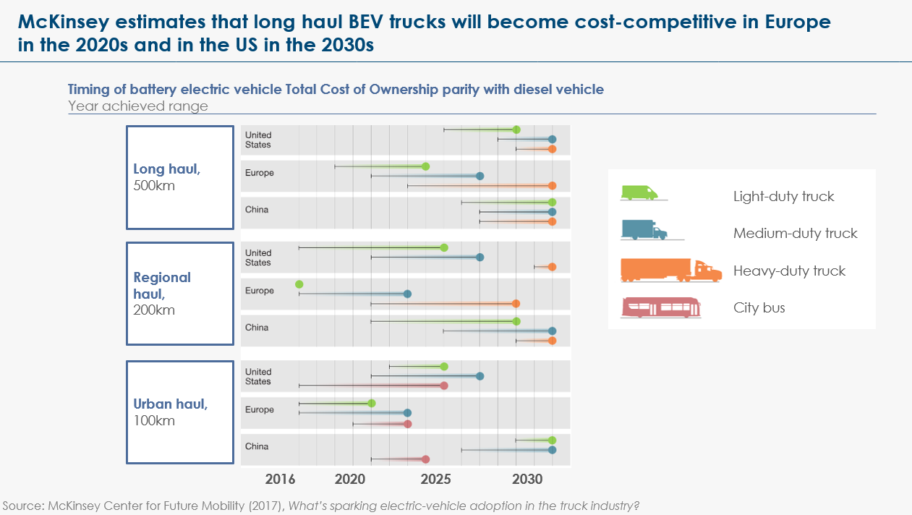
Exhibit 3

  - Electric drive trains will make complete decarbonisation of heavy-duty road transport possible only when electricity generation is totally decentralised. Our analysis suggests that BEVs produce lower total emissions than diesel or gasoline once the carbon intensity of electricity is <875 g/kWh (which is already the case in most developed economies), and for hydrogen FCEVs this figure is <440 g/kWh (which is rarer today). This should not, however, prevent governments from pushing the deployment of electric drivetrains, as long as they simultaneously implement a coherent power decarbonisation strategy, with the aim of ensuring that electric drivetrains are carbon-reducing over their lifetime.
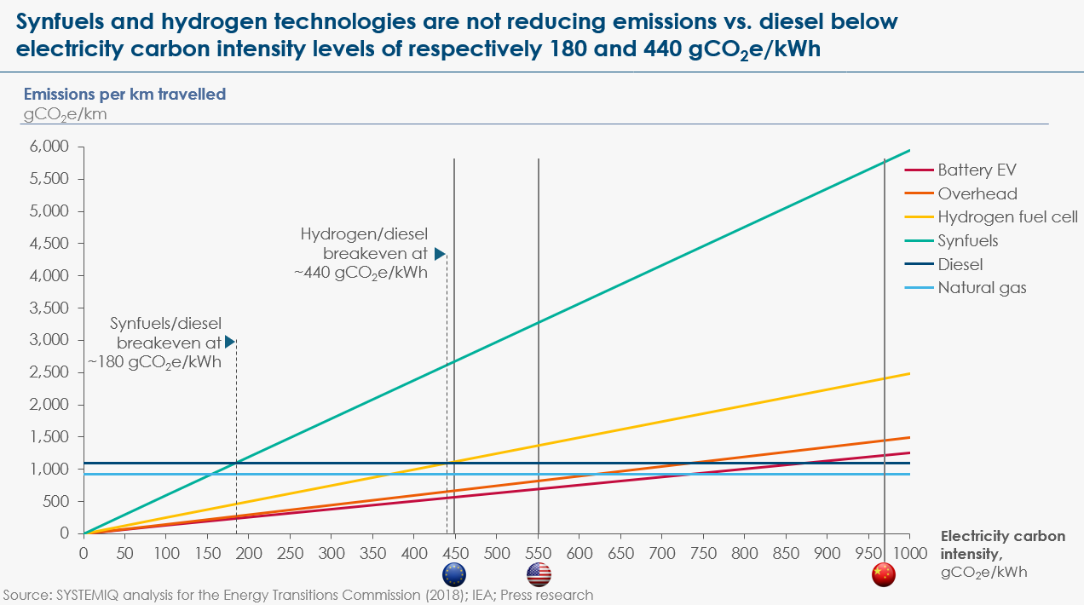
Exhibit 4

- STATUS: What is preventing the decarbonisation of heavy-duty road transport?
Decarbonisation of heavy-duty road transport is already beginning, with select automotive companies and governments making pushes to put electric and hydrogen buses and trucks on the road. However, for proper large-scale adoption to begin, back-bone infrastructure is required and private capital alone is unlikely to deliver that infrastructure.
  - Electric / alternative drivetrains are less profitable for OEMs than ICEs. In terms of short-term profits, manufacturers do not have any incentive to accelerate the transition, although they have in principle a longer-term interest in investing early to take a first mover advantage in terms of technology development.
  - The trucking industry has witnessed early forays of new products from truck manufacturing companies seeking to lead the adoption of new electric and hydrogen fleets. Tesla and Nikola have already announced new models, while Daimler’s Mercedes-Benz truck division is developing commercial trials. Chinese manufacturers are targeting potential export markets to hold their electric truck sales volume dominance.
    - Nikola recently unveiled a new version of its hydrogen-powered electric semitrailer truck that will be aimed at European customers. This could be the first European zero-emission commercial truck and may also serve other international markets including Asia and Australia. Nikola is currently working with Norwegian firm Nel Hydrogen to deploy more than 700 hydrogen stations across the U.S. and Canada by 2028, and European stations are planned to come online around 2022 aiming to cover most of the European market by 2030.
    - Tesla continues to develop its all electric long-haul truck Tesla Semi. The company has not yet released the actual specifications of its battery for the Semi, but its roadmap includes the commercialization of two versions of the vehicle, a 800-km long range and a 480-km short range versions. Elon Musk, CEO, has stated that the vehicle would likely have a range close to 970km per charge.
    - Daimler’s Mercedes-Benz electric truck division is currently conducting trials of an all-electric truck for on-road testing, expecting to continue over the next year. The test will be conducted over a 100km daily tour with a 25-tonne truck that includes a refrigeration unit for food. The company has been working with this technology since 2010 and has been producing a first series of fully electric trucks since 2017.
  - Despite the above early progress, two sets of implementation challenges could easily significantly delay the transition: infrastructure deployment and upfront switching cost.
  - Infrastructure: While the cost to the vehicle owner will be in favour of BEV and FCEVs very soon, there is a pre-requisite that supporting charging / refuelling infrastructure be built out first. Taking the UK as an example:
    - Taking the UK as an example:
- For BEVs, assuming 100kW “fast” chargers at US$60,000, building 8000 charging stations (i.e. current number of diesel / gasoline stations) would roughly represent a US$500M investment. This infrastructure could be shared for LDVs and HDVs.
- For FCEVs, the hydrogen refuelling infrastructure would be smaller, as it would serve the long-haul HDV segment only. Based on US$2-3M per refuelling station, installing 5000 new stations would represent roughly US$10-15B investment.
- Catenary: With a cost of $1-4M per km, installing catenaries on the UK’s motorways and trunk roads would, for instance, represent an investment of $12-50B.
    - In light-duty EV charging, private investments (i) are currently not making money and are plays for future strategic advantage and (ii) are creating interoperability challenges (e.g., Tesla-only chargers). While some battery recharging or hydrogen refuelling will be done within depots and distribution centres, and can therefore be driven by private companies, widespread conversion to BEVs and/or FCEVs will require a significant network of shared recharging or refuelling facilities, at least partly publicly funded.
  - Upfront switching cost:
    - Large professionally managed trucking fleets should respond rationally as the total cost of operation of electric drivetrains begins to outcompete ICE vehicles. However, many smaller trucking operators, sometimes facing financing constraints, may focus primarily on upfront cost rather than total cost of operation and may therefore replace fleets far more slowly. The fall in cost of batteries is likely to bring the upfront cost of BEVs below the upfront cost of ICEs in the 2030s, but the upfront cost of FCEVs might stay higher for the foreseeable future.
    - Two additional set of challenges might slow down adoption: (i) upfront cost of infrastructure build-up at depots for both ICE and EV (BEV or FCEV), (ii) learning how to operate logistics for such a fleet.

- EMERGENCE: What is the critical minimum scale needed to shift the market?
Minimum scale is not in question when it comes to manufacturing of e-trucks at sufficient scale to be competitive with ICE. However, there is a requirement for sufficient infrastructure to be in place to provide confidence to fleet owners in shifting over to electric drivetrains.
  - Although minimum scale is not in question when it comes to manufacturing e-trucks, accelerating adoption in the most favourable market segments can help accelerate cost reduction – and therefore drive earlier adoption in other market segments.
  - Governments should ensure that a minimum “sufficient” scale of public charging infrastructure is in place both (i) along critical freight corridors for medium and long-haul and (ii) within major cities to support light and medium duty trucks for short haul operations as well as long-haul operations (given that cities are the origin and destination of most long-haul road freight).
  - This “sufficient” scale can be defined by a number of chargers, charging speed and supporting electricity network / hydrogen production and distribution network reinforcements to avoid long waiting periods.

  - Infrastructure deployment should be thought through nationally, in consultation with major fleet operators, to respond to the specificities of local demand, in particular with regards to which freight corridors are most used and should therefore be higher-priority. Such collaborations should also include truck manufacturers, site owners (e.g., motorway service stations, fuel stations), utilities and fuel providers. A jointly agreed infrastructure deployment plan would also create greater certainty on future demand and possibly enable a public-private financing model for the required infrastructure.
  - Consultation with industry should also uncover which type of vehicle is preferred by end users in order to develop the right type (EV v. FCEV v. overhead wiring) of infrastructure. Our assumption is that FCEV infrastructure should be deployed for long-haul freight, while BEV infrastructure should be deployed for short-haul freight. There will be some overlap between the two networks (especially given the need to also deploy BEV charging infrastructure for light-duty vehicles). The existing uncertainty on the exact maximum range at which BEVs will be able to operate should not constitute a barrier to early investments, if both BEV and FCEV infrastructure are already deployed for the two most extreme (short-haul / long-haul) use cases.
  - Again, in the case of BEV truck charging infrastructure, this could combine with light-duty EV charging infrastructure, thus spreading such costs over both demand sources.
  - In Europe, where many countries are located within a tight geographic area and there is a significant amount of cross border trade, coordination on infrastructure standards will be necessary. For larger, continent-sized countries, such as the US, in the short to medium-term, ICE truck will likely continue to carry out cross-border trade. However, as EV fleets reach mass penetration, infrastructure coordination will be required beyond smaller regions than the EU.

- DIFFUSION: Where can this initial scale-up happen?
The initial scale-up can happen in major cities with medium-duty trucks and buses, as well as in major freight corridors between major cities for longer-haul. This can be kicked-off with early moves by bus fleets from governments and government-connected entities, and by major corporations with large fleets.
  - In terms of manufacturing, initial market signals appear to already be there and have led various manufacturers (including incumbents like Daimler) to move to supply electric trucks. A strengthening of the demand signals could encourage bolder moves away from ICE vehicles manufacturing in the industry though, in particular through:
    - Emissions regulations: Recent EU standard setting targets for manufacturers on their fleet-wide average CO2 emissions of new lorries registered in a given calendar year (15% reduction from 2025, 30% reduction from 2030) constitute a first step. They include incentives for uptake of zero-emissions vehicles including a super-credit system for trucks from 2019 until 2024. A tightening of the emissions targets would create a market at scale in Europe.
    - ICE bans: Announcement of future bans on circulation of ICE vehicles, including for heavy-duty transport, by a certain date from cities, regions and countries also create greater certainty on future demand for alternative drivetrains that can be taken into account by manufacturers.
    - Voluntary commitments: The EV100 campaign has triggered initial deployment of BEVs in light-duty commercial fleets. A similar campaign for heavy-duty trucks, targeting in particular logistics providers and retailers could have a similar impact.
  - The Chinese example as shown that early technology adoption at scale can accelerate cost reductions and therefore drive cost down in a way that then accelerates adoption by other market segments. However, in the case of road transport, infrastructure deployment is a prerequisite to adoption.
  - For BEVs:
    - Early moves to electric drivetrains can be driven by fleets from cities / local governments and entities serving them (e.g., municipal buses, waste management).
    - Private sector uptake through global voluntary commitments of major logistics services firms who own large local delivery fleets (like DHL and UPS) to an expanded version of EV100 could also be pursued in parallel.
    - Related infrastructure deployment is likely to combine some company/organisation-specific charging infrastructure at depots and some public infrastructure coordinated by local governments.
  - For FCEVs (and/or catenary wiring):
    - More so than for BEVs, early adoption needs to go hand-in-hand with deployment of the infrastructure along major freight routes. It could therefore be orchestrated at national level in a set of volunteer countries, through a collaboration of major long-haul fleet operators (logistics services firms and corporate fleet operators, especially retail companies) who could commit to switching to FCEV on major freight corridors once the appropriate infrastructure is in place.
    - Most likely volunteer countries would be those with (i) strong climate / air pollution-related commitments, (ii) an automotive industry which can benefit from early local markets to innovate and capture export market shares, (iii) cheap renewable electricity and green hydrogen. Europe, China and some US States would be the most obvious candidates.

- RECONFIGURATION: What actions could be taken and by whom?
National and local policymakers can deliver a package of measures to [a] create “pull” – support market adoption via pulling forward the economics and delivering supporting infrastructure, and [b] provide “push” – set standards supporting a shift to electric drivetrains and restrict use of ICEs. In parallel, collaboration with fleet operators, manufacturers and energy providers is essential to ensure that infrastructure development serves use patterns.
  - At national level, purchase subsidies, combined with subsidies for depot infrastructure, can create near upfront cost parity between e-trucks and ICE trucks at an earlier date that would happen if left to market forces. Already in place excise duties – which in Europe add ~65% to the pre-tax cost of fuel – will also, until and unless electricity is equivalently taxed, greatly increase the cost-competitiveness of BEVs and FCEVs. For instance, including these taxes would push the diesel ICE figures in Exhibit 2 up to US$65,000, i.e. twice the total operating cost of BEVs by 2030.
  - Local policy initiatives can continue driving the decarbonisation of intra-city road transport, which will have the additional benefit to help support scale-up of manufacturing, charging infrastructure build-out, and drive cost reductions in both those dimensions. Mexico City, Paris, Madrid, Athens committed to end diesel engine use by 2025, Paris to end gasoline engine use by 2030. Trucks are specifically targeted by “clean air zones” policies, e.g., Los Angeles has launched a Clean Trucks Program.
    - Urban bus fleets are beginning to go electric, most dramatically in China. Shenzhen, from 2015 to 2018, converted 16k buses to electric and in total 62k logistics vehicles. A recent report suggests that almost all of China’s 1 million urban buses will be electric by 2025. Given this accelerated push, once buses are converted, the battery production capacity that has been built up could re-point to shift to electric trucks. A commitment to shift to 100% EV urban bus fleets by 2030 at the latest could be taken by different cities networks, in particular the C40.
    - The same cities could take a parallel commitment to develop the sufficient EV charging infrastructure required to cover other forms of medium-duty intra-city traffic.
    - As the above moves are deployed, these cities could then push beyond their ICE bans on cars & vans and put forward either ICE bans or very stringent carbon emissions limits on trucks.
  - An expansion of the global EV100 campaign to medium- and heavy-duty trucks, with a particular focus on getting buy in from major logistics services providers and major retailers, could in parallel drive private-sector adoption of BEVs and FCEVs.
  - However, to enable such a commitment to be manageable for these companies, infrastructure deployment needs to be thought through in parallel. As exposed in sections 4 and 5, this should be thought through at national level, under the leadership of transport ministries, in consultation with major fleet operators, truck manufacturers, site owners (e.g., motorway service stations, fuel stations), utilities and fuel providers. In EU coordination on infrastructure standards should take place, given the high-level of cross-border trade.
    - Infrastructure deployment could be phased, starting with major freight corridors, and progressively expanding to lower-utilisation segments of the road network.
    - Public-private partnership could probably provide the funding mechanism for this infrastructure.
    - This transition might lead to the emergence of leasing companies, bundling the provision of vehicles, charging, maintenance, and, at times, even drivers for a flat monthly or annual fee. These new entrants should be associated to any national consultation.
  - Beyond those initial markets, deployment at scale could come from fleet emissions standards for new vehicles with gradually increasing targets, which could only be met via a shift to electric drivetrains, established in line with expected technology availability for different fleet segments. The progressive tightening of the recently announced European Commission’s first ever CO2 emissions standards for heavy-duty vehicles in the EU should be planned accordingly.

IEA (2017), Energy Technology Perspectives
IEA (2017), Energy Technology Perspectives
IEA (2017), The Future of Trucks
Vivid Economics and ETC (2017), Economic growth in a low carbon world; ETC (2018)
RMI (2014), Reinventing fire: transportation sector methodology
RMI (2014), Reinventing fire: transportation sector methodology
ICCT, 2019, CO₂ emissions standards for passenger cars and light-commercial vehicles in the European union
UK Department for Transport data series
European Council of the European Union, April 2019, Stricter CO₂ emissions standards for cars and vans signed off by the council
Energy Transitions Commisison (2019), Sectoral Focus on Heavy-Duty Road Transport: http://www.energy-transitions.org/sites/default/files/ETC%20sectoral%20focus%20HeavyRoadTransport_final.pdf
McKinsey Center for Future Mobility (2017), What’s sparking electric-vehicle adoption in the truck industry?
https://www.rolandberger.com/publications/publication_pdf/roland_berger_trends_trucks_trailer.pdf
EV100 is the campaign coordinated by The Climate Group through which corporates commit to 100% electric vehicles in their light-duty fleets. To our knowledge, the expansion of the EV100 campaign to medium trucks and heavy trucks is in reflection.
Rocky Mountain Institute (2019), Shenzhen: A City Miles Ahead
BNED (2018), Electric Buses in Cities

