How to trigger initial deployment of zero-carbon technologies – Cement briefing note

- CONTEXT: Cement production and carbon emissions
Decarbonising cement production constitutes one of the most difficult decarbonisation challenges, as CO2 emissions from cement are twofold: energy-related emissions and process emissions. The latter are particularly difficult to avoid. Growth in demand is expected in the developing world, where buyers’ and consumers’ ability to absorb the extra cost related to decarbonisation is likely to be lower.
  - The production of Portland cement (which is currently the predominant cement type) entails the heating of ground limestone (CaCO3) to an extreme temperature (>1400°C) in kilns to produce calcium oxide (CO) where CO2 is emitted as a result.
  - Cement accounted for c. 2.2Gt of CO2 emissions globally in 2014 (with 1.2Gt of process emissions and 0.75Gt of energy-related emissions arising from high heat production). This is the equivalent of 7% of total global emissions from the energy system. Under a business-as-usual scenario, emissions could rise to 2.3Gt per annum by 2050.
  - The three biggest producers (LafargeHolcim, Anhui Conch and Heidelberg) capture more than half of the global market. LafargeHolcim alone holds a 25% global market share. The capital intensity of cement production reinforces this concentration, making it difficult for smaller actors to enter the market and compete with larger firms.
  - Globally, cement firms tend towards vertical integration, producing their own concrete in downstream operations. This also reinforces concentration.
  - The highest-performing cement companies (who occupy the top quintile) capture almost the full economic profit of the industry, whereas the next 60% of companies (quintiles 2 to 4) create returns just above or below the cost of capital.
  - By contrast, the market for cement – i.e. the construction industry – is highly fragmented structure, with multiple small companies and complex contracting chains spanning diverse parties.

  - As overall demand for cement is shifting from the developed to the developing world (Exhibit 1), most new capacity investment is located in India, Africa, Latin America, and Southeast Asia. In fast-growing markets in Africa, Asia, and Latin America, a new type of cement player has come to prominence: the regional champion. In India, 4 regional players account for 44% of capacity. In West Africa, the market is dominated by 6 producers, of which 4 regional players.
  - By contrast, China is facing an overcapacity issue since the early 2000s. The Chinese authorities have led efforts to eliminate 400Mt of capacity (1/10th of total Chinese capacity) over the past few years and consolidate the market through mergers of hundreds of producers. Chinese companies have expanded internationally through the Belt and Road Initiative. China has also ramped up exports of (subsidised) cheap cement to other markets (in particular in Africa) leading to accusations of dumping by local producers. At the same time, China has somehow counterintuitively increased imports of cement from neighbouring countries to face shortages in periods where Chinese cement plants are closed due to air pollution peaks and energy shortages. Overall, China has imported more cement than it has exported in 2018.
  - Since it is too heavy and low in value to be traded internationally, cement has historically been primarily a local industry. Only around 3% of global production is traded across borders, primarily in neighbouring countries (e.g. Mexico/US/Canada, EU/North Africa/Turkey, China/Vietnam).
  - However, the world is currently facing a unique situation due to the extent of the Chinese overcapacity: Chinese exports to Africa have been growing recently and competing with local production because of (i) very cheap (subsidised) low-quality production in underutilised plants and (ii) ability to ship at low cost in bulk carriers which have carried commodities from Africa to China on their return journey – i.e. in vessels that would be empty otherwise. This situation is unlikely to apply to regions which (i) have higher quality standards and (ii) do not export large amounts of commodities to China. It is also possible that Chinese costs will rise again with (i) new air pollution regulations on Chinese cement production and (ii) decarbonisation of shipping.
  - Efforts to reduce emissions from cement production have historically been led during 10 years by the Cement Sustainability Initiative (CSI), which convened 24 cement producers representing >20% of global cement production. However, the initiative was shut down and merged with the Global Concrete and Cement Association (GCCA) in January 2019. Initial discussions with the GCCA indicate ambition to play an active coordination role on emissions reduction across the sector. The Chinese industry has also been under pressure to reduce emissions due to air pollution issues. As a result, several producers have decreased their emissions intensity and invested in R&D (see Exhibit 2).
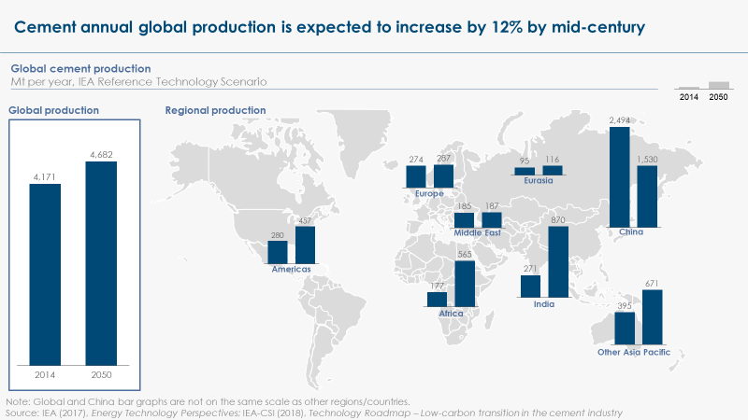
Exhibit 1

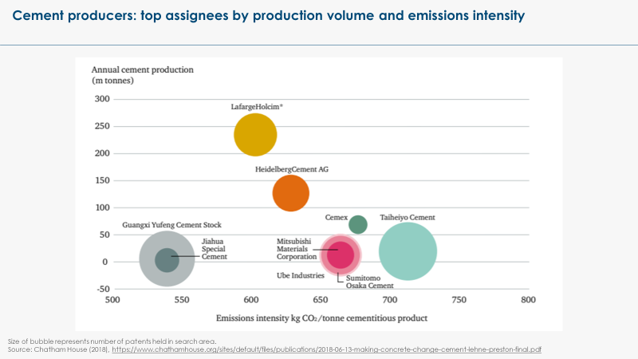
Exhibit 2

- PATHWAYS: How can cement be decarbonised?
Energy-related emissions can be reduced through a switch to low-carbon energy sources. But, unless there is a breakthrough in cement chemistries, the deployment of carbon capture will be indispensable to fully decarbonise cement production.

  - It is possible to significantly reduce carbon emissions from cement through demand reduction, energy efficiency and a coal-to-gas shift.
A. Reducing primary cement production through materials efficiency. This could be achieved in 3 main ways: (1) through greater materials recirculation (although cured cement cannot be recycled, concrete can be reused and new technologies enable to extract and recycle the uncured cement embedded in concrete), (2) through more efficient use of materials in buildings, and (3) by getting greater value out of each square meter of building (via more intensive occupation and longer lifetime). Global emissions from cement could be reduced by 45% in 2050 compared with baseline levels if more circular approaches were adopted. Some of these measures are likely to entail negative abatement cost per tonne of CO2 saved, but the main challenge to implementation will be the fragmented structure of the construction industry.
B. Reducing demand for cement through materials substitution. Timber and bamboo could in principle play a major materials substitution role in the buildings sector, already used at scale in several geographies. Since the energy input in manufacturing timber is less than 30% that of cement, and the process emissions are nil, total emissions from timber production represent less than 15% of those generated by cement production. In addition, timber acts as an effective carbon sink, storing the CO2 absorbed during forest growth for as long as the building exists. The major constraint, however, will be the limited timber supply. There are several other alternative building materials, though generally these are at an earlier stage of development. New concrete chemistries can also reduce the cement input per tonne of concrete, with some cement-less concretes currently being developed.
C. Improving energy efficiency. Improving energy efficiency, even within current production processes, constitutes a short-term carbon mitigation opportunity. The IFC/World Bank have identified about 20 possible technologies (including retrofits) and measures, which together could deliver 10% energy savings on the typical thermal cement production process, most of them with a 2-year payback period. However, retrofitting often entails high upfront capital costs that individual industry players cannot always bear, especially in developing economies.
D. Coal to gas shift. As a transitional solution, it would be possible to significantly reduce emissions by shifting from coal to gas in China, India and the rest of the Asia Pacific region, which stand out as regions where cement production is currently most dependent on coal.
  - For cement production to be fully decarbonised, it is necessary to eliminate both (i) CO2 emissions resulting from energy used to produce intense heat for the kilns and (ii) CO2 emissions from the chemical process which convert limestone into calcium oxide.
A. Energy-related emissions can be eliminated via a switch to zero-carbon energy sources:
- Utilising waste or biomass in existing kilns is a proven technology, already used on an industrial scale. It requires only a modest retrofit to existing kilns, but is unlikely to be scalable across all markets, given constraints on total supply of waste and sustainable biomass.
- Replacing fossil fuels with green hydrogen could require significant furnace redesign and would currently be significantly costlier than the high-carbon alternative.
- Using electricity as the heat source in kilns is theoretically possible, but the technology has not yet been demonstrated and will not be market ready in the short term.
- Finally, it is possible to capture carbon emissions from energy, alongside process carbon emissions.
B. New cement chemistries can reduce – but not fully eliminate – process emissions:
- Belite clinker is the most readily available alternative to conventional clinker today, but it only achieves a modest 10% emissions reduction.
- Calcium sulphoaliminate (CSA) or carbonisation of calcium silicates (CACS) clinkers could deliver more significant emissions reductions (20 to 30%), but the required mineral inputs are less readily available.
- Magnesium-silicate-based cement could potentially eliminate emissions completely, but the required mineral feedstocks are scarce in many regions and this solution is therefore unlikely to be scalable.
- Alkali/Geo-polymer-based-cements, in particular, pozzolan-based cements, are possibly the most promising pathway forward, as they could eliminate 70% of emissions, utilise minerals which are widely available across all continents, and have been demonstrated at scale (proving to be cost-competitive).
C. Applying carbon capture (combined with either storage or use) to cement plant is therefore an indispensable part of the decarbonisation pathway for cement.
- Carbon capture can be applied to both energy-related and process emissions, or to process emissions only. In the absence of a breakthrough in cement chemistry, it will be the only solution to process emissions. Even if new cement chemistries are used, carbon capture would still be needed to capture likely remaining process emissions.
- Carbon capture equipment can be fitted on existing kilns, enabling retrofitting. However, current capture technologies only capture up to 90% of the carbon stream, and therefore only constitute a near-zero-carbon solution.
- Carbon capture is likely to be more expensive for cement than for other industrial sectors (US$110 per tonne of CO2 captured for a first-of-a-kind plant versus <US$65 for iron and steam methane reforming, US$90 per tonne for nth-of-a-king plants) given the relatively low concentration of CO2 emissions in exhaust gases from the cement production process.
- Several technologies are being developed to increase purity in the CO2 flow and therefore reduce cost of capture while enabling higher capture rates. Innovative kiln design could separate exhaust gases from fuel combustion (low in CO2) from the exhaust gases of calcination (almost pure CO2), allowing the latter to be captured at lower cost. Burning fossil fuel input in pure oxygen rather than air (oxy-combustion) would also increase the percentage of CO2 in the heat-related emissions. These technologies, however, would be more difficult to retrofit on existing plants.
- There is potentially an opportunity to use CO2 captured in cement plants to cure concrete, therefore creating a circular carbon model within the cement value chain. However, the scale of this opportunity is still uncertain.
  - The way forward will most likely vary by location, in line with (significant) differences in renewable energy resources. In most regions, applying CCS/U to both energy and process emissions will likely be the cheapest decarbonisation option for the foreseeable future, as electrification of kilns is still an unproven technology and use of hydrogen for heat production would only be cost-competitive if hydrogen can be produced at low cost from electricity below $20/MWh. Regions with large sustainable biomass resources could find it more competitive to combine biomass use with CCS/U.

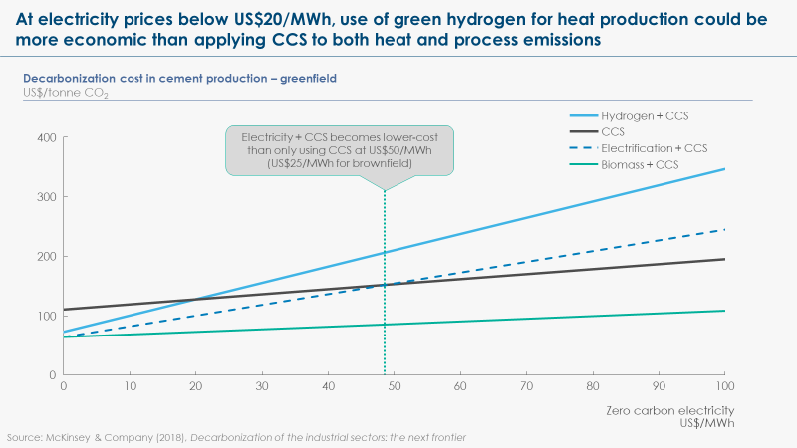
Exhibit 3

- STATUS: What is preventing the decarbonisation of cement?
Although it is technically possible to achieve quasi full decarbonisation of the cement sector, it is one of the most difficult and costliest sectors of the economy to decarbonise, given carbon capture deployment is both indispensable and expensive. Decarbonisation could potentially double the price of a tonne of cement, by adding around US$100 per tonne.
  - Decarbonising cement production will have a significant impact on the costs faced by the construction industry, adding more than US$100 per tonne of cement, which means roughly doubling its cost. This would then translate into a 30% increase in the cost of concrete, with a material impact on the construction value chain.
  - The key challenge in cement decarbonisation is therefore how to deal with the extra-cost faced by intermediary stakeholders in the construction value chain, especially during the initial phase of the transition, when technology costs are likely to be relatively higher than in the later stages of the transition. These extra-costs would entail significant risks of competitiveness loss for any first-mover if competitors were not on a level playing field. The localised nature of the cement industry, however, implies that this competitiveness issue can be solved on a regional basis and does not require international coordination.
  - The ETC estimated that the maximum impact on the price faced by the buyers of a typical house would only be around a 3% increase. The additional cost of cement would indeed be diluted in the multiple other sources of costs faced by the end buyers.
- This makes it likely that consumers could be willing to support policies and initiatives which would drive decarbonisation. In particular, it implies that public procurement could play a significant role in driving demand for zero-carbon construction materials without significantly adding to the total cost of these operations.
- However, this propensity to absorb the extra cost is likely to be lower in developing markets, where future demand for cement will be concentrated.
  - Most of the decarbonisation technologies required to decarbonise cement production face specific deployment constraints:
- Use of waste and biomass as a heat source is technically feasible – and indeed already done on an industrial scale – but limited by availability of feedstock.
- Hydrogen-based and electrified kilns, which would more scalable solutions, are currently in early stages of development: they have been lab-tested, but have not yet been demonstrated at commercial scale.
- Even carbon capture, which is the most crucial technology for cement, has not yet been demonstrated on an industrial scale in the cement sector. Although there are opportunities for CCU, including within the cement-concrete value chain, CCS is likely to be required on a significant scale, implying investments in the carbon transport and storage infrastructure. Deployment is made more difficult by the fact that cement production tends to be distributed across multiple plants scattered geographically, increasing significantly the cost and potentially threatening the social acceptability of the necessary carbon transport infrastructure.
- Meanwhile, some alternative cement chemistries, such as pozzolan-based cements, have already been used in commercial projects and could potentially be cost-competitive, but the conservative nature of the construction sector and the rigidity of building codes, many of which are outdated and do not make allowances for new materials and designs, get in the way of large-scale deployment.
  - The structure of the industry is not favourable to any form of change:
- While the biggest global cement players hold several patents for lower-emissions technologies, analysis by Chatham House suggests that these companies are not currently deriving significant monetary or strategic advantage from their patents. As per point 1.5, they do not need to innovate to capture value in the sector.
- Overcapacity in China – as well as in developed markets – disincentives investments.
- High capital costs and market concentration constitute significant barriers to entry for start-ups and SMEs. The biggest players are being accused by new entrants to leverage their dominant position vis-à-vis a more fragmented construction industry to actively block access to market to new entrants.
- The construction sector is constituted of a large number of local SMEs. These companies have a lower propensity to adopt innovative practices and technologies due to lack of awareness, upfront costs, and organisational culture. The fragmented nature of the sector makes it difficult to coordinate action among cement buyers.

- EMERGENCE: What is the critical minimum scale needed to shift the market?
Investing in a commercial-scale low-carbon cement facility will require significant and sustained demand equivalent to the output of a modern integrated facility (i.e. minimum 1Mt per annum).
  - The minimum size of a new greenfield cement production facility is typically 1Mt per annum. This is the equivalent to:
- Less than 1% of the capacity of LafargeHolcim, Anhui Conch or Heidelberg;
- About 0.5% of the European market and about 1% of the US cement market;
- About 0.5% of the demand from public construction in the US (public buildings and public infrastructure) and about 25% of the demand for public buildings only;
- The equivalent of 2-5 times the amount of cement required for a major infrastructure project (e.g. ~430,000T for Hinkley Point C’s construction, 260,000T supplied by LafargeHolcim for a major transport infrastructure project for the Grand Paris, ~175,000T for London’s Olympic Park);
- The equivalent of 10-15 times the amount of cement required for a smaller infrastructure project (85,000T for a dam wall, 77,000T for a road tunnel);
- The equivalent of 20,000 3-bedroom houses (accounting for 50T per house) – for comparison the UK targets 240,000 new homes per annum.
  - If the whole industry was to be decarbonised by 2050, more than 4500 low-carbon plants would have to be built between 2020 and 2050, i.e. more than 150 per year. An intermediary objective of 1,000 Mt of low-to-zero-carbon cement production capacity by 2030 would appear to be in line with the longer-term objective.
  - By comparison, demand is expected to grow by c.600Mt in India and c.400Mt in Africa by 2050, which could represent a significant opportunity if new capacity was built using zero-carbon technologies.

- DIFFUSION: Where can this initial scale-up happen?
Bringing down the cost of zero-carbon cement may require initial investments in more mature markets where public procurement can absorb initially higher costs. But new large-scale investments in cement facilities will be driven by and located in developing economies, where development finance institutions could potentially play a role in absorbing the extra cost of decarbonisation.
  - Demand is currently roughly stable in the European and US markets, where market saturation has been reached, which is in principle not favourable to investments in low-carbon facilities. However, the importance of public procurement in these markets (up to half of the cement demand) and continuous procurement spending in infrastructure areas offers a powerful changer lever.
- Regional coalitions of national and local governments taking voluntary commitments to procurement of green cement could create an initial demand signal – as long as they represent an aggregated pluriannual demand of more than 1Mt per annum and they are based on a share definition/labelling of green cement. Deployment of new procurement rules for public buildings and public infrastructure could then create demand at scale, triggering cost reductions in different decarbonization technologies.
- Localisation of the first low-carbon plants near/within industrial clusters that could benefit from a joint carbon transport and storage infrastructure (for instance in the North Sea) could lower costs and facilitate deployment of carbon capture.
  - Cement production in India and Africa is likely to more than triple over the next 35 years as urbanisation drives huge demand for concrete (see Exhibit 1). Prospects in the cement industry are attracting foreign direct investments.
- Capacity build-up represents a major opportunity to deploy low-carbon technologies at scale, and possibly adapt the geography of cement production to the requirements of carbon transport and storage infrastructure development.
- However, in the short term, these markets may also be particularly price-sensitive. Creating a market for low-carbon cement in these regions would likely require a combination of (i) protection against the current influx of cheaper, high-carbon Chinese cement and (ii) incentives from major funders of public and private infrastructure to procure green cement. The latter can be enforced through tighter public procurement standards. However, in the absence of such standards, DFIs could play a major role in incentivising procurement of low-carbon cement through their portfolio of investments.
  - Although China is grappling with the consequences of overcapacity, it has the ability – and seemingly the political will – to play a catalytic role in the development of low-carbon cement, driven in particular by air pollution concerns.
- China has emerged as a key cement innovation hub. According to Chatham House, over half of all patents for new cement technologies are owned by Chinese companies and academic institutions and China has invested more than any other country in cement research and development (R&D).
- In the last five years, China has also stipulated that companies must install advanced anti-pollution technologies to meet raised standards for the production of materials such as cement. However, to date, Chinese firms abroad – especially those expanding in the context of OBOR – have not been held to the same standard.
- The scale of new investments planned in Asia in the context of OBOR and the integrated nature of these investments – encompassing design, financing, construction and maintenance of infrastructure projects, as well as provision of construction materials – could represent a major opportunity to develop new low-carbon materials value chains across multiple geographies. For instance, 6 new cement plants have been built in Laos since 2015, when the country began a railway project funded and constructed by Chinese businesses. The six plants have a combined capacity of 4.8 million tonnes of cement per year.

- RECONFIGURATION: What actions could be taken and by whom?
The local nature of the cement market makes it possible to drive decarbonisation through national regulation on both production (emissions standards) and consumption (buildings standards). But regional coordination is necessary and some international coordination would be beneficial.
  - R&D funding and low-cost financing for increasing scales of demonstration of new technologies would accelerate development of decarbonisation options for cement.
  - Given the importance of public procurement for the construction market, there is a strong case for setting public procurement standards requiring procurement of low-carbon cement, first in developed economies and then in developing economies. To take into account the time required to upgrade existing plants or build greenfield plants, public authorities could announce these regulations ahead of time (e.g. c.5 years before implementation) and start with lower-carbon requirements (e.g. -50%) with a progressive tightening to reach zero-carbon requirements at a later date (e.g. 2040).
  - Beyond public procurement practices, full decarbonisation of the cement sector will likely require both:
- A revision of building standards, in a way that introduces more flexibility in materials usage (enabling greater materials efficiency, materials substitution and market entry of new cement and concrete chemistries) and imposes tighter regulations on the carbon-intensity of construction materials (ideally based on an universal carbon labelling and tracking system across the value chain);
- Regulations on carbon emissions from production.
  - Given the regional nature of the cement market, regional harmonisation (e.g. within the EU and with neighbouring countries, within North America) of these different standards would be preferable (and could be combined with some border adjustment).
  - International harmonisation of how to account for carbon emissions of cement production and how to track and account for the embedded carbon emissions of construction materials throughout a complex and fragmented value chain could facilitate deployment of good practices, in particular within the biggest global conglomerates. It could also enable better information of finance players, including DFIs. This could possibly be done under the umbrella of a trade body like the World Green Buildings Council.

Energy Transitions Commission (2019), Mission Possible – Sectoral Focus – Cement http://www.energy-transitions.org/sites/default/files/ETC%20sectoral%20focus%20-%20Cement_final.pdf
https://www.statista.com/statistics/586706/leading-cement-manufacturers-based-on-market-share-globally/
https://www.chathamhouse.org/sites/default/files/publications/2018-06-13-making-concrete-change-cement-lehne-preston-final.pdf
https://www.mckinsey.com/industries/chemicals/our-insights/the-cement-industry-at-a-turning-point-a-path-toward-value-creation
https://www.mckinsey.com/industries/chemicals/our-insights/the-cement-industry-at-a-turning-point-a-path-toward-value-creation
https://www.outlookbusiness.com/markets/feature/uneven-road-ahead-4994
https://www.globalcement.com/magazine/articles/1079-cement-in-west-africa
http://www.worldstopexports.com/cement-exports-by-country/ // http://www.worldstopexports.com/cement-imports-by-country/
https://www.economist.com/business/2013/06/22/ready-mixed-fortunes
Energy Transitions Commission (2019), Mission Possible – Sectoral Focus – Cement http://www.energy-transitions.org/sites/default/files/ETC%20sectoral%20focus%20-%20Cement_final.pdf
500,000m3 of ready-mixed concrete was estimated as needed to build the London Olympic Park (http://www.sci-network.eu/fileadmin/templates/sci-network/files/Resource_Centre/Guide/SCI-Network-Snapshots-www.pdf) / Typically, 1m3 of concrete is made up of 350Kg of cement, 700Kg of sand, 1,200Kg of chippings and 150 Litres of water.” (http://www.planete-tp.com/en/concrete-mix-design-a221.html).
https://www.globalcement.com/news/itemlist/tag/Infrastructure
https://www.iisd.org/project/public-procurement-and-innovation-low-carbon-infrastructure
In India, according to data released by the Department of Industrial Policy and Promotion (DIPP), cement and gypsum products attracted foreign direct investments worth USD $5.26 billion between April 2000 and June 2018.
https://www.chathamhouse.org/sites/default/files/publications/research/2018-06-13-making-concrete-change-cement-lehne-preston.pdf
https://uk.reuters.com/article/us-china-silkroad-cement-insight/shuttered-at-home-cement-plants-bloom-along-chinas-new-silk-road-idUKKCN1PO35T
https://www.bcg.com/en-gb/publications/2018/trillion-dollar-plan-new-silk-road.aspx

