How to trigger initial deployment of zero-carbon technologies – Aviation briefing note

- CONTEXT: Aviation and carbon emissions
Carbon emissions from aviation are the fastest growing of all transport sectors and currently contribute 3% to global emissions from energy and industry.
  - Emissions from the aviation industry currently amount to circa 1Gt CO2, accounting for 3% of total global emissions and having grown more than 4% per annum in five of the last six years. Under a business-as-usual scenario, they could further reach 1.8Gt by 2050, representing >4% of global emissions and 14% of transport sector emissions.
  - Beside carbon emissions from fuel combustion, aviation yields other non-CO2 greenhouse gases with global warming effects. It is estimated that CO2 only accounts for 40% of total climate change relevant impacts of aviation, the remaining made up of, e.g., NOX, water vapor, sulphate particles, soot particles and contrail formation depending on atmospheric conditions.
  - Passenger traffic represents nearly 90% of global carbon emissions from aviation. Passenger-kilometres have increased by a factor of 12 since 1970, by more than 5.5% every year since 2013, and are forecasted to grow by another 238% by 2050 in a business-as-usual scenario. Growth of aviation passenger numbers is highly correlated with GDP per capita, as Exhibit 1 shows. Asia-Pacific will account for more than half of new passengers by 2036.
  - Freight traffic is forecasted to double by 2036, with belly and dedicated freight volumes rising significantly.
  - Domestic flights account for the majority of passenger-km today, but, from the 2020s onwards, international travel is expected to have outgrown domestic travel. By 2040, international flights are expected to represent 1.5 times domestic passenger numbers.
  - Depending on the region/market segment, business travels represent 10-30% of flights vs. 70-90% for leisure/private travel. However, they are typically twice as profitable and can sometimes represent up to 75% of an airline's profits, as businesses are willing to pay more to book last-minute flights, non-stops or premium-section seats.
  - Whereas almost 50% of flights are sub-500 nautical miles, only 15-20% of emissions can be attributed to short-haul travel. The majority of emissions is made-up by long-haul flights. (See Exhibit 2)

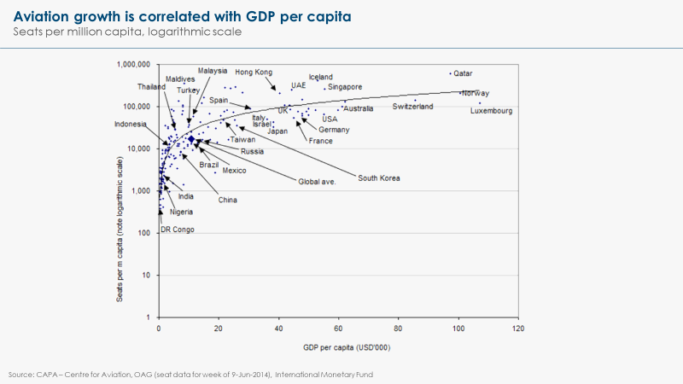
Exhibit 1

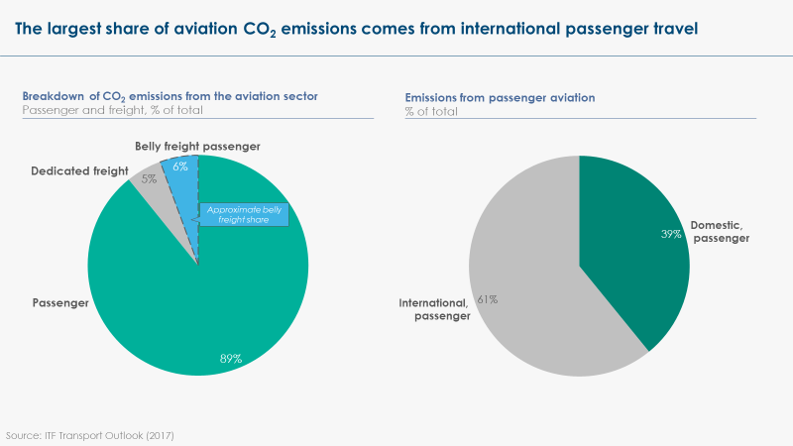
Exhibit 2

  - There are more than 5,000 airlines in the world having an ICAO code, of which roughly 800 operate scheduled services. 290 of these airlines are organised in IATA, making up 82% of passenger traffic. The sector is therefore highly fragmented.
  - At the same time, the biggest players do hold a significant share of the market. The Top 10 airlines have a 36% market share based on passenger revenue kilometres. 5% of airports make up more than 90% of international flights.
  - The top 10 airlines globally (by revenues) are American Airlines, Delta, Lufthansa, United, FedEx, Air France-KLM, Emirates, IAG (British Airways, Iberia…), Southwest Airlines, China Southern Airlines. Among the biggest players, those most active in climate-related discussions and participating in pilot projects are Lufthansa, United, FedEx, KLM, IAG. Some smaller airlines are also leading climate efforts, including Cathay Pacific, JetBlue Airways, Qantas, Japan Airlines and Indian airline SpiceJet, which is much smaller than other potential first movers, but interestingly located in the developing world.
  - The top 15 airports globally (by number of passengers) are Atlanta International, Beijing International, Dubai, Los Angeles, Tokyo Haneda, Chicago O’Hare, London Heathrow, Hong Kong, Shanghai, Paris-Charles de Gaulle, Amsterdam Schiphol, Indira Gandhi Delhi, Guangzhou Baiyun, Frankfurt, Dallas Fort Worth. Only six airports offer a regular SAF supply today. These pioneering airports are Oslo Gardemoen, Bergen, Stockholm Arlanda, Seattle-Tacoma, San Francisco International, and Brisbane. Airports Council International Europe, representing over 500 European airports, have committed to achieving net zero carbon emissions for operations under their control (i.e. excluding flights) by 2050. Within ACI Europe, Heathrow, Schiphol and Aéroports de Paris are leading efforts to develop an SAF offer at scale in partnership with airlines.
  - The aviation market is an international market, regulated by an international body (ICAO), not included in the Paris Agreement and historically mostly free from regional/national policy interventions (see point 6.6 for exceptions).
  - Jet-A fuel (kerosene) is a global commodity and needs to be provided at the same quality level wherever an aircraft lands. Average spot prices are around 0.5 US$/litre, depending on the size of the offtaker.
  - Jet-A fuel is provided by specialised companies, often subsidiaries of larger oil and gas majors such as AirBP, Shell, or Air Total. The market for jet fuel is among the most profitable for their parent companies. The market is very consolidated and the top 7 jet fuel providers own 68% of the market.

- PATHWAYS: How can aviation be decarbonised?
Decarbonising aviation is technically feasible. For long-haul flights, a switch to sustainable aviation fuels (biofuels or synthetic fuels) is the only foreseeable technical pathway and will represent a significant economic cost. However, electrification (BEV or FCEV) is likely to develop for short-haul aviation in the next 5-10 years, providing a more economical alternative to conventional jet fuel.

  - Economic growth generally leads to an increase in aviation demand. Opportunities to curb demand growth are more limited in the transport sector compared to the industrial sector (where materials recycling constitutes a huge efficiency opportunity). Nonetheless, a combination of greater energy efficiency, greater logistics and operational efficiency, modal shift to high-speed rail, and reduced demand for passenger flights might still deliver up to 15% emissions reduction in aviation by 2050.
A. Improving energy efficiency. Aviation has historically improved its energy efficiency by 1-1.5% per annum, through a combination of better engine efficiency and improved airframe design. Overall, improved efficiency has led to a 50% decrease in fuel costs for airlines since 1968. Further improvements are limited by thermodynamics of engines and aerodynamics and can likely only lead to another 30-40% carbon impact reduction by 2030, according to IATA’s technology roadmap.
B. Improved logistics and operations. Better air traffic management (ATM) could deliver approximately 52Mt of CO2 savings by 2030 (compared to 2010 levels) if applied in Europe (via the Single European Sky ATM Research Program, SESAR) and in the United States (via the Next Generation Air Transportation System) only.
C. Modal shift. There is a significant potential to shift from short-haul domestic and intra-regional air travel to high speed rail, which would yield an average of 80% reduction in energy per kilometre travelled. Successful examples of modal shift between aviation and high-speed rail include the Eurostar between the UK and the continent, or the Shinkansen in Japan. However, significant investment in the rail infrastructure is required for such shift to occur. Moreover, only short-haul passenger traffic could possibly be eliminated, limiting total impact on CO2 emissions from the sector.
D. Demand reduction. The development of videoconferencing may also moderate the growth in business traffic. Significantly higher prices for air travel (potentially arising from use of sustainable aviation fuels) may also somewhat moderate the growth of leisure traffic – and probably to a lesser extent of business traffic. Moreover, recent consumer movements outright condemning aviation have already led to passenger reductions, e.g., 3% domestically in Sweden in 2018 vs 2017.
  - Whereas the electrification of road transport is well on its way, the same process in aviation faces a technological hurdle: fuel density. Batteries only contain 1/40th of the energy that jet fuel contains per kg and hydrogen only contains 1/3 per litre. Although BEV and FCEV planes could provide unique advantages (better economics, no CO2 emissions at point of use, no non-CO2 emissions either, etc.), fuel density means that only short-haul flights could be electrified at this stage (unless there is a fundamental breakthrough in battery chemistry). There are more than 170 projects on electrifying aviation under development, usually targeting up to 500NM range and <20-seat aircraft with market entries planned around 2023.
  - To fully decarbonise long-haul aviation, however, the only technically feasible solution is to switch to sustainable aviation fuels (SAF). It is technologically possible (and already done today) to produce the chemical equivalent to jet fuel:
- One option is to turn biomass to biofuels – five production pathways are currently certified for aviation and many others are under development.
- The second option is to produce synthetic fuels or “synfuels”, which is produced from a combination of CO2 (coming from direct air capture or capture from flue gases) and hydrogen (potentially from electrolysis of renewable power).
- These fuels would still emit GHG when used, but could in principle be close to net-zero emissions over their lifecycle (lifecycle assessments of existing SAF indicate on average 80% emission reduction).
- The major advantage of SAF is their “drop-in” capability: they can be used in existing engines and in existing infrastructure, without a need for new investments. Moreover, all certified fuels can be blended with fossil jet fuel. The ASTM has presently certified blending up to 50%. Blends up to 100% have been demonstrated by constructors, but are not yet certified by ASTM and commercially available. This means that there are neither technical barriers (the airframe manufacturers Boeing and Airbus have supported use of SAF for a long time), no legal barriers to immediately increasing the use of SAF in the aviation industry.
- Two types of companies are developing production of SAF:
  - Companies without an aviation background: SAF from biomass have been produced initially by specialised companies such as Neste, Fulcrum, or World Energy, who not only supply to the aviation industry, but also to other sectors like road transport. Synfuels are similarly produced by specialised new entrants, either using CO2 captured on the back of industrial plants (e.g. Sunfire) or using CO2 from Direct Air Capture (e.g., CarbonEngineering or Climeworks).
  - Conventional jet-fuel suppliers: Conventional jet-fuel suppliers mentioned in 1.14 have developed their own SAFs, set up partnerships or acquired licenses to provide SAF.
  - Partnerships between new entrants and conventional suppliers are seen as a mutually beneficial, as the conventional jet-fuel supplier provides existing infrastructure and relationships with airports, whereas the former provides new production routes know-how.
  - The aviation market will therefore probably be split into different segments with different decarbonisation pathways depending on range and aircraft size. Under the assumption that electrified aircraft can deliver on their cost savings promises (becoming cheaper than SAF, but also cheaper than conventional jet fuel), everything that can be, will be electrified, starting with sub-500NM travel from 2025 with new aircraft. As technology improves, higher ranges or larger aircrafts could be unlocked for electrification (see Exhibit 3).
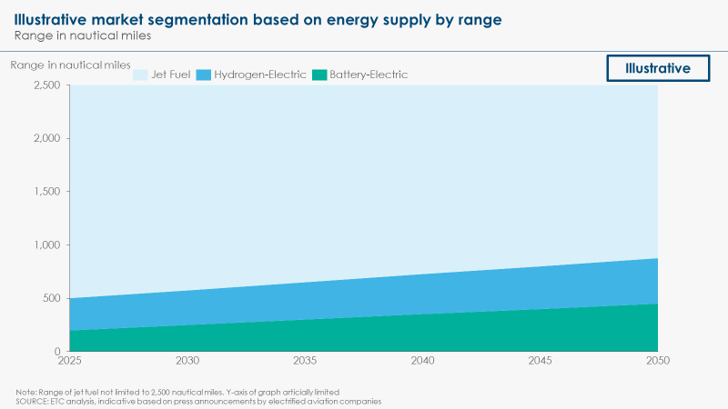
Exhibit 3

  - In parallel, carbon offsets are lauded by industry as a market-based decarbonisation measure. Under CORSIA (Carbon Offsetting and Reduction Scheme for International Aviation), aircraft operators of ICAO member states will be required to offset CO2 emission units based on their annual fuel consumption. This initial use of offsets can be justified given that the aviation industry faces high mitigation costs per tonne of CO2 (US$150-US$230 depending on premium cost of alternative hydrocarbons), whereas some offsetting companies charge as little as US$10-25 per tonne of CO2. However, offsets should only be transitional if the world is to reach the target of net-zero carbon emissions from the energy and industrial systems by mid-century.

- STATUS: What is preventing the decarbonisation of aviation?
Given the international nature of aviation and the cost differential between SAF and conventional jet fuel, it is impossible for any given player to accelerate decarbonisation without losing to competitors, unless policy measures create a level playing field and/or the industry develops a differentiated market for zero-carbon aviation. Meanwhile, fully electric aviation cannot yet provide a cost-competitive alternative to conventional jet fuel for short-haul, as it requires those technologies to reach technological maturity.
  - Airlines face intense global competition on prices, which is what has historically driven considerable improvement in fuel efficiency. The last 10 years have seen the rise of low-cost carriers, further increasing a harsh competition on costs. Today, fuel makes up ~23.5% of an airline’s operating costs.
  - Although technical feasible, the deployment of sustainable aviation fuels face four major hurdles in today’s markets:
A. Cost differential.
- Certified sustainable aviation fuels are currently 50-100% more expensive (adding 0.3 to 0.6 US$/litre) than conventional jet fuel, including existing US and EU incentives, and between 3-6 times without. Today’s sub-scale production (only one facility entirely dedicated to SAF jet fuel by World Energy in California) is hampered by cost of feedstock (many feedstocks are more costly than fully refined conventional jet fuel, e.g., cooking oil and tallow at 0.88-1.25 US$/l) and sub-scale production costs.
- Some producers and researchers estimate that SAF prices can be brought below the price of conventional jet fuel at 0.3 US$/l thanks to economies of scale and learning curve effects (in particular for the synthetic fuel route). However, the most common stance in the industry is that, even if scale can reduce this cost differential, SAF will continue to be more expensive than conventional jet fuel in the foreseeable future (in particular bio-based routes, for which the cost of feedstock will remain an issue).
- Given current biofuels costs and probable short-term improvements, a carbon price of 115 to 230 US$/t CO2 would be required to trigger a switch from conventional jet fuel to SAF, making aviation one of the most expensive sector to abate.
- The impact on the price of flight tickets is difficult to assess, given how pricing mechanisms operate in the aviation industry. The ETC estimates that it could represent a 10-20% increase in the price of a long-distance economy flight ticket. This is the highest variation in end consumer prices that the ETC is expecting from the decarbonisation of harder-to-abate sectors. However, international aviation accounts for less than 3% of global household consumption, so the impact on the yearly spend of most consumers should be limited.
- Moreover, taking into account passed fuel efficiency improvement (-50% of fuel consumption), a doubling of fuel prices per litre of fuel would bring total fuel costs for airlines back to their 1968 level. Continued energy efficiency improvement (as per point 2.1-A) would similarly limit the cost impact of a switch to SAF on airlines and passengers.
B. International competition. Given the competitive landscape, the cost differential of using SAF could not be absorbed by a single airline if there is not a level playing field (or a differentiated premium market for lower-carbon flights). Similarly, airports flag a risk of rerouting if a single airport was to impose carbon-related regulations.
C. Sustainable feedstock availability. There are legitimate concerns about the risks of scaling-up bioenergy use, including biofuels use in aviation, in terms of forest and biodiversity conservation, as well as competition for land use with food production. A range of analyses on the maximum supply of sustainably sourced bioenergy exists, reaching widely different results (from near zero to >200 EJ). Based on IEA estimates, the ETC recommends considering that about 70EJ of bioenergy could be available from waste and residues only (municipal waste, agricultural residues, wood residues) without creating a risk of any land use change. To decarbonise the whole of aviation, between 20-40EJ of bioenergy might be required, which would represent a 30-60% share of this budget. Aviation could legitimately claim priority use of this limited resource, given the lack of alternative decarbonisation options. Any scale-up of biofuels use in aviation should, however, be the object of very strict regulations on sustainable sourcing of fuels.
D. Pace of scale-up. Some airlines currently state that there is a shortage of SAF supply that does not enable them to accelerate their decarbonisation. This statement reflects the fact that a lead-time of 3-4 years for a fuel production facility to be built and start producing, which implies that offtake commitments should be concluded 3-4 years ahead of actual purchase to create demand certainty, and therefore unlock financing for new plants. In addition, most biofuel and synfuel producers have to decide between producing fuels for the automotive, maritime, or aviation sectors, as all require the same feedstock, but different product qualities. The fact that significant subsidies exist for alternative fuel uses in road transport, but not in aviation, distorts the market. Since demand for automotive biofuels rose drastically in the late 2000s/early 2010s, most sustainable fuel capacity has been built for this application. World Energy, for example, only produces jet fuel at one of its six facilities in the USA. The introduction of SAF subsidies in aviation and/or the suppression of biofuel subsidies in the automotive sector would be essential to increase SAF production.
  - Meanwhile, the main hurdles to the deployment of electrified aviation are technology readiness and infrastructure build-up. Today’s electric aircrafts can only seat 2 passengers and fly for approximately one hour (Pipistrel, Bye Aerospace). Commercialisation timelines by companies like Eviation, Ampaire, ZeroAvia, etc. indicate that first 9-19-seat aircraft should be available before 2025. Recharging (for BEV) and refuelling (for FCEV) infrastructure would have to be built-up in airports to enable the deployment of these new technologies, which is currently slowed down by the uncertainty on which technology might win the short-haul market and by when. Certification to aerospace standards could also slow down the deployment process.

- EMERGENCE: What is the critical minimum scale needed to shift the market?
The minimum size of a new greenfield sustainable aviation fuel refinery is typically >100,000 tonnes per annum, which represents about 10% of the annual traffic between London and New York. A capacity of 500-570Mt would be required by mid-century to meet 100% of expected aviation fuel consumption, which represents roughly 10% of the existing oil refinery capacity worldwide.
  - Only ~15,000 tons of dedicated SAF production capacity exist today. The largest announced facility (the Paramount Extension in California by World Energy) would have 462,000 tons of dedicated capacity. The current pipeline of facilities, mostly found in the US and Europe, amounts to ~1.2M tons of SAF (largely from bioenergy), which is likely the maximum realistic potential volume available by 2024, falling short of IATA’s 2% target by 2025, which would amount to 6M tons (300M ton jet fuel demand in 2025 forecast). The IEA’s SDS scenario suggesting a 5% SAF share by 2025 (i.e. 15Mt) seems even further out of reach.
  - By comparison, meeting an expected 500-570Mt of aviation fuels consumption by 2050 would require at least:
- >5,000 minimum-size (i.e. 110kT) SAF production facilities, which, if this build-up happens between 2020 to 2050, would represent ~170 new plants per year (ICAO);
- 2,500-3,000 mid-size (i.e. 200kT) SAF production facilities, which, if this build-up of larger plants starts after 2025, would represent 100-120 new plants per year between 2025 to 2050 (ETC);
- 1,500-2,000 large-size (i.e. 300kT) SAF production facilities, which, if this build-up of larger plants starts after 2025, would represent 60-80 new plants per year.
  - Depending on the size of the facilities, investments could be in the order of US$350-500M per plant (ICAO / IEA).
  - This investment could potentially be brought down – and SAF production scale-up accelerated – if retrofitting existing oil refineries. A capacity of 500-570Mt would be required by mid-century to meet 100% of expected aviation fuel consumption, which represents roughly 10% of the existing oil refinery capacity worldwide.
  - The biggest offtake commitments that have currently been taken by airlines are in the order of 75kt, which means that SAF providers need to secure offtake commitments from several airlines to be able to build up even a small (110kt) new facility. The additional capacity of one 110kt refinery would represent less than 10% of yearly London <> New York passenger numbers (i.e. ~340,000 roundtrip tickets London <> New York roundtrip).
  - To reach 5% of global jet fuel consumption by 2025, 15Mt of SAF production capacity would have to be built, representing roughly:
- ~20% of the US consumption or of the European consumption;
- ~40% of the Chinese consumption;
- The total fuel consumption of 2-3 international airports (given that the major international airports consume 4-10Mt per year).

- DIFFUSION: Where can this initial scale-up happen?
Growing initial markets for SAF requires simultaneously growing demand for and production of sustainable aviation fuels. Demand could be stimulated intra-zone in Western Europe, North America and potentially China, with an initial focus on business travel. Meanwhile, initial uptake of electrified aviation is likely to be found in inter-island services (e.g., Hawaii, British Isles, Indonesia) and other specific markets (e.g., Norway).
  - Consumer willingness to pay for either offsets or SAF-powered flight tickets has been polled frequently, e.g., in studies by Embry-Riddle Aeronautical University. Many airlines have recently extended their offer of voluntary offsetting schemes, e.g., KLM, Lufthansa (launch of Compensaid, an online platform where flight emissions can be ‘offset’ either by purchasing carbon offsets or by paying the difference to sustainable aviation fuels directly). However, uptake of “green flight” products remains limited to date. Lufthansa reports that less than 1% of passengers choose to offset their flights, whereas Qantas reached a 10% share of passengers.

  - By contrast, an increasing number of corporates disclose their carbon footprint and are encouraged to offset their business travel. It is therefore possible – and indeed initial discussions have started within the Clean Skies for Tomorrow initiative led by WEF – to imagine that a buyers’ alliance of business travel (uniting major global corporates and travel agencies) could jointly commit in 2020 to purchasing premium green flights by 2025 (therefore shifting their spending from offsets to green tickets). This would create a demand signal for investment in new production facilities.
  - Demand for an increasing share of sustainable aviation fuels could be generated in regional hubs, where a coalition of airports, airlines and representatives of customers could jointly agree to increase uptake of SAF (for instance, within Europe, the United States or India). This approach is currently being pursued by the Clean Skies for Tomorrow Initiative, under the WEF-ETC Mission Possible Platform umbrella.
- This would have to be done on a scale that mitigates competitiveness risks, by coordinating several major airports within a regional zone (Western Europe, all or part of the US, Eastern China) and all airlines operating between these airports.
- The role of airports in stimulating demand can be significant. Only a limited number of airports needs to provide and/or mandate SAFs to impact a large proportion of the traffic (as less than 5% of all airports handle 90% of international flights).
  - Meanwhile, supply could be derived from (i) local production hubs in the regions where demand for SAF would be growing (with a potential focus on waste-based and synthetic fuels), (ii) production hubs in countries where SAF production can support economic growth on a national level and leverage either large bioenergy resources or cheap renewable electricity for synfuels production (Latin America for the former, India, the Middle East, or North Africa for the latter). Existing fuel infrastructure would allow it be moved globally, especially if a digital traceability and credit exchange system is put in place to enable trading.
  - As for electrified aviation, adoption will likely be driven by favourable economics. The short-routes required for initial market entry are likely to be found in island nations or regions such as the UK, Hawaii, Indonesia, etc. At the same time, countries where geography limits modal shift opportunities for short haul flights and where strong carbon emission reduction targets are already in place such as Sweden or Norway, could represent another initial market. Norway’s first scheduled electric flight is expected to take place before 2025. This is promoted by Norway’s airport operator Avinor, which is tasked by the government to find ways to achieve strong decarbonisation in the aviation sector. Norwegian airlines such as Wideroe have bought into this and expect to replace their ageing fleets with low-emission, electrified aircrafts. Similarly, Hawaiian operator Mokulele airlines or Canadian operator Harbour Air expect to commercially operate electric aircrafts within the next few years.

- RECONFIGURATION: What actions could be taken and by whom?
In the short term, 4 major types of action could be pursued to unlock low-carbon aviation: (i) a “green buyers’ alliance” for aviation, (ii) government/airport mandated blends of SAF, (iii) government/airport mandated taxes on high-carbon aviation, (iv) infrastructure and R&D support for electrified aviation. In the longer term, a renewed ICAO commitment to net-zero by 2050 (instead of -50%) combined with some form of international carbon pricing or emissions standard on aviation will be essential to drive full decarbonisation.
  - To establish early demand for sustainable aviation fuels will require (i) the definition of a clearly differentiated “green flight” offer (with a labelling system defining what constitutes a green flight or not) and (ii) upfront commitments for the offtake of this “green flight” offer, not only at airline level, but at end-consumer level. As discussed in point 5.2, this is most likely to initially come from a voluntary coalition of corporate buyers, which could for instance include major professional services firms.
  - As described in point 5.3, new obligations could be put in place on a regional scale, either in the form of fuel mandates with increasing mandated SAF blends or in the form of increased airports taxes for non-compliant airlines. These could be put in place by airlines or governments, taking into account the need to differentiate intra-zone and extra-zone flights (although this distinction might sometimes be imperfect).
  - Examples of flight taxes already exist in certain European countries such as Germany, Sweden, or, most recently, the Netherlands and France. The taxes are usually per passenger departing an airport in the specific country, ranging from a symbolic 1.5 EUR for trips within the EU from French airports to a more significant 42 EUR for trips longer than 6,000 km from German airports. These prices, however, are currently too low to make a fuel switch to SAF economic for airlines. A carbon price of ~US$115-230 per tonne of CO2, which could translate to a similar tax per passenger for long-haul flights, could be required to trigger a fuel switch given current cost differential.
  - Meanwhile, electrified aircrafts producer (which include major airframe manufacturers like Airbus and Boeing, engine manufacturers like Rolls-Royce, and start-ups) require additional R&D support until they reach certification stage. In addition to that, early commercial deployments can be supported by infrastructure investments at airports (battery recharging and hydrogen fuelling), zero-emission requirements in relevant PSO tenders, or co-financing of initial aircraft acquisitions.
  - In the longer term, international regulation will be required to drive the deployment of SAF at scale if these remain more expensive than the alternative, despite cost reductions. Coordination within ICAO, IATA, and member states should ensure that the level of ambition of aviation’s decarbonisation targets is increased, ideally to net-zero emissions by 2050, and that efforts across the globe are aligned to avoid competition distortions. Two mechanisms could then drive uptake: fuel mandates, which have the advantage of creating a certainty on fuel switch, and prices, which would have to be high enough to really trigger a fuel switch.
  - Individual countries could also follow the lead of Norway or Sweden, which will mandate that any aircraft refuelling at their airports must use SAF blends from as early as 2020, with more aspirational goals (e.g. Sweden aims at fossil-free aviation by 2045) in the long-term. Initially small blends (e.g., Norway mandates 0.5% by 2020) can be increased gradually over time, and possibly limited to some intra-zone corridors. Most countries also subsidise certain routes through public service offerings (PSOs) and could mandate SAF blends on these.

Announced sustainable aviation fuel production facilities
Producer | Purchaser | Off-take production per year (Mt) | Start / length of agreement
Air Total | Airbus / China Airlines | 5 A350-900 deliveries at 10% blend | 2017 / N/A
AltAir | United Airlines | 0.015 | 2016 / 3
AltAir | Gulfstream / World Fuel | N/A | N/A / 3
AltAir | SkyNRG / KLM | N/A | 2016 / 3
AltAir / Neste | KLM / SAS / Lufthansa / AirBP | 0.001 | 2016 / N/A
Amyris / Total | Airbus / Cathay Pacific | 48 A350 deliveries at 10% blend | 2016 / N/A
Fulcrum | Cathay Pacific | 0.106 | N/A / 10
Fulcrum | United Airlines | 0.274-0.547 | N/A / 10
Fulcrum | Air BP | 0.152 | N/A / 10
Gevo | Lufthansa | 0.024 | N/A / 5
RedRock | Southwest | 0.152 | N/A / N/A
RedRock | FedEx | 0.024 | N/A / 7
SG Preston | Jet Blue | 0.03 | 2019 / 10
SG Preston | Qantas | 0.024 | 2020 / 10
SkyNRG, SHV | KLM | 0.075 | 2022 / 10
World Energy | United, KLM, Gulfstream, Lufthansa, SAS, others | 0.462 | N/A / N/A

ETC (2018) – Mission Possible, Sectoral Focus, Aviation (http://www.energy-transitions.org/sites/default/files/ETC%20sectoral%20focus%20-%20Aviation_final.pdf)
Eurocontrol (2019) – European Aviation Environmental Report 2019
IATA (2019) – Industry Fact Sheet
IATA (2019) – Industry Fact Sheet
Schäfer et al. (2018) – Technological, economic, and environmental prospects of all-electric aircraft
ICAO, IATA, and Flight Global (2018) – World Airlines Ranking
ICAO (2019) – Freedoms of the Air
EIA (2019) – U.S. Gulf Coast Kersone-Type Jet Fuel Spot Price
https://www.mordorintelligence.com/industry-reports/jet-fuel-market
ETC (2018) – Mission Possible, Sectoral Focus, Aviation
ICAO (2016) – ICAO Environmental report 2016
Swedavia (2019) – Passenger statistics for December and full-year 2018
Public announcements by various electric aviation startups, e.g., Eviation, ZeroAvia, Ampaire
Roland Berger (2018) – Aircraft Electrical Propulsion
Fischer-Tropsch hydroprocessed kerosene (FT-SPK), Hydroprocessed esters and fatty acids kerosene (HEFA-SPK), Iso-paraffins from hydroprocessed fermented sugars (HFS-SIP), Alkylation of light aromatics from non-petroleum sources kerosene (FT-SPK/A), Alcohol-to-jet synthetic paraffinic kerosene (ATJ-SPK)
Aviation benefits without borders – Beginner’s Guide to Sustainable Aviation Fuel
Aviation benefits without borders – Beginner’s Guide to Sustainable Aviation Fuel
IATA (2019) – Fuel Fact Sheet
ICAO (2018) – Sustainable Aviation Fuels Guide
IEA (2019) – Are aviation biofuels ready for take off
See table at the end of this document
Clean Skies for Tomorrow Initiative
See table at the end of this document
https://www.anna.aero/2016/08/31/london-to-new-york-market-analysed/
https://www.forbes.com/sites/stephenrice1/2019/06/05/the-public-supports-sustainable-aviation-and-they-are-willing-pay-for-it/#37169e0c7282
https://www.bbc.co.uk/news/science-environment-48133365
https://www.euronews.com/2019/07/10/aviation-tax-which-eu-countries-charge-passengers
ICAO (2017) – Sustainable Aviation Fuels Guide, SkyNRG, World Energy

