Transforming Power Systems: Pathways to a Reliable, Affordable and Clean Energy Future
April 2025

Contents
Introduction 3
1. Managing the system balancing challenge 6
1.1 Solar and wind will be the primary source of power generation in the future 7
1.2 Types of balancing challenge and variations by region 12
1.2.1 Types of balancing challenge 12
1.3 Regional differences in balancing needs 16
1.4 Matching power supply and demand: technologies and business models 29
1.4.1 Continued use of flexible dispatchable generation 30
1.4.2 Long distance and international transmission. 35
1.4.3 Energy storage 38
1.4.4 Demand side flexibility 45
1.5 Relative costs of balancing options and optimal mix by duration. 48
1.5.1 Short duration storage costs 55
1.5.2 Medium-long duration storage costs 56
1.5.3 Ultra-long duration balancing costs 60
1.6 Total system generation costs 68
2. Managing grid expansion to minimise grid costs per kwh 79
2.1 Grids expanding and changing to deliver clean electrification 80
2.1.1 Changing demands at different network levels 82
2.2 Scale of required investment for distribution and transmission grids 84
2.2.1 Implementation challenges at different network levels 85
2.3 Optimisation to reduce grid investment needs. 86
2.3.1 Demand side flexibility – a major opportunity to reduce distribution network investment. 87
2.3.2 Innovative grid technologies to reduce network investment needs 92
2.3.3 Optimal location of generation, storage and new large-scale demands 98
2.4 Trends in grid service costs per kwh 99
2.5 Implementation and policy priorities 102
3. Total system wholesale costs in the long-term and during transition 105
3.1 Total system wholesale costs in the long-term 105
3.2 Total system costs during the transition; policies to speed cost reduction 107
3.2.1 Causes of recent trends in electricity prices 107
3.2.2 Possible short term trends in total system costs 110
3.2.3 Policy actions to speed the transition to lower power system costs. 112
3.2.4 Planning for gas network decommissioning 113
4. Key enablers for cost effective power system development 115
4.1 Strategic vision and planning 116
4.2 Market design to incentivise efficiency and reduce cost of capital 117
4.2.1 Multiple revenue stream for storage and flexibility provision 118
4.2.2 Reducing revenue risk to lower the cost of capital 121
4.2.3 Targeted funding to accelerate high-impact technologies 123
4.2.4 Price signals to encourage efficient location 124
4.3 Grid regulations to support investment, encourage cost reduction, and speed connection 128
4.3.1 Incentives for investment in innovative grid technologies. 128
4.3.2 Connection rules: addressing backlogs and streamlining processes 129
4.3.3 Grid fees: removing legacy barriers 131
4.4 Digital tools and AI for more efficient grid management 134
4.4.1 Data and AI Modernization for Smarter Grids 134
4.4.2 Advanced Metering and Digitalization to Enable Flexibility 135
4.5 Addressing supply chain and workforce constraints 136
4.5.1 Potential supply chain bottlenecks and actions to overcome 137
4.5.2 Workforce Challenges and Solutions 137
4.6 Consumer engagement and product design to enable demand side flexibility 138
4.6.1 Building Consumer Trust in Demand Side Flexibility Technologies 138
4.6.2 Attractive products and services to enable DSF 140

Introduction
Clean electrification, driven by the decarbonisation of power systems and the substitution of electricity for fossil fuels in industry, transport, and buildings, is the foundation of the transition to a global net-zero economy. In many sectors, direct electrification will be the most cost-effective route to decarbonisation; in others, hydrogen produced via electrolysis is likely to play a significant role.
As a result, total electricity demand will grow dramatically. The ETC’s latest updates to the two scenarios published in December 2023 suggest that the share of direct electricity usage could increase from 21% of final energy demand today to 62–71% by mid-century (see Exhibit 0.1). Total global electricity demand could potentially reach around 90,000 TWh by 2050, compared to 30,000 TWh today.
Exhibit 0.1
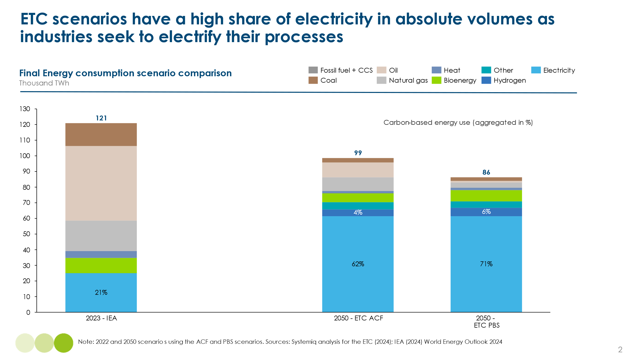
Clean electricity could be delivered in several ways. Many countries have large hydropower resources, and both nuclear power and geothermal resources could play a role in providing continuous zero-carbon power. The ETC will be conducting detailed analysis of the potential role of these technologies later in 2025. However, in many parts of the world, the dominant sources of zero-carbon power are likely to be wind and solar. Many estimates of cost-effective power decarbonisation project that the share of variable renewable electricity (VRE) in total power supply will reach 70% or even higher.
This reflects the dramatic reductions in the cost of solar PV over the last 10 years, and the less dramatic but still significant fall in wind power generation costs. In many parts of the world, the cheapest way to produce a kilowatt-hour is from wind or solar resources, and this cost advantage versus fossil fuels will widen in future.
The crucial challenge is what to do when the sun does not shine and the wind does not blow, and how to balance electricity supply versus demand across days, weeks, months, and years. This can be achieved via the use of multiple energy storage technologies, but also by encouraging demand-side flexibility (DSF) or using long-distance HVDC lines to interconnect regions with different weather patterns. Some of these options, however, will add costs to total system operation.
Rapidly increasing electricity demand also requires large-scale expansion of both transmission and distribution grids. In addition, the shape of grids will need to change significantly, for instance, to connect wind and solar resources far from demand centres, and to accommodate large-scale decentralised generation (in particular, rooftop solar). These changes will often impose significant cost, but these costs can be reduced by the application of multiple innovative grid technologies.
This report therefore analyses how electricity systems will need to adjust to accommodate rising electricity demand and high shares of renewables. Our analysis and conclusions are set out in the following four chapters:
- Managing the system balancing challenge. It is technically and economically possible to manage system balancing challenges in systems with very high (e.g. 80%+) VRE penetration, delivering round-the-clock electricity at costs below those of today’s fossil fuel-based systems. The lowest total system costs will be seen in sunbelt countries with large solar resources and primarily short duration balancing needs. Costs will be higher in high-latitude countries, which are primarily dependent on wind resources and have significant long-duration balancing requirements.
- Managing grid expansion to minimise grid cost per kilowatt-hour. Global required annual grid investments could grow from $370 billion in 2024 to around $850 billion in the 2030s and 2040s, but these costs could be reduced by up to 35% through the application of multiple innovative grid technologies (IGTs). Maximising demand-side flexibility also represents a particularly low-cost opportunity. Grid costs per kWh may initially rise slightly in some countries, but by 2050, should be at or below today’s levels.
- Total system wholesale costs in the long term and in transition. In the long term, total system wholesale cost per kWh in power systems with high VRE shares could be significantly below the cost of today’s fossil fuel-based systems in low-latitude, sunny countries, Mediterranean climates, and in China. Costs could also be somewhat lower in high-latitude countries, which will depend primarily on wind resources. It is vital to also focus on cost during the transition, particularly in high-latitude countries that are currently dependent on expensive gas supply. Speeding up the transition to future lower-cost systems will require careful policy design.
- Key enablers for cost-effective power system development. To achieve the potential low costs of much larger electricity systems, primarily dependent on variable wind and solar resources, requires a combination of strategic vision, optimal power market design and grid company regulation, the application of new grid management technologies, actions to overcome potential supply chain constraints, and key forms of customer engagement.

- Managing the system balancing challenge

The Energy Transitions Commission has emphasised in several reports that achieving a zero-carbon global economy requires extensive clean electrification. This will require increasing global electricity consumption two to three times by 2050, with further significant growth thereafter, and ensuring that electricity generation produces minimal or zero emissions. Such a transformation can be both feasible and cost-effective – including power systems where 70% to 90% of generation comes from intermittent renewable sources such as wind and solar. The following sections explain how, addressing five key messages:
- While hydropower, nuclear and geothermal will play significant roles in many clean power systems, and while there will remain a role for thermal dispatchable power plants, wind and solar are likely to be cost competitive generation sources in most countries.
- As the share of intermittent renewables rises, power systems will need to balance energy supply and demand across days, weeks, months and years. The severity and the specific nature of this challenge varies by country/region. In particular, there is a significant difference between the balancing challenge in low latitude sunbelt countries and in high latitude wind belt countries.
- The balancing challenge can be addressed using a range of available technologies and business models, including flexible dispatchable generation, innovative grid technologies, long-distance interconnection, energy storage solutions such as batteries, and demand-side flexibility. Different solutions are best suited to different timescales, and a key question is how long the economically viable duration of lithium-ion batteries can extend to, given the significant reductions in battery costs in recent years.
- Balancing costs tend to rise with the duration over which balancing is required and are therefore higher in countries with longer-duration needs. However, in all countries there are viable and cost-effective solutions for balancing power systems with high shares of variable renewable energy (VRE).
- In low latitude countries with large solar resources, total system wholesale electricity cost – including both generation and storage – will be lower, and in some cases significantly lower, than in today’s fossil fuel-based systems. In high latitude countries primarily reliant on wind generation, costs will be higher than in the sunbelt countries but are likely to be at or slightly below today’s levels.

- Solar and wind will be the primary source of power generation in the future

Over the past decade, the share of intermittent renewable energy in global power systems has grown significantly. In 2023, as shown in Exhibit 1.1 below, countries such as Germany, Ireland, Spain, Uruguay, Denmark, and Portugal generated over 40% of their electricity from wind and solar, with Denmark leading the group with nearly 70% of generation from wind and solar,.
Exhibit 1.1
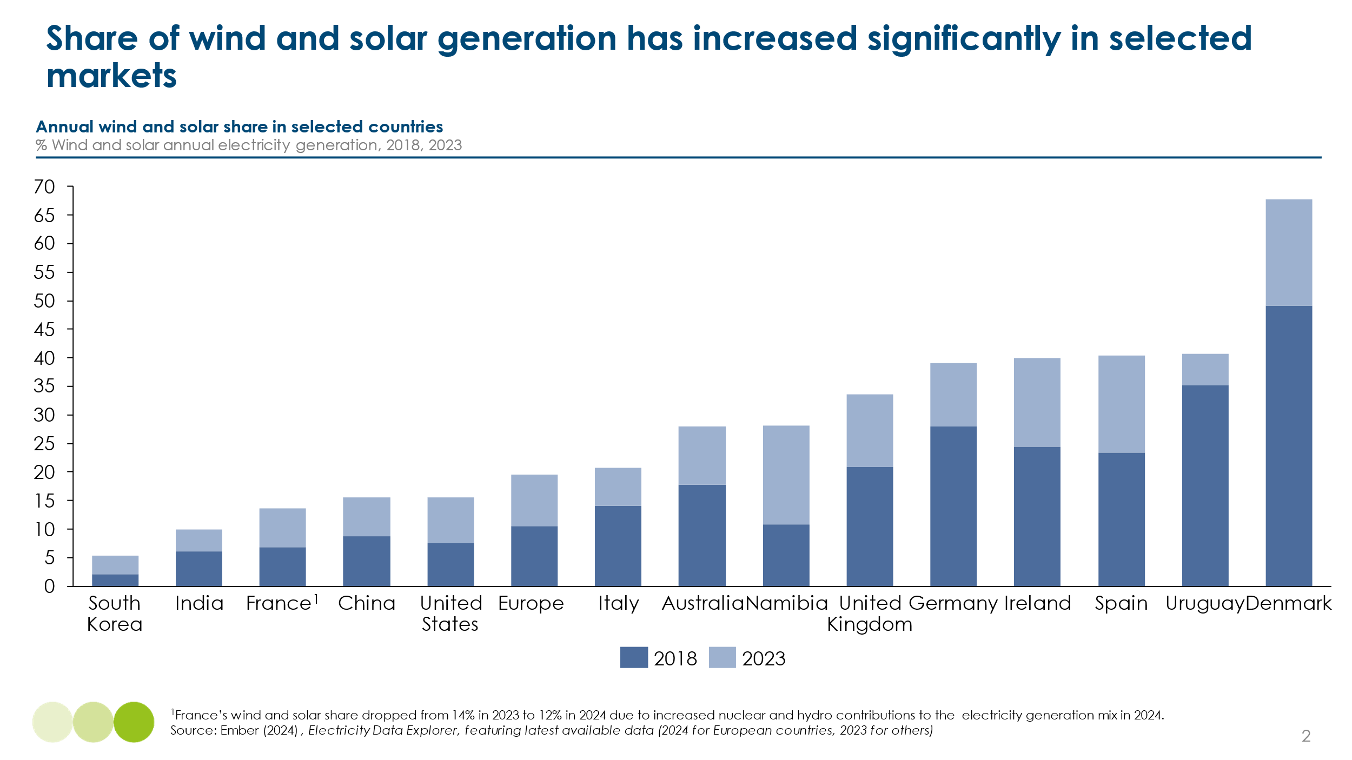
Solar photovoltaic deployment has soared, with global annual installations reaching around 450 GW in 2023, driven by rapid growth in China. This expansion has continually outpaced successive International Energy Agency (IEA) projections, as shown in Exhibit 1.2 below and is far more rapid than the ETC envisaged in our 2021 report Making Green Electrification possible. Similarly, between 2014 and 2024, global wind power capacity experienced substantial growth. In 2014, the cumulative installed wind capacity was approximately 369 GW. By the end of 2023, this capacity had surpassed 1,000 GW.

Exhibit 1.2
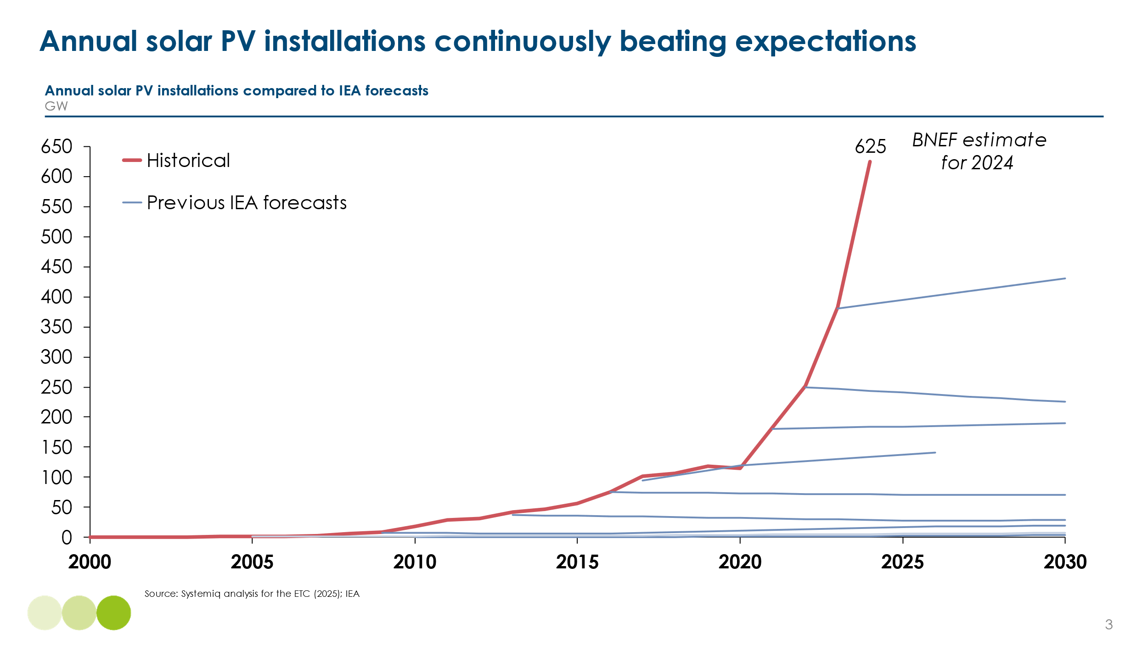
This rapid growth of wind and solar has been driven by faster than expected cost reduction. Since 2010, solar and wind LCOE has declined by 92% and 70% respectively, as shown in Exhibit 1.3 below. This has largely been driven by the capital expenditure costs for fixed-axis photovoltaic (PV) systems falling by 82% since 2010, while wind turbine costs have fallen by 68% for onshore wind and 59% for offshore wind in real terms since 2010. In China, we have seen reductions of 83% and 79% in solar and wind capital expenditure from 2014 to 2024. Together with installation and other cost reductions, this has driven rapid reductions in the levelised cost of electricity (LCOE) and contract prices for solar and wind supply.
Exhibit 1.3
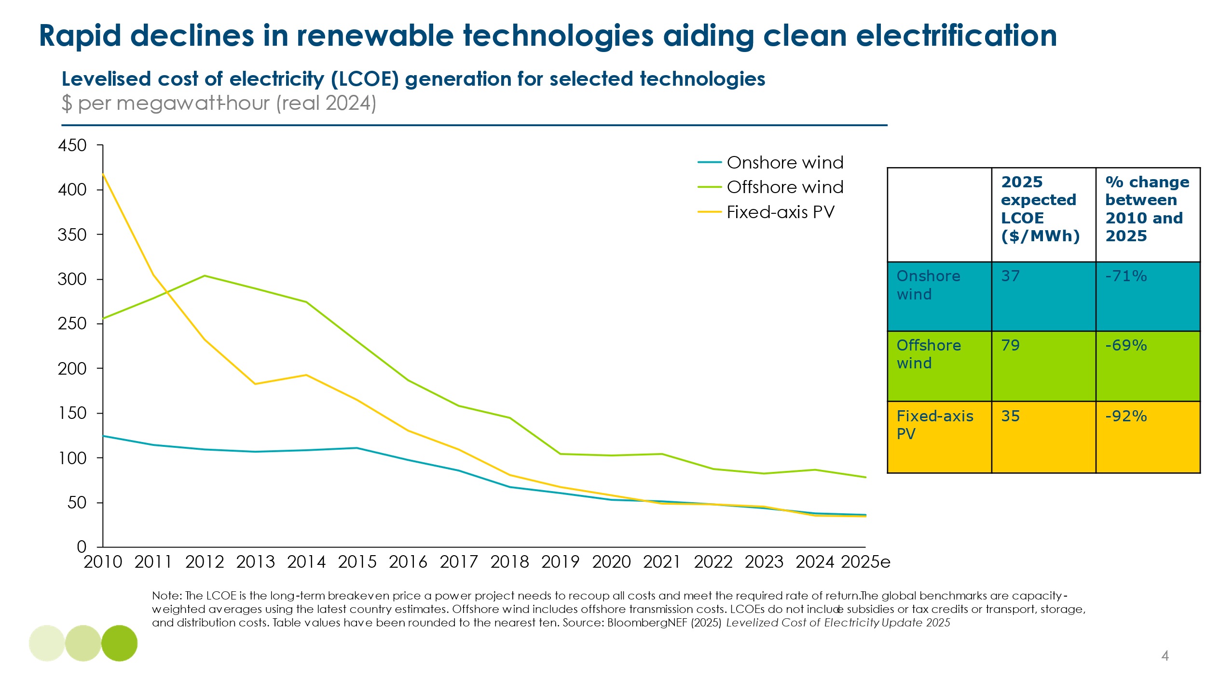
These cost reductions have now made unsubsidised solar and wind competitive sources of power generation in many countries. Reasonable projections of future cost levels suggest that this advantage will continue to grow in the future, with solar becoming the cheapest way to produce a kilowatt hour of electricity in almost all countries (see Exhibit 1.4, Exhibit 1.5 and Exhibit 1.6 below).
Exhibit 1.4
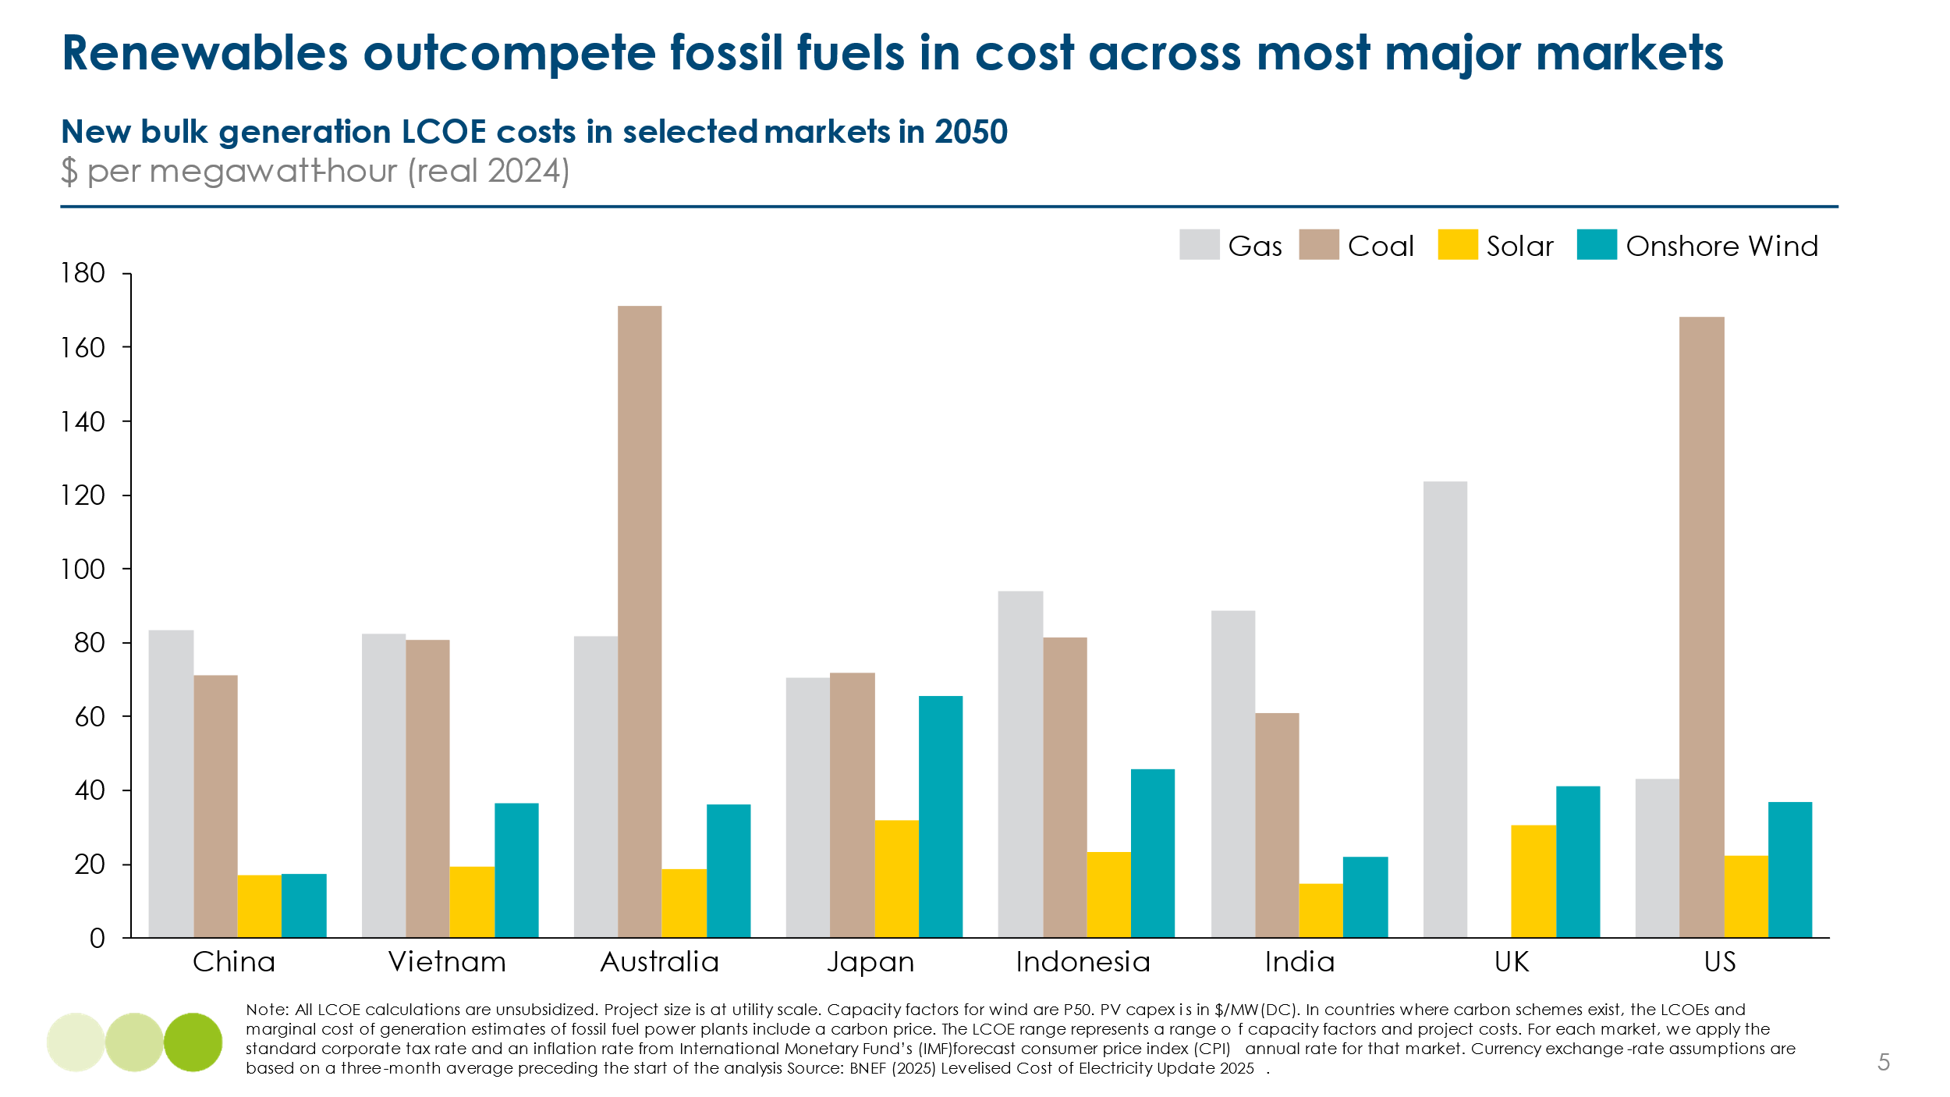

Exhibit 1.5
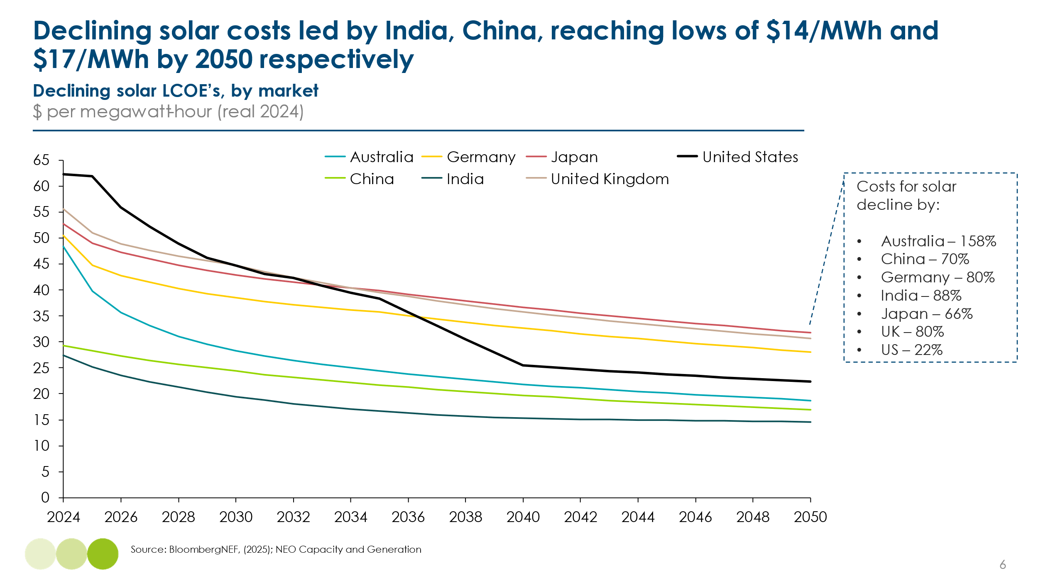

Exhibit 1.6
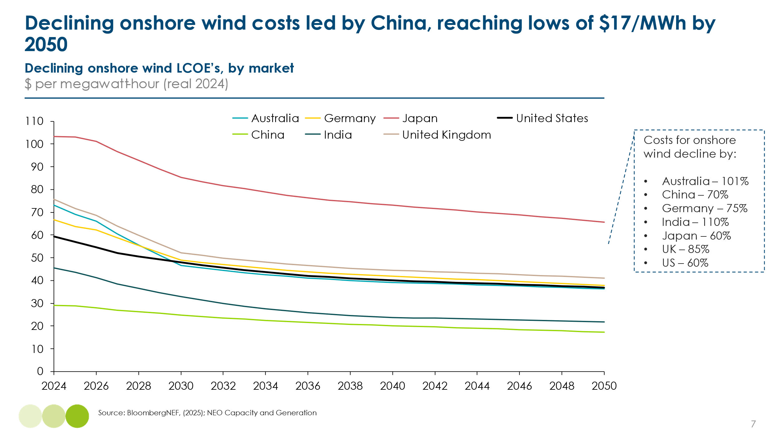
​The cost competitiveness of solar and wind energy does not preclude significant roles for other low-carbon generation options. Pumped hydropower remains highly cost-competitive in many regions and continues to provide substantial shares of electricity generation in countries like Norway and Brazil. In Brazil, for instance, hydropower contributed to 67% of the nation's total electricity generation in 2023. ​
The ETC believes that existing nuclear plant lives should be extended for as long as possible, due to their very low marginal cost of operation. However, new nuclear developments, regardless of whether large fission plants, small modular reactors, or, in the long term, fusion, face current economic challenges, including high capital costs and long construction timelines. These new nuclear development costs might reduce over time and present opportunities for supplying low-carbon, baseload energy to large demand sources such as data centres. Additionally, there is growing interest in developing various forms of geothermal energy supply as a complementary low-carbon resource. The ETC plans to analyse the potential roles of nuclear and thermal sources in global power systems later in 2025, with a report expected in early 2026.
Despite these alternatives, wind and solar are highly likely to play the dominant role in power systems. Reasonable scenarios (see Exhibit 1.7) suggest that by 2050 or 2060, the share of wind and solar generation could be as high as 82% in the UK, 62 % in China and 97% in India. In Indonesia, analysis by the ETC‘s partner organisation the IESR has suggested that solar resources could in principle produce over 88% of the nation’s electricity.
The feasibility of achieving such high shares of variable renewable energy (VRE) is still debated in many countries. Some power system experts, particularly those with experience in fossil fuel–dominated systems, express concerns that a grid reliant on renewables could become technically unstable beyond a certain threshold. At the same time, many policymakers fear that renewable-dominated systems may ultimately prove more expensive once the full costs of storage, flexible backup capacity, and grid integration are taken into account.
The crucial question explored in this chapter is how to effectively balance electricity demand and supply in systems with high shares of variable renewables, and the associated cost implications.

Exhibit 1.7
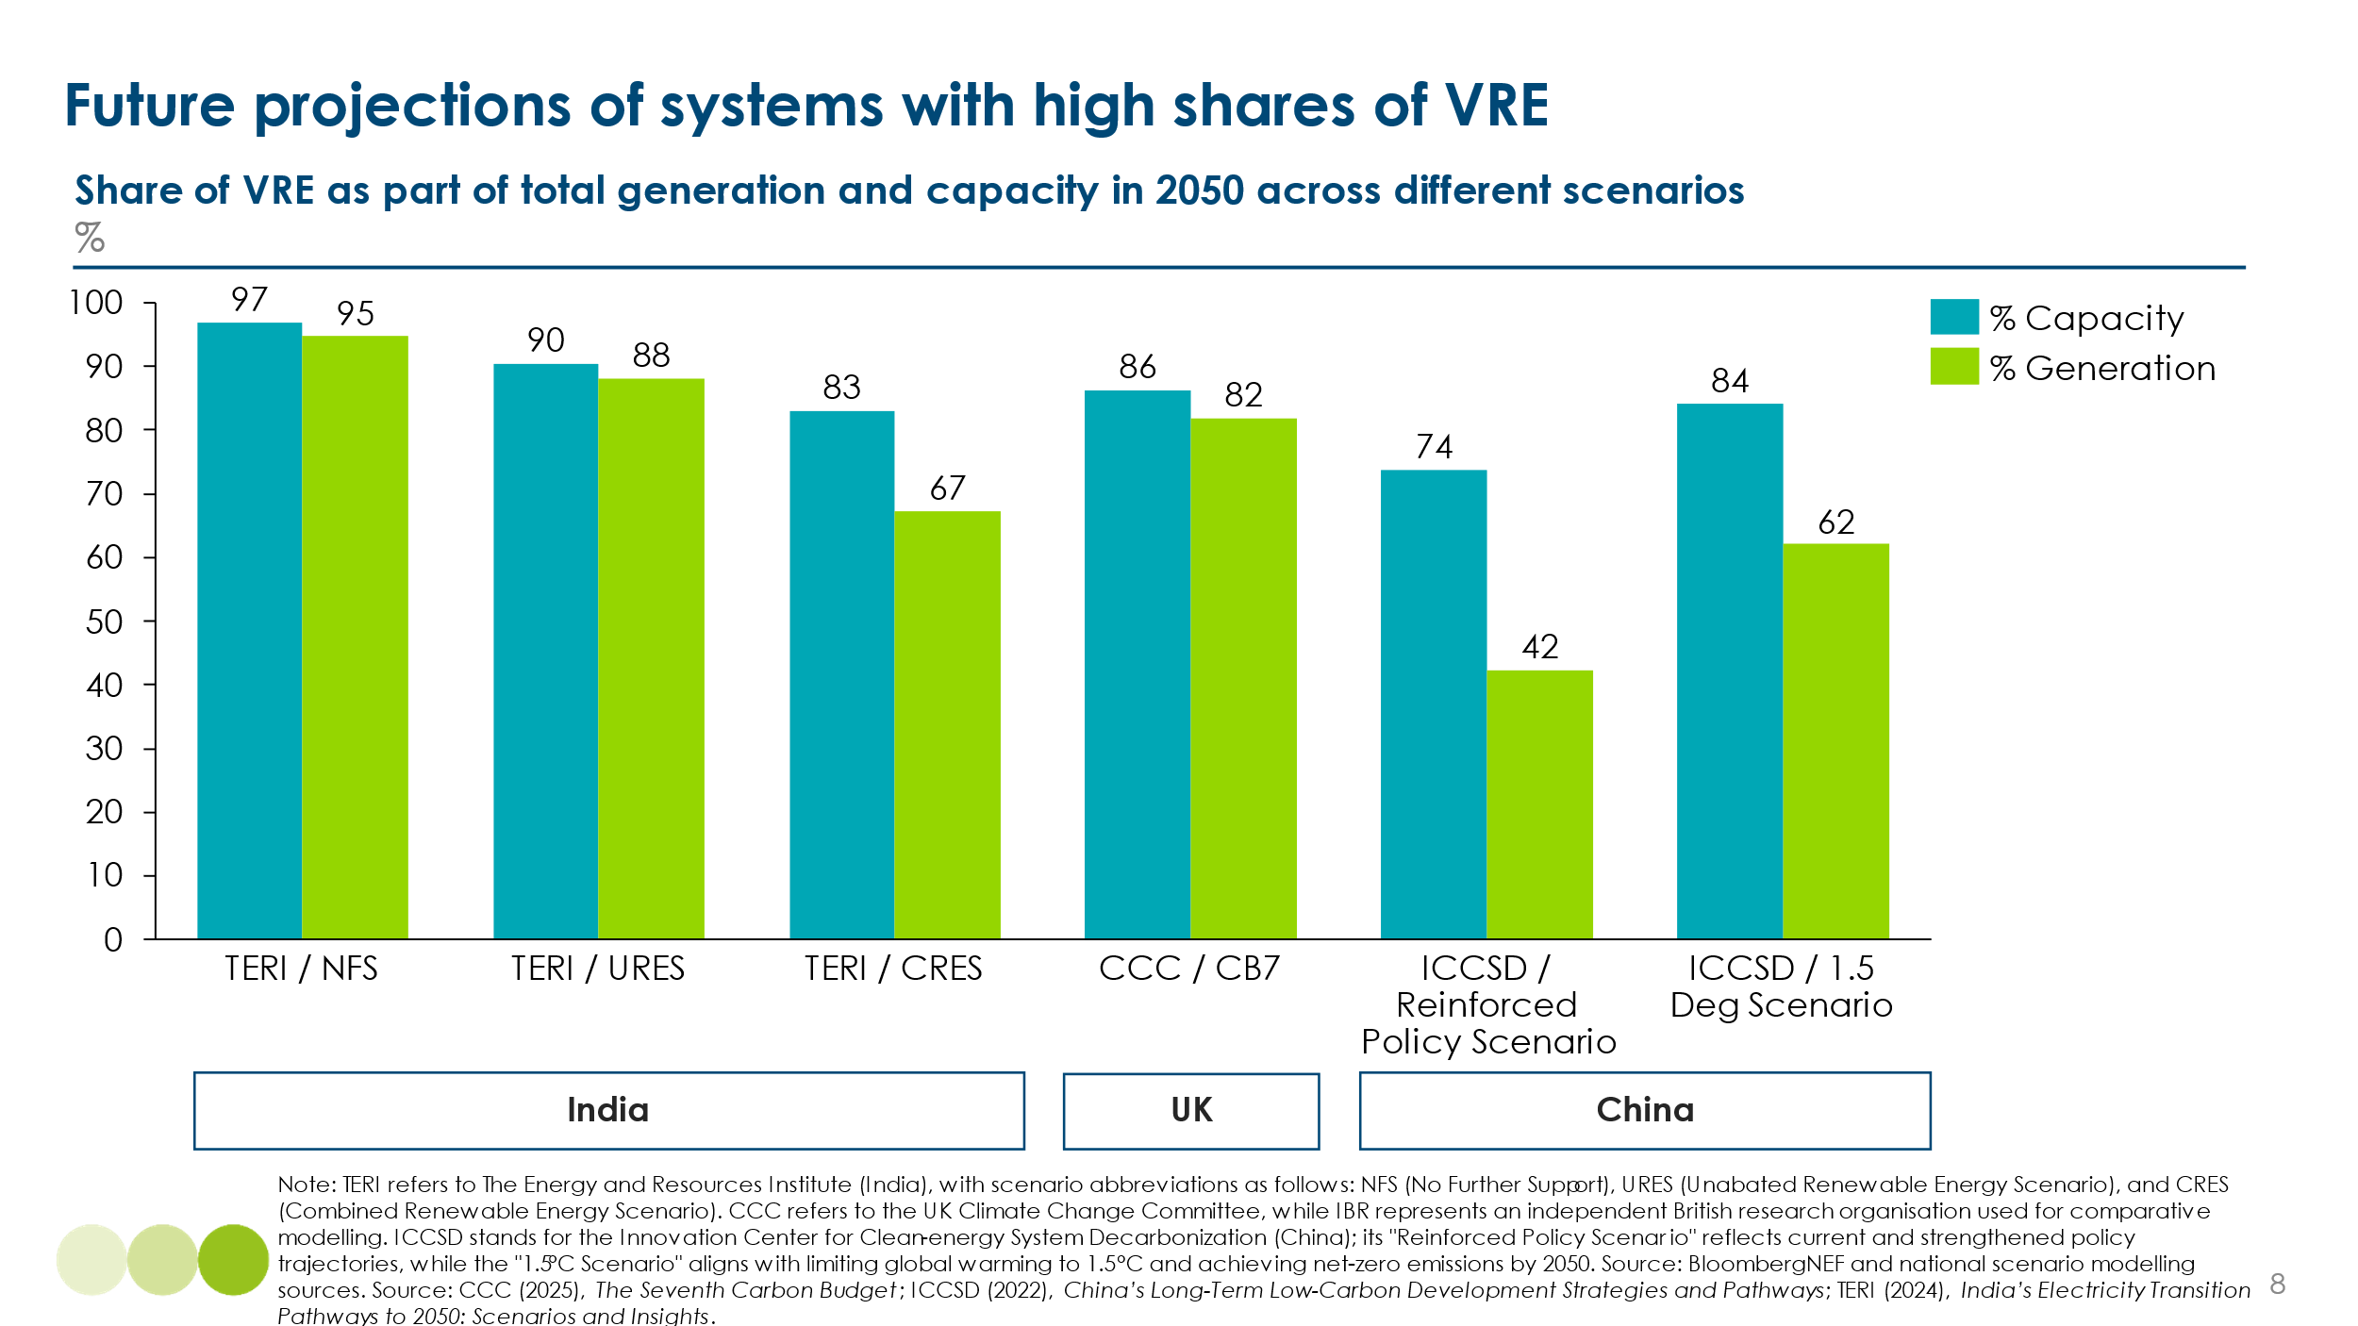

- Types of balancing challenge and variations by region

- Types of balancing challenge
There are two different dimensions to the balancing challenge: 1) the technical challenge of ensuring stable system operations and 2) matching energy supply and demand across a range of timescales.
1) The technical challenge: ensuring stable system operation.
Power systems must maintain grid stability across very short, near-instantaneous timescales. Traditional systems, where most electricity was generated by spinning turbines, driven by fossil fuels, nuclear heat, or hydropower, were designed to achieve stability through specific mechanical and control features.
However, stability must be delivered in new ways in systems dominated by wind and solar. Existing technologies are already capable of addressing the three key technical stability challenges:
- The need to manage system inertia, which is required to ensure grid stability and appropriate frequency response. In the past, large rotating generators provided natural inertia to resist sudden changes in supply and demand. As these plants phase out, grid operators are deploying new technologies such as synchronous condensers and grid-forming inverters to replicate these stabilizing functions (see Box A).
- The need to manage voltage control, as voltage needs to be kept within a safe range to ensure system stability, which can be done deploying control technologies such as static var compensators (SVC), static var generators (SVG), static synchronous compensators (STATCOM), or thyristor-controlled series capacitors (TCSC).
- The need for variable renewable generation units to ensure they remain connected and operational during and after a fault condition, such as a voltage dip or short circuit, without tripping or causing a system collapse. This can be done by setting grid code standards to ensure sufficient high voltage ride through (HVRT) capability.
The deployment of these technologies, alongside the continued presence of some turbine-based generation in most future power systems, will enable the reliable operation of electricity systems with 70% or higher share of variable renewable energy (VRE). This is not only theoretically feasible but has already been demonstrated today across windows of high wind and solar generation.
While Exhibit 1.7 above presents current and projected annual VRE shares, much higher shares have been observed over the short timescales relevant to system stability (see Exhibit 1.8 below). In the UK in 2025, wind and solar have accounted for over 78% of electricity generation in specific hours, and over 79% in Germany in 2025. Major system operators in both countries have confirmed that even higher instantaneous shares are operationally manageable.
The UK National Electricity System Operator (NESO) foresees no insurmountable technical barriers to operating a system that, by the mid-2030s, generates around 70% of annual electricity from wind and solar. On certain days and hours, this share is expected to exceed 80%, and in specific hours, particularly during nuclear outages, it could rise above 95%.
Exhibit 1.8
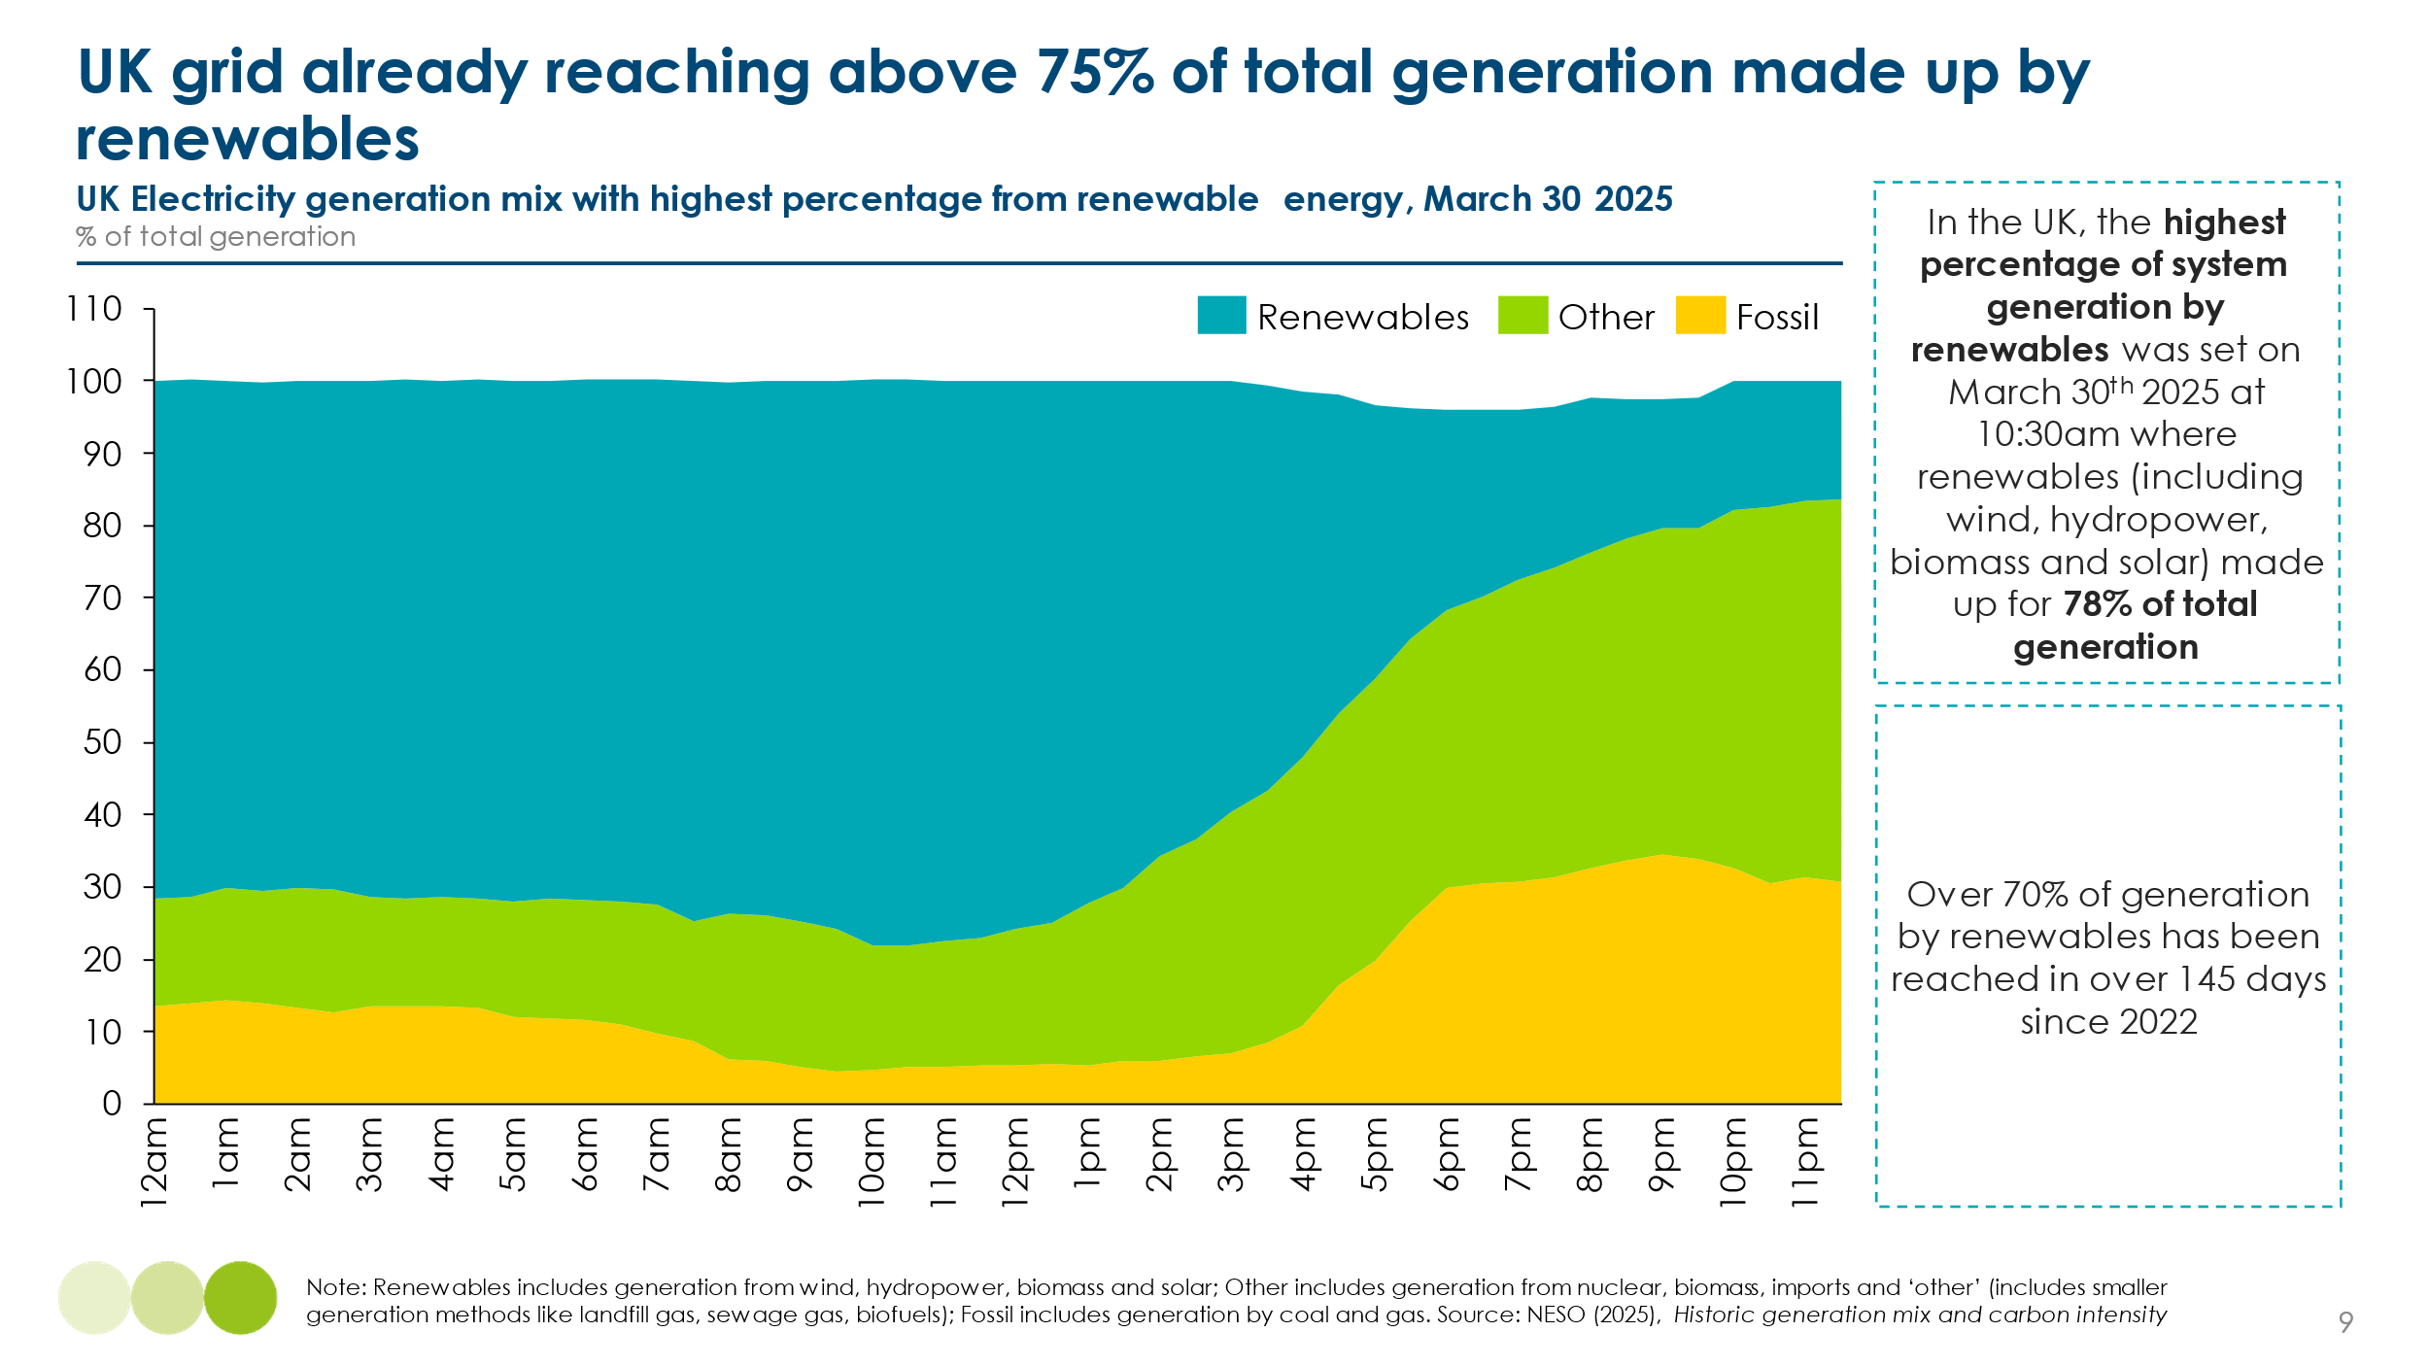
Box A – System inertia: new needs and solutions for a high variable renewables grid
The challenge of maintaining grid stability on very short timescales, ranging from seconds to minutes, has traditionally been managed through system inertia provided via the use of dispatchable fossil fuel plants. In fossil fuel plants, large rotating generators provided inertia, a natural resistance to sudden changes in grid frequency, alongside the capability to quickly ramp generation up or down to match supply and demand. However, as power systems shift towards variable renewable generation, which often lacks inherent inertia and dispatchability, maintaining stability has required new technologies.
Grid operators, including the UK’s National Electricity System Operator (NESO), are increasingly deploying new inertia technologies such as synchronous condensers and grid-forming inverters to maintain grid stability as renewable energy penetration rises:
- Synchronous condensers, already in use at sites like the Lister Drive project in Liverpool, replicate the inertia traditionally provided by large spinning turbines, delivering critical frequency stability, voltage control, and short-circuit strength without relying on combustion-based generation.
- Inverters play a critical role in converting electricity from renewable sources such as wind and solar into a form compatible with the grid. There are two primary types: grid-following inverters, which rely on an existing grid signal to synchronize, and grid-forming inverters, which can independently establish and regulate grid frequency. The latter is particularly significant for maintaining grid stability, as it replicates the function of traditional synchronous machines.
- By providing a stable frequency reference, grid-forming inverters enable other grid assets to synchronize effectively, thereby supporting system inertia and frequency stability. This capability is especially important during periods of high renewable generation when conventional sources of inertia are limited. Grid-forming inverters are currently being trialled by National Grid in the UK and other international grid operators to enhance system resilience and support black start capabilities.
- Additionally, companies like Reactive Technologies have developed advanced measurement tools, such as their GridMetrix technology, which provides real-time, accurate measurements of grid inertia and system strength, enabling operators to make informed decisions to maintain stability as renewable integration increases. ​
These technologies, alongside advanced grid management tools, are crucial for balancing supply and demand in low-carbon power systems and ensuring system resilience as the share of wind and solar generation grows.
Collectively, the successful usage of these technologies indicates that power systems can maintain stability and reliability through the use innovative grid technologies as the reliance on fossil fuel plants for short-term balancing diminishes.

2) Matching supply and demand over different timescales
Electricity supply and demand must match across a range of different timescales (see Exhibit 1.9) to ensure a stable power system. There are different nuances to balancing in each timescale, such as:
- Short duration (up to 8 hours): Solar generation varies on a predictable daily pattern but is also subject to less predictable hourly variations due to changing hourly cloud cover. In contrast, wind generation has a significantly more variable daily pattern. Daily demand patterns often entail specific predictable peaks (e.g. in early evening residential use in many countries). Mechanisms are therefore needed to adjust supply or demand in line with each other over a diurnal cycle.
- Medium-long duration (8-50 hours): Wind supply can vary significantly from day-to-day or week to week as weather patterns change. Solar supply can also vary day to day, especially in many high latitude countries. Daily demand varies due to more predictable weekly cycles (e.g. less commercial and industrial demand at weekends) and less predictable developments (e.g. surges of heating demand in cold winter weeks, or in air conditioning demand during heat waves)
- Ultra-long duration (50+ hours). Demand can vary across the year in relatively predictable seasonal patterns (e.g. if heating is electrified in high latitude countries, electricity demand will tend to be higher in winter), and this is sometimes matched by seasonal variations in supply (e.g. wind supply tends to be higher in winters and in some tropical latitude countries wind supply is concentrated during monsoon periods). However, wind supply can also vary significantly from year to year and in ways which are less predictable e.g. during high latitude winter anticyclones wind supply may fall for several weeks and this may coincide with high heating demand (the so-called “dunkelflaute” effect).
Exhibit 1.9
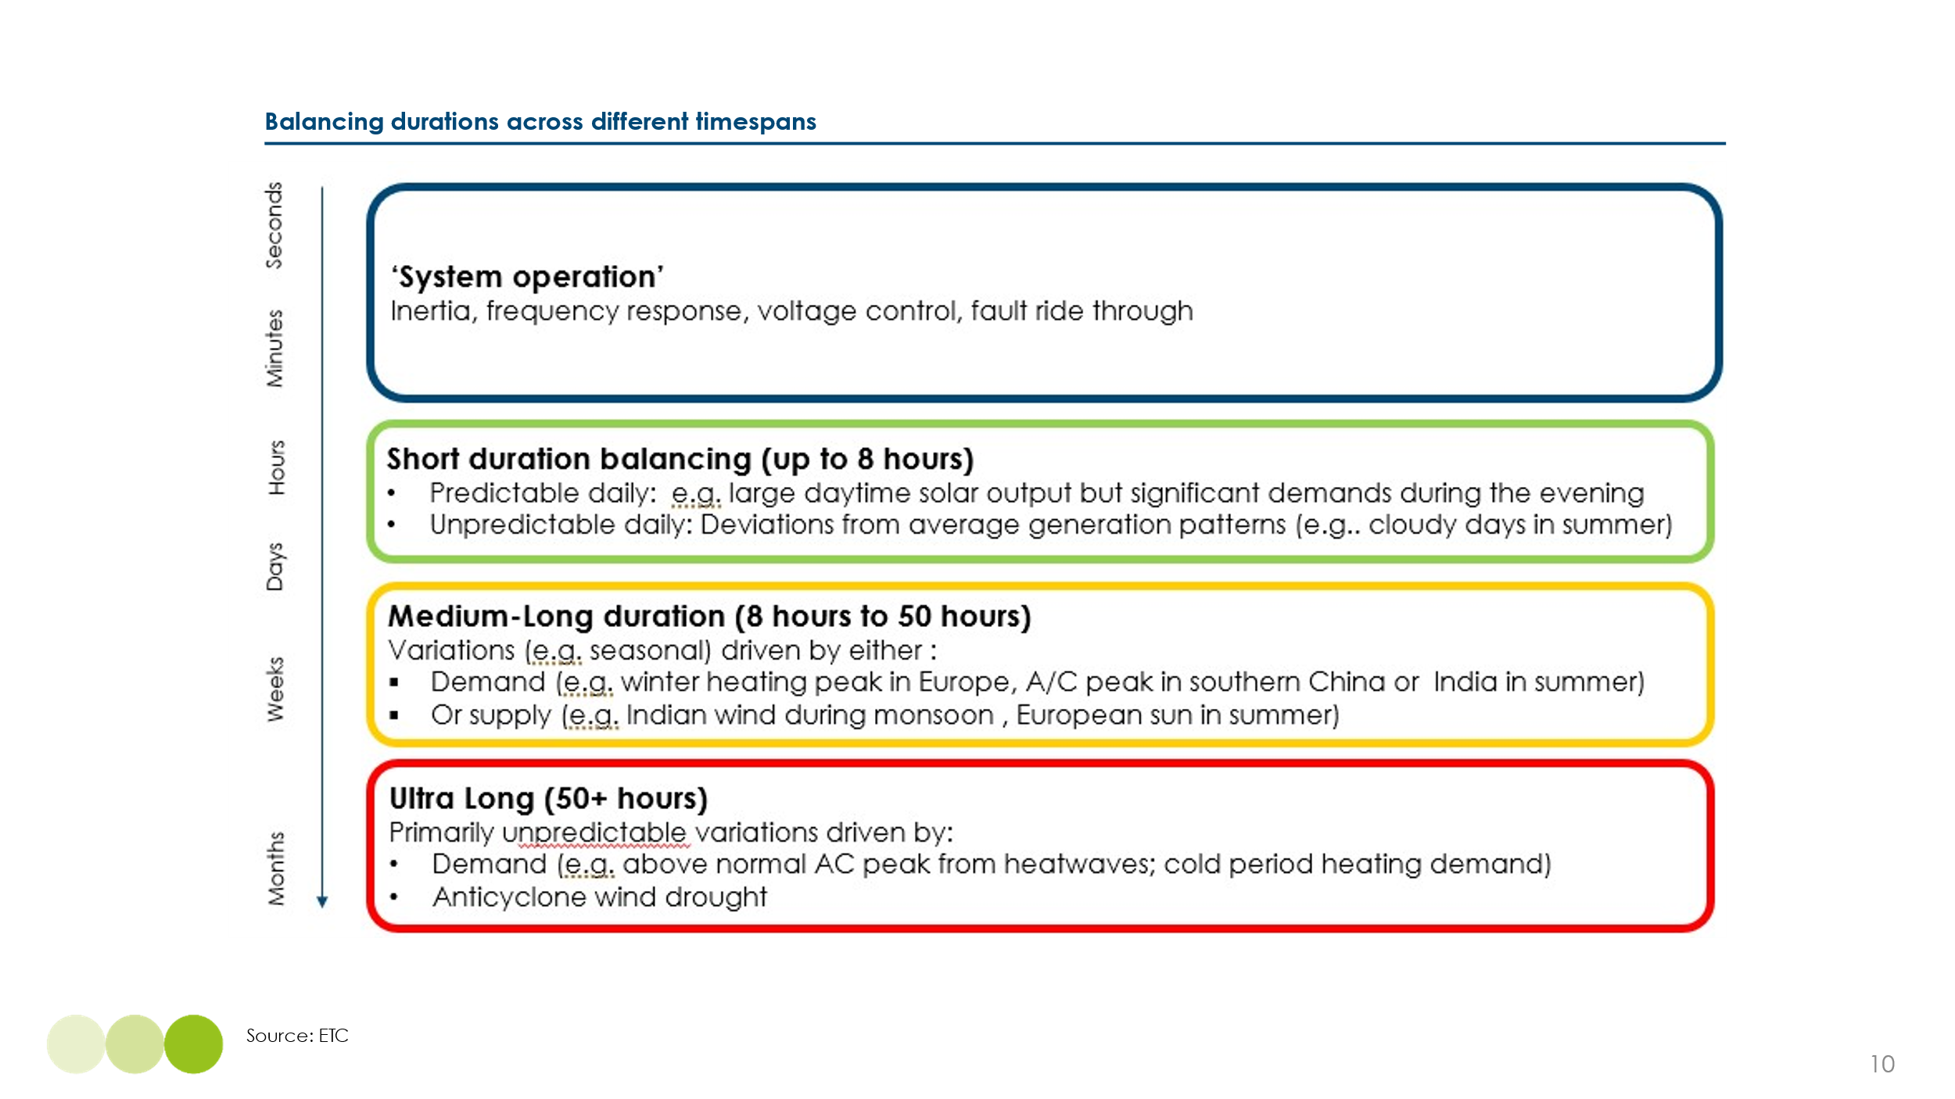

- Regional differences in balancing needs

Different countries will have inherently different balancing characteristics, due to differences in wind and solar resource, as well as the shape of demand due to different residential and commercial end use patterns.
Exhibit 1.10 shows key differences between four different “regional archetypes “:
- Northern latitude regions, such as the UK, Germany and Canada, have high wind potential but lower solar potential. Wind supply tends to be higher is spring and autumn, while future electricity demand will peak in winter due to heating needs.
- Tropical regions, including India, Thailand, and Mexico, have high solar irradiance with seasonal variability due to monsoons. Cooling is a major driver of increasing power demand because of rising prosperity and rising temperatures.
- Mediterranean regions, such as Spain, Morocco, and Türkiye, benefit from strong summer solar generation and moderate wind availability, with demand spiking in hotter months due to cooling needs.
- Countries with mixed climates, such as China, the United States, and Chile, span large geographic areas with substantial variation in wind and solar resources across regions. These regional differences often result in complementary generation profiles, which can help smooth variability in supply. When supported by long-distance, high-capacity transmission infrastructure, such geographic diversity can significantly enhance the ability to balance electricity supply and demand at the national level.
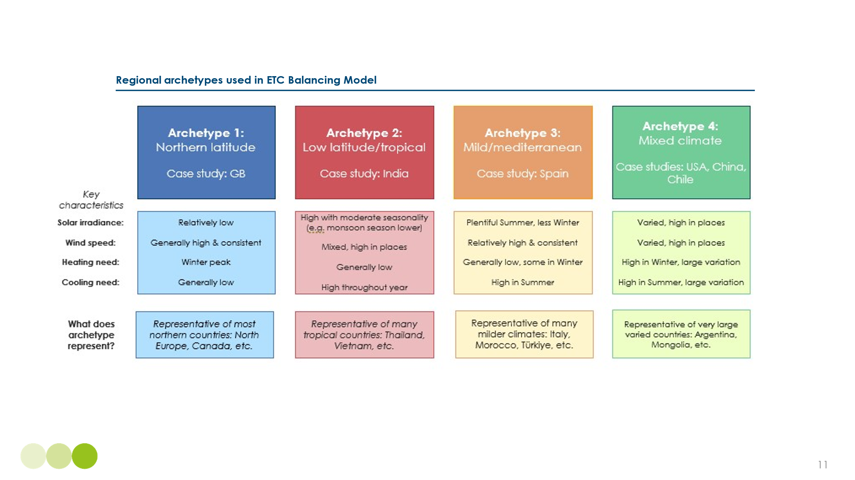
Exhibit 1.10
To assess the scale and nature of the balancing challenge across the different system archetypes, we have modelled four representative countries—China, India, Spain, and the UK. For each, we compare potential future demand variation with variable renewable energy (VRE) supply under an illustrative scenario in which VRE capacity is sized to meet 100% of annual electricity demand (see Box B for methodology).
While this is not a cost-optimal configuration, since least-cost zero-carbon systems will always include other generation sources such as nuclear, hydropower, or dispatchable gas with CCS, it provides a useful upper bound on system balancing requirement. This approach enables us to examine both the maximum potential scale of surplus and deficit, and how the nature of the balancing challenge varies by system archetype.
The model captures the temporal variation in both electricity demand and VRE output and quantifies the resulting imbalances between supply and demand.

Box B – Modelling the balancing need
Overview: The ETC has built an illustrative model that showcases the balancing challenge, in terms of necessary balancing durations, and the associated costs, for four regional archetypes. The model assumes 100% generation from wind and solar, with no generation from fossil fuels, nuclear, geothermal, hydropower and no interconnection to other countries. We assumed 100% wind and solar generation in this model to focus purely on the balancing challenge without fossil, nuclear, hydro, or interconnection.
While some sources of low-carbon baseload can meet a share of the total balancing needs, it typically cannot fully solve the issue presented by variable renewable generation and other balancing solutions in systems with some low-carbon baseload will still be required. For example, even large nuclear fleets such as France’s are only moderately flexible, with limited ability to ramp rapidly or follow demand on intra-day timescales and are often prioritised for baseload operation to maintain economic viability. Therefore, excluding low carbon baseload is still useful to understand the balancing patterns. Future ETC work will explore the role of low-carbon baseload in more detail.
How the model is structured: The ETC’s balancing model assesses three key components (Exhibit 1.11) for four countries, representing each of the archetypes discussed above. As shown in Exhibit 1.10 above, the chosen countries were the UK to represent Northern Latitude, India for the Tropical Climate, China for the Mixed Climate and Spain for Mediterranean regions.
Exhibit 1.11
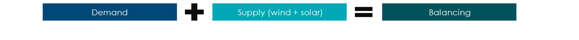

- Demand Analysis: Detailed 2050 hourly load profiles obtained from expert forecasters which are reflective of high electrification and specific, hourly peak profiles based on future loads (e.g., EVs, heat pumps) and patterns in a fully electrified system. The demand profiles used excluded demand side flexibility (or demand side response), in order to understand the ‘baseline’ extent of demand peaks. Profiles are shown below in Exhibit 1.12 below.
- Supply Analysis: Bihourly weather data was obtained from 1994 to 2023. We then overlaid this with assumptions of wind and solar installed capacities for each country, based on assessments of government targets, as well as other studies. By applying historical weather patterns to these capacities, renewable generation for each year was estimated, developing minimum, average, and maximum scenarios based on the variation in output from different weather years. However, future shifts in weather patterns due to climate change were not accounted for in this analysis. Supply profiles can be seen in Exhibit 1.13.
- Balancing sizing: Demand and supply data were then matched every 2 hours to assess periods of wind and solar generation excess and shortfall relative to demand. Based on this matching, we then assessed the extent to which deficits could be met by different balancing technologies, by assuming a given capacity in each system of short, medium-long and ultra-long duration storage capacity. Storage deployment assumed that a sequential deployment of energy storage - with short-duration storage deployed first until depleted, followed by medium-long-duration storage for 10 to 50 hours, and finally ultra-long-duration storage for needs exceeding 50 hours

Our model assesses the potential future variation of both demand and VRE supply, and the resulting surpluses and deficits of supply relative to demand.
Future demand variation
The patterns of possible future demand variations by region across the year, and for a “worst case” scenario on a weekly basis, are shown in Exhibit 1.12. The key takeaways per archetype system are as follows:
- In the UK, electricity demand in 2050 could range from a winter peak of 165 GW to a summer minimum of around 20 GW, primarily driven by seasonal variation in electric heating demand. In addition to this predictable seasonal swing. Exhibit 1.12 shows that demand may vary significantly from week to week in winter, as changing weather conditions affect heating loads. Demand also fluctuates on a daily and hourly basis, requiring flexible system operation throughout the year.
- In India, seasonal variation in electricity demand is less pronounced, but there is a strong weekly cycle and considerable day-to-day variability, reflecting industrial and commercial usage patterns.
- In China, the continental scale of the country creates some natural balancing effects. For example, peak heating demand in the north often coincides with lower cooling needs in the south. However, electricity demand is still typically higher during mid-summer due to widespread use of air conditioning, and again in winter months (December and January) due to heating. In recent years, summer air-conditioning loads have grown sharply, and a noticeable drop in industrial demand during Chinese New Year is also evident in the data.
- In Spain, electricity demand is shaped by both cooling and heating needs, with peaks in summer due to air conditioning and in winter due to electric heating, particularly in regions without access to gas heating. Daily and weekly demand patterns are also influenced by industrial activity and the timing of agricultural irrigation.
Exhibit 1.12
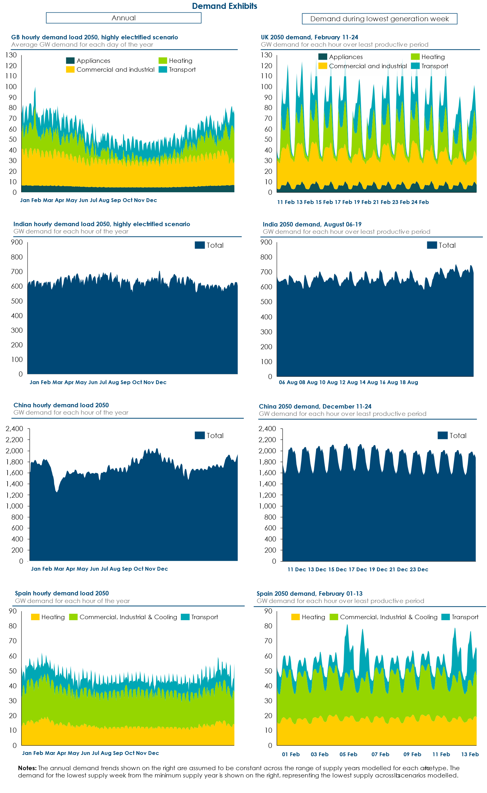
Future supply variation
Wind and solar resources vary significantly across different regions of the world. As shown in Exhibit 1.13, global patterns reveal that solar radiation is generally stronger and more consistent throughout the year in low-latitude countries, while wind speeds tend to be higher and more stable in high-latitude regions. In many low-latitude countries, wind availability is concentrated in specific seasons, such as during the monsoon.
There are important exceptions to these general trends. For instance, solar radiation levels are lower in equatorial tropical forest regions due to persistent cloud cover, while desert regions benefit from high and relatively constant solar irradiance year-round.
Exhibit 1.13
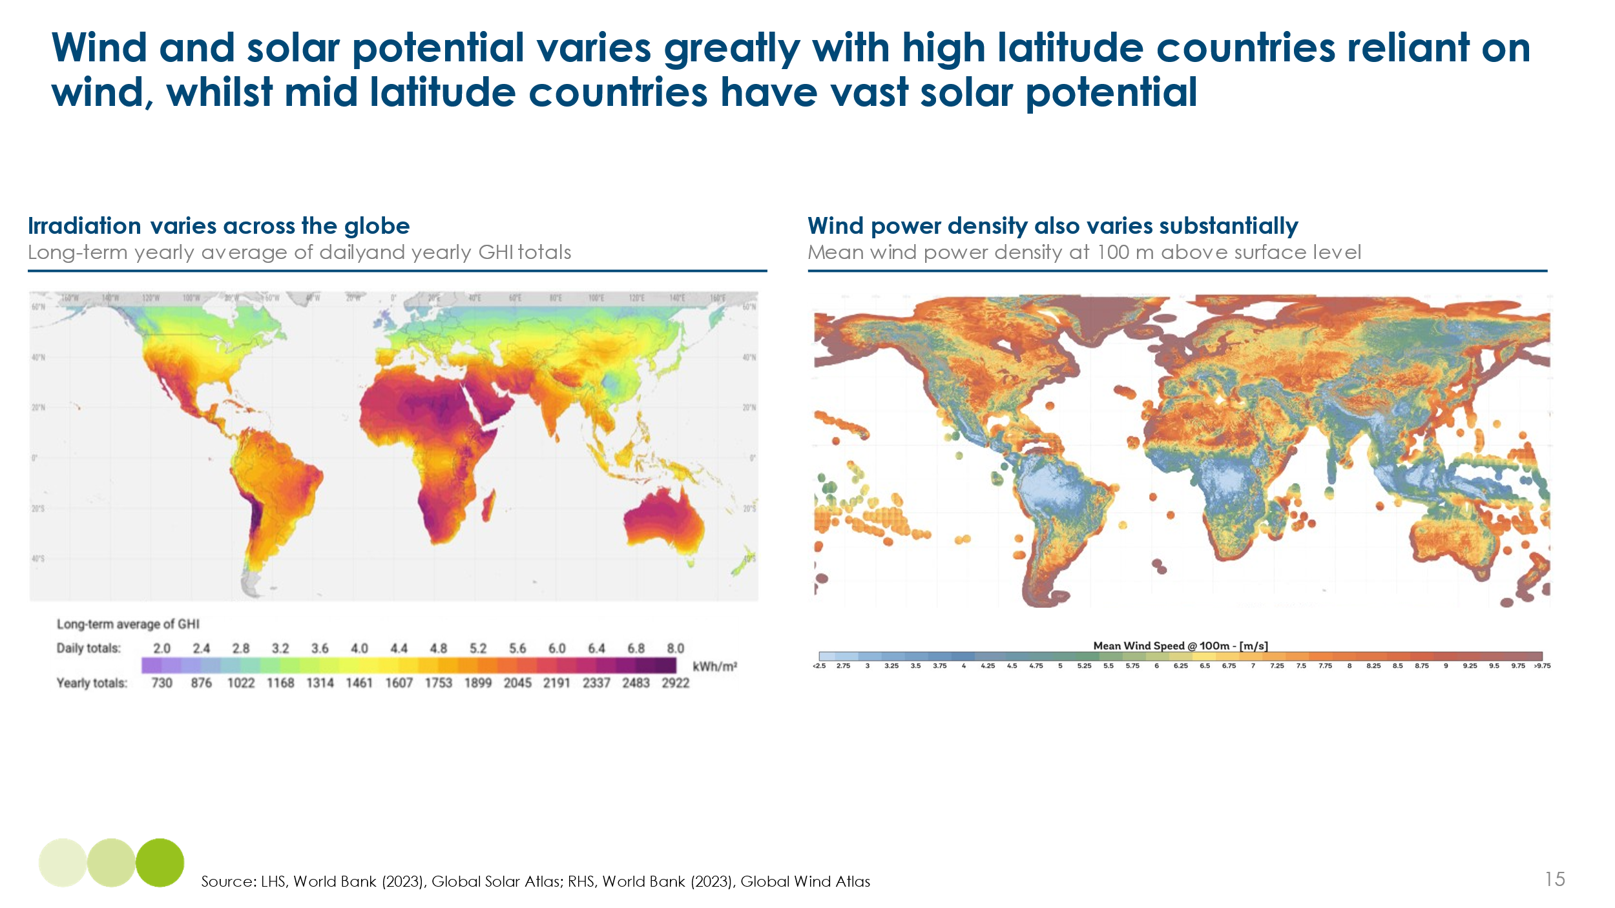
Exhibit 1.14 illustrates the variation in power supply which would occur in systems where VRE supply had been sized to make it possible in aggregate to meet all annual demand from VRE supply.
- In the UK, a renewables-based system would be dominated by wind generation, with typical seasonal peaks in February–March and again in September–October. However, wind output varies significantly from week to week. Solar generation would be substantially higher in summer than in winter and is also subject to considerable intra-day and day-to-day variability.
- In India, solar output declines during the monsoon season due to increased cloud cover, but this is partially offset—at least at the national level—by a concurrent increase in wind generation. While daily solar variability is generally less extreme than in the UK, it remains an important operational consideration.
- China benefits from a large and relatively stable solar resource, particularly in its desert regions, where utility-scale solar megaprojects are under development. With sufficient long-distance transmission infrastructure, this could enable relatively steady solar supply throughout the year. Wind resources, such as those in Inner Mongolia, also show relatively low variability both seasonally and diurnally.
- In Spain, both solar and wind resources contribute significantly to the system. Solar generation is strong and consistent across much of the country, especially in summer, while wind provides an important complement, particularly in winter and in coastal and northern regions.

Exhibit 1.14
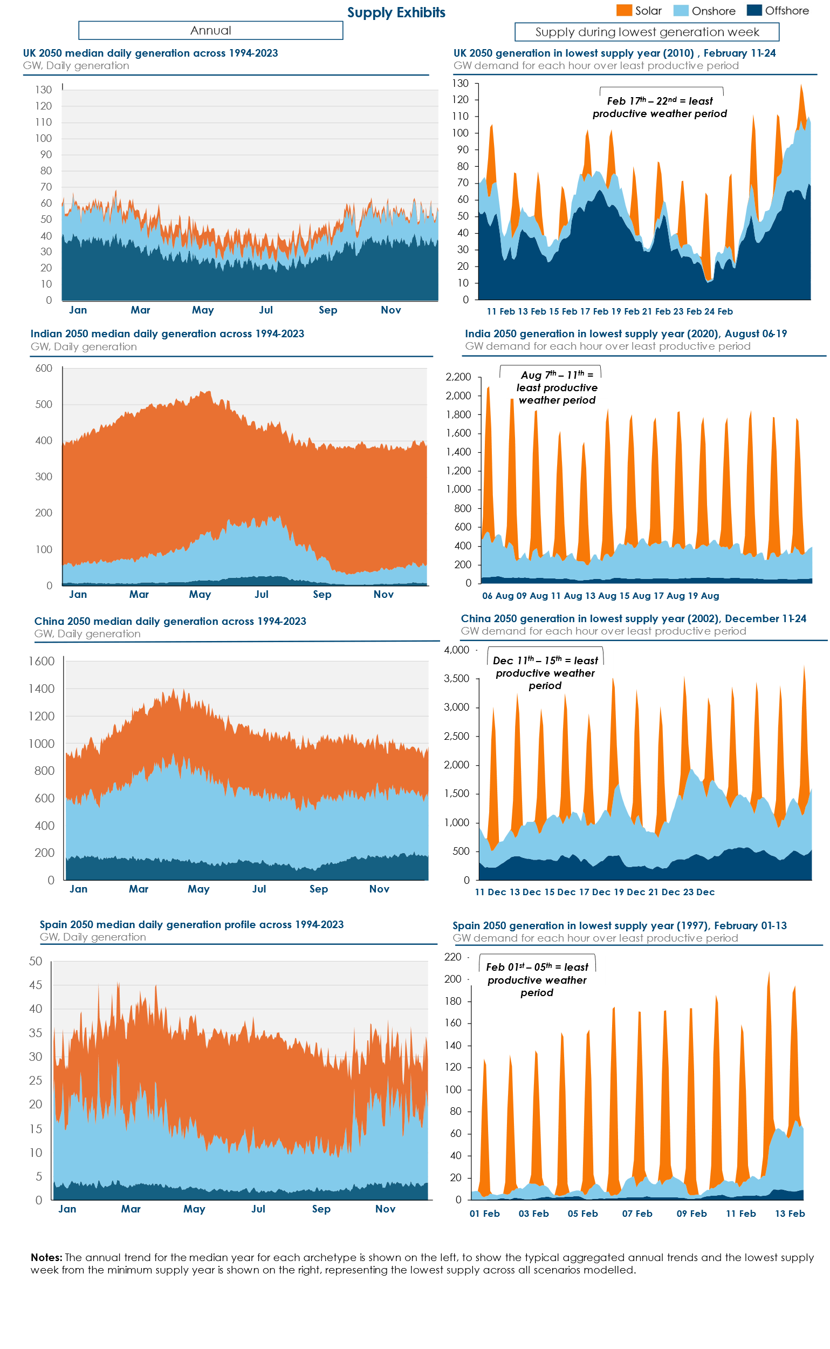
Nature and scale of the balancing challenge for different regional archetypes
The demand and supply variations can be combined to assess the extent and duration of supply shifts required to match demand. Exhibit 1.15 presents the resulting surpluses and deficits for the UK, calculated as the difference between variable renewable supply and projected electricity demand. The analysis reveals substantial multi-week deficits during certain winter periods, alongside more frequent but shorter-term deficits throughout the year.
Exhibit 1.15
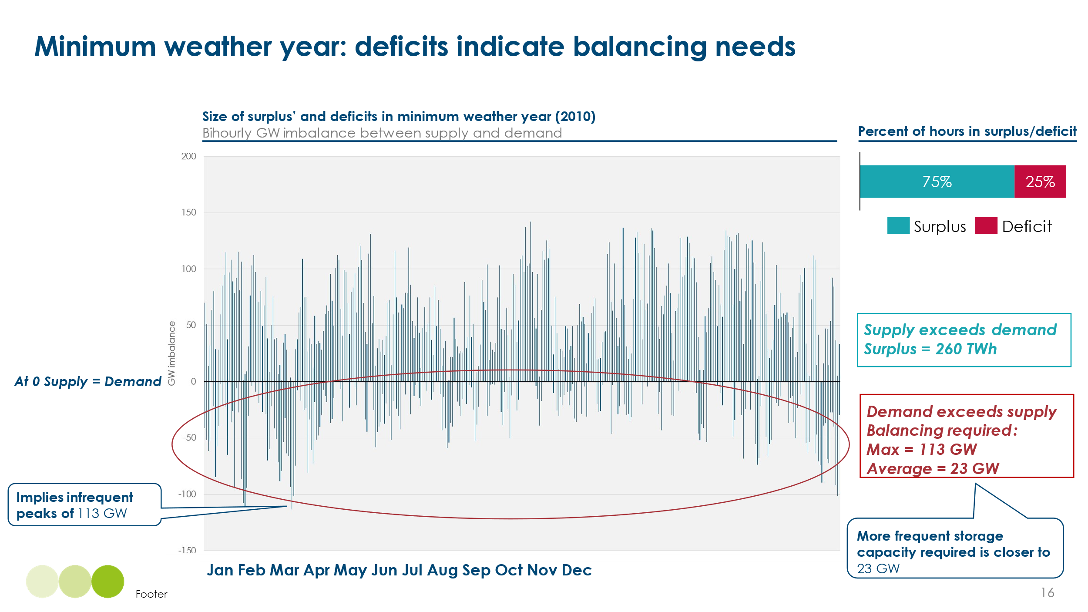
The nature of the balancing challenge varies significantly across regions, reflecting differences in the mix of natural renewable resources and in the temporal variability of both supply and demand across multiple time horizons.
Northern latitude system – UK case study
In the UK, an illustrative 100% variable renewable energy (VRE) system with 235 GW of installed capacity could generate approximately 780 TWh of electricity annually. After accounting for transmission losses and efficiency losses during storage charging and discharging, this would be sufficient to meet around 520 TWh of final electricity demand. Given the UK’s natural resource endowment, the system would be predominantly wind-based.
Modelling indicates that 91% of supply and demand (in kWh terms) would be naturally concurrent. The remaining 9% would require temporal shifting, either by moving supply across time or through flexible demand. Of this, approximately 3% of total supply would need to be shifted over periods of multiple weeks or months. While this is a relatively small share of total energy, the cost and complexity of enabling ultra-long-duration balancing to make it one of the most significant challenges in high-wind systems such as the UK.
Exhibit 1.16
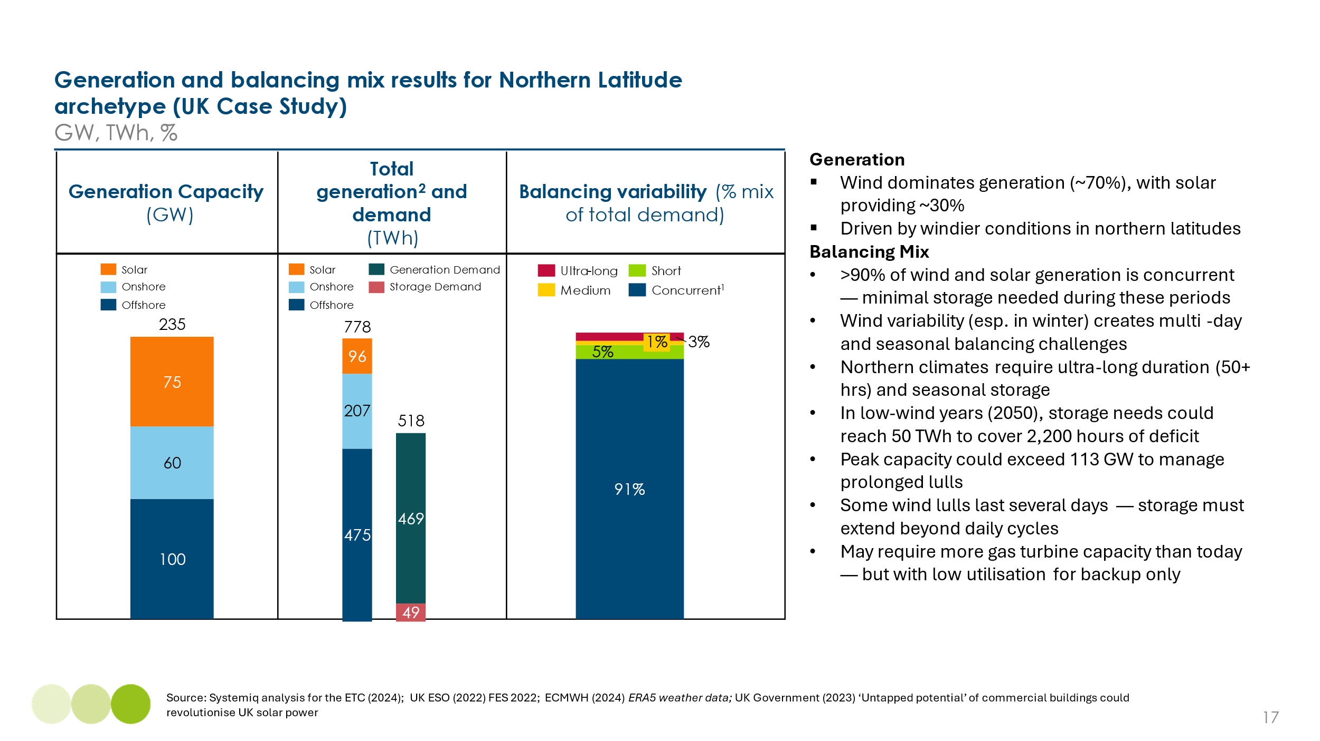

Tropical archetype – India case study
In a stylised 100% variable renewable energy (VRE) system for India, solar would account for approximately 80% of installed capacity. This system could generate around 7,300 TWh of electricity annually by 2050, sufficient to meet projected demand of approximately 5,500 TWh, representing a fivefold increase from today’s total electricity consumption of around 1,100 TWh. Electricity demand is expected to continue rising significantly beyond 2050.
Given the system’s strong dependence on solar generation, modelling suggests that 38% of electricity supply would need to be time-shifted to align with demand—such as to enable cooling loads to continue after sunset. However, the vast majority of this balancing requirement would occur over short durations (intra-day or day-to-day), with minimal need for seasonal or multi-week balancing.
Exhibit 1.17
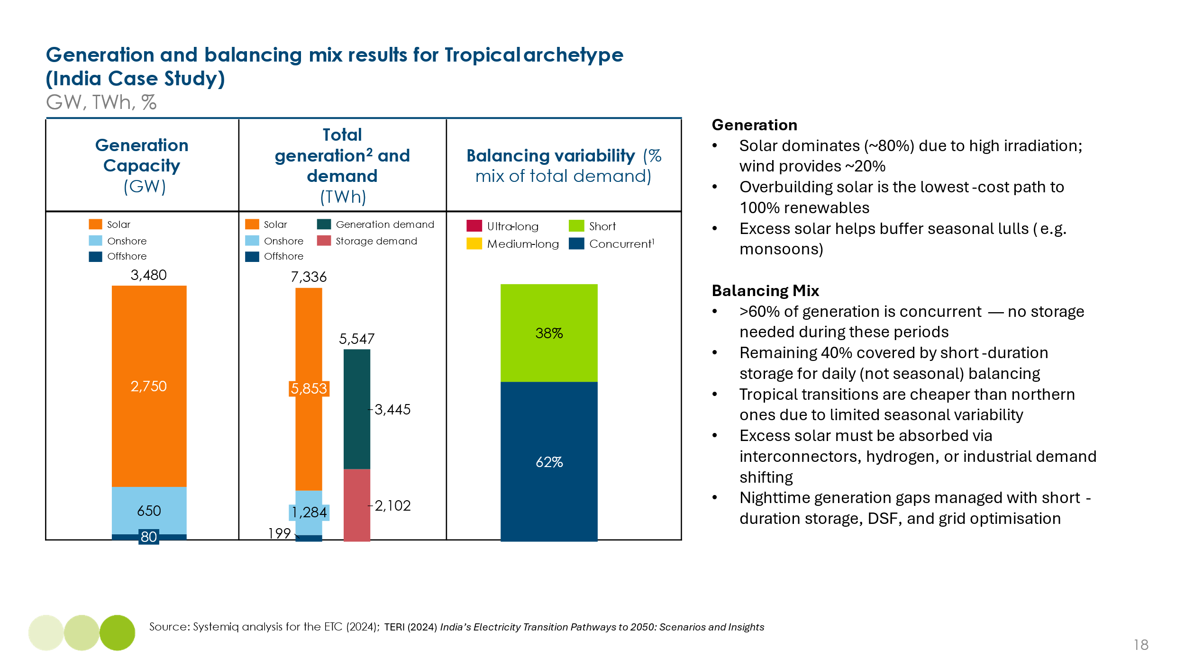
Mixed climate archetype – China case study
By mid-century, electricity consumption in China could reach approximately 15,000 TWh per year. In a stylised 100% variable renewable energy (VRE) system, this would require around 18,900 TWh of annual generation, accounting for system losses. Both wind and solar would contribute significantly to the generation mix.
Modelling suggests that 90% of electricity supply and demand would be naturally concurrent—comparable to the northern latitude case. Short-term balancing would be required for around 7% of total supply, slightly higher than in the UK, while ultra-long-duration balancing—over weeks or months—would be needed for just 2%.
However, these figures represent the aggregate national picture. At the regional level, imbalances between supply and demand could be more pronounced. Long-distance, high-capacity interconnection will therefore be critical to enable balancing across China’s climatically diverse demand zones.

Exhibit 1.18
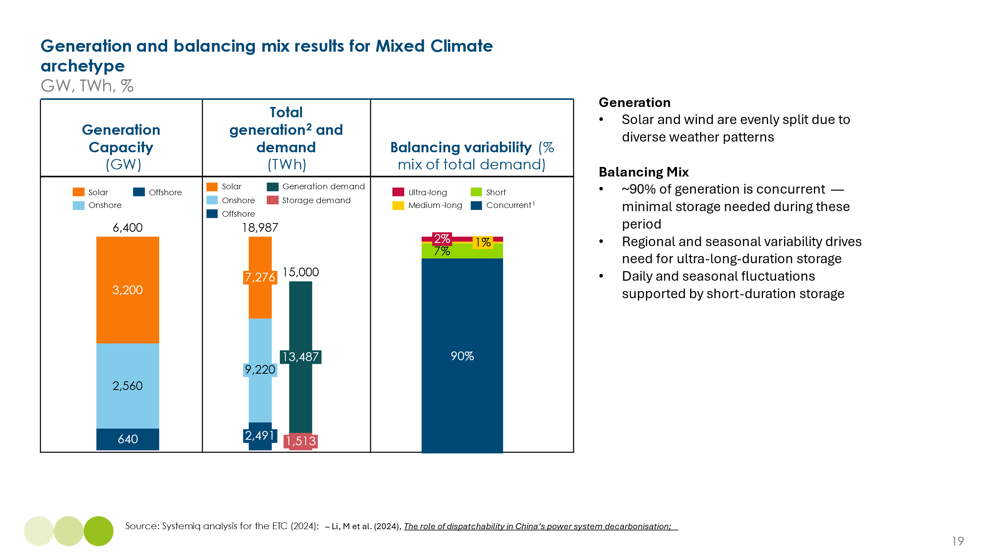
Mediterranean climate (Spain case study)
By mid-century, electricity consumption in Spain could reach approximately 400 TWh per year. In a stylised 100% variable renewable energy (VRE) system, this would require around 650 TWh of annual generation, accounting for system losses. Both wind and solar would contribute significantly to the generation mix.
Modelling suggests that 80% of electricity supply and demand would be naturally concurrent—comparable to the northern latitude case. Short-term balancing would be required for around 20% of total supply, approximately halfway between the UK and India’s system needs, while ultra-long-duration balancing—over weeks or months—would be needed for just 1%.
However, there remain regional variations in Spain, with stronger wind resources concentrated in the north and higher solar irradiance in the southern and central regions. Combined, these resources are highly complementary, enabling the high concurrent VRE generation.
Exhibit 1.19
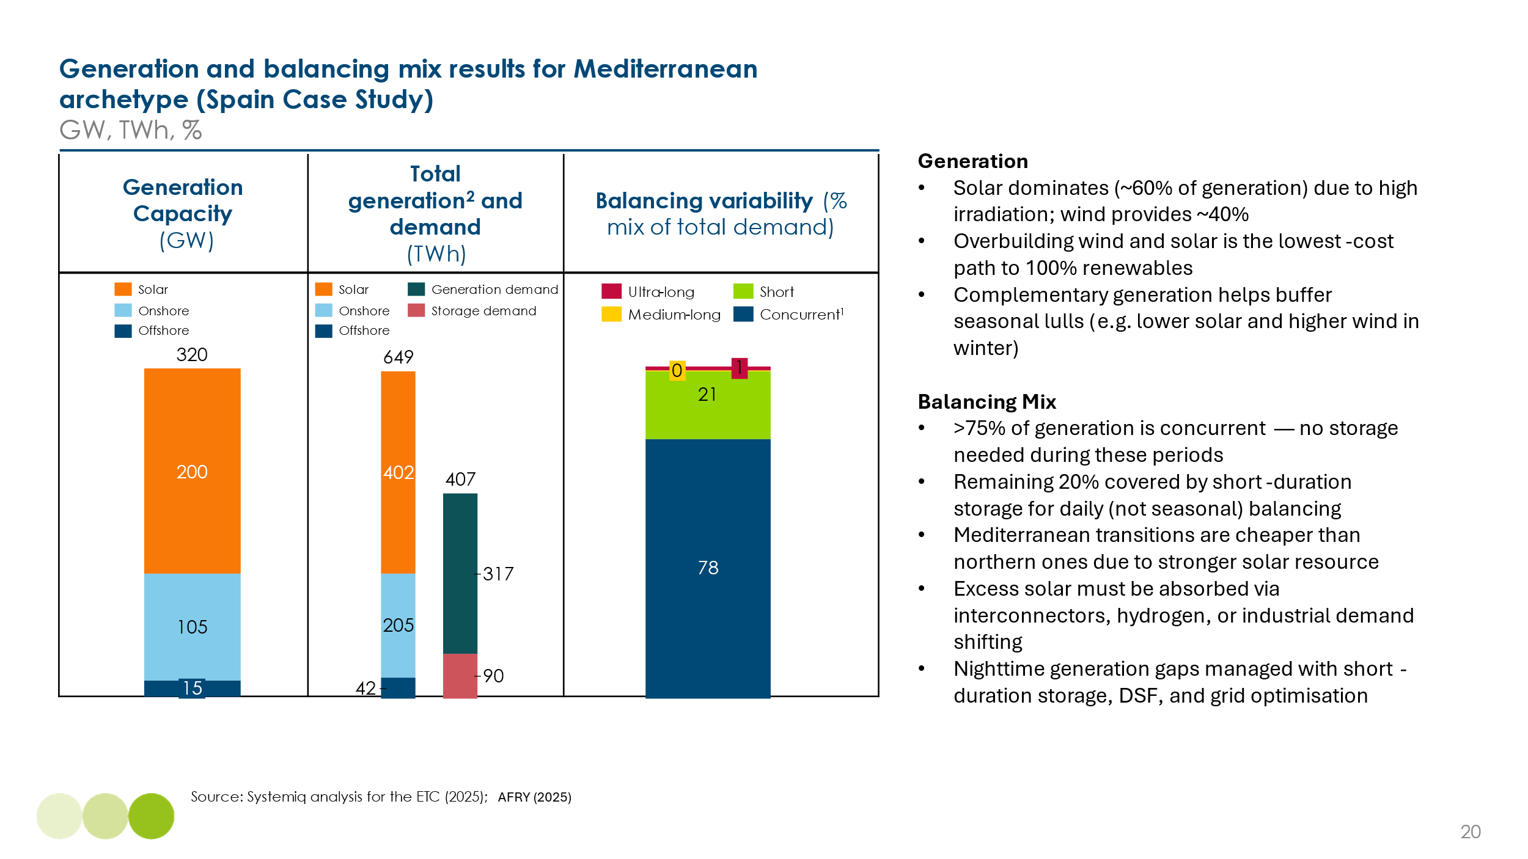

- Matching power supply and demand: technologies and business models

A range of technologies and business models can be deployed to address the different balancing challenges outlined above (Exhibit 1.20). These solutions can be grouped into four broad categories, each addressing specific balancing timeframes, with some overlap between them:

- Flexible, dispatchable generation, which can be ramped up or down to complement variable renewable supply.
- Long-distance transmission infrastructure, including national, cross-regional and international interconnectors, which can enable geographic balancing by connecting areas with complementary supply and demand patterns.
- Energy storage technologies, ranging from batteries for intra-day balancing to long-duration storage solutions such as pumped hydro, compressed air, or hydrogen. A key question is how far the potential role of battery storage can extend given dramatic reductions in battery cost per kwh of storable energy.
- Demand-side flexibility, which involves shifting electricity use to better align with variable supply, reducing the need to shift generation.

Exhibit 1.20
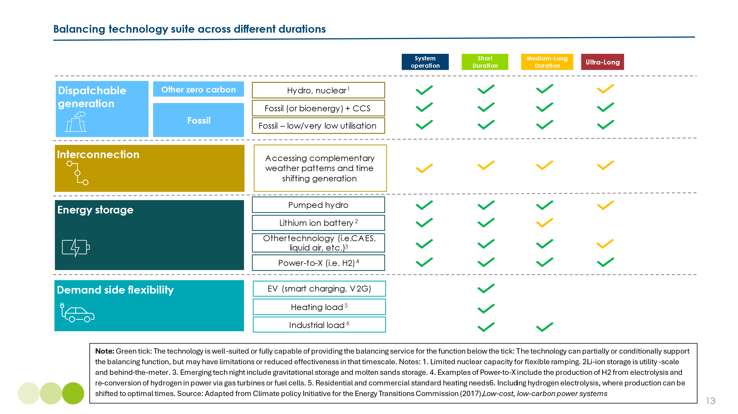

- Continued use of flexible dispatchable generation

In most current electricity systems, balancing is achieved primarily by adjusting the output of turbine-based power plants. Gas turbines can ramp up and down rapidly, coal-fired plants can vary output within a limited range, and dammed hydropower offers substantial operational flexibility.

As discussed in Section 1.2, a fully variable renewable energy (VRE) system would require significant balancing actions. However, in practice, almost all electricity systems are likely to retain a role for flexible, dispatchable turbine-based generation within a VRE-dominated mix.

Countries with abundant hydropower resources relative to demand—such as Brazil and Norway—will continue to rely heavily on hydro as a dispatchable low-carbon source. In many other countries, thermal generation is expected to retain a role, particularly during the transition period, to provide firm capacity and system stability when VRE output is low.

The UK provides a useful example of how flexible, dispatchable gas plants can support the integration of renewables. Since 2010, the carbon intensity of UK electricity has fallen significantly, with a 75% reduction from 500 gCO₂/kWh in 2010 to 124 gCO₂/kWh in 2024. This reduction has been achieved through a shift from coal to gas generation, alongside a rapid increase in wind and solar output — which rose from 25 TWh per annum to 145 TWh per annum over the same period. Importantly, the gas fleet has operated with increasing flexibility, with annual output falling from 288 TWh in 2010 to 90 TWh in 2024, while responding to fluctuations in both VRE supply and total electricity demand.
Exhibit 1.21
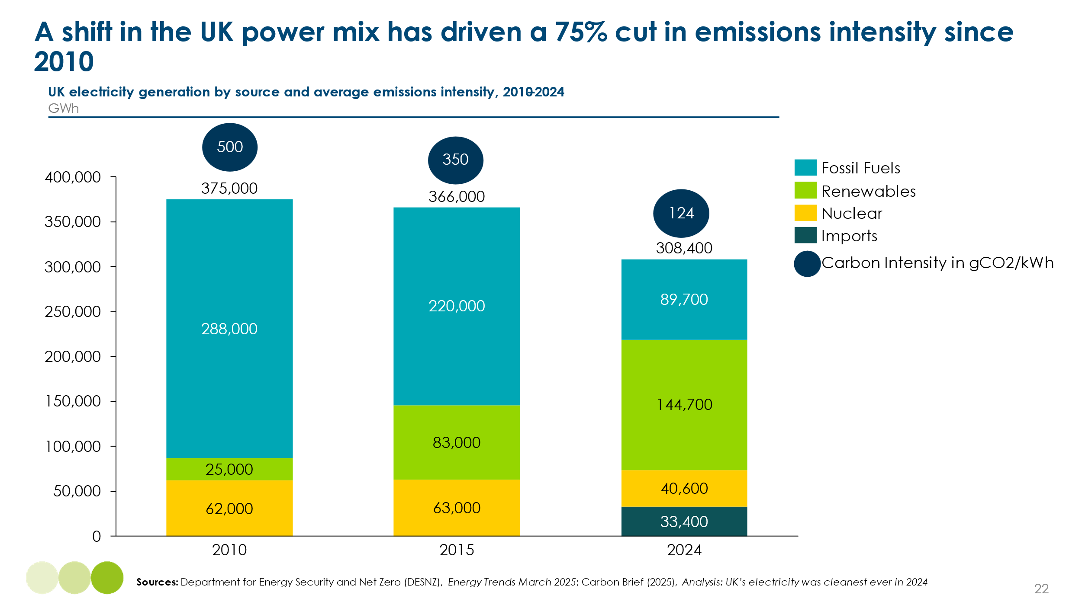

This illustrates an important insight for countries in the early stages of power system decarbonisation. In most systems, variable renewable energy (VRE) can grow to over 40% of total electricity generation, with supply and demand managed effectively even without large-scale deployment of the storage technologies discussed below. However, two challenges remain: increasing the operational flexibility of coal generation and progressing from partial to full decarbonisation.

Increasing the operational flexibility of coal generation

Gas generation is inherently flexible, with combined-cycle gas turbines (CCGTs) capable of rapid ramping, and open-cycle gas turbines (OCGTs) offering even greater flexibility at the expense of efficiency and cost.

Coal plants are technically less flexible, but a range of emerging technologies can extend both the range and speed at which they can vary output (see Box C). Enhancing the flexibility of coal plants, and operating them at progressively lower utilisation rates, could and should play a central role in enabling coal-dependent power systems, particularly in China and India, to reach the early phases of decarbonisation.

BOX C: Coal generation has the potential to run flexibly under certain conditions
While coal generation is typically less flexible in terms of varying output during the days or weeks, modifications to coal plants can enable them to run more flexibly. From a technical perspective, running coal plants more flexibly requires changes across three key features (Exhibit 1.22):
- Start-up time. Rapid start-up time i.e. the time it takes for a plant to turn on, allows plant to reach its minimum level of operation quicker. However, this can add greater thermal stress, and there are limitations to start-up time reductions.
- Minimal load. A lower minimal load means the plant can stably produce at lower outputs. However, efficiency is lower and there are technical limitations when operating at minimal load.
- Ramp rate. This is the speed at which net power feed-in can be adjusted, which must be fast to match variations in renewable generation. A higher ramp rate allows the plant to adjust output more rapidly. Rapid changes can result in thermal stress, so there are technical limitations to this speed.
Typically, hard coal plants are more flexible than lignite.
Exhibit 1.22
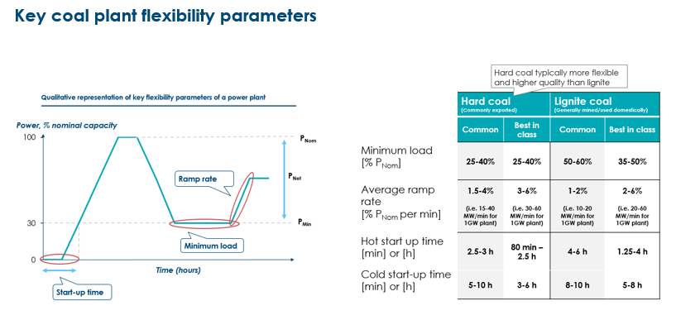
The retrofits required to increase flexibility entails an additional cost, which also varies by type of coal plant (it is typically more expensive for older, less efficient plants). In Europe, retrofit packages for coal plant flexibility have been in the range of $60-80m for 600 MW projects, equivalent to ~10% of already spent capex for the plant. This type of investment could initially add ~2$/MWh to the cost of delivering electricity from the plant; however, the additional cost would largely be offset by opex reductions due to efficiency improvements in the plant, therefore making retrofits broadly cost neutral over the long run.
In Germany, the Neurath Block E plant saw light retrofits which extended the life and increased efficiency, as well as modified the technical parameters, which enabled cost-effective substantial increases in flexibility (Exhibit 1.23). Overall, coal plants are already providing significant flexibility in Germany, operating in 15-minute intraday markets.
Exhibit 1.23
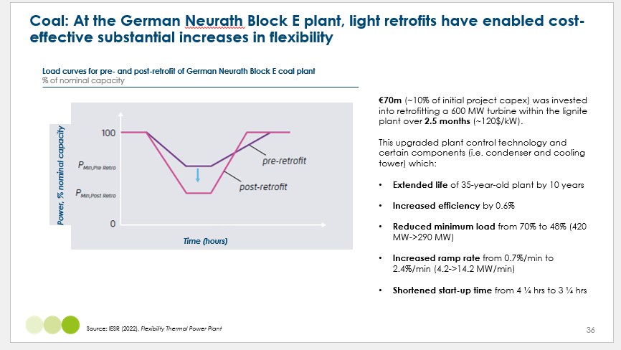
The ability of coal to run flexibly means as renewables grow, balancing can be met initially with existing fossil generation running in a more flexible manner. Previous ETC analysis suggests that India and China could achieve ~30% of wind and solar penetration with no new fossil generation capacity:
- TERI’s study on India showed that 32% of electricity could be met by variable renewables by 2030 (up from 10% in 2023), and that flexibility could be met principally with flexibility from conventional generators, in particular the coal and hydro fleet, as well as an increasing role for battery storage (60 GW in 2030). The study laid out that India’s young coal plants (80% of total capacity -185 GW - are 20 years or less) should be retrofitted to operate more flexibly, by:
  - Reducing minimum load from 55% to 30-40%
  - Increasing ramp rate per plant of 1%/m to 2%/m
  - Increasing all-India ramp speed capability to 700 MW/min
  - At least 16GW of capacity must be able to 'two-shift' - that is, to start up and shut down multiple times per week (up to four starts), depending on system needs.
- In China, 2030 scenarios showed that 28% VRE penetration could be absorbed without need for any new fossil additions due to existing thermal and hydro generation, with a minimal role for battery storage (2GW in 2030) and moderate role for pumped hydro storage (81GW).
Furthermore, an IESR study for Indonesia highlights how the country’s relatively young coal fleet (with an average age of just nine years) can and should be retrofitted to operate more flexibly. The study identifies three key priorities for retrofit: reducing minimum load levels from 50% to 30%, increasing ramp rates to twice their current levels, and shortening start-up times from 2–10 hours to 1.3–6 hours.
Meanwhile, Denmark’s coal fleet is already playing a flexible role. Despite being a low-gas, low-hydro system, Denmark has reached nearly 70% variable renewable generation annually without large-scale storage development, by combining high levels of interconnection (9 GW, ~25% of capacity) with more dynamic operation of existing thermal assets. In 2024, wind and solar were running alongside 8% coal, 21% bioenergy, and a heavily interconnected system.
The main challenge is ensuring the correct planning and market design to reward plants running flexibly. Implementing appropriate mechanisms to reward flexibility will be essential, including enhancing long-term planning processes to identify coal plant transitions to run more flexibly, as well as reforms to market agreements such as renegotiation of contracts to enable lower running hours.

Progressing from partial to full system decarbonisation
Operating gas or coal plants flexibly can play a critical role in the early stages of power sector decarbonisation. However, achieving full decarbonisation will require additional measures, including either:
- The addition of carbon capture and storage (CCS) technologies to gas or coal plants, enabling them to operate with near-zero emissions; or
- The conversion of gas turbines to run on low-carbon hydrogen, with the hydrogen produced via electrolysis from surplus wind and solar generation. Both hydrogen combustion in gas turbines and hydrogen storage, such as in salt caverns, are technically feasible and are discussed in more detail in Section 1.4
The relative economics of these two approaches, alongside a third option in which a small volume of unabated gas remains in the system and is offset by carbon dioxide removal, are assessed in Section 1.4 below.

Exhibit 1.24
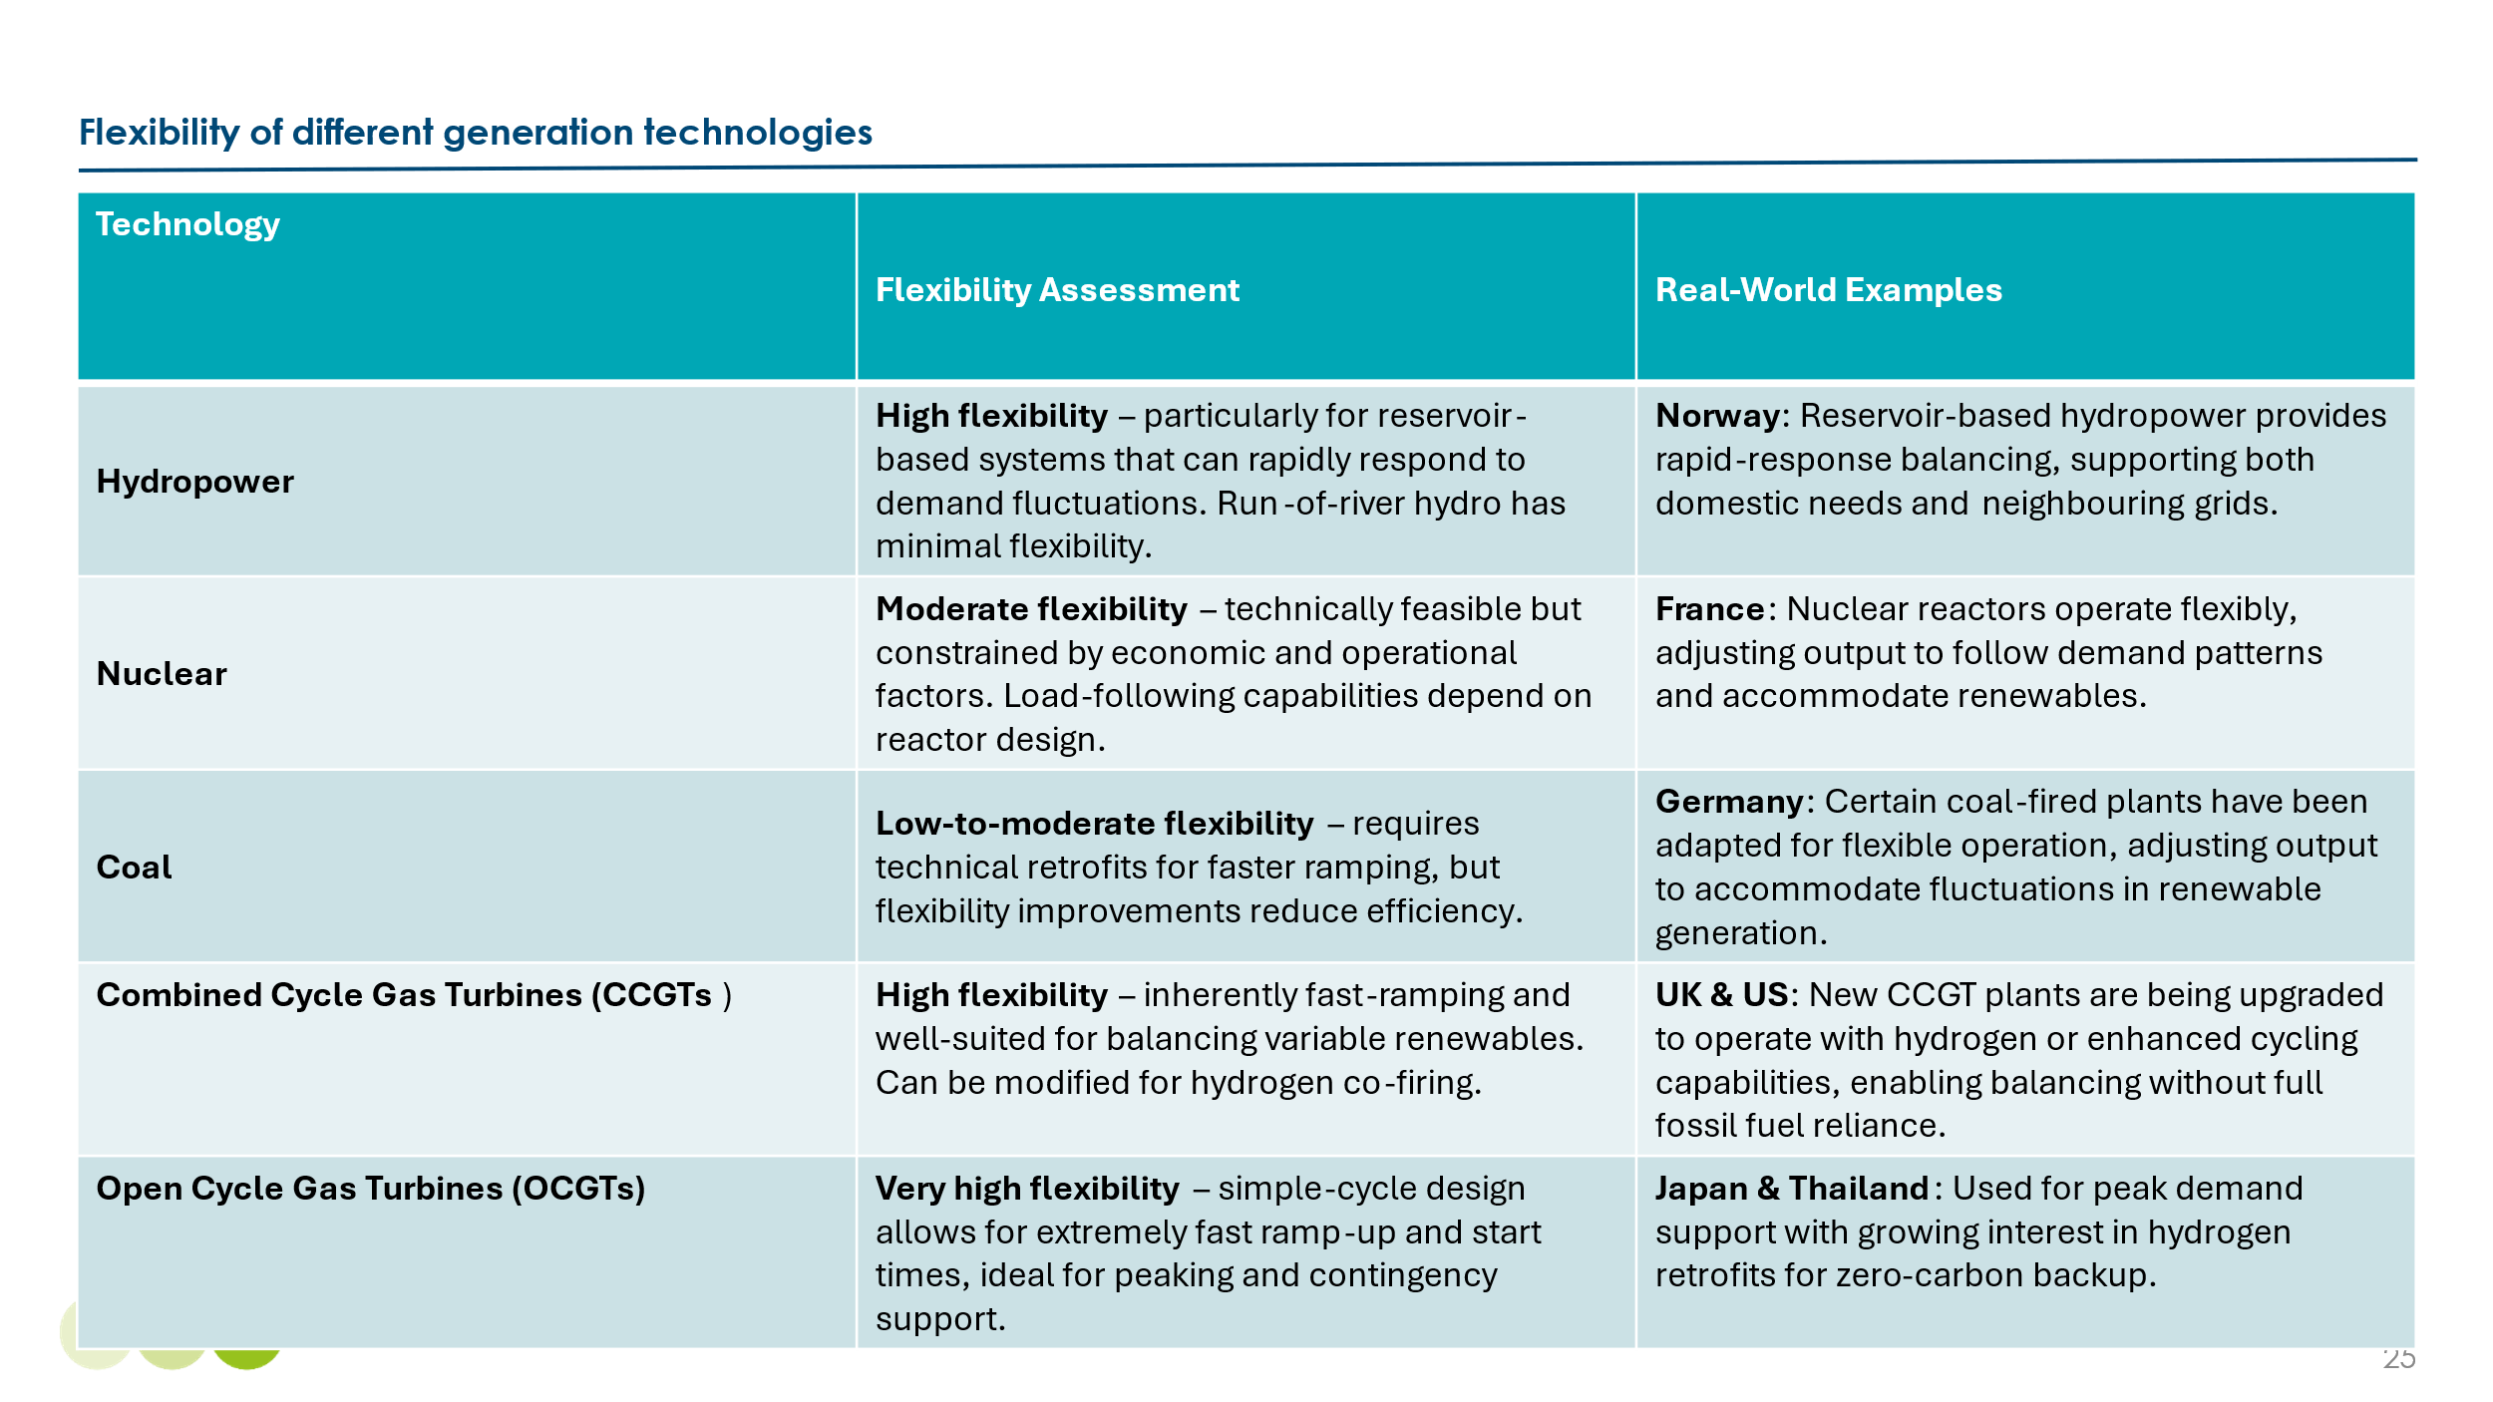

- Long distance and international transmission.

The larger the geographical area covered by an interconnected electricity system, the lower the variability in both variable renewable energy (VRE) supply and power demand is likely to be. This is particularly true when different regions experience uncorrelated patterns of generation and consumption. As a result, long-distance transmission, typically delivered via high-voltage direct current (HVDC) lines, is a critical enabler of balancing in VRE-dominated power systems. This applies both within large countries and across national borders.

The ETC has conducted a detailed analysis of the potential role of long-distance transmission, with a particular focus on international interconnection. Our Insight Briefing Long-distance Transmission: A Critical Route to Scale Clean Power sets out the key findings from this work.

Long-distance transmission can provide two distinct benefits:
- Enabling low-cost renewable electricity from resource-rich areas to be delivered to demand centres that would otherwise rely on more expensive local generation.
- Connecting regions with uncorrelated variable renewable energy supply and demand profiles, reducing the need for storage by smoothing variability across time and space. For instance, west-to-east transmission links could allow evening electricity demand in India to be met by solar power from regions where the sun is still shining, such as the Middle East. Similarly, north–south connections can bridge complementary wind and solar profiles, as in the case of North Sea wind and North African solar.

The economics of either of these business rationales will depend on the cost of long-distance transmission compared with the benefits which result. These costs vary significantly between countries and between different types of transmission line technology (e.g. subsea versus overground versus underground) but in many cases costs for HVDC projects could typically range between 3 to 10 $ per MWh per 1000 km. This means long distance transmission could be a cost-effective enabler of high VRE shares. The exhibit below shows the cost range for 1,000 km projects in key geographies (noting that project costs spread over longer distances, e.g. 4,000 km, could reach the lower bound cost of $3 per MWh per 1000 km).

Exhibit 1.25
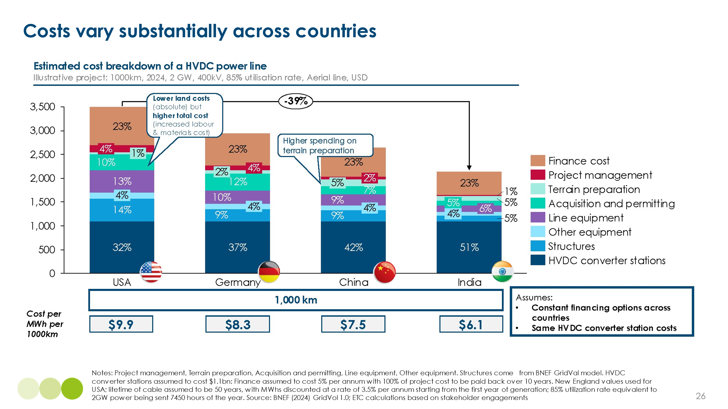

China is already deploying HVDC technology on a large scale. It has a very extensive network of ultra-high-voltage (UHV) network of over 30 lines, with the largest being the Changji-Guquan Ultra High Voltage Direct Current (UHVDC) transmission line, which spans over 3,300 km, has a voltage of 1,100 kV, and a transmission capacity of 12 GW. Within Europe, multiple international connectors have been developed - in total, Europe currently has over 400 interconnectors across 39 national systems (for instance from the UK to Norway , Ireland , France , Belgium and the Netherlands), though in most cases these are relatively short distance compared with the longest Chinese lines.

Our ETC analysis has identified several potentially attractive applications for international interconnection. Overall, the modelling results suggest there is very large global potential for cross border interconnection, with a small number of high potential links (shown on the Exhibit 1.26) having potential to deliver by 2050: 15% of global power demand, 1.8 Gt per annum carbon reductions (equal to 13% of global power sector emissions), and $100 billion dollars of savings per year.
Exhibit 1.26
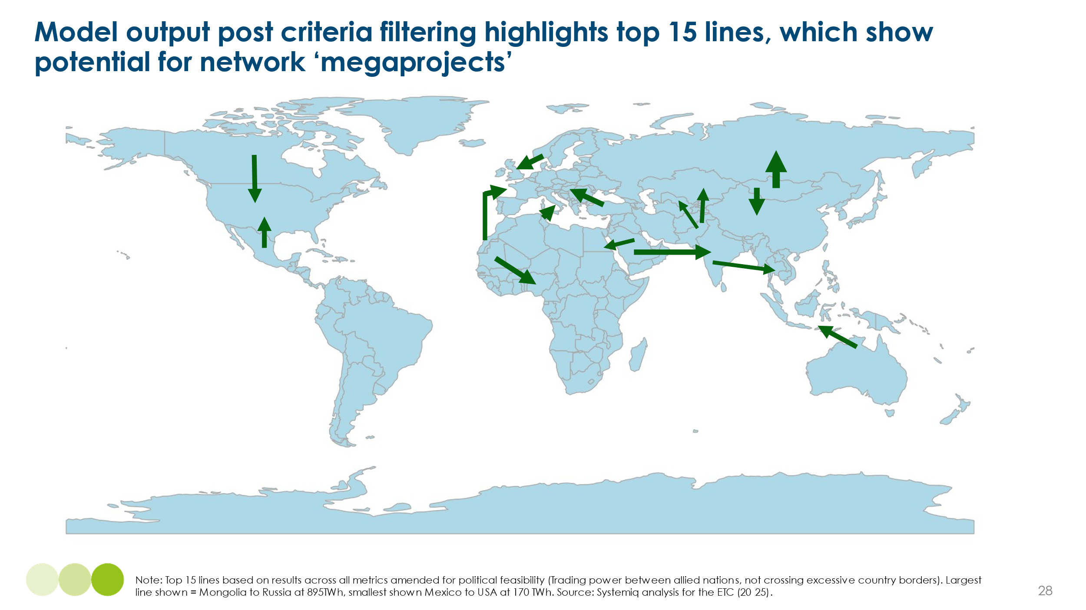

Both long distance transmission links within large countries and between countries can face significant implementation barriers, relating to supply chain constraints, opposition to infrastructure building, planning delays, or the complexities of agreeing international deals. Some of these can be partly overcome via improvements in grid technology which are discussed in Chapter 2 and key policy actions required to remove barriers are discussed in Chapter 4.

- Energy storage

A wide range of technologies can provide energy storage across the full spectrum of required durations, each with distinct advantages and trade-offs, as outlined in Exhibit 1.27 below.
Exhibit 1.27
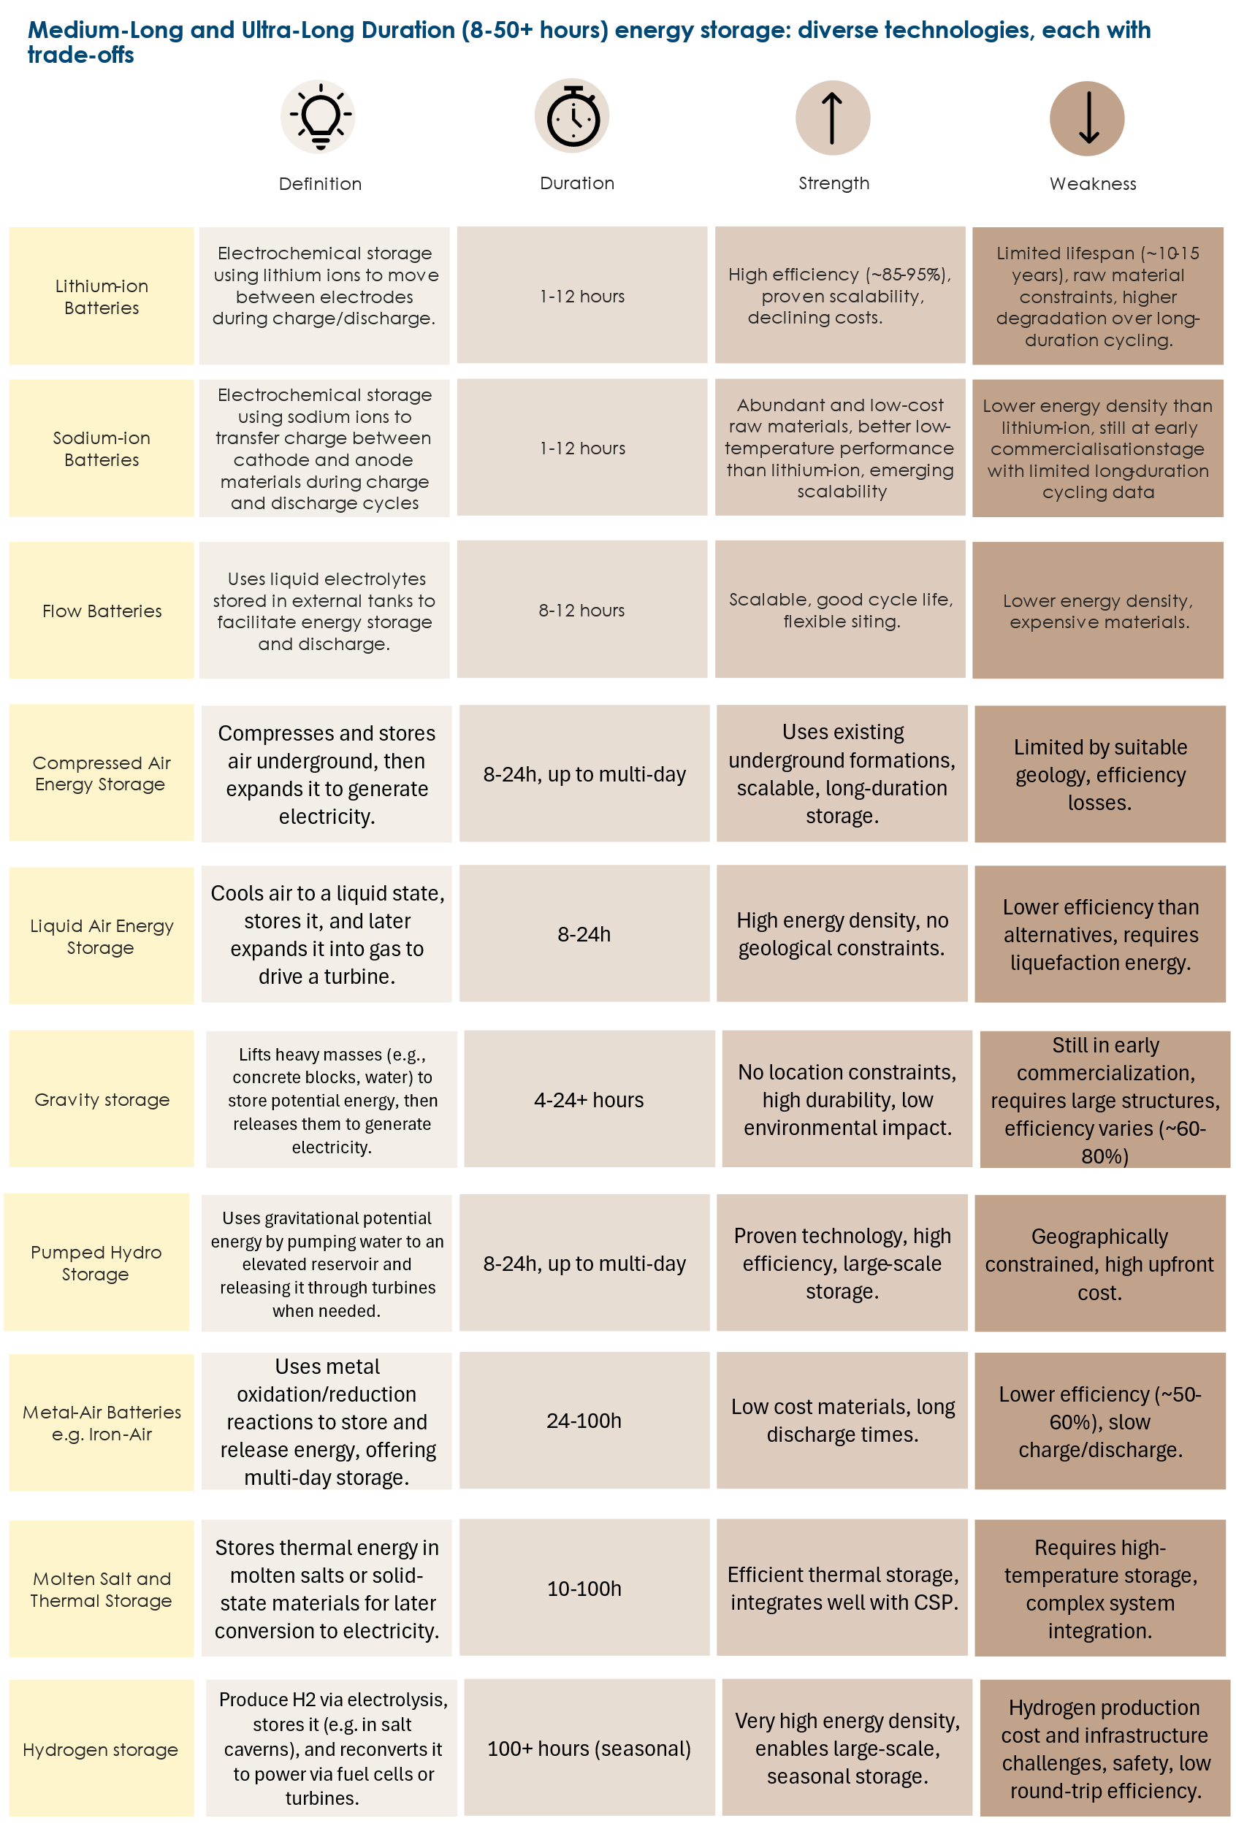
The relative economics of these technologies are explored in detail in Section 1.4 and will continue to evolve with ongoing technological progress and operational learning. It is neither possible nor necessary to predict in advance the precise optimal mix of technologies that will be deployed. However, Exhibit 1.28 presents a view of the set of storage solutions which are likely to play a significant role at different durations and project scales.

Exhibit 1.28
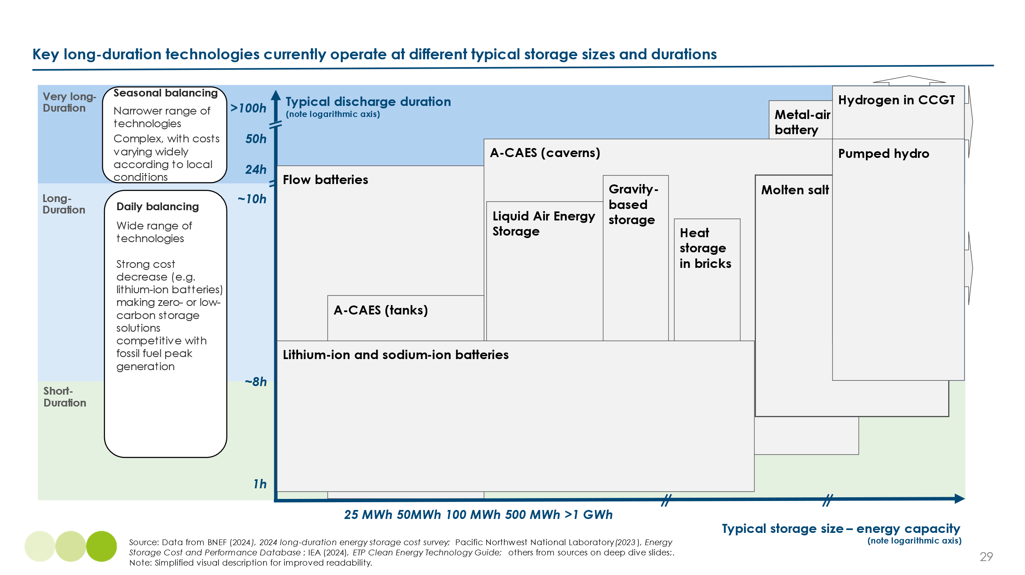

Short duration: the dominance of batteries.

Short-duration storage systems (ranging from 0 to 8 hours) are essential for managing hourly and day-to-day fluctuations in renewable energy supply and for providing critical ancillary services such as frequency regulation and rapid response to maintain grid stability. Among the various technologies capable of delivering these services, lithium-ion batteries have become the predominant choice. This dominance is attributed to several key factors:
- Lithium-ion batteries offer high round-trip efficiencies, typically ranging between 85% and 95%, facilitating effective energy storage and release. They also possess the capability to charge and discharge quickly, making them well-suited for applications requiring immediate power delivery.
- Unlike alternatives such as compressed air or pumped hydro storage, which often necessitate extensive engineering and site-specific infrastructure, lithium-ion batteries benefit from modular and scalable designs. The advent of containerised solutions—where battery packs and management systems are integrated into standard shipping containers—has further streamlined deployment processes, allowing for rapid installation and flexibility in various locations.
- Over the past decade, the cost of lithium-ion battery packs has seen a dramatic decline of 87% from $872/MWh in 2012 to $115/MWh in 2024. This substantial decrease has been driven by advancements in manufacturing processes, economies of scale, and improvements in battery chemistry, enhancing the economic viability of lithium-ion batteries for large-scale energy storage applications.
These attributes collectively position lithium-ion batteries as a leading solution for short-duration energy storage needs in modern power systems.
Exhibit 1.29
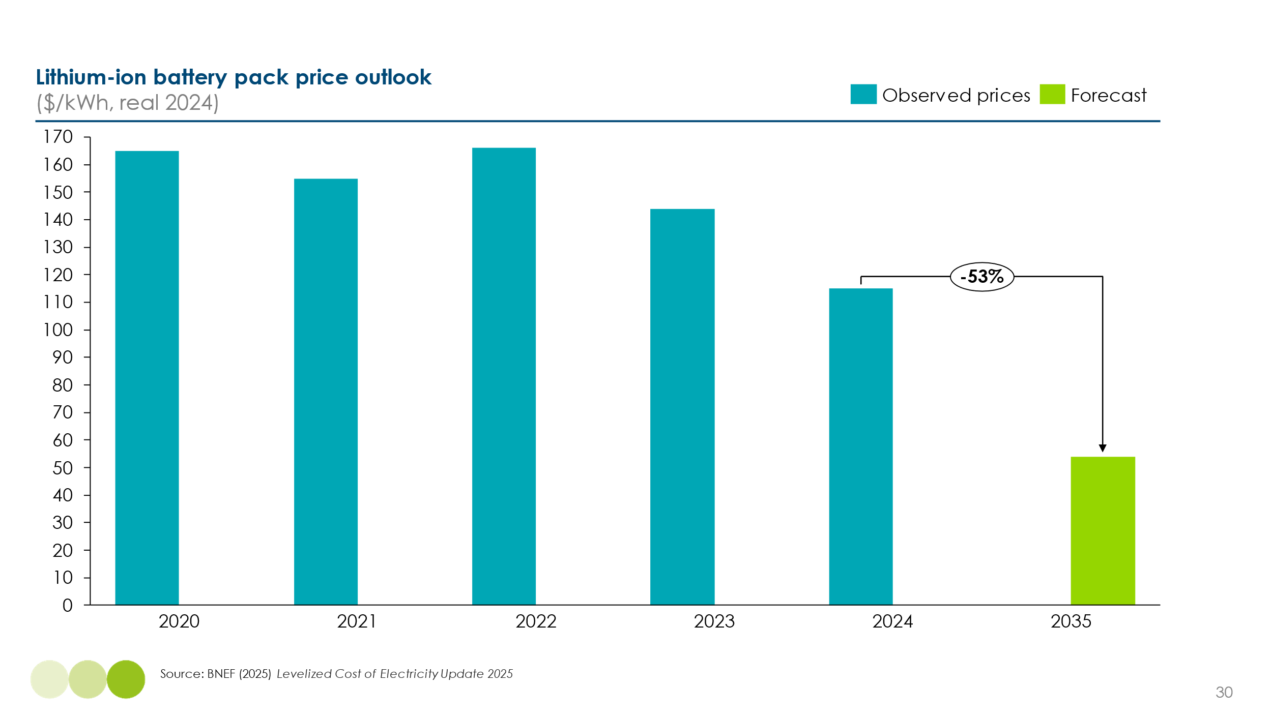

This fall in price reflects technical innovation, the achievement of large manufacturing economy of scale and learning curve effects:

- Adoption of Lithium Iron Phosphate (LFP) Chemistries: Since around 2019, the rapid adoption of LFP battery chemistries has contributed to cost reductions. LFP batteries are less expensive than the previously dominant Nickel Manganese Cobalt (NMC) chemistries due to the absence of costly materials like cobalt and nickel. Additionally, LFP batteries offer longer lifespans, with some manufacturers guaranteeing up to 10,000 charge-discharge cycles without significant degradation. This longevity is crucial for applications requiring daily or more frequent cycling.​
- Economies of Scale in China: China has achieved substantial economies of scale in battery manufacturing. By the end of 2023, China's battery manufacturing capacity reached approximately 2.2 terawatt-hours (TWh), nearly double the global demand projected for 2024. This overcapacity has led to intense price competition and significant cost reductions.​
- Projected Future Cost Declines: Bloomberg New Energy Finance (BNEF) forecasts a 46% reduction in battery pack prices between 2025 and 2035. In China, LFP pack prices are already as low as $66 per kilowatt-hour (kWh), and further reductions are anticipated, potentially reaching $45 per kWh by 2035.
- Sodium-ion batteries have also emerged as a promising alternative to lithium-ion. Sodium-ion offers comparable power performance and thermal stability to LFP chemistries, while relying on more abundant raw materials. While current cycle life and energy density are lower than leading lithium-based chemistries, recent cell-level data indicates energy densities of 120–160 Wh/kg which will be sufficient to support deployment in stationary applications. While costs for sodium-ion cells are currently higher than lithium-ion, due to these technologies not benefitting from the economies of scale that lithium-ion battery producers have developed, sodium ion batteries will decline in price due to the high levels of industrialisation expected from China’s battery producers. Sodium will also become particularly important if lithium prices rise from the current level, with prices in the first quarter of 2025 sitting at the lowest level point since 2021.

Given the inherent advantages of batteries, and the prospects for further cost reduction, it is highly likely that batteries will dominate the short duration storage market.

Medium-long duration storage

The optimal balance of different technologies is less clearly defined at storage durations above eight hours. This reflects both a wider range of potentially competitive technologies and the fact that limited deployment has been required to date, since fossil fuel plant flexibility can meet medium-long duration balancing needs at low to moderate levels of variable renewable energy (VRE) penetration. However, large-scale deployment of medium-long duration storage will become increasingly important as VRE penetration continues to rise.

Batteries are technically capable of meeting medium-long duration storage needs, since they can be charged and discharged at slower rates than their maximum power capacity. However, the historically high capital cost per kilowatt-hour of storage has made them uneconomic for applications with limited charge/discharge cycles, such as those required for medium-duration balancing, compared to their use in short-duration energy shifting or ancillary services. As battery costs continue to fall, there is an open question as to how far up the duration curve batteries can become cost-competitive (see Box D).

Several alternative technologies are likely to play a significant role in medium-long duration storage. These include:

- Compressed air energy storage (CAES), with air stored either in geological formations such as salt caverns or in engineered storage vessels.
- Pumped hydro storage, typically deployed in large-scale projects. Other gravity-based systems are also being explored, including technologies that lift and lower solid masses such as concrete blocks or heavy weights in mine shafts or towers, converting potential energy to electricity. While less mature than pumped hydro, these systems may offer greater siting flexibility and modularity.
- Alternative battery chemistries, such as vanadium redox flow batteries and iron-air batteries. Flow batteries, such as vanadium redox, are well-suited to medium-long duration applications and have been deployed primarily at small scale due to their lower energy density and higher balance-of-system costs. Iron-air batteries, which operate via reversible oxidation, are currently being developed for large-scale, long-duration storage due to their projected low cost per kWh and suitability for multi-day storage.
- Thermal energy storage, where materials such as bricks are heated using surplus electricity and later discharged either as heat or converted back to electricity via a steam turbine. In most current applications, stored energy is primarily used to provide industrial or district heat, where round-trip efficiency is less critical. However, systems that reconvert heat to power—such as those using steam turbines or thermophotovoltaic cells—are also available, though typically with lower overall efficiency. Other “power-to-heat” and “heat-to-power” configurations are also under development, with use cases spanning from industrial decarbonisation to flexible grid support.
The cost competitiveness of these technologies, both in absolute terms and relative to lithium-ion batteries, depends on a combination of capital cost per kilowatt-hour stored and round-trip efficiency, as considered in Section 1.5. Their potential role will also depend on:

- Geographical constraints, with some technologies requiring specific physical conditions (e.g., underground caverns for CAES or elevation differences for pumped hydro)
- Project scale and complexity, as technologies like pumped hydro and CAES typically require larger capital investment, longer development timelines, and are highly dependent on planning and permitting processes, compared with the more modular and rapidly deployable nature of battery systems.

BOX D - THE RAPID DECLINE IN BATTERY PRICES MAKES LITHIUM-ION SUITABLE FOR LONG-DURATION ENERGY STORAGE
The rapid decline in lithium-ion battery prices has challenged the conventional notion that batteries cannot serve long-duration storage needs. Historically, lithium-ion was considered uneconomical beyond 4-6 hours of storage, as stacking additional battery cells became cost-prohibitive. However, recent cost reductions and advancements in battery design have led to the deployment of 8+ hour lithium-ion systems, positioning them as viable contenders in long-duration markets.
Several manufacturers are now developing lithium-ion battery systems optimized for long-duration applications. Examples include CATL’s ‘Tener’ cell-to-pack battery and Powin Energy’s Centipede Stack 800, both designed for 8+ hours of storage. These systems enable flexible deployment without geographical constraints, unlike pumped hydro or CAES.
Real-world deployments underscore this shift:
- In California, the Tumbleweed (69 MW/552 MWh) and Goal Line (50 MW/400 MWh) lithium-ion systems were selected in long-duration procurements, signalling their economic viability in multi-hour balancing markets.
- In Australia, RWE’s Limondale BESS (400+ MWh, 8-hour) secured a government-backed tender, demonstrating investor confidence in lithium-ion for long-duration storage applications.
It is becoming increasingly clear that lithium-ion batteries have no inherent technical limitation on duration. By increasing the number of battery packs stacked within a storage system, lithium-ion systems can be designed for 8+ hours or even multi-day storage. The key constraints are economics and project design choices; developers must weigh capital costs, degradation rates, and market opportunities when determining the optimal storage duration.

Ultra-long duration storage

As discussed in Section 1.3.1, ultra-long-duration flexibility can be delivered through dispatchable thermal turbine-based plants. These can be made low carbon either by adding CCS to continued methane combustion or by switching from methane to hydrogen as the fuel source. In the former case, the energy storage system is effectively the existing natural gas storage infrastructure, which can support seasonal balancing. In the latter case, hydrogen produced via electrolysis during periods of renewable generation surplus is stored for later use in gas turbines or fuel cells.

The primary option for hydrogen storage is in underground salt caverns. Analysis suggests that several of the countries expected to require large-scale ultra-long-duration storage possess sufficient salt cavern capacity to meet anticipated needs, for example, countries with the highest potential in the United States (particularly the Gulf Coast), Germany, the United Kingdom, and Canada. Other countries such as China, France, and the Netherlands also have viable formations, though development remains at an earlier stage. These caverns are typically located in regions with historical use for natural gas storage and are now being assessed or repurposed for large-scale hydrogen applications.

An alternative technology for ultra-long-duration storage is iron-air batteries, which exploits the chemical reaction between iron and oxygen. During discharge, iron is oxidised to form iron oxide (releasing energy), and during charging, the iron oxide is reduced back to iron (absorbing energy). While round-trip efficiency is relatively low, this may be offset by very low capital costs, due to the use of abundant and low-cost materials such as iron, air, and water.

- Demand side flexibility

Demand-side flexibility (DSF) is defined as the ability to adjust the timing of electricity use, thereby reducing consumption during peak hours. It represents an alternative to balancing actions that shift supply across time periods. By reducing the need for energy storage, DSF can lower the overall cost of balancing within a high-VRE power system. It can also reduce the required capacity and cost of networks, and is therefore also discussed in Chapter 2, which considers network investments needed to support rising electricity demand.

Significant opportunities exist for DSF in households and commercial buildings, these primarily addressing the short duration balancing challenge. The two most important opportunities are:

- Electric vehicle (EV) charging, where vehicle owners shift charging to off-peak periods: the electrification of road transport will create a large, underutilised distributed storage resource. Passenger EVs are used around 5% of the time, leaving it parked for the other 95%, and a standard 60 kWh EV battery can store multiples of an average household’s daily electricity consumption, even in a deeply electrified economy. This creates significant, and cost-free, potential to align charging demand with periods of surplus VRE generation—typically overnight in high-latitude, wind-dominant regions, and midday in sunbelt countries with high solar potential (see Box F, Chapter 2, for discussion of emerging midday solar surpluses in Australia).
- In principle, EV batteries could also export electricity back to the grid through vehicle-to-grid (V2G) applications, if users know their vehicles will be parked for extended periods. V2G requires specific hardware and smart charging infrastructure.
- Shifting heating and cooling loads in both residential and commercial buildings: Space heating and cooling will be key drivers of rising electricity demand across different regions. While demand for thermal comfort is time-specific, electricity input to achieve this can be shifted by several hours if buildings are sufficiently well insulated. This opportunity is discussed in detail in the ETC’s recent report on Net-Zero Buildings. Improving insulation involves upfront investment—particularly in retrofitting existing buildings—but often delivers cost savings by reducing total energy use, even before accounting for demand-shifting benefits. It can therefore be a very low-cost method to provide short duration balancing flexibility.

Exhibit 1.30 sets out the estimated potential for DSF in the buildings and road transport sectors. In principle, up to 25% of total electricity demand in these sectors could be time-shifted with minimal impact on consumer comfort or convenience, and at low cost.

Exhibit 1.30
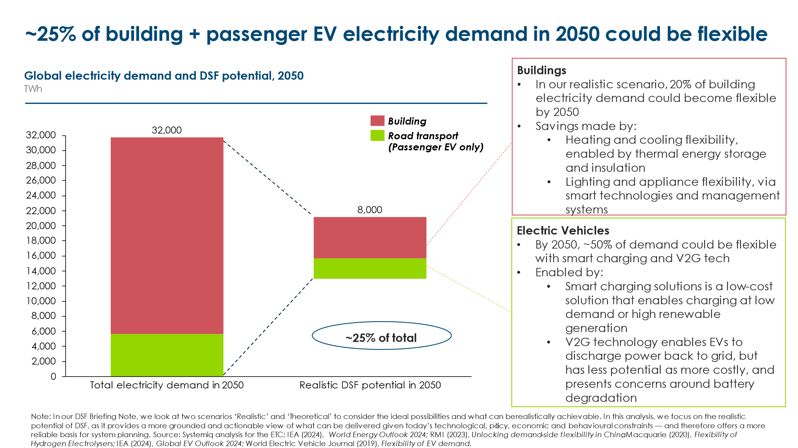

Seizing this large potential in the household and commercial sectors will require the development of time-of-day pricing. The ETC’s Briefing Note Demand side flexibility – unleashing untapped potential for clean power discusses this and other actions required to drive DSF adoption which we also consider in Chapter 4 of this report.

Exhibit 1.31
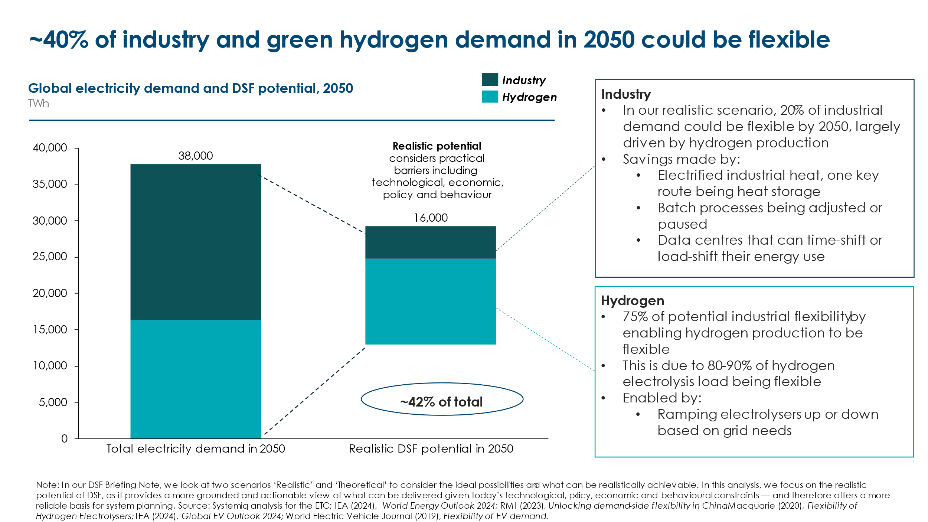

As shown in Exhibit 1.31 above, there are also significant opportunities for short duration DSF in industrial sectors, and longer duration DSF in the production of green hydrogen.

- Heat batteries convert electricity into heat, which can then be stored in cheap amply available materials. This heat energy can either be output later on directly or converted back into electricity. They are particularly effective when the stored energy is used directly for heat, minimising conversion losses associated with electricity-to-heat-to-electricity cycles. By converting intermittent renewable electricity into continuous, high-temperature thermal energy, heat batteries enable industrial processes to have constant heat supply from variable power generation. Currently, over 40 technology providers offer heat batteries or heat-as-a-service solutions to support industrial decarbonization. However, the technology remains nascent technology due to high upfront costs, limited industry awareness, and integration challenges within existing industrial processes. Widespread adoption will depend on further cost reductions, supportive policies, and increased demonstration projects to prove their reliability at scale
- Hydrogen production via electrolysis, coupled with storage in salt caverns and subsequent combustion in gas turbines, is anticipated to play a pivotal role in long-duration energy balancing, especially in high-latitude, wind-rich regions. Beyond grid balancing, a zero-carbon economy will necessitate substantial volumes of zero-carbon hydrogen to decarbonize sectors such as shipping, steel, fertilizers, and petrochemicals. Projections indicate that achieving a global zero-carbon economy could require the production of approximately 400-500 million tonnes of clean hydrogen annually by 2050. This would correspond to an electricity demand of about 16,000 TWh, considering that producing one tonne of hydrogen via electrolysis requires approximately 50 MWh of electricity. ​
- While some green hydrogen will likely be produced using dedicated variable renewable energy (VRE) sources, integrating electrolysis with grid electricity can optimize costs by operating during off-peak, low-price periods. This approach leverages periodic surpluses of electricity supply inherent in high-VRE systems. Modern electrolysers are increasingly flexible, enabling demand-side flexibility over short durations. Furthermore, green hydrogen production is highly relevant to addressing long-term energy balancing challenges. ​

- Relative costs of balancing options and optimal mix by duration.

Balancing supply and demand in high-VRE systems means that total system costs will exceed the levelised cost of electricity (LCOE) from generation alone. The nature of these additional costs depends on the specific balancing technologies or business models employed.
- For energy storage, the main cost drivers are the capital cost per kilowatt-hour (kWh) of storage capacity (e.g., for batteries or pumped hydro) and the round-trip efficiency — the percentage of input electricity that can be recovered for end use. Exhibit 1.35 presents projected capital costs and efficiencies for selected storage technologies in 2035. Additionally, for storage systems with round-trip losses, the cost per usable kWh depends on the price of input electricity: the higher the input cost, the greater the impact of those efficiency losses. Box E illustrates how the levelised cost of energy (LCOE), storage capital costs, and round-trip efficiency together influence the levelised cost of storage (LCOS)
- Demand-side flexibility (DSF) costs are more difficult to quantify and are often low or zero as DSF is not their main application. For example, if an EV driver shifts charging to off-peak hours to benefit from lower prices, the cost may be negligible beyond the inconvenience or behavioural adjustment. However, some forms of DSF — such as improved insulation to allow shifting of heating or cooling — do involve capital costs, as discussed in the ETC’s report on Net-Zero Buildings. Still, these investments may be justified independently by reductions in overall household energy use.
- Running fossil fuel plants flexibly (rather than at baseload) has cost implications due to reduced utilisation. The cost impact depends on the specific plant type (e.g. open-cycle gas turbine vs. combined cycle gas turbine), as well as whether the plant is already built or new — with new builds incurring full capital recovery requirements.
- The cost of long-distance interconnection is primarily driven by the capital and operational cost of transmission lines and end-point infrastructure. However, in some cases these costs may be fully or partly justified by generation cost arbitrage (i.e. connecting regions with different LCOEs). In such cases, the balancing benefits of interconnection may be realised at little or no incremental cost.

Box E – Levelised Cost of Electricity (LCOE) and Levelised Cost of Storage (LCOS) Methodology
Overview: ETC analysis featured in Exhibit 1.35 and Exhibit 1.36 uses the levelized cost of electricity (LCOE) and levelized cost of storage (LCOS) to compare the costs across different technologies and time durations. Although imperfect, these metrics are commonly used to help stakeholders identify the cost-competitiveness of different technologies at various durations.
The LCOE formula has been used to calculate costs for the following generation assets in Exhibit 1.35 and Exhibit 1.36: long-distance transmission, nuclear, hydropower, CCS on CCGT, and unabated gas. These are generation technologies that directly produce electricity, making LCOE the appropriate metric to assess their cost per unit of energy output over their lifetime.
LCOS has been used in relation to all energy storage categories, including batteries, thermal storage, pumped hydropower, compressed air and hydrogen storage costs. These technologies store previously generated electricity and later discharge it, meaning their costs are best evaluated based on the energy they can deliver over time, accounting for efficiency losses, cycling rates, and charging costs.
While LCOE and LCOS measure different aspects of the power system, they are comparable in illustrating the relative costs of different balancing technologies, hence why they have both been included in Exhibit 1.35 and Exhibit 1.36. This comparison helps highlight the trade-offs between baseload generation and flexible storage solutions in meeting system needs. However, several assumptions underpin these calculations, as noted below in Exhibit 1.32:
Exhibit 1.32
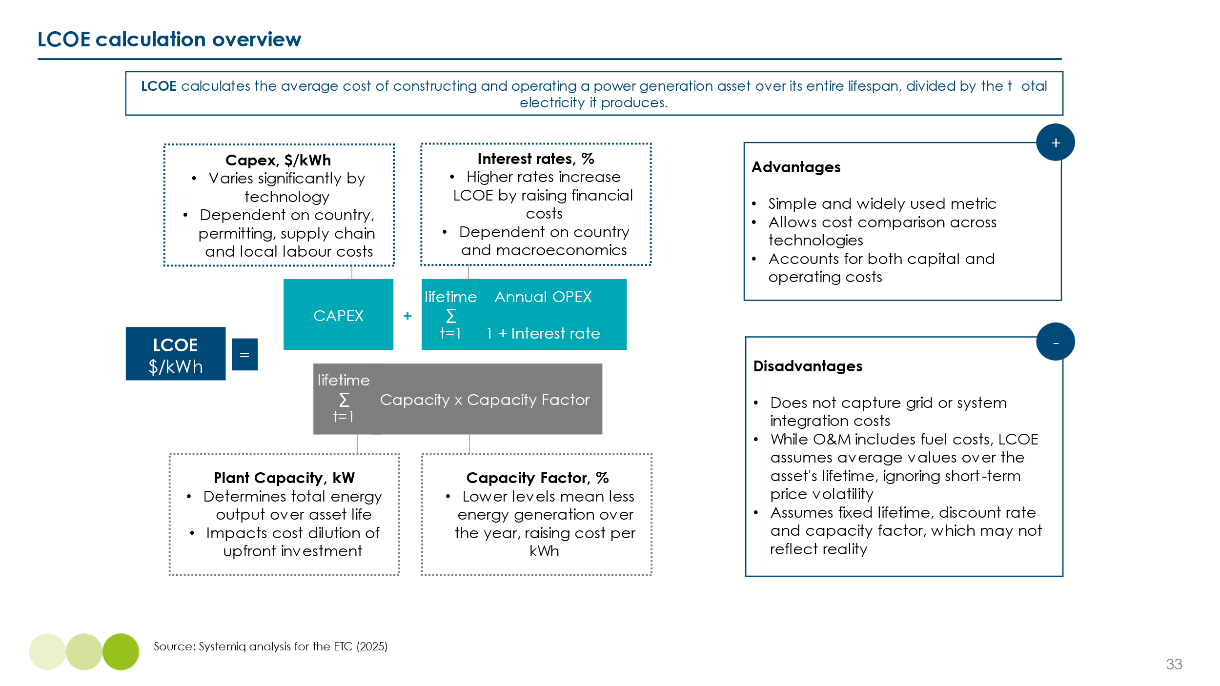
Assumptions: LCOE
- LCOE calculations include figures for Plant Capacity, CAPEX, OPEX, Capacity Factor, Discount Rate based on data from BloombergNEF and Systemiq analysis for the ETC.
- Capacity factor for long duration assets was set at 5% to showcase the low utilization of ultra-long duration storage
- Two scenarios were run, one based on technologies based in China and the other ex-China to compare the cost variations across regions.

Exhibit 1.33
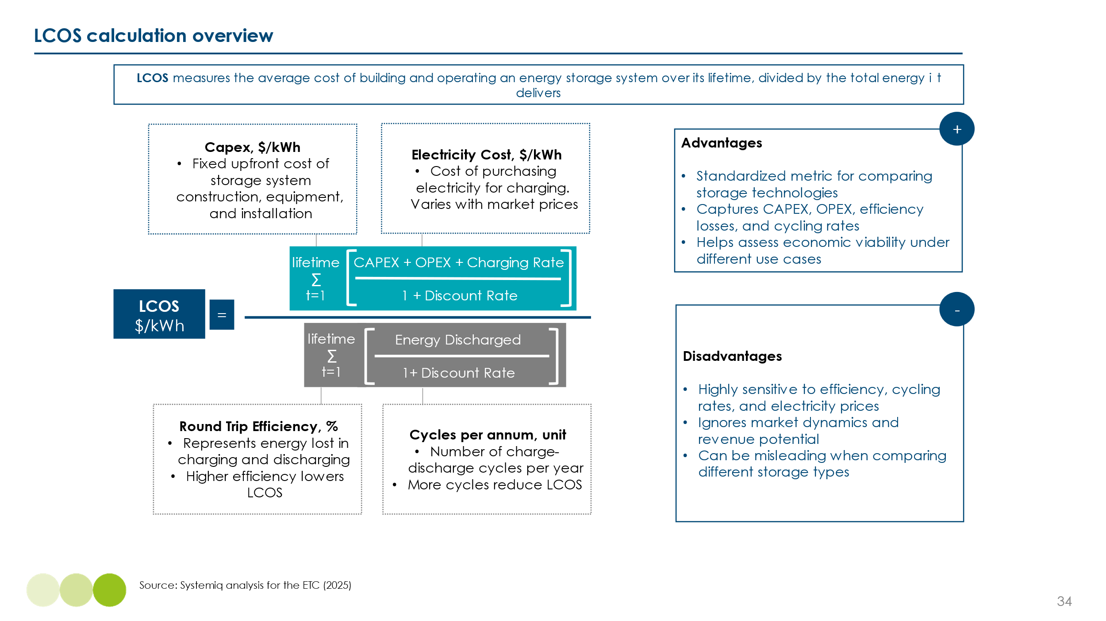
Assumptions: LCOS
- For energy storage, the key cost metric is the levelised cost of storage (LCOS), which reflects the full cost of delivering usable electricity from storage. LCOS calculations incorporate capital expenditure (CAPEX), operating expenditure (OPEX), an annualisation factor, number of charge/discharge cycles per year, lifecycle efficiency, and the cost of electricity input.
- Efficiency losses are not treated as a separate cost line but are reflected implicitly through the lifecycle efficiency and electricity input cost: the lower the round-trip efficiency and the higher the input electricity price, the greater the impact on LCOS. Exhibit 35 and 36 illustrates how variations in efficiency and input electricity cost interact to affect overall storage economics.
- For energy storage and batteries, we use CAPEX based on BloombergNEF historical and forecasted fully installed energy storage systems for short and long duration storage. Fully installed system prices include battery CAPEX, PCS, Balance of plant, and installation and labour, EPC and grid connection costs.
- For pumped hydropower, historical data and forecasts from PNNL were used.
- H2 storage figures are based on three models; hydrogen production ($/kg), hydrogen storage ($/kg), and electricity generation from H2 powered CCGTs ($/MWh), with data from multiple sources.
- Two scenarios were run, one based on assets located in China and the other ex-China to compare the cost low and high electricity price variations across regions.
- Short duration systems were modelled on a 4-hour system; medium-long duration systems were modelled on a 10-hour system.
- Electricity costs included are $0.0/kWh for China and $0.07/kWh for ex-China
- Estimating and comparing the relative costs of different flexibility technologies and business models requires multiple assumptions and subjective judgements, and these costs will evolve over time as technologies mature and deployment scales. Assumptions built into our LCOE and LCOS assumptions for our 2035 model are noted below in Exhibit 1.34.

Note the year 2035 was chosen to highlight the near-term costs that face stakeholders, given the importance of developing many of these technologies in the short-term in order to meet net-zero targets.

Exhibit 1.34


Exhibit 1.35 and Exhibit 1.36 present indicative ranges for the cost of delivered electricity from various flexibility solutions, using two illustrative assumptions for electricity input cost:
First scenario assumes a zero cost of electricity input. This reflects conditions likely to occur during certain hours of the year in high-VRE systems, when wholesale electricity prices fall to zero due to surplus generation. Under this assumption, the cost per MWh delivered equals the levelised cost of building and operating the relevant asset, with no adjustment for energy losses due to inefficiency.

Exhibit 1.35
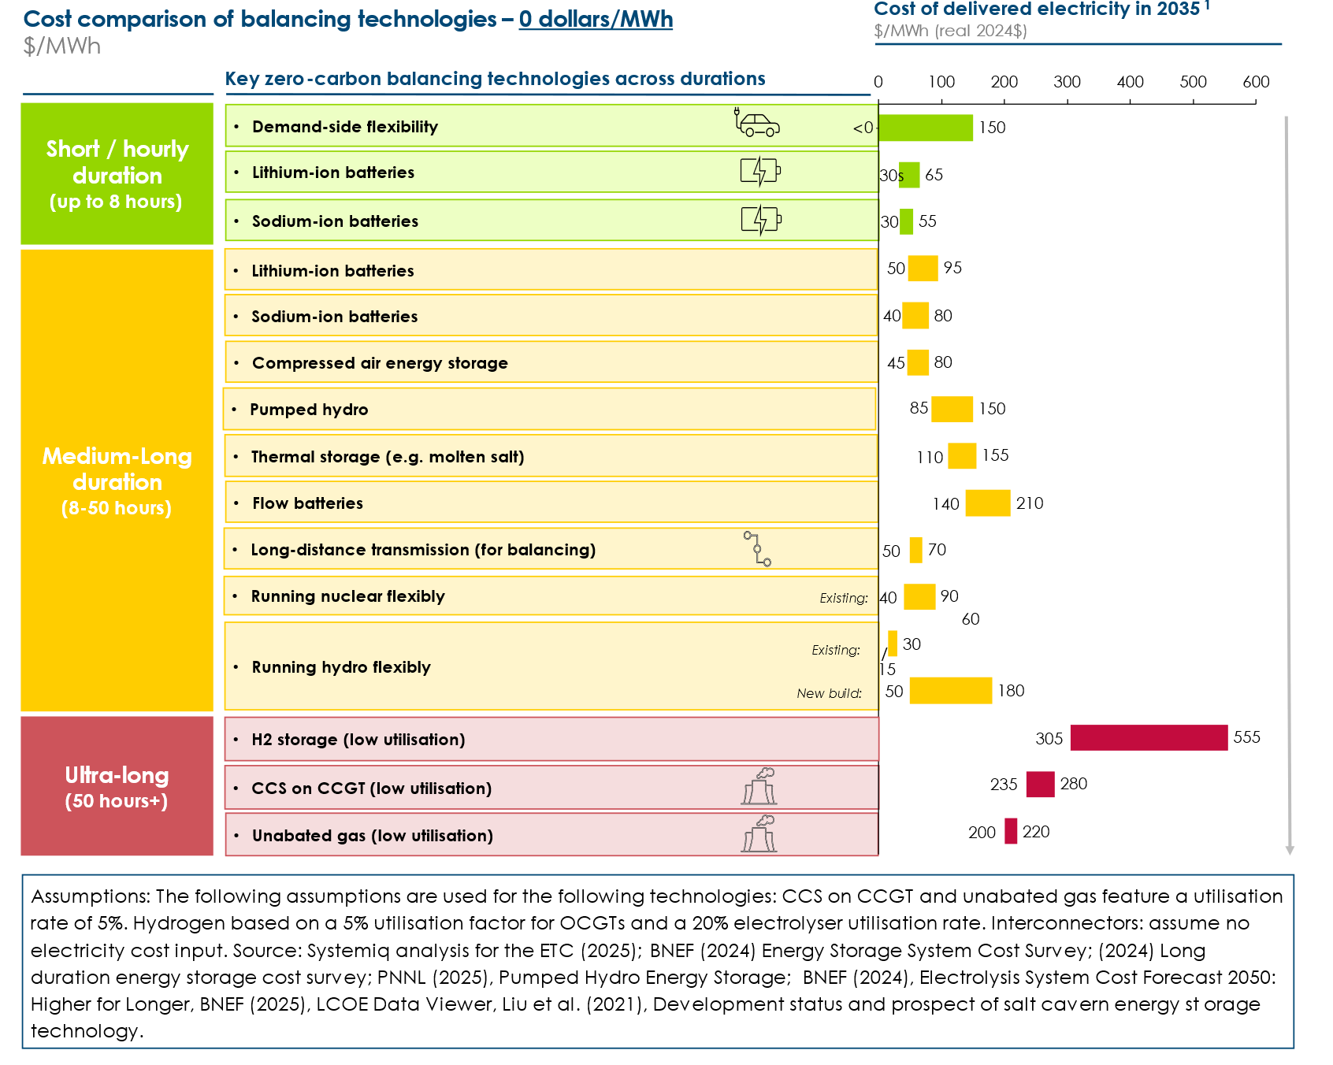

Second scenario assumes a fixed electricity input cost of $70/MWh, and incorporating the cost impact of round-trip efficiency losses. This is a stylised assumption designed to illustrate how input costs interact with technology efficiency to affect the levelised cost of delivered electricity.

Exhibit 1.36
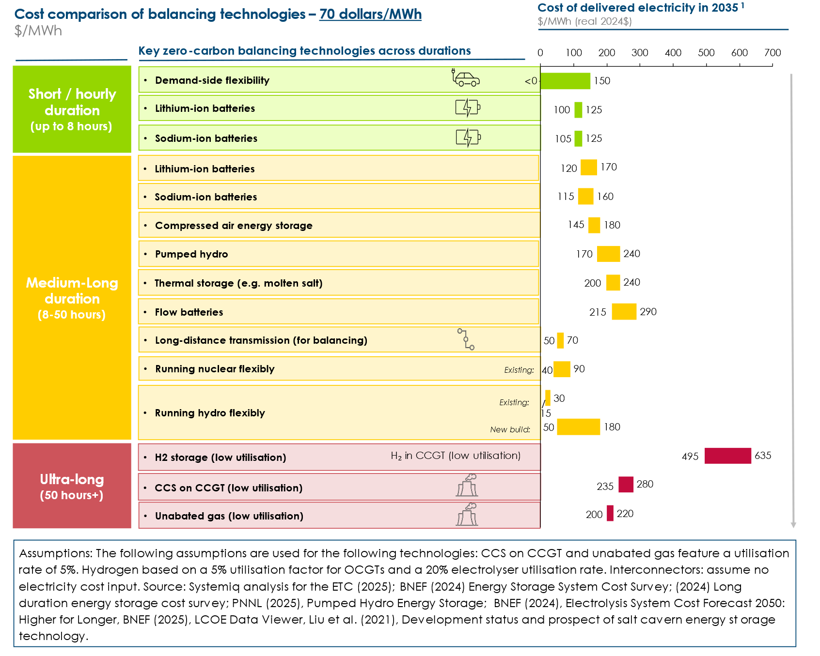

In each case, the figures represent the effective cost of usable electricity delivered from the storage or flexibility solution. These should be interpreted as indicative of the relative performance and competitiveness of different technologies under varying system conditions.

The impact of flexibility costs on total system generation costs can then be approximated by multiplying the share of total electricity shifted (i.e. not consumed at time of generation) by the LCOS. For example, if the base generation cost is $50/MWh, the LCOS is $150/MWh, and 10% of electricity needs to be time-shifted, the average system cost rises to:

(1-10%) × $50 + 10% × $150 = $60/MWh

This simplified model illustrates how even relatively high flexibility costs may have a limited effect on total system cost if only a modest share of demand must be shifted.

- Short duration storage costs

Our estimates suggest that demand-side flexibility (DSF) and battery storage technologies—particularly lithium-ion and sodium-ion—will enable short-term balancing at relatively low cost.

As discussed above, many DSF options—such as shifting electric vehicle charging or pre-heating buildings—are effectively costless to deploy, as they rely on existing equipment and involve minimal behavioural disruption. Others, such as those requiring insulation or smart controls, entail modest capital costs but are still low-cost relative to alternative flexibility options. Maximising the potential for DSF is therefore a critical priority in building low-cost, high-renewable power systems.

Based on the assumptions in Exhibit 1.35 lithium-ion batteries could deliver stored electricity at a total cost of $30–65 per MWh when electricity input is assumed to be zero-cost (as may occur during periods of VRE surplus). When an electricity input cost of $70/MWh is assumed, the LCOS rises to $100–130 per MWh. These figures include both capital expenditure and efficiency-related costs. These results showcase that even when input electricity is valued at $70/MWh, both demand-side flexibility and battery-based solutions (particularly sodium-ion) remain competitive. At short durations, efficiency losses have a smaller impact, but they still matter. The relatively high efficiency of lithium-ion and sodium-ion batteries (typically 85–90%) helps contain LCOS even when electricity input is not free.
Sodium-ion batteries, while less commercially mature today, are expected to undercut lithium-ion in cost by 2035. This is due to their use of more abundant and lower-cost materials (such as sodium and iron instead of lithium and cobalt), their improved thermal stability which reduces safety-related system costs, and potentially lower degradation rates under specific operating conditions. However, these projections depend on successful large-scale commercialisation and further performance optimisation.
Scaling these cost-effective short duration balancing solutions will require supportive policy and market frameworks. For battery storage, key enablers include access to multiple revenue streams—energy, capacity, and ancillary services markets—and expedited grid connection processes. For DSF, persistent barriers such as low consumer awareness, regulatory uncertainty, limited financial incentives, and infrastructural constraints (e.g. smart meter availability) continue to limit uptake. Additionally, data privacy and cybersecurity concerns remain important deterrents to consumer engagement. Solutions to overcome these challenges are explored further in Chapter 4.

- Medium-long duration storage costs

The cost of medium-long duration balancing options will vary significantly by country with some able to utilise low-cost options made possible by existing assets, resources or location. Specifically cost will be low if countries
- Have significant existing hydro power generation or hydro resources to support low-cost hydropower development.
- Have existing nuclear assets which can vary output in line with medium term variations in demand or VRE supply.
- Are well located to develop long distance (including international) interconnection to regions which have lower VRE generating costs and uncorrelated weather systems.
As shown in Exhibit 1.35, in countries with such advantages, some medium- to long-duration balancing options—such as long-distance transmission, flexible operation of existing nuclear and hydro assets—can be delivered at lower cost per MWh than short-duration lithium-ion battery storage.
In contrast, where such conditions do not apply, medium- to long-duration balancing is likely to be significantly more expensive. This is due to:
- The relatively higher cost per cycle of lithium-ion batteries, which are optimised for frequent cycling and become less cost-effective at low utilisation rates
- The lower round-trip efficiencies of alternatives such as compressed air energy storage (CAES) and pumped hydro, which lead to higher costs when electricity input prices are not negligible
The relative cost competitiveness of different technologies shifts in favour of non-lithium-ion alternatives as duration increases. Lithium-ion battery costs are largely invariant with duration since they scale with energy capacity ($/kWh), but their cost per MWh delivered increases when used infrequently. In contrast, technologies like CAES and flow batteries (e.g. vanadium redox flow) involve both fixed capacity costs ($/kW) and scalable energy storage costs ($/kWh), meaning their average cost per MWh falls as duration increases.
Exhibit 1.37
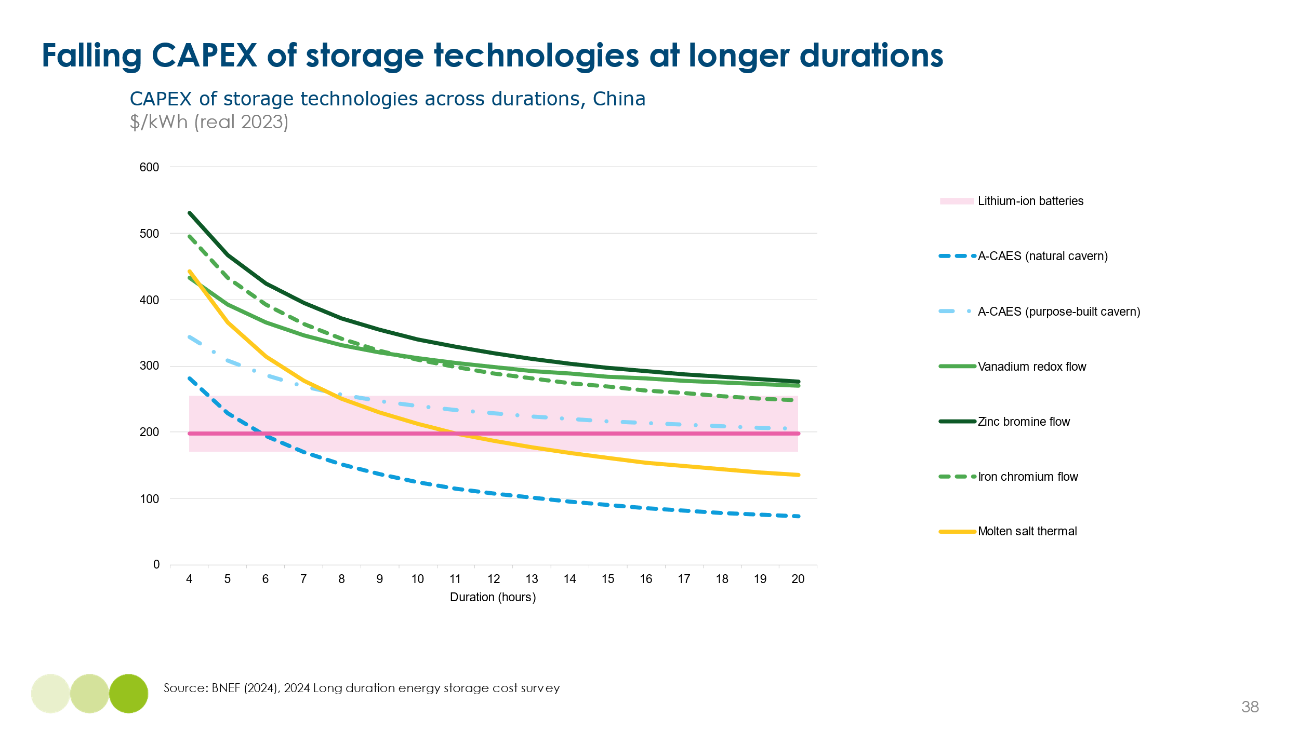

Exhibit 1.37 above uses real 2023 data from China to illustrate this:
- At durations below 10 hours, lithium-ion batteries remain cost-competitive.
- CAES becomes a lower-cost option at durations between 10 and 20 hours, due to its more favourable scaling characteristics.
- Flow batteries, while potentially suited to longer durations, are currently less competitive due to high raw material costs (e.g. vanadium) and limited economies of scale. Their competitiveness depends heavily on whether they reach large-scale commercialisation before other technologies fill the market need.

Exhibit 1.38
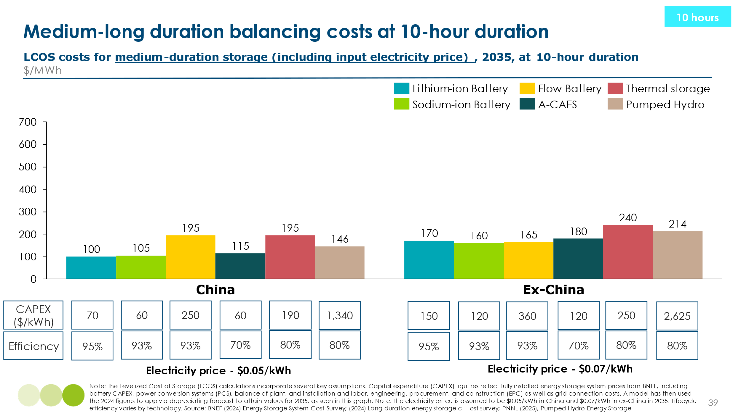
Exhibit 1.39
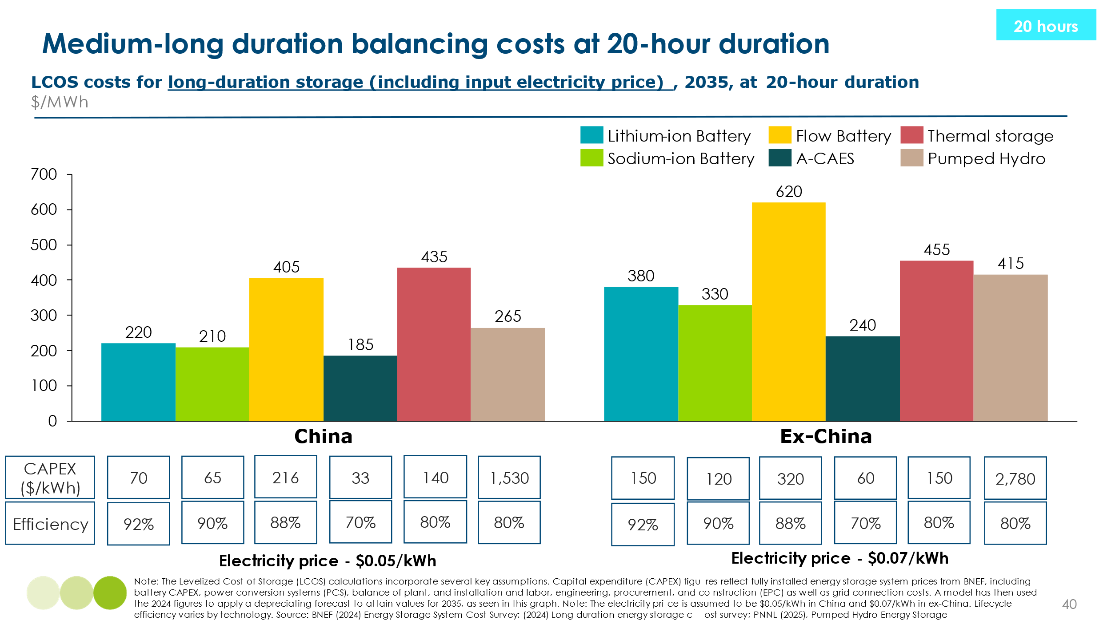
Exhibit 1.38 and Exhibit 1.39 illustrate projected LCOS ranges for medium-long duration storage modelled at 10- and 20-hour duration in 2035, across technologies and geographies. Lithium-ion and sodium-ion batteries remain the lowest-cost options at 10-hour durations in China (around $100–105/MWh), but their cost increases significantly at 20 hours, reaching $330–380/MWh ex-China.
By contrast, A-CAES becomes increasingly competitive as duration increases — while it is more expensive than lithium-ion at 10 hours, by the 20-hour mark its cost is 30–40% lower than lithium-ion and 25–30% lower than sodium-ion in both China and ex-China cases. This reflects three key advantages:
- Low marginal cost of added storage: Compressed air can be stored cheaply in caverns or tanks, meaning extending storage duration doesn’t require large increases in capital expenditure.
- Decoupled power and energy scaling: Unlike batteries, A-CAES allows the power (turbine) and energy (storage volume) components to be sized independently, improving cost-efficiency for longer durations.
- Minimal degradation and long asset lifetime: Mechanical systems degrade much more slowly than batteries, improving economics over time and under low cycle rates.
Meanwhile, flow batteries and pumped hydro show higher LCOS across all durations, particularly ex-China, due to high capital costs and site limitations. Thermal storage, or molten salt, appears broadly uncompetitive in China and ex-China at both durations, primarily due to its higher system integration and infrastructure requirements. Unlike battery or compressed air systems, molten salt storage requires high-temperature environments, complex heat exchange systems, and integration with compatible generation assets (such as CSP or steam turbines), all of which drive up capital costs. Additionally, limited deployment to date means costs have not benefitted from the same learning curve or economies of scale as battery technologies, further reducing its competitiveness on a levelised cost basis.
Together, these results highlight A-CAES as a cost-effective solution for long-duration storage, especially in systems with low cycling needs and deep balancing requirements — outperforming battery technologies in cost at durations beyond 10 hours.

- Ultra-long duration balancing costs

Ultra-long-duration storage (50+ hours) is crucial for ensuring electricity supply during prolonged periods of low renewable generation, such as extended low-wind conditions. As discussed in Section 1.3 of this chapter, the need for such storage is minimal in many sunbelt countries. Even in high-latitude, wind-belt countries, the number of hours requiring ultra-long storage can be limited — potentially under 5% of the year (438 hours) — if the system is designed with deliberately oversized wind and solar capacity, as illustrated in Exhibit 1.16 from Section 3 However shifting these hours will be expensive since it involves the use of assets cycled only a small number of times per year.

In countries with significant hydro resources—particularly where hydropower can be stored behind dams—hydropower will play a major role. Increased operational flexibility of nuclear plants will also be important. Gas turbines are also likely to continue having a role, using either hydrogen or methane as fuel, with hydrogen stored in salt caverns and methane in existing gas storage infrastructure.

The cost elements involved for an ultra-long duration storage system based on hydrogen are illustrated in Exhibit 1.40 below.
Exhibit 1.40
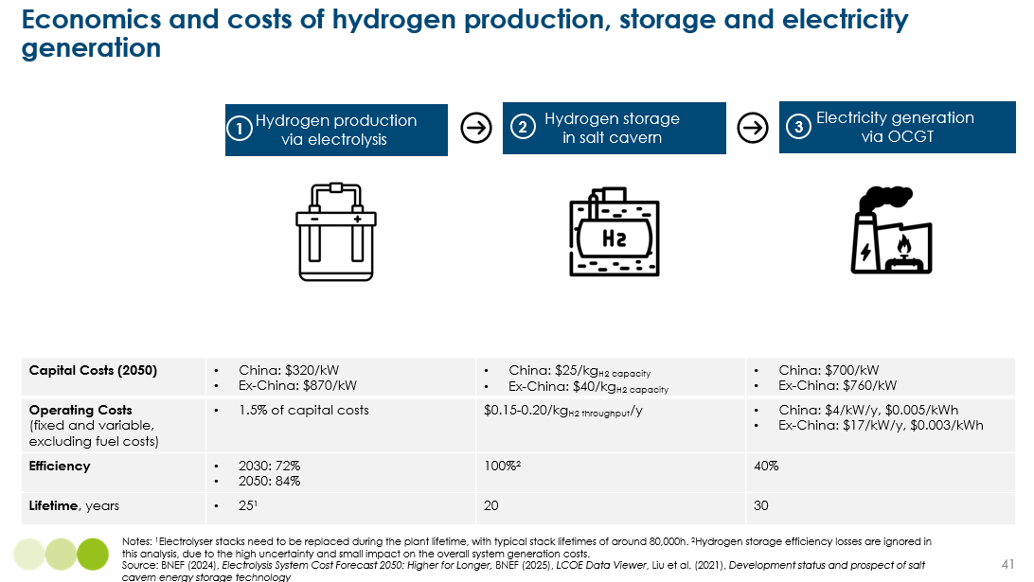

The total cost reflects the combination of:
Electrolyser CAPEX and utilisation. Cost of electrolyser systems have not fallen at the rapid pace anticipated five years ago, and projections of future cost have increased as analysts have developed better understanding of the complex balance of system requirements in electrolyser systems. But costs are much lower in China than elsewhere, and progress in developing standardised and modularised designs may drive further reduction. We have assumed 2050 costs of $870/kW for a complete system outside China, and $320/kW in China. This implies that if ex-China companies are willing to purchase their systems from China, including using Chinese engineering, procurement, and construction (EPC) capabilities, the ex- China costs might fall significantly below our assumption.
The resulting annualised CAPEX and OPEX costs depend on the electrolyser utilisation rate. If they are only used 10% of all hours per annum, annualised CAPEX and OPEX costs for the ex-China case could be $7/kg or $0.21/kWh_{H2} but at a utilisation rate of 50% this would fall to $1.4/kg and $0.04/kWh_{H2}
Electrolyser efficiency and electricity input costs Many existing electrolysis systems work at around 50 to 60% efficiency rates but efficiencies above 80% are possible and will likely become the standard by 2050. We have assumed 72% in our 2035 estimates, rising to 84% by 2050. If the cost of electricity were $0.07/kWh, an efficiency rate of 84% would imply electricity input cost of $0.083/kWh_{H2} or $2.8/kg. But if electricity is used only when supply is an excess of demand, and wholesale prices very low or even negative, the electricity input cost be close to zero.
Exhibit 1.41 shows the resulting cost of hydrogen production for different combinations of CAPEX, electrolyser utilisation rate, and electricity input cost. In our estimates of total LCOS for 2050 we have used the sensitivities indicated at A and B in the table. These reflect the trade-off between:
- Running electrolyses at a low utilisation rate of 20%, but with the electricity input cost potentially very low or zero.
- Running them at a higher utilisation rate of 50%, but with an electricity input cost of an electricity input cost of $0.07/kWh.
Exhibit 1.41
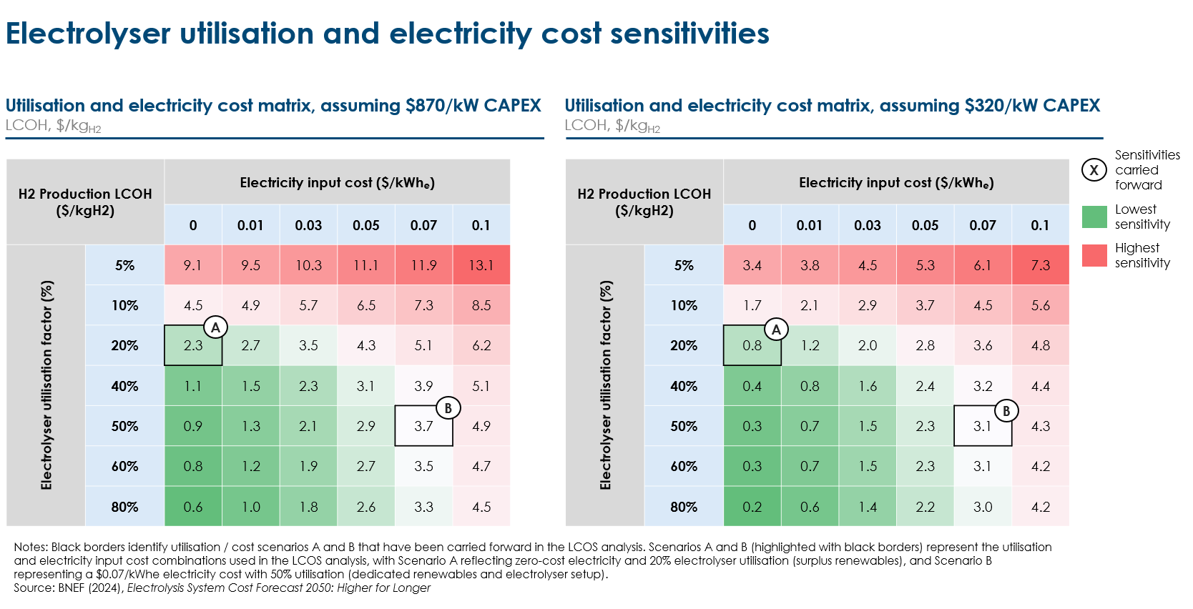Storage in salt caverns. Storage in salt caverns, with 12 cycles of storage and discharge per year, is estimated to cost about $0.35-0.60 per kg, or $0.011 - $0.018/ per kwh _{for} 2035-2050 estimates. Even major changes in the underlying assumptions would not change the conclusion that hydrogen storage costs are a small part of total system costs.
Gas turbine capex, utilisation and efficiency. The cost per kWh of reconverting the hydrogen to electricity in gas turbines depends on:
- The CAPEX and utilisation rate of the gas turbines: if the turbines are only used for 438 hours per annum (5% of all hours), which is an upper bound for our estimated need for ultra-long duration balancing, the annualised CAPEX cost could contribute $ 0.17/kWh (Ex-China 2050) and $0.16/kWh (China 2050) to the cost of electricity delivered.
- Their efficiency, with open cycle gas turbines (OCGT) achieving efficiencies of about 40%, while combined cycle gas turbines (CCGT) can achieve 60%. This means that an OCGT needs to use 2.5 kWh_{H2} of hydrogen input to produce a kWh of electricity, and a CCGT 1.67 times.
Despite their low efficiency, OCGTs will still be the economic solution if utilisation rates are very low, given their higher flexibility and lower capital cost per kW than CCGTs. CCGTs could become the economic option if utilisation rates are someone higher, for instance if the turbines were used to meet medium-duration as well as ultra-long duration balancing needs. In our estimates below we assume the OCGT option.
Total cost estimates: Given the multiple different factors considered above, estimates of the full system levelised cost of storage (LCOS) for hydrogen production, storage, and gas turbine reconversion, have a wide range. In Exhibit 1.42 and Exhibit 1.43 we show estimates for 2035 and 2050, for both China (low electrolyser costs) and ex -China (high electrolyser costs) with two different scenarios for electricity price and electrolyser utilisation:

- Exhibit 1.42 shows what the costs would be if electrolysers were used only 20% of the time, but with a zero input electricity cost. In this case the total costs are dominated by the CAPEX and OPEX of the two lightly-used capital assets – the electrolysers and the gas turbines

- Exhibit 1.43 shows results assuming a 50% electrolyser utilisation rate, but with an input electricity cost of $0.07 per kWh. In this case , the contribution of electrolyser CAPEX and OPEX to total delivered electricity costs are lower, but there is a large impact of electricity input costs, as a result of the efficiency losses in both electrolysis and combustion.

Total calculated LCOS for 2050 lies in the range $260-$430/MWh in China and $430-530/MWh in ex-China. The impacts on total system generation and balancing costs for each regional archetype are discussed in Section 1.6.

Exhibit 1.42
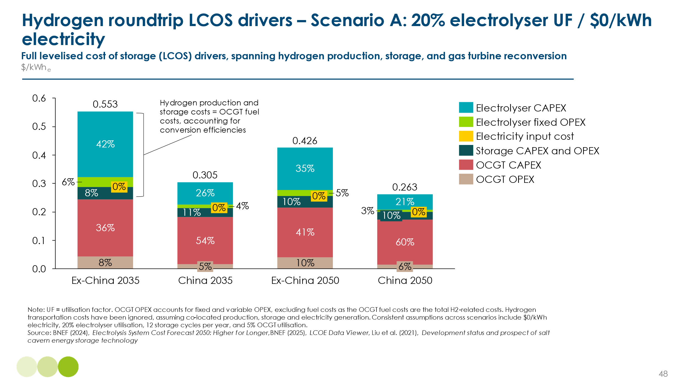
Exhibit 1.43
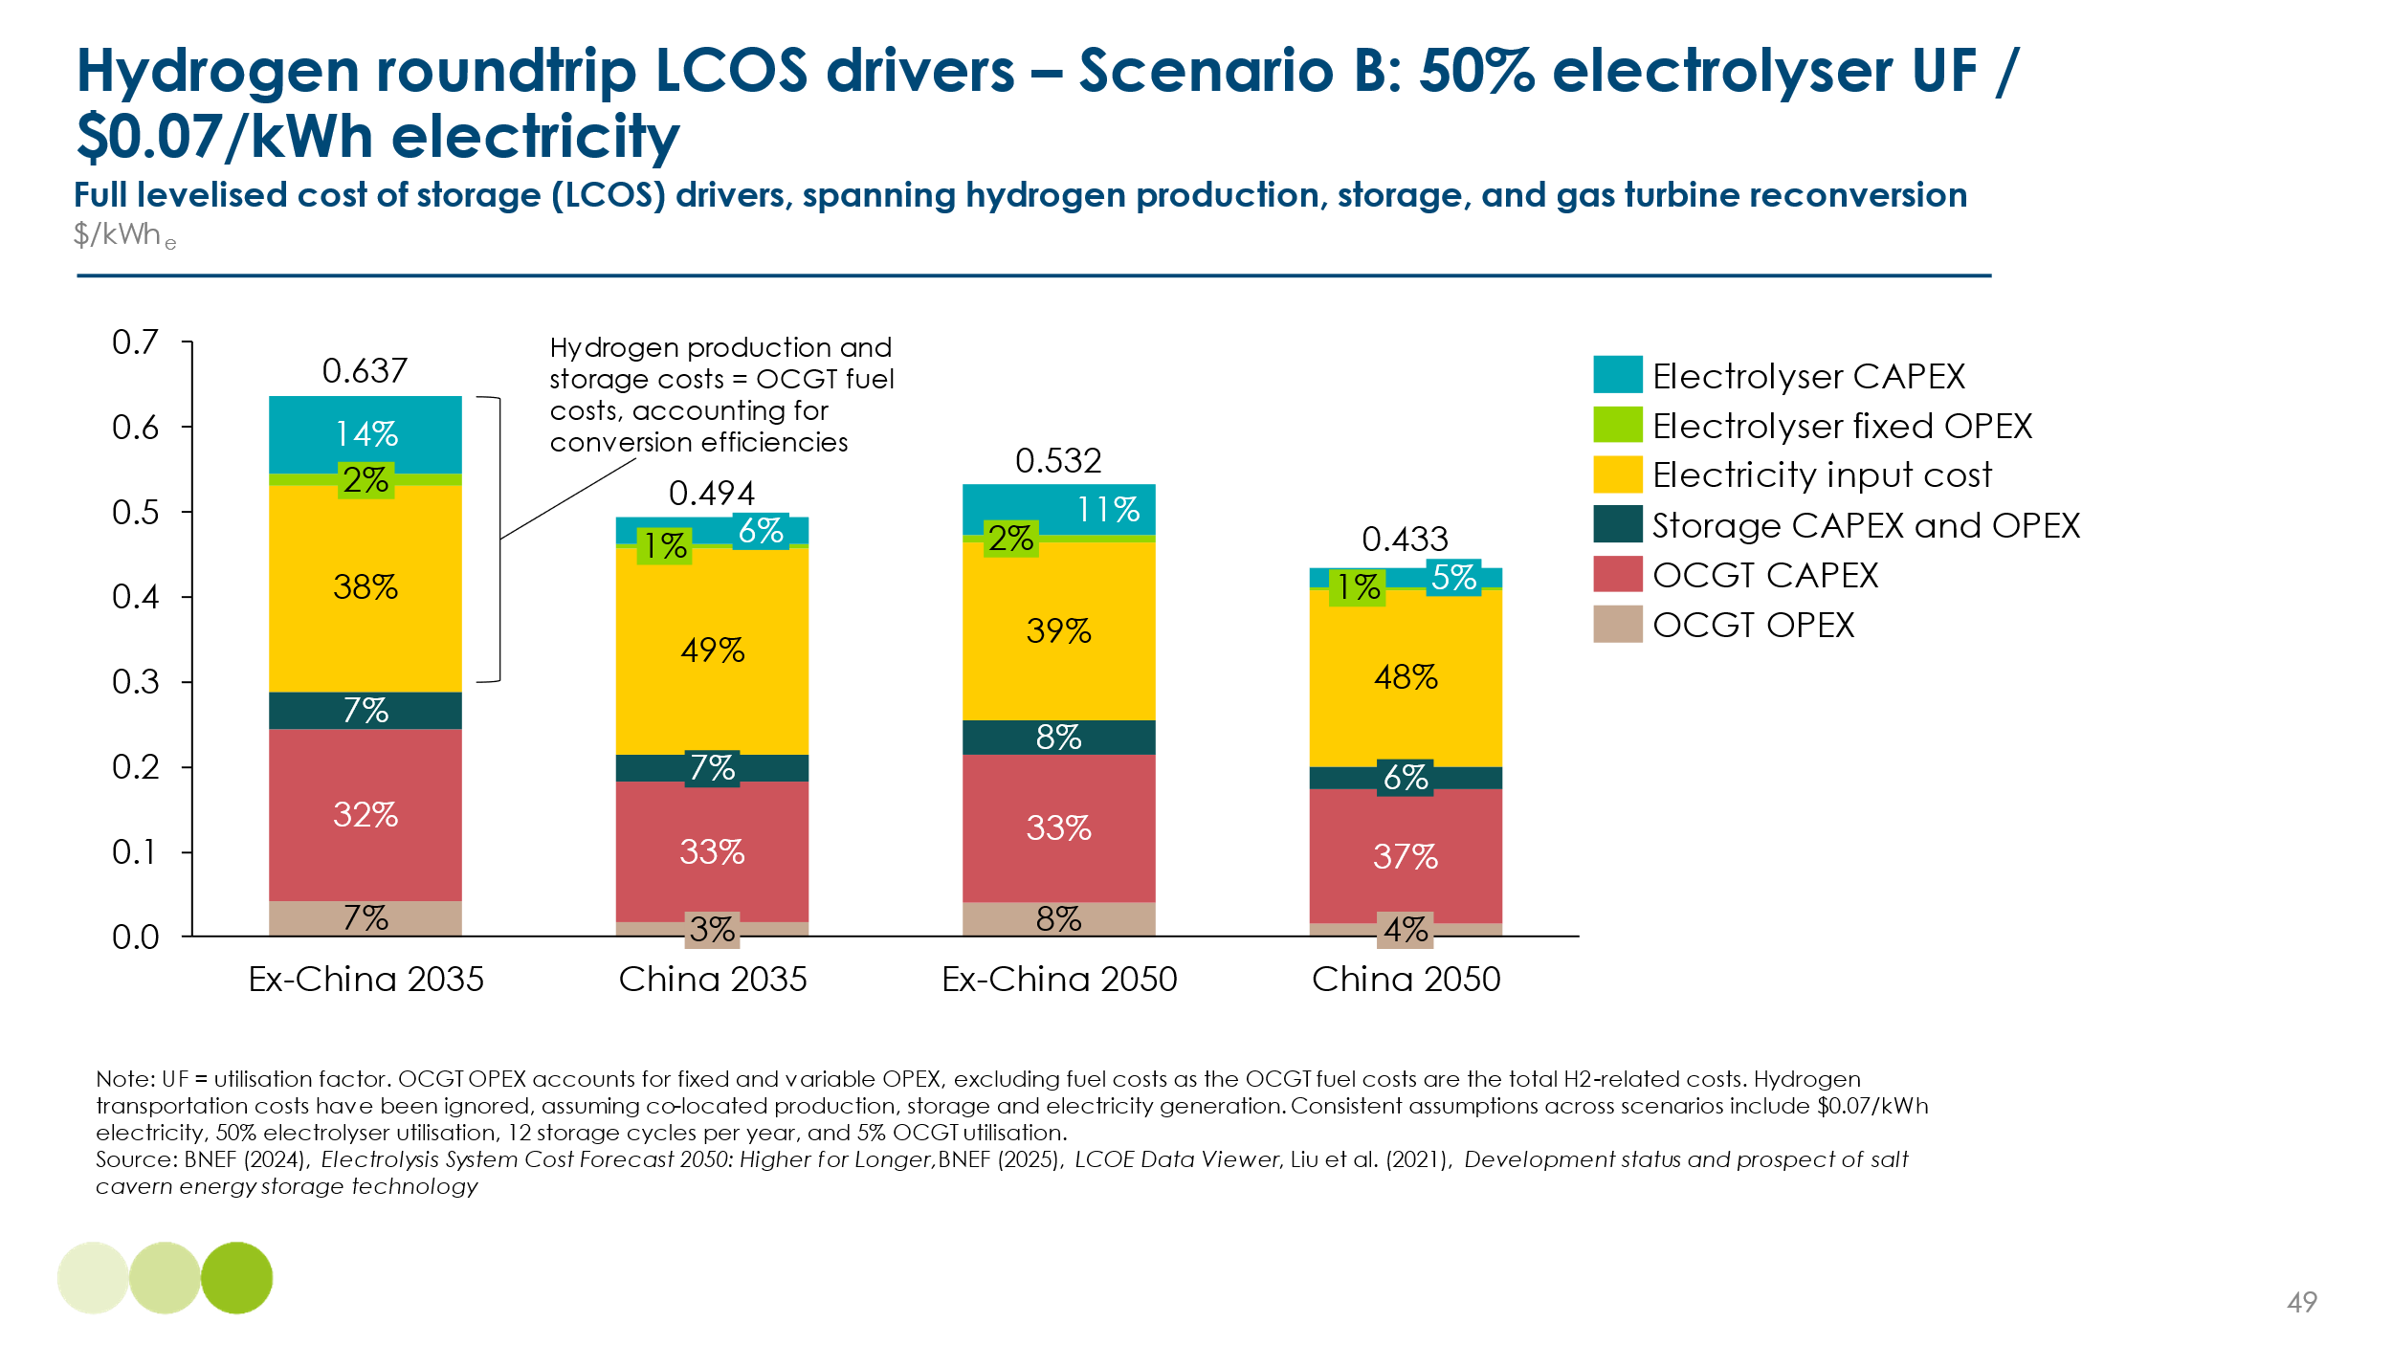
An alternative way to achieve ultra-long duration balance would be to continue burning methane in gas turbines, adding carbon capture and storage (CCS) to achieve net-zero emissions. In this case, as shown in Exhibit 1.44.
- Annualised CAPEX and OPEX cost resulting from gas turbines used for only a small percentage of hours would be significant, but lower than in the hydrogen option due to less expensive turbines.
- This option avoids the requirement for electrolysers but instead requires the addition of CCS equipment which would have the same very low utilisation rate as the gas turbines
- The primary energy input would be gas, rather than electricity.
- The effective system efficiency would reflect the baseline efficiency of a gas turbine (approximately 60% for CCGTs or 40% for OCGTs) , reduced by the parasitic electricity load of the carbon capture process (e.g. equivalent to approximately 10-15% of the electricity generated).

Total resulting LCOS in 2050, at a utilisation rate of 5%, could lie in the $235 – 275 per MWh range in China and ex-China, with Exhibit 1.35 and Exhibit 1.36 showcasing that this positions CCGT with CCS as a more cost effective solution than hydrogen at an ultra-long duration, dependent on the gas price.

Exhibit 1.44
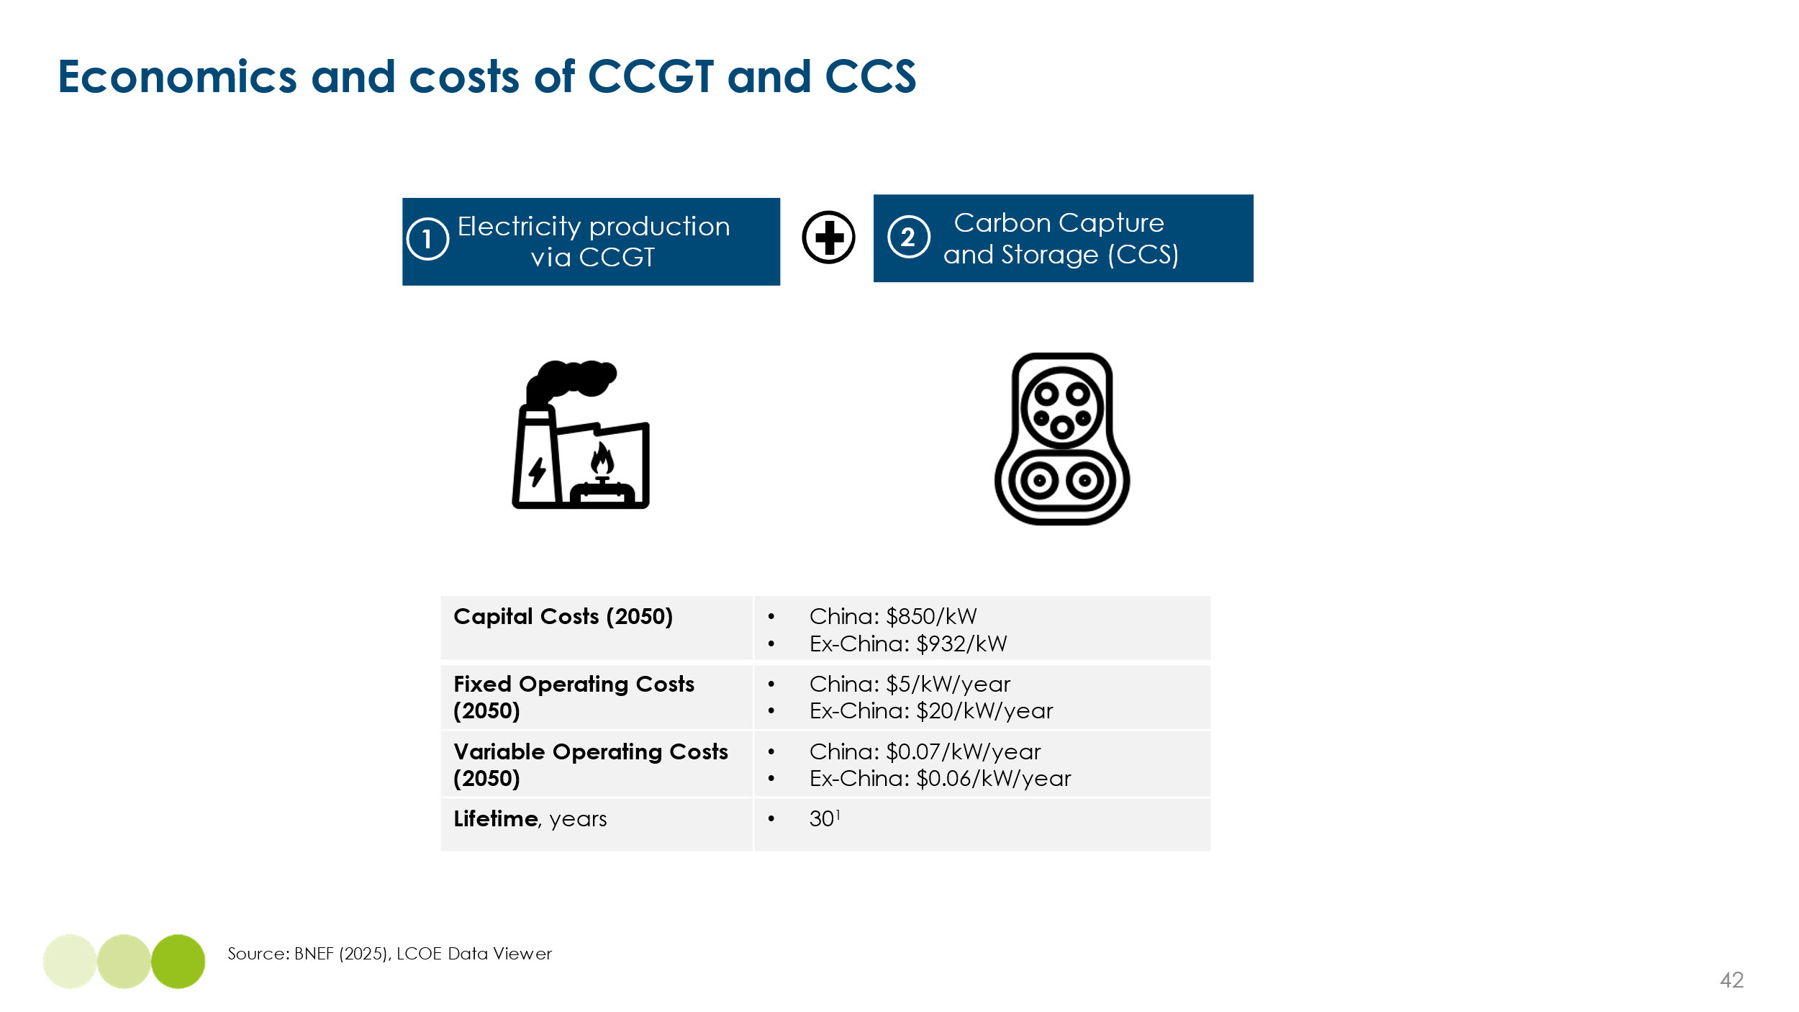

Whatever solution is chosen, the cost per MWh shifted is likely to be significantly higher than the least cost options for short and medium-long duration balancing. And while the total system cost impact is kept low by the small percentage of all hours that need to be shifted, the implication is that the “last mile” of power system decarbonisation will be the most expensive, and especially so in high latitude countries.

This raises the question of whether these costs could be reduced by stopping short of complete power system decarbonisation and instead, offsetting small residual emissions via the use of carbon reductions (whether nature based or engineered).

Exhibit 1.45 presents a highly illustrative comparison of three ways the UK could meet its ultra-long duration balancing need in a low-wind year, using gas turbines. It highlights the scale of capacity and fuel infrastructure required to cover rare but critical balancing events, as well as the trade-offs between cost and emissions across different technology options. The analysis assumes 15 TWh of generation is needed annually and that all costs are evenly distributed across UK households via electricity bills.

- For the UK to achieve ultra-long duration balance using gas turbines it might need to increase total turbine capacity from today’s 36 GW to 115 GW, operating on average only 130 hours per annum (1.5% capacity factor) to produce 15 TWh of electricity when wind and solar supply is very low or entirely absent.
- The cost of electricity delivered from hydrogen electrolysis and turbines at very low utilization rate could be as high as $920 per MWh. The household cost could be $250 per annum compared to a scenario using existing gas turbines with no abatement.
- In the case of gas peakers with CCS, costs could be somewhat lower at $780 per MWh and $210 per household, while maintaining zero emissions.
- However, if unabated gas peakers are used, the household cost falls to $125 per year, due to lower capital and fuel costs. However, this scenario would lead to 6 million tonnes of CO₂ emissions annually from just this balancing function.

If instead of seeking to drive power emissions to zero via the use of hydrogen or gas plus CCS, the UK chose to offset these residual emissions using carbon removals, the net cost could be lower. The ETC‘s 2021 report on carbon removals, Mind the Gap: Achieving carbon neutrality in the UK’s power sector explored likely future costs of both nature-based and engineered carbon removals, along with the associated risks relating to permanence and certainty. It suggested that the costs of permanent and certain engineered removals via direct air carbon capture and storage (DACCS) might eventually fallen from today’s $300-$600 per ton of CO2 to $100. If these costs did fall below $400 per ton, it could be less expensive to accept 6 million tons of residual emissions from unabated gas turbines and offset them, rather than using hydrogen or gas with CCS to eliminate emissions altogether.

A pragmatic approach to “last mile” decarbonisation is therefore appropriate, with the optimal solution in many countries likely to involve some combination of hydrogen combustion in turbines and continued unabated gas combustion offset by removals.

Exhibit 1.45
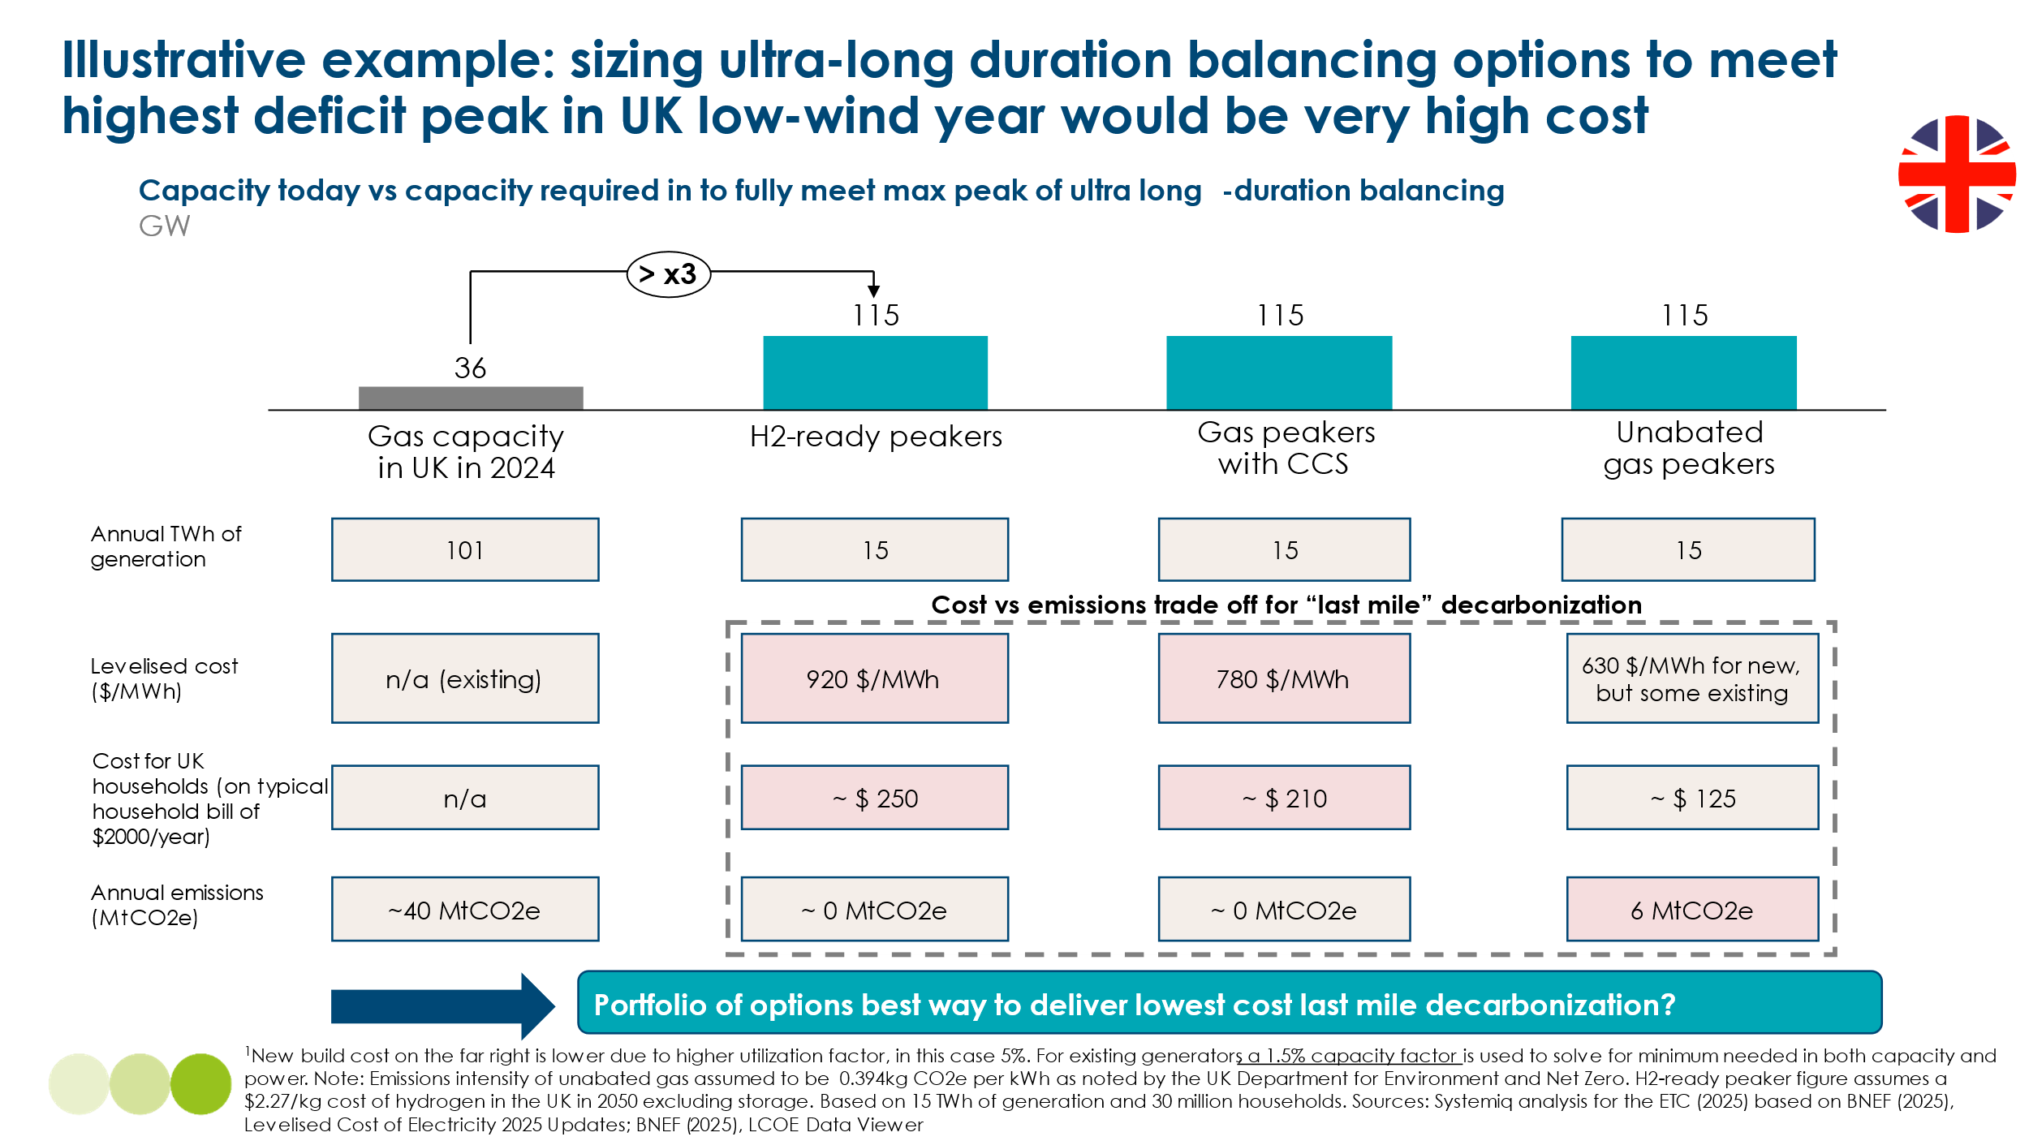

- Total system generation costs

The total system generation costs is given by the cost of generation itself (the levelised cost of producing a kilowatt hour of electricity from either renewable or other sources), plus the cost of storage or other forms of balancing flexibility. The latter is determined by the cost per kilowatt hour of flexibility for different durations of demand–supply shift, multiplied by the number of hours that need to be shifted.
In this section, we present estimates of what the total system generation costs might be for four different archetypes in the period post-2050, under the following unrealistic assumptions:
- 100% of electricity supply is ultimately provided by wind and solar (though with some converted to hydrogen and then burned in gas turbines).
- The systems are effectively built anew in 2050, such that the relevant costs are those projected for each technology in that year.
- There is no allowance for the potentially low-cost or costless benefits of demand-side flexibility, nor for the potential for low-cost supply or balancing via long-distance interconnection.
While these are unrealistic assumptions, the results help to illustrate how the balancing challenge and resulting costs vary by region.
To develop more realistic estimates of total generation system costs in 2050, it is essential to use dispatch models that simulate in detail how the system balances over the course of the year, ideally in half-hourly (or shorter) time intervals. We have therefore compared our results with those produced by dispatch models for the different regions. The following factors could lead dispatch model results to be either higher or lower than our illustrative estimates:
- Lower than 100% shares of wind and solar supply, allowing for the use of hydro, nuclear, or other zero-carbon sources. If these are cheaper than wind and solar, costs may be lower than our illustrative estimates; if more expensive, they may be higher.
- Allowance for demand-side flexibility, which tends to reduce estimated costs.
- Greater granularity in balancing analysis, including different approaches to the trade-off discussed in Section 1.2 between the higher costs of oversizing VRE supply and the resulting reduction in balancing needs. This could raise or lower system costs.
- Alternative technology cost assumptions, which could also increase or decrease total system costs.
- Allowance for the “legacy” costs of more expensive contracts (e.g. renewable contracts for difference or renewable obligation certificates) entered into before 2050, which may have higher prices than new contracts signed in that year.

Exhibit 1.46
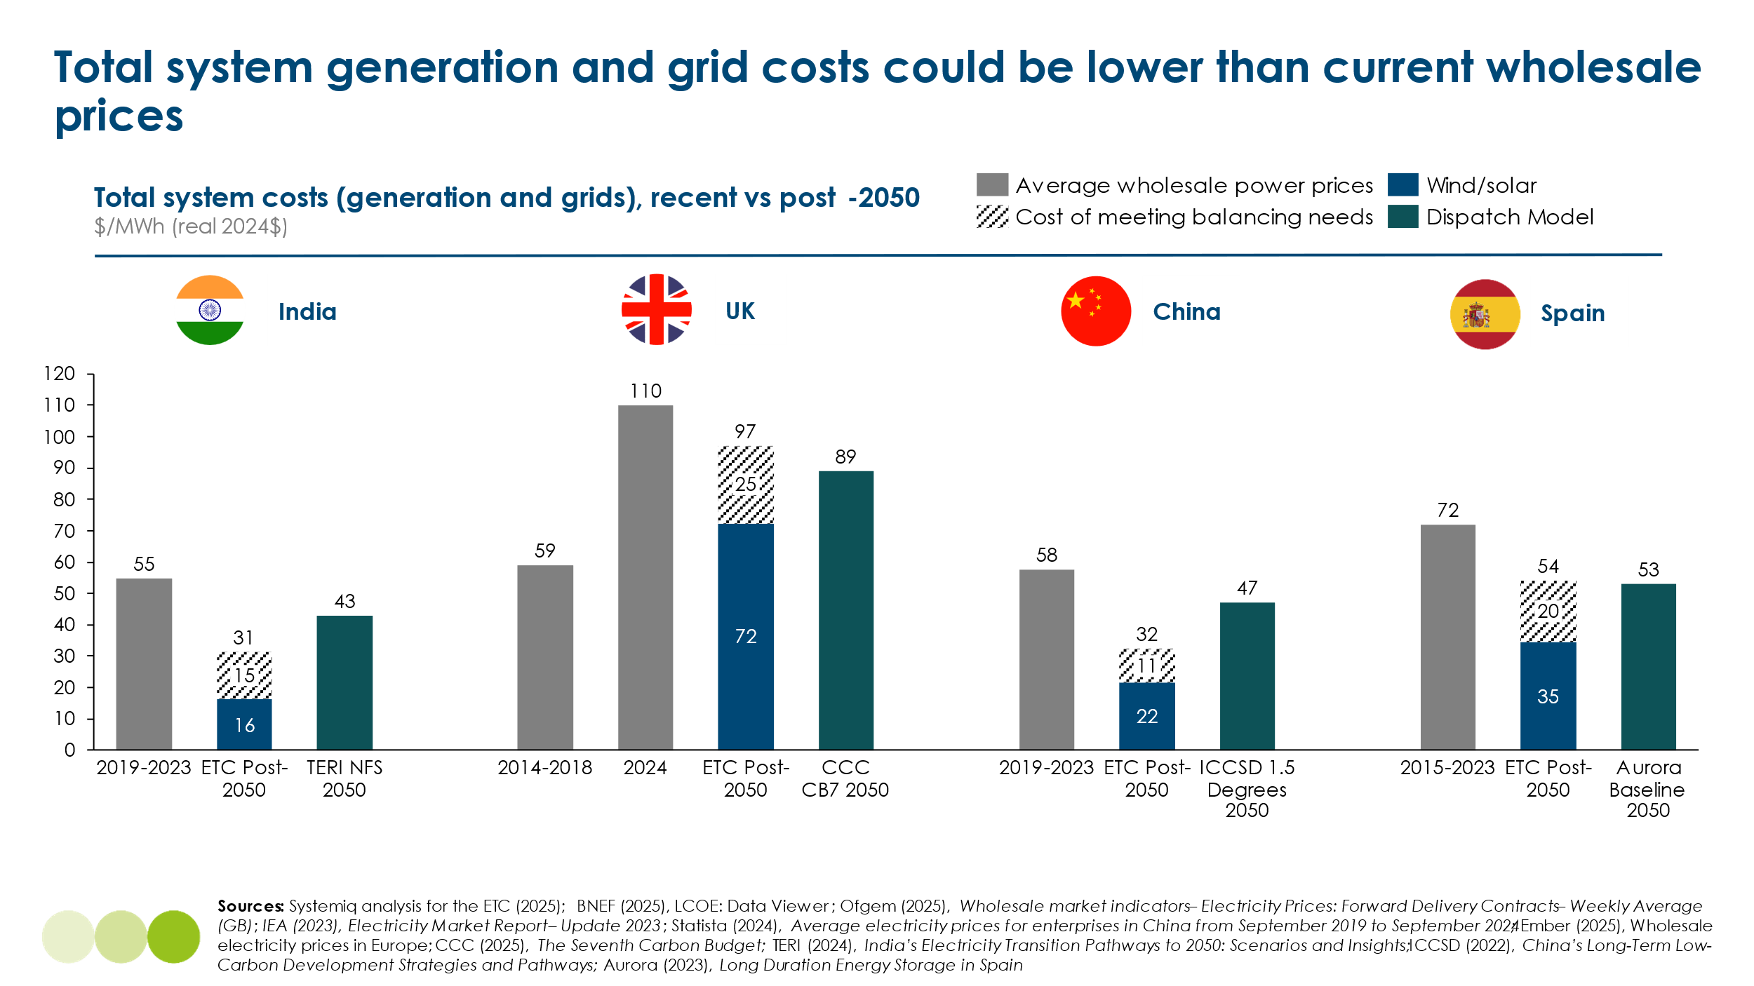
Our illustrative estimates and dispatch model results suggest that:
- It will be possible to build systems with high shares of variable renewables that deliver electricity in 2050 and beyond at costs similar to—or in some cases below—current wholesale electricity prices, as shown in Exhibit 1.46 above.
- Total system generation costs will be significantly lower in low-latitude, sunbelt countries than in higher-latitude, wind-belt countries. This reflects both the low cost of the solar-plus-battery solution that dominates in low-latitude regions and the greater complexity of the balancing challenge in northern countries.
The additional costs resulting from required investments in transmission and distribution grids are considered in Chapters 2 and 3. Chapter 3 also addresses the crucial issue of costs to consumers during the transition to the end point considered here.
Northern Latitude Archetype - UK Case study
Our illustrative results for the northern latitude archetype, using the UK as a case study, are shown in Exhibit 1.47. They suggest:
- The system is heavily wind-dominated, with approximately 88% of total generation coming from offshore and onshore wind, and 12% from solar. Installed capacity is significantly oversized relative to demand, with 235 GW of renewables (comprising 100 GW offshore wind, 60 GW onshore wind, and 75 GW solar) generating 778 TWh annually to meet 518 TWh of end-use demand.
- Generation costs are estimated at $50/MWh, reflecting continued cost reductions in both onshore and offshore wind. These costs are higher than those in solar-led systems, due to the relatively higher cost of offshore wind.
- Balancing requirements represent 9% of annual demand and are met through a combination of storage solutions across three durations:
  - Short-duration storage meets 5% of demand (26 TWh), at a levelised cost of $90/MWh.
  - Medium-duration storage meets 1% of demand (7 TWh), at a cost of $185/MWh.
  - Ultra-long duration storage covers 3% of demand (16 TWh), required for extended periods of low wind and high seasonal demand. This is modelled at $585/MWh, based on conservative assumptions for hydrogen turbines. Future innovation or regional transmission could reduce this cost, and it will be further explored in follow-on modelling.
- Combining generation and balancing costs yields a total system generation cost of $97/MWh. Of this, $18/MWh, nearly 20%, is attributable to ultra-long duration storage, despite its relatively limited role in covering annual demand. This reflects the high cost of ensuring security of supply during infrequent but critical multi-day or seasonal imbalances.
Exhibit 1.47
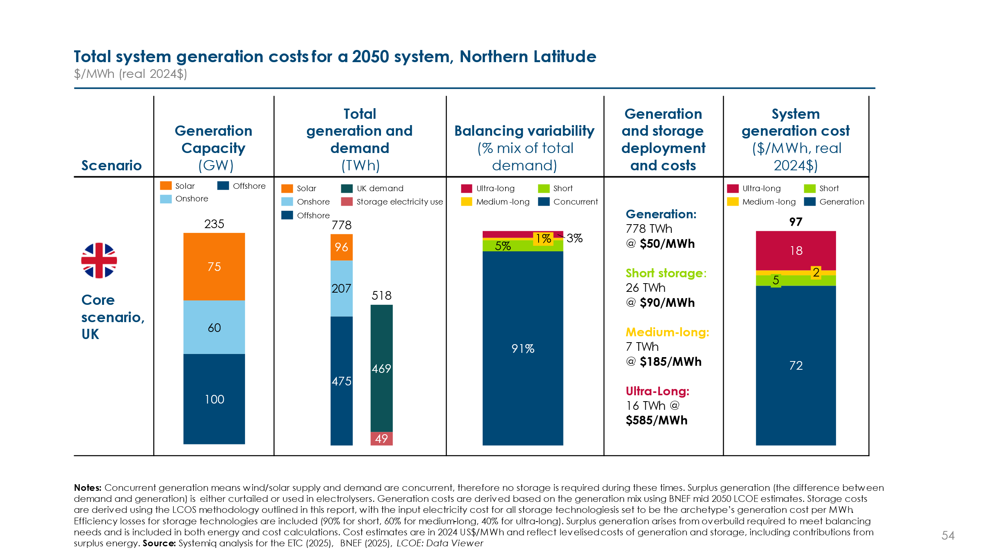
Exhibit 1.48 compares our illustrative UK results with those from other major dispatch-based studies: the UK Climate Change Committee’s Seventh Carbon Budget (CCC / CB7). The CCC results are based on dispatch modelling carried out by AFRY, and reflect a more diversified generation mix.
In contrast to the ETC scenario, which models a 100% wind and solar system, the CCC analysis assumes that variable renewables account for 82% of generation, with a continued role for nuclear (79 TWh) and interconnectors (−2 TWh net). While these resources offer additional firm capacity and seasonal balancing, they are associated with higher unit costs. For example, the CCC scenario includes long-term contracts such as the contracts for difference for Hinkley Point C, with a strike price significantly above projected renewables costs even by 2050.
The CCC modelling estimates a total system generation and balancing cost of $89/MWh, compared to $97/MWh in the ETC scenario. Despite slightly lower overall costs in the CCC case, this difference is driven by modelling assumptions, including the use of existing legacy assets, more conservative capacity factors for VRE (33% for onshore wind, 47% offshore wind, 10% for solar), and a significantly higher total installed capacity (353 GW vs. 235 GW).
Importantly, both scenarios estimate future system costs below today’s average UK wholesale electricity price of ~$110/MWh (2024). Broader comparisons for all four regional archetypes are provided in Exhibit 1.46 alongside historical wholesale price benchmarks.
Drivers of recent volatility in UK and European power prices are explored further in Chapter 3.2.
Exhibit 1.48
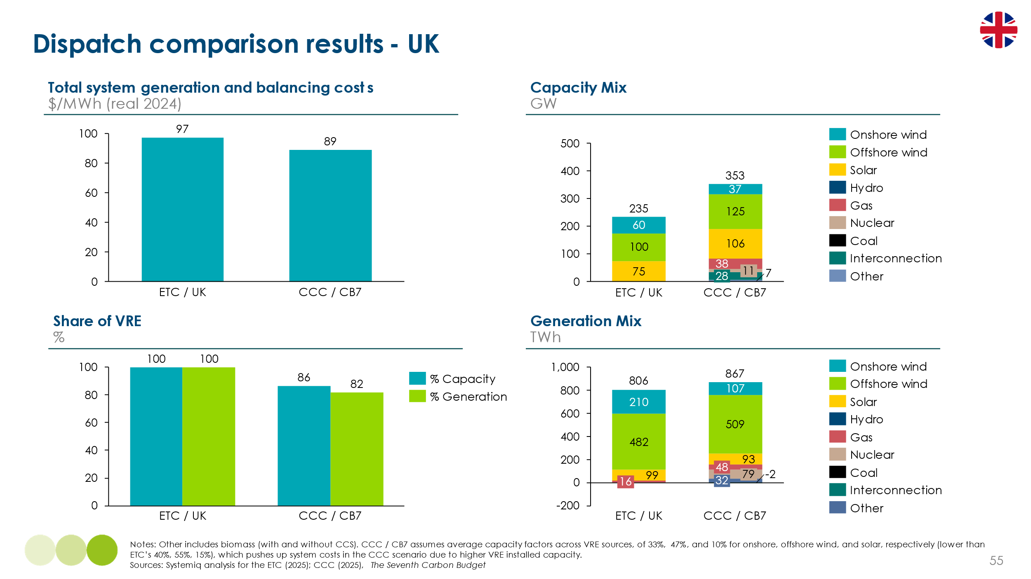
Low latitude archetype - India Case study
Exhibit 1.49 shows our illustrative estimates for a tropical system archetype, using India as a case study.
- The system is 100% VRE, dominated by solar, which accounts for approximately 79% of installed capacity and 80% of total generation. Generation costs are projected to fall to $15/MWh by 2050, reflecting India’s high solar resource availability and continued cost reductions in PV technologies.
- Balancing requirements represent 38% of annual demand, driven primarily by daily solar variability. These are met almost entirely by short-duration storage, delivering 2,100 TWh annually at a levelised cost of $45/MWh. No medium- or ultra-long-duration storage is required in this scenario.
- The total system generation cost is estimated at $31/MWh, with approximately $16/MWh (over 50%) attributable to the cost of balancing supply during periods of low or no solar availability, particularly evening and night hours. This highlights the cost impact of diurnal variability, even in high-solar contexts.

Exhibit 1.49
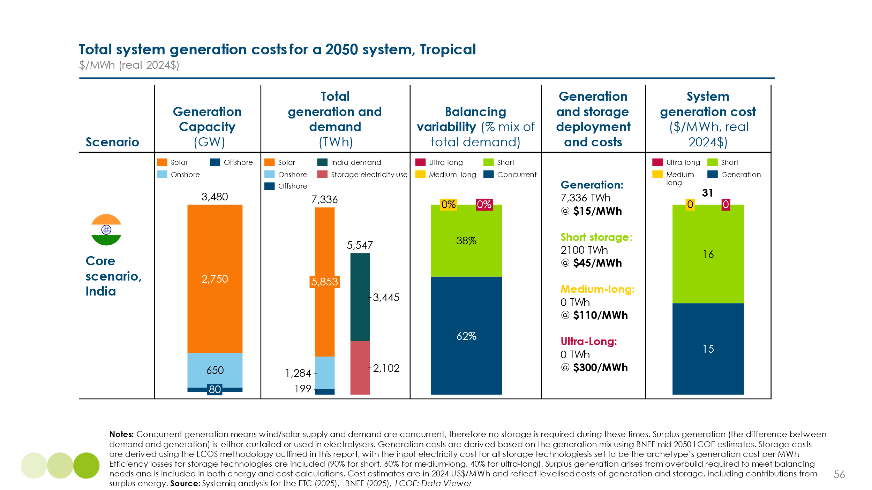
Exhibit 1.50 compares our illustrative results for India with those from TERI, the ETC’s Indian partner, based on its 15-minute interval dispatch model. TERI presents three scenarios—NFS (no fossil fuels), URES (unconstrained renewables), and CRES (constrained renewables)—which vary in assumptions about land availability, fossil fuel use, and the solar–wind mix. These result in VRE generation shares ranging from 67% to 95%, compared to 100% in the ETC case.
- TERI’s modelling suggests total system generation and balancing costs of $39 to $43/MWh, compared to $31/MWh in the ETC scenario.
- The higher costs in the TERI scenarios reflect less aggressive assumptions on solar PV and battery storage cost reductions, as well as lower capacity factors for renewables (e.g. 30–33% for wind vs. ETC’s 40% assumption, and 24% for solar vs. ETC’s 15%).
- Despite these differences, all scenarios show system costs well below India’s current wholesale electricity price, reinforcing the case for cost-effective decarbonisation of India’s power sector.

Exhibit 1.50
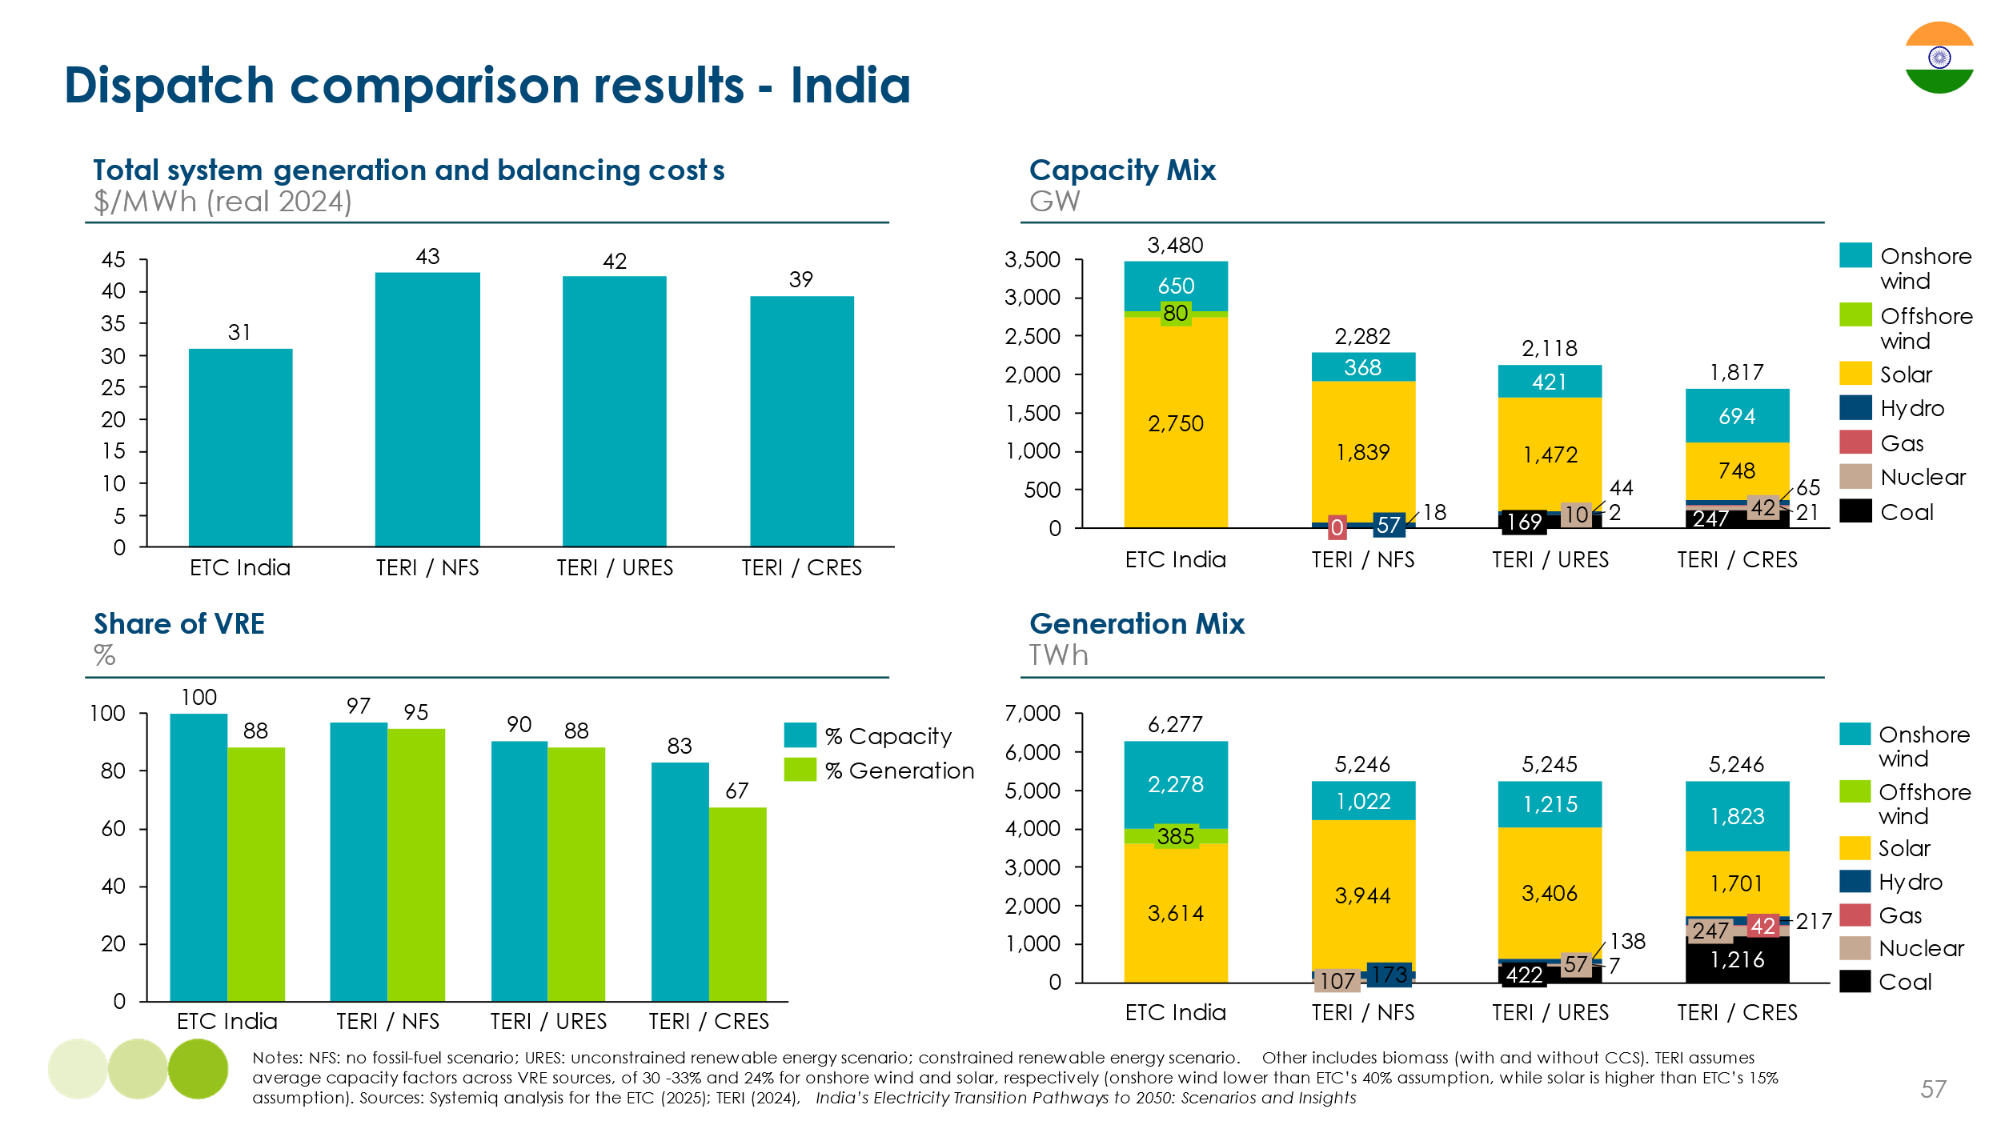
Mixed climate archetype – China case study
Our illustrative estimates for a mixed climate system archetype are shown in Exhibit 1.51, using China as a case study. This scenario results in system costs comparable to India, reflecting a balancing complexity between the tropical and northern archetypes, but offset by lower assumed costs for several storage technologies.
- The generation mix lies between the UK and India cases, with wind accounting for 71% of total generation and solar for 29%. Total installed capacity reaches 6,400 GW, generating 18,987 TWh to meet 15,000 TWh of electricity demand.
- Generation costs are estimated at $20/MWh, higher than in India but lower than in the UK. This reflects the availability of low-cost wind resources in regions such as Inner Mongolia and the combined contribution of both wind and solar to the system mix.
- The total system generation cost is $32/MWh, with ultra-long duration storage contributing $7/MWh, more than 20% of the total cost, despite covering only 2% of annual demand (330 TWh). This reflects the increased seasonal balancing challenge compared to India, requiring significant energy shifting across longer durations.
Exhibit 1.51
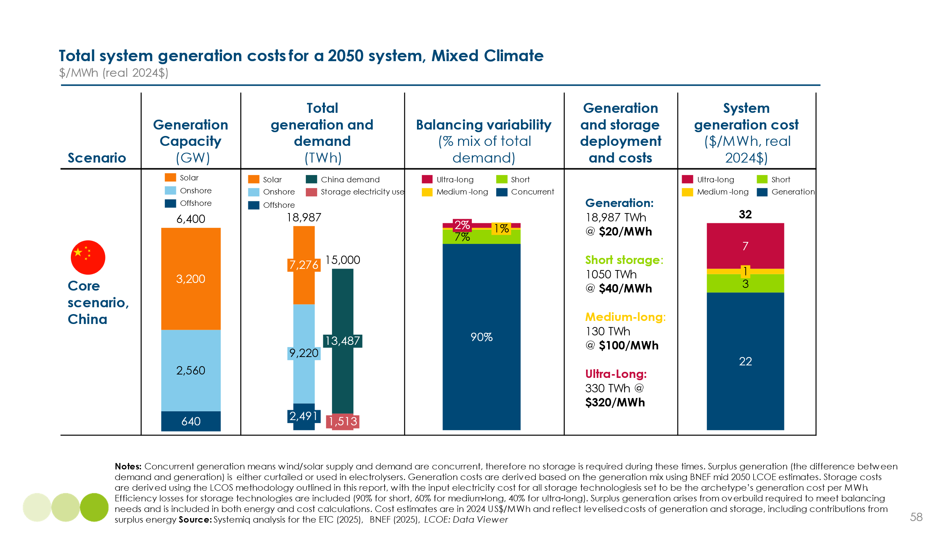
Exhibit 1.52 shows a comparison of our illustrative modelling for China with results from the Institute of Climate Change and Sustainable Development (ICCSD), the ETC’s Chinese partner. ICCSD examines two scenarios with varying levels of zero-carbon generation:
- In the Reinforced Policy Scenario, the generation mix comprises 42% VRE, 20% nuclear, and 12% hydro — for a total of 74% zero-carbon power. This scenario results in a total system cost of $35/MWh, very close to our own estimate of $32/MWh.
- In the 1.5°C-aligned scenario, the VRE share increases to 62%, with 16% nuclear and 10% hydro, for a total of 88% zero-carbon power. In this case, system costs rise to $47/MWh, reflecting the increased system integration and flexibility requirements associated with a higher share of variable renewables.
In both scenarios, the ETC and ICCSD projections are below China’s current average wholesale electricity price of $58/MWh, indicating a clear pathway to lower-cost, zero-carbon power.
Exhibit 1.52
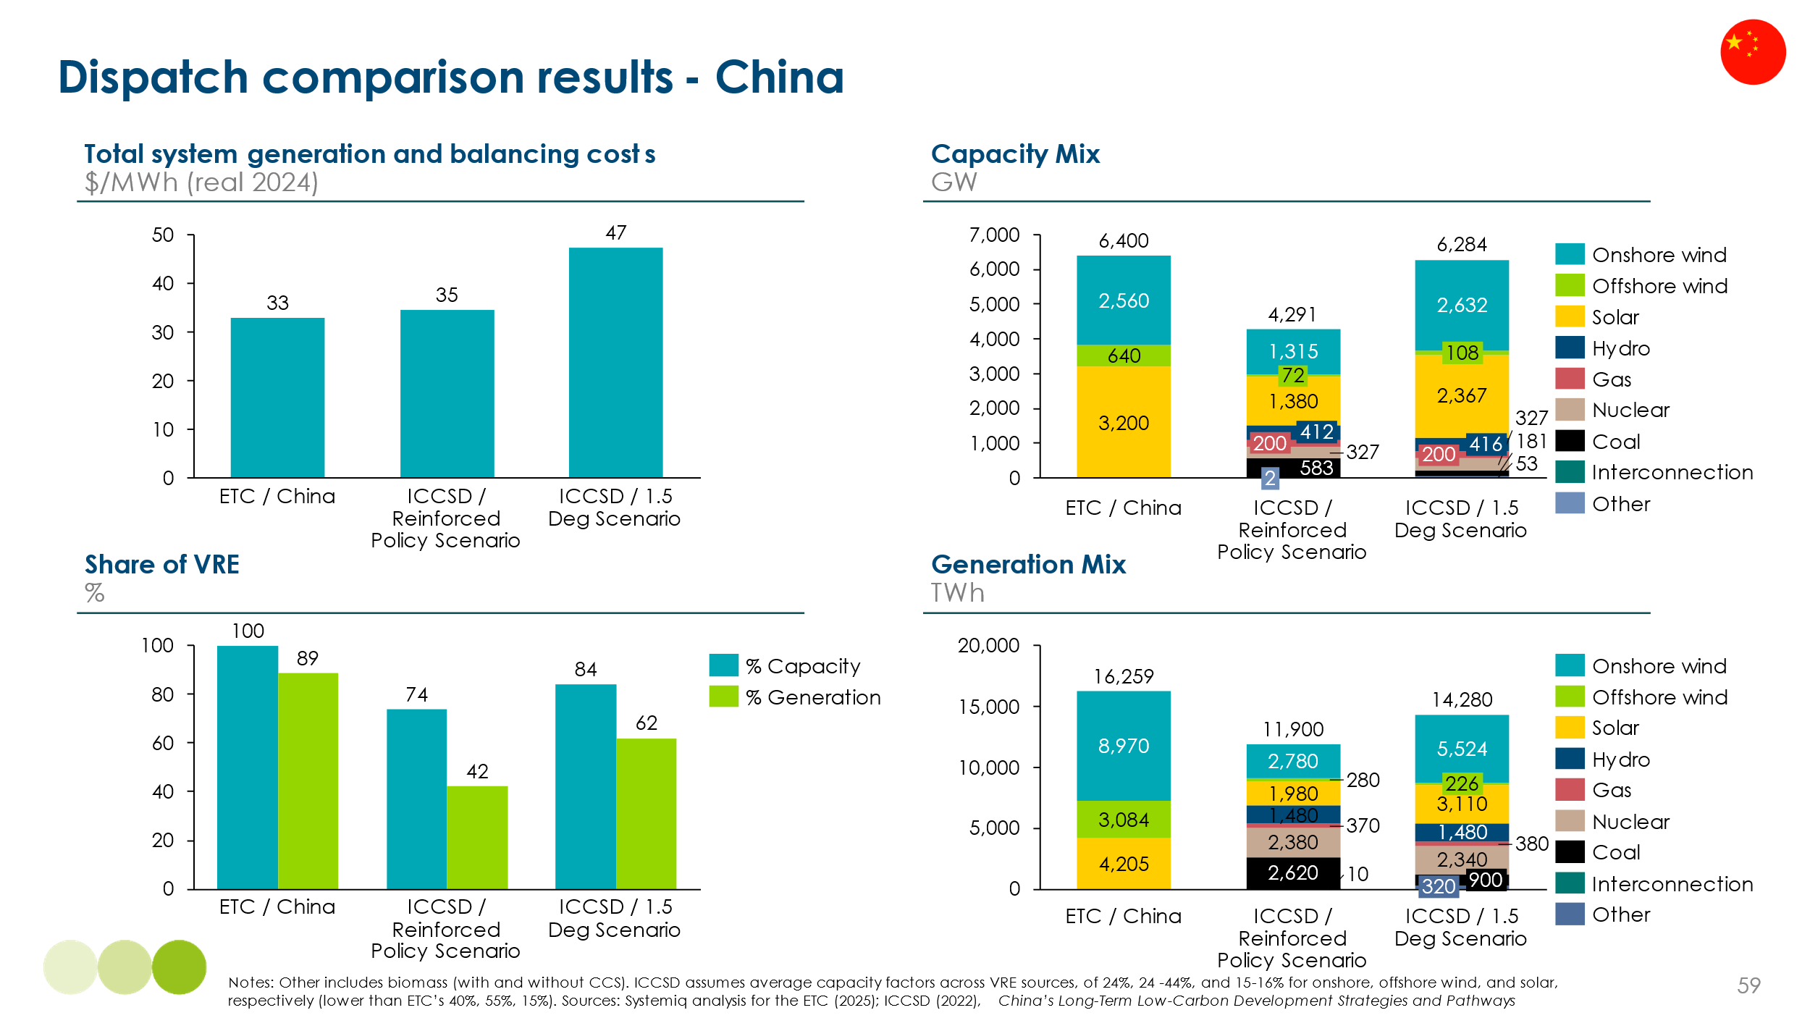
Mediterranean climate archetype – Spain case study
Our illustrative estimates for a Mediterranean climate system, using Spain as a case study, are shown in Exhibit 1.53. System costs are higher than those in India and China, due to a greater need for short- and ultra-long-duration balancing, though they remain well below historical European electricity prices.
- The generation mix is dominated by solar, which provides 62% of total generation, with onshore wind supplying 32% and a modest offshore wind contribution (6%). The system includes 320 GW of capacity, generating 649 TWh annually to meet 407 TWh of demand.
- Generation costs are estimated at $25/MWh, reflecting Spain’s excellent solar resource base. However, balancing requirements are more complex than in the tropical archetype, with a mix of diurnal and seasonal variability requiring short-duration storage and limited contributions from medium- and ultra-long-duration technologies.
- The total system generation cost is estimated at $54/MWh, comprised of $35/MWh from generation, $12/MWh from short-duration storage, $7/MWh from ultra-long duration storage, and $0.2/MWh from medium-duration balancing. The medium-duration requirement is minimal in absolute terms, but highlights the value of even small volumes of flexible, multi-day storage in a solar-heavy system.

Exhibit 1.53
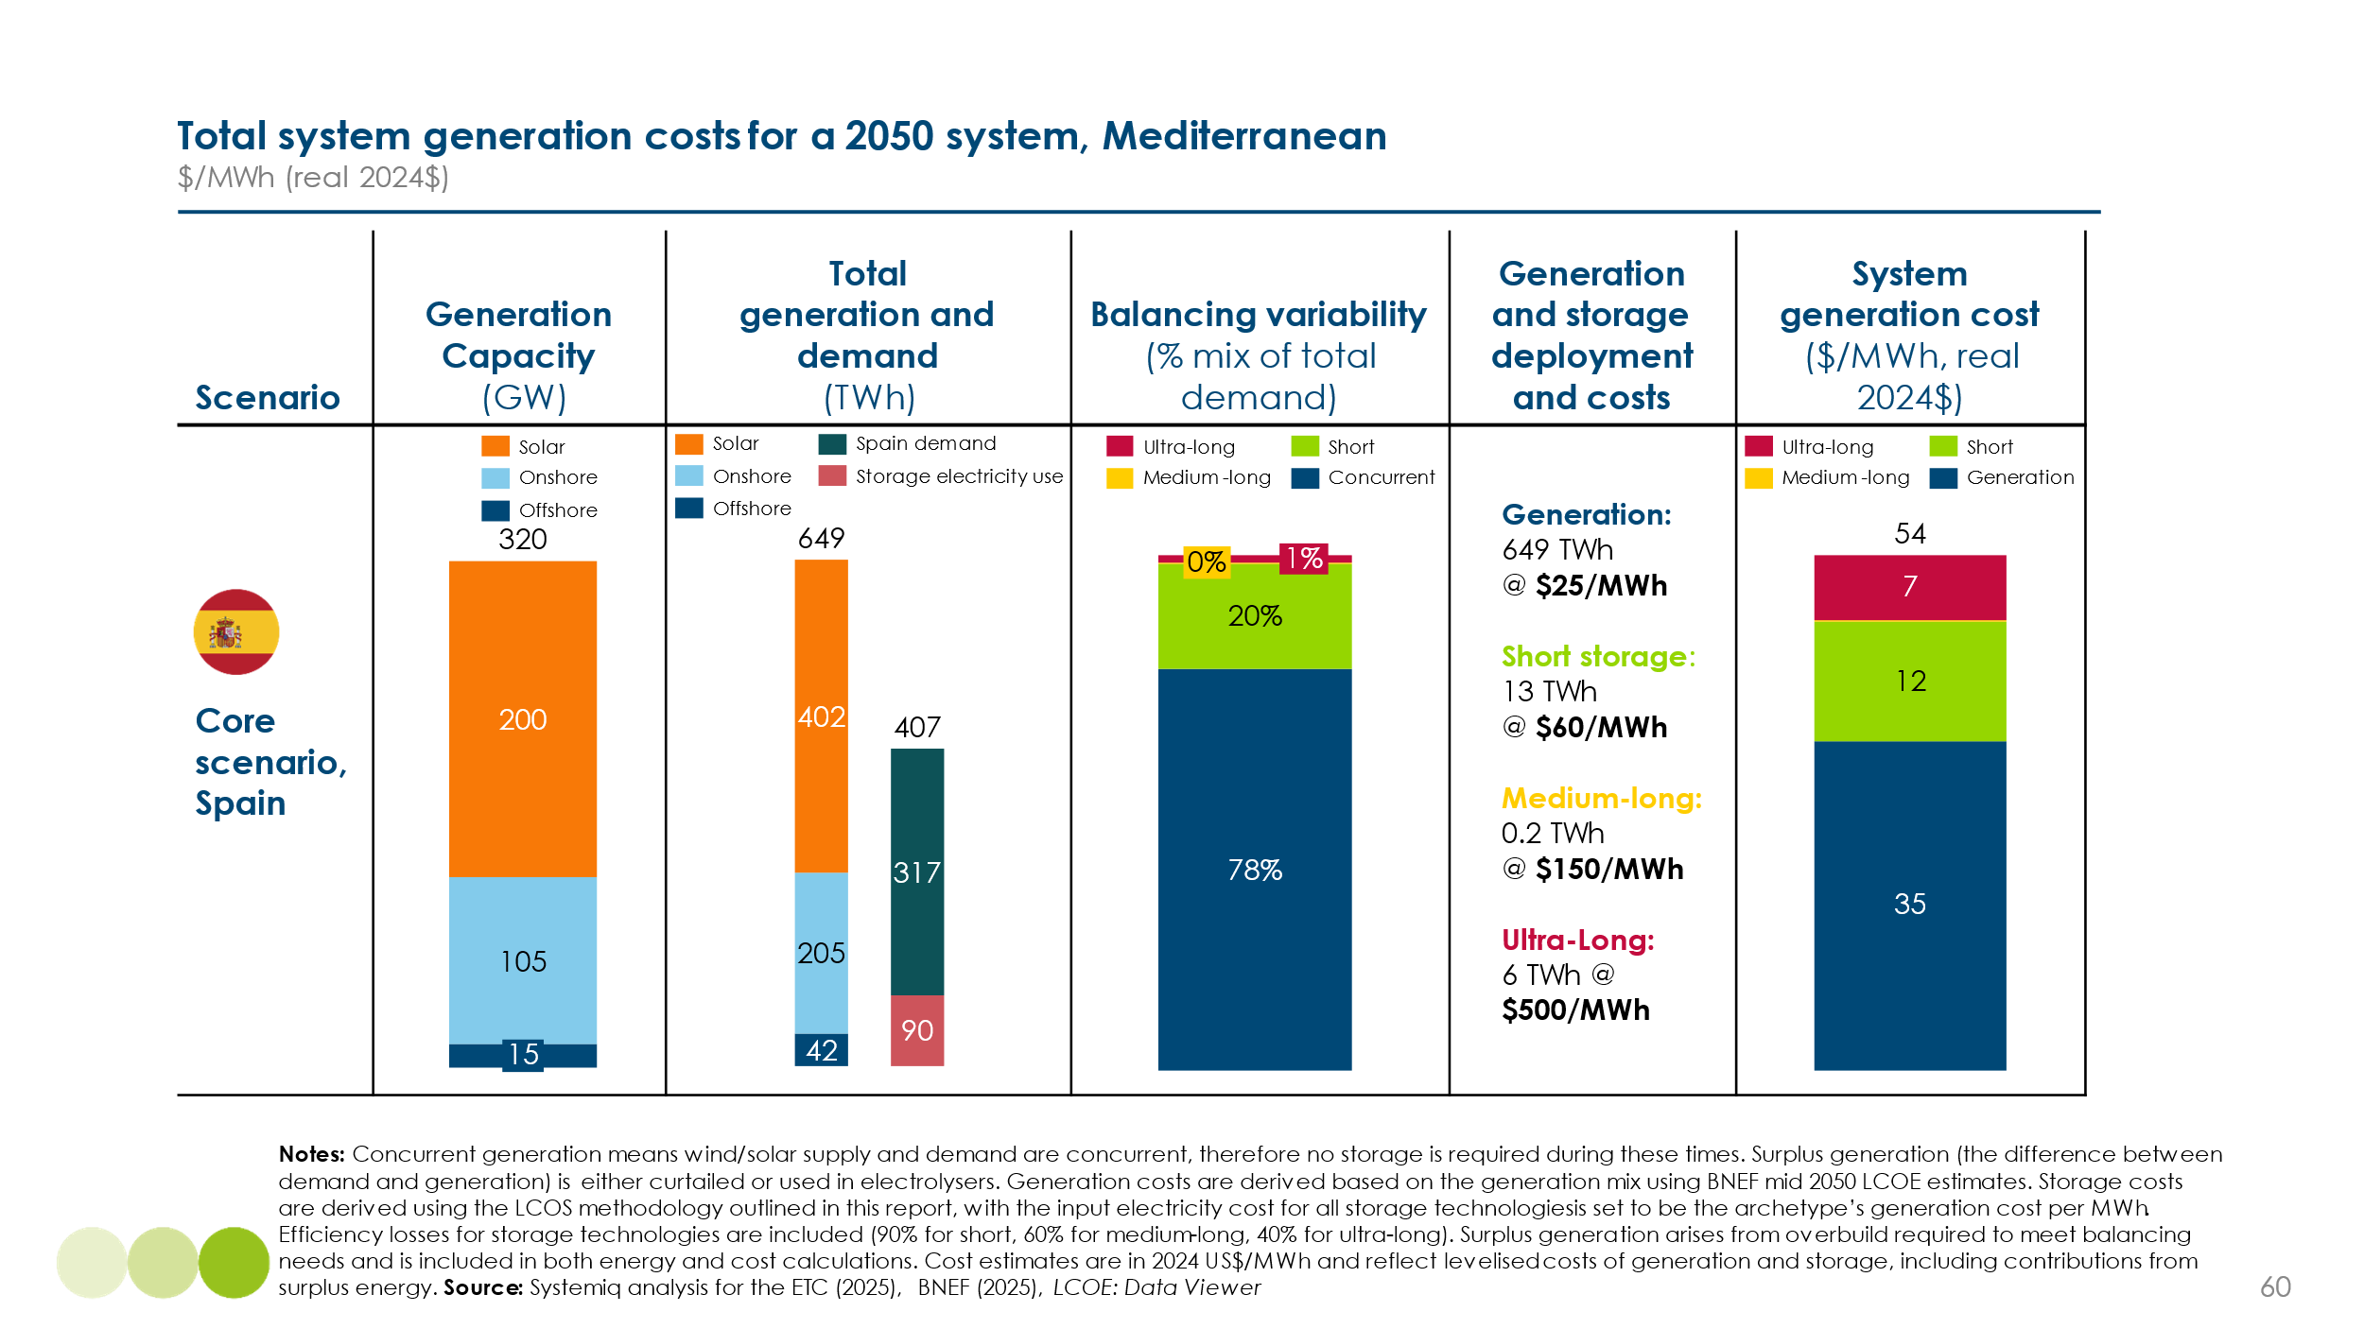

Exhibit 1.54 compares our illustrative modelling for Spain with results from Aurora’s dispatch model. Aurora assumes a lower VRE share (91% vs our 100%) and includes some firm capacity from nuclear and gas. This reduces the storage requirement while increasing total firm capacity:
- In the Aurora Baseline scenario, total system costs are slightly lower at $53/MWh. The generation mix includes less wind (109 GW in Aurora and 120 GW in ETC), moderate solar buildout, and a notable role for interconnection, alongside some continued gas and nuclear capacity.
Both scenarios show that a low-cost, near-zero-carbon power system is achievable in Spain. Estimated costs remain well below historical averages, underscoring the potential of solar-dominated systems in Southern Europe — even where some storage and seasonal balancing are still required.
Exhibit 1.54
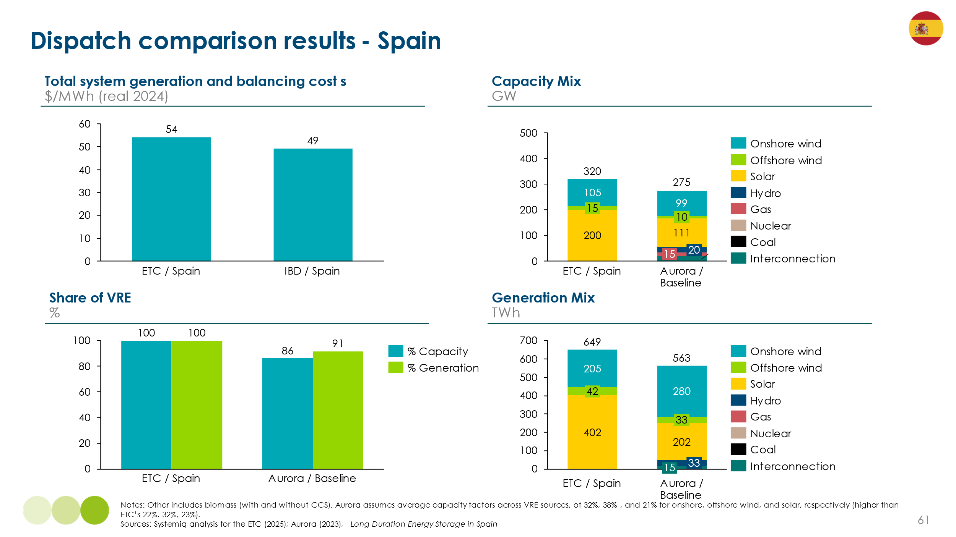

Collectively, these case studies highlight the diverse pathways to low-cost, zero-carbon power systems across different regional contexts — with generation mixes, balancing needs, and system costs shaped by local resources and technologies, yet all delivering electricity more affordably than today.

- Managing grid expansion to minimise grid costs per kwh

The large increases in electricity demand shown in the introduction will require not only a huge expansion of renewable and other low carbon generation, but also large scale expansion of both transmission and distribution grids. In our September 2024 publication Building Grids Faster: The backbone of the energy transition, the ETC provided an assessment of the scale of the grid build challenge – a projection that grids will more than double in size by 2050 to enable a net zero pathway – and laid out the critical priorities to deliver this build.

This chapter describes the grid build challenge and the implications for grid costs, covering in turn:

- The need for large scale grid investment. Significant investments will be needed to grow and modernise both transmission grids (which support high-voltage, large-scale movement of electricity spanning larger distances) and distribution grids (which support lower voltage, connecting to end-use demand). Global required grid investment could grow from $370 billion in 2024 to around $850 billion per annum in the 2030s and 40s.

- The opportunity to reduce costs by optimal grid design and operation. This will entail deploying multiple innovative grid technologies (IGT) and ensuring maximum demand side flexibility (DSF). These approaches could reduce required grid build by up to 35% versus a business as usual scenario.

- Trends in grid costs per kWh. Total grid costs will inevitably increase. This may initially result in small increases in grid costs per kWh, but as electricity demand increases to match the new capacity, the per kWh cost could fall by 2050 and could be significantly below current levels if opportunities for grid optimisation are seized.

- Implementation and policy priorities, including reform of planning and permitting systems, market designs to create incentives for optimal grid development, and actions to overcome potential supply chain constraints.

- Grids expanding and changing to deliver clean electrification
Power decarbonisation and wider electrification are together changing the “map“ of electricity networks by increasing the complexity of grid design and operation. [Exhibit 2.1]. Four factors are particularly important:

- The growth of renewable power generation and the reduced role for large thermal plants. This tends to produce a more dispersed generation system with a, larger number of generation assets often located further away from major demand centres.

- Electrification of road transport, buildings, and industry. This leads both to increasing average and peak power supply needs at household and local distribution level and can create new locations of industrial demand to be connected to the grid.

- The increasing role of rooftop solar PV generation, sometimes combined with battery capacity, which moves generation supply “behind the meter,“ potentially reducing the need for, and revenue off, distribution network companies.

- The development of multiple forms of storage capacity, which could connect at different levels of the distribution and transmission grits.

These factors have implications for the pattern and scale of demand, the scale of investment and the implementation challenges faced at different network levels.

Exhibit 2.1
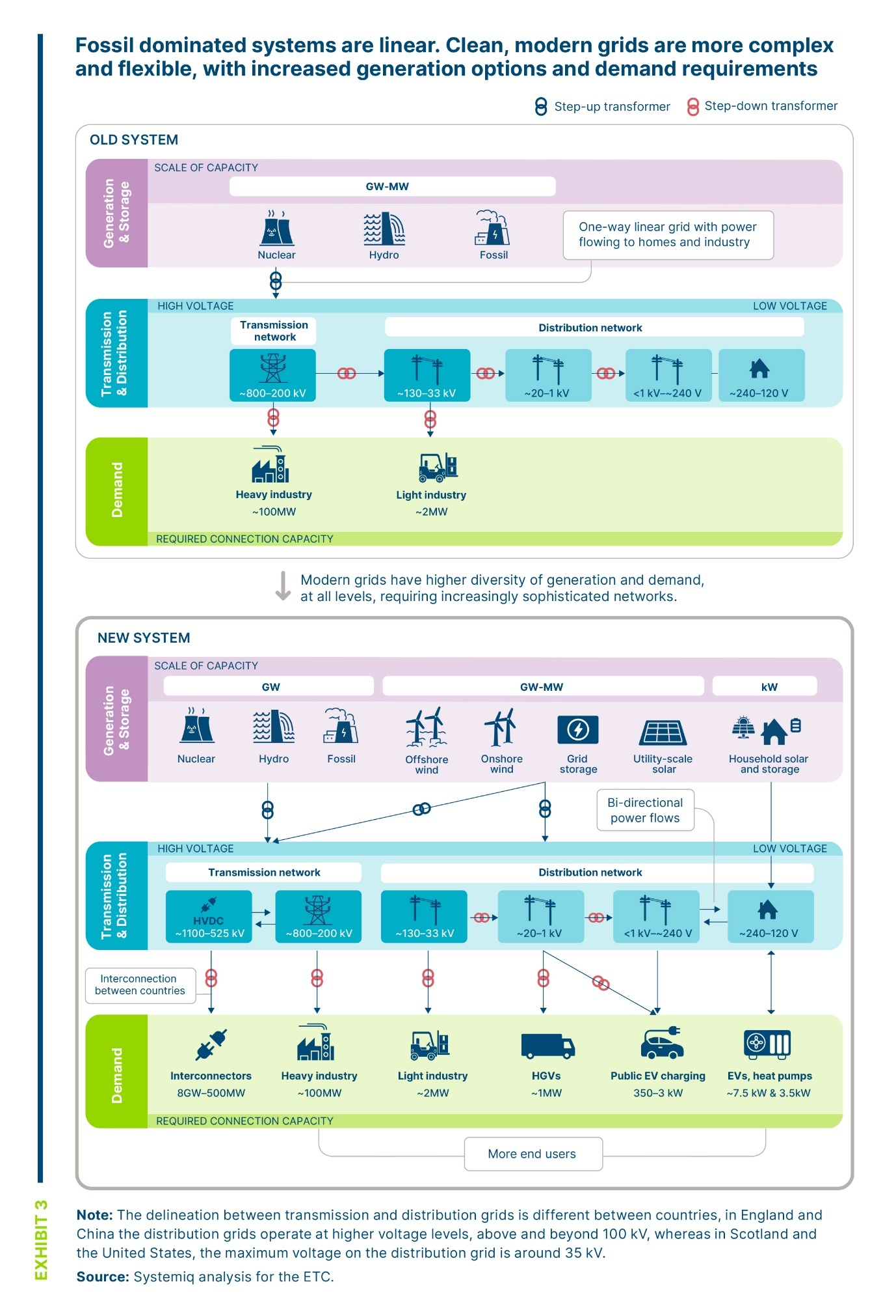
- Changing demands at different network levels
Distribution networks represent the largest part of the power network system, accounting for 66m km of wires globally, versus 7m km in the transmission network . The changing demands facing distribution networks differ by network level [Exhibit 2.2].
Exhibit 2.2
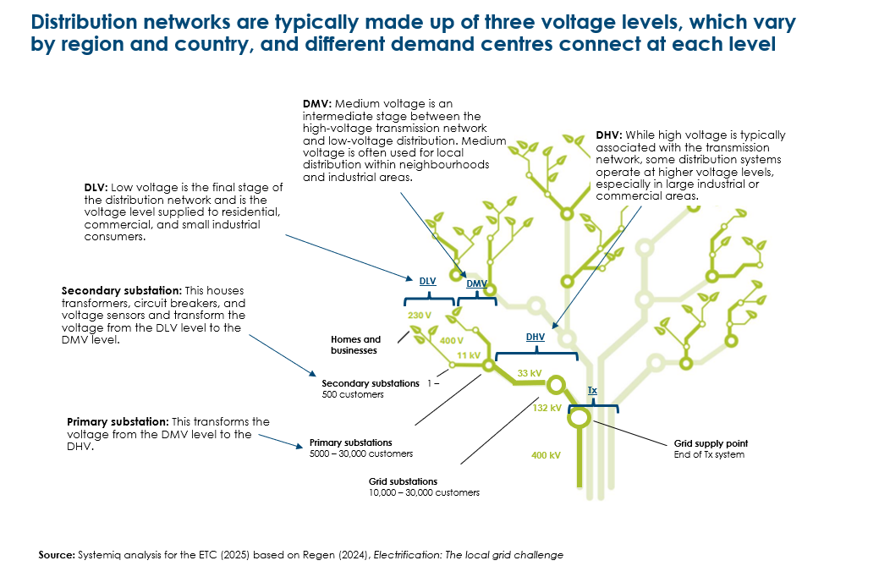
The distribution low voltage (DLV) system delivers electricity to households and small businesses. The voltage level is 100-127 V at a frequency of 60 Hz in the United States, Canada, Japan, and parts of Central and South America and 220-240 V at 50 Hz in most of Europe, Asia, Africa, and Australia. At this network level, a single electrical secondary substation (of 400 kW) capacity may serve 100 households in an urban setting (although this varies significantly across substations and regions, and rural substations serve fewer customers). Key drivers of change at this level are a greater use of a wide range of electrical appliances, increased air conditioning as the climate warms, switches to heat pumps in colder countries, and domestic charging of electric vehicles. Together, these changing demands will drive significant increases in both average and peak power demands. For example:
- Households in UK currently consume 0.2-0.8 kW on average, 5-10 kW at peak and 5-20 kWh per day. In the future, consumption could reach 0.5-1.2 kW, 8-22 kW, and 10-30 kWh, respectively.
- Households in India currently consume 0.1-0.3 kW average 1-3 kW peak and 3-7 kWh per day, In the future, consumption could reach 0.4-0.8 kW, 5-10 kW, and 10-20 kWh, respectively.
Many households and small business will in future use rooftop solar combined with battery systems to cost-effectively cover a significant proportion of demand (up to 50+% in UK, and close to 100% on many days in sunbelt countries). However, as electrification increases, some individual substations may need to be replaced at significant capital cost (e.g., $300k per secondary substation).
The distribution medium voltage (DMV) system (6.6-36 kV), pools supply to multiple neighbourhoods and will also in some cases directly connect to medium scale electricity users such as supermarkets and EV charging facilities for vans, buses and trucks. A medium voltage substation may serve 10-20 low level substations, equivalent to 1-10 MW of capacity and 1,000-5,000 households.
At the distribution high voltage level (DHV) primary substations upgrade the network voltage from the DMV level to the DHV level (45 kV to 230 kV). Commercial and industrial users (generally in the sub-10 MW range) often connect at this level. DHV level connections are likely to increase as a result of:
- The increasing electrification of light industry (e.g., heat generation for food processing) ) and large scale agricultural operations, plus the growth of data centres.
- Increasing investments in grid scale batteries which may connect at this level (or at the DMV level).
- Increasing development of moderate scale commercial solar rooftop arrays and small wind farms which may also connect at either DMV or DHV levels,
The transmission level typically serves electricity supply and demand for a whole country, or large regions of a country (for example the US has three major and two minor transmission networks, with only light interconnection between them). Overall the transmission level must manage changing trends at each distribution level and provide any additional system balancing services to ensure that overall grid frequency remains in the required range (e.g., 49.5-50.5 Hz in the UK and 57-62 Hz in the US).
- Scale of required investment for distribution and transmission grids
To deliver the required growth in electricity and accommodate the changing nature of power generation and consumption, countries will need to significantly expand and upgrade their grids. Estimates suggest that the total global grid length must grow by 2-4 times by 2050, growing from around 73 million km of grid in 2022 to around 150–200 million km in 2050, with growth across all regions (as shown in Exhibit 2.3).
Exhibit 2.3
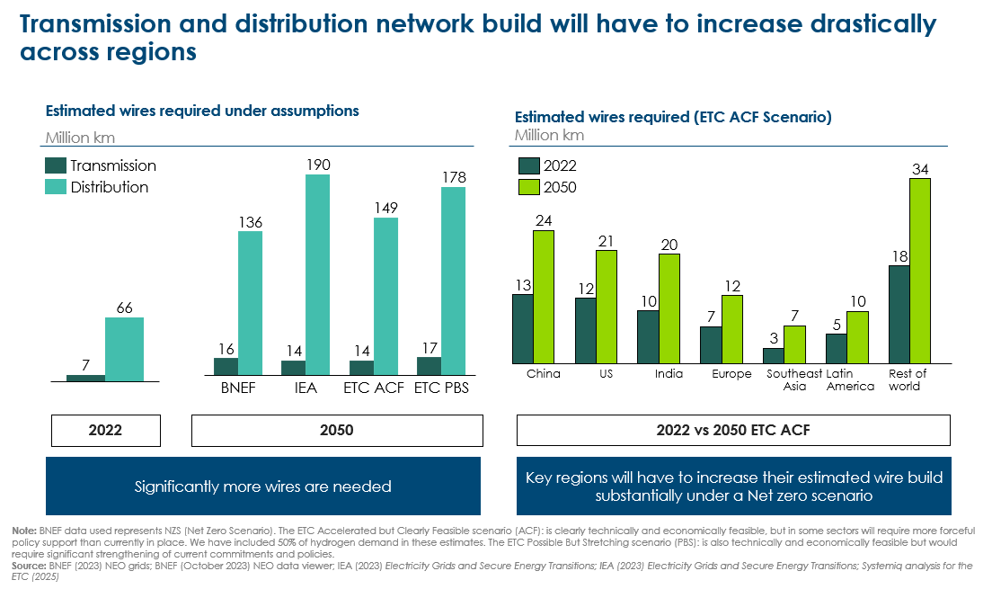
Both transmission and distribution grids will need to more than double in length. Costs per km for the high voltage and power capacity transmission lines (plus related equipment) are on average around 5-7 times higher than for distribution networks, but distribution networks are still likely to account for around 55% of all investment [Exhibit 2.4].
Exhibit 2.4
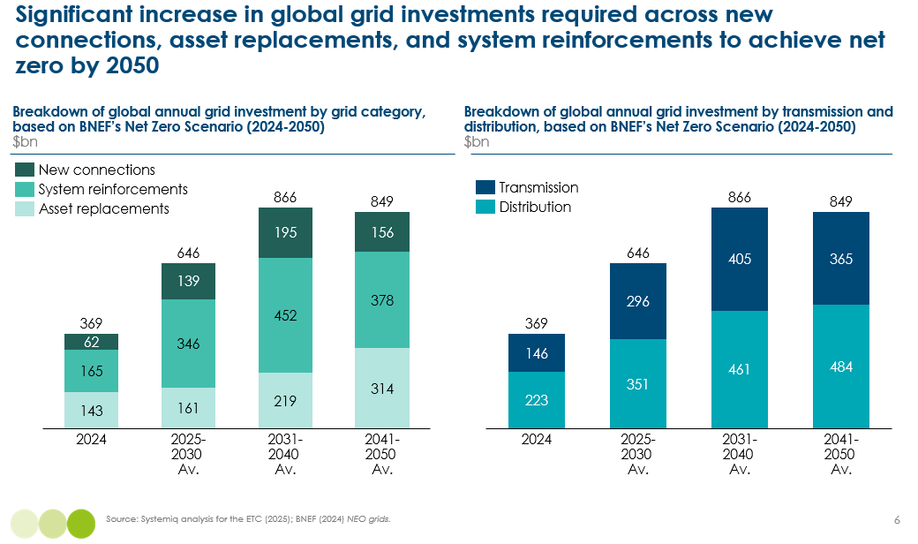
In addition to extending networks to connect new sources of supply and demand, investments will also need to cover the maintenance of exiting assets [Exhibit 2.4].
Replacing ageing assets to maintain the existing asset base: The need for this investment can be partially reduced by increasing grid digitalisation (through flexibility software management solutions such as digital twins), which can improve information on maintenance needs. These replacement investments will be concentrated in developed economies where grid infrastructure is older on average.
System reinforcements: These include investments to increase the capacity of existing power lines plus changes to existing grid infrastructure to enable higher complexity and flexibility in grids (e.g., enabling bi-directional power flows in distribution networks) as well as grid management optimisation/digitalisation (e.g., installing sensors and software for managing higher complexity power flows).

- Implementation challenges at different network levels
Delivering the scale of investment needed will be a major implementation challenge at both the transmission and distribution level.
At the transmission level, the average global annual buildout required is 0.25-0.36 million km/year through to 2050. The main challenges around achieving this transmission buildout include:
- Permitting delays faced by transmission projects, especially in advanced economies where the development of transmission lines often takes up to 8 years (compared to 1.5 to 3 years in China and India, respectively). These delays in part reflect local opposition to visually intrusive new pylon line developments
- Supply chain constraints, Lead times for key components such as cables and transformers have nearly doubled in recent years, with record-high backlogs and procurement delays now common.
- Rising prices for cables and transformers due to high demand, inflation, and increased costs of critical materials such as copper, aluminium, and steel.
- Skilled workforce shortages, with an estimated 1.5 million job gap in the power grid sector by 2030.
At the distribution level, the average global annual buildout required will be 2.5-4 million km/year l. In many countries this new build grid extension will be easier to achieve than system reinforcements, where challenges include:
- The sheer number and complexity of the upgrades required, many of which will require digging up streets.
- Regulatory regimes which in some cases make it difficult to invest ahead of rather than in response to rising demands.
- Imperfect information relating to existing assets, reflecting past ad hoc approaches to system reinforcement and inadequate record keeping. As a result, distribution companies often do not know how much spare capacity there is at different levels of the network and may invest in more new assets than what is needed to meet demand. Analysis by Vivid Economics and Imperial College London showed that, in the UK, over 40% less additional cable length would be required in their ‘high headroom’ scenario.

- Optimisation to reduce grid investment needs.
Three types of action could significantly reduce the need for additional grid investment, in each case effective market design and regulation will be key to seizing the potential:
- Demand side flexibility (DSF) to reduce the peak electricity demands which determine required grid capacity at different levels in the network. This could cut required distribution system investment by up to 40% percent. Market designs which support time of day pricing are a key enabler.
- Deployment of innovative grid technologies (IGT‘s) which can significantly increase the efficiency with which grid assets are used. These could in principle reduce required grid investment needs by as much as 35%. Changes in grid company regulation may be required to create strong market incentives for their deployment.
- Optimal location of generation and storage assets, and of major new demand centres, including the use of existing grid connections and the optimal use of international interconnectors. Maximising this potential will require market designs which create incentives for optimal location.

- Demand side flexibility – a major opportunity to reduce distribution network investment.
The potential for demand side flexibility to help balance electricity supply and demand was discussed in Section 1.4. By shifting demand away from peak demand periods, DSF can reduce the need to invest in the various forms of short duration storage which would otherwise be required to achieve balance. DSF can also play a very important role in reducing the need for new distribution network investment since network capacity needs are driven by peak electricity demands.
Peak demands in electricity systems are already very significantly higher than average demands across the day [Exhibit 2.5] but the peak to average ratio could increase still further as a result of wider electrification.
- In the UK, the electrification of road transport (with significant vehicle charging at household level) and of residential heating could drive an increase in the typical household’s daily winter peak demand from 8 kW to 22 kW, but optimal adoption of DSF could reduce this to 13 kW [Exhibit 2.6].
- In India, rising demand for aircon and other electric appliances could drive and increase in typical summer daily peak demand from 1.5 kW to 8 kW, but the optimal deployment of DSF could reduce this to 5 kW.
Achieving these potential reductions in individual household peaks would reduce the need for increased network investment at the individual household level, in the low-voltage network and at secondary substations. It has been assumed that these increases in demand will require capacity increases at each stage of the network, including cables and transformers (in substations), unless optimisation measures, such as DSF, are implemented. Alongside network upgrades, fuses in buildings will need upgrading in line with the capacity increase (e.g., from 60A to 100A for a house going from a peak demand of 8kW to 20kW) .
At the level of medium voltage networks and primary substations, increases in demand could be even higher due to the connection of commercial and industrial demand sources which connect at this level. However, the impact of residential peak demand is somewhat reduced by an averaging effect at higher voltage levels, with peak demand in different households and locations being partially offset.
At DHV and transmission grid levels, the impact of peak demand is also reduced by an averaging effect. But DSF could still have a material impact on total required network investment at these levels.
Another potential impact is increasing utilisation and decreasing redundancy in the networks. The general reliability standard used in electricity networks is the ‘N-1 criterion’, which means that the system must be able to continue operating without exceeding operational limits despite the failure of one critical component (transmission line, transformer, or generator). DSF could decrease the redundancy required to a more economically optimal N-0.5 to N-0.75 range by increasing the headroom in the system, enabling security of supply with fewer components.

Exhibit 2.5
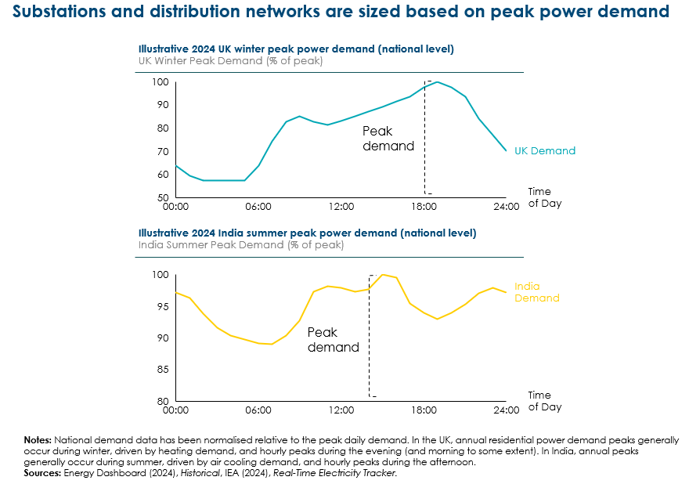

Exhibit 2.6
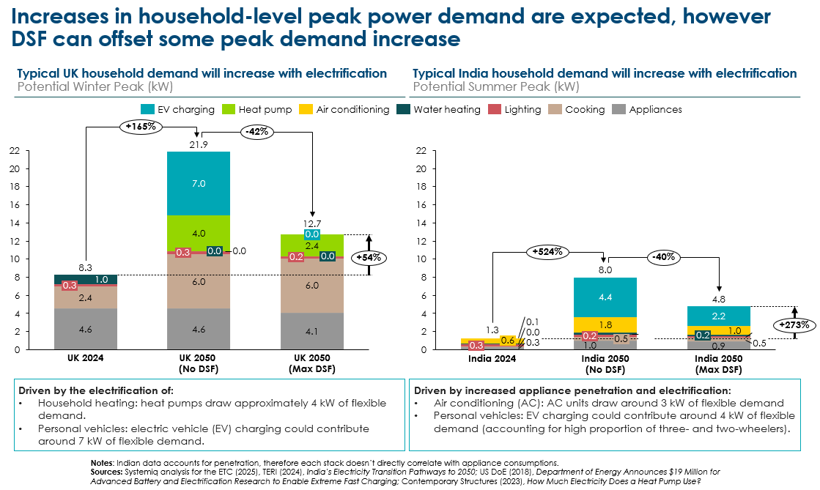
The impact of DSF on household peak demand from the grid, can be achieved by shifting consumer demands (e.g. the timing of EV charging, heating, or Aircon system use) away from peak periods. But it can also be achieved by installing rooftop solar PV if demand naturally aligns with solar production or can be shifted to align, or if batteries are installed at building level. Box F describes developments in Australia and Pakistan, where large scale deployment of rooftop solar promises to significantly reduce local distribution network requirements (as well as peak generation needs) aided by time of day pricing for both import from and export to the grid.
Seizing the very large potential for DSF to reduce distribution network costs will require:
- Accelerating smart meter rollout
- Implementing time-of-use tariffs, real-time pricing, or wholesale price signals to incentivise behavioural demand response.
- Establishing clear rules on data usage, exchange and interoperability standards
- Reducing barriers to entry via financing through financial institutions and government -backed grants
- Incentivising automated demand response across key demand-side technologies (including electric vehicles, heat pumps, and other home appliances).

Box F – Rooftop solar impacts in Australia and Pakistan
Australia’s rapid adoption of rooftop solar power is fundamentally transforming its electricity system. Once designed for one-way energy flow from large coal-fired plants, the National Electricity Market (NEM) now faces significant challenges from the two-way electricity flows caused by widespread rooftop solar installations, with over 25 GW of installed rooftop solar capacity. Approximately one-third of Australian homes now have rooftop solar, with some states like Queensland and South Australia seeing penetration rates nearing 50%. This rapid uptake means rooftop solar at times provides more than half of total electricity demand across the NEM, and even up to 70% in Western Australia’s separate Wholesale Electricity Market.
This transformation presents operational challenges, particularly around "minimum system demand" periods, when solar production exceeds local energy consumption, creating reverse energy flows back into the grid. In South Australia, rooftop solar penetration is so high that on mild sunny days, it not only meets all local electricity demand but also exports surplus electricity to neighbouring regions. Consequently, Australia's energy system operators face critical security risks, including voltage instability, overloaded distribution networks, and negative wholesale energy prices occurring up to 80% of daytime hours in states like South Australia and Victoria.
Responding to these issues, Australia has implemented emergency backstop mechanisms, enabling grid operators to temporarily curtail rooftop solar production to maintain grid stability. Concurrently, innovative market designs such as dynamic operating envelopes (DOEs), community battery storage programs, and dynamic pricing incentives encourage more efficient energy use and storage solutions. These interventions aim to maximise the benefits of rooftop solar while managing its impact on grid stability and reliability.
Pakistan’s rooftop solar market is at a more nascent stage but is experiencing rapid growth driven by frequent power outages, high electricity prices, and declining costs of solar installations. The Pakistani government has actively encouraged solar adoption through initiatives such as net-metering policies, allowing consumers to offset their electricity bills by feeding surplus solar energy back into the grid. As a result, Pakistan’s grid-connected, net-metered rooftop solar capacity reached about 4.1 GW by December 2024 (up from 1.3 GW in June 2023), however these metered statistics are likely an underestimate as Pakistan imported 13 GW of solar modules from China in 2024.
Rooftop solar in Pakistan is already alleviating pressure on the strained national grid, especially during peak summer demand. Additionally, solar adoption is empowering communities and small businesses by reducing energy costs and enhancing energy security. However, Pakistan faces its own challenges, such as the need for substantial grid upgrades to accommodate increasing levels of distributed solar generation and issues around the financial sustainability of net-metering schemes amid rising adoption rates, with power distribution companies (DISCOs) facing revenue shortfalls due to some demand for grid electricity being offset by self-consumption, leading to higher tariffs for some non-rooftop solar users.
Overall, both countries exemplify the profound changes rooftop solar can induce in national electricity systems, highlighting the importance of forward-looking grid management strategies, including maximising deployment of DSF solutions, residential and grid-scale batteries to fully harness the benefits of distributed renewable energy.

- Innovative grid technologies to reduce network investment needs
Exhibit 2.7 and Exhibit 2.8 describe eight high potential innovative grid technologies (IGT’s) which could significantly reduce required grid investments. They include
- Hardware-based IGTs which expand firm line capacity via changes to pylons and wires
- Software-based IGTs optimise wires and networks which improve system visibility, decision-making, and performance
- Flexibility management software solutions, including digital twins, which are cross-cutting and can be applied alongside all IGT options assessed,
Some of these IGTs are specifically designed for either the transmission or distribution network, and some can be implemented in both:
- Advanced conductors are primarily designed for high voltage overhead transmission lines.
- IGTs which can be implemented across transmission and distribution networks include Dynamic Line Rating (DLR), Flexible AC Transmission Systems (FACTS), and Storage as Transmission Asset (SATA).
Potential benefits, technological readiness and costs vary by IGT [Exhibit 2.9].
- Advanced conductors could potentially double the power capacity which can be carried by lines of pylons, have a TRL of 9 and at a cost of 50-200k per km will be cost-effective in many situations.
- Super conducting materials could potentially increase line capacity by 4 to 10 times, but are at a much earlier stage of TRL, and will be more expensive even when deployed on a large scale134.
- Various software based enhancements to grid operation – such as grid inertia measurement, flexible AC transmission systems (FACTS) and dynamic line rating (DLR) could each potentially increase network capacity by around 30%. These technologies have high TRLs and far lower costs than the hardware based solutions. DLR has been deployed in several countries, for example LineVision’s deployment in the UK and US.
The applicability of these IGTs will vary by specific circumstance and needs to be assessed in detail for each national network. Available studies suggest large potential benefits.

- In Europe, a study by CurrENT found that implementing IGTs could feasibly unlock a 20 – 40% capacity improvement of the European network by 2040. Taking a more conservative view of a 10–20% grid capacity increase, deployment of these technologies could equate to gaining the equivalent of 4–8 years of new grid build136.
The US Department of Energy also estimates that deploying existing advanced grid technologies could increase US grid capacity by 20-100 GW and defer $5-35B in transmission and distribution costs over the next five years.
Exhibit 2.7


Exhibit 2.8
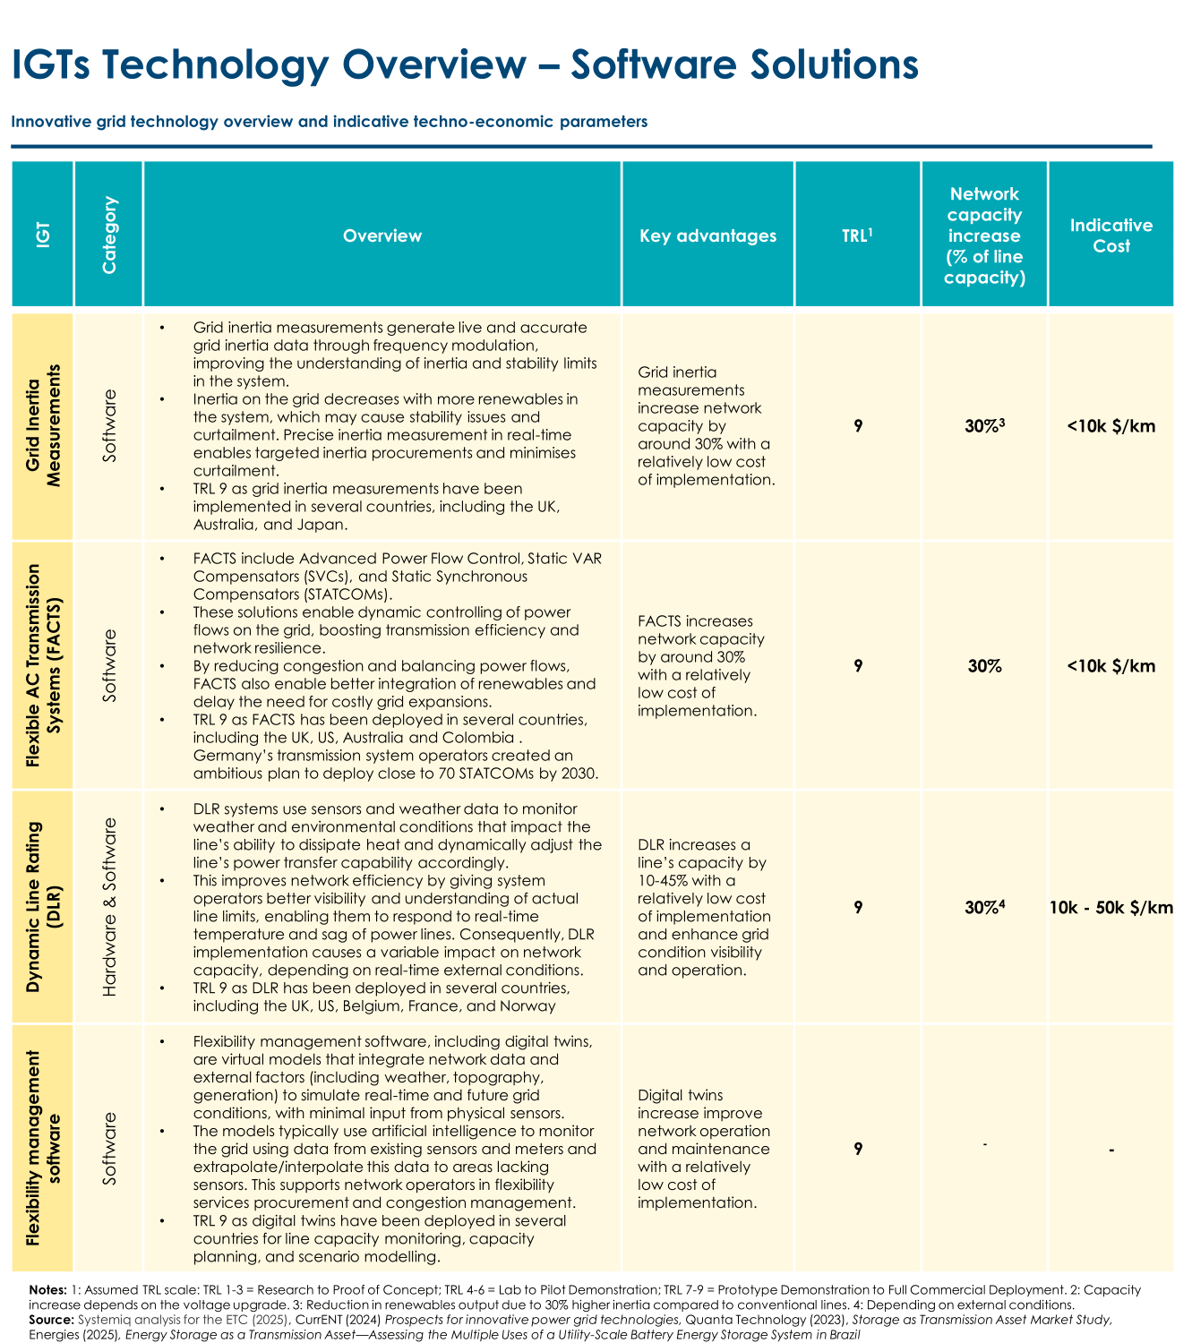

Exhibit 2.9
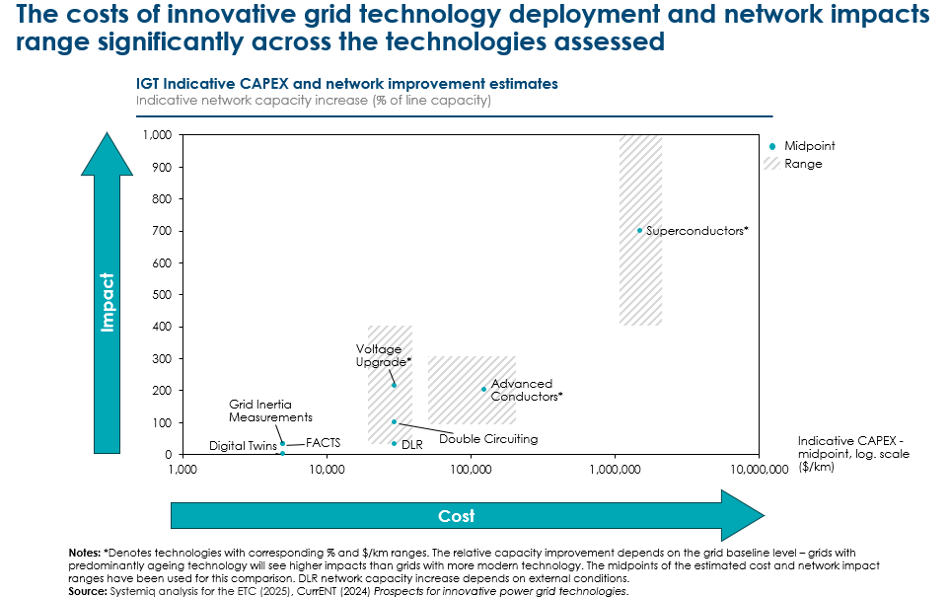

In addition to significantly reducing the need for grid investment and the resulting network costs case faced by household and business consumers, IGTs could also help reduce connection queues for new locations of generation supply and large industrial/commercial demand.
They could also reduce social opposition to necessary grid build, and as a result reduce barriers to rapid grid capacity expansion.
In many countries (particularly in the developed world) social opposition to large scale energy infrastructure projects is one of the reasons behind the long planning and permitting timelines for grid infrastructure. Transmission line projects can take up to 10 years, despite construction only taking 1-2 years. Grid optimisation through the application of IGTs could reduce opposition to developments by:
- Reducing the number of lines required as IGTs can achieve the required power throughput with less cable and less pylon lines
- Reducing the size of pylon line infrastructure, since optimised cables (such as advanced conductors, DLR-activated lines) have less sag and require less material per unit of capacity than conventional wires, resulting in smaller pylon towers which are further apart (subject to safety constraints relating to electrical arcing).
Other potential options to improve the social acceptance of grid infrastructure includes deploying new, less aesthetically offensive pylon designs (for example the ‘T-pylon’), developing green transmission corridors which can be used to increase biodiversity, persuading the population on the necessity for grid build as part of the wider energy transition (and non-energy transition related demand growth), and financially reimbursing affected communities.
Seizing the very large potential of IGTs will require appropriate regulatory systems which create incentives for transmission and distribution system operators to use an optimal combination of solutions. In several countries current regulatory systems place incentives on grid operators to reduce operational expenditure but add new capital investment to the regulatory asset base, which is then multiplied by an allowed rate of return and passed through as an increased cost to consumers. This reduces the incentive to use new technologies which reduce capital assets required per kilowatt of power delivered.
Existing regulatory structures of this sort are likely to lead to suboptimal levels of investment in the more CAPEX-heavy types of IGT [Exhibit 2.10].
Exhibit 2.10
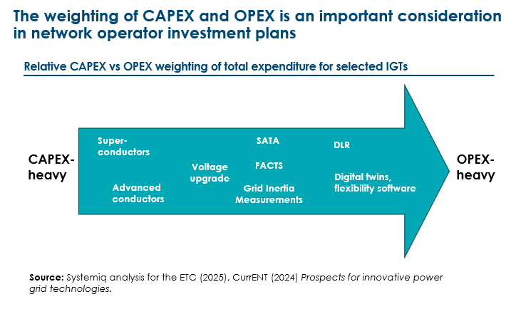

- Optimal location of generation, storage and new large-scale demands
Among the drivers of increased grid investment are the development of new sources of renewable supply located away from existing grid networks, and new sources of industrial and commercial power demand. Incentives which encourage the optimal location of supply and demand assets, alongside sufficient storage both sides, can therefore reduce overall grid investment needs. Key areas of opportunity are:

- Storage located close to areas of transmission or distribution congestion can provide Storage as a Transmission Asset (SATA) services which has been deployed in several grids around the world, including Germany the US, and Brazil. Storage close to renewable production assets can also ensure greater utilisation of transmission lines, including the long distance HVDC lines (domestic or international) as discussed in Chapter 1.2.
- Electrification of industrial processes and rapidly rising investments in AI related data centres, are creating new electricity demands which will require high capacity grid connection needs; the cost of these can be reduced if price signals incentivise location close to areas of surplus generation or grid connection capacity.

- New sources of electricity supply (whether renewables, or nuclear) will impose less grid investment need if there are incentives for these to be built close to centres of demand where this is possible.

- The grid investment consequences of both new demand sources and new supply could in some cases be reduced if they can be located where there are already existing high-power grid connections. Decommissioned coal plants could, for instance, be optimal locations for small modular nuclear plants, various types of large storage facility, or energy intensive industrial processes. This opportunity is particularly relevant in countries with significant planned phase-out of coal capacity in the coming years, for example South Africa, where approximately 10 GW of coal generation capacity will be decommissioned over the next ten years. Eskom has already started working on this solution by signing land leases for 2 GW with independent renewable power producers at the Majuba and Tutuka power stations142.

- Development of international interconnectors could reduce the combination of grid and generation investment needs, compared to scenarios in which countries sought to balance supply and demand within their own territories.
Optimally located solutions will be highly system-specific, reflecting trade-offs between minimising generation costs (which may entail supply from far distant locations) and minimising transmission costs. The key priority is therefore to develop market designs and other regulatory approaches which ensure the costs of grid congestion and implications for future grid investment needs are reflected in the price signals (whether relating to grid connection or to electricity prices) which investors consider when making location decisions.
- Trends in grid service costs per kwh
Exhibit 2.11 shows an estimate of how total required grid investment could vary over time. The variations reflect different waves of investment which will occur at different times in specific regions, but the overall pattern is a big increase in global investment between now and 2030, and a roughly constant level of around $850 - $1,050 billion per annum from then to mid-century. Beyond 2050, investments are likely to decline in most countries, since the period of major new capacity expansion will be complete, but with continued significant investment in low income countries such as Africa which will still be growing electricity consumption rapidly.
Exhibit 2.11
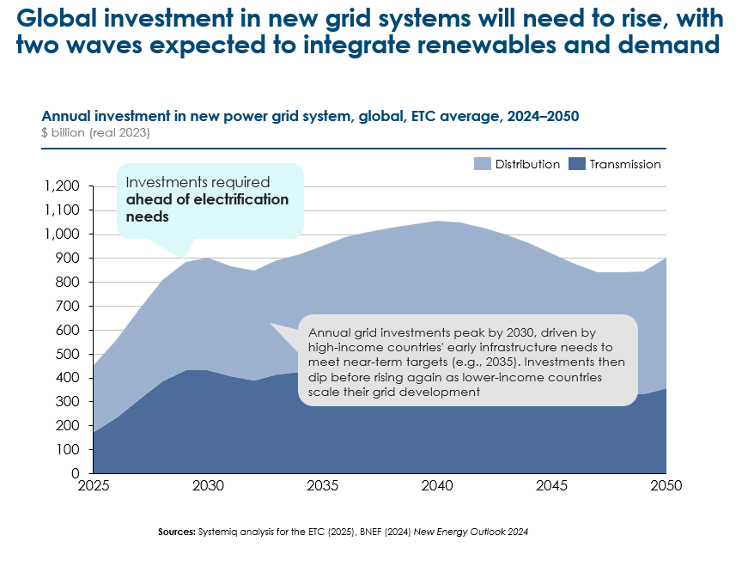
Grid investments are typically incurred by grid operating companies which charge consumers annually for grid service on a mix of per connection, per kW and per kWh bases, with different regulation regimes governing allowable costs and rates of returns. Exhibit 2.12 presents estimates of possible resulting grid service costs on a per kWh basis, where this will result from:
- The total payments which grid companies will receive. We have estimated these on the basis of an assumed allowable rate of return of 5% real. The actual cost of capital will vary significantly but country, but this cost will then be reflected in the allowable rate of return.
- Divided by total electricity demand to produce a per kWh charge.
At a global level, this analysis suggests that average grid service costs per kWh could rise slightly from now until 2040 but then fall back to today’s level by 2050. The initial increase is due to the upfront investments needed to build and reinforce the grid infrastructure ahead of rising electricity demand. Some of this investment is not driven by the energy transition; a third involves replacing ageing assets in developed countries.
At the regional level, several key insights emerge [Exhibit 2.12]:
- In the UK, an initial increase in cost per kWh is driven by upfront investments needed to build and reinforce the grid infrastructure ahead of rising electricity demand. The cost then decreases as demand increases faster than the rate of grid repayment from around 2035.
- China’s annual grid investments ramp up quickly until 2030, then slow as grid build out approaches completion. Demand in China is expected to continue to increase at a constant rate until 2050, driven by further electrification and growth. The grid cost per kWh therefore decreases after 2030.
- In India, grid investment is expected to keep up with demand until 2050, with roughly constant costs per kWh.
- In Spain, demand growth accelerates from 2030 onwards, while grid investments rise leading to steadily increasing grid costs per unit demand in the 2020s, which stabilises after 2030, but at a higher level than today.
Given the several assumptions required in this analysis, the figures on Exhibit 2.12 should be treated as illustrative indicators of broad levels and trends, not precise predictions. But they illustrate two key points.
- Grid service cost per kWh are in most countries likely to remain broadly at the same level between now and mid-century.
- However, moderate increases and decreases might result from the balance between total grid investment (and subsequent cost recovery charges) and total electricity demand.
This highlights the vital importance of ensuring a balance between the pace of grid expansion and the pace of electricity demand growth, avoiding either:
- Grid investments failing to anticipate demand growth which has a result might be constrained by grid capacity shortages
- Electrification is proceeding much slower than grid capacity expansion , resulting in increased per KWh charges for grid services,)
Exhibit 2.12
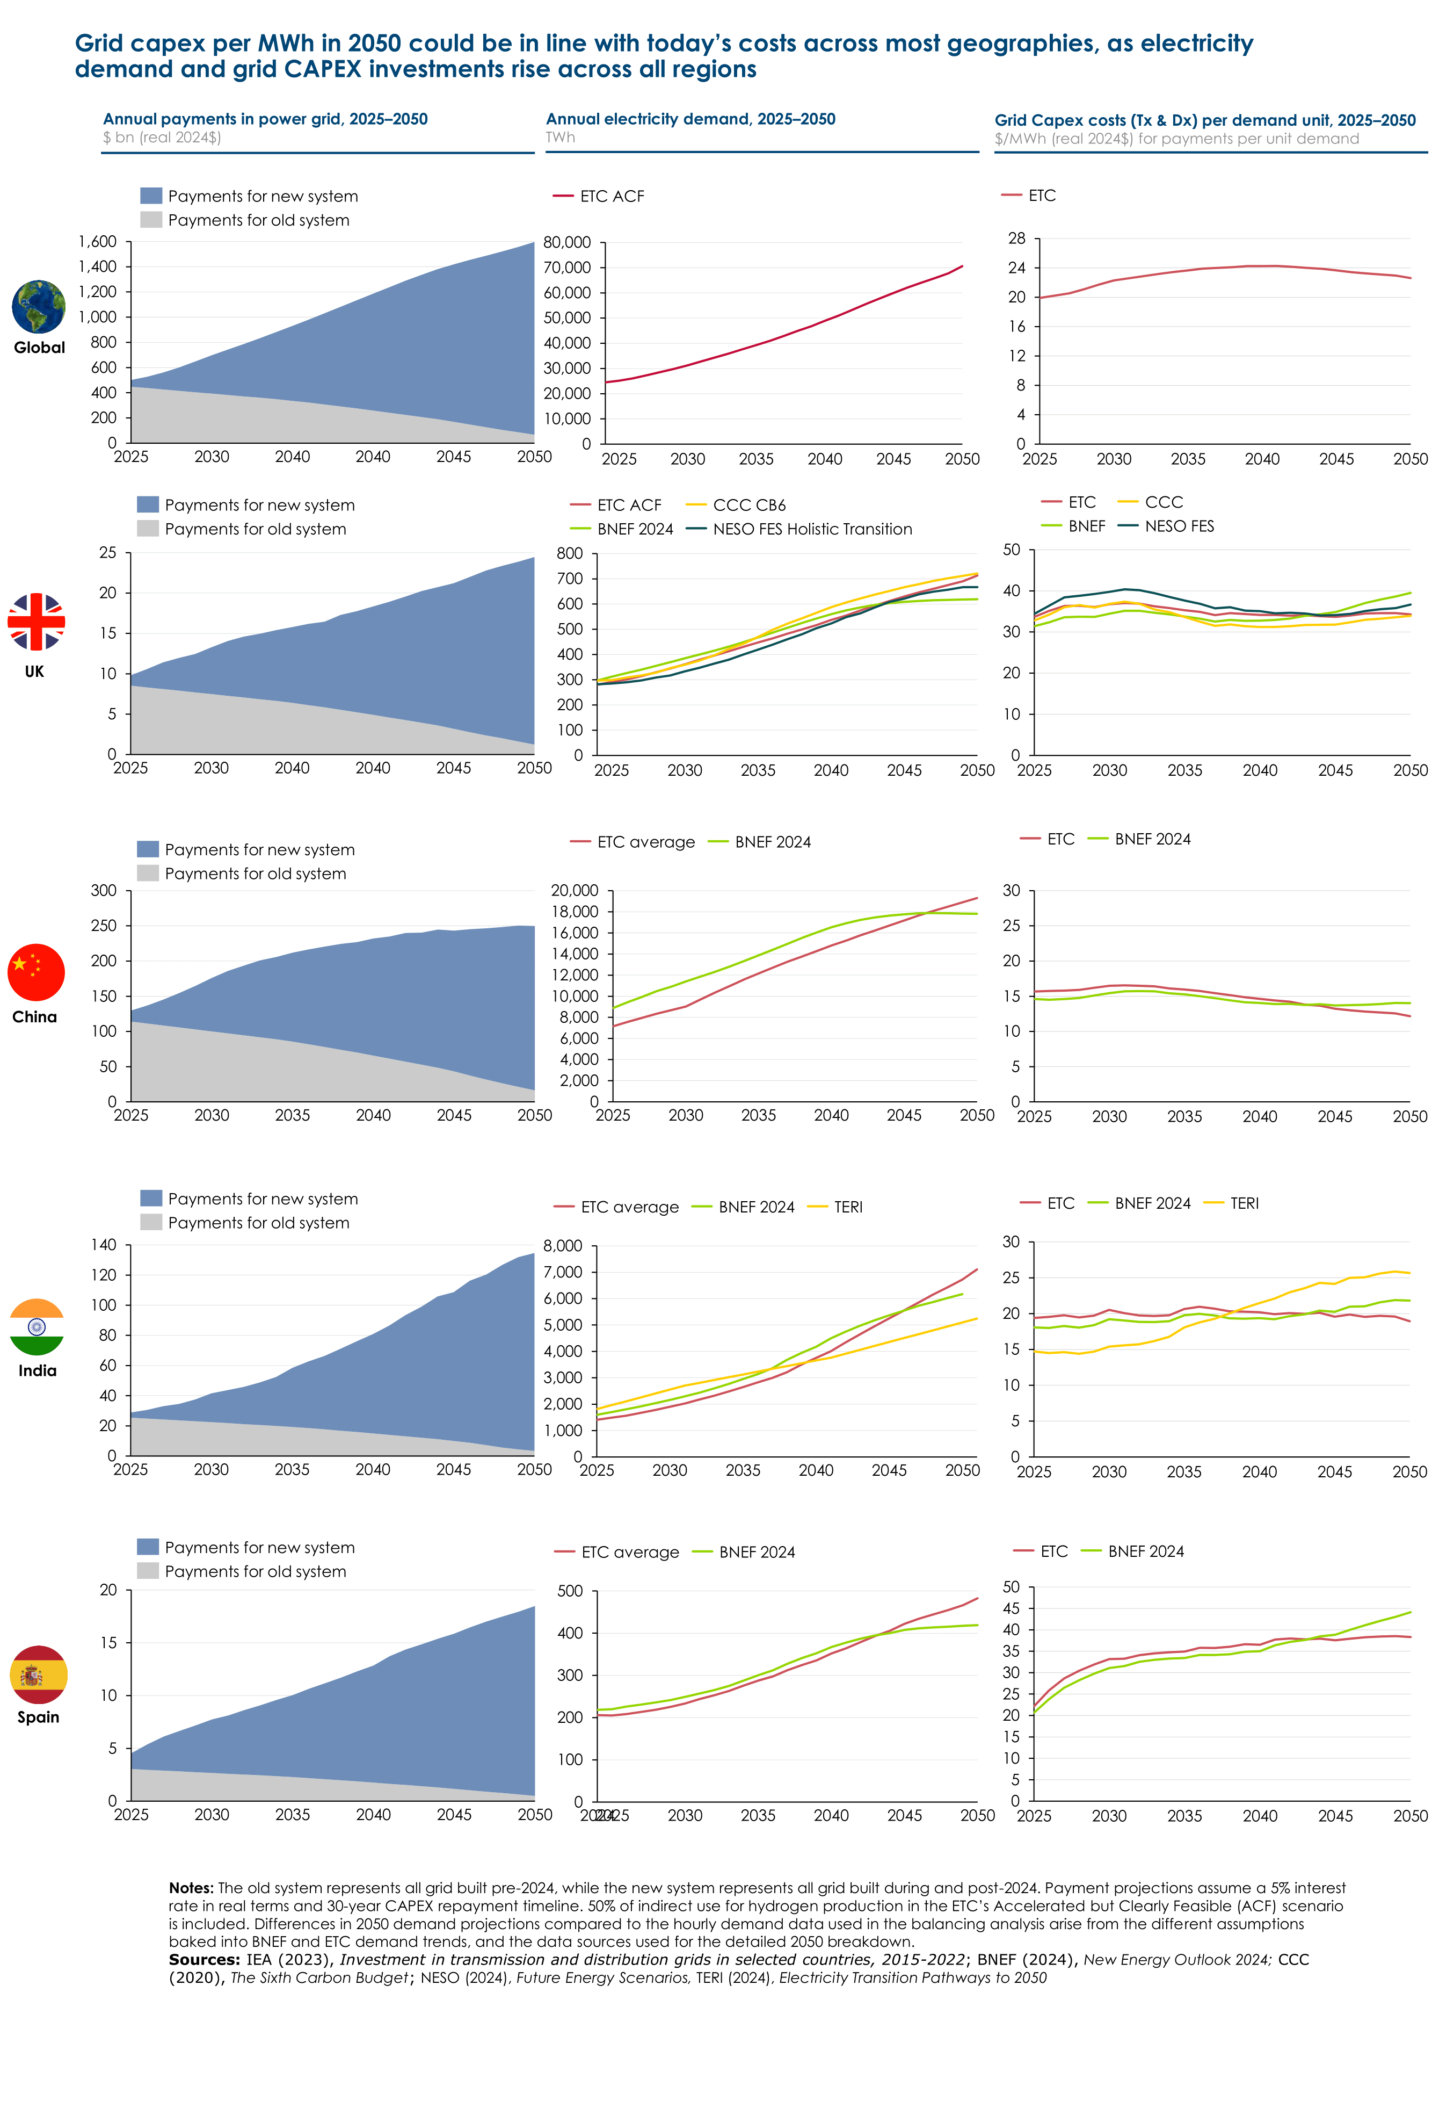
The estimates for grid investment presented above, and the resulting grid service charges per kWh implicitly assume some level of application of the levers which could reduce grid investment costs as discussed in 2.3 – demand side flexibility, innovative grid technologies (IGTs), and optimal location of supply, storage and demand. Maximum use of these leaves could significantly reduce grid charges below the baseline levels indicated in Exhibit 2.12.
- As discussed in Section 2.3.2, estimates by CurrENT suggest that IGTs have the potential to increase grid capacity in Europe by 20-40% by 2040., significantly reducing the need for investment in new line and equipment capacity.
- A reasonable deployment scenario suggests that maximum application of IGTs could reduce cumulative required investments in European networks between now and 2050 by $1.3 trillion or 35%.
Policies which encourage maximum possible use of demand side flexibility and IGTs , and encourage optimal location of supply , storage and capacity are therefore vital
Exhibit 2.13
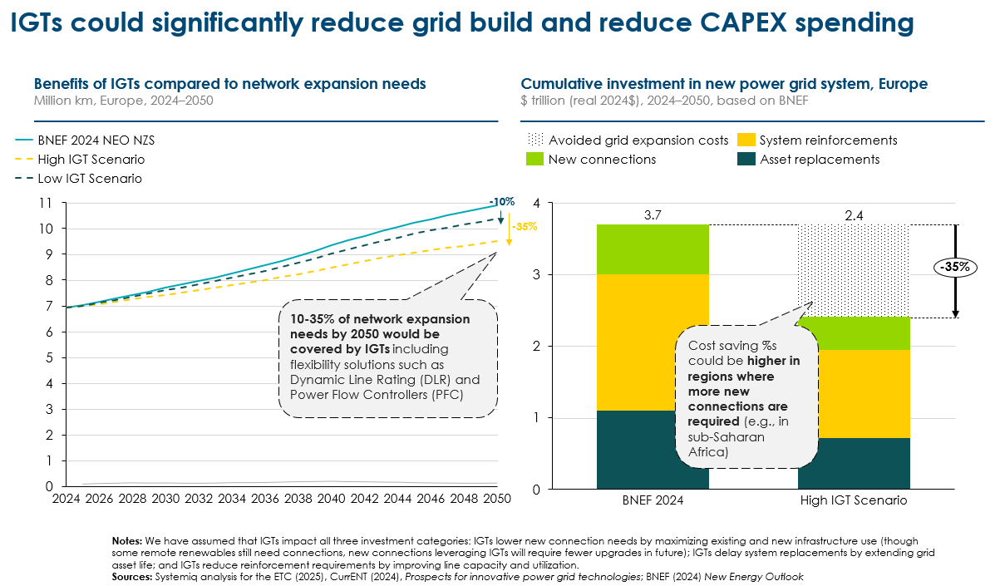

- Implementation and policy priorities
Delivering decarbonised and electrified economies will require major expansion, reinforcement and upgrade of transmission and distribution networks, but the scale and cost of this investment could be significantly reduced via the levers described in Section 2.3.

Key implementation and policy priorities are therefore:

- Setting clear strategies for decarbonisation and electrification, which identify the need for grid investment in anticipation of demand growth but also ensures that demand growth rapidly follows to utilise grid capacity, reducing the cost of grid services per kWh

- Designing regulatory approaches to grid investment which create incentives for the use of IGTs; these can reduce both the cost and disruption of new infrastructure development where technology makes alternatives available.

- Developing power market designs which ensure that the implications for required grid investment are taken into account in locational decisions on new supply, storage and demand.

- Maximising the potential for demand side flexibility by facilitating the development of time of day pricing.

- Streamlining planning and permitting systems to allow faster development of major new grid infrastructure developments, while seeking social acceptance via use of IGTs to reduce scale of new build where possible, improved pylon designs and payments to affected households.

- Identifying potential supply chain constraints, which could slow the pace and increase the cost of grid expansion and developing targeted public policy actions (e.g. development bank finance for new investment) which could overcome these. Key current concerns relate to supply of transformers, HVDC cable and cable laying ships. Skill shortages could exist for linesman and power engineers. Investment in new or expanded copper mines will be needed to ensure adequate long-term supply.

The details of these required actions were described in the ETC‘s 2024 report, Building grids faster: the backbone of the energy transition [Exhibit 2.14].
Exhibit 2.14
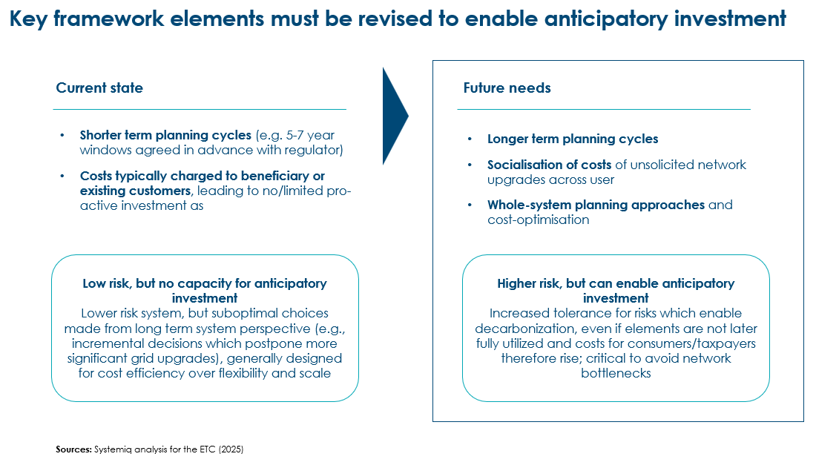

- Total system wholesale costs in the long-term and during transition
Chapter 1 concluded with estimates of total system generation cost in 2050 in four different regional archetypes and chapter 2 analysed the challenge of building grids, the potential for reduced cost via the use of demand side flexibility and innovative grid technologies, and the resulting implications for grid service costs per kWh. In this chapter, we look at the implications for total wholesale system cost of electricity supply in both the long and short term. Key conclusions are that:
- In the long-term, total system wholesale cost per kWh in power systems with high VRE shares could be significantly below the cost of today’s fossil fuel based systems in low latitude sunny countries, Mediterranean climates, and in China. They could be somewhat lower than recent wholesale electricity prices spikes in high latitude countries which will depend primarily on wind resources.
- It is also vital to focus on the cost of the transition, particularly in high latitude countries which are currently dependent on expensive gas supply. Speeding the transition to future potential lower costs will require careful policy design. In early 2026, the ETC will publish a detailed report on the issues relating to consumer power prices over the short- to medium-term.
- Total system wholesale costs in the long-term
Exhibit 3.1 combines the analysis of total system generation cost presented in chapter 1 and the analysis of potential future grid cost per kWh in Chapter 2. This combination represents total system wholesale cost but does not include other bill cost components such as the cost of customer contact and billing, electricity supplier margins, taxes, or other levies.
Key findings are that:
- In sunny, low-latitude countries (India case study), total system wholesale costs in 2050 could be around $50/MWh. This is significantly below wholesale prices in today’s fossil fuel based systems.
- In Mediterranean climate countries (Spain case study), costs could also be significantly below current levels, at around $80/MWh.
- In Mixed Climate countries (China case study), future clean power system could be achieved at cost significantly below today’s wholesale cost of around $73/MWh.
- In the high latitude archetype (UK case study), wholesale costs in 2050 could be around $130/MWh. This is slightly above the level seen in the 2010s, and slightly below the high levels seen in the early 2020s.
The key difference is driven by total system generation cost, as explained in chapter 1. However, differences in grid cost, potential cost of technology and installation also can play a significant role. Key points are that:
- Sunny low latitude countries (e.g. India, Thailand, Mexico, and much of Africa) are projected to have the lowest total system costs. This is primarily because of the collapsing cost of solar PV and batteries, and the dominance of the diurnal short-duration balancing challenge. In addition, many developing economies are building new grid infrastructure, allowing them to design systems better suited to renewables and modern technologies with fewer legacy constraints and lower need for widespread retrofits.
- Mediterranean climate countries (e.g. Spain, Australia, California, and Chile) will likely reach similar or lower costs given abundant solar and in some cases wind generation resources.
- China, a continental scale mixed-climate country, is projected to enjoy relatively low costs. This is partly the result of lower capital costs of products and installation. However, it also reflects China‘s opportunity to use domestic long-distance HVDC lines to connect areas of abundant cheap VRE resource with demand centres, and to interconnect different VRE resources which have uncorrelated supply patterns. The US should also, in principle, be able to enjoy this continental scale mixed climate advantage, but only if it develops more integrated power systems via investment in long distance transmission.
- High latitude countries (e.g. UK, Germany, and Japan) are expected to have significantly higher total system wholesale costs than in the other regional archetypes. This reflects a combination of (i) the dominance of wind (and in particular offshore wind) in power generation (ii) The significant need for more expensive ultra-long duration storage (iii) the need for extensive replacement, reinforcement and upgrade of existing grids which were designed around a fossil fuel-dominated system and (iv) higher project installation costs than India and China, and significantly higher product input costs than in China.

Exhibit 3.1
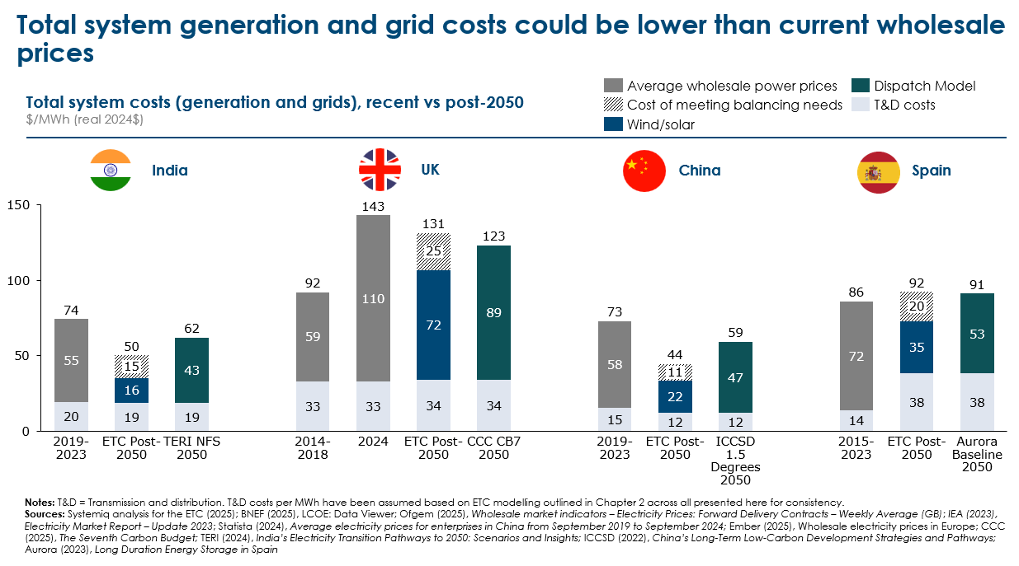

- Total system costs during the transition; policies to speed cost reduction
As described above, it is highly likely that by 2050 it will be possible to run power systems with high shares of variable renewables (e.g. 60+%), at total system costs lower than today’s fossil fuel-based systems. However, the cost to consumers during the transition is also important and, in several countries, whose current power systems are dependent on imported gas, electricity costs increased in the significantly early 2020s. This has led to claims that the transition to a zero-carbon power system is increasing, rather than decreasing, power system costs.
This section therefore considers:
- The drivers of recent trends in electricity prices in the high latitude countries in Europe.
- Likely trends in total system cost over the short term: the UK example
- Key policies to speed the transition to potentially lower long-term costs.
- Managing the rundown of gas distribution networks: a significant issue in many high latitude countries
- Causes of recent trends in electricity prices
Over the period 2021 to 24, Europe experienced significantly higher electricity prices than before 2020. In some cases, prices have returned to the previous level but in several they are still significantly higher than in the 2010s (see Exhibit 3.2). The most important driver of these increases was the price of gas in Europe which increased dramatically after Russia’s invasion of Ukraine in 2020, with increases in LNG prices also having an effect on electricity prices in some other regions. But cost related to the early stages of the transition to zero carbon power also played a role.
(Exhibit placeholder: the rise and fall of consumer electricity prices in e.g., Germany , France , Spain and UK 2022 – 25)
Gas prices setting the marginal cost of electricity: The fundamental driver of volatile electricity prices in Europe is that the wholesale price of electricity is primarily determined by the cost of gas even though gas generation accounts for a relatively small and declining proportion of the generation mix. In 2022, natural gas was the price setter for 63% of all hours across the EU even though it only provided 22% of electricity [Exhibit 3.2].
In some cases, for instance in France, large corporates can be shielded from the resulting volatility by fixed price power purchase agreements (PPAs); and at the generator level, an increasing share of renewable electricity supply is covered by forms of partially fixed price contract, e.g. contracts for difference (CfDs). But this still leaves most consumers and businesses exposed to prices varying with the price of gas, while supplies of renewable power which are not covered by fixed price contracts receive high economic rents when gas prices are elevated.
Exhibit 3.2
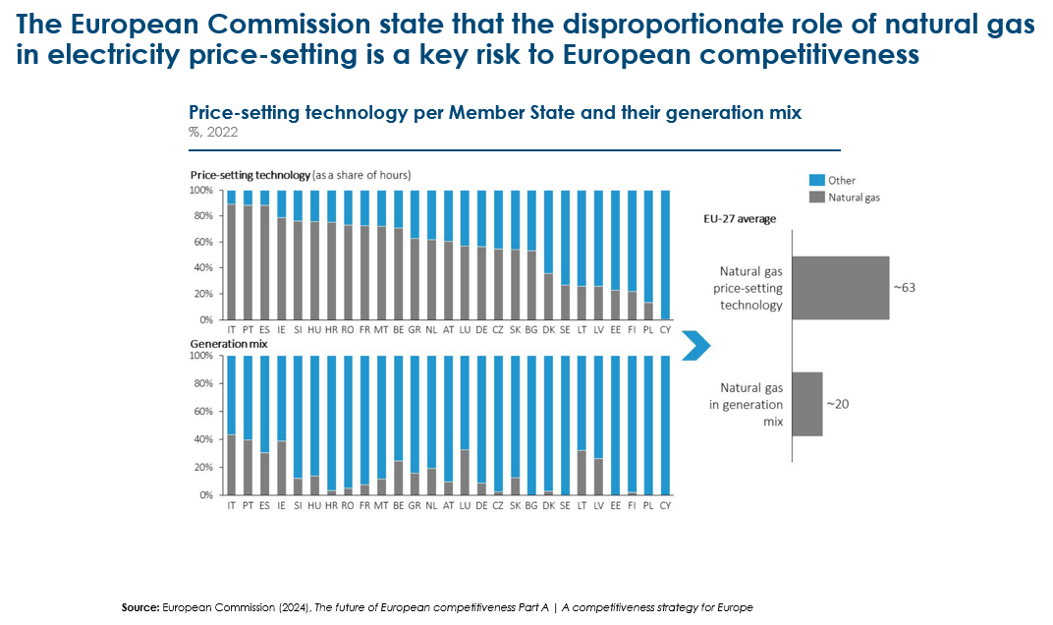
Initial costs of the energy transition: In addition, however, costs related to the early stages of the power system transition, and decisions on how to recover these, have played a role in increasing electricity prices in some countries. Exhibit 3.3 shows key determinants of the increase in a typical UK consumer’s annual electricity bill between 2015 and 2025, rising from around £450 to reach £1300 in 2022- 23, and then falling to around £900 today. The most important driver of this increase was the wholesale price of electricity, set primarily by the marginal cost of gas generation and therefore reflecting variations in the gas price. But three other factors have also been important:
- Rising network and balancing costs: These reflect the costs of upgrading the U.K.’s aging electricity grid to handle new renewable sources and to build capacity ahead of growth in electricity demand. As Chapter 2 discussed, if electrification does not rise fast enough to match increasing grid capacity, grid service cost per kWh will increase. It also reflects rising costs within the Balancing Mechanism, by which the National Energy System Operator (NESO) brings actual electricity dispatch in line with physically possible transmission, and which often requires high “constrain on” payments to gas generators and “constrain off” payments to renewable suppliers. These additional costs will only disappear at the end of contract terms.

- Policy costs related to early stage subsidies for renewables: Looking ahead, renewables have the potential to deliver electricity more cheaply than fossil fuels. However, subsidies were needed to stimulate the early stages of renewable deployment when costs were significantly higher. Feed-in tariffs were initially used to deliver fixed prices for renewable supply which were well above average wholesale prices. Renewable Obligations Certificates (ROCs), which provided explicit subsidies per kWh above the wholesale price, were subsequently deployed. CfDs can, in theory, result in payments either to or from VRE providers, but until now have mainly been a net cost to the system.

- Other social and environmental levies used: to recover the costs of social and environmental programs from electricity bills rather than general taxation. These include:
  - Assistance for Areas with High Electricity Distribution Costs (AAHEDC) to subsidise power lines in remote areas of North Scotland.
  - Warm Home Discount, which subsidises winter bill reductions on for poorer households and pensioners.
  - Energy Company Obligation (ECO) which subsidises insulation and heating upgrades in poorer households.
  - Smart Meter Net Cost Change to recover the cost of energy suppliers installing smart meters, in line with their obligations.
In addition, it should be noted that the wholesale price of electricity reflects the impact on the cost of gas generate electricity of the UK‘s carbon tax and of carbon prices within the emissions trading scheme (ETS), neither of which are imposed on gas supply to buildings.
Exhibit 3.3
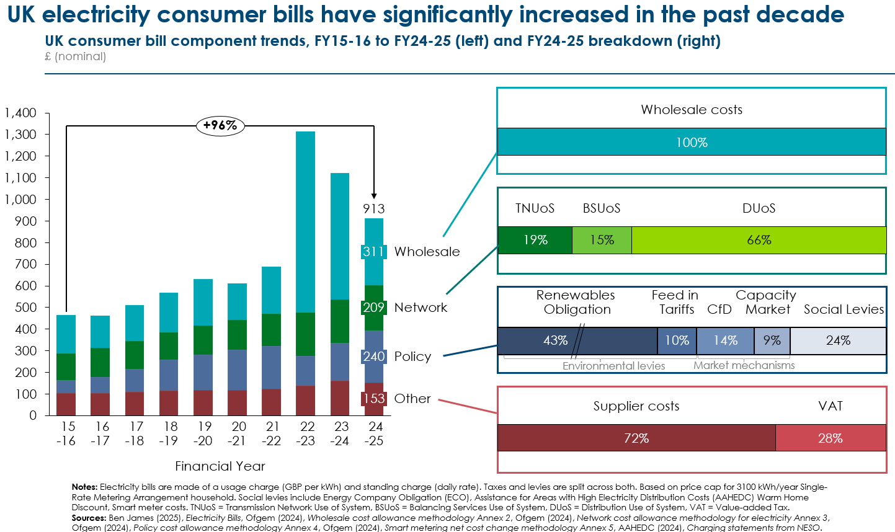
- Possible short term trends in total system costs
Looking forward, the short- to medium-term trends in electricity prices in Europe and other high latitude countries will be influenced by a balance of favourable and adverse factors:
- Prices will tend to reduce as expensive initial VRE contracts expire at the end of contract periods. For instance, the cost to the UK system of ROCs will begin falling from 2027, when support ends for projects accredited on or before 25 June 2008, and will be completely phased out by 2037. Gradually falling technology costs will also tend to reduce the cost of new contracts.

- Aggressive targets to drive early decarbonisation of power, particularly if facing supply-side constraints, may produce short-term cost increases. And as Chapter 1 described, the cost of balancing energy supply and demand will increase as countries drive carbon intensity below the level which can be achieved simply by running fossil fuel plants flexibly.
The UK National Energy System Operator (NESO) has developed an estimate of the potential costs of achieving the UK’s clean power by 2030 target, with the carbon intensity of electricity reaching around 15 g/kWh versus 124g in 2024 (Box G). Their scenarios, as shown in [Exhibit 3.4, suggest that:
- The cost per kWh of a zero-carbon power system in 2030 will be 20 to 40% higher than the eventual UK cost in 2050 suggested by both the ETC‘s illustrative analysis or the CCC dispatch model results.
- In NESO’s lower cost “New Dispatch“ scenario, the eventual costs are still above the average expected cost in the counterfactual scenario which does not accelerate progress and misses the UK’s legally binding carbon targets, resulting in a 2030 grid carbon intensity of 78 gCO₂/kWh. However, the counterfactual scenario would leave the UK consumer more exposed to gas prices, and in some circumstances would generate a higher system cost per kWh.
These estimates highlight the importance of:
- Carefully assessing the costs of more rapid, versus slightly slower transition towards completely decarbonised power systems. A slower path of reduction once low carbon intensity levels have been achieved (e.g., below 75g per kWh). This could help moderate short-term costs and prices and stimulate electrification which, as discussed in Chapter 2, needs to keep pace with power sector decarbonisation.
- Considering the alternative options for “last mile” decarbonisation discussed in Section 1.4.3.3.
- Implementing policies which speed the transition to the potentially lower costs of high VRE systems.

Box G: Case Study: the UK’s 2030 Clean Power target is expected to slightly increase system costs compared to today’s system.
In 2024, the Labour government adopted a 2030 Clean Power target for the UK, and declared a national Mission around the clean power goal. Subsequently, the UK’s national energy system operator (NESO) outlined a feasible pathway to achieving the government’s commitment to clean power by 2030. The clean power target was defined by NESO as “at least as much power being generated from clean sources as Great Britain consumes across the year, and when unabated gas generation makes up less than 5% of Great Britain’s generation in a typical weather year” .
Achieving this will require a shift to a system with high shares of variable renewables, accompanied by flexible storage assets and some dispatchable/firm generation. This has been modelled via two scenarios: Further Flex and Renewables and New Dispatch, which set out achievable pathways:
- NESO’s Further Flex and Renewables scenario is based on high levels of demand side flex and storage, fast deployment of renewables and no new dispatchable power. This results in a carbon intensity of 15 gCO₂/kWh (down from 124 gCO₂/kWh in 2024) is achieved with a system cost of £133/MWh (equivalent to $170/MWh, real 2024).
- NESO’s New Dispatch scenario, lower renewables growth with high deployment of new low carbon dispatchable power (CCS and hydrogen) and nuclear capacity, a carbon intensity of 16 gCO₂/kWh is achieved with a system cost of £126/MWh (equivalent to $161/MWh, real 2024).

Exhibit 3.4
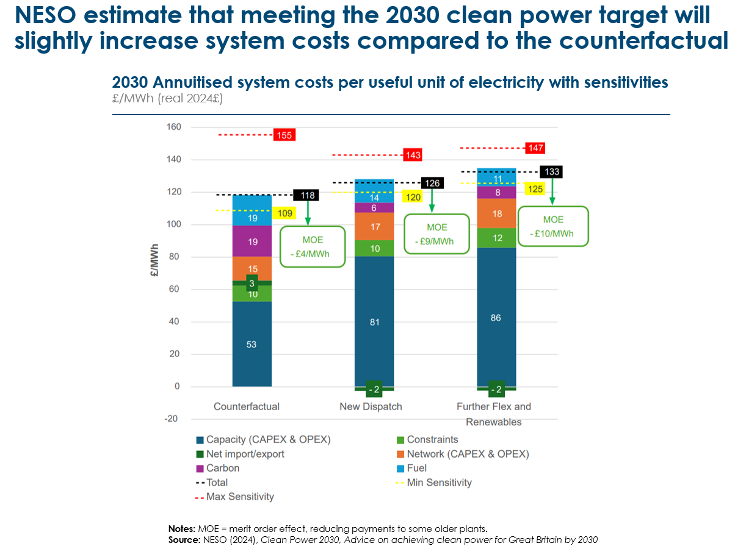
- Policy actions to speed the transition to lower power system costs.
Key policy actions to speed the transition to the potentially lower price systems of the future include:
- Reducing the number of hours where gas sets the wholesale price by rapidly scaling renewables supply, via auctions and well-designed two-way CfDs and corporate PPAs to reduce the exposure of consumers to volatile fossil fuel markets. Zonal or locational marginal wholesale pricing could reduce the exposure of electricity consumers to gas-driven price spikes by ensuring that a smaller volume of demand pays for gas as the marginal producer. Data-driven approaches should be leveraged to increase system efficiency, for example by modernising software systems responsible for system balancing (e.g., redispatch) to improve visibility and deployment of batteries over gas.
- Rebalancing policy costs across gas and/or generation taxation. This could rebalance costs more fairly than the current system, reducing this component of the electricity bill. This would also help make key electrified technology (including electric vehicles and heat pumps) more competitive respect to fossil fuelled counterfactuals.
- Time-of-use tariffs, real-time pricing, or wholesale price signals pricing enabling consumers to shift their electricity use to low, off-peak electricity costs rather than average costs. This is an important tool to align consumer demand with wind and solar supply, to reduce gas reliance in the system. Scaling storage and demand-side flexibility, alongside ensuring that it can play into the system instead of gas (e.g. market access, resolving IT issues).
- Incentivise self-reliance across residential and industrial properties, for example through integrating clean technologies (including rooftop solar, heat pumps, and electric vehicles). This has a significant potential to reduce bills (to zero in some cases, in line with Octopus’ Zero Bill homes initiative in the UK) but also wider network costs as more homes increase their energy self-sufficiency.

- Planning for gas network decommissioning
It is clear that the only way to achieve a very low and eventually zero carbon global economy is through massive clean electrification including the electrification of building heating as described in the ETC‘s recent report on Achieving Zero-Carbon Buildings: Electric, Efficient and Flexible.
As a result, countries which rely on gas to meet extensive building heating needs will have to face the costs of eventually closing down their gas distribution networks. Parts of the long-distance gas transmission and storage network may be repurposed to support the transport of CO2 (for CCS applications) or of hydrogen: and parts may continue to transport natural gas used by large industrial sites equipped with CCS or by gas peaker plants within power systems. Overall, there are relatively limited opportunities to repurpose gas distribution grids in decarbonised energy systems.
The countries most affected by this challenge are high latitude ones such as Canada, Europe, Russia, and Japan, together with northern regions within mixed climate continental-scale countries such as the US and China, though the scale of the Chinese gas grid is small as a result of past reliance on coal rather than gas as a residential heating source.
Countries therefore need to develop clear plans for the eventual decommissioning of gas distribution grids. As part of the European Green Deal and the Fit for 55 policies policy package, Article 52b was passed in December 2023, which mandates natural gas distribution system operators to develop plans to decommission natural gas networks in anticipation of declining gas demand. Implementation will require:
- Developing frameworks for decommissioning gas networks on distribution and transmission level and monitoring network operator implementation at a national level.
- Ensuring that the next Ten-year Network Development Plan, due to start in 2026, is based on a comprehensive joint scenario with detailed information on the parts of the network that should be decommissioned, or repurposed.
- Finalising the methodology for the certification of low carbon gas in a delegated act (the public consultation for which was launched in late 2024).
Equally important is to develop plans for how to recover the remaining costs of the gas distribution network as the number of users declines. If costs are recovered via connection charges per customer, the resulting increase in cost per user may in some cases be socially unacceptable. A balance will therefore have to be struck between creating incentives for gas users to electrify and avoiding severe income effects by shifting the costs from users to public budgets.

- Key enablers for cost effective power system development

Chapters 1,2 and 3 have illustrated that it will be possible to build power systems with very high levels of variable renewable generation and greatly expand transmission and distribution grids, while keeping total system wholesale cost per kWh below, and in some cases significantly below, those seen in today’s fossil fuel based systems. Achieving this will require effective policy design and implementation
Previous ETC reports have described many of the actions required, including:
- Appropriate market design, such as deploying two-way Contracts for Difference (CfDs) to provide revenue certainty and lower the cost of capital for renewable projects – discussed in the ETC’s 2021 power sector report: Making Clean Electrification Possible.
- Reforming planning and permitting processes, particularly by setting clear national deployment targets, enabling digitalisation of permitting, and improving local administrative capacity – covered in the report Streamlining Planning and Permitting to Accelerate Wind and Solar Deployment report.
- De-bottlenecking clean energy supply chains, by expanding critical material processing, diversifying manufacturing bases, and enabling trade in clean energy technologies – covered in Better, Faster, Cleaner: Securing Clean Energy Supply Chains and Material and Resource Requirements for the Energy Transition.
- Scaling grid infrastructure investment and delivery, through anticipatory planning, coordinated spatial development, and regulatory reform – covered in the Building Grids Faster briefing note.
This chapter highlights six categories of government and private sector action required to address the specific challenges of system balancing and optimal grid design and operation (see Exhibit 4.1). These include:
- Setting a strategic vision
- Ensuring that key aspects of market design incentivise efficient decisions and reduce the cost of capital
- Incentivising grid companies to reduce costs via the application of new technology possibilities, while supporting the large scale investments needed.
- Applying digital and AI based capabilities to manage power systems more efficiently.
- Addressing potential supply chain bottleneck.
- Consumer engagement and product design to enable demand side flexibility
Exhibit 4.1
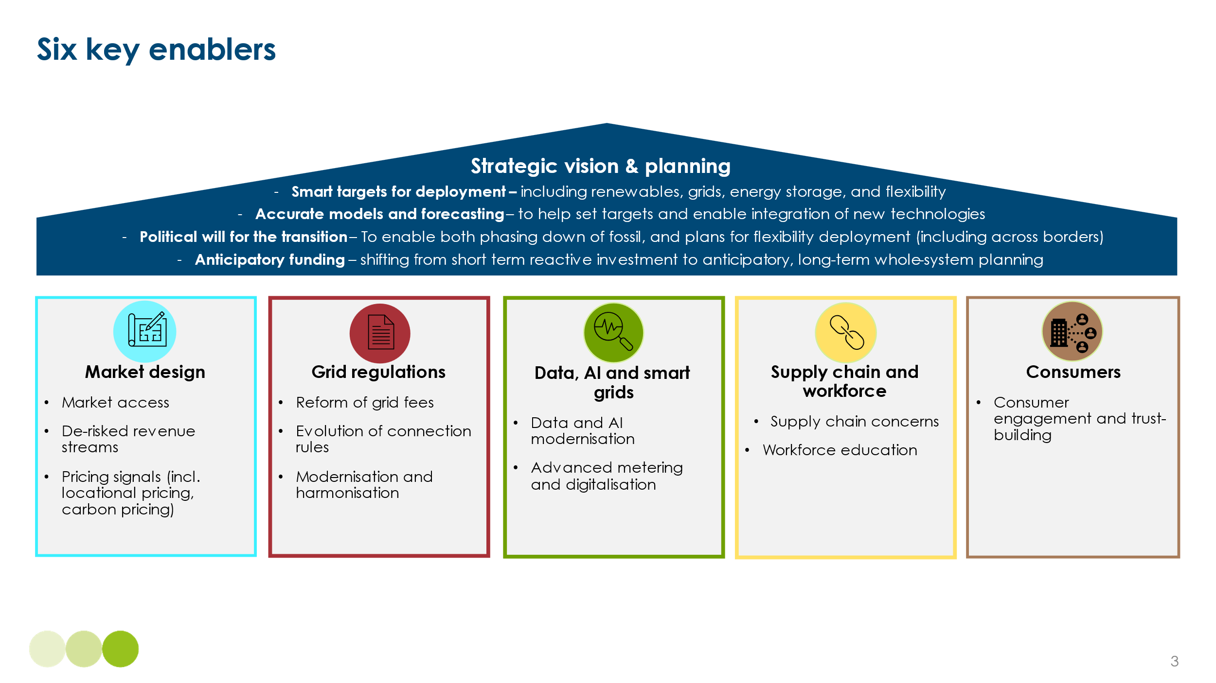
- Strategic vision and planning
Unlike in traditional fossil-based systems, where dispatchable power plant capacity would be scaled incrementally with only limited coordination, the development of systems based on high share of variable renewable generation and supported by multiple different storage and flexibility capabilities, is likely to require greater coordination between different investors and operators. This will be best achieved if there is an overall strategic vision for the development of the power system within which Individual companies can plan their developments. This should include:
- Clear and ambitious emissions intensity reduction targets aligned to overall net zero goals with sufficiently long time horizons to guide infrastructure investment. For example, Chile has implemented a 30-year energy planning process that informs national transmission planning and aligns generation and grid development with climate goals.
- Indicative clean capacity targets covering both generation and storage. In India, the government’s consistent policy support and long-term targets under the National Electricity Plan and Renewable Energy Roadmap have played a key role in accelerating investment in battery storage and grid-scale renewables. The regulatory clarity provided by the Central Electricity Regulatory Commission (CERC), including guidelines for ancillary services and storage participation in markets, has given investors confidence to finance large-scale projects.
- Medium term auction schedules for different types of renewable generation and storage capacity.
These will need to be underpinned by:
- Sophisticated analytical capacity - for instance within electricity system operators, to model likely developments of demand, generation capacity, storage and transmission capacity and degree of consumer response to demand side flexibility opportunities. This modelling can help anticipate possible imbalances between different parts of the system e.g. transmission congestion constraints.
- A willingness to support investment ahead of demand, while also ensuring that electrification policies drive power demand growth broadly in line with the expansion of system capacity
- Market design to incentivise efficiency and reduce cost of capital
Market pricing, determined by competitive bidding can be a key driver of efficiency, and carbon pricing has played a key role in supporting some aspects of decarbonisation within European carbon markets, for instance by driving a shift from coal to gas based operation. But as the International Carbon Action Partnership (ICAP) has argued, its impact on the deployment of flexibility options will be limited.
Instead, the financial viability of projects which meet the balancing challenge will be heavily influenced by the structure of contracts within the markets for electricity capacity and other services.
Electricity markets around the world typically buy and sell electricity ahead in real time (known as ‘wholesale pricing’) with pricing ‘windows’ of 15 or 30 minutes duration, and additional ancillary services being procured directly by the system operator closer to real-time in order to balance the system. Over time, the complexity of market design has increased as additional mechanisms have been introduced; these include fixed or partially fixed contracts for renewables (Feed-in-tariffs, or Contracts for difference), capacity payments, payments for more sophisticated ancillary services (e.g. sub-second balancing), and payments to constrain capacity on or off if the outcome of market trading cannot be physically delivered.
While existing arrangements and reform priorities vary significantly between countries, four areas emerge as particularly important across many national contexts (see Exhibit 4.2).
Ensuring market access for new storage or flexibility options to multiple revenue streams, thereby:
- Reducing revenue risks and cost of capital to support investment in new storage and long distance interconnectors, which require high upfront investment.
- Targeted support for new technologies to reach positive business cases
- Ensuring that price signals incentivise locational decisions, whether for generation or storage, which take account of possible future transmission constraints
Exhibit 4.2
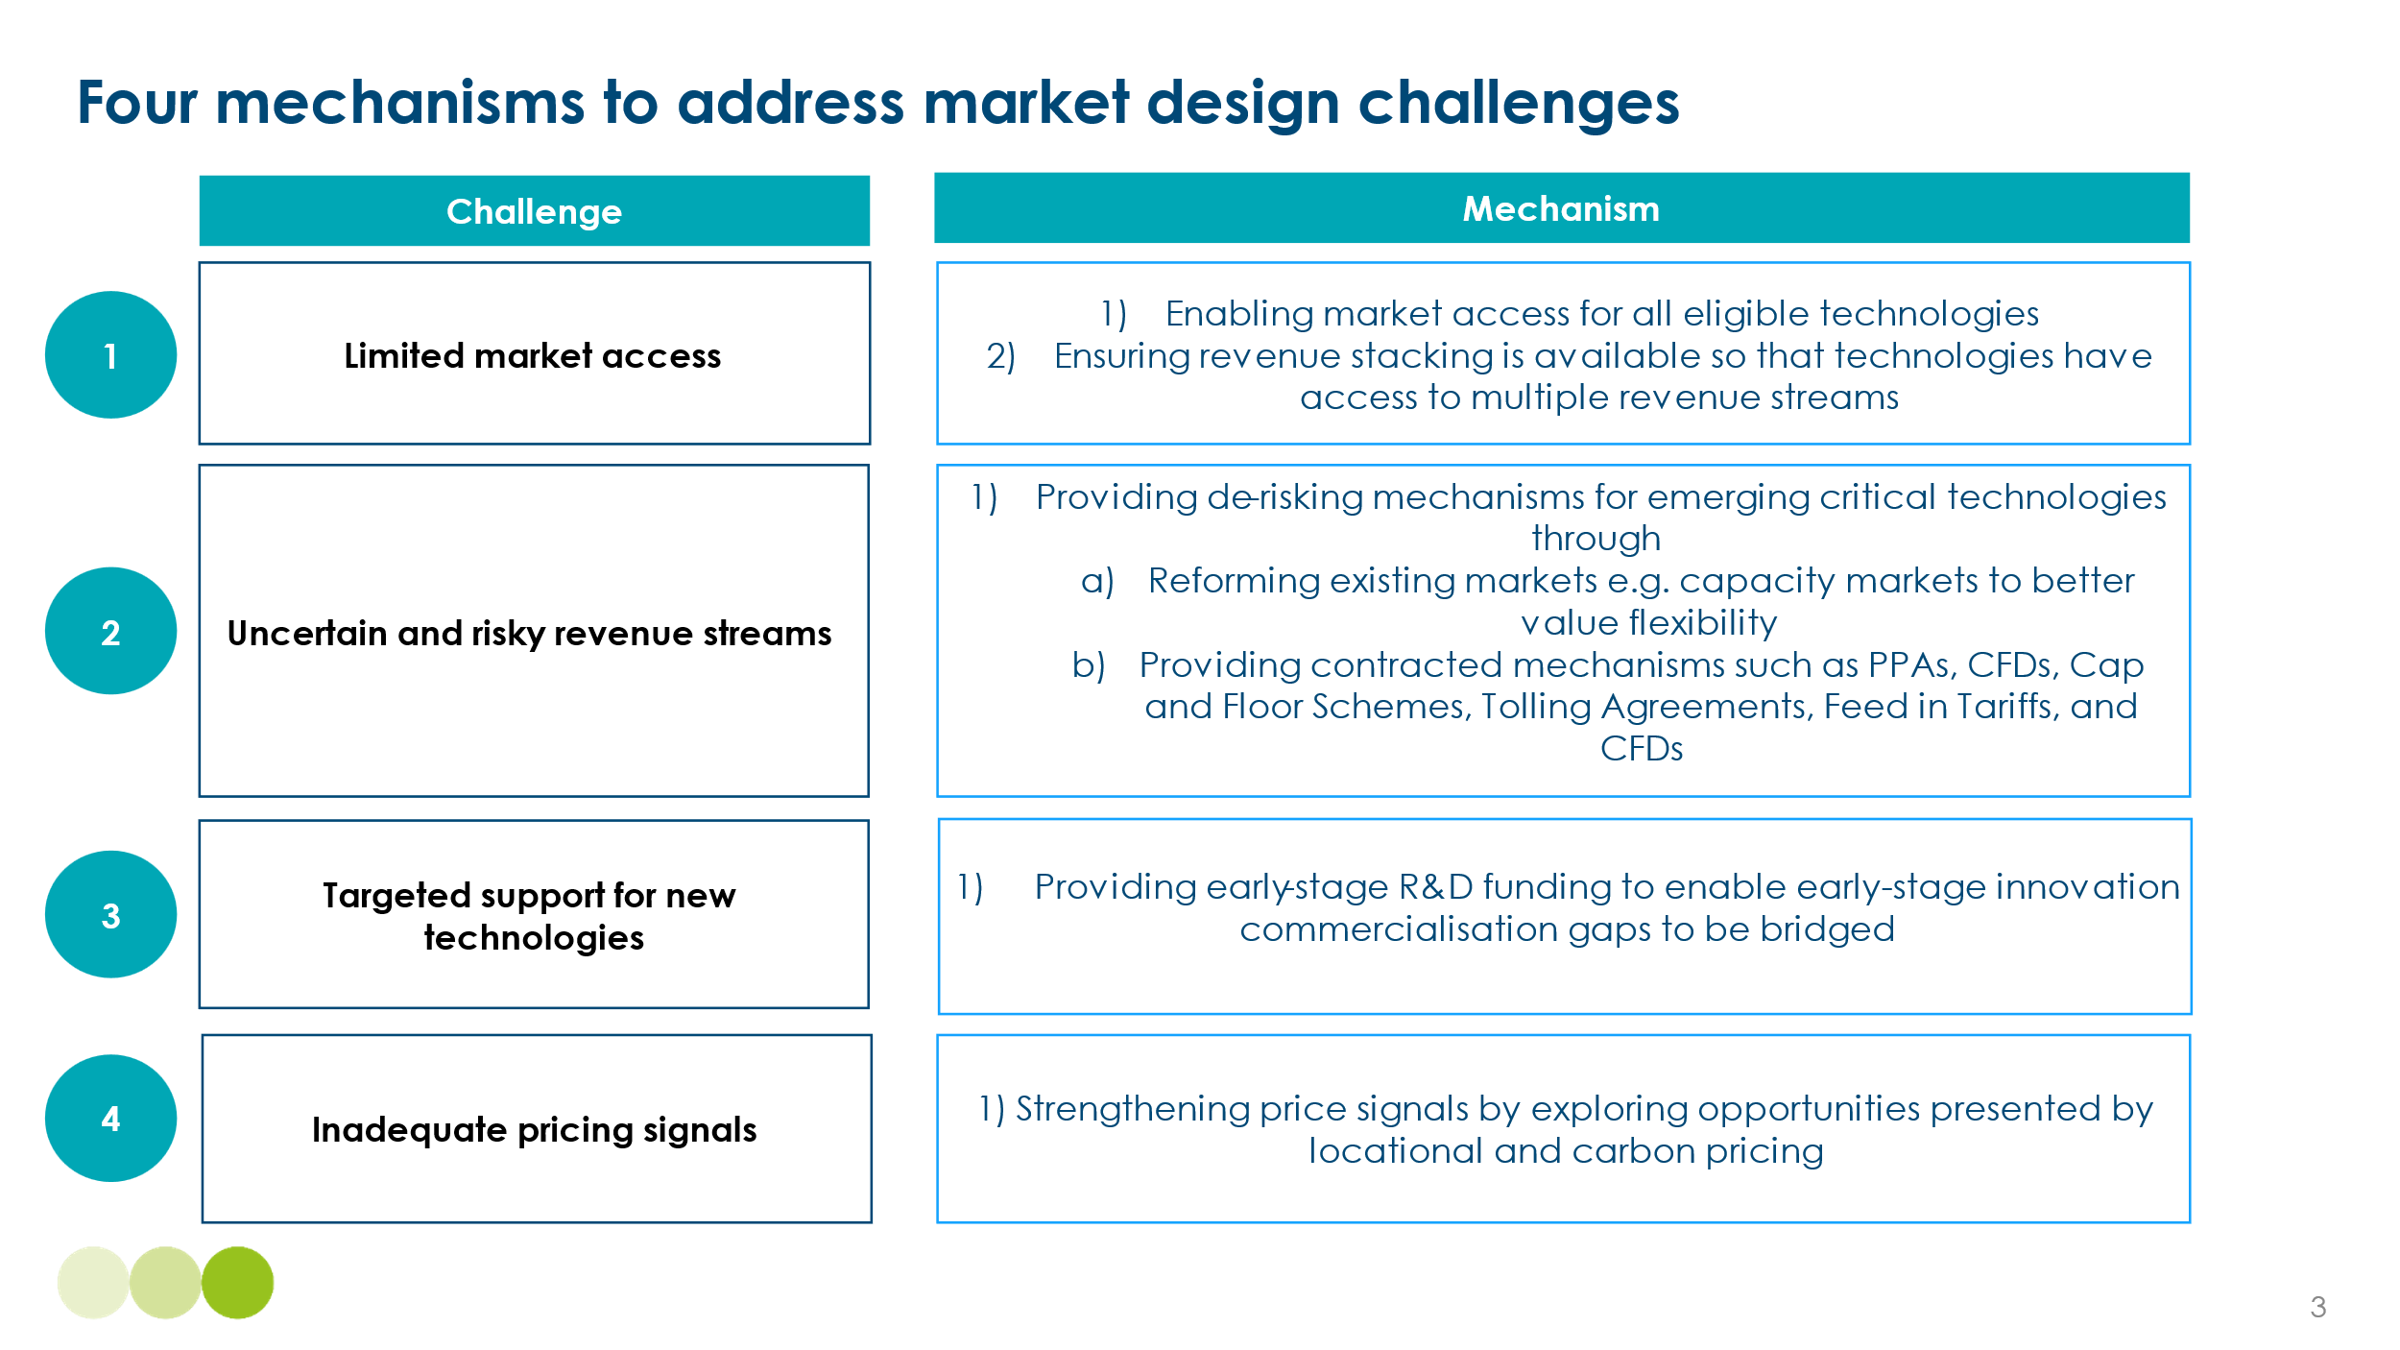
- Multiple revenue stream for storage and flexibility provision
The initial deployment of storage and flexibility technologies has been primarily driven by participation in the ancillary services markets, which focus on very short term grid balancing challenges. Investment on the scale required to achieve the different elements of balancing described in Chapter 1 will likely need to be remunerated by several different revenue streams.
Exhibit 4.3 describes four types of market in which storage and flexibility providers could participate and Exhibit 4.4 shows the role that these might play in different balancing durations highlighting the different roles policy and market design play in enabling investment.
Exhibit 4.3
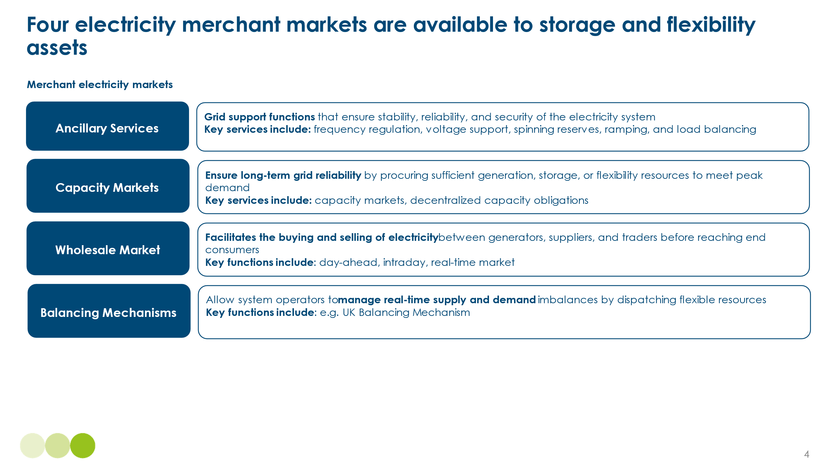

Exhibit 4.4
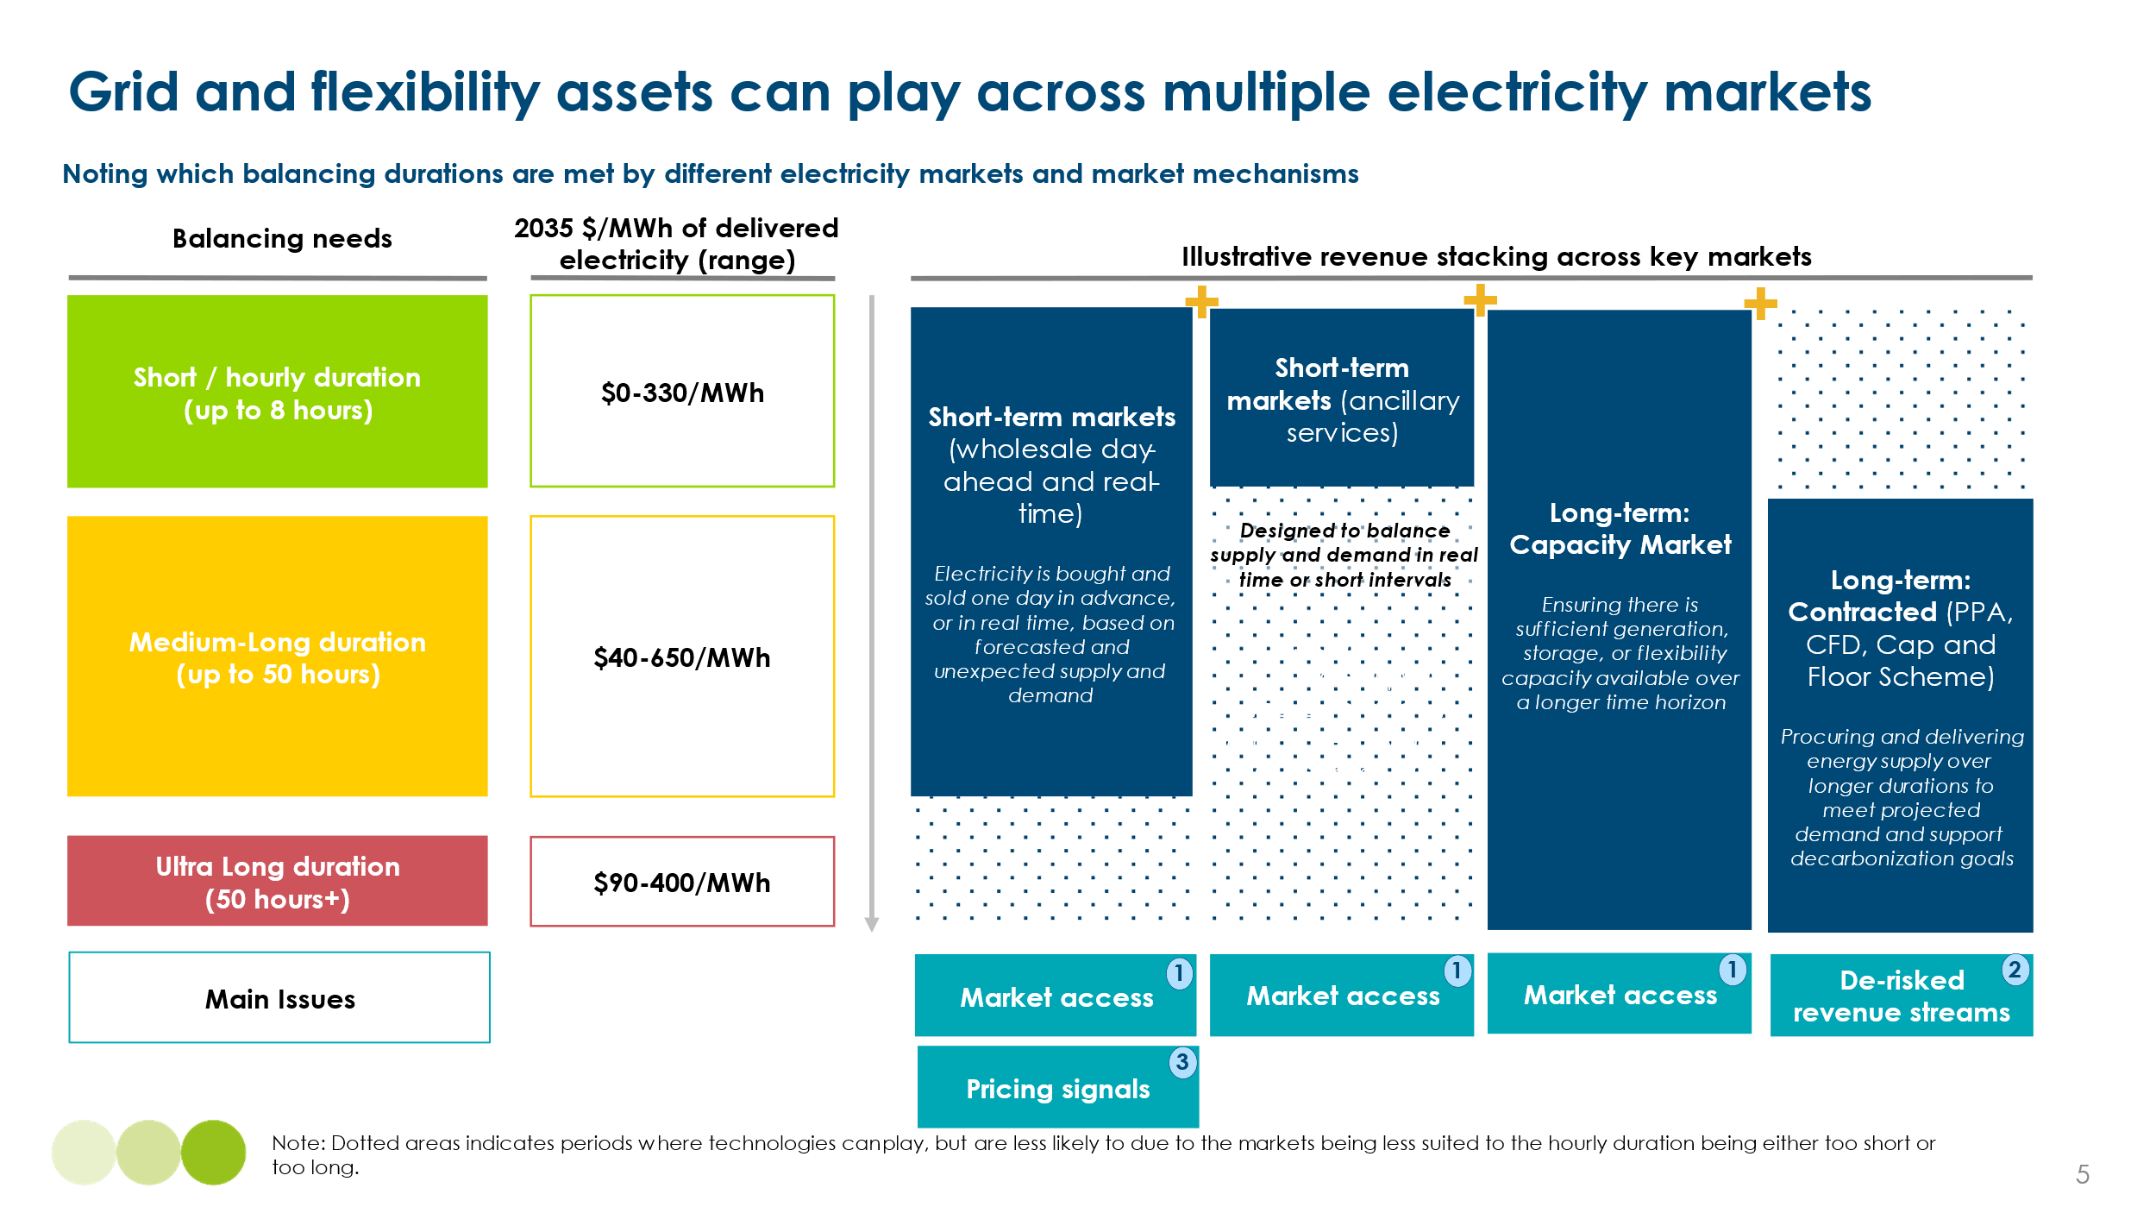
Market access across these areas is growing and moving beyond relying solely on ancillary services. For example, the Tehachapi Energy Storage Project in California successfully accessed multiple revenue streams, including wholesale market participation, energy arbitrage, frequency regulation, and capacity payments. Similarly, in South Australia, large-scale battery projects such as the Hornsdale Power Reserve have benefited from stacking revenues across frequency control ancillary services, energy arbitrage in the wholesale market, and network support services.
Similarly, in the UK, our analysis of storage revenues shows that reliance on a single market, such as wholesale, can leave assets with insufficient revenues to cover costs. This is highlighted in Exhibit 4.5 below, which showcases that when battery storage systems leverage revenue stacking - combining earnings from capacity markets, ancillary services, balancing mechanisms, and wholesale markets - total revenues increase, making storage financially viable and supporting a robust business case.
Exhibit 4.5
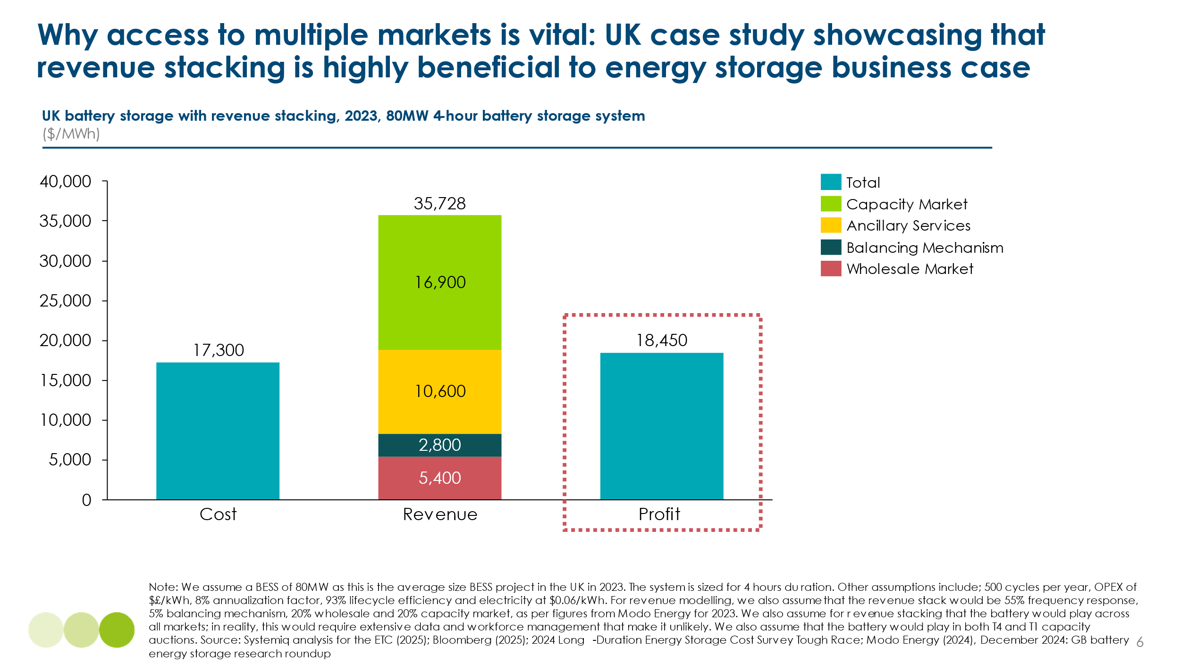
Ancillary services provide a crucial revenue source for flexibility assets, but these markets can face declining revenue opportunities as more assets participate, particularly in ancillary services due to its inherently small market size. This is showcased in Exhibit 4.6 below, highlighting the declining revenues from ancillary services in the UK due to market saturation.
Exhibit 4.6
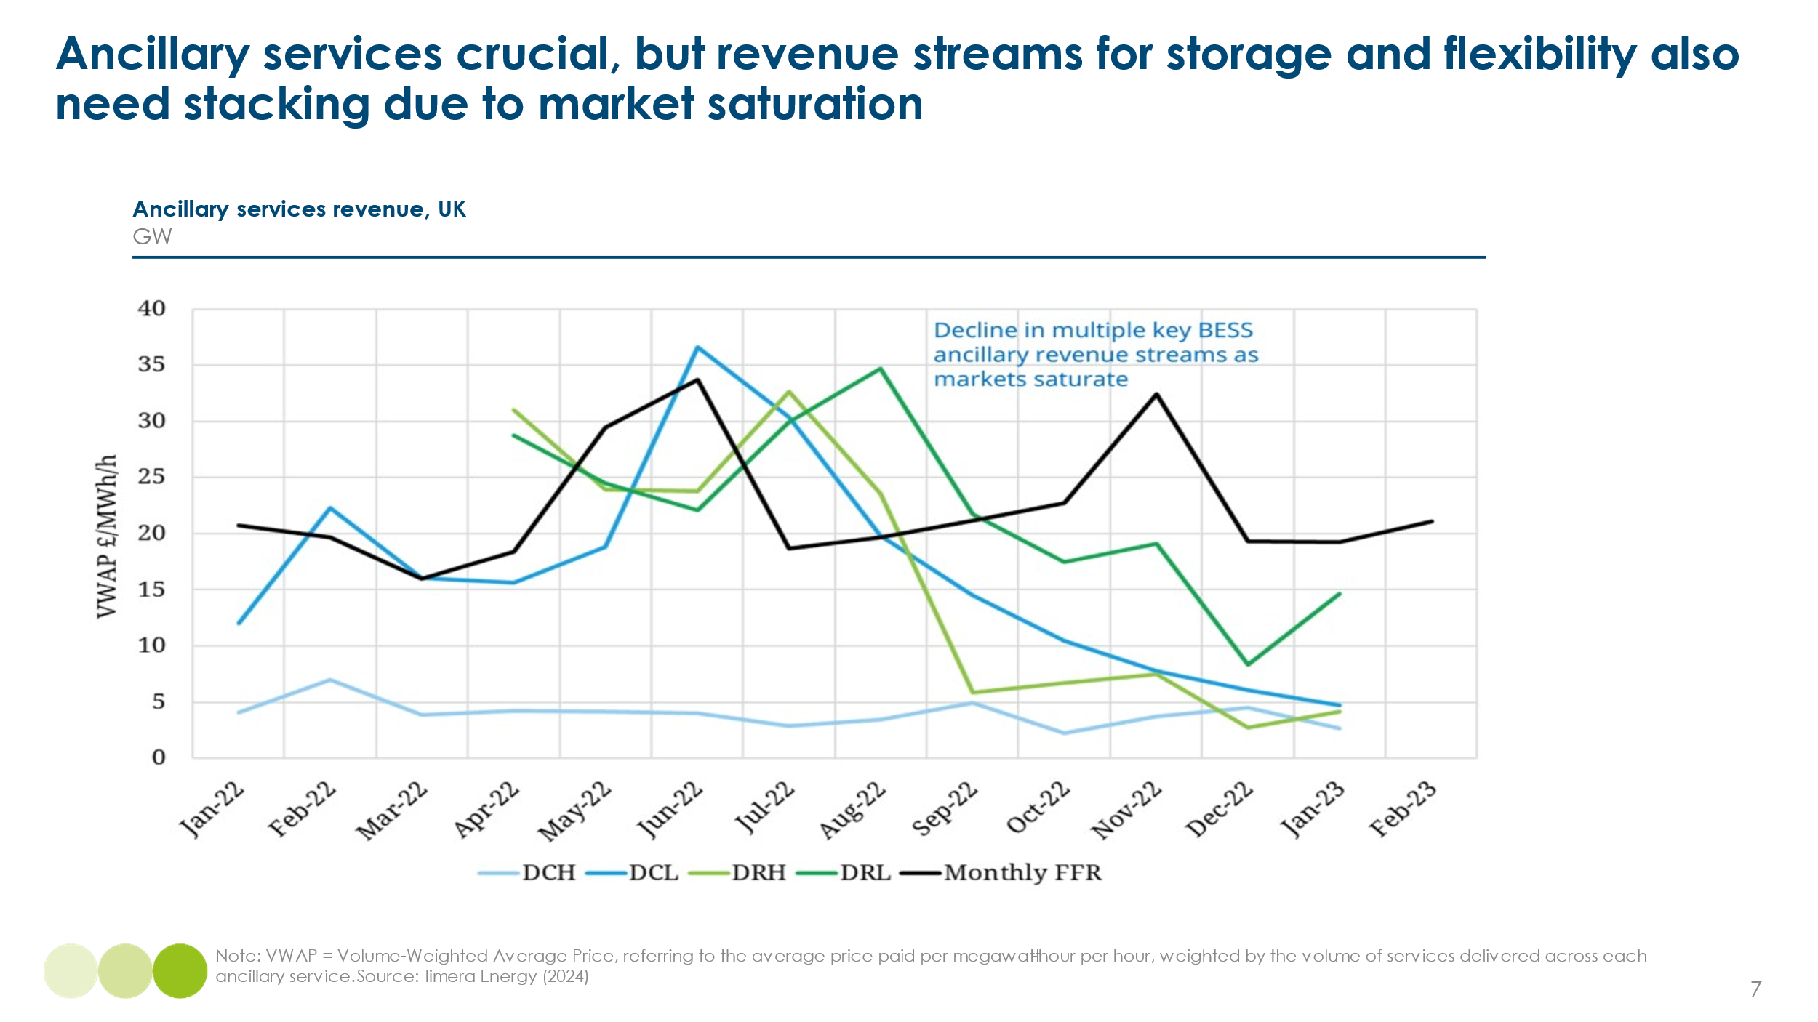
Revenue stacking is therefore essential to deploy flexibility assets, and ensuring storage can access multiple revenue streams is key to scaling deployment.
- Reducing revenue risk to lower the cost of capital
Many of the options available to achieve systems balance described in Chapter 1 will require high upfront capital investments and lengthy payback periods. Some will entail lengthy development phases before the start of operations and revenue receipt. This is particularly true of longer duration storage projects and long distance HVDC lines. The cost of capital (i.e. required rate of return) will therefore be a key determinant of project economics. If projects are remunerated by participation over time in fluctuating wholesale markets, uncertainty about future revenue streams will increase the cost of capital.
This challenge also existed historically in the development of wind and solar generation projects, and various contract structures emerged to reduce revenue risk by ensuring fixed or partially fixed prices for a share of power generated. These types of contracts will also need to play a role in storage, flexibility and long distance interconnector projects.
Exhibit 4.7
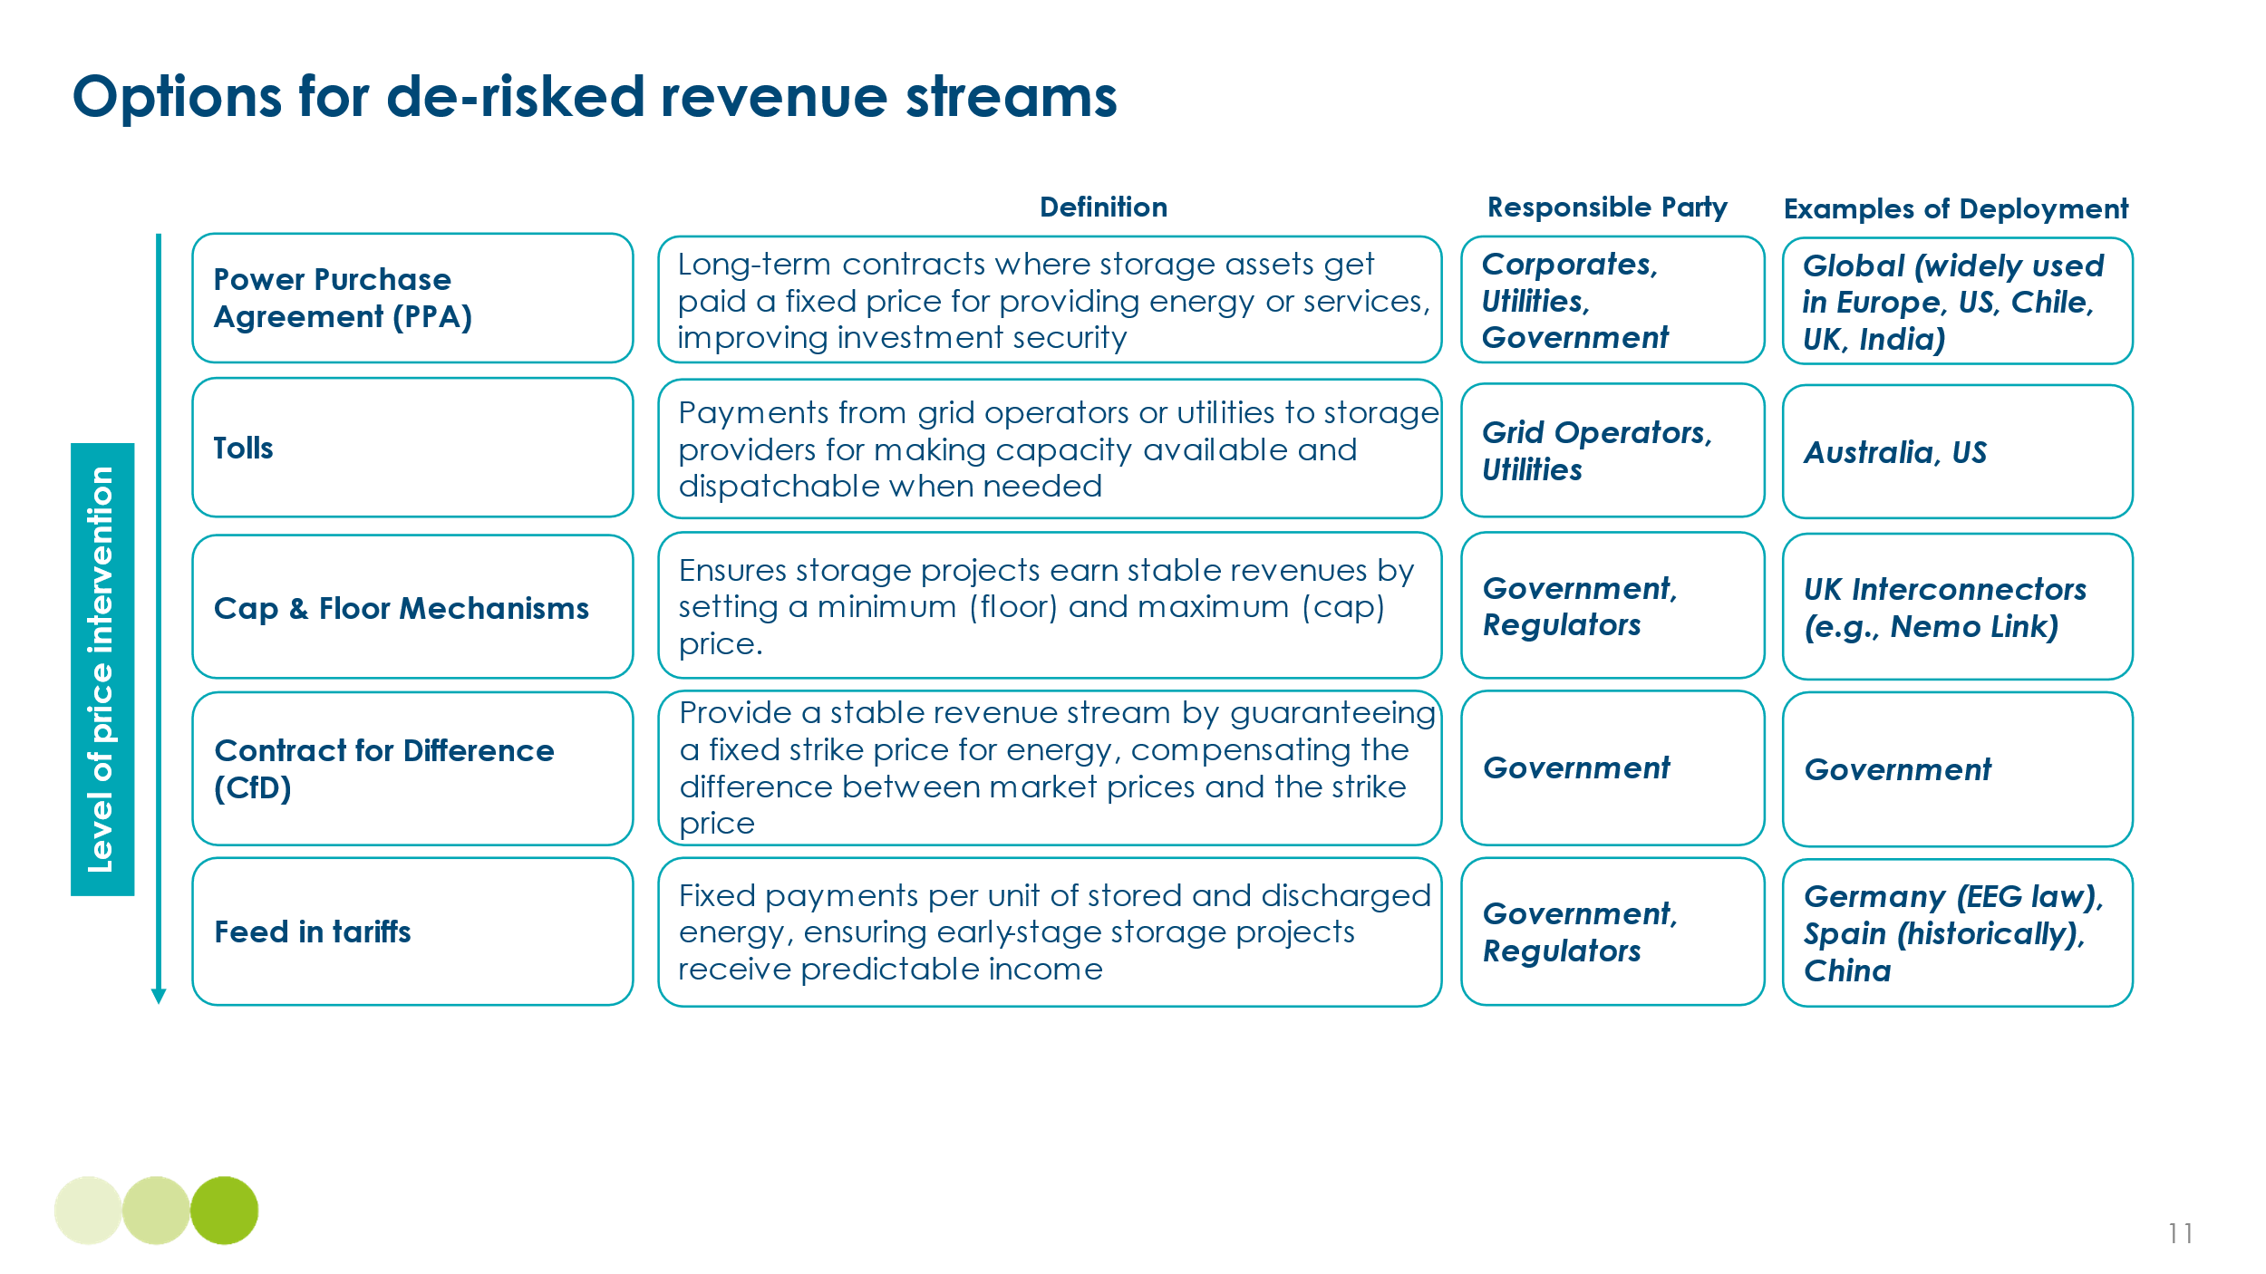
In implementing derisking mechanisms, governments and system operators should seek to balance the benefits of revenue certainty (and thus reduced cost of capital) with the benefits of some exposure to market competition. This implies:
- Maintaining some exposure to market prices to encourage technological and business system innovations and short-term operational efficiency
- Enabling significant competition between different flexibility technologies (e.g. batteries, pumped storage, demand response and interconnectors) while providing adequate support for new technologies in early stages of development
- Adapting mechanisms as markets mature for instance as costs decline and the need for any element of subsidy reduces
Policies and market structures aimed at reducing revenue uncertainty can involve separate contracts for generation and storage. An alternative approach is to require developers to bid to supply electricity on a round-the-clock basis, bundling together combinations of generation sources, storage technologies, and potentially demand-side flexibility to meet delivery commitments at the lowest cost. This model, successfully applied in India, shifts the focus from securing revenue for individual inputs (e.g. solar, wind, batteries) to providing certainty for the desired output: reliable, 24/7 electricity. Box H below describes India’s successful use of this round-the-clock contracting mechanism."
[Box H: Round-the-clock contracts in India (to follow)]
Exhibit 4.8 illustrates the cost, revenue, and profit gap between short duration and medium-to-long duration storage, even where both have access to revenue stacking. This highlights the need for structured funding mechanisms to support long-duration storage, not only due to higher technology costs, but also because current market designs fail to adequately value or incentivise longer-duration flexibility.
Exhibit 4.8
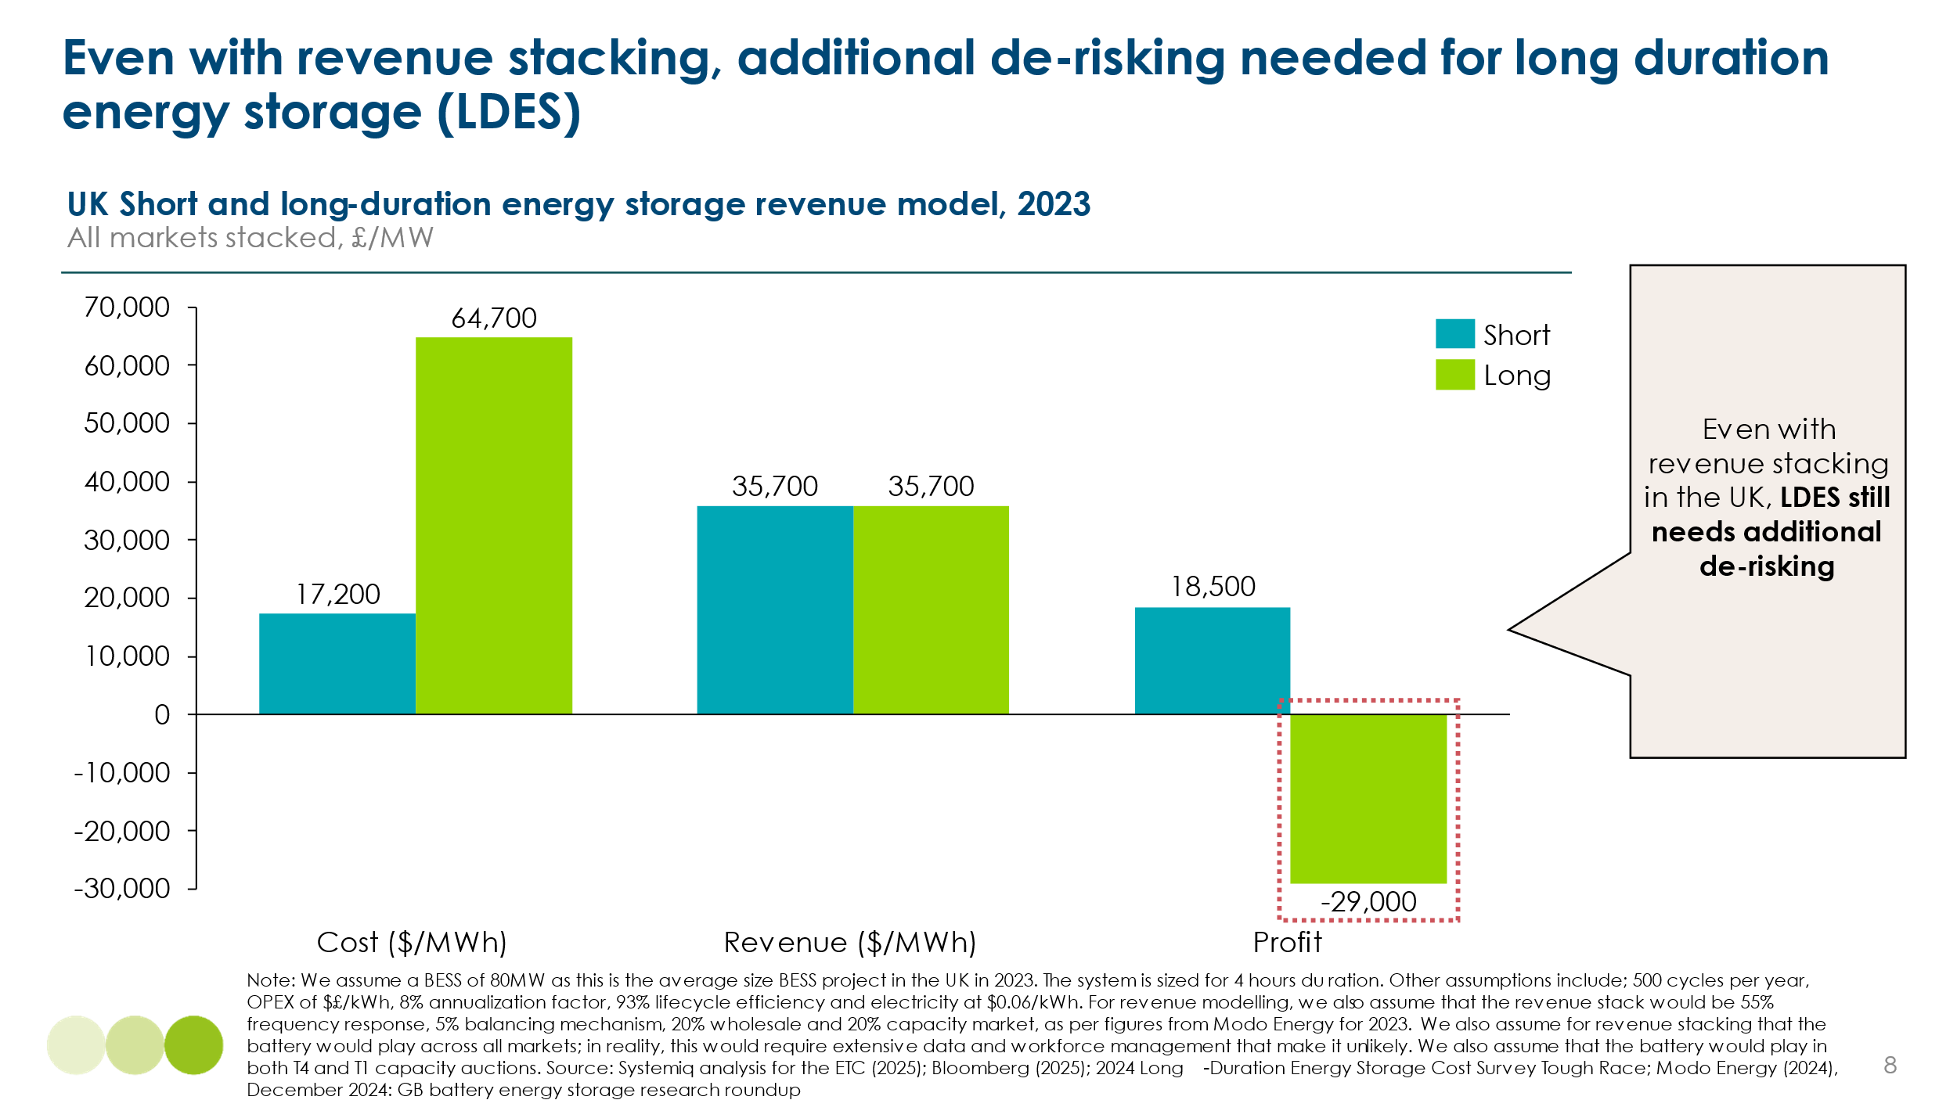

- Targeted funding to accelerate high-impact technologies
In addition to de-risked revenue streams, some flexibility assets could also benefit from additional funding to support earlier-stage development. These funding mechanisms are distinct from revenue support mechanisms—such as contracts for difference (CfDs), power purchase agreements (PPAs), capacity markets, tolling contracts, and feed-in tariffs—which provide price certainty once a project is operational. Funding mechanisms instead address earlier-stage barriers, targeting high capital intensity, technology risk, or limited track record, which prevent projects from securing financing. Strategic funding should be reserved for technologies that face significant commercialisation barriers, with targeted support for solutions that meet the following criteria:
- Nascent but necessary technologies – Innovations still in early development that lack a track record of large-scale deployment, such as next-generation grid-forming inverters and novel long-duration storage, but could be critical for future systems.
- High-capex solutions – Technologies with large upfront costs and long payback periods, making it difficult to secure affordable private financing, such as high-voltage direct current (HVDC) interconnectors and iron-air batteries.
To address these challenges, two key funding approaches are recommended, as highlighted in Exhibit 4.9:
- Short-term deployment support which reduces upfront costs and improves bankability, ensuring first-of-a-kind projects can reach commercial scale. Mechanisms include capital-side support such as tax credits (e.g., U.S. Inflation Reduction Act storage tax credits), subsidies, and grants (e.g., Germany’s innovation tenders).
- Long-term innovation enablers which reduces investment risk and supports later-stage commercialization to ensure high-impact solutions reach large-scale deployment. Mechanisms include non-revenue-based tools such as loan guarantees (e.g., EU infrastructure loans for interconnectors) and R&D funding (e.g., U.S. Department of Energy grants for long-duration storage).
Exhibit 4.9
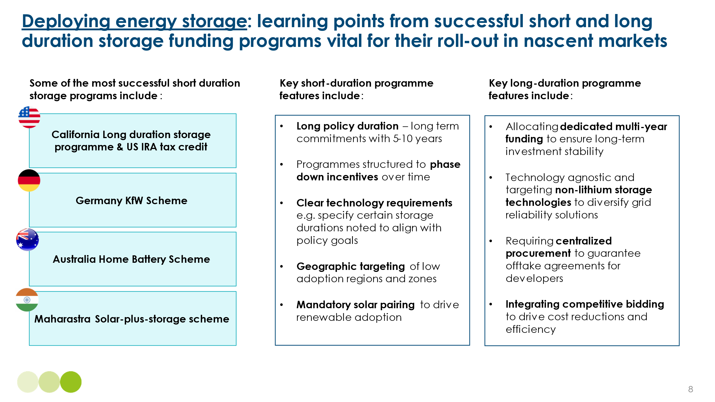

- Price signals to encourage efficient location
As Chapter 2 Section 2.3 described, grid investment needs can be reduced by encouraging the optimal location of new generation sources, storage capacity and large scale demands. Location based pricing is one mechanism to help achieve this.
While many markets already include some form of locational pricing to reflect the proximity of generation to demand centres, locational marginal pricing (LMP) goes further by dividing the wholesale market into smaller zones, each with its own real-time price. These prices reflect local generation costs, demand variations, and transmission congestion. By providing granular, location-based price signals, LMP incentivises investment in energy storage and demand-side flexibility where grid constraints are most severe. In congested areas, higher and more volatile prices indicate stronger returns for flexibility and new generation. In areas with excess generation, lower prices encourage energy-intensive businesses to locate there.
There are two categories of LMP - zonal pricing and nodal pricing. Zonal pricing divides the market into regions with distinct prices based on regional supply and demand balances. Nodal pricing assigns prices at individual nodes or connection points in the grid, reflecting local conditions with higher precision. In practice this means that whilst a market might have tens of regions it could have thousands of nodes.

Exhibit 4.10
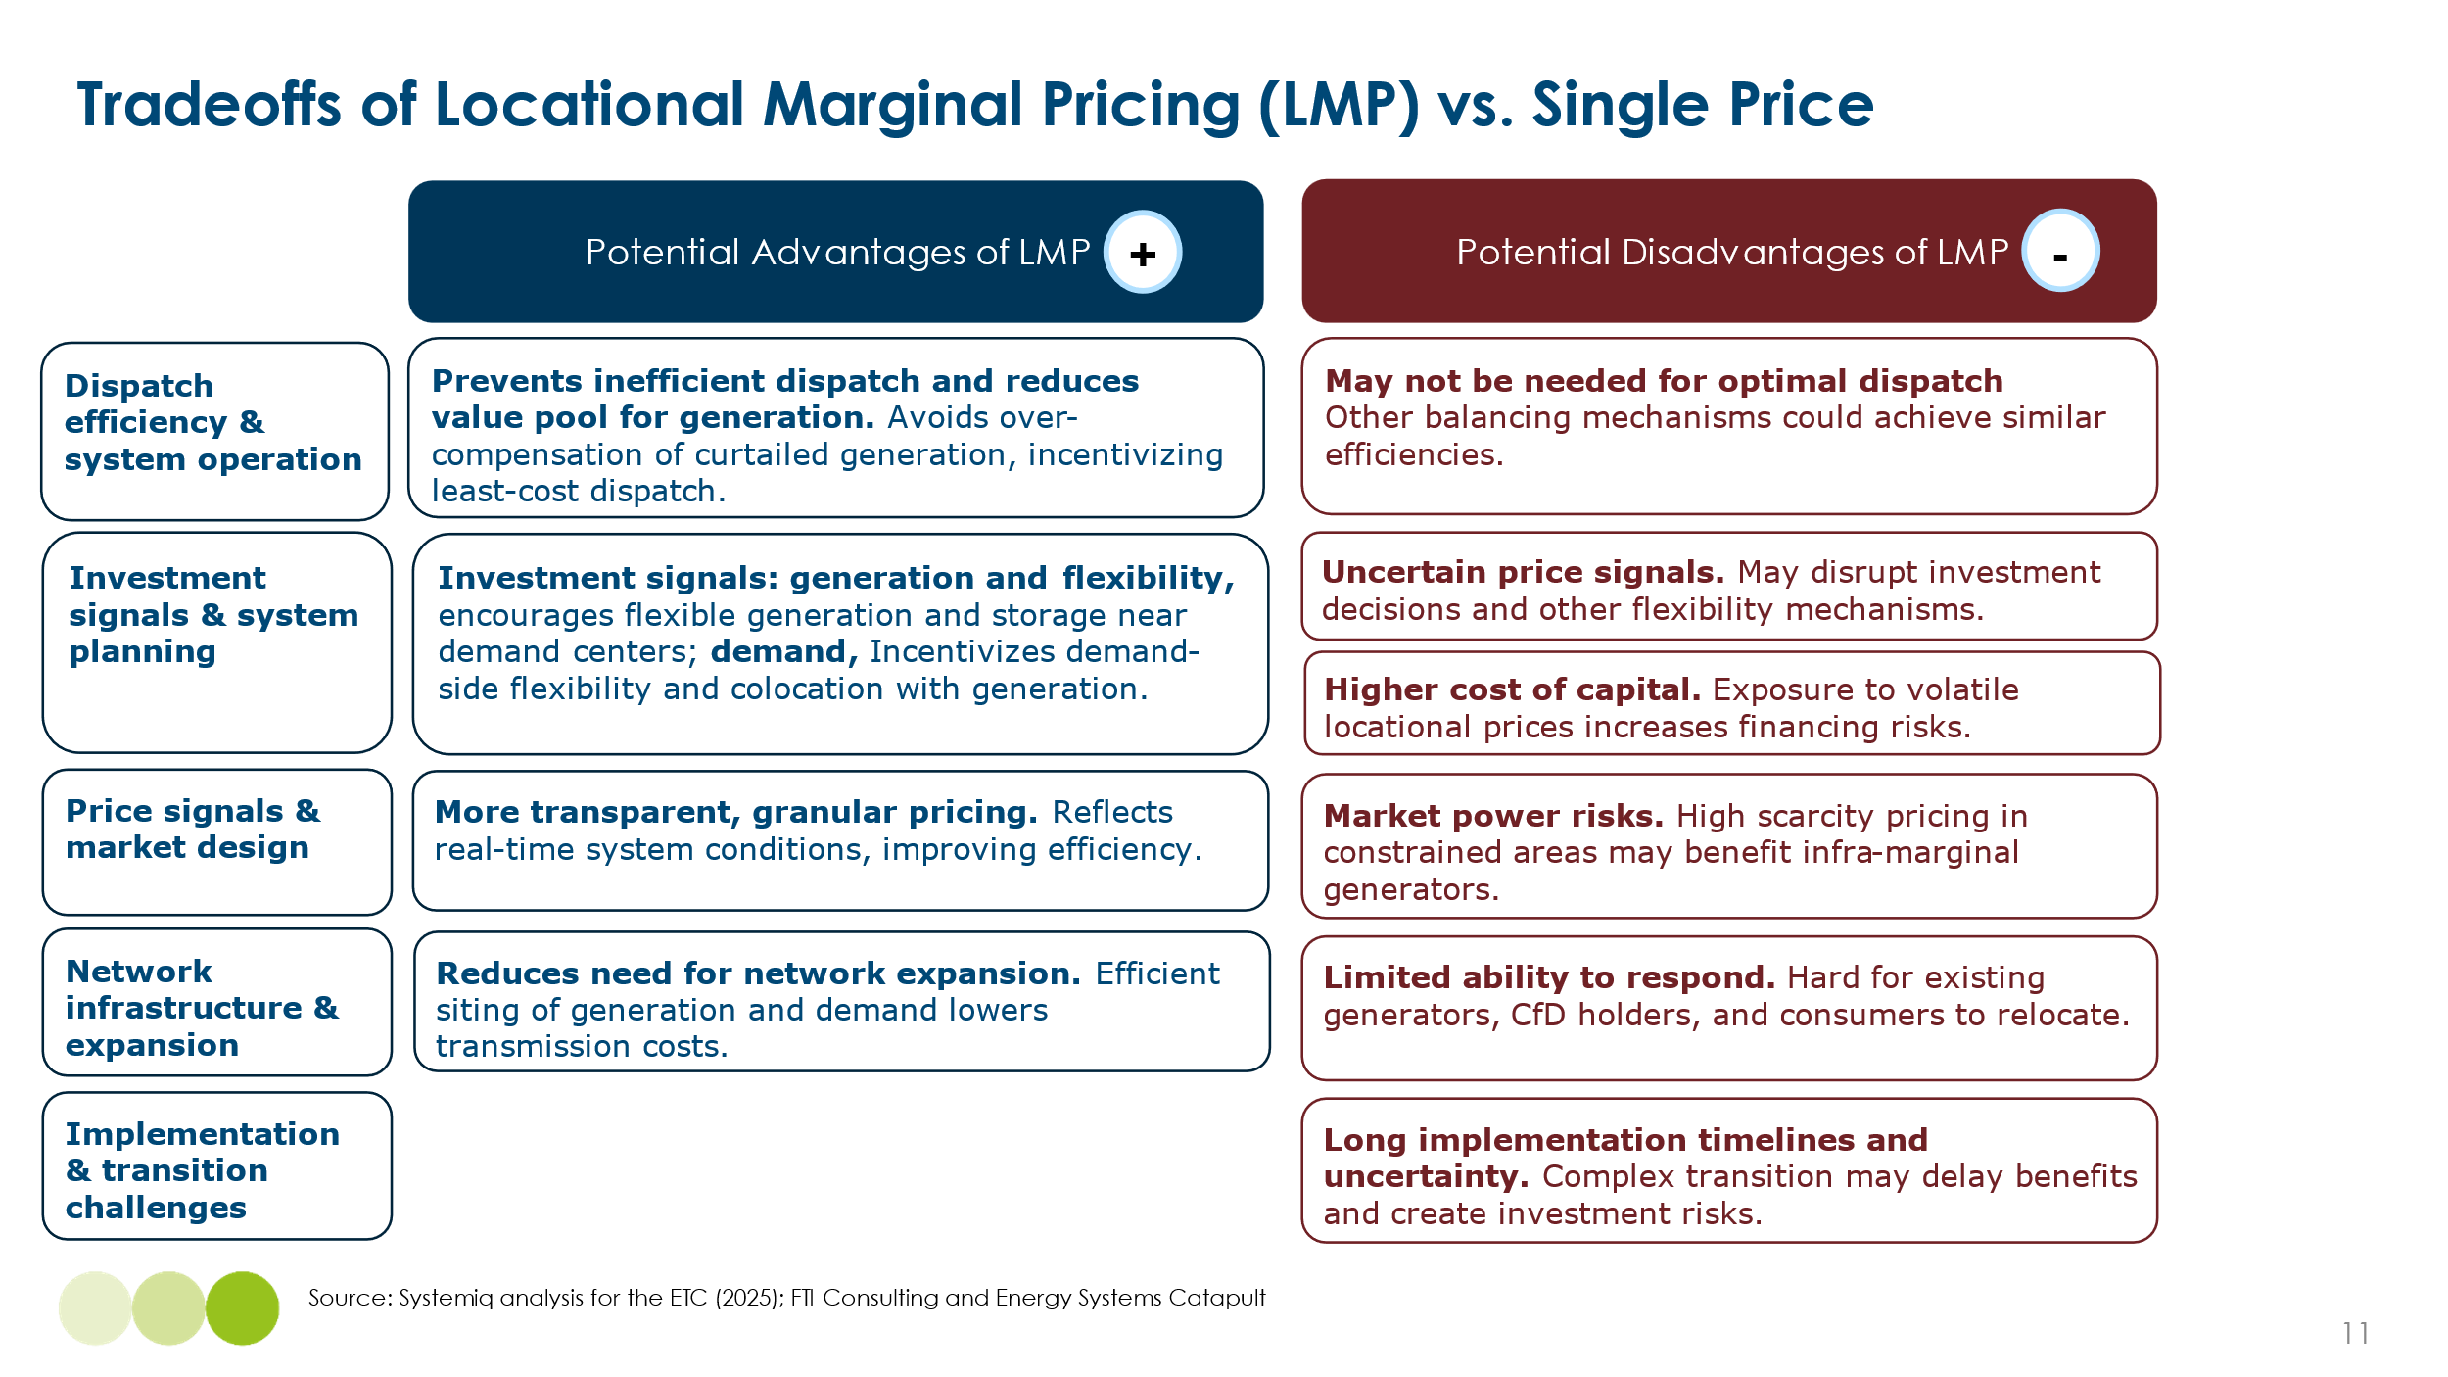
There are many factors to consider regarding the implementation of LMP, as highlighted in Exhibit 4.10 above. Implementing LMP requires careful consideration of market design, regulatory frameworks, and investor confidence. While LMP can lead to more efficient dispatch and strategic siting of flexibility resources, it may also introduce market uncertainty due to price volatility and increase complexity for developers. Therefore, complementary measures such as capacity payments or ancillary service markets are often necessary to stabilize revenues and encourage long-term investments.​
Most countries do not currently use LMP, opting instead for uniform pricing models.

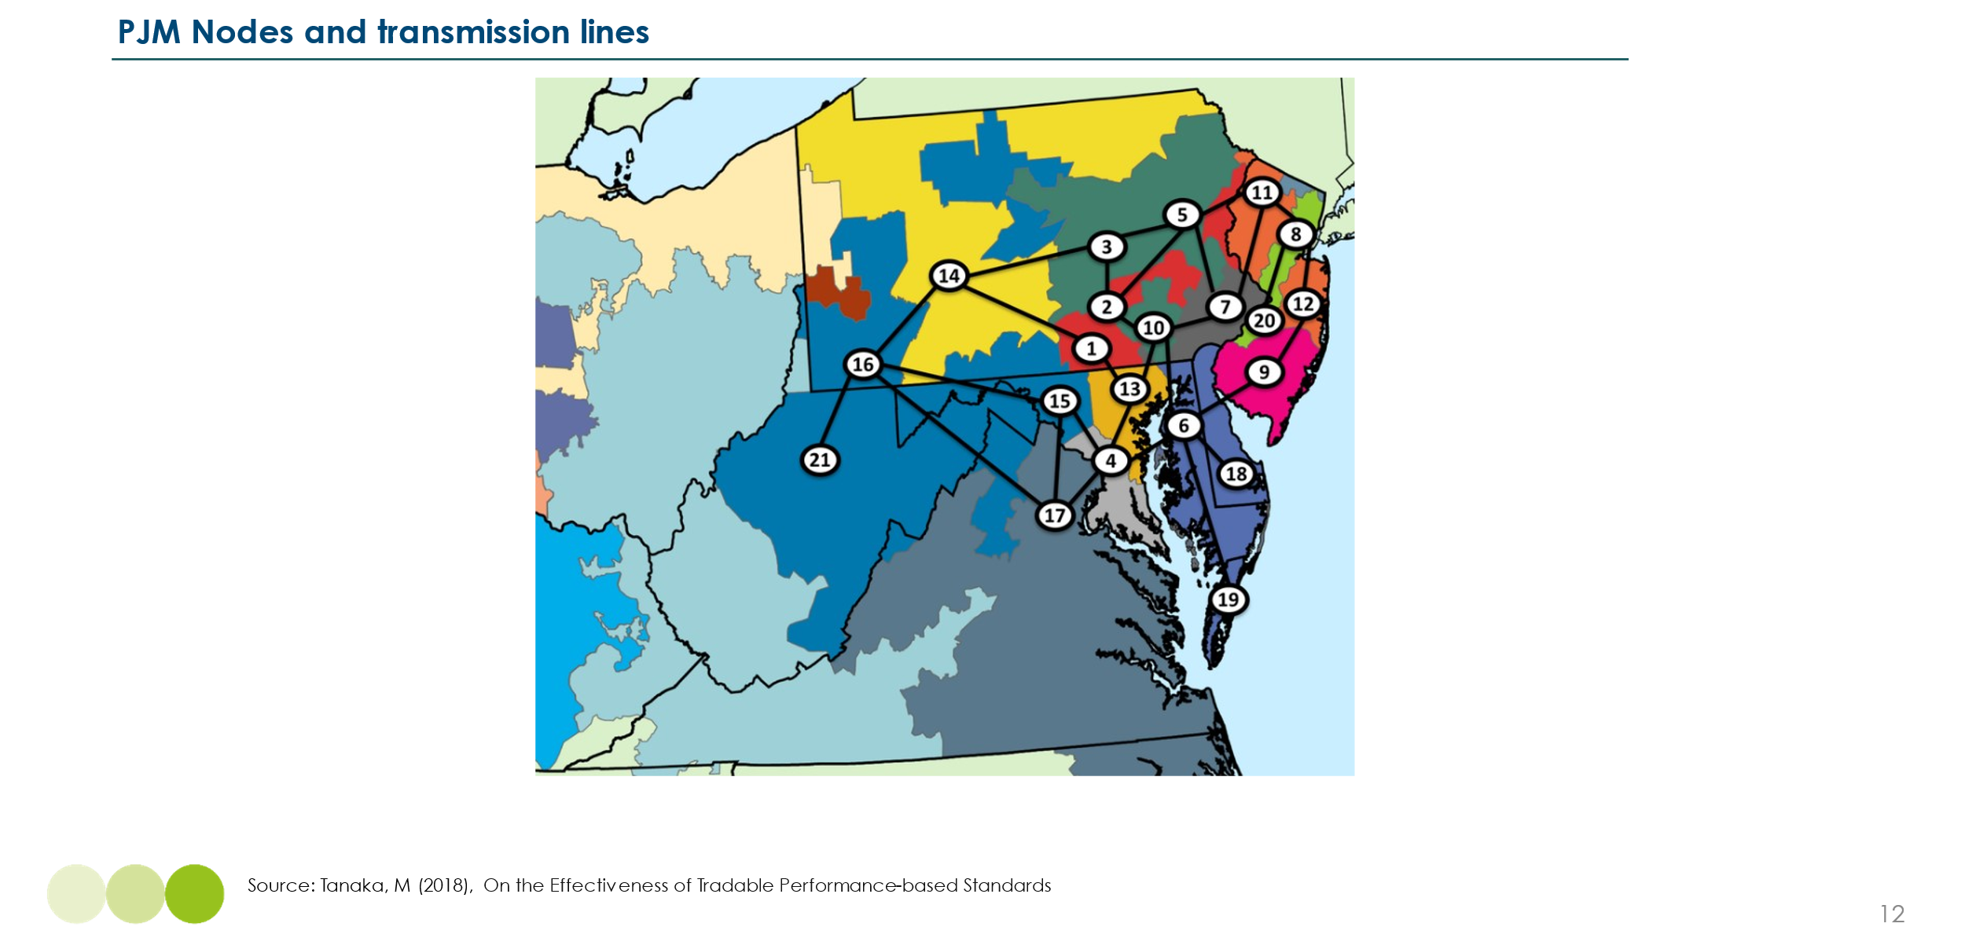
Box I - Case Study Example: LMP and Storage Deployment in PJM
Exhibit 4.11

The PJM Interconnection in the United States, one of the largest wholesale electricity markets globally, operates under a locational marginal pricing (LMP) model, which creates greater price variation across different locations compared to single-price markets. This structure has influenced flexibility investments in several ways:
- Operational Optimization: LMP increases price volatility by reflecting real-time congestion and local supply-demand imbalances, leading to wider fluctuations in electricity prices than in single-price markets. Storage developers leverage this volatility by charging when LMPs are low and discharging when LMPs spike, allowing for higher arbitrage opportunities than in a uniform pricing system.
- Strategic Siting: Rather than uniformly high-priced congested areas, storage assets are strategically located in areas with high price volatility, where frequent and significant LMP fluctuations allow them to capture greater spreads. This targeted placement improves grid reliability by alleviating local constraints and enhances financial returns.
- Revenue Diversification: While revenue stacking occurs in both LMP and single-price markets, LMP markets provide additional value by amplifying price signals for flexibility assets. Storage projects in PJM not only participate in energy arbitrage but also earn enhanced revenues from capacity payments and ancillary services, as these markets reflect locational price dynamics more accurately. This results in higher revenue potential compared to single-price markets, where uniform pricing can limit these locational incentives.

While LMP has been used in markets like PJM to enable more efficient dispatch of flexibility resources, its applicability varies by market. Some jurisdictions may prioritize alternative approaches, such as capacity mechanisms or targeted grid investments, to enable flexibility deployment in a way that aligns with their specific regulatory and market structures.
​In the UK, transitioning to zonal pricing has been proposed to better reflect regional variations in electricity supply and demand. This approach could lead to significant cost variations across different zones, with costs to generators in different zones potentially shifting by +/- £10-15/MWh (compared to generation costs for wind energy of £76-105/MWh for onshore and offshore wind in the UK today).
The EU’s electricity market operates on a zonal pricing model, where each “bidding zone” has a single wholesale electricity price. In most cases, a country forms a single bidding zone, which supports efficient cross-border trade but fails to reflect internal grid constraints. Some EU countries have adopted more granular zonal pricing—Italy, Sweden, and Denmark have multiple internal zones to reflect structural congestion. Outside of Europe, countries like New Zealand, Singapore, and Chile have also introduced nodal or regional pricing systems.
In summary, LMP is a potential mechanism to enhance grid efficiency by providing location-specific price signals. However, implementation requires careful consideration of market design, including safeguards against market power abuse and unintended cost shifts across regions. The Energy Transitions Commission will conduct deeper analysis into locational marginal pricing later in the year.
- Grid regulations to support investment, encourage cost reduction, and speed connection

Chapter 2 outlined the significant investments required in transmission and distribution grids to enable widespread electrification and power sector decarbonisation. It also highlighted the substantial potential to reduce these costs through demand-side flexibility, innovative grid technologies (IGT), and optimal siting of generation, storage, and new demand.
Enablers relating to optimal location of storage assets were considered in Section 4.2.4, and enablers for demand side flexibility will be considered in Section 4.6. Well-designed regulation and planning rules relating to grid companies are essential to:
- Create incentives for optimal investment in innovative grid technologies
- Reduce barriers to grid expansion and rapid connection.
- Address legacy issues relating to grid connection fees.

- Incentives for investment in innovative grid technologies.

As Chapter 2 Section 2.2 described, there are notable opportunities to reduce required grid investment by deploying multiple variants of innovative grid technologies (IGTs). This would not only reduce costs, but in some cases reduce the need for major new pylon line or other physical developments which might face social opposition
In several countries, however, existing regulation of transmission and distribution companies can dampen the incentive to invest in measures that would lower the capital assets required per kilowatt-hour delivered. This often occurs when regulation encourages grid operators to minimise operational expenses, while allowing capital investments to be added to the regulatory asset base. These capital costs are then multiplied by an allowed rate of return and passed on to consumers as part of the grid cost.
Regulators should therefore explicitly review and if necessary, reform approaches to operating and capital cost pass through to increase incentives for IGT deployment.

- Connection rules: addressing backlogs and streamlining processes
Lengthy and opaque grid connection processes are among the biggest constraints to scaling flexibility assets. Flexibility assets face complex permitting and approval requirements, often with multi-year delays that erode investment cases and increase system costs. The backlog in connection queues can last up to 14 years in the UK and 7 years in the US. Exhibit 4.12 below highlights the urgency of reform. Notably, the UK energy regulator Ofgem approved major grid connection reforms in April 2025 aimed at eliminating speculative 'zombie' projects and fast-tracking viable clean energy developments, a move expected to significantly reduce connection delays and unlock substantial investment in renewable infrastructure.
Exhibit 4.12
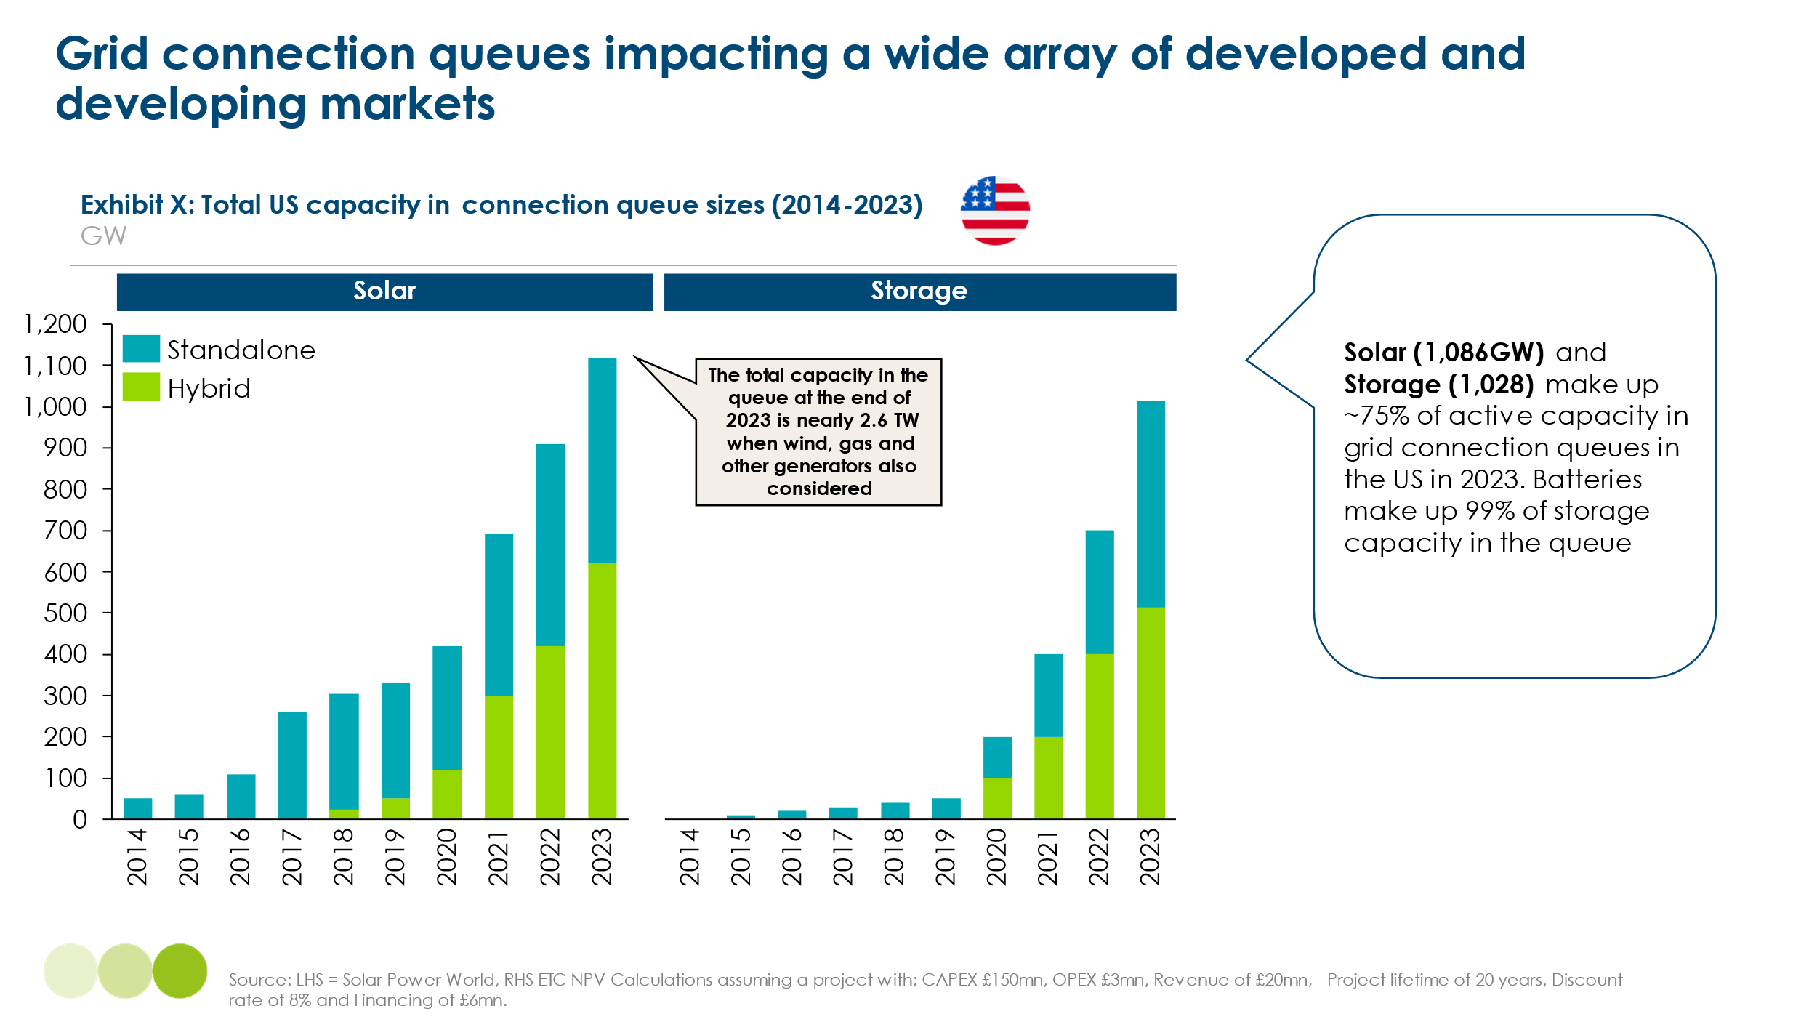
Key measures to accelerate grid connections are highlighted in Exhibit 4.13 below:
Exhibit 4.13
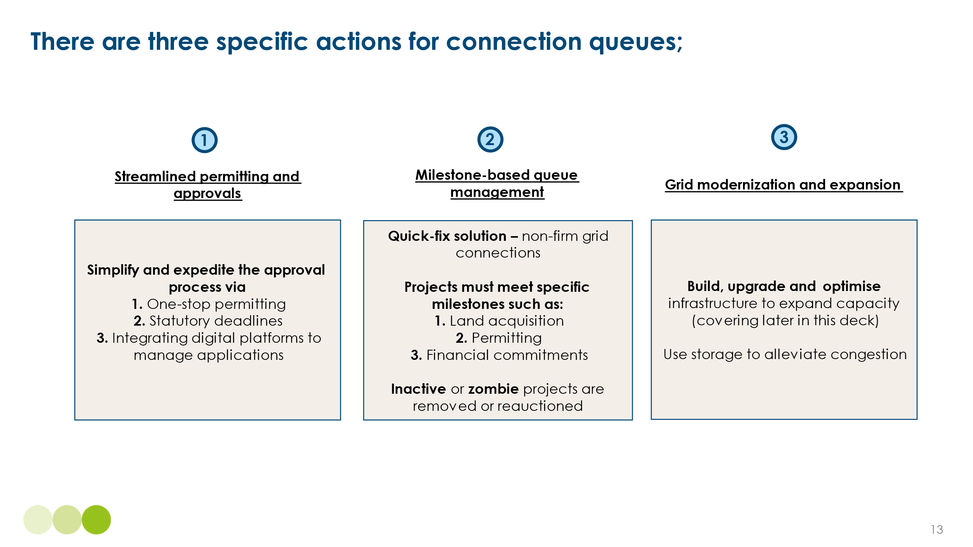
Each of these measures can play a crucial role in addressing connection delays, but there are implementation considerations to maximise effectiveness:
- Streamlining permitting and approvals reduces administrative bottlenecks but requires regulatory coordination to enforce deadlines and maintain transparency. For example, in the United States, the Federal Energy Regulatory Commission introduced Order 2023, requiring grid operators to provide clearer timelines and study processes for new connections, ensuring projects move through the queue more efficiently.
- Milestone-based queue management helps prioritize viable projects, but if too rigid, it may inadvertently disadvantage smaller or innovative developers. The UK’s National Grid ESO recently introduced stricter milestone requirements for connection applicants, removing stalled projects from the queue. However, concerns remain that emerging technologies with longer development timelines could face unintended barriers.
- Grid modernisation and expansion is essential to reducing connection queues by increasing the physical hosting capacity of the network. Many backlogs stem from transmission or distribution constraints in specific zones, particularly where renewables and storage projects are concentrated. Strategic investments in substations, transformers, and line upgrades at these pinch points can unlock stalled projects and enable new flexibility assets to connect more quickly, as discussed in Chapter 2.
While these reforms collectively enhance queue efficiency, their success depends on balancing speed, fairness, and cost-effectiveness in execution.
The UK is one example of a market where connection rules have been reformed to address project backlogs and improve queue efficiency. Recent changes introduce stricter project milestones, requiring proof of land ownership, financial commitments, and permitting evidence to prevent speculative projects from delaying grid access. These measures aim to prioritise ready-to-build projects and remove inactive applications, ensuring a more efficient allocation of grid capacity. However, they also introduce additional complexity and higher upfront costs, particularly for smaller developers, highlighting the need for a balanced approach that streamlines connections while maintaining accessibility.
Other countries to enact grid connection reform include:
- Australia: AEMO’s First-Ready, First-Connected reform replaces the legacy queue with a merit-based system, requiring developers to meet key project milestones to retain their queue position.
- California (CAISO): Implemented queue management reforms that remove inactive or slow-moving projects and introduced deposit requirements to ensure commitment from developers.
- Ireland (EirGrid): Introduced Enduring Connection Policy (ECP) rounds, where connection offers are awarded based on project readiness and alignment with grid needs, rather than time of application.

- Grid fees: removing legacy barriers
Current grid fee structures often do not adequately account for the unique role of flexibility technologies, such as battery storage and demand-side flexibility, leading to inflated costs and market distortions. These fees were originally designed around traditional, one-way electricity flows from large, centralised generators to passive consumers. As a result, many regulatory frameworks treat storage as both a consumer (when charging) and a generator (when discharging), resulting in double charging that significantly erodes the commercial viability of these assets.
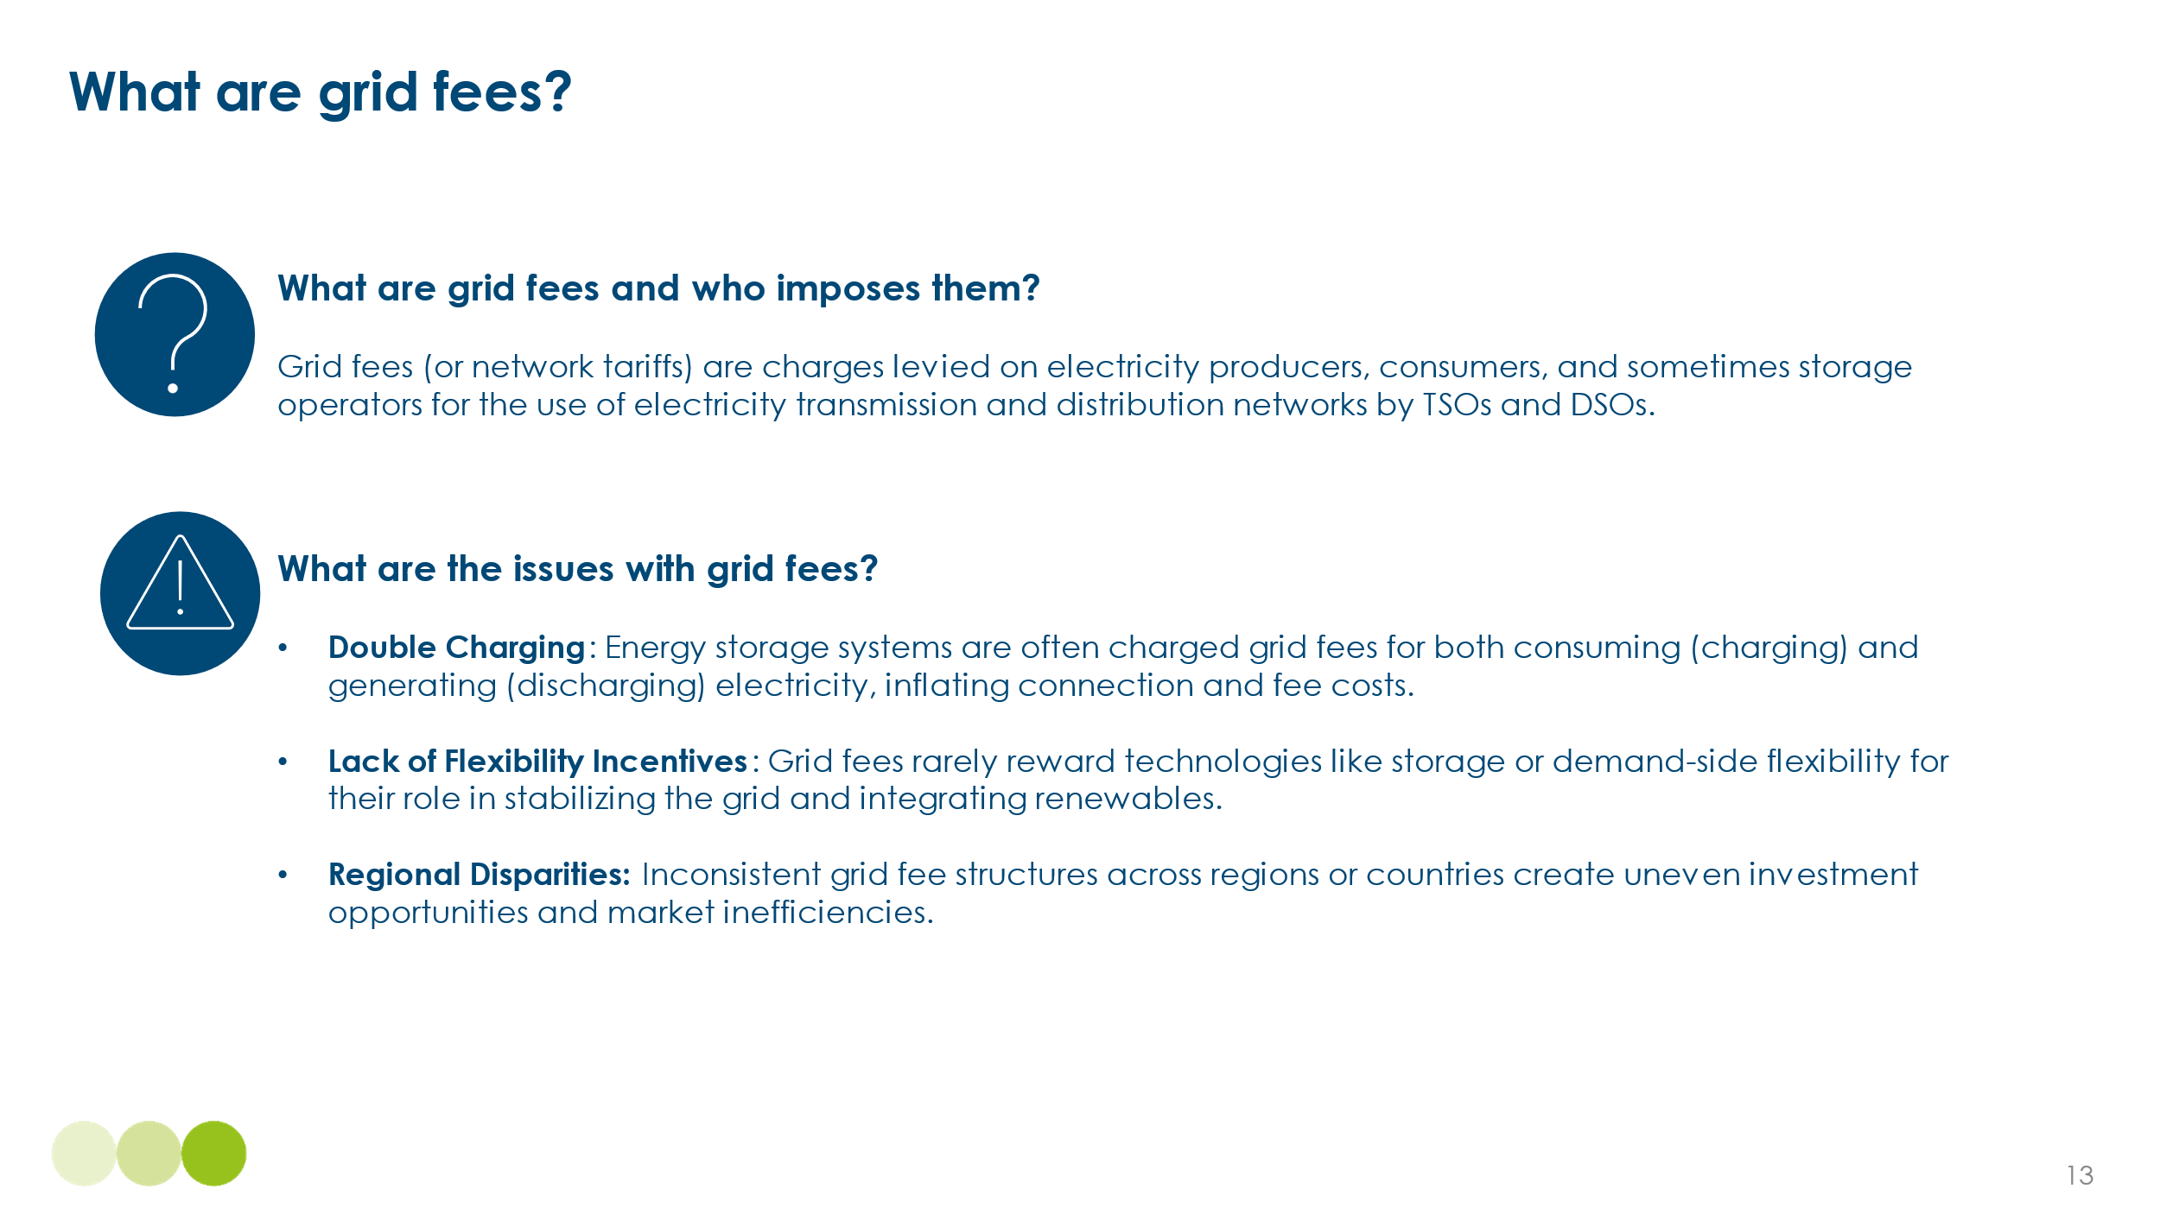
Because flexibility and storage technologies don’t fit neatly into legacy categories, grid fees often do not adequately reflect their system value, such as congestion relief or balancing support. Countries that have seen early growth in storage, particularly across Europe, have been forced to confront these issues sooner, making grid fee reform a central policy discussion. As a result, markets like Italy, Spain, the Netherlands, and Finland have begun introducing exemptions or revised tariffs that better reflect the operational characteristics of flexible assets.
Exhibit 4.14

Introducing non-firm (intermittent) grid access for lower fees is becoming a key solution for flexibility assets, allowing storage and demand-side flexibility technologies to connect more quickly while reducing overall system costs. Relying exclusively on 100% firm grid connections represents a legacy barrier that limits the speed and scale of flexibility deployment. In markets such as Denmark, the Netherlands, UK and Australia, intermittent grid access models are being introduced to enable faster integration of storage and demand-side flexibility without waiting for full network upgrades. This approach not only improves investment signals for flexibility but also optimises network utilisation by ensuring congestion alleviation assets are available where needed most.
Solutions are summarised in Exhibit 4.15 below:
Exhibit 4.15
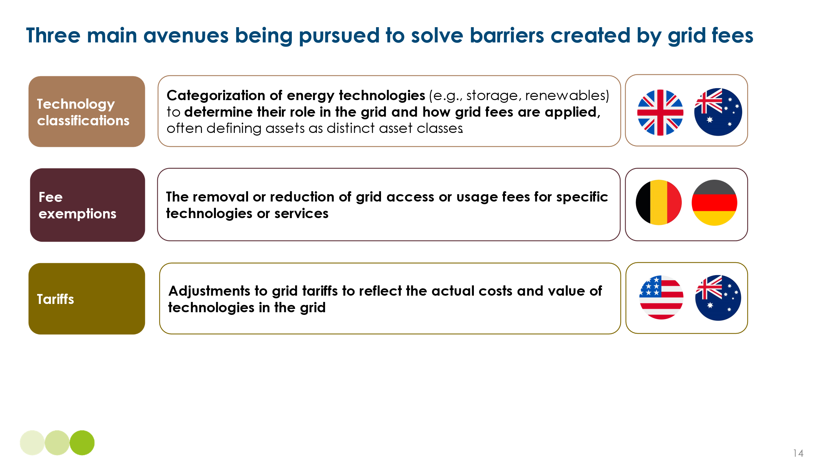

Case study: The Netherlands
The Netherlands' energy storage sector has been significantly hindered by its grid fee framework, particularly due to double charging and the absence of exemptions available in neighbouring markets. Storage operators must pay for both importing and exporting electricity, leading to some of the highest grid fees in Europe.
- In 2024, grid fees for a 3000 full-load-hour offtake profile in the Netherlands stand at €86.7/MWh, significantly higher than Germany (€56.5/MWh), Belgium (€13.9/MWh), and France (€12.5/MWh).
- Unlike Germany (where storage and electrolysers are exempt from these fees), or Belgium and France (where storage benefits from reduced charges), Dutch storage developers face limited exemptions, making the country a less attractive investment location for grid-scale batteries and electrolysers.
- TenneT, the Dutch transmission system operator, has implemented temporary 67% reductions through non-firm agreements and time-weighted rates, but these remain interim measures rather than long-term structural reforms.
This case illustrates the competitive disadvantage faced by markets that fail to adapt their tariff structures. Without intervention, markets with high grid fees risk reduced investment, slower flexibility deployment, and higher system costs, as flexibility assets are priced out of the market.
Similar reforms are emerging elsewhere, for example
- Germany: Waived double grid fees for battery storage systems to remove barriers to deployment.
- India: Exempted transmission charges for renewable and storage projects commissioned before 2025.
- Chile: Offers reduced grid charges and simplified access for small-scale distributed energy and storage.
- China: Piloting time-of-use and location-based tariffs to incentivise demand-side flexibility.
- Digital tools and AI for more efficient grid management
Power systems with a high share of variable renewable generation and significant decentralised generation and storage assets will require more active real time management than past systems. Shifting generation and demand profiles will require real time visibility and actions in response to ensure balancing at the multiple durations described in Chapter 1.
Traditional grid operation systems designed around centralised dispatchable generation face challenges in accommodating variable renewables, energy storage, and demand-side flexibility. These challenges include slow responses to grid imbalances, inefficient congestion management, and underutilisation of flexibility assets due to lack of visibility.
Two categories of new capability are required:
- Data analytics and AI capabilities to improve system resiliency and optimise grid operations, for example through AI-driven grid forecasting
- Advanced metering and digitalisation to support storage and flexibility solutions
- Data and AI Modernization for Smarter Grids
Effective management of more complex power systems can be enhanced by:
- AI-Driven Grid Forecasting: Machine learning models analyse weather patterns, historical generation trends, and grid congestion data to improve renewable output predictions and reduce curtailment.​
- Real-Time System Monitoring & Balancing: AI enhances grid visibility by integrating data from IoT devices, smart meters, and sensors, allowing faster responses to demand fluctuations and supply variability.​
- Automated Flexibility Dispatch: AI optimizes battery storage and DSF, ensuring flexibility assets are activated at optimal times to alleviate congestion and balance the grid.​
- Grid Planning & Infrastructure Simulation: AI-powered tools enable faster and more detailed scenario modelling, aiding system operators and policymakers in making informed investment decisions for grid expansion.
A notable example is Google X's Tapestry project, which aims to create an AI-powered, unified platform for grid management. By integrating real-time data and predictive analytics, Tapestry seeks to enhance system resilience and optimize renewable energy integration. In collaboration with Chile's National Electric Coordinator, Tapestry has enabled grid planners to run simulations 86% faster and conduct 30 times as many scenarios simultaneously, facilitating more efficient and accurate grid planning. ​
- Advanced Metering and Digitalization to Enable Flexibility
Bringing more grid and flexibility technologies onto power systems requires real-time data, dynamic system optimisation, and automated control mechanisms. Advanced Metering Infrastructure (AMI) and digitalization are essential in enabling greater market participation of energy storage, demand-side flexibility, and other grid-supporting technologies by improving data visibility, market integration, and operational efficiency.
The deployment of smart meters, sensors, and digital control systems enhances the ability of grid operators, aggregators, and consumers to respond to grid conditions in real time. Key benefits include:
- Optimised Demand-Side Flexibility: AMI enables automated, price-responsive energy consumption, allowing storage, electric vehicles, and smart appliances—such as heat pumps, electric water heaters, and smart thermostats—to shift demand away from peak periods, alleviating congestion and reducing system costs​
- Increased Visibility for Grid Operators: Digitalisation provides granular data on energy flows, supporting real-time forecasting and allowing more effective integration of flexibility resources such as battery storage and virtual power plants
- Grid Resilience and Predictive Maintenance: AI-driven monitoring detects grid congestion and equipment failures before they occur, reducing downtime and improving the reliability of flexibility assets
To fully integrate storage and demand-side flexibility, power systems must accelerate the deployment of smart meters, AI-driven forecasting tools, and digital flexibility markets. By providing real-time visibility, automated control, and market access, these technologies enable faster deployment and more effective utilization of flexibility resources, supporting the transition to a resilient, low-carbon energy system.
Despite the clear potential of AI and digital technologies to improve grid efficiency and flexibility, regulatory and commercial frameworks have not kept pace with innovation. A key barrier is the high upfront cost of deploying advanced metering infrastructure, sensors, and AI systems—combined with uncertain or long-term payback periods. This cost-benefit mismatch is especially challenging in regulated environments where savings may accrue to the system, but the investment risk is borne by utilities or third-party providers. In many cases, existing regulatory structures do not recognise or reward the system value of data-driven flexibility, creating weak incentives for deployment.
To overcome this, regulatory frameworks should evolve to explicitly value the role of digital and AI-based tools in delivering flexibility and system optimisation. This could include allowing digital solutions to participate in flexibility markets, providing upfront support or incentives for enabling infrastructure (such as AMI), and adjusting cost recovery models to better reflect whole-system benefits. Such reforms are essential to accelerate the integration of smart grid technologies and unlock their potential to support a more dynamic, low-carbon power system.
- Addressing supply chain and workforce constraints
The large scale investment needed in transmission and distribution grids (as discussed in Chapter 2) and in the multiple forms of the grid and flexibility technologies described in Chapter 1, could be constrained by bottlenecks in either:
- Supply chains for specific equipment or installation capability
- The skilled workforce required
- Potential supply chain bottlenecks and actions to overcome
The ETC has previously assessed potential supply chain bottleneck and vulnerabilities with respect to
- Minerals and materials supply in our 2023 report Material and Resource Requirements for the Energy Transition
- Supply chains to support European decarbonisation in the 2023 report Better, Faster, Cleaner: Securing clean energy technology supply chains, June 2023
- Supply chains specifically related to the offshore window industry in the 2024 report Overcoming Turbulence in the Offshore Wind Sector
In addition to the issues discussed across these reports, investments in grid storage and flexibility will create rapidly rising demand for multiple specific technologies and capabilities. In some areas there are no immediate threats to easy availability of equipment but in others, supply constraints could slow the pace of transition; in particular:
- Battery energy storage solutions are available on a highly standardised basis, at falling prices, and enabled by manufacturing capacity developments (primarily in China) more than sufficient to meet projected demand.
- But the rapid availability of several other inputs – including HVDC cable and large transformers – is currently constrained, with only a small number of suppliers and long lead times for delivery.
- As discussed in Chapter 1 Section 4.3, there are currently huge variations in the cost of electrolyser systems between China and the rest of the world , raising questions about whether Chinese supply can be used to reduce costs outside China
- And even where global capacity is easily sufficient to meet demand, the concentration of that supply in one country, namely China, can create concerns.
Strategies for power system development should therefore include explicit analysis of possible future supply constraints and policies to overcome these. Key actions to achieve this include:
[PLACEHOLDER - SECTION TO FOLLOW ON SUPPLY CHAIN SOLUTIONS TO ADDRESS BOTTLENECKS]
- Workforce Challenges and Solutions
Rapid deployment of grid flexibility technologies requires a highly skilled workforce, but shortages in key roles and long training lead times could slow progress. Workforce strategies must be scaled up now to meet future energy transition demands.
Many critical grid roles, such as line workers, power engineers, and technicians, require extensive training, with some positions taking up to seven years to qualify. Additionally, the evolving nature of power systems demands new digital skills in automation, AI-driven grid management, and cybersecurity. Without targeted workforce development, the expansion of grid and flexibility solutions will face significant delays.
Leading solutions:
- Advanced training programs: Governments and industry stakeholders should expand vocational training and apprenticeship schemes to fast-track skilled labor development. For example, the UK will need to increase its lineman workforce from 200 to 1,200 to meet expansion targets, necessitating scaled-up training initiatives.
- Industry-academia collaboration: Aligning energy sector needs with education programs ensures a steady pipeline of skilled professionals. Germany’s vocational training model integrates industry experience with formal education, helping maintain a stable power sector workforce.
- Continuous upskilling and knowledge transfer: Ongoing training programs should focus on reskilling existing workers for emerging grid technologies. National Grid’s ‘Grid for Good’ program in the UK provides technical training in smart grid technologies to meet future workforce needs.
- Consumer engagement and product design to enable demand side flexibility

Chapter 1 Section 3.1 described the major role which demand side flexibility could play in meeting the short duration balancing challenge with less investment in storage. In addition Chapter 2 Section 2.1 described how DSF can reduce the need for distribution grid investment.
Seizing this potential will require building customer understanding and trust in DSF related products and developing high-quality product offerings to support DSF deployment.

- Building Consumer Trust in Demand Side Flexibility Technologies
Demand side flexibility (DSF) could play a role in large industrial and commercial companies, particularly when combined with battery or heat storage. In many of these organisations, professional energy managers are likely to respond to the economic opportunities enabled by building and process control technologies, falling storage costs, and time-of-day pricing.
By contrast, residential and small commercial users may be slower to engage, due to limited awareness of concepts like time-of-day pricing and behind-the-meter storage. These technologies are often seen as complex, opaque, or intrusive—leading to hesitation in adoption and participation.
Exhibit 4.16
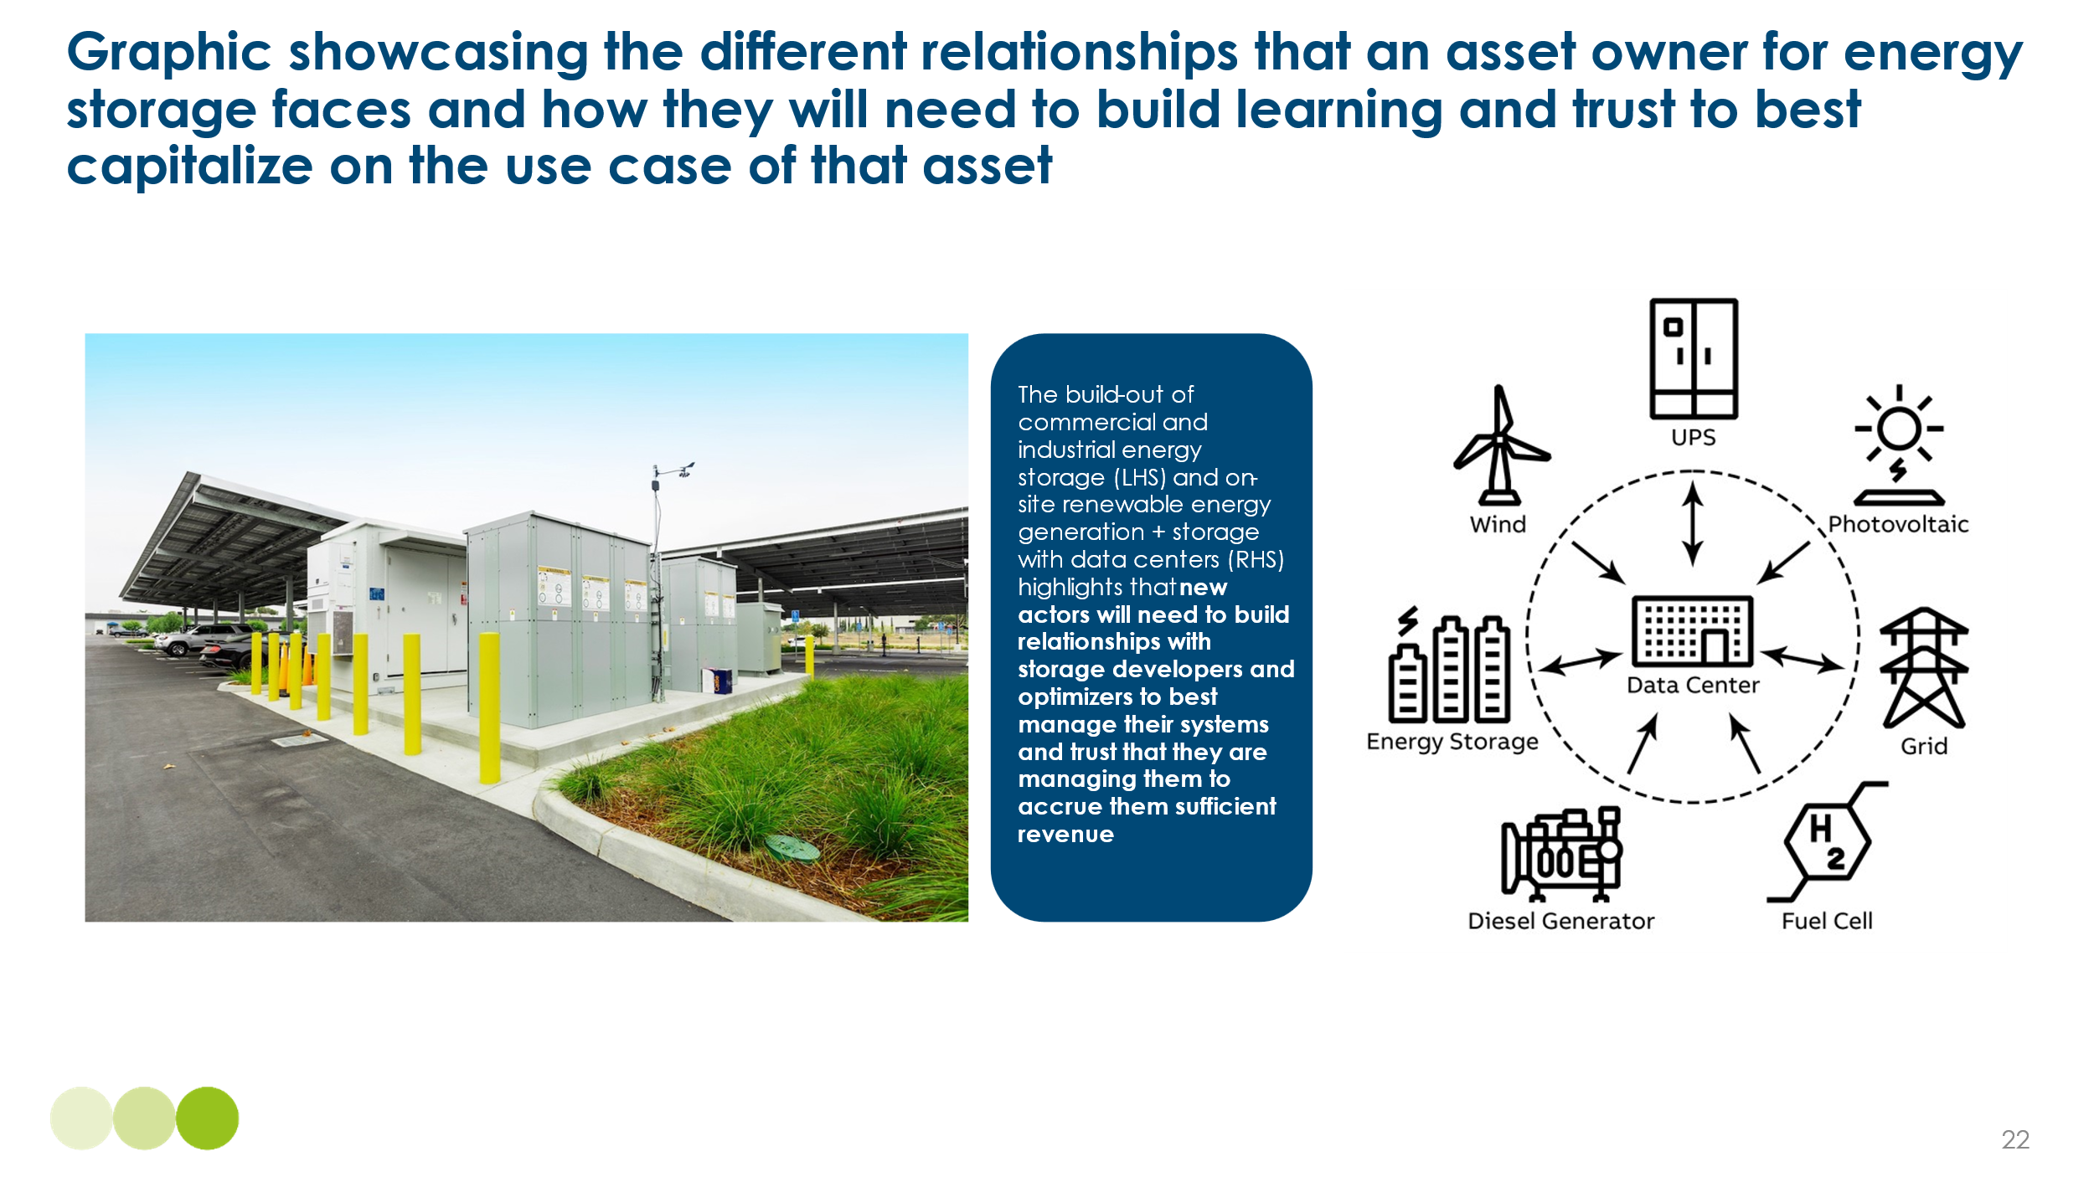
This lack of familiarity does not always reflect active distrust, but it highlights a knowledge gap that must be addressed. For example, as showcased by Exhibit 4.16 above, commercial and industrial consumers may be unsure about the business case for investing in battery storage or joining a flexibility market due to the added complexity of new systems, while residential users may be concerned about impacts on comfort, privacy, or energy bills.
To build trust, energy retailers and service providers must:
- Invest in consumer education, highlighting how flexibility delivers cost savings, emissions reductions, and improved resilience. For instance, the UK’s Demand Flexibility Service engaged 1.6 million households through clear financial incentives and communications.
- Ensure transparency and user control, so consumers understand how automated systems work and can adjust settings to reflect personal or operational preferences. Smart EV charging and heat pump controls should avoid one-size-fits-all algorithms.
- Guarantee strong data privacy protections, including transparent governance, robust cybersecurity, and clear consent protocols to reassure users that their real-time energy data is secure and used to their benefit.
By addressing these concerns and raising awareness, stakeholders can lay the groundwork for confident consumer participation in the energy transition.
- Attractive products and services to enable DSF
Once awareness and trust are established, the next challenge is to design systems that enable consumers to engage easily, confidently, and at scale. Strengthening engagement means reducing friction, offering clear incentives, and ensuring technologies are tailored to user needs.
Key enablers of consumer engagement include:
- Seamless automation, minimising the need for manual control while allowing consumers to set boundaries and preferences.
- System transparency, so users understand how their participation affects both their bills and the wider system.
- Reliable incentives, offering predictable financial rewards and safeguards against negative impacts.
- Interoperability, ensuring flexibility assets—like batteries, heat pumps, or EVs—can be easily integrated and controlled.
Case studies show how this is already working in practice. Octopus Energy’s Kraken platform uses AI to optimise energy use across connected home devices. In its 2022 Saving Sessions, over 200,000 UK households reduced peak electricity demand by 108 MW, with minimal manual intervention. These kinds of frictionless, rewarding participation models demonstrate the potential for rapid scaling.
Importantly, DSF is not limited to developed economies. Emerging markets are piloting innovative models to enable flexible demand:
- India is rolling out smart meters nationwide, creating the infrastructure for time-of-use pricing and responsive demand
- South Africa has piloted utility-managed appliance control, reducing peak load without requiring active user involvement.
- Nigeria is scaling pay-as-you-go solar-plus-storage systems, helping consumers manage load and costs—early steps toward full flexibility integration.
These examples show that with the right digital tools, incentives, and system design, consumers everywhere can become active participants in the energy transition.
Exhibit 4.17 below illustrates how solutions driving consumer engagement can be pursued in both developed and developing countries.
Exhibit 4.17
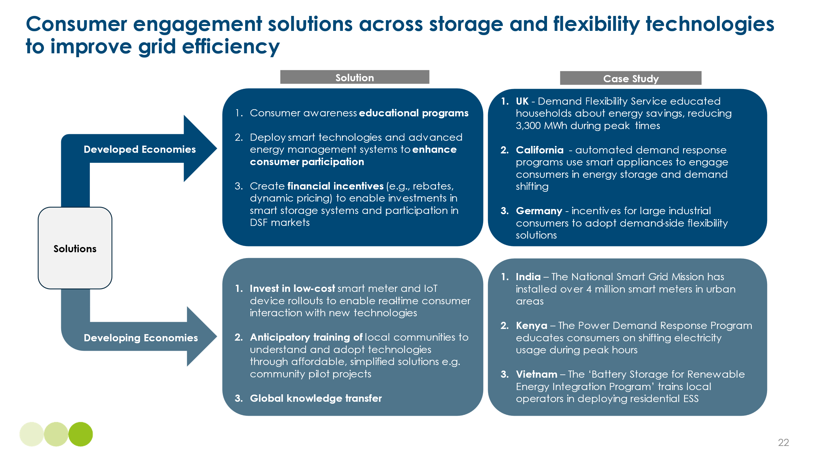
Consumer engagement is central to the success of a breadth of grid and flexibility technologies, including energy storage, innovative grid technologies, and most importantly, demand-side flexibility. Ensuring transparency, financial viability, and ease of participation will drive broader adoption, supporting grid stability, decarbonisation, and cost efficiency.

Energy Transitions Commission (2023), Fossil Fuels in Transition: Committing to the phase-down of all fossil fuels.
Energy Transitions Commission (2021), Making Clean Electrification Possible: 30 Years to Electrify the Global Economy.
IEA (2021), Net Zero by 2050: A Roadmap for the Global Energy Sector; IRENA (2023), World Energy Transitions Outlook 2023.
IRENA (2023), Renewable Power Generation Costs in 2022.
Lazard (2023), Levelized Cost of Energy Analysis – Version 16.0; BloombergNEF (2023), New Energy Outlook.
Energy Transitions Commission (2021), Making Clean Electrification Possible: 30 Years to Electrify the Global Economy
Energy Transitions Commission (2021), Making Clean Electrification Possible: 30 Years to Electrify the Global Economy
Ember (2025), Electricity generation – Wind and solar. https://ember-energy.org/data/electricity-data-explorer/
It is important to note that it is relatively easy for small countries to achieve high VRE shares if they are interconnected with large countries. But the growth of VRE shares across multiple interconnected countries (e.g. Spain and Portugal, and Germany and Denmark) illustrates high VRE penetration is possible across wide geographic areas
International Energy Agency (IEA). Snapshot of Global PV Markets 2023. IEA PVPS, April 2024. Available at: https://iea-pvps.org/wp-content/uploads/2024/04/Snapshot-of-Global-PV-Markets-1.pdf (Accessed April 2025).
WWEA (2024), World Wind Energy Half-Year Report 2024. World Wind Energy Association
BloombergNEF (2025), Levelized Cost of Electricity Update 2025
NREL (2021), Documenting a Decade of Cost Declines for PV Systems. Available at: https://www.nrel.gov/news/program/2021/documenting-a-decade-of-cost-declines-for-pv-systems.html
Harvard Business Review (2024), The Long-Term Costs of Wind Turbines. Available at: https://hbr.org/2024/02/the-long-term-costs-of-wind-turbines
BloombergNEF (2025), Levelized Cost of Electricity Update 2025​: Charts and Data
Reuters (2024), Brazil diversifies clean power sources away from hydro. Available at: https://www.reuters.com/markets/commodities/brazil-diversifies-clean-power-sources-away-hydro-2024-03-14/ (Accessed April 2025).
CCC (2025), The Seventh Carbon Budget
ICCSD (2022), China’s Long-Term Low-Carbon Development Strategies and Pathways
TERI (2024), India’s Electricity Transition Pathways to 2050: Scenarios and Insights
IESR (2021), Deep Decarbonization of Indonesia’s Energy System: A Pathway to Zero Emissions by 2050. Institute for Essential Services Reform
Stable system operation requires instantaneous supply/demand balance to maintain frequency within an acceptable range. If supply and demand are in significant imbalance, frequency deviations can cause generating units to trip off.
https://www.energy-transitions.org/wp-content/uploads/2021/01/RMI_ETC_China-Zero-Carbon-Electricity-Growth-report_2020_EN.pdf
NESO (2025), Historic generation mix and carbon intensity
Energy-Charts (2025), Total net electricity generation in Germany in 2025. Located: https://www.energy-charts.info/charts/power/chart.htm?c=DE&source=total&interval=year
National Energy System Operator (NESO), Clean Power 2030, December 2024.
Watt-Logic (2021), Synchronous condensers help stabilise the GB electricity grid. https://watt-logic.com/2021/02/15/synchronous-condenser/
National Renewable Energy Laboratory (NREL). (2023). Introduction to Grid Forming Inverters.
Energy Storage News. (2023). Grid-forming technology and its role in the energy transition.
National Electricity System Operator (NESO). (2024). How Grid Forming Technology is Changing.
Reactive Technologies. (2024). GridMetrix – Real-time Inertia Measurement for Grid Stability.
BloombergNEF (2023) – Power Transition Trends: Flexibility in Low-Carbon Grids.
Source: UK - UK ESO (2022) FES 2022; India - The Energy Resources Institute (TERI) (2024) India’s Electricity Transition Pathways to 2050: Scenarios and Insights; China – Li, M et al. (2024), The role of dispatchability in China’s power system decarbonisation; Spain – AFRY (2025)
Source: Systemiq Analytiq analysis for ETC using ECMWH (2024) ERA5 weather data; UK Government (2023) ‘Untapped potential’ of commercial buildings could revolutionise UK solar power; TERI (2024) India’s Electricity Transition Pathways to 2050: Scenarios and Insights
AEMET (Agencia Estatal de Meteorología), “Wind and Solar Energy Resources in Spain,” 2022; Global Solar Atlas and Global Wind Atlas, World Bank/DTU (2023).
Carbon Brief (2025), Analysis: UK’s electricity was cleanest ever in 2024
Department for Energy Security and Net Zero (DESNZ), Energy Trends March 2025
Systemiq analysis for the Energy Transitions Commission (2025), based on hourly generation profiles from National Grid ESO and BEIS (now DESNZ) historic datasets.
Notes: Cost of coal plant assuming capex costs of $1200/kW, a typical 600 MW coal plant may cost $720m. This could range from $700/kw, or $420m for 600MW in China to $2000/kw, or $1200 for 600MW in Japan. Retrofit costs can range from $50-200m depending on geography and extent up upgrades. Source: IEA 2018 in Peerapat, 2018; Agora (2017), Flexibility in thermal power plants
Agora (2017), Flexibility in thermal power plants; Ember (2024), Electricity Data Explore
Energy Transitions Commission (2021), Making Clean Electrification Possible: 30 Years to Electrify the Global Economy.
Source: TERI (2020), Renewable power pathways: modelling the integration of wind and solar by 2030; Government of India (2023), A roadmap for achieving 40% technical minimum load.
This is despite China’s hydro capacity which is less flexible than that of other countries, reflecting both physical limits (e.g. more run-of-river hydro and fewer dams, lower reservoir capacity, and lower height drops) and rigid contractual mechanisms. Source: Rocky Mountain Institute and Energy Transitions Commission (2021), China Zero-Carbon Electricity Growth in the 2020s: a Vital Step Towards Carbon Neutrality
Source: IESR (2020), Understanding flexibility of thermal power plants: Flexible coal power generation as a key to incorporate larger shares of renewable energy
Source: Ember (2024), Electricity Data Explorer
Note that while the continued use of gas or coal plants would imply that the system was not 100% VRE dependent, if the gas turbine fleet were converted to burn hydrogen, a 100% VRE system is theoretically possible though still unlikely in practice
Assuming over 1,000 km with high utilisation rates, e.g., 85%, for above ground projects, $3 per MWh per 1000km for a 4,000 km overground line in India, to $10 per MWh per 1,000 km for a 1,000 km line in New England, USA. Systemiq analysis for the ETC.
NS Energy (2020), Changji-Guquan UHVDC Transmission Project.
Ember (2024), Clean flexibility is the brain managing the clean power system.
The top 10 lines across each category deliver these level of benefits, combining results across all categories would result in substantially greater benefits.
National Renewable Energy Laboratory (2024) Barriers and Opportunities To Realize the System Value of Interregional Transmission
New York State Energy Research and Development Authority (NYSERDA), Energy Storage System Performance Impact Evaluation, 2024
BloombergNEF (2025), LCOE Data Viewer
Ecotree Lithium (n.d.). LiFePO4 Battery Cycle Life and Durability. Available at: https://ecotreelithium.co.uk/news/lifepo4-battery-cycle-life-and-durability (Accessed April 2025).
PV Magazine (2025), The battery boom of 2024 as one of five trends in renewables
BloombergNEF (2025), Levelised Cost of Electricity Update 2025
BloombergNEF (2024), Sodium-Ion Batteries: Technology and Cost Outlook
PV magazine (2024), New sodium-ion developments from CATL, BYD and Huawei. Accessed at https://www.pv-magazine.com/2024/11/28/new-sodium-ion-developments-from-catl-byd-huawei/
CRU (2024), Sodium-ion batteries will take time to become cost-competitive
Nasdaq (2025), Lithium Market Update: Q1 2025 in Review
California Community Power (2022), Seven California Community Power Members Contract for 69 Megawatts of Long Duration Energy Storage
RWE (2023), RWE successful in Australian tender with long duration battery storage project https://www.rwe.com/en/press/rwe-renewables/2023-05-01-rwe-successful-in-australian-tender-with-long-duration-battery-storage-project/​
US DOE (2020). Hydrogen Storage Technical Assessment: Underground Storage.
IEA (2021). Global Hydrogen Review. https://www.iea.org/reports/global-hydrogen-review-2021
HyUnder Consortium (2013). Assessment of Potential for Large-Scale Underground Hydrogen Storage in Europe.
Note: oxidation is exothermic—releasing energy—and reduction is endothermic—requiring energy.
ETC (2025), Demand side flexibility – unleashing untapped potential for clean power
IEA, Global EV Outlook 2020, pg. 87
Nicholas, M., Hall, D., & Wappelhorst, S. (2023), Opportunities for Vehicle-Grid Integration in a Decarbonised Energy System, National Renewable Energy Laboratory
ETC (2025), Achieving Zero-Carbon Buildings: Electric, Efficient and Flexible
ETC (2025), Demand side flexibility – unleashing untapped potential for clean power
Systemiq (2024), Catalysing the Global Opportunity for Electrothermal Energy Storage: Promising New Technologies for Building Low-Carbon, Competitive, and Resilient Energy Systems
World Business Council for Sustainable Development (2024), Industrial Heat: An Overlooked Piece in the Decarbonization Puzzle
Systemiq analysis for the ETC (2025)
ETC, 2021, Global Hydrogen Executive Summary
ETC (2025), Achieving Zero-Carbon Buildings: Electric, Efficient and Flexible
BNEF (2024) Energy Storage System Cost Survey; (2024) Long duration energy storage cost survey
PNNL (2025), Pumped Storage Hydropower
Source: Systemiq analysis for the ETC (2025); IRENA (2021), Green Hydrogen Cost Reduction Report; BloombergNEF (2025), LCOE Data Viewer; Liu et al (2024), Development status and prospect of salt cavern energy storage technology
NE Research (2024), Revolutionizing Energy: China's Sodium-Ion Batteries Set to Outpace Lithium by 2025, Sparking a $14 Billion Market Transformation
Energy Transitions Commission (2024), Unlocking Demand-Side Flexibility for a Net-Zero Power System.
Source: BNEF (2024), 2024 Long duration energy storage cost survey
RPOW (n.d.), Molten Salt Energy Storage.
Thundersaid Energy (n.d.), Costs of Thermal Energy Storage
Systemiq analysis for the ETC (2025); BNEF (2024), Electrolysis System Cost Forecast 2050: Higher for Longer. Ex-China electrolyser systems are assumed to source stack and non-stack equipment from China (i.e., using Chinese component CAPEX estimates with an uplift for transportation), and other CAPEX items, including EPC, utilities, storage and compression are assumed to be sourced locally.
It is important to note that 1 kWh of hydrogen (denoted as kWhH2, LHV here, using hydrogen’s lower heating value (LHV) of 33.3 kWh/kg) is not equivalent to 1 kWh of electricity, due to the difference in useful energy (or exergy) that each form of energy can provide. The conversion efficiency of 1 kWh of hydrogen to electricity is 40-50% using am OCGT or CCGT, therefore 1 kWh of hydrogen is approximately equivalent to 0.4-0.5 kWh of electricity.
This is the cost per kwh of chemical energy in the H2 ; converting this to electricity will involve efficiency losses which increase the cost of electricity finally delivered .
BNEF (2024), Electrolysis System Cost Forecast 2050: Higher for Longer
Liu et al. (2021), Development status and prospect of salt cavern energy storage technology
ScienceDirect (n.d.), Combined Cycle Gas Turbine Power Plant
Wang et al. (2019), Performance evaluation of open cycle gas turbines in different market scenarios, Energy Policy,
Global CCS Institute (2011), CO₂ Capture Technologies – Post Combustion Capture (PCC)
Using an assumed gas price of $6MMBtu. Figure sourced from: BloombergNEF (2025), LCOE Data Viewer
The 15 TWh figure reflects the estimated annual electricity output required from H₂-ready CCGTs to meet long-duration balancing needs in a UK 2050 scenario. It is derived from modelled peak deficits occurring during periods of extremely low wind and solar generation, when other flexible resources are unavailable. This value aligns with system balancing modelling conducted for low-VRE periods and assumes an adjusted 1.5% annual capacity factor, consistent with the infrequent but critical nature of ultra-long duration dispatch.
Assumptions here include: an electrolyser utilization factor of 20%, H2 storage with 12 cycles per annum, and an OCGT utilization rate of 1.5% to align with the low utilization modelling in this particular example. These household cost estimates reflect the full system cost of delivering 15 TWh of balancing energy, spread across 30 million households and adjusted for the share of electricity in total energy demand. They are used as a way to illustrate the comparative cost burden of different decarbonisation pathways.
Energy Transition Commission (2021), Mind the Gap: Achieving carbon neutrality in the UK’s power sector
ETC, 2021 – Mind the Gap, p. 25
Wholesale market indicators – Electricity Prices: Forward Delivery Contracts – Weekly Average (GB)
ETC (2024), Building Grids Faster: The backbone of the energy transition
Systemiq analysis for the ETC (2024), BNEF (2024), New Energy Outlook
BNEF (2024) New Energy Outlook
While most countries use a similar tiered system, the exact terminology and voltage thresholds vary.
World Population Review (2025), Voltage by Country 2025
Systemiq analysis for the ETC (2025)
Systemiq analysis for the ETC (2025) based on TERI (2024), India’s Electricity Transition Pathways to 2050: Scenarios and Insights
The Renewable Energy Hub (2025), Solar Panels UK: A Guide for 2025; Zhang, Z. et al. (2025), Worldwide Rooftop Photovoltaic Electricity Generation May Mitigate Global Warming, Nature Climate Change
Systemiq analysis for the ETC (2023) based on Statement Of Methodology And Charges For Connection To National Grid Electricity Distribution (South West) Plc’s Electricity Distribution System
Europacable (2014), An Introduction to Medium and Low Voltage Cables in Distribution Networks as support of Smart Grids
Systemiq analysis for the ETC (2025)
Network Power Connections (2025), Voltages And Their Classifications
Systemiq (2025), A Lightning Moment For Industry
North American Electric Reliability Corporation (2025), ERO Enterprise, Regional Entities
Mains Frequency (2017), GB Mains Frequency
Systemiq analysis for the ETC (2024), BloombergNEF (2024), New Energy Outlook
Global average grid costs per km estimate based on BNEF (2024) New Energy Outlook 2024 Grids
It should be noted that deploying new distribution network infrastructure (including substations and circuits) is generally easier than transmission infrastructure due to the lower voltage levels, simpler cable protection schemes, and generally lower regulatory and planning barriers. Source: NESO (2024) Clean Power 2030
IEA (2025), Building the Future Transmission Grid
Systemiq analysis for the ETC (2025); BNEF (2023) New Energy Outlook; IEA (2023) Electricity Grids and Secure Energy Transitions; IEA (2023) Electricity Grids and Secure Energy Transitions;
Vivid Economics, Imperial College London (2019), Accelerated electrification and the GB electricity system
Systemiq analysis for the ETC (2025), CurrENT (2024) Prospects for innovative power grid technologies.
TERI (2024), India’s Electricity Transition Pathways to 2050: Scenarios and Insights
Local distribution networks are designed to cater for peak loads, considering 'After Diversity Maximum Demand' (ADMD), which is used to determine the required size of the distribution network, accounting for demand diversity effects (i.e., people using appliances at different times) to determine the aggregated peak demand patterns for a demand zone. This reduces the average per-household peak demand by up to around 70% (relative to an individual household peak demand).
This analysis simplifies the significant variations across demand zones (in terms of numbers of customers, demand diversity patterns, and peak demand timing) to develop illustrative examples of the future impacts on distribution networks.
National Infrastructure Commission (2025), Electricity distribution networks: Creating capacity for the future
ETC (2025), Demand Side Flexibility Briefing Note
Clean Energy Council (2024), Rooftop solar and storage report
The Guardian (2023), ‘Go hard and go big’: How Australia got solar panels onto one in every three houses
Australian Government (2025), Small-scale installation postcode data
IEEFA (2024), Optimizing solar incentives and grid infrastructure in Pakistan can benefit power distribution companies and energy consumers
Bloomberg (2024), Pakistan Sees Solar Boom as Chinese Imports Surge
Systemiq analysis for the ETC (2025), CurrENT (2024) Prospects for innovative power grid technologies, BNEF (2023), New Energy Outlook Grids
National Grid (2022), National Grid trials new technology which allows more renewable power to flow through existing power lines
Source: CurrENT (2024) Prospects for innovative power grid technologies.
US Department of Energy (2024), Pathways to Commercial Liftoff: Innovative Grid Deployment
The ETC (2024), Building Grids Faster: The backbone of the energy transition
The US Department of Energy (2024), Pathways to Commercial Liftoff: Innovative Grid Deployment
National Grid (2023), What is a T-pylon?
For example, in La Guajira, Colombia, renewable energy and grid infrastructure development has met resistance from Indigenous communities concerned about environmental and cultural impacts. The situation underscores the necessity of educating and involving local populations in the planning and benefits of grid developments to ensure equitable and accepted energy transitions. Source: AP News (2025), Renewable energy ambitions in northern Colombia collide with Indigenous worries
Quanta Technology (2023), Storage as Transmission Asset Market Study, P. F. Torres et al. (2024), Energy Storage as a Transmission Asset—Assessing the Multiple Uses of a Utility-Scale Battery Energy Storage System in Brazil
Blended Finance Taskforce (2023), Better Finance, Better Grid
The discount rate has been set to 5% across all countries to enable a simple comparison across regions in this analysis, however this would vary significantly by country in reality.
IEA (2023), Investment in transmission and distribution grids in selected countries, 2015-2022
BloombergNEF (2024), New Energy Outlook 2024; CCC (2020), The Sixth Carbon Budget; NESO (2024), Future Energy Scenarios
CurrENT (2024) Prospects for innovative power grid technologies.
10-35% offsetting has been assumed here due to BloombergNEF’s inclusion of some flexibility in their New Energy Outlook Net Zero Scenario which we have used as a baseline.
Systemiq analysis for the ETC (2025), CurrENT (2024) Prospects for innovative power grid technologies, BNEF (2023), New Energy Outlook Grids
ETC (2023), Streamlining planning and permitting to accelerate wind and solar deployment
ETC (2023), Material and Resource Requirements for the Energy Transition
ETC (2024), Building grids faster: the backbone of the energy transition
Ofgem (2019), Guidance for generators that receive or would like to receive support under the Renewables Obligation (RO) scheme
BNEF (2025), LCOE: Data Viewer
NESO (2024) Clean Power 2030, Annex 4: Costs and benefit analysis
Carbon Brief (2024), Analysis: How the UK plans to reach clean power by 2030
UK Government (2024), Clean Power 2030 Action Plan
NESO (2024), Clean Power 2030, Advice on achieving clean power for Great Britain by 2030
Carbon Brief (2025), Analysis: UK’s electricity was cleanest ever in 2024
Octopus (2025), 100,000 Zero Bills homes by 2030
ETC (2025), Achieving Zero-Carbon Buildings: Electric, Efficient and Flexible
Climate Action Network (2024), Gas Package Analysis: The Good, the Bad and the Ugly of the revised Directive and Regulation
European Commission (2024), Commission launches consultation on draft methodology for low- carbon hydrogen
Energy Transitions Commission (2021), Making Clean Electrification Possible: 30 Years to Electrify the Global Economy
Energy Transitions Commission (2023), Streamlining Planning and Permitting to Accelerate Wind and Solar Deployment
Energy Transitions Commission (2023), Better, Faster, Cleaner: Securing Clean Energy Technology Supply Chains, ETC (2023) Material and Resource Requirements for the Energy Transition
Energy Transitions Commission (2024), Building Grids Faster: Accelerating Grid Infrastructure to Meet Demand for Clean Power,
Energy Transitions Commission, Building Grids Faster: The Backbone of the Energy Transition, March 2024
Central Electricity Authority (India), National Electricity Plan (Volume I – Generation), 2023. Available at: https://cea.nic.in/national-electricity-plan
International Carbon Action Partnership (2021), Carbon Pricing in the Power Sector: The role of emissions trading in a decarbonised power sector, ICAP. Available at: https://icapcarbonaction.com/system/files/document/carbon-pricing-in-the-power-sector_final.pdf
Southern California Edison. (2022). Tehachapi Energy Storage Project: Advancing Grid Reliability and Renewable Integration. Retrieved from https://www.sce.com
Neoen (2020), Hornsdale Power Reserve – Case Study on the Benefits of Grid-Scale Battery Storage
Timera Energy. (2023). Battery investors confront revenue shift in 2023. Retrieved from https://timera-energy.com/blog/battery-investors-confront-revenue-shift-in-2023/
Tanaka, M (2018), On the Effectiveness of Tradable Performance-based Standards
Salles, M. B. C., Huang, J., Aziz, M. J., & Hogan, W. W. (2017). Potential Arbitrage Revenue of Energy Storage Systems in PJM. Energies, 10(8), 1100.
DiRenzo, B. (2024). Navigating PJM’s Evolving Battery Storage Landscape. Enverus
PJM. (2019). Energy Storage in PJM: A Perspective
BEIS (now DESNZ), Review of Electricity Market Arrangements (REMA) consultation documents, 2022–2024
Bloomberg (2025), LCOE Data Viewer
ACER (2021), The European Wholesale Electricity Market Design: Main Features and Perspectives
European Commission (2023), Electricity Market Design Reform – Impact Assessment Accompanying the Proposal for a Regulation of the European Parliament and of the Council
ENTSO-E (2022), Bidding Zone Review: Technical Report.
Electricity Authority of New Zealand (2020). Review of the New Zealand Wholesale Electricity Market. https://www.ea.govt.nz/development/work-programme/pricing-cost-allocation/spot-market-review/
Veolia North America (2024). Nodal vs Zonal Electricity Markets: What’s the Difference and Why It Matters?
Rudnick, H., Barroso, L., & Mocarquer, S. (2021). Chile’s Electricity Markets: Four Decades on from Their Original Design.
The Guardian (2024). Renewable energy firms face up to 14-year wait for grid connections in UK. Published on November 4, 2024.
The Verge (2024). US Department of Energy announces $30 million funding to speed up interconnection using AI.
Ofgem (2025), Major reforms to grid connection process will speed up delivery of clean energy
Federal Energy Regulatory Commission (FERC) (2023). Order No. 2023: Improvements to Generator Interconnection Procedures and Agreements. Published July 28, 2023
Financial Times (2024). UK National Grid ESO implements stricter milestone requirements to reduce connection delays
National Energy System Operator (2025), Connections Reform Methodologies – March 2025
AEMO (2023), First Ready, First Connected: Improving Connections to the NEM
CAISO (2022), Interconnection Process Enhancements
EirGrid (2021), Enduring Connection Policy Phase 2 Overview
IEA (2023), Grid integration of variable renewable energy: Flexibility options and good practices, International Energy Agency.
Aurora Energy Research. (2024). Grid fee outlook for the Netherlands 2045. Retrieved from https://auroraer.com/insight/grid-fee-outlook-for-the-netherlands-2045/
EASE (2022), The Way Forward for Energy Storage: Grid Fees Across Europe
Energy Storage News (2024), Netherlands: Non-firm grid connections and lower fees could double BESS deployments
Timera Energy. (2024). Netherlands BESS in focus as grid fees reformed. Retrieved from https://timera-energy.com/blog/netherlands-bess-in-focus-as-grid-fees-reformed/
BMWK (Federal Ministry for Economic Affairs and Climate Action) – Energiewirtschaftsgesetz (EnWG) amendment 2023.
Ministry of Power, Government of India (2022), Waiver of ISTS Charges for Renewable Energy and Storage Projects.
Government of Chile – Energy Ministry: Distributed Generation Law 2022 (Netbilling Reform) Summary: Facilitates small-scale renewables and batteries by reducing upfront charges and simplifying grid access.
NDRC (2023), Notice on Advancing Time-of-Use and Location-Based Tariff Pilots for Industrial Users
Energy Transitions Commission (2025). Demand-side flexibility – unleashing untapped potential for clean power.
X (formerly Google X). (2024). Tapestry: AI-Powered Grid Management and Planning. Retrieved from https://x.company/projects/tapestry/
Latitude Media. (2024). In Chile, Google X is Taking AI-Powered Grid Tools Out of Pilot Purgatory. Retrieved from https://www.latitudemedia.com/news/in-chile-google-x-is-taking-ai-powered-grid-tools-out-of-pilot-purgatory/
Energy Transitions Commission (2024). Achieving Zero-Carbon Buildings: Electric, Efficient and Flexible
Octopus Energy (2022), Believe it or watt: Octopus Energy customers provide 108MW of grid flexibility in first Saving Session.
Government of India (2023), National Smart Metering Programme Dashboard
CSIR and SANEDI (2022), Smart Grid Pilot Projects in South Africa: Lessons Learned
Odunfa & Ogunbiyi (2022), Scaling Pay-As-You-Go Solar in Nigeria, RMI Insight Brief

