Long-distance Transmission: A Critical Route to Scale Clean Power
April 2025

Contents

Introduction 3
1. Fundamentals of long-distance transmission 6
2. The reasons to build long-distance links in high variable renewable power systems 12
3. Top global opportunities for international long-distance transmission 20
4. Unlocking the potential of long-distance transmission 28

Introduction

All routes to a global zero emissions economy require massive clean electrification. Scenarios developed by the ETC suggest that electricity’s share of final energy demand will have to rise from around 20% today to over 60% by mid-century. This implies an almost tripling of global electricity supply rising from today’s 30,000 TWh to 79,000 TWh in the ETC’s Accelerated but Clearly Feasible (ACF) scenario and 83,000 TWh in the ETC’s Possible but Stretching (PBS) scenario.
In most countries, the cheapest way to produce a kWh of zero-carbon electricity is now from wind or solar resources, and the cost of wind and solar power continues to decline. Nuclear and geothermal sources may also play a significant role in some countries, and the ETC will be conducting a detailed analysis of their potential from 2025 to 2026. But it is highly likely that in most countries the majority, and in some cases up to 80% of electricity, will come from intermittent renewable sources like solar and wind.
However, countries’ wind and solar resources vary significantly with wind speeds, solar insolation intensity, and land availability (for solar farms in particular) which in part reflects population density. As a result, there will be major differences in the levelised cost of renewable electricity (LCOE) between countries. Moreover, power systems with high shares of generation coming from variable renewables will need to solve the challenge of balancing supply and demand: what to do when the sun doesn’t shine and the wind doesn’t blow.
Meeting this challenge will require the deployment of many technologies, investments and business models, including:
- Large scale expansion and reinforcement of both transmission and distribution grids to connect sometimes new locations of supply and new types of demand. The ETC‘s report on Building Grids Faster: The Backbone of the Energy Transition sets out the scale of the investment need and the policies required to support optimal development.
- Large scale investment in multiple forms of electricity or heat storage, including batteries, compressed air, pumped hydro, and hydrogen.
- And the development of “demand side flexibility“ incentives (e.g., time-of-day pricing) and business models, to shift power demand away from peak periods.
The ETC‘s forthcoming report on power systems transformation, to be published in summer 2025, will assess the relative role of all of these balancing options and investments.
In addition, long distance transmission links, including international connections, could play a major role in both:
- Enabling low cost renewable supply to meet demands in far distant locations where renewable generation would be much more expensive or constrained by resource availability.
- Facilitating supply and demand balance by linking locations which have uncorrelated weather supply and demand patterns.
This long distance transmission, typically using very high voltage direct current (DC) lines, could occur within large area countries such as China, India, Canada, US, Brazil or Australia. China, in particular, has a very extensive ultra-high-voltage (UHV) network of over 30 lines, with the largest being the Changji-Guquan Ultra High Voltage Direct Current (UHVDC) transmission line, which spans over 3,300 km, has a voltage of 1,100 kV, and a transmission capacity of 12 GW. But in addition to these within-country long distance links there could be an increasing role for long distance links between countries.
Transmission over borders is not a new concept; the first long-distance transmission link connected Switzerland’s abundant hydroelectric resources to power industrial and residential needs in Northern Italy in 1906. Europe, in total, currently has over 400 interconnectors across 39 national systems.
But until now, global interconnectors were often between countries in close proximity and bordering each other. For instance interconnectors between different European countries essentially act as transmission links which in large area countries would be counted as domestic.
Now, however, there is increasing interest in very long distance international interconnection.
- Major projects are being developed or proposed to link Morocco to the UK or western Australia to Singapore
- The COP29 “Global Energy Storage and Grids Pledge” advanced by the Presidency included a specific focus on the potential for long distance transmission.
- Proposals are being advanced for the development of a West African Power Pool (WAPP) and an Association of Southeast Asian Nations (ASEAN) Power Grid. And Prime Minister Modi of India has championed the idea of major east-west connections with the concept of One-Sun-One-World-One-Grid.
This Insights Briefing therefore assesses the role that very long distance transmission could play in enabling increasing shares of renewable generation, covering in turn:
- Chapter 1 – Fundamentals of long-distance transmission
- Chapter 2 – The reasons to build long-distance links in high variable renewable power systems
- Chapter 3 – Top global opportunities for international long-distance transmission
- Chapter 4 – Unlocking the potential of long-distance transmission
Our analysis suggests that long-distance international transmission could play a major and valuable role in the future global power system. A small number of links could in principle deliver 15% of global power demand, 1.8 Gt per annum of carbon reductions (equal to 13% of global power sector emissions), and $100 billion of savings per year. Some projects are emerging as particularly high potential, including Morocco to UK; Australia to Southeast Asia; and Canada to USA.

1. Fundamentals of long-distance transmission
Long distance transmission projects consist of a number of key components spanning cables, converter stations, and transformers to connect to the main grid, and are typically based on HVDC. While projects can utilise either HVDC or High Voltage Alternating Current (HVAC) - which is more widespread and the type of current that electricity grids run on – over longer distances, HVDC cables are preferred due to lower losses over the length of the wires, which offset the need for expensive converter stations to convert power back into AC for grids [Box A]. Exhibit 1.1 highlights the key elements of HVDC projects, using an illustrative example of a subsea HVDC link.
Exhibit 1.1
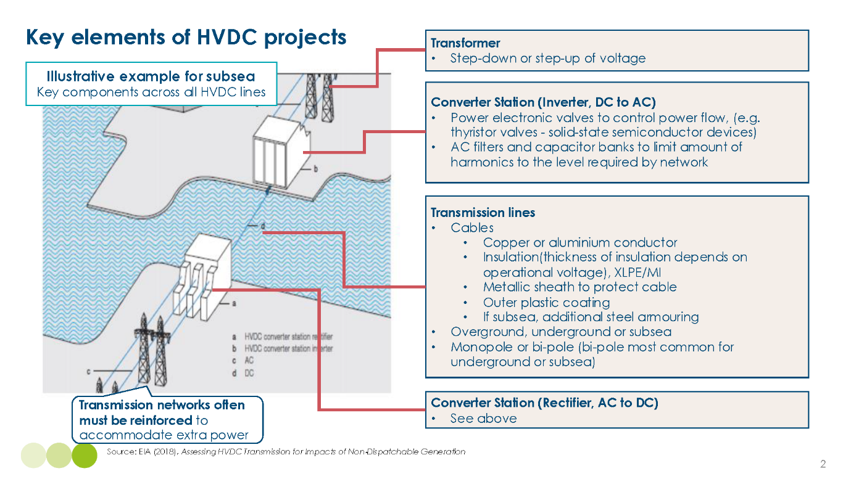

In terms of costs, HVDC projects are highly capital intensive, with projects totalling in billions. Several components are most significant in terms of costs;
- HVDC converter stations – required to convert power from alternating current (AC) to DC and back again, in tight supply and essential for every HVDC project.
- Structures – upon/in which the power conductors are held, which are typically made of steel (e.g., pylons for aboveground lines, cable conduits for underground cable structures).
- Equipment – including line equipment such as conductors, and – for overground lines – the installation cost of stringing wires up to pylons, as well as other equipment costs such as circuit breakers, switchgear, monitoring and control systems, etc. which are essential for safe operation of the line.
- Siting costs, including the acquisition and permitting costs of acquiring land and progressing through various permitting requirements, as well as terrain preparation – ensuring the land or seabed is suitable for cables to be deployed, which is much more costly in adverse conditions (i.e. for mountainous regions, deep underwater).
- Project management – including staff costs for the duration of the project.
- Finance costs – reflecting interest payments required to pay for equipment and staff.
Exhibit 1.2
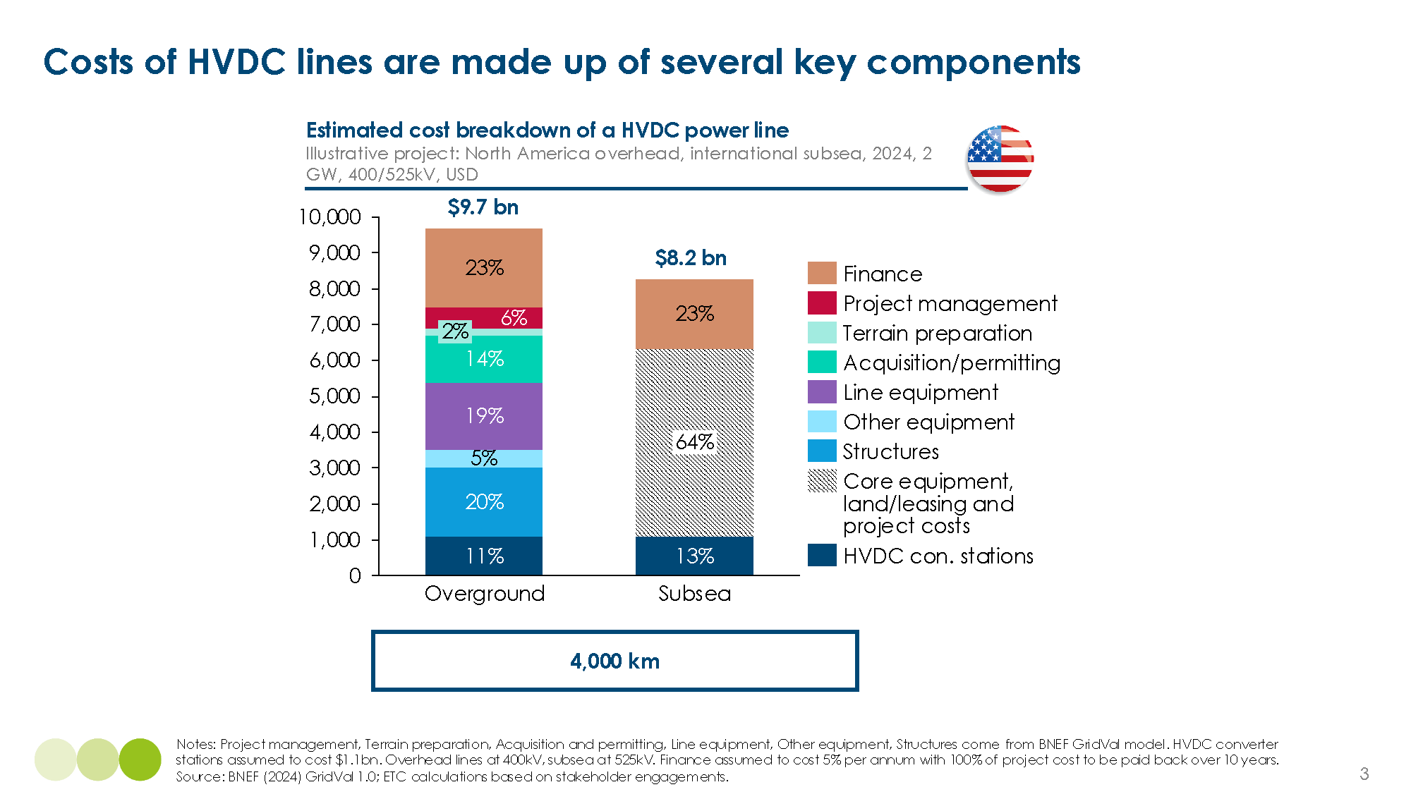

Costs of long-distance transmission projects can be expressed through “$ per MWh per 1000 km” - representing the cost of sending power over a given distance. While project costs differ across project type and location; for HVDC projects over 1,000 km with high utilisation rates, e.g., 85%, costs could typically range between 3 to 10 $ per MWh per 1000 km. For example, an overground line as shown in Exhibit 1.2 may cost a total $9.7 billion over 4,000 km, which at a 2 GW capacity with 85% utilisation is equivalent to $7 per MWh per 1,000 km. To provide an order of magnitude comparison, current renewable energy levelised costs of electricity range from $35 per MWh for solar PV in India, to up to $145 per MWh for onshore wind in Indonesia.
Finance costs and utilisation rates are key components for transmission costs. They are highly variable by project and have a large impact on overall economics:
- Financing rates can have a significant impact; increasing the financing rate from a hypothetical 0% to a 10% financing rate could increase overall project costs by ~60%. Exhibit 1.3 below shows that finance costs could make up ~ 23% of overall project costs.
- Utilisation rates are also critical to overall costs per MWh, as illustrated in Exhibit 1.3. For a 4000 km line, total costs could range from $20–250 per MWh holding all other variables equal; this would be $5–60 per MWh per 1000 km. Business cases will therefore significantly vary based on utilisation; for example, a lower utilisation project serving a specific peak capacity function would need to be remunerated at levels making up for higher costs from lower utilisation.
Exhibit 1.3
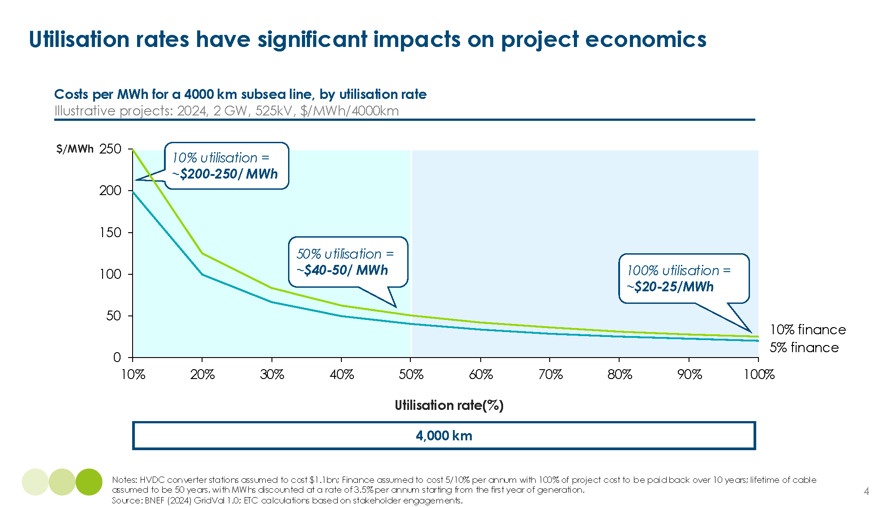

Overall, long distance transmission projects will vary based on the country and project type, impacting the relative competitiveness of global projects:
- Cost variations by country. Aboveground projects have costs which vary widely by country. 1,000 km lines built in India are around 40% cheaper than those in the US. [Exhibit 1.4]. Acquisition and permitting costs vary by country, with land and permitting costs typically more expensive in developed countries. Terrain preparation costs can also be vastly different in across regions; India, for example, is much more mountainous than Germany, with the ground requiring much more costly terrain preparation for line-holding structures than relatively flat Germany. Line equipment and structures also make up a big component, including labour, raw materials and metals such as steel and aluminium.
- Cost variations by project type. Overall, undergrounding tends to have the highest costs, while aboveground and subsea lines are more competitive – with subsea lines potentially the most competitive option at very long distances (4,000 km) [Exhibit 1.5]. In practice, decisions to underground are largely driven by non-cost related factors, such as heavy local opposition to certain stretches of aboveground wires. As noted previously, HVAC aboveground lines are increasingly less competitive at longer distances.
Exhibit 1.4
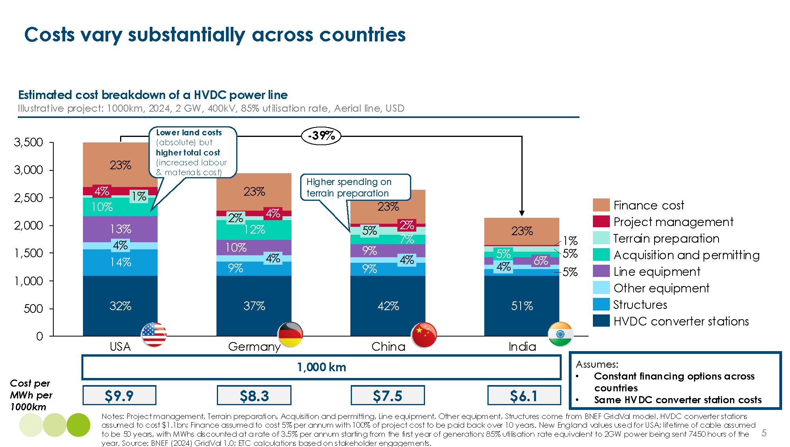

Exhibit 1.5
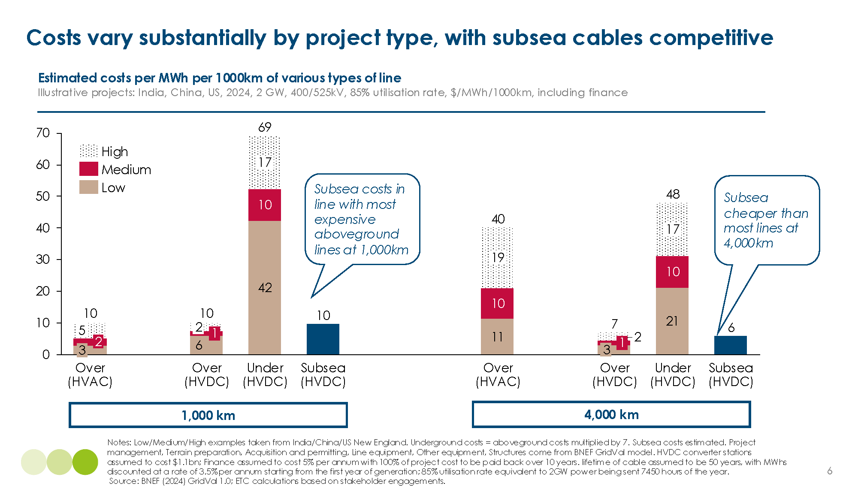

Box A: When are HVAC vs. HVDC cables used?
Long-distance transmission projects can utilise HVAC or HVDC cables. Both are generally made up of the same materials, which depend on the use of the cable across aboveground, underground and subsea. The key differences are that HVDC cables are much thinner – they require half as much materials as HVAC cables, fewer pylons to hold the wires, and have fewer losses, at ~3% of power per 1,000 km compared to ~7% per 1,000 km for HVAC cables. This makes HVDC much cheaper per km of wire as HVAC lines:
- Suffer from corona discharge at high voltages which produce electrical frequencies and causes AC electricity to lose almost three times as much energy than DC cables which have no frequency.
- Produce a “skin effect” where alternating currents induce magnetic “eddy currents” which oppose the current flow. The higher the frequency, the closer to the surface the current is conducted, and the thicker the cable must be to transmit the same amount of power.
In terms of fixed costs, HVDC lines require converter stations on either end of a HVDC power line to convert the power into AC, as all national power grids run on AC networks. The converter stations are costly, and a tight market has driven up costs, rising to ~$1.1 billion for a pair. High fixed costs mean that HVAC is preferred over short distances, whereas HVDC are more prevalent over longer distances. This is reflected in global deployment of the technologies, with over 7 million km of HVAC wires installed today, compared to around 130,000 km of HVDC wires, of which around 20,000 are subsea. The breakeven distances of the technologies vary by use case, as HVAC cables experience even greater losses when underground or subsea, whilst HVDC lines remain well insulated from losses. These nuances are outlined in exhibit 1.6.
Exhibit 1.6
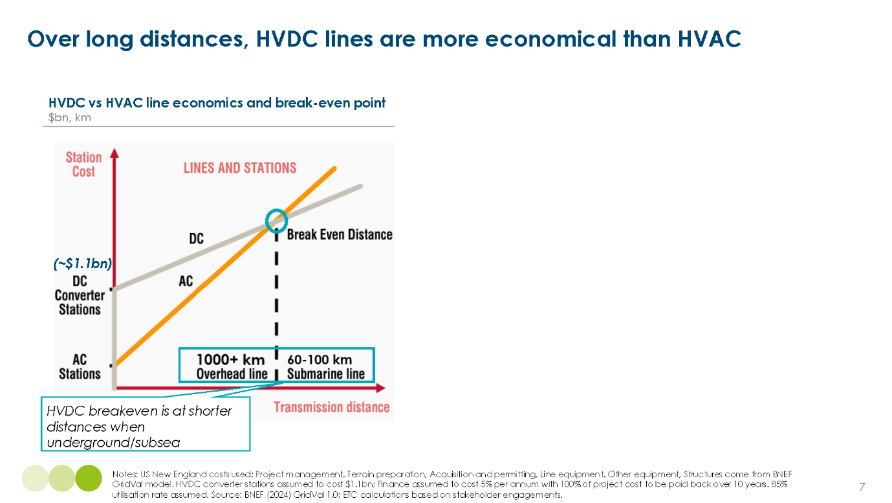

Table 1 provides a breakdown of the cost per MWh per 1,000 km to send power on HVAC cables vs. HVDC cables for an illustrative example of a project in the USA, highlighting the economic case of HVDC over longer distances.
Table 1 Costs/MWh/1000km for overhead lines, USA
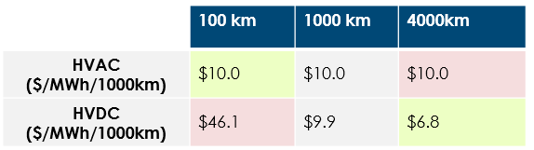
Note: New England, US costs used; Project management, terrain preparation, acquisition and permitting, line equipment, other equipment and structures come from BNEF GridVal model. HVDC converter stations assumed to cost $1.1 billion; Finance assumed to cost 5% per annum with 100% of project cost to be paid back over 10 years. 85% utilisation rate assumed. Quoted costs for 4000 km lines are used for New England, USA but these are illustrative as New England lines are not this long. Source: BNEF (2024), GridVal 1.0; ETC calculations based on stakeholder engagements with members and experts.

2. The reasons to build long-distance links in high variable renewable power systems

Delivering clean power systems based primarily on variable renewables will require running higher complexity, expanded electricity systems. In its work on power systems transformation, the ETC has addressed the importance of several enabling technologies – including the need to build new and more efficient grids, as well as expanding storage and demand side flexibility.,
Long-distance transmission can also enable more efficient flows of power across systems. Connecting cheap, clean electricity from areas of renewable energy abundance to areas of renewable energy scarcity at ever increasing distances could reduce the costs and increase the speed towards a low-carbon system. In particular, it can offer two major potential benefits:
- Low-cost clean generation – Long distance transmission (primarily via links where power flows in one direction) can leverage global cost differentials in wind and solar, based on different countries’ resource endowment, land availability, as well as the difference in capital costs across countries. Key factors include differences in:
  - Solar irradiation and wind speeds – There is a high variation of solar irradiation around the world, with better resources in equatorial and tropical countries, at low altitudes and particularly in desert or dry climate locations [Exhibit 2.1]. Wind resource also varies greatly across the world, where high latitude countries experience fastest mean wind speeds [Exhibit 2.2].
  - Population density – Across the whole world, there is plenty of land to support required solar and wind energy development, but availability may be limited in countries with very high population density. For example, Singapore has a very high population density of 8,000 people per km², and therefore very limited land to deploy renewables to meet the demand of its dense population. There is high potential for a link from a close by low population density country such as Australia (three people per km²) to deploy renewables at a massive scale, and transmit the clean power to Singapore where it is needed.
These differences are reflected in significant variations in the costs of renewable generation around the world.
- Balancing – Long distance transmission could in some cases play a role in providing balancing across countries, providing electricity at useful hours for the system, when local renewable supply is less intensive – either via a one-way link, or via a two-way link.
Through these routes, long-distance transmission can also help to overcome specific land and resource availability constraints, and reduce emissions across grids where there is a notable divergence.
Exhibit 2.1
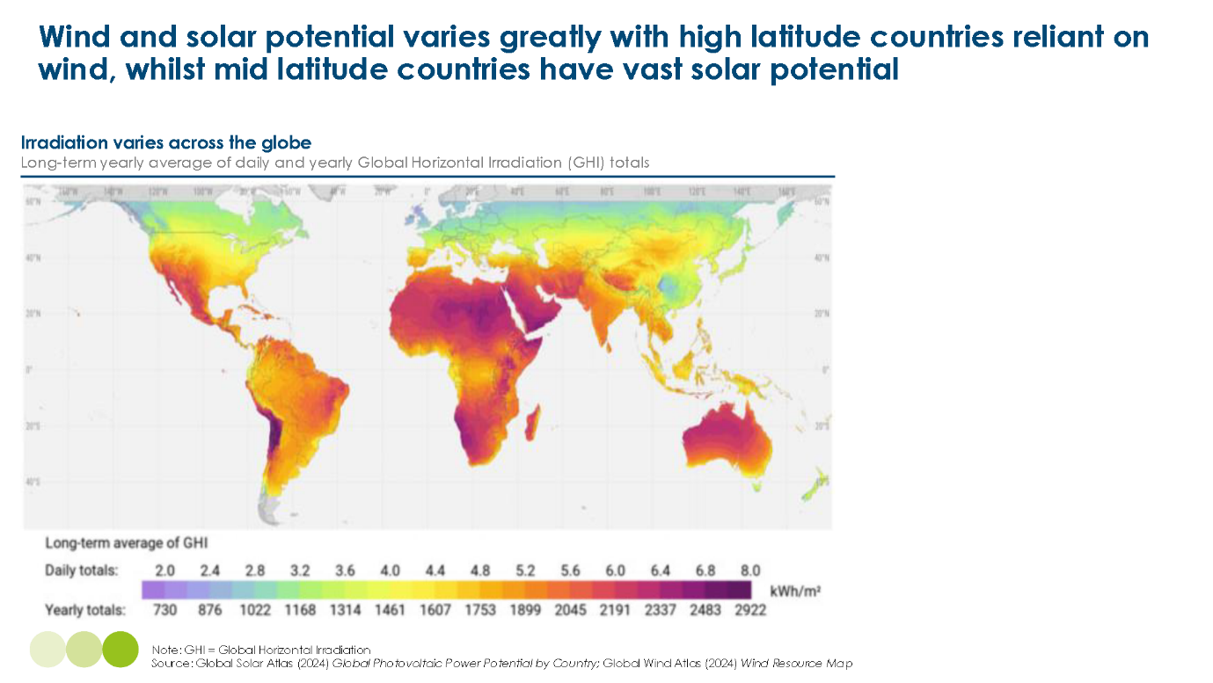

Exhibit 2.2
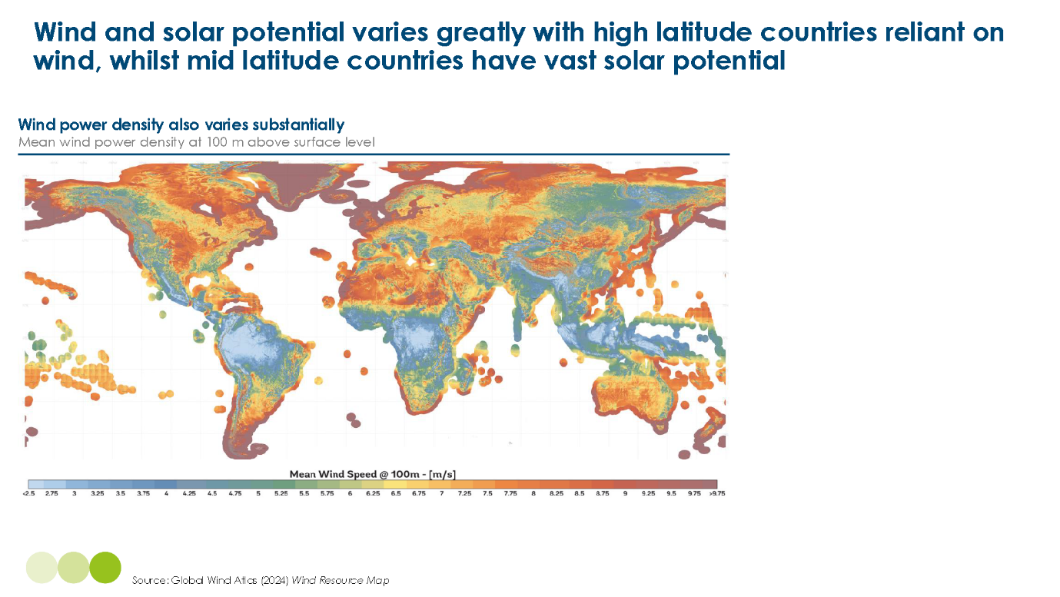

Building long distance transmission for cost-effective generation
The economics of this case fundamentally depends on whether the cost of renewable generation of the importing country will be higher than the cost of renewable generation of the exporting country, plus the cost of transmission. Around the world the resource mix means that a number of such projects could be beneficial. For example:
- Saudi Arabia – India. Generating power in Saudi Arabia plus the cost of transporting power to India is lower than the LCOE of solar power in India today, as illustrated in Exhibit 2.3. Furthermore, the sun sets in India three hours after it sets in Saudi Arabia, so Saudi solar can also provide power for crucial hours in which Indian solar power would not be generating, as highlighted in Exhibit 2.4. Therefore, it could also deliver the second benefit: balancing.
- Australia – Singapore. There could be substantial benefits from a clean power link between Australia and Singapore, In fact, all in 2050 equivalent costs for clean generation, batteries and transmission connecting the countries come in at almost half the price of gas generation based on imported LNG and the associated carbon price in Singapore.
- Tunisia – Italy. There could be large benefits from a Tunisia to Italy link, with 2050 Tunisian generation plus transmission costs summing to $25 per MWh, much less than the associated average wind and solar costs of $34 per MWh in Italy.
Exhibit 2.3
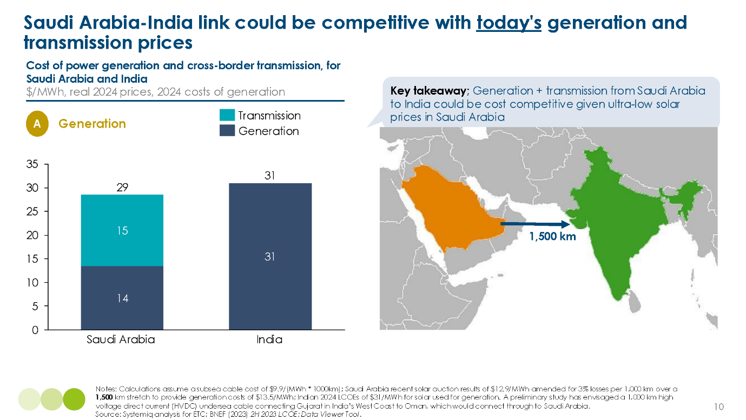

Exhibit 2.4
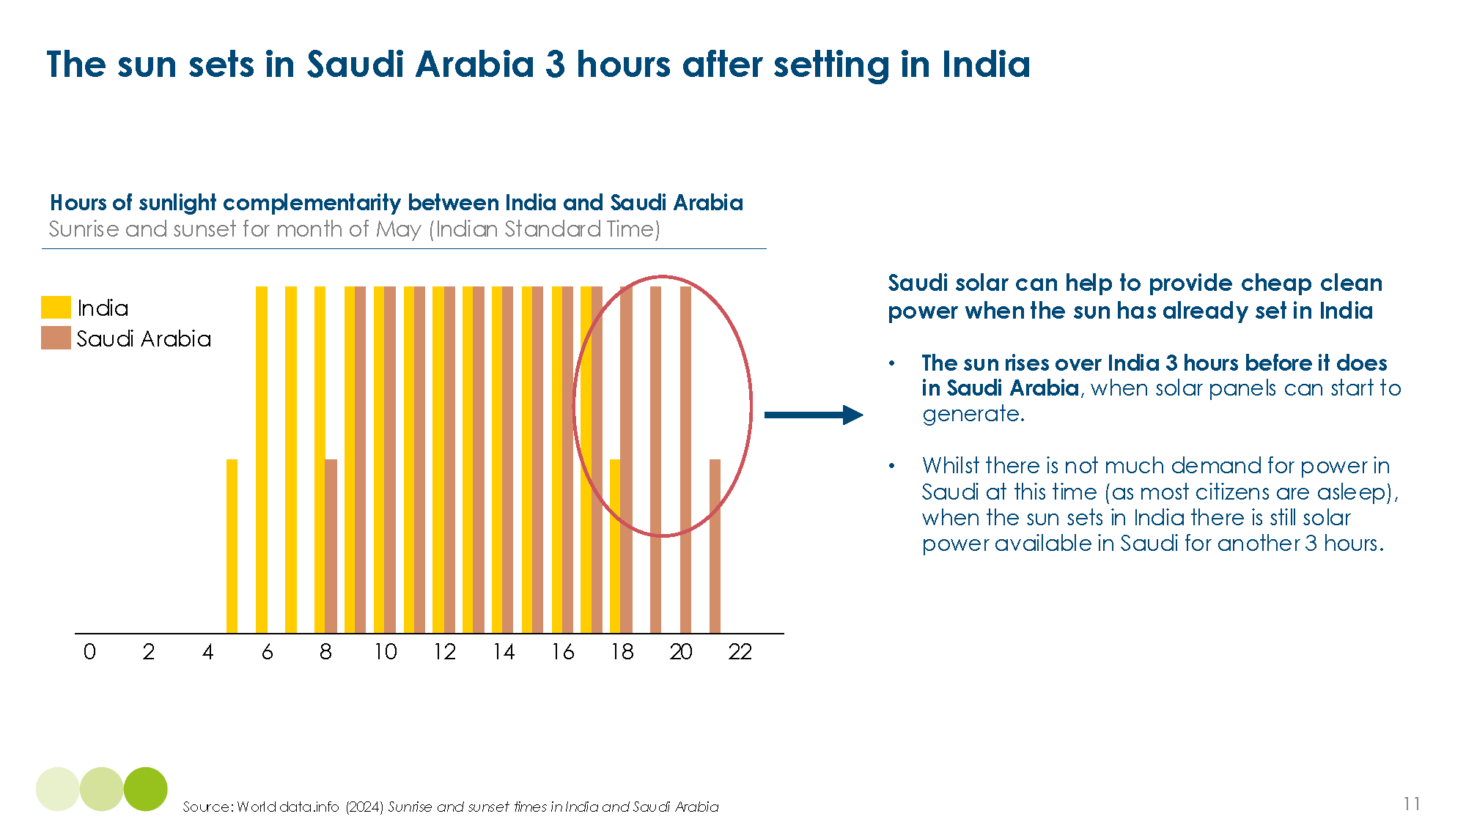

However, in some cases long-distance transmission may prove too expensive to connect two systems despite potential opportunity on cost differentials. ETC analysis shows that the case for a link between Vietnam and Malaysia may be less clear. There are however potential benefits of a wider balancing area which could come from a greater interconnected ASEAN “super-grid”.
Building long distance transmission for balancing
Long distance transmission could, in some cases, play a role in providing balancing for high variable renewable systems. The need to manage system balancing increases as the penetration of wind and solar grows. This includes both meeting system operation challenges at the fraction-of-a-second level, as well as providing zero-carbon electricity at times when variable generation is not producing, including across hours, days, and multiple weeks.
For second by second power system balancing needs, interconnectors can physically ramp up and down very fast to adjust for immediate demand/supply needs i.e. over 100 MW per minute - in line with gas peaker plants.
For balancing over more extended durations, the key issue is the availability of consistent generation in the exporting country. There are two ways that long distance transmission can provide balancing, via:
- Using non-correlated weather and demand patterns to provide electricity at grid optimal times. For example, the six hour time difference between New York and Paris means that in every month of the year there is strong misalignment - and therefore balancing potential - across solar generation patterns, making a case for linking European and US grids [Exhibit 2.5].

- Using storage in addition to non-correlated weather and demand patterns, to provide a firm electricity source that can be exported.
Overall, the economics of long distance transmission for balancing will depend on whether the cost of renewable generation of the exporting country, plus storage if used, will be lower than the cost of providing the generation and balancing locally. This is shown in exhibit 2.6, illustrating the economics of Tunisian exports into Italy, in a number of cases: generation only; balancing based on uncorrelated patterns; balancing with the addition of storage at the export site. Adding storage (batteries) to the Tunisian side to fully “firm” the link enables it to compete with the more expensive medium-duration balancing in Italy for benefits of $17 per MWh (B2).
A Morocco to UK power link could have similar benefits. While the costs associated with the required 4,000 km line may make the project not economic compared to UK offshore wind, ETC analysis finds that when batteries and wider storage costs are factored in the project, it becomes much more competitive and generates savings of $21 per MWh.

Exhibit 2.5
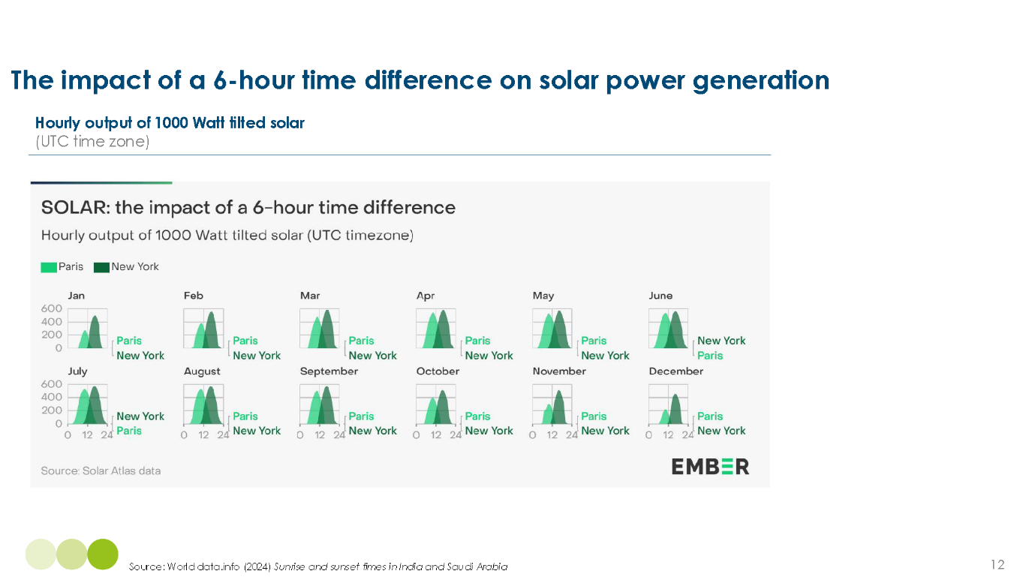

Exhibit 2.6
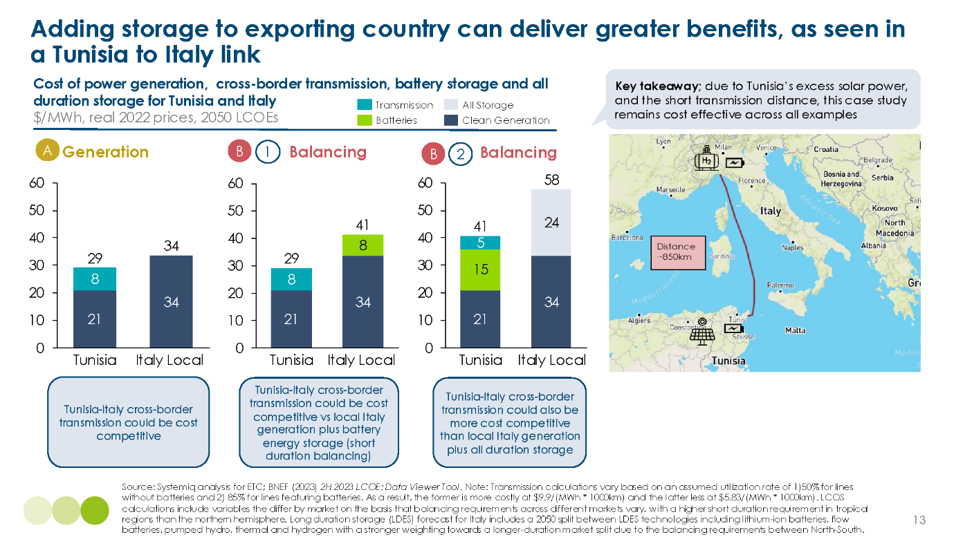

3. Top global opportunities for international long-distance transmission
Long distance transmission could play a major role in reducing the costs of power decarbonisation within large countries such as China, Russia, India, Australia, Canada and USA. However, the technology’s potential could also transcend borders if issues relating to political risk and coordination are overcome.
To assess the scale of this opportunity of international long-distance transmission, the ETC in collaboration with Systemiq developed a global optimisation model, matching 2050 hourly wind and solar supply to demand at country-level, to identify top opportunities for export. This modelling builds on previous work from other organisations such as Transition Zero to illustrate top opportunities under a number of key filters, including total traded volume, contribution to balancing, and to overcome land constraints for local renewables.
This chapter outlines the modelling methodology in Box B. It then presents key findings on top links against key criteria (cost savings, balancing potential, emissions savings, land availability), and highlights specific projects with high potential.
Box B: Modelling methodology for global potential of international long-distance transmission
The optimisation model is based on illustrating a 2050 global energy system where power is provided solely by wind and solar generation, where it is cost-effective to do so. The model then solves for the most impactful international long-distance transmission links. The optimisation is also filtered against a range of key criteria to understand the best opportunities across a number of factors. The modelling to assess the global potential of international long-distance transmission used a four step process:
1. Supply
- Estimated the 2050 potential wind and solar supply for each country using satellite data to map potential areas for renewable development across the globe; assigned usable land percentages building on initial assumptions created by Transition Zero.
- ETC collected historical weather data for the past 30 years using the ERA 5 model to establish a baseline for the amount of wind and sun that would be received by countries. ETC processed this data using the open-source python “Atlite” model to convert the weather data into energy systems data for average renewable generation potential based on a 31 km grid of the globe.
- Land available for renewables and average generation potential were together to give 2050 potential of wind and solar energy generation for each country and region.
2. Demand
- Obtained 2015 hourly demand curves via the PLEXOS model for every country. We then scale 2015 curves to projected 2050 demand levels, based on the ETC targets; and BNEF Net Zero Scenario projections where ETC targets were not available.
- Averaged between the original PLEXOS curves and our fully scaled projections for more accurate peak demands as directly scaling the 2015 to 2050 results lead to overly high peak demands.
3. Trade prioritisation
- Obtained/calculated 2050 LCOE data for wind and solar across each country and combined this with our established costs of transmitting power between countries from Chapter 1.
- Combined the economic factors together in a model to “solve” for a long list of top interconnectors by highest traded value over time. This gave us a large list of around 1000 interconnectors.
4. Criteria filtering
- Against key criteria to establish a final set of results and highlight the most transformational new international long-distance connections.
Key criteria and model results
Exhibit 3.1 shows the links the model suggests might be economic, and the relative scale of the potential cross border flows, given analysis of fundamental volumes, costs and land availability. But several of these projects may not be feasible in the foreseeable future given other factors which the model does not capture. For instance:
- While in principle China could be a large low cost exporter to Japan and South Korea, political considerations and concerns about security of supply make developments unlikely in the near term.
- Pakistan shows up as a high potential exporter to central Asian countries due to its very high insolation and available land, but political instability in surrounding countries (particularly Iran and Afghanistan) make some of these export opportunities very challenging.
- Large potential flows from northern and northwest Africa (e.g., Mauritania and Algeria) to Nigeria are high potential. We note that these would currently be challenged by the political instability of the countries en route, so may require more expensive subsea cables for security of supply if the links are to be built in the near term.
- Cost of capital, which is low in some markets but high in many, reflecting country-specific risks that will feed into any project developments.

The scale and benefits of the different links can be assessed by considering five criteria:
- Total volume traded – I.e. potential volume traded in TWh.
- Cost-effectiveness – The cost differential between wind and solar costs in importing versus exporting countries.
- Daily and seasonal balancing – The extent to which the interconnection will facilitate low cost balancing of power supply and demand by time of day or year.
- Emissions reduction – The potential to reduce emissions in the net importing country given its current carbon intensity of generation.
- Land constraints – The potential to provide power from a country with low population density and large land availability to one with low land availability due to higher population density or specific geographical conditions.
Exhibit 3.2 shows for each of these criteria, the links which the model suggests score highest.
Combining a consideration of these criteria, and excluding the possibility of China to Korea/ Japan, suggests the highest significant possibility projects shown on Exhibit 3.3
Exhibit 3.1
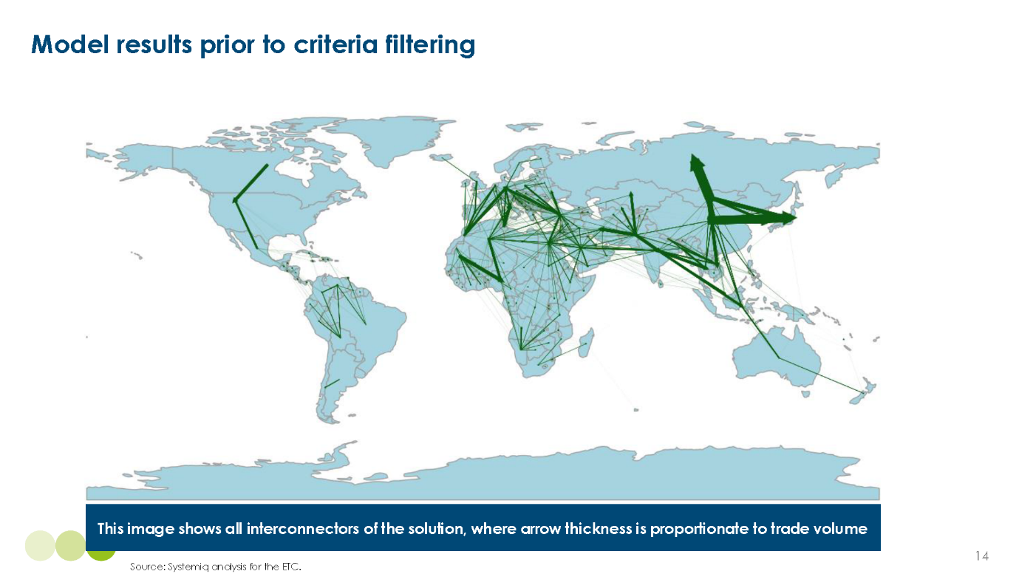

Exhibit 3.2
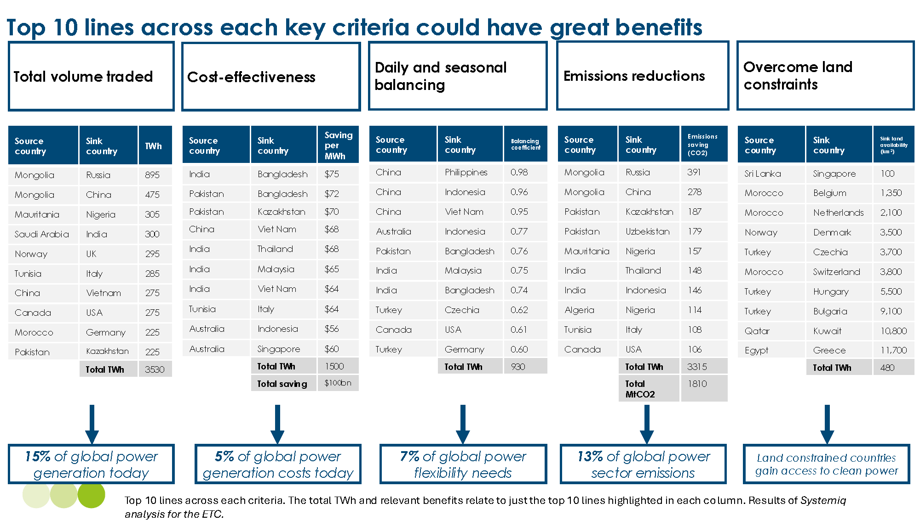

Exhibit 3.3
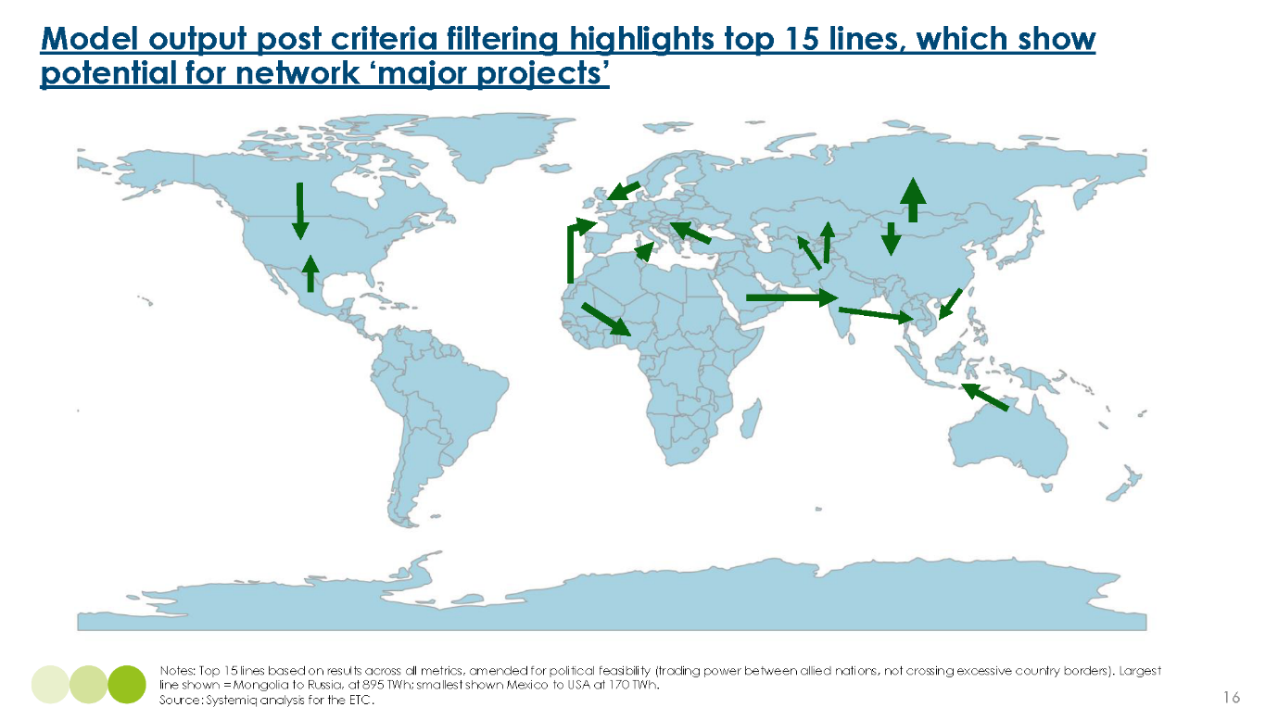

Major project details and issues
Overall, the modelling results suggest very large global technical potential for cross border interconnection, with a small number of high potential links having potential to deliver by 2050: 15% of global power demand, 1.8 Gt per annum carbon reductions (equal to 13% of global power sector emissions), and $100 billion of savings per year.
Within the total overall list, we describe below four major projects (or combinations of project) which have significant short term potential, and the others where there is significant potential, but some of which face significant implementation challenges.
Four major cross border possibilities
1) North Africa to Europe represents a major opportunity, exploiting both the lower cost of renewables generation, and the lack of time correlation between renewable availability in North Africa vs. northern Europe. For instance, over 900 TWh of clean power per year could be sent from Morocco to Northern Europe, utilising abundant land and weather resources of Morocco to countries with strong power decarbonisation targets. Tunisia also has very significant potential, with possible subsea transmission to northern Italy and onward transmission to northern Europe. Other neighbouring North African countries may also have potential.

Exhibit 3.4
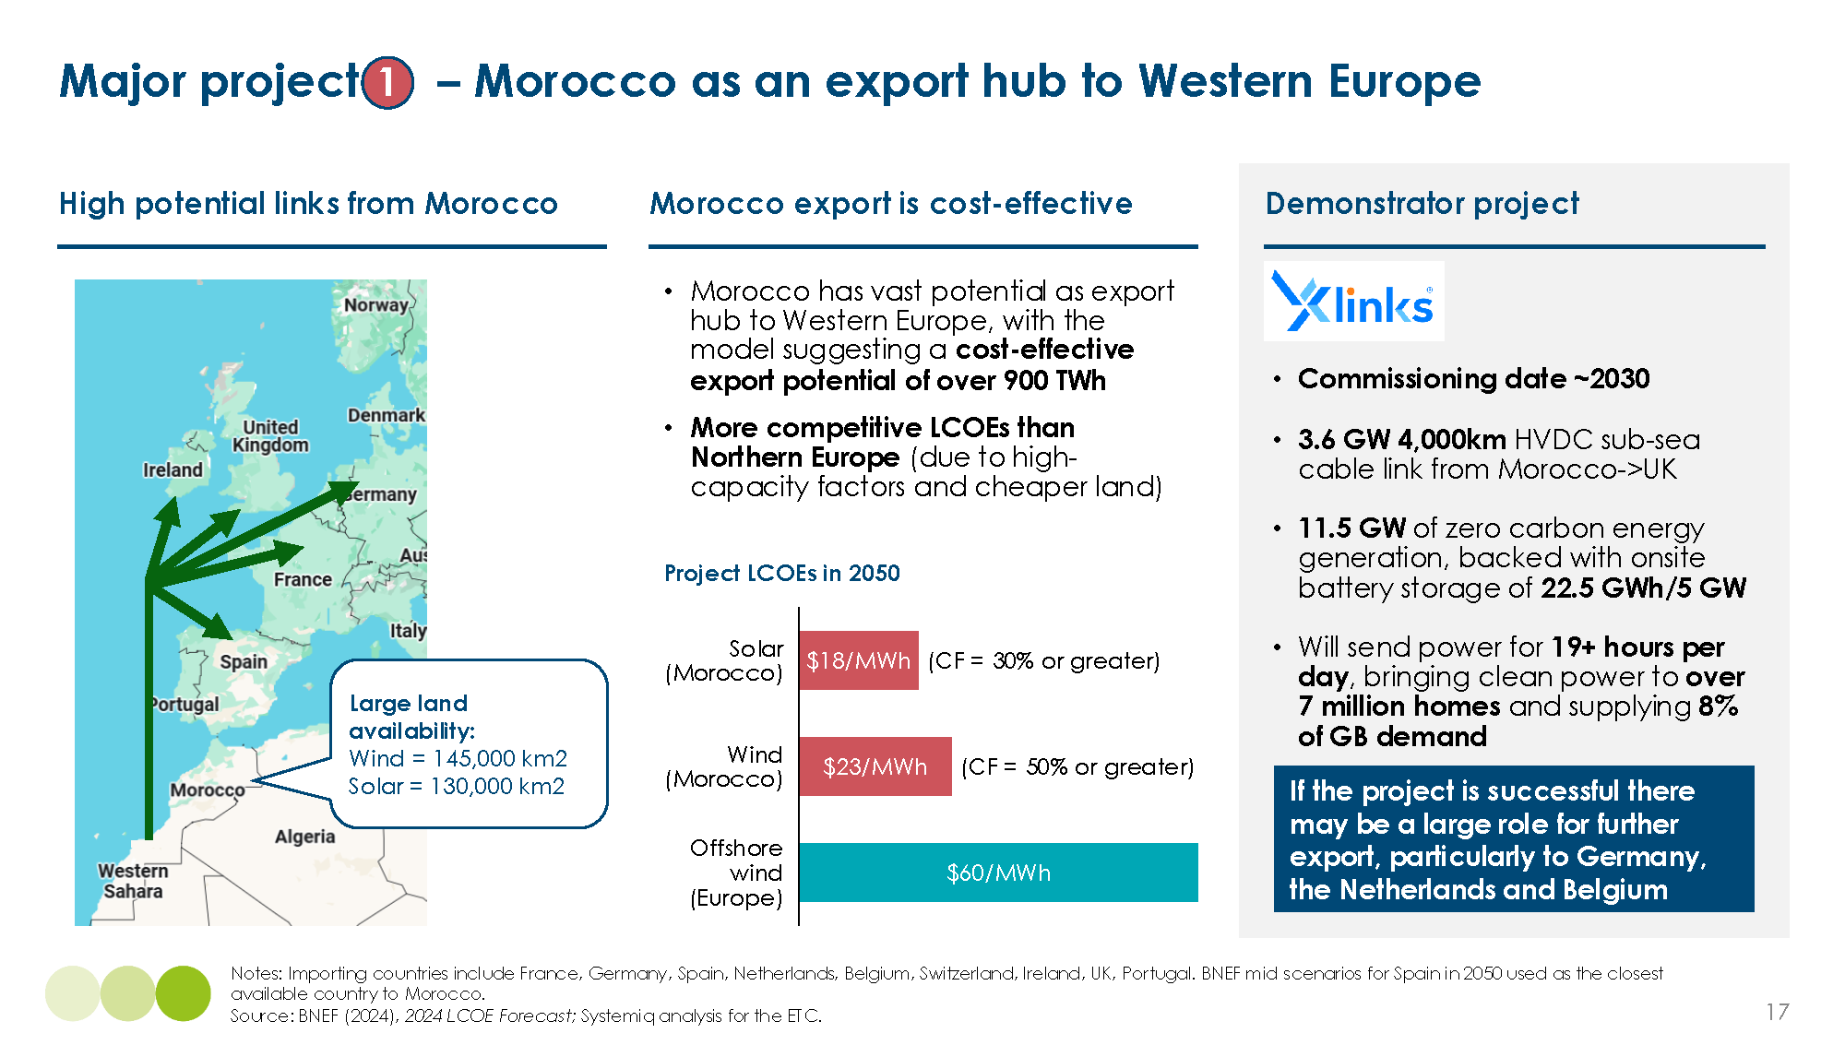

2) Australia as an export hub to Southeast Asia – over 300 TWh per year could be sent to Southeast Asia, utilising the excellent land and weather resources of Australia to send power to land and weather constrained countries. If the Australia to Singapore demonstrator project is successful many other countries could stand to benefit from new lines.
Exhibit 3.5
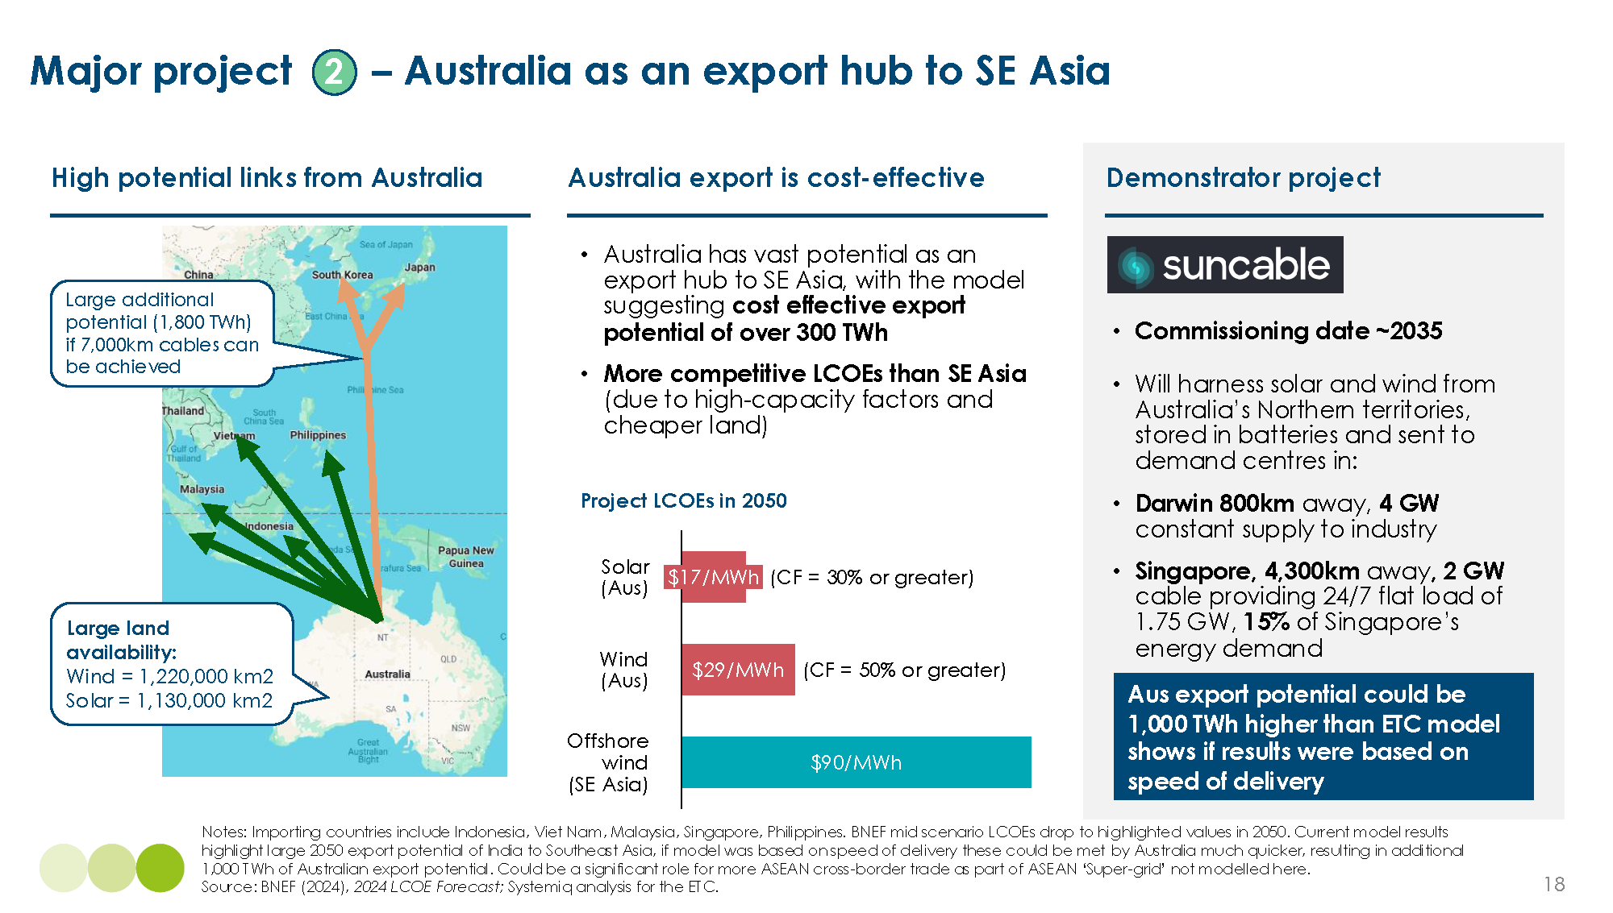

3) Increased exports from Canada and Mexico to USA – over 400 TWh of power could be sent each year (around 10% of total US consumption), utilising wind potential from the vast land of Canada and consistent solar potential from close-to-equator Mexico to help fuel the ever-increasing US demand for energy without increasing emissions.
Exhibit 3.6
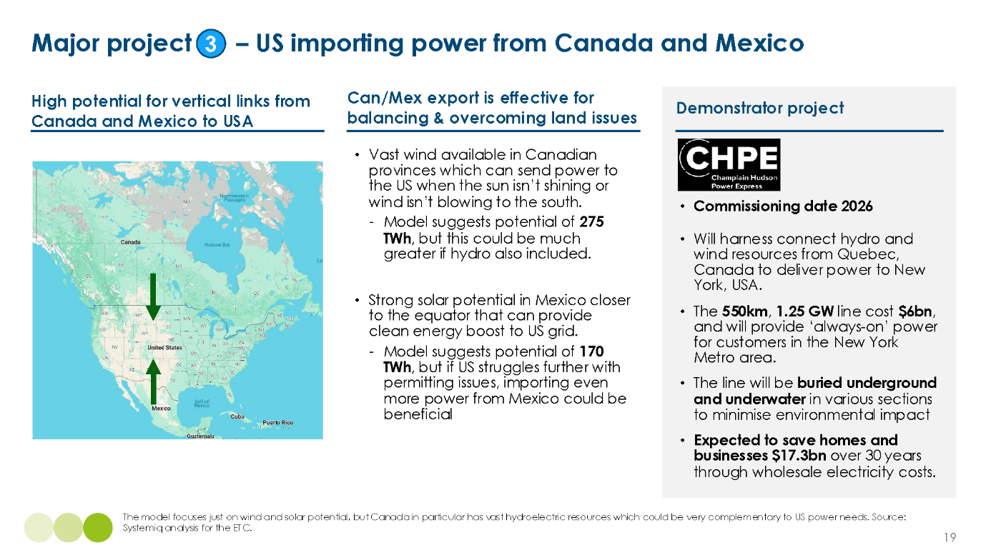

4) West to east solar power export starting in India. In principle, there could be a large opportunity to transmit solar power across long distances from west to east, using mid-day/afternoon sun in one location to meet evening power demand in other location. India could be the centre of the first large scale implementation of this “One Sun, One World, One Grid” concept.
Exhibit 3.7
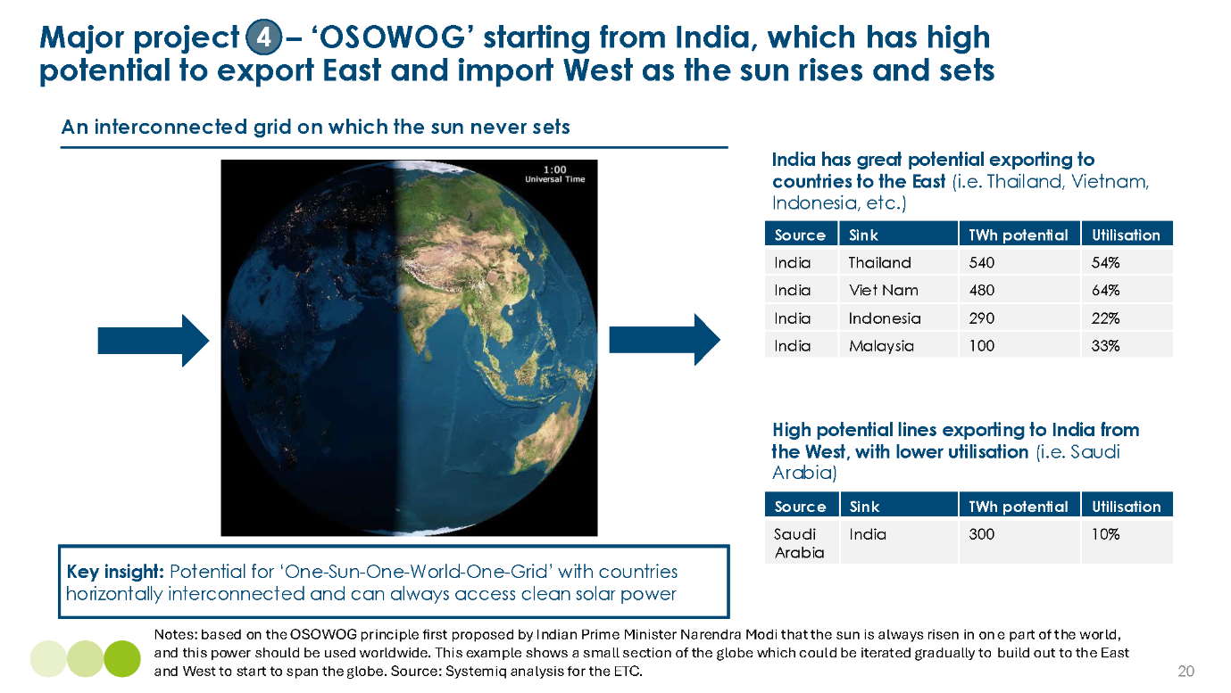

Other high potential links – though with major implementation challenges in some cases
1. Very large renewable potential in Mongolia, potentially exported to China. Mongolia has excellent wind resources and plentiful land as a result of very low population density. It would therefore be a cross border source of renewable electricity for China, complementing the large wind and solar potential of China’s western and northern provinces (e.g., Inner Mongolia) which will be connected to China’s more populous eastern provinces via within country long distance HVDC transmission lines.
2. Türkiye to Central and Eastern Europe. Given Türkiye’s large land availability, high insolation and wind potential, our model suggests that over 700 TWh per annum could be exported to countries with poorer weather generation potential, and help overcome continental-European land and permitting constraints. This would, however, require significant investment in overground transmission.
3. Mauritania and Algeria to West Africa. Almost 450 TWh of annual potential exists, and the West African Power Pool has already started work to improve cross-border flows in the region. This would arbitrage the big difference in insolation levels between northern and western Africa which is visible in Exhibit 2.1, and help meet potentially rapid growth in electricity demand. Current low levels of power demand and political instability in many of the relevant countries through which lines would pass are however significant impediments to any short/medium term developments.
4. Pakistan to Kazakhstan and Uzbekistan. Another high potential link, particularly in terms of emissions savings, where 380 TWh could deliver over 360 Mt per annum of carbon savings if lines are built to their full potential. However, these lines would likely have to go through Afghanistan which may be hostile to the transfer of power across their borders.
5. China to Southeast Asia. China could provide 500 TWh to Southeast Asian countries including Vietnam, Indonesia, Thailand and the Philippines, however due to territorial disputes in the South China Sea there may be a lack of willingness for some countries to sign long-term power supply agreements with China.
This section has highlighted the strong potential for large scale interconnection resulting from the ETC’s analysis. There are likely to be many other smaller projects which make economic sense in specific regions. Several of these are indicated by the narrower lines on Exhibit 3.1.

4. Unlocking the potential of long-distance transmission
ETC analysis shows that there is significant potential for greater long distance transmission to deliver clean power across the globe. There are, however, some critical barriers which must be overcome to realise the full potential, some of which are more severe than others:
- Political feasibility, severe: Political agreements between countries trading power can be difficult especially where lines cross international borders. In some cases, fundamental differences in political ideology may prevent countries agreeing on line development and halts possibility of specific high-impact lines. In other cases, quid pro quo may need to be offered to countries to increase acceptance. In addition, whilst interconnection generally brings down the average price of electricity, in some cases, and especially if power companies monopolise benefits, consumer bills in a country can increase. It is therefore important to ensure consumers feel benefits of new lines by passing through the lower average costs of power to bills to build support for new lines.
- Geopolitical and energy security challenges, some valid concerns: There is a hesitancy to commit to importing large percentages of power from neighbours and some concerns about security of cables to hostile actors and environmental shocks., A diversity of supply is required, and countries should gain confidence in interconnection as cross-border trading becomes more common
- Finance, fairly severe: It can be hard to agree funding and revenue mechanisms between parties. However, once offtake agreements are secured international investors tend to be attracted to the large nature of these projects.
- Supply chain constraints, fairly severe (short-term): There are limits to the short-to-medium-term supply of cables, transformers and vessels. Long-term planning is required to provide clarity to OEMs to scale up, whilst some scaling up and self-production is underway and growing.
- Lack of demonstrators, some valid concerns (short-term): There are somewhat of a lack of very long-distance demonstrators to prove that power can be sent over 2000 km+. However, China already has long-distance aboveground transmission of over 2,200 km, and Xlinks are developing a 4,000 km subsea cable expected to commission around 2030.
- Technical, not particularly severe: There can be some technical issues linking up grids on different frequencies (i.e. 50 vs. 60 Hz used in different ASEAN countries). However, these can be overcome, as seen by Europe’s grids which are connected by over 400 interconnectors, whilst Japan’s East (50 Hz) and West (60 Hz) grids are on different frequencies, and trade power effectively via HVDC.
Importance of transnational collaboration
Overall, barriers have varying degrees of severity, and taken together provide a challenging policy environment and contribute to a slow rollout of cross-border transmission outside of Europe. Most large-scale cross-border transmission projects in the past have been the result of transnational collaboration coordinated by large bodies to ensure geopolitical alignment and shared benefits amongst stakeholders. Box C highlights a successful example of transnational collaboration to build cross-border links in NSCOGI/NSEC, and examples of other groups seeking to promote and build more international transmission links.
Box C: Transnational coordination groups to increase cross-border collaboration
NSCOGI/NSEC, the North Seas Countries’ Offshore Grid Initiative/North Seas Executive Councial, has already been very successful in helping build interconnection in the North Sea, with more than 17 major subsea cables already in operation in the North Sea and English Channel, and another 10 in planning or construction. This was a long-term project, however, and required lots of negotiations and work NSCOGI/NSEC over a number of years:
- Early 2000s – Initial discussions and recognition of the potential for North Sea energy cooperation take place.
- 2009 – NSCOGI formally established.
- 2010-2015 – Members conducted feasibility studies, identified potential interconnection projects, and worked on regulatory harmonisation.
- 2016 – NSCOGI evolved into the North Seas Energy Cooperation (NSEC), broadening its scope to include other energy sources and cooperation areas.
- 2021 – The North Sea Link, a major interconnector between Norway and the UK, became operational, demonstrating the feasibility of cross-border electricity trade.
For the cooperation and benefits we have seen in the North Seas to take place in other areas of the globe we will need to see other organisations grow to facilitate these discussions and foster greater collaboration. TERAMED could be the NSCOGI of the Mediterranean. Launched in 2024, it aims to promote greater cross-border power trade in the Mediterranean region, with a common target of 1 TW of renewable energy capacity by 2030.
There will also be a role for larger international institutions to promote the establishment of a more globally connected international energy system. The Global Energy Interconnection Development and Cooperation Organisation (GEIDCO) is taking a lead role here, having so far conducted in-depth studies on the economic and social development, energy resources, and electricity supply and demand of over 100 countries; and proposed the GEI Backbone Grid plan, focusing on accelerating GEI development and building a modern energy system dominated by clean energy.
The Green Grids Initiative (GGI) is a new secretariat partnership in this space and seeks to further action-orientated cooperation to support global electricity grid development. GGI will also be a lead advocate in a worldwide campaign mobilising governments behind a global target on green grids.

Recommendations
To overcome challenges to long distance transmission projects, there are four critical actions that should be prioritised:
- Cross-border transmission should be placed on the global action agenda, including via the COP process and through key global actors such as MDBs, global grids initiatives
- Support given to international initiatives to facilitate cross-border cooperation and facilitate agreements.
- Cross-border transmission to be a key focus of upcoming COP processes, particularly with a focus on North-South cooperation and benefits sharing.
- Within and across regions, key countries must consider cross-border transmission as part of a strategic vision for network expansion
- Continent scale countries such as China, India and the US should conduct large scale transmission planning to generate where most effective and help balance wide geographical areas. They should also consider cross-border connections where beneficial.
- Smaller countries, such as the ASEAN group, should continue plans to work together to interconnect their power grids to widen the generation and balancing area.
- Implementation will be on decade-long timescales, requiring sustained political will starting now
- Support & derisking mechanisms for cost-effective demonstrator projects.
- Detailed cost-benefit analyses for longer-term projects must strongly consider impacts on consumer bills to increase political acceptance.
- Introduce business models and begin or advance political cooperation processes.
- Address skills, components (e.g., HVDC cables & converter stations) and materials gaps
- Conduct strategic planning to understand needs well in advance of demand to enable procurement, scaling up of factories and training where possible.
- Consider making bulk purchases of critical components to benefit from economies of scale and provide clarity to suppliers.
- Make strategic investments in critical component manufacturers (i.e. HVDC cable manufacturers) where demand is forecast to outpace supply.

International Energy Agency (2024), Electricity 2024 Analysis and forecast to 2026.
International Energy Agency (2024), Electricity 2024 Analysis and forecast to 2026.
Unpublished FFiT (QCF workstream research)
BNEF (2024), 2024 LCOE Forecast.
Solar insolation intensity refers to the amount of solar energy received per unit area over a given time. It's a measure of how much sunlight is hitting a specific area. See PV Education, Calculation of Solar Insolation, available at https://www.pveducation.org/pvcdrom/properties-of-sunlight/calculation-of-solar-insolation.
ETC (2024), Building Grids Faster: The Backbone of the Energy Transition.
ETC (2025), Demand side flexibility – unleashing untapped potential for clean power.
BNEF (2023), Cost of Clean Energy Technologies Drop as Expensive Debt Offset by Cooling Commodity Prices.
NS Energy (2020), Changji-Guquan UHVDC Transmission Project.
Mohammadi and Meisen (2010), Cross-Border Interconnections on Every Continent.
A strong contributing factor to this is the relatively smaller surface area of European countries; in general, the wider the balancing area within connected power grids, the better the benefits are for cost-effective balancing and generation. Ember (2024), Clean flexibility is the brain managing the clean power system.
Northsealink, The world’s longest subsea interconnector linking the UK and Norway, available at https://www.northsealink.com/. [Accessed 15/03/2025].
COP29 (2024), COP29 Global Energy Storage and Grids Pledge, available at https://cop29.az/en/pages/cop29-global-energy-storage-and-grids-pledge.
The West African Power Pool (WAPP) aims to improve cross-border and reliable flows of electricity in West Africa, while the ASEAN Power Grid project seeks to construct regional power interconnection to connect to Southeast Asian countries, first on cross-border bilateral terms, eventually leading to a total integrated Southeast Asia power grid system. The One-Sun-One-World-One-Grid project seeks greater interconnection across the world, on the basis that cheap solar energy will always be available in some parts of the world in abundance.
Assuming above ground projects, $3 per MWh per 1000 km for a 4,000 km overground line in India, to $10 per MWh per 1,000 km for a 1,000 km line in New England, USA. See exhibit 1.6 for wider cost range. Systemiq analysis for the ETC.
Assuming 85% utilisation rate and 3.5% discount rate over 50 years; Systemiq analysis for the ETC.
BNEF (2024), Levelized costs of electricity 2H 2023.
Considering a subsea line at 4,000 km. Assuming a project finance model where the projects are financed over a 10-year period, with borrowing costs at 5%. We assume all of this finance is paid back over the 10-year period. Finance models can be varied, with costs arrived at by ETC calculations based on stakeholder engagements.
For a 2 GW line, a utilisation rate of 100% means that 2 GW of power are sent from Country A to Country B in all 8760 of the hours of the year. Whereas a 10% utilisation rate would send an average of 2 GW of power for 876 hours of the year.
Similar costs are assumed across geographies for financing and HVDC converter stations due to lack of confirmed, quantitative data; however, these may vary quite substantially. In reality, governments may step in to assist in financing projects at a much more competitive rate due to the vital nature of these as “infrastructure projects of national significance”. China may be able to build converter stations at a lower cost, but projects are not yet available on the open market, with limited appetite from western transmission system operators to rely on importing complex components which could come with energy security risks. Source: ETC engagement with expert stakeholders.
In advanced economies, overground wires are made up of mostly aluminium and occasionally reinforced with steel, whilst underground and subsea cables often use copper instead of aluminium, and may have steel reinforcements, and occasionally lead sheathing (although this is in process of being phased out). Less developed economies still tend to favour copper even in aboveground lines; See BNEF (2020), Copper and Aluminium Compete to Build the Future Power Grid.
Ibid.
Corona discharge is an electrical discharge caused by the ionisation of a fluid such as air surrounding a conductor carrying a high voltage, resulting in power losses. See Cence Power (2022), The Benefits of HVDC Transmission Systems (High-Voltage Direct Current).
The skin effect does not exist in DC cables as DC electricity does not oscillate and can travel directly down the cable.
The current lead time for new stations are 10 years or more, with 90% of the market share in Europe met by three companies (Siemens Energy, Hitachi Energy and GE Vernova), with the market expected to be very tight until at least 2030. ETC engagement with expert stakeholders. BNEF (2024), Europe's High-Voltage Converters: Just Enough for 2030.
BNEF (2024), New Energy Outlook Grids; IEA (2024), Electricity Grids and Secure Energy Transitions.
ETC (2024), Building Grids Faster: The backbone of the energy transition.
ETC (2024), Demand side flexibility: unleashing untapped potential alongside electricity grids and storage.
Solar irradiation is defined as the amount of energy that reaches a unit area over a specified time, expressed as kWh per m². See Rumbayan, Abudureyimu and Nagasaka (2012), Mapping of solar energy potential in Indonesia using artificial neural network and geographical information system.
Systemiq analysis for the ETC; Ember (2024), Regional grids key to Singapore’s energy future; BNEF (2024), NEO 2024.
BNEF 2050 projections for LCOEs in India reach $15 per MWh for both wind and solar respectively, whilst for South Korea these stay as high as $41 per MWh. See BNEF (2023), 1H 2023 LCOE: Data Viewer.
Saudi Arabia has the additional benefit of being much less land constrained than India, with a population density of just 16 people per km², compared to 473 people per km² in India.
See Systemiq analysis for ETC; BNEF (2023), 2H 2023 LCOE: Data Viewer Tool. Note: Transmission calculations vary based on an assumed utilisation rate of 1) 50% for lines without batteries and 2) 85% for lines featuring batteries. As a result, the former is more costly at $9.9 per (MWh * 1000 km) and the latter less at $5.83 per (MWh * 1000 km). LCOE calculations assume an 100% PV outlook for power generation in Australia in 2050, compared with an LNG price in Singapore that includes a carbon price of $80 per tCO_{2e} that will be implemented by government from 2030 onwards
Source: Systemiq analysis for ETC; BNEF (2023), 2H 2023 LCOE: Data Viewer Tool. Note: Transmission calculations vary based on an assumed utilisation rate of 1) 50% for lines without batteries and 2) 85% for lines featuring batteries. As a result, the former is more costly at $9.9 per (MWh * 1000 km) and the latter less at $5.83 per (MWh * 1000 km). LCOE calculations assume 1) 35% onshore wind and 65% PV outlook for Tunisia and 2) 15% offshore wind, 30% onshore wind and 55% PV for Italy.
Assuming a 2050 clean power from Vietnam plus transmission costs coming in at $43 per MWh which is the same as a 2050 Malaysian fossil system, and more expensive than forecast costs of clean power in Malaysia in 2050 of $33 per MWh. Source: Systemiq analysis for ETC; BNEF (2023), 2H 2023 LCOE: Data Viewer Tool. Note: Transmission calculations vary based on an assumed utilisation rate of 1) 50% for lines without batteries and 2) 85% for lines featuring batteries. As a result, the former is more costly at $9.9 per (MWh * 1000km) and the latter less at $5.83 per (MWh * 1000km). LCOE calculations assume 1) 50% solar PV and 35% onshore wind mix in Vietnam in 2050 2) 60% solar PV, 10% hydropower and 30% fossil fuel outlook for Malaysia in 2050.
ASEAN, ASEAN Power Grid Enhancing Electricity Interconnectedness, available at https://aseanenergy.org/publications/asean-power-grid-interconnections-project-profiles/.
Where 2-way interconnectors are concerned, the system operators also need to permit sufficiently high ramp rates (i.e. 100 MW per minute allowed in UK, and only 30 MW per minute allowed in Nordics. This is due to limits set by Nordic system operators for ease of management rather than technical capability. A dedicated “islanded” transmission link could provide substantial system operation benefits, as it provides power only to the host grid. The Xlinks project is expected to provide 80% of nameplate capacity, enabling cost effective ramping up and down to help with ancillary services of voltage support, frequency regulation and black start assistance as needed; This is especially true of newer Voltage Source Converter lines. Source: Systemiq analysis for the ETC; Conversations with National Grid and Xlinks experts.
Ember (2024), Security and efficiency: The case for connecting Europe and North America. The same analysis shows benefits exist from non-correlated wind patterns and variations in demand on either side of the Atlantic
Note: Transmission calculations vary based on an assumed utilisation rate of 1) 50% for lines without batteries and 2) 85% for lines featuring batteries. As a result, the former is more costly at $9.9 per (MWh * 1000km) and the latter less at $5.83 per (MWh * 1000km). For LCOEs, we assume 100% clean generation, with an energy mix of 5% offshore wind, 30% onshore wind and 65% solar PV for Morocco in 2050, and 100% offshore wind for the UK. In our LCOS calculation for all storage, we assume long duration energy storage (LDES) forecasts for the UK include a 2050 split between LDES technologies such as lithium-ion batteries, flow batteries, pumped hydro, thermal and hydrogen. Source: Systemiq analysis for ETC; BNEF (2023), 2H 2023 LCOE: Data Viewer Tool.
This model builds on similar initiatives, such as from Transition Zero, which modelled the cost savings under a global clean power scenario with full potential of global interconnection. Source: Transition Zero (2023), Cables to change the world.
This paper is an addition to earlier analysis by Transition Zero (2023), Cables to change the world, which looked at the top 10 cables which save the most money by 2040 on route to a net-zero power system. They assessed costs under two key scenarios 1) Cross-border transmission build out was restricted to today’s levels, 2) Further cross-border transmission enabled. Their analysis identified an overall benefit of $3 trillion by 2040 in scenario 2. ETC’s analysis builds on this work including through the addition of other key criteria, assuming a global power system dominated by variable renewables, and highlighting greatest potential major projects.
Transition Zero (2023), Cables to save the world.
European Centre for Medium-Range Weather Forecasts, European Centre for Medium-Range Weather Forecasts Reanalysis v5 (ERA5), available at ECMWF.int. [Accessed 12/10/24].
Energy Exemplar, PLEXOS The Energy Analytics and Decision Platform for all Systems, available at https://www.energyexemplar.com/plexos. [Accessed 12/10/24].
ETC (2023), Fossil Fuels in Transition: Committing to the phase-down of all fossil fuels. Targets based on Possible But Stretching Scenario.
BNEF 2050 LCOEs used wherever possible. Where these did not exist, the ETC made informed judgments and generally used the closest country values when possible. For example, for Western European solar LCOEs we use German values; and for Latin America onshore we use Chilean values. In some instances, applying other countries values directly doesn't accurately reflect the risk associated with the new country; so we applied an additional risk factor. For example, for onshore wind in Libya and Sudan the closest value here was Spain and so we used this valued multiplied by 1.5 to reflect the increased risk in these countries. Source: Systemiq analysis for the ETC; BNEF (2024), 2024 LCOE Forecast.
Similarly, large flows in the model shown from China to Russia likely reflect a model limitation, which represents each country as one location, and does not therefore capture the reality that Russia’s major power demand locations lie far from the Chinese border.
The top 10 lines across each category deliver these level of benefits, combining results across all categories would result in substantially greater benefits.
Central and Eastern Europe includes: Germany, Ukraine, Poland, Romania, Czechia, Hungary, Bulgaria, Belarus, Slovakia, North Macedonia, Italy.
West African Power Pool, available at ecowapp.org. [Accessed 10/12/2024].
West Africa includes: Nigeria, Ghana, Cote d’Ivoire, Cameroon, Senegal, Mali.
This refers to an agreement to provide a set amount of power for allowing a new transmission line to run across a country’s borders.
Atlantic Council (2024), Concerns grow over possible Russian sabotage of undersea cables.
New Scientist (2025), Supercharged hurricanes will cause more blackouts across the US.
Via XLCC, Xlinks have created a new cable manufacturing company to build new cables for the Xlinks project. See Xlinks’ mission, available at XLCC.co.uk. [Accessed 10/12/2024].
This includes the Hami-Zhengzhou UHVDC line. China Daily (2024), Xinjiang's Hami boosts role in nation's electricity network.
See Xlinks (2023), Renewable energy development planning statement, available at https://infrastructure.planninginspectorate.gov.uk/wp-content/ipc/uploads/projects/EN010164/EN010164-000114-7.2%20Planning%20Statement.pdf. [Accessed 10/04/2024].
Global Toshiba (2021), New East-West HVDC Commissioned, Interconnecting Nagano and Gifu Prefectures.
Rabobank (2023), The Growing Strategic Importance of Interconnectors: a Look at the North Sea Region.
European Commission, The North Seas Energy Cooperation, available at https://energy.ec.europa.eu/topics/infrastructure/high-level-groups/north-seas-energy-cooperation_en.
TERAMED, available at Teramedinitiative.com. [Accessed 10/12/2024].
GEIDCO, available at Geidco.org. [Accessed 10/12/2024].
Global Renewables Alliance (2024), Green Grids Initiative (GGI) boosts global leadership, available at https://globalrenewablesalliance.org/news/green-grids-initiative-ggi-boosts-global-leadership/.

