Carbon molecules within a low emission energy and materials system (working title)
October 2025

Contents
introduction: the use of carbon in the current and future system 4
1. the role of electrification 9
1.1 Electrification of high temperature industrial heat 10
1.2 Molten Oxide Electrolysis and Electrowinning – electrifying the iron-making process 13
1.3 Advancements in battery chemistries 14
1.4 Electrification enablers – sodium-based batteries and small nuclear reactors (SMR) and nuclear micro reactors (NMR) 17
1.5 A maximum electrification unconstrained power supply scenario. 20
2. the role of hydrogen 22
2.1 Geological hydrogen 23
2.2 Electrolyser system and balance of plant costs 24
2.3 Possible future costs of zero carbon hydrogen 26
2.4 Conclusions about the role of hydrogen 27
3. reducing the amount of ‘primary’ carbon in the system – carbon circularity levers that reuse, reallocating or recycle carbon 28
3.1 Demand Reduction: Elimination, Reuse and Substitution 29
3.2 Advanced sortation 35
3.3 Mechanical recycling 38
3.4 Chemical recycling and thermo conversion 41
3.5 Carbon capture and utilisation 49
3.6 A maximum circularity scenario 53
4. Sustainable sourcing of primary carbon 55
4.1 Categories of Carbon Capture Systems 56
4.1.1 Direct Capture (Atmospheric and Oceanic) 59
4.1.2 Point-Source carbon capture 69
4.2 Biomass Carbon: Harnessing Biological Productivity 79
4.2.1 More Productive Land – Degraded land and more productive energy crops 81
4.2.2 More Land – Alternative Proteins 89
4.2.3 New Sources of Biomass – Macro and Microalgae 93
4.2.4 Biomass Conversion: Improving Utilization of Bio-resources 97
4.3 Conclusions about sourcing of primary carbon 102
5. managing end of life carbon 104
5.1 Managing and storing gaseous CO₂ 105
5.1.1 Sedimentary CO₂ storage 105
5.1.2 Innovation: in-situ CO₂ mineralisation 108
5.2 Managing solid carbon 111
5.2.1 Existing solid carbon management practices 112
5.2.2 Innovation: advanced landfill technologies 113
5.3 Conclusions on end-of-life carbon management 120
6. technology trade-offs 120
7. technology scenarios 2050 125
8. key conclusions and recommendations 130

introduction: the use of carbon in the current and future system

Carbon is one of the most common elements on the planet and a crucial foundation of human biology , technology and economic activity. Carbon based molecules which derived from plant and animal life condensed over 1 million years to form fossil fuels. These fuels enabled the Industrial Revolution and have powered dramatic increases in human living standards over the last 200 years.
Human use of carbon based molecules today amounts to around 11.5 Gt per year. The vast majority—9.8 Gt—comes from fossil fuels including coal, oil, and gas. An additional 1.5 Gt is sourced from bioresources, while 0.2 Gt is provided by recycled or reused carbon (Exhibit 0.1).
At the end of life, the 0.2 Gt of recycled or reused carbon is joined by 1.0 Gt that remains in long-term use and 0.2 Gt that is stored in solid form. However, the majority—10.1 Gt—is emitted into the atmosphere through combustion, resulting in ~37 Gt of CO₂ (based on a conversion factor of 3.66 tonnes of CO₂ per tonne of carbon).
Exhibit 0.1: Carbon source and destination for the energy and materials sectors, today, Mt C
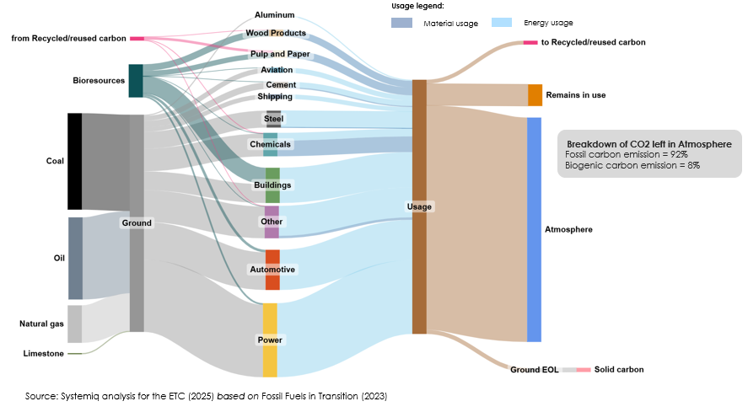
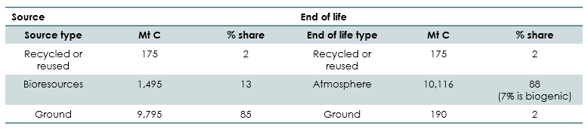
These emissions are driving a relentless rise in the concentration of CO₂ in the atmosphere, leading to global warming that threatens severe harm to human welfare. To limit temperature increases to well below 2°C, and ideally to 1.5°C, it is essential to reduce CO₂ and other greenhouse gas emissions to net zero by mid-century.
Electrification and power sector decarbonisation will be the primary levers to achieve this emissions reduction and all major net-zero scenarios project a dramatic increase in electricity’s share of final energy demand, reaching 54% and 59% in the 1.5°C-aligned pathways published by the IEA and IRENA respectively (Exhibit 0.2). Analysis by the ETC in the Fossil Fuels in Transition report suggested even higher levels, with electricity reaching 62% in the Accelerated but Feasible (ACF) scenario and 71% in the Possible but Stretching (PBS) scenario.
But even in the most ambitious electrification scenarios there remains a need for carbon molecules in several sectors of the economy. In aviation and shipping, for instance, batteries will not be light enough to enable electric flight except over very short distances at least for several decades, and in plastics, carbon molecules are essential building blocks of the material whatever the energy source.
In the ACF scenario, it is anticipated that 31% of total energy demand in 2050 is still expected to rely on the use of carbon molecules. In the more ambitious PBS scenario, this figure drops to 22%. As a result in the ACF scenario:
- Though total demand for carbon in the energy system is projected to decline by 66% by mid-century, this would still imply a need for 3.6 Gt of carbon input (Exhibit 0.3).
- Material demand for non-energy uses, excluding plastics (which are included in the energy analysis), could grow from 0.8 Gt to 1.1 Gt (Exhibit 0.4).
Exhibit 0.2:
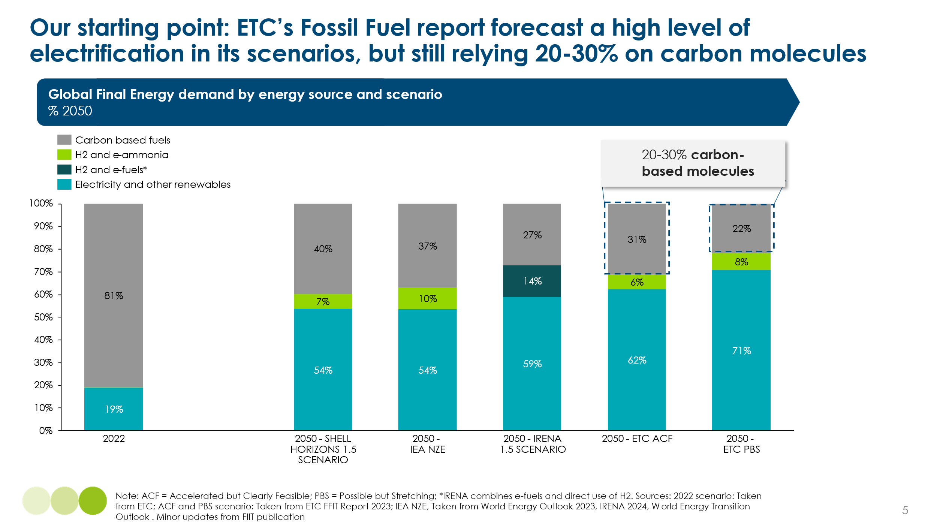
Exhibit 0.3
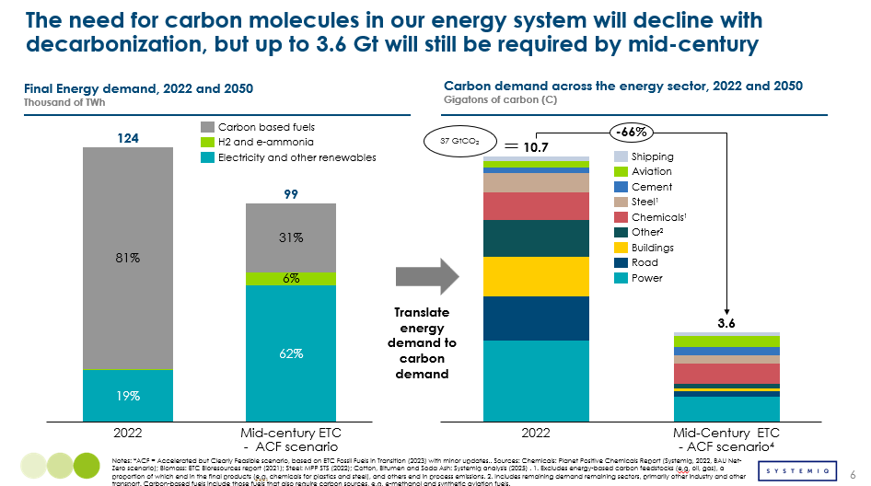

Exhibit 0.4
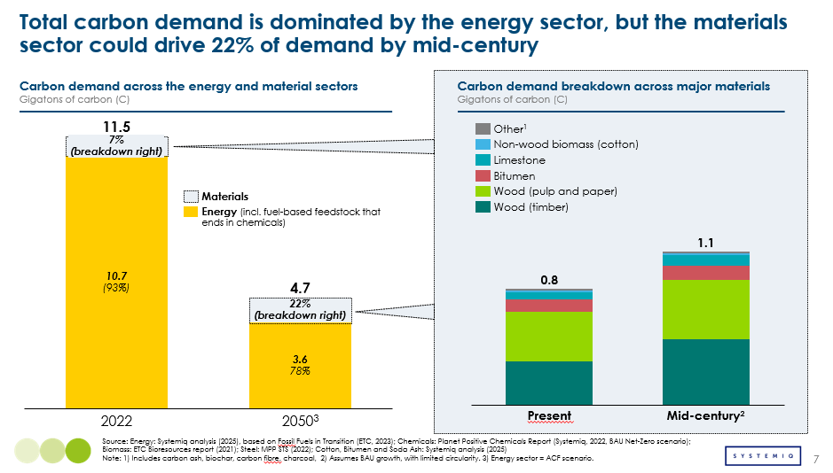
It is essential that all of this carbon is sourced and used in a way which results in zero net emissions. This is achievable if carbon is either recycled or reused, sourced from sustainable bioresources, or sourced from fossil fuels with carbon capture and storage (CCS) applied.
This report analyses the options for sourcing and using the required carbon in a sustainable, zero-emissions fashion. It focuses on the role of technological developments which could either further reduce the need for carbon molecules, or enable its sustainable supply and use. It covers in turn:
- The maximum potential role of direct electrification in a zero-emissions global economy
- The contribution of hydrogen and non-carbon hydrogen derivatives
- The potential to cycle and reuse carbon molecules, whether via plastic recycling, carbon capture and utilisation or other means
- Sustainable sources of primary carbon, covering both:
  - Carbon capture and storage to enable continued fossil fuel use at net zero emissions
  - Sustainable bioresource supply
- Options for storing carbon in gaseous or solid form at the end of life
- A comparison of the options: trade-offs between alternative approaches in terms of natural resource use, technological availability and cost
- Scenarios for the future pattern of carbon sourcing, utilisation, and final destination
Exhibit 0.5 shows one of the four scenarios which are set out in Chapter 7. In this scenario total carbon demand would be in line with those set out in Exhibit 0.3 and Exhibit 0.4 – with 3.6Gt for energy use and 1.1Gt for use as material. This implies a dramatic reduction in the total need for carbon by mid-century, but also a dramatic change in the sources and destination compared with those shown on Exhibit 0.1
- Sources: 57% rather than 85% now derives from fossil fuel sources, 30% rather than 13% from bioresources, while the share of carbon supply deriving from recycling or reuse has grown from 2% to 13%
- Destinations: Only 10% of carbon is emitted to the atmosphere without capture. 47% is stored in gaseous form, 8% in solid form, 20% remains in ongoing use, and 13% is recycled.
Other scenarios presented in Chapter 7 explore how this pattern would change if the objective were either to maximise recycling and reuse, to minimise fossil fuel use via maximum bio resource supply, or to expand CO2 storage to allow a large ongoing role for fossil fuels.
Exhibit 0.5 ACF mid-century, Carbon Source and destination for the energy and materials sectors, Mt C
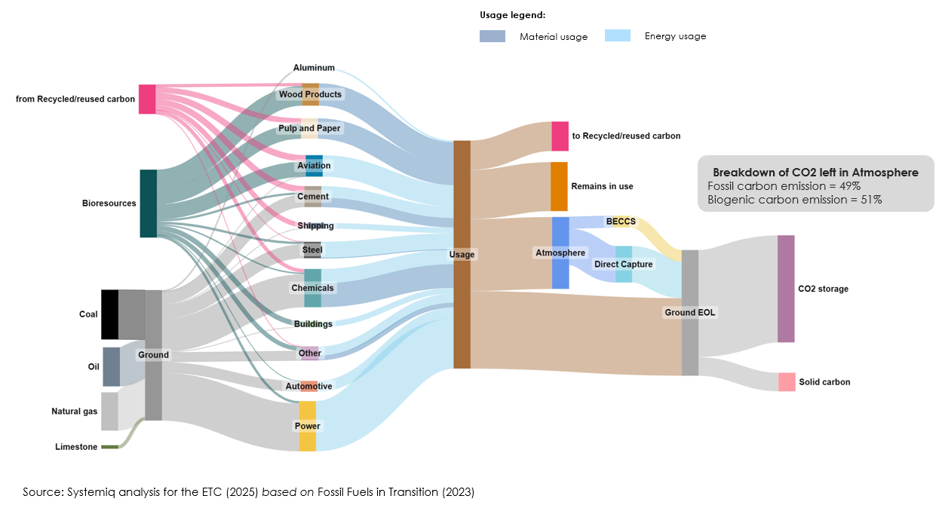

the role of electrification

As shown in Exhibit 0.2, the ETC’s previously published scenarios suggest that the direct use of electricity could account for 62–71% of final energy demand by mid-century. In this chapter, we assess whether emerging technological developments could enable even higher levels of electrification, and examine the resulting implications for carbon molecule demand.
We investigate 3 high potential opportunities for further electrification beyond the levels shown in Exhibit 0.2
- Electrification of high temperature heat processes, particularly in cement and petrochemicals
- Electrification of primary iron production via electrolysis or electrowinning as alternatives to using hydrogen as a reduction agent
- Improvements in battery chemistry which might enable greater electrification of shipping and aviation.
We also consider the potential for new technology developments to make it easier to decarbonise electricity supply – whether via lower cost storage (sodium-ion batteries) or new zero carbon generation (small modular nuclear).
Building on this analysis, we present a scenario of “maximum electrification and unconstrained power supply”, which if achievable, would see under which electrification could rise to as much as 77% of final energy demand. This would reduce the demand for carbon molecules by 24% relative to the levels shown in Exhibit 0.3.

1.1 Electrification of high temperature industrial heat

Overview
Electrification of high temperature heat has the potential to further electrify industrial processes above 400°C, reducing reliance on fossil fuels and CCU/S. Over 60 EJ of energy is required annually for industrial heat above 400°C, with cement (~1400°C), steel (~1600°C), and chemicals (~800°C) being the primary sectors. (See Exhibit 1.1) Today, nearly all of the energy used for high-temperature industrial heat is fossil-fuel based. Heat pumps cannot meet the demand for high-temperature heat as they are limited to temperatures below 400°C, making them unsuitable for high-temperature applications. Electrifying high-temperature heat, if made cost-effective, could significantly reduce the dependence on fossil fuels (even with CCS) while driving a substantial increase in electricity demand.
Exhibit 1.1
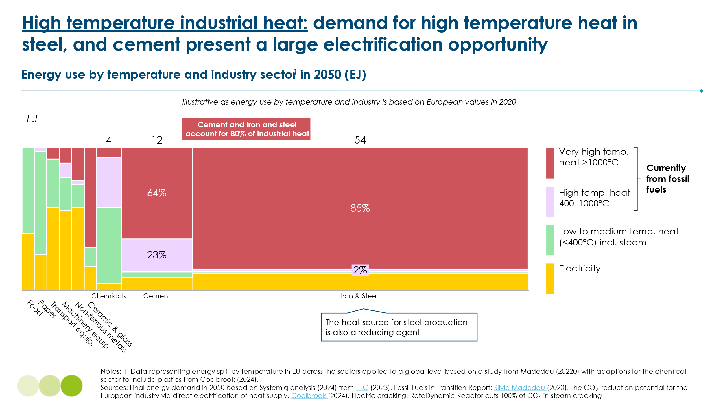
New electrification technologies are advancing, enabling heat electrification through shockwave, electric and plasmas and resistance heating. Energy efficiency for electrified heat ranges from 50% to 95%, generally outperforming fossil fuels due to lower conversion losses. Large industrial companies, including BASF, Technip Energies, Algoma, Cementa, and Siemens, are exploring further electrification of their processes, alongside new innovators like SaltX and Coolbrook entering the space. There are various ways to generate heat with electricity (Exhibit 1.2), shockwave, plasma technology, and resistance heating are making, amongst others, significant advancements in recent years.
Exhibit 1.2
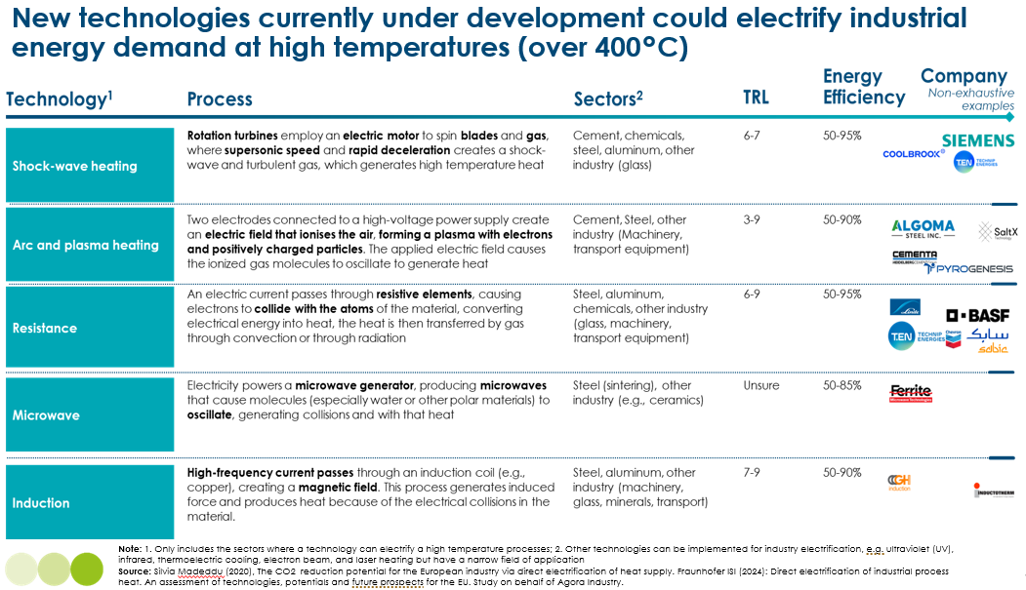

Costs
The key advantages that high-temperature heat electrification might offer over other decarbonization technologies stem from its more efficient use of energy. Depending on the technology and the application, energy consumption could be reduced up to 40% compared to fossil fuel-based systems, primarily due to lower conversion losses enabled by direct electrification. This could be more economical than other low-carbon alternatives as higher capital costs of the emerging technologies are offset by this efficiency. Exhibit 1.3 shows a case study of how an electrified cement kiln could be cost competitive with a conventional cement kiln into the future. The cost of electricity is key to competitiveness and particularly this cost of electricity relative to a fossil alternative energy price, which can vary highly across regions. This comparison is for projected economics; for example shock-wave heating, a type of high temperature heat technology suited to the cement sectors is currently at TRL 6-7. The realization of these economics ultimately depends on whether such technologies can successfully reach market readiness, and there remains significant uncertainty around their scalability, cost trajectory, and commercial deployment timelines.
Exhibit 1.3
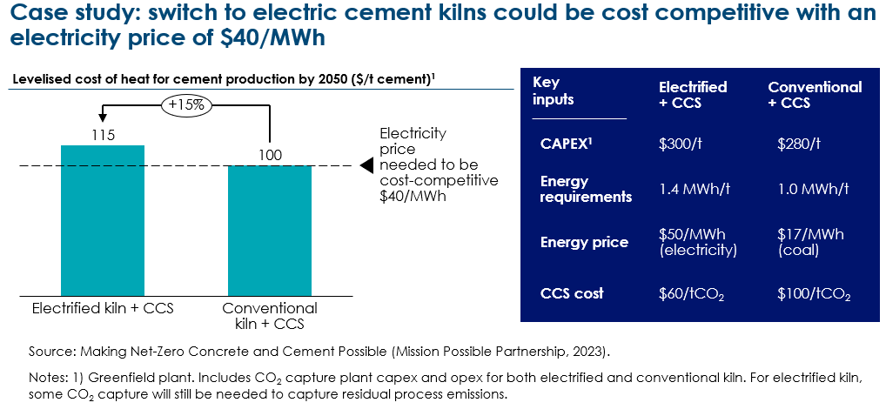

Barriers and enablers
Besides the economic challenge, a reliable, low-cost clean electricity would greatly benefit high-temperature heat technologies. A firm and close to constant energy supply is needed, as these systems struggle to ramp up and down due to high temperatures. This could pose challenges with renewables intermittency and other increasing requirements on the power system such electrification of the passenger road transport and data centres.
Achieving and maintaining high temperatures requires materials that can endure extreme conditions over long lifetimes. For example, electrifying cement kilns poses durability challenges because electric heating methods like plasma torches and induction create different heat patterns than traditional fuels, which can stress kiln materials in new ways. Materials to line high-temperate industrial equipment like cement kilns, furnaces and reactors must withstand intense heat, chemical reaction from raw materials, and frequent temperature changes, all of which can reduce their lifespan. Ensuring even heat distribution and material resilience remains a key hurdle.

1.2 Molten Oxide Electrolysis and Electrowinning – electrifying the iron-making process

Overview
Molten Oxide Electrolysis (MOE) and Electrowinning have the potential to electrify iron-making processes. MOE and Electrowinning are two novel technologies that apply an electrochemical process to convert iron ore into iron using electricity. These technologies could reduce reliance on hydrogen and CCU/S (as alternate decarbonization pathways for iron/steel), while increasing overall electricity demand. MOE processes iron ore by immersing it in a molten oxide bath heated to approximately 1600°C. An electric current then breaks down the iron ore, producing molten iron. With electrowinning iron ore is suspended in an alkaline solution at about 100-110°C, where a current reduces the iron ore to iron. MOE modules are bus-sized, enabling scalable expansion by adding units, and since the product is molten, it eliminates the need for an Electric Arc Furnace (EAF); Electrowinning operates at lower temperatures, allowing integration with intermittent renewables, which can reduce power costs. Several large-scale iron and steel companies are investigating the viability of electrowinning and MOE, which are currently advancing at TRL 5, with pilot plants having a capacity of up to 40-80 kt of iron.

Costs
With electricity prices below $65/MWh, molten oxide electrolysis (MOE) and electrowinning could become more cost-effective than other low-carbon steelmaking alternatives (Exhibit 1.4). Their higher capital costs may be offset by lower energy consumption, making them competitive under favourable electricity pricing. Capital expenditures for MOE and electrowinning are expected to be comparable in scale to those of direct reduced iron with electric arc furnaces (DRI-EAF). Additionally, these technologies could offer around 6% lower energy use compared to hydrogen-based steelmaking routes. Ultimately, their cost-competitiveness will hinge on regional electricity prices relative to fossil fuel alternatives, which vary significantly across geographies.
Exhibit 1.4
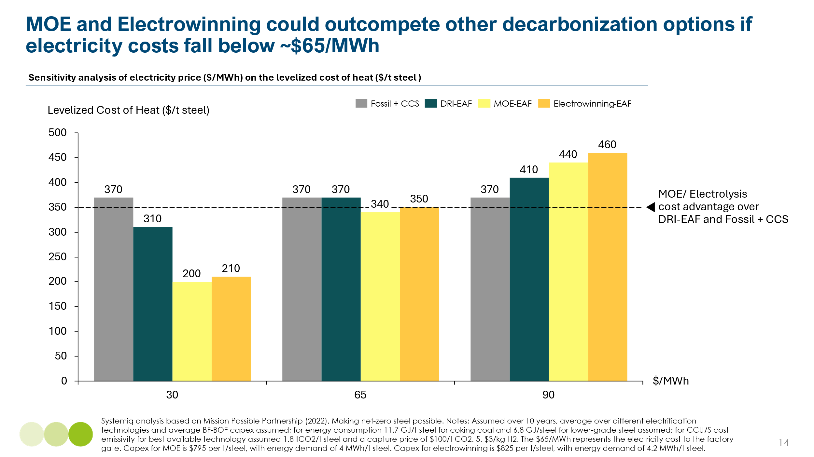

Barriers and enablers

Despite their potential, MOE and electrowinning face some barriers to commercial deployment. While potentially more energy-efficient, they must still compete with lower-cost fossil-based steelmaking with CCUS and H₂ DRI, which are more commercially ready today. Operational costs are also uncertain, particularly due to anode degradation at extreme temperatures (~1600°C). Similar to high temperature industrial heat electrification, Molten Oxide electrolysis requires close to constant clean power supply due to high temperature needs (1,600°C). Electrowinning and other electrochemical processes (e.g., direct electrochemical reduction or oxygen decoupled electrolysis) operate at lower temperatures (60°C-300°C), hence intermittent energy is sufficient.

1.3 Advancements in battery chemistries

Overview
The rapid scale-up of battery manufacturing, driven by surging global demand, is creating a dynamic landscape where multiple battery chemistries can coexist and evolve in parallel. Global battery production capacity is projected to grow from 3 TWh/year in 2023 to 9 TWh/year by 2030, exceeding the anticipated 6 TWh/year demand from electric vehicles (EVs) and stationary storage. This expansion is expected to drive continued improvements in energy density, cost reductions, and broader adoption, particularly in emerging markets.
A major area of innovation lies in next-generation battery technologies designed to overcome the limitations of conventional lithium-ion systems. Among these, solid-state batteries are gaining attention for their potential to significantly enhance energy density, safety, and charging speed. Such developments have the potential to further accelerate electrification in mobility due to the high energy density levels they can possibly achieve (see Exhibit 1.5). Battery densities of liquid li-ion batteries have been advancing rapidly and by now achieve gravimetric energy densities of ~ 500 Wh/kg (CATL). Solid-state batteries, currently pre-mass production, get to similar levels today and are explored by major developers including Toyota, Samsung SDI, LGES, SK On, CATL, and BYD. However, they represent just one pathway among many. Advances in anode and cathode materials—such as silicon-based anodes and lithium-metal anodes—are also contributing to performance gains across various battery types.

Exhibit 1.5
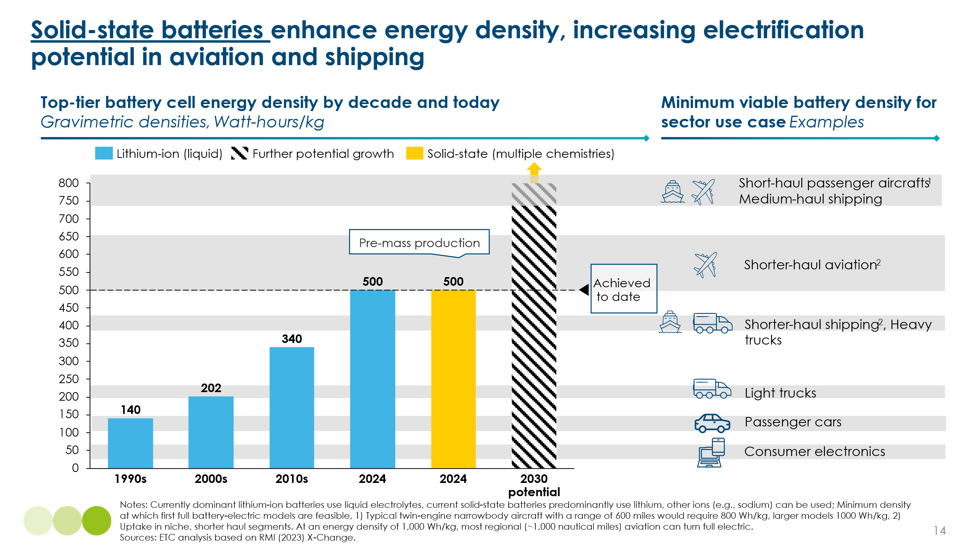
Such developments are expected to enable steady performance improvements across all battery chemistries, with historical learning rates for battery technologies typically ranging between 7-9% annually. For instance, semi-solid-state advancements, such as CATL's (a benchmark battery provider) developments, demonstrate incremental gains in energy density and efficiency. Ultimately, the evolution of battery technology is not about a single breakthrough, but rather a portfolio of innovations that collectively enhance the viability of electrification across sectors—but particularly in transportation.

Costs
Rapid declines in battery costs could make electrification for some transportations segments economic, potentially accelerating beyond anticipated levels (see Exhibit 1.6). For example in shipping, at battery prices of $100/kWh; battery-electric ships could be competitive with fuel oil ships (<1,500 km), another halving of the price would make ships up to 3,000 km competitive. With liquid Li-ion batteries already within this threshold, the electrification of all intra-regional shipping appears increasingly feasible.
Exhibit 1.6
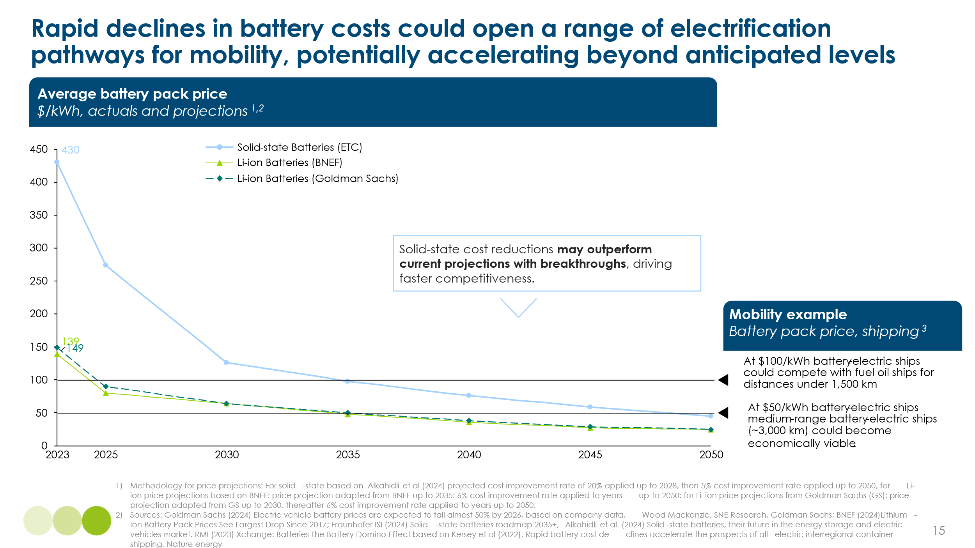
Battery-electric aviation faces economic and technical hurdles. While battery costs are declining, no clear threshold has been established as the tipping point for economic viability in aviation, and energy density remains a major constraint. Some first-generation electric aircraft, suitable for short-range flights, are targeting entry into service before 2030, though widespread deployment for flights of several hundred kilometers is unlikely before 2040. In the near term, hybrid-electric aircraft may serve as a transitional solution, enabling incremental emissions reductions while technologies mature.

Barriers and enablers
The key challenge in advancing next-generation batteries lies in industrializing new chemistries at scale and at competitive cost, particularly for transport applications. Many emerging battery types face higher production costs than mature lithium-ion chemistries like LFP, largely due to low manufacturing volumes and the need for novel production processes. At the same time, the parallel development of multiple chemistries stretches R&D budgets across competing approaches, potentially slowing progress for each.
Manufacturing complexity is a common barrier: for example, solid-state batteries require precise control over materials and interfaces, making high-quality, consistent production difficult. While full solid-state designs continue to face delays, semi-solid-state variants are progressing steadily, and several OEMs—including Toyota, BMW, Ford, Mercedes, and Nio—have announced plans to integrate solid-state technologies by 2030. However, these are just one part of a broader innovation landscape, where incremental improvements across a range of chemistries will be critical to meeting the diverse performance, cost, and safety needs of future electric mobility.

1.4 Electrification enablers – sodium-based batteries and small nuclear reactors (SMR) and nuclear micro reactors (NMR)

Decarbonizing the power system requires full electrification and zero-carbon power from variable renewable energy (VRE). As VRE increases, so do balancing needs. Two technologies were explored as having emerging potential to support a system that requires clean, firm power generation; sodium-based batteries and small nuclear reactors (SMR) and nuclear micro reactors (NMR).

Sodium based batteries
Next-generation sodium-ion batteries have made significant strides in recent years, entering low-volume commercial production and are being deployed in stationary applications such as data centers and telecoms, indicating near-commercial readiness. These batteries are particularly well-suited for stationary energy storage, offering advantages such as low-temperature tolerance, long cycle life, and enhanced safety (Exhibit 1.7). While early sodium-ion batteries had energy densities around 160 Wh/kg, CATL announced its second-generation sodium-ion battery, known as Naxtra, with improvements in energy density and cycle life over the first generation that makes it approaching lithium iron phosphate (LFP) batteries.
Sodium-ion batteries offer a potential cost advantage over LFP due to the abundance of sodium and the use of simpler, less expensive materials, such as iron-based cathodes and aluminium current collectors. However, these cost benefits are contingent on achieving manufacturing scale comparable to lithium-ion technologies. At present, low production volumes result in higher per-unit costs. Additionally, sodium-ion batteries still face limitations in energy density, which restricts their use in electric vehicles. Nonetheless, techno-economic models suggest that sodium-ion batteries could become cost-competitive with low-cost lithium-ion variants by the 2030s, especially as energy density and performance continue to improve. Rather than competing directly, sodium-ion and lithium-ion technologies are increasingly seen as complementary, with potential convergence in scalability and technical performance.
Exhibit 1.7
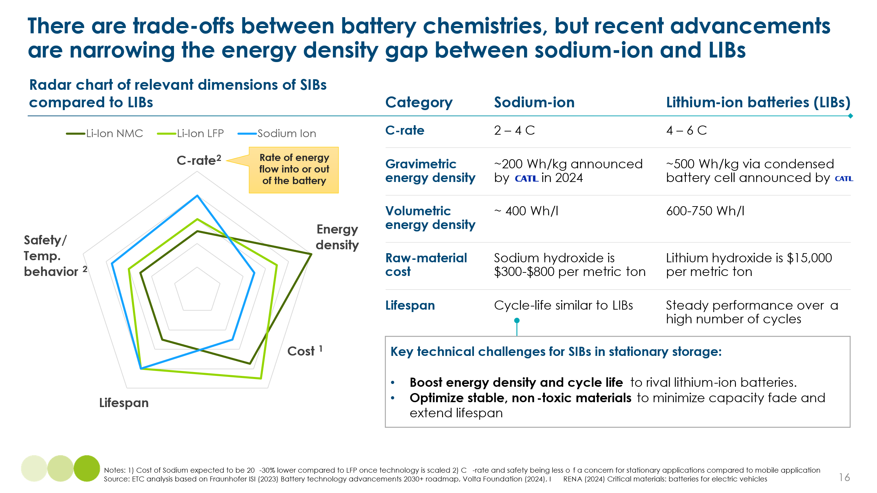

Nuclear fission: Small Nuclear Reactors (SMR) and Nuclear Micro Reactors (NMR)
Nuclear energy has re-emerged as a strategic clean power option, driven by surging electricity demand from data centers and Big Tech’s push for reliable, dispatchable energy. In 2024, Google, Microsoft, and Amazon announced major investments in nuclear, positioning it as a central theme in clean energy investment. Small Modular Reactors (SMRs, <300 MW) and microreactors (<50 MW) are gaining attention for their scalability, shorter construction timelines, and potential for lower costs compared to traditional nuclear plants. These designs include both conventional technologies like Light-Water Reactors and advanced systems such as Molten Salt and Liquid Lead-Cooled Reactors.
Despite growing interest, SMRs and microreactors face significant barriers. These include high upfront costs, complex licensing, low technical readiness (TRL 3–5 for many advanced designs), and an underdeveloped supply chain. While modular construction could reduce levelized costs of electricity (LCOE) through faster deployment and simplified safety systems, real-world challenges persist. The cancellation of NuScale’s SMR project in 2023 due to escalating costs ($20,000/kW) highlights these risks. Advanced SMRs may offer lower projected costs ($4,000–6,000/kW) due to lower fuel and safety costs, simpler regulator and potentially faster deployment ²⁸. But commercialization is unlikely before the late 2030s. Environmental concerns, waste disposal, and public opposition also remain a hurdle.

1.5 A maximum electrification unconstrained power supply scenario.

Exhibit 1.8 presents an assessment of the potential impact of the electrification technologies considered under a scenario of maximum electrification and unconstrained clean power supply. The combination of the technologies assessed could eventually lift electricity to 77% of final energy demand, the share of hydrogen would decline from 8% to 6%, while the contribution of carbon-based energy carriers would fall from 22% to 17%.
Exhibit 1.9 illustrates the implications for demand for carbon molecules and hydrogen, expressed in terms of the final energy they supply. Carbon-based final energy demand falls from 18,600 TWh in the PBS scenario to 14,300 TWh. This would imply a reduction in carbon use for energy uses from 2.2 Gt to 1.9 Gt. The two largest potential drivers of reduced demand are a transition within steel-making to electrowinning or MOE, and the electrification of heat input to cement making.
The analysis illustrates the significant long-term potential for even greater electrification than assumed in our ACF and PBS scenarios. But it also shows that even in the most extreme electrification scenarios, and even in the very long term, there will be an irreducible demand for significant carbon inputs into the energy system.
Exhibit 1.8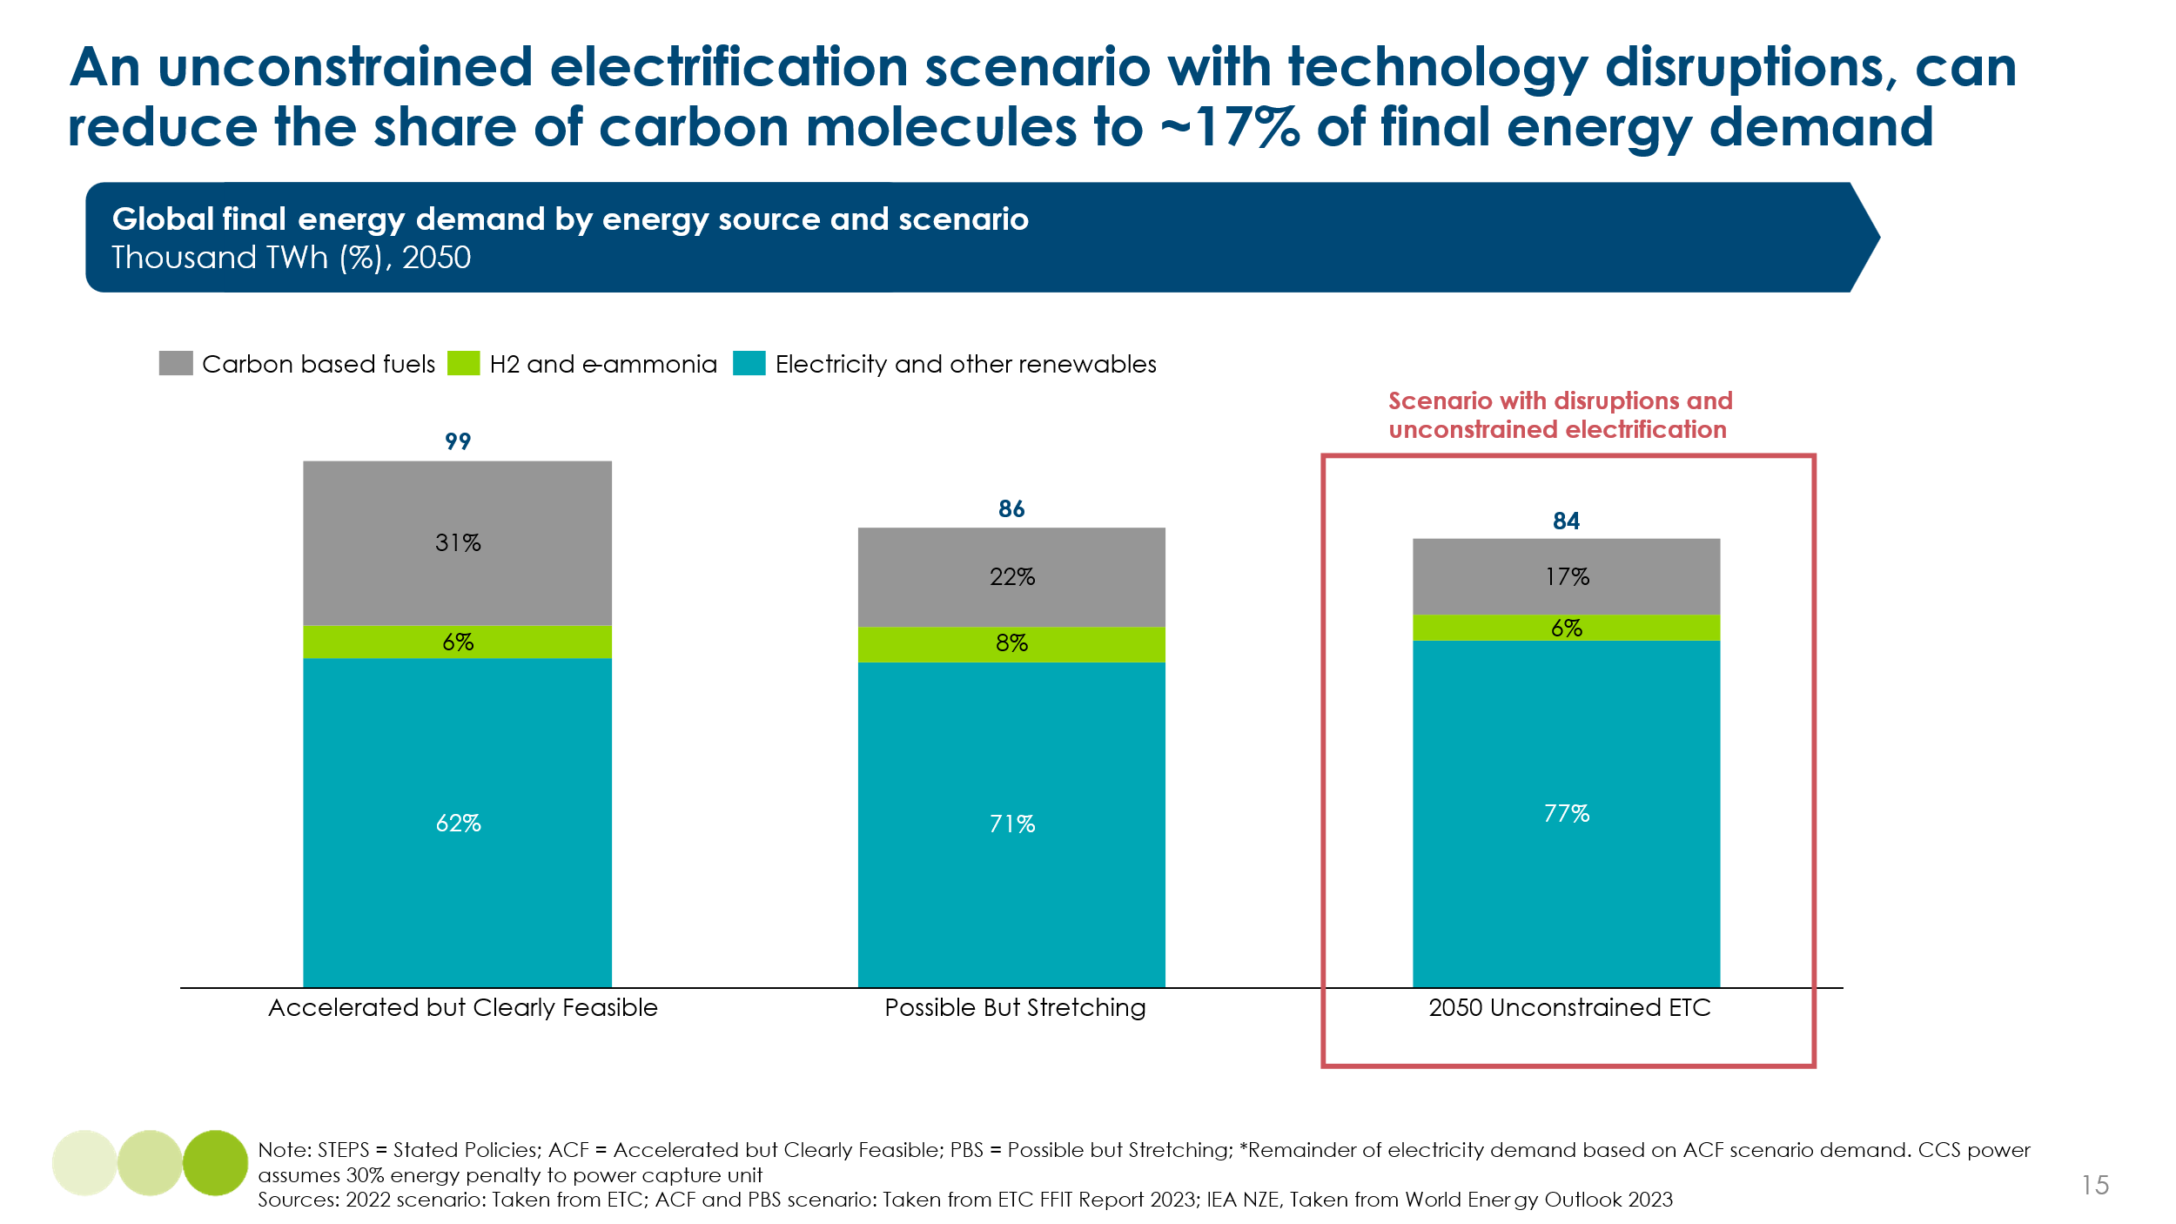

Exhibit 1.9
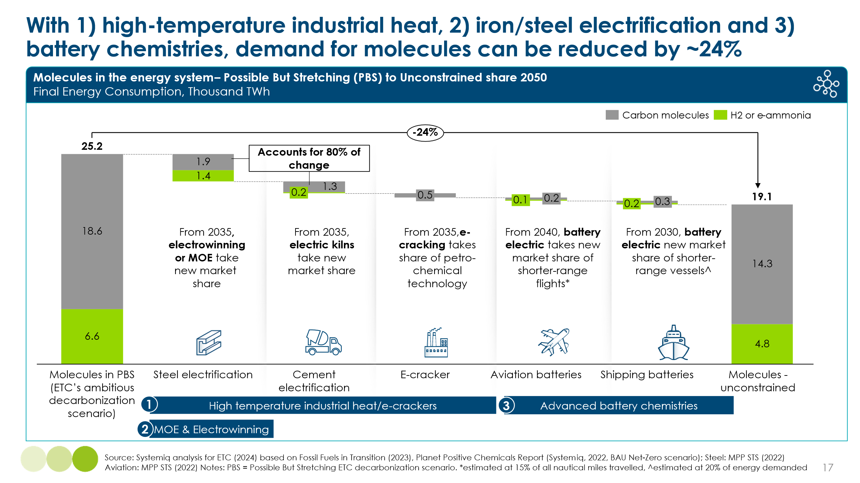

the role of hydrogen

Many projections of the role that hydrogen and non-carbon hydrogen derivatives will play in the energy transition have been revised down over the last five years. The IEA, BloombergNEF, and the Hydrogen Council have all reduced their projections for global hydrogen demand in 2030 and 2050. At the ETC, our 2020 report Hydrogen: A Critical Pathway estimated potential global demand in 2050 at up to 800 million tonnes. However, by 2023, in our Fossil Fuels in Transition report and in subsequent revisions, we have reduced this estimate down to between 390 million tonnes under the Accelerated but Feasible (ACF) scenario and 480 million tonnes under Possible but stretching (PBS).
These revised projections reflect:
- More rapid progress than anticipated in battery and other technologies which enable direct electrification
- Slower progress than anticipated in reducing the cost of green hydrogen, primarily because of higher than predicted electrolyser capital costs
- Improved understanding and recategorization of sectoral end-use
In the Unconstrained Electrification scenario shown in Exhibit 1.8, the use of hydrogen, either directly or embedded in e-ammonia could be reduced from 8% to 6% of 2050 final energy demand. This would imply around 150 Mt of hydrogen used per annum in 2050, with the largest uses seen in ammonia production for fertiliser, ammonia for shipping, and iron making (Exhibit 2.1). There would in addition be hydrogen used as an input to hydro carbon fuels, petrochemicals and as a storage mechanism with the power system.
In this chapter, we assess whether two categories of technological and cost development might imply higher use of hydrogen shown in Exhibit 2.1:
- The exploitation of geological or “white hydrogen“
- More rapid progress in electrolyser technology and cost reductions, including reflecting developments in China.

Exhibit 2.1:
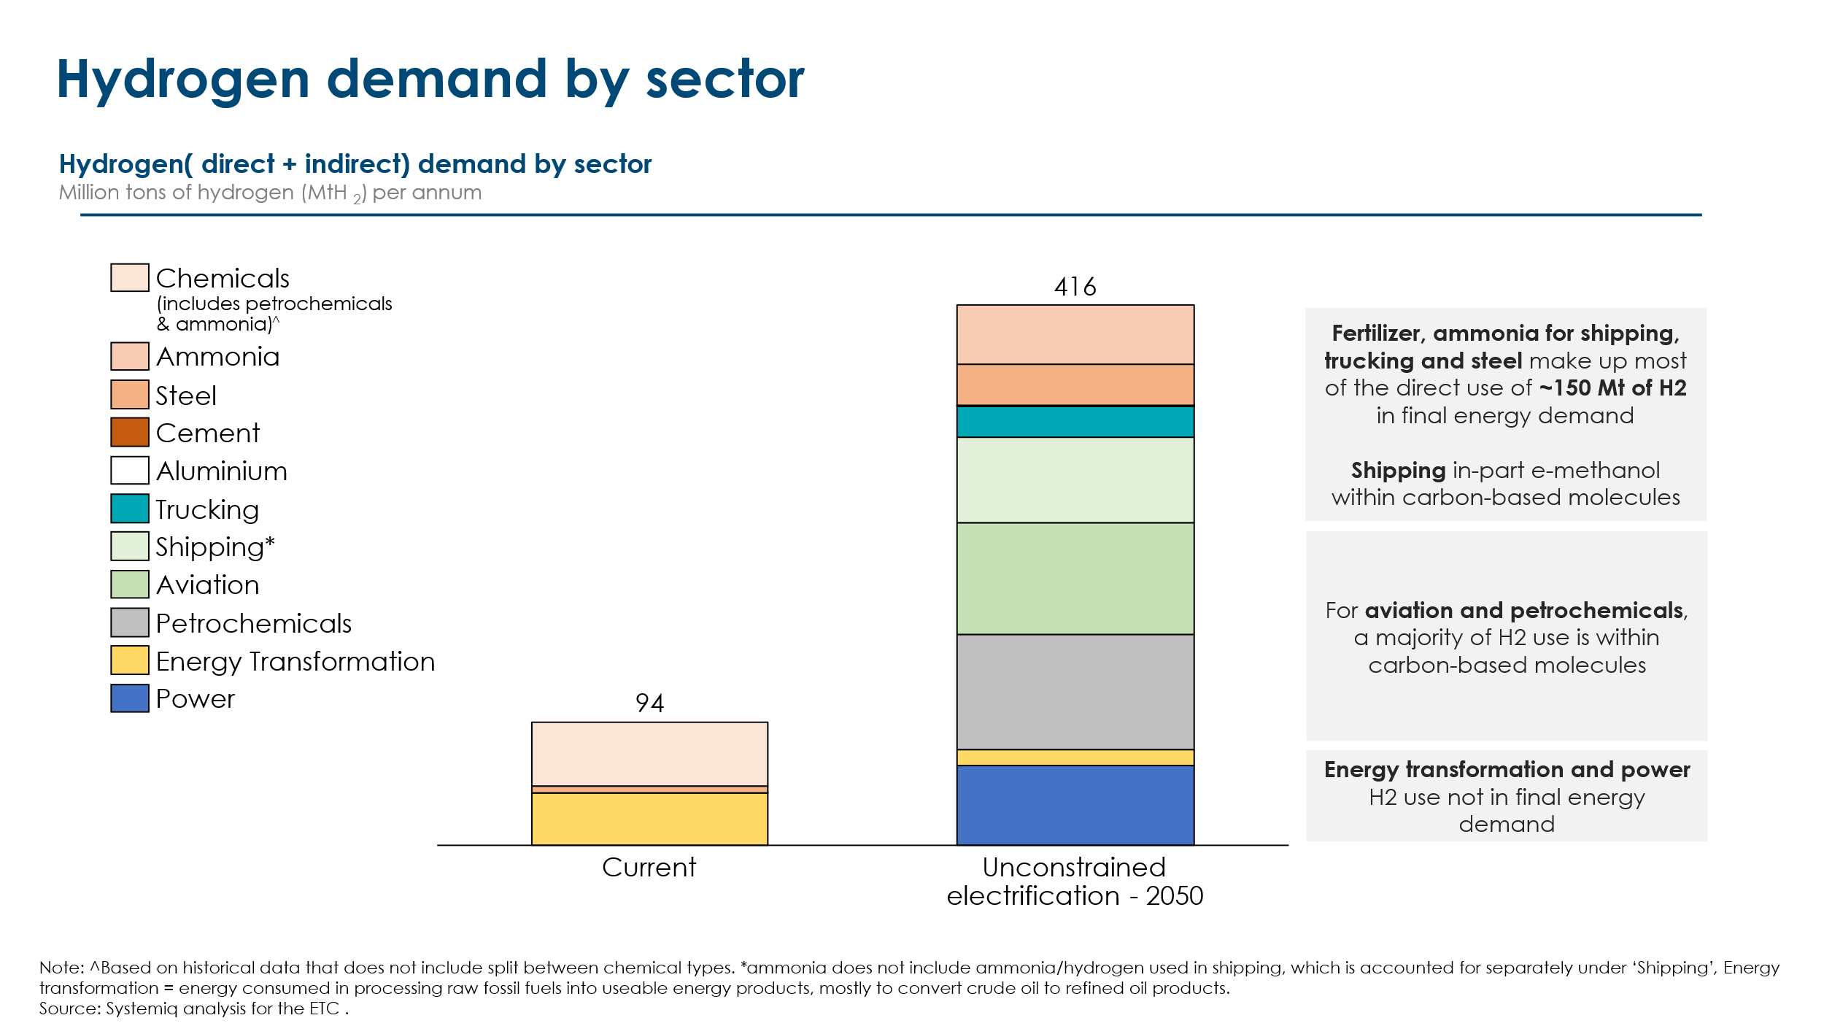

2.1 Geological hydrogen

Overview and costs
The Earth contains very large resources of naturally occurring geological hydrogen , also known as “white hydrogen”; but the range of estimates is very wide. A recent review of available data and studies suggests a most probable value of 5.6 trillion tonnes but with a lowest estimate of just 1 billion and an upper estimate of 10 billion trillion.
This resource is however widely dispersed and only a small fraction of it is likely to be economically recoverable. The same study suggests that feasible global generation of natural hydrogen might be 15-30 million tonnes per annum: versus our ETC projection of total 2050 hydrogen demand of ~400-500 million tonnes. If this volume were available at a competitive cost, it would increase the likelihood that hydrogen would be competitive versus other decarbonisation options in several of the applications assumed in that scenario.
White hydrogen involves drilling through geological layers and injecting a mixture of water, sand and chemicals under high pressure to release the gas from rocks. Currently it is at a technology readiness level of 3-4, with a number of explorations project ongoing for the resource, however no commercial scale production is expected until 2030. Only one white hydrogen resource has been developed to date, which is a small volume in Mali since 2023, which is used for power in a nearby village. The targeted costs of white hydrogen for the few companies that are looking to become commercial are in the range of 0.5-1 USD/kg H2 by 2030. However, little is known about detailed breakdowns of these costs and how achievable they are.

Barriers
White hydrogen costs are relatively unknown, but there could be challenges with high exploration and capital costs challenges in drilling for the resource. Key technical challenges include determining optimal drilling depths, accurately measuring subsurface hydrogen concentrations, and identifying viable extraction methods. These factors could drive up the cost of early-stage projects. In addition, white hydrogen may face unique logistical hurdles compared to other forms of low-carbon hydrogen. Because natural hydrogen deposits are geologically constrained, they may be located far from demand centres, potentially incurring high transportation costs. This geographic inflexibility could limit its competitiveness relative to green or blue hydrogen, which can often be produced closer to end-use sites by design.

2.2 Electrolyser system and balance of plant costs

Overview and costs
Advances in electrolyzer technology and manufacturing, along with improvements in the balance of plant and design optimization, are expected to reduce capital costs of green hydrogen over time. There are four primary electrolyzer technologies in the market today. Alkaline and PEM (polymer electrolyte membrane) based technology are already at technology readiness level 9. Less developed technologies AEM (Anion Exchange membrane and SOEC (solid oxide electrolyzer cell) are at TRL 7 and 8 respectively. Advancements continue to be made in higher efficiency electrolyzers (such as SOEC), and trade-offs explored between costs and other dimensions (e.g. efficiency, stack lifetimes) to develop electrolyzers with less reliance on expensive materials such as Anion Exchange Membrane (AEM) technology.
In the near term at least, the levelized cost of electrolysis based hydrogen will be driven by the capital costs of electrolyzer systems. The capital costs vary according to the types of electrolysers and are expected to reduce over time (Exhibit 2.2). Costs are expected by 2030 to fall in the range of 30-45%, just based off of advancements in manufacturing technology, learning rates and balance of plant improvements. If fully optimized, a further 10-25% cost reduction is reported to be possible, driven by maximizing learning rates through successive project build outs, procuring at large volumes, and rigorous design simplification. However, a large portion of total installed cost comes from EPC-related expenses—such as civil works, installation, and permitting—which have historically shown low learning rates. As a result, even if electrolyzer equipment costs decline significantly, the overall system CAPEX is likely to fall more modestly unless full project delivery is also optimized.
Exhibit 2.2
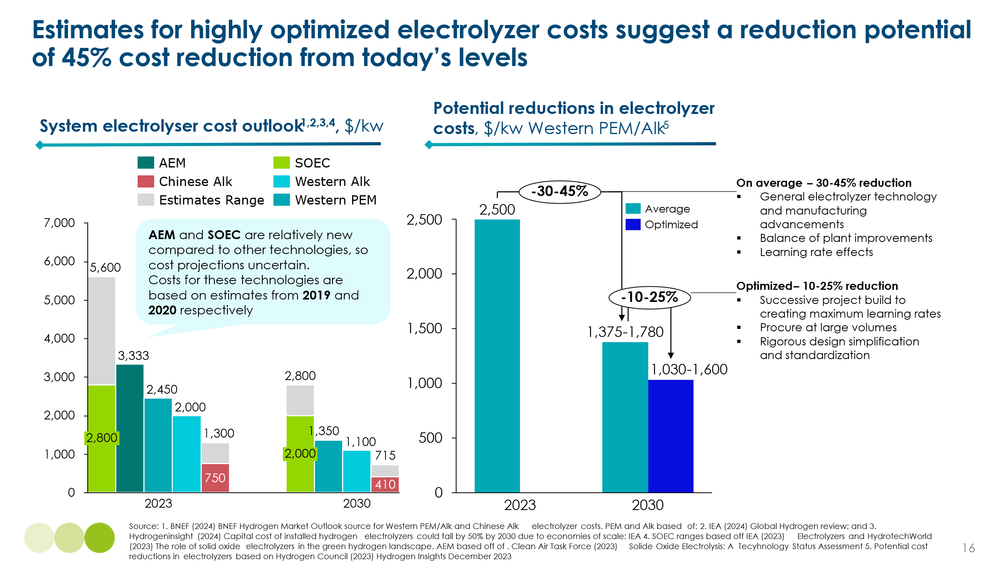

Barriers
Electrolyzer systems face challenges with reaching cost competitiveness with fossil based technologies (with and without CCS). While capital costs of electrolyzers are expected to decline, the cost of electricity remains the most significant factor in the levelised cost of hydrogen. This makes access to low-cost renewable power essential. In addition, the intermittency of renewable energy poses a major challenge for green hydrogen. It affects not only the design and sizing of electrolyzer systems but also increases the required capacity for renewable generation and storage to maintain a steady hydrogen output. This adds to overall system costs and complexity.
Technical barriers also persist. Stack degradation and replacement remain cost drivers, particularly for high-efficiency systems like solid oxide electrolyser cells (SOECs), which operate at high temperatures. Extending stack lifetimes is still a key technical hurdle. Proton exchange membrane (PEM) electrolyzers also face cost barriers due to their reliance on scarce materials, more so than technologies like alkaline or anion exchange membrane (AEM) systems. Finally, infrastructure requirements for hydrogen production at scale, such as storage, pipelines, and transport, mirror those of current hydrogen routes and will require significant investment and planning.

2.3 Possible future costs of zero carbon hydrogen
Over the last five years, and in the major developed countries in particular, the cost of green hydrogen production has not fallen as fast as was initially projected. This reflects a far slower pace of reduction of electrolyser capex costs than anticipated. But hydrogen developers in China and India continue to be confident of achieving low cost green hydrogen production – e.g. below $2 per kilogram sometime in the 2030s. This reflects both very low renewable electricity costs in India and low electrolyser capex costs in China.
As a result, latest IEA estimates of the cost of producing green hydrogen suggest very wide ranges, with the estimated 2030 of green H2 produced with solar PV ranging from 2 to $11 per kilogram (Exhibit 2.3).
Costs of producing grey hydrogen from natural gas, or blue hydrogen with CCS added, also show a very large range due to large regional variations in the price of gas.
Overall however the IEA analysis suggests that up to 2030, green hydrogen will only be cost competitive versus grey or even blue in the most favourable locations. But developments discussed above are likely to improve the cost competitiveness of both natural and green hydrogen over time. In particular
- It seems likely that in favourable locations natural “white“ hydrogen will be available at $0.5-1 per kilogram, which will be competitive with grey hydrogen in most locations: The crucial issue is what volume is likely to be available at that cost.
- Green hydrogen production will eventually fall significantly below $2 per kilogram in favourable locations such as China or India, given future trends in both electrolyser and renewable electricity costs. This is in line with initial estimates but at a later date than initially anticipated.

Exhibit 2.3
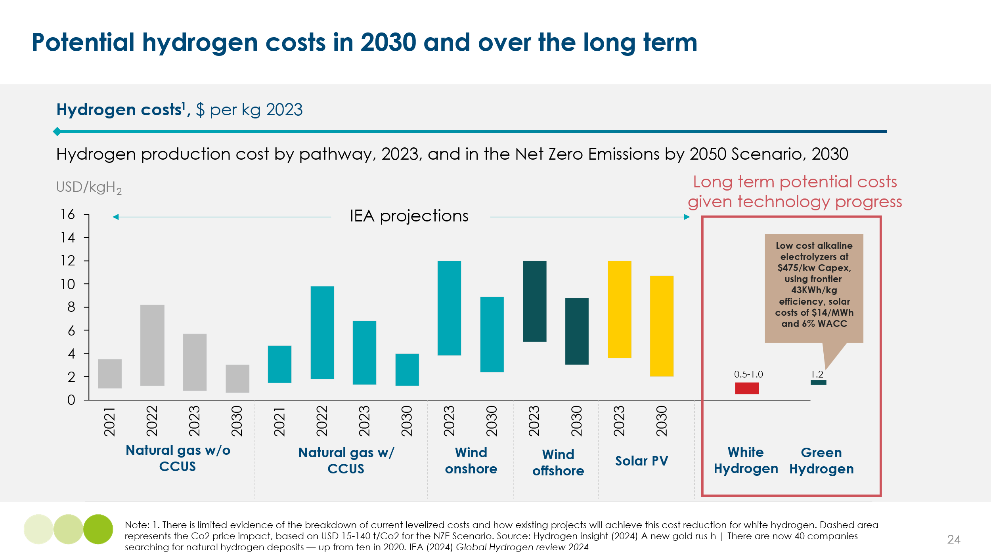

2.4 Conclusions about the role of hydrogen
The two possible technologies/cost trends considered above, seem likely to deliver significant reductions in the cost of zero carbon hydrogen over the long-term, supporting the economic application of hydrogen and ammonia in several of the sectors shown in Exhibit 2.1, including for instance shipping and iron making as well as the main existing use in fertiliser production.
But progress in direct electrification technologies will likely continue to squeeze hydrogen out of some applications where a significant role was previously assumed e.g. heavy goods vehicle road transport: and we have not identified major opportunities to extend the role of pure hydrogen or ammonia at the expense of hydrocarbon fuel uses (e.g. in aviation).
As a result, while hydrogen will play a significant role in some sectors, including iron making and shipping, we do not assess it likely that further progress in the economics of hydrogen production or use will reduce the requirements for carbon molecules below the absolute minimum of 17% of total energy supply shown in Exhibit 1.8.

reducing the amount of ‘primary’ carbon in the system – carbon circularity levers that reuse, reallocating or recycle carbon
Chapters 1 and 2 assessed the maximum potential to reduce the need for carbon inputs via the direct use of electricity and the use of hydrogen and non-carbon hydrogen derivatives. This demand for carbon could be met either with carbon reused and recycled within the economy, or with “primary“ carbon sourced from fossil fuels, bio sources, the atmosphere or the oceans. Chapters 4 analyses the potential to source primary carbon in a truly sustainable fashion. This chapter that analyses the maximum potential to reduce primary carbon demand by reuse and recycling within the economy. As outlined in Exhibit 3.1, this chapter covers:
- The potential to reduce demand via elimination, reuse and substitution. We focus primarily on the potential in plastics but also assess the more limited potential for other materials
- The role of advanced sortation technology. This is not in itself a recycling technology but a key enabler of both mechanical and chemical recycling
- The maximum potential for mechanical recycling of plastics, which involves physically processing waste materials into new products without altering their chemical structure.
- The potential for increased chemical recycling and thermo conversion which converts waste (in particular plastics) into chemical building blocks.
- The potential role for various forms of carbon capture and utilisation, which can reduce the demand for primary carbon by using the same carbon molecules for more than one economic activity.
A “maximum circularity” scenario is generated and its implications and potential impact for total primary carbon demand are assessed.
Exhibit 3.1
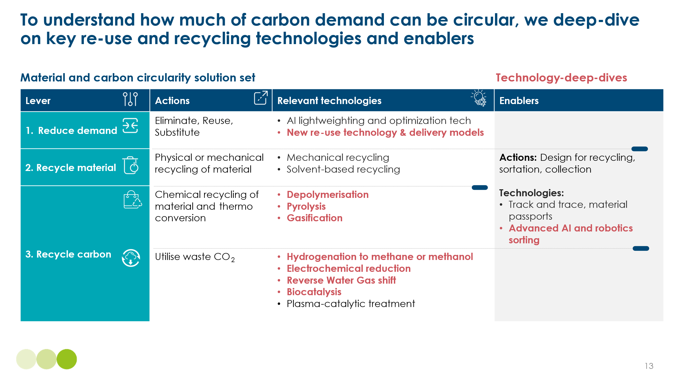

3.1 Demand Reduction: Elimination, Reuse and Substitution

Overview
Before recycling, demand reduction measures can directly reduce the volumes of carbon-intensive materials needed to deliver the same functions. These are upstream circularity strategies, targeting the design and consumption phases of products rather than post-consumer waste management.
Demand reduction can be categorized into three levers:
  - Elimination : removing excess materials or resources in products when they are unnecessary (e.g., in automotive and construction, where safety margins often lead to overuse).
  - Substitution: Replacing single-use materials with either lower-carbon density alternatives (e.g., cardboard) or more durable materials (e.g., changing single use plastic cutlery to stainless steel).
  - Reuse: Extending the lifespan of materials without changing their composition (e.g. replacing single use items with more durable products)
Together, these measures have the potential reduce demand for primary carbon molecules in the materials sector. Among them, as shown in Exhibit 3.2, reuse is likely to be the most significant demand reduction lever. This is especially true in the packaging sector, which is the largest driver of demand for chemicals.
Exhibit 3.2
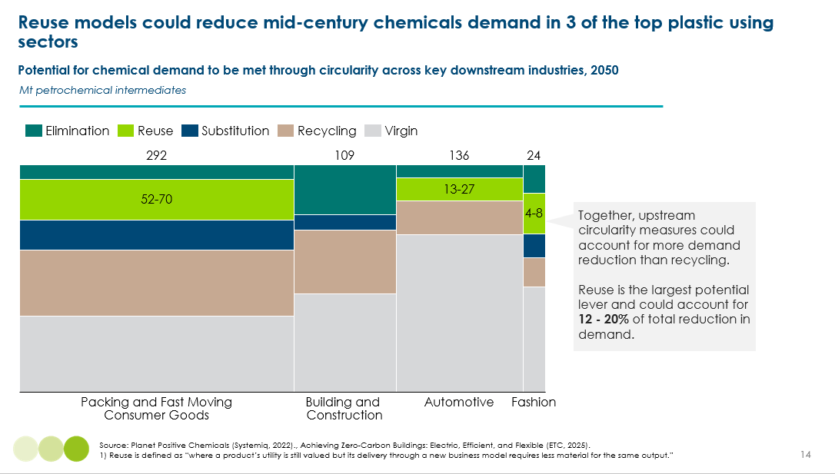
Reuse of materials can be classified into three broad modalities:
  - Recommerce: Extending product lifespans by enabling multiple ownership cycles (e.g., second-hand markets). This model is expected to scale most notably in textiles, reaching up to 25% market share of the fashion industry by mid-century. This only represents a small proportion of total demand.

  - X-as-a-Service (XaaS): Shared-use business models that replace individual ownerships(e.g., Uber for cars, WeWork for buildings, laundromats for white goods). XaaS has a large potential coverage, as it is applicable across most industries. Although we are seeing shifts to rental and sharing economies, notably in the transport sector, it is assumed that XaaS faces a scalability ‘ceiling’ due to behavioural inertia in the short to mid-term. Consumers are likely to replace single-use plastic bags more readily than giving up ownership of homes, clothes, or cars.

  - Reuse of packaging: Services and business which provide the utilities previously furnished by single-use items, while using the same materials. This includes refill and return systems in the consumer and business-to-business sectors.
While reuse covers a wide range of use models, the reuse and refill of packaging has the largest potential for demand reduction. Packaging reuse is not new. Many examples, such as refilling pantry items from a dispensary, have only been displaced by single-use packaging in the last 50 years. In general, reuse models have been (re) emerging across consumer goods sectors.

Costs
Brands are beginning to experiment with new ‘reuse’ business models. These require rethinking, adding complexity to supply chains and additional operational expenses for the collection, transport, cleaning and refill of packaging. Reuse also implies changes for the specifications for the packaging itself, which must be able to withstand and facilitate multiple refill and return cycles while remaining visually and chemically unaltered. Exhibit 3.3 shows a total system cost-per-use analysis of the economic impact of shifting from single-use to reusable packaging. Despite the averaging of production and disposal costs across successive uses, the additional operations trigger cost increases ranging from 55- 137%. The difference in cost deltas across sectors is driven primarily by the new requirements for durability and washability of packaging. The cost increase is greater for heavier materials (e.g., food packaging vs. personal care), with extreme cases like switching from plastic to glass showing a significant cost rise.
Exhibit 3.3
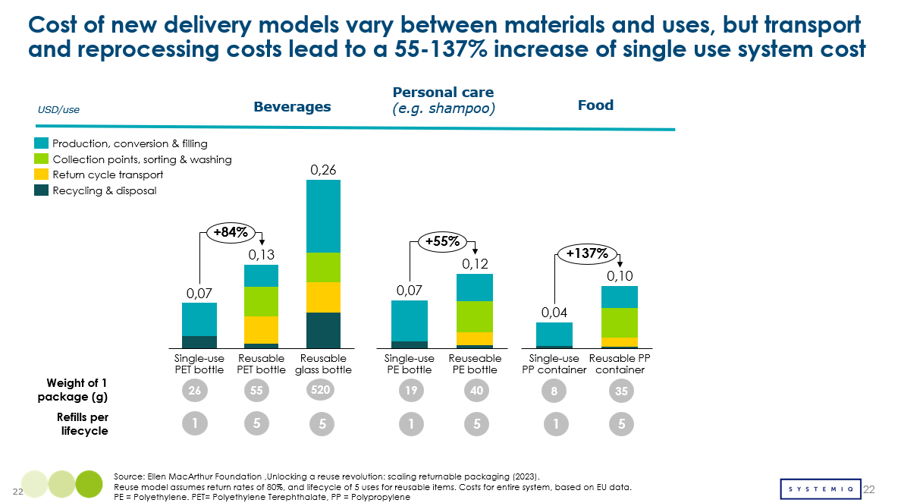
Despite initial cost challenges, economies of scale can drive significant cost reductions. The high barriers to entry – needed to establish new supply chains, cleaning and refill technologies – could be mitigated via economies of scale. This includes:
  - Market share expansion: More companies participating in reuse increases efficiencies.
  - Shared infrastructure: Shifting from company-specific supply chains and cleaning and refill infrastructure to collectivized infrastructure shortens supply chains, as trucks are able to travel to the nearest available processing plant.
  - Standardized packaging: Using common formats for beverage bottles or food packaging enables centralized cleaning and refilling across brands, optimizing operational costs. While this may seem like an ambitious measure, there is precedent: for example, all beverage bottles have the same size of neck opening to be able to use standardized refill equipment.
Exhibit 3.4
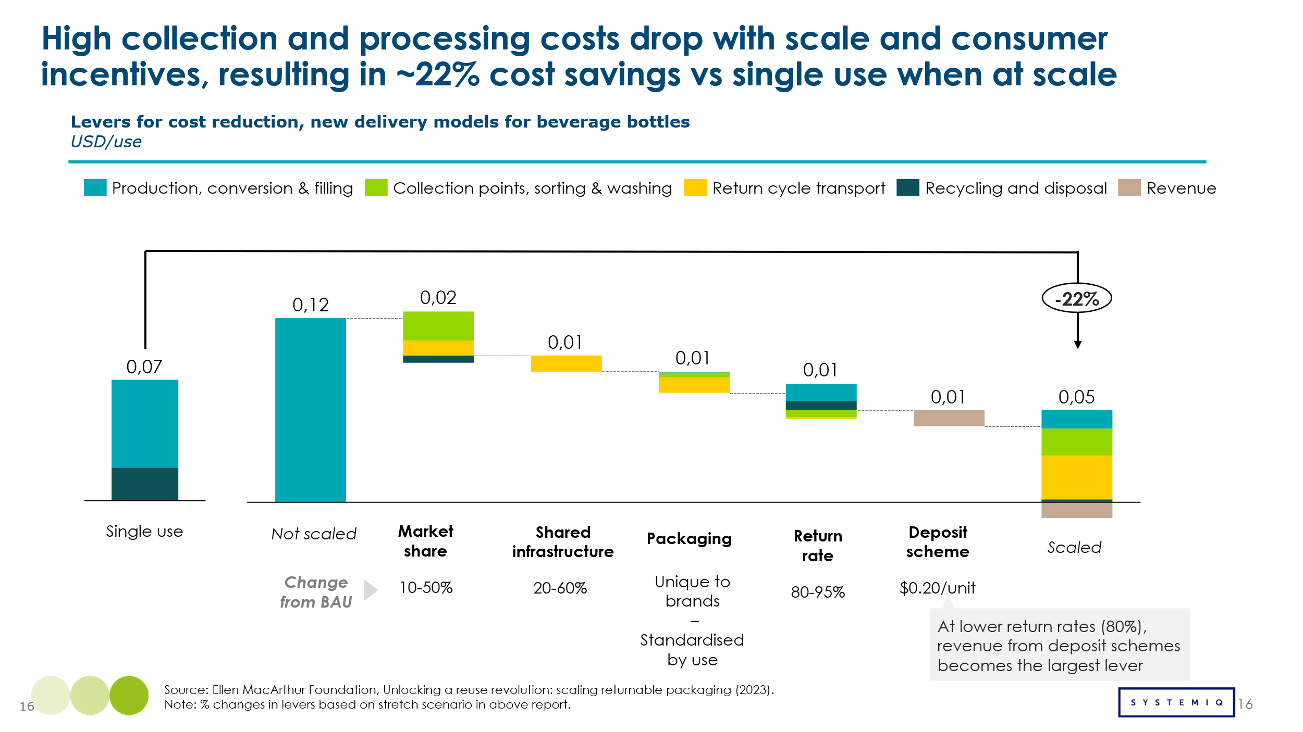

Impact
Similarly to costs, the carbon-reduction potential of reuse models also depends on the scaling of the system. Exhibit 3.5 shows that reuse has a substantial impact on emissions reduction and material demand; when it is done at scale, this is true across all sectors. However, fragmented adoption limits impact—especially in food packaging. Reuse systems reduce emissions from both production and end-of-life disposal, as these are spread across several uses. Additional emissions from increased transportation, cleaning and refill are minimal, and could be close to zero in a clean grid, electrified mid-century future. Taken together, scaled reuse offers a dual benefit: it cuts emissions and reduces overall costs, making it a compelling option for sustainable, cost-effective systems change.
Exhibit 3.5
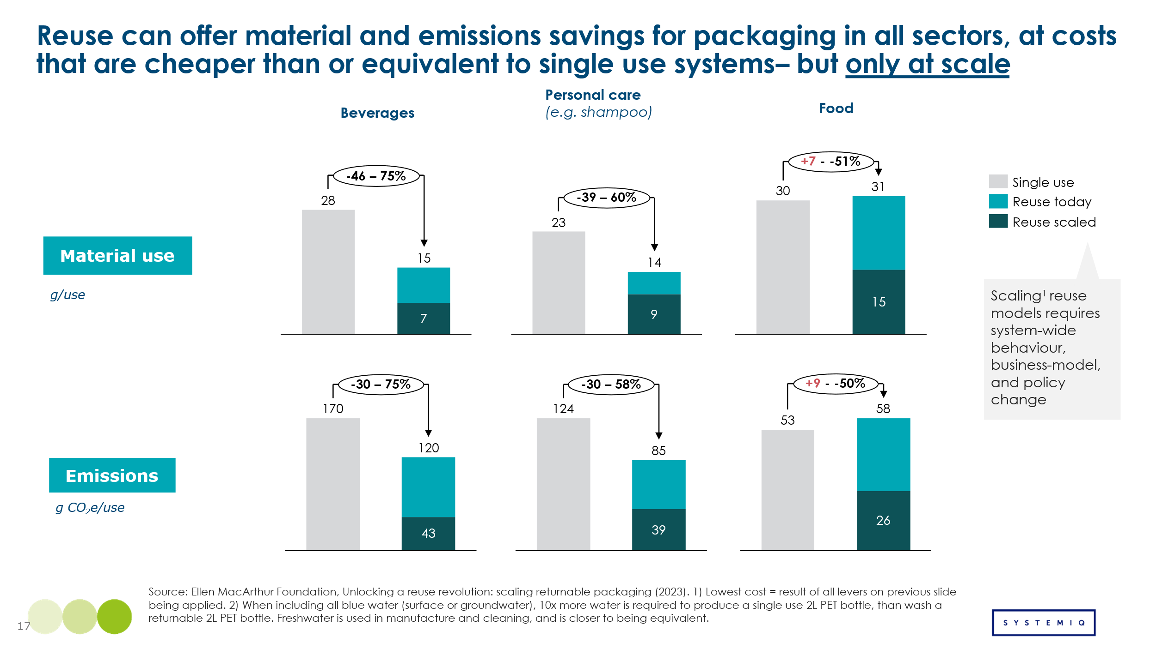

Barriers and Enablers
Despite promising economics and emissions reduction potential, regulatory and behavioural inertia remains a significant barrier to scaling reuse. Reuse models are not unattractive to business: subscription models offer businesses a captive consumer base and valuable data insights on product usage. However, being a first mover in a fragmented system, is costly and requires betting on customer buy-in and long-term revenue models, rather than immediate returns on investment. Without coordinated policy, action from Fast Moving Consumer Goods, and brands and retailers, consumer-driven change will be slow and incremental. However, implementing these changes for businesses are not operationally simple.
Some policy efforts to encourage reuse exist such as the EU Packaging and Packaging Waste Regulation, setting mandatory reuse targets for specific sectors. Some countries, like Germany and the Netherlands, have implemented sector-wide deposit return schemes for beverage containers - with great success. The UK has implemented charges for single-use carrier bags in supermarkets. These policies are very localized, mostly in the EU, and limited in scope. Despite this, they may remain best-in-class examples: consumer-facing policies tend to be unpopular with voters. Scaling reuse therefore presents a system-change quandary: without behaviour change and direct consumer demand, it relies on ambitious policy. Passing more ambitious reuse policy, however, may require both political and social will to shift over time.

3.2 Advanced sortation

Overview
Currently, only 9% of plastic waste even reaches a recycling facility, and in the best-performing countries, this figure is still just 14%. As shown in Exhibit 3.6 sortation is currently a system bottleneck in the plastics system. The biggest loss of material that could be recycled occurs after collection, primarily due to limited economic demand for sorted waste, limited segregation of waste at the collection stage, and insufficient sortation infrastructure. Material Recovery Facilities (MRFs) are few, small-scale, and not operating at full capacity due to complex economics.
Exhibit 3.6 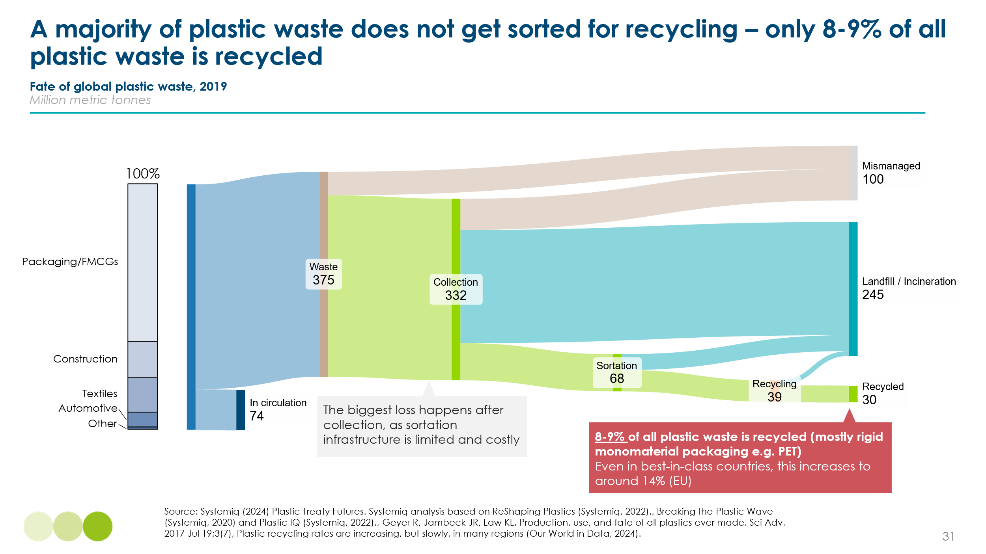
In a complex sector with ‘traditional’ MRF set-ups ranging from fully-manual sortation line to sensors able to identify clear plastic bottles, untangling the innovations that could transform the system is difficult. ‘Advanced sortation’ encompasses a range of technologies across the value chain, as shown in Exhibit 3.7.
Exhibit 3.7
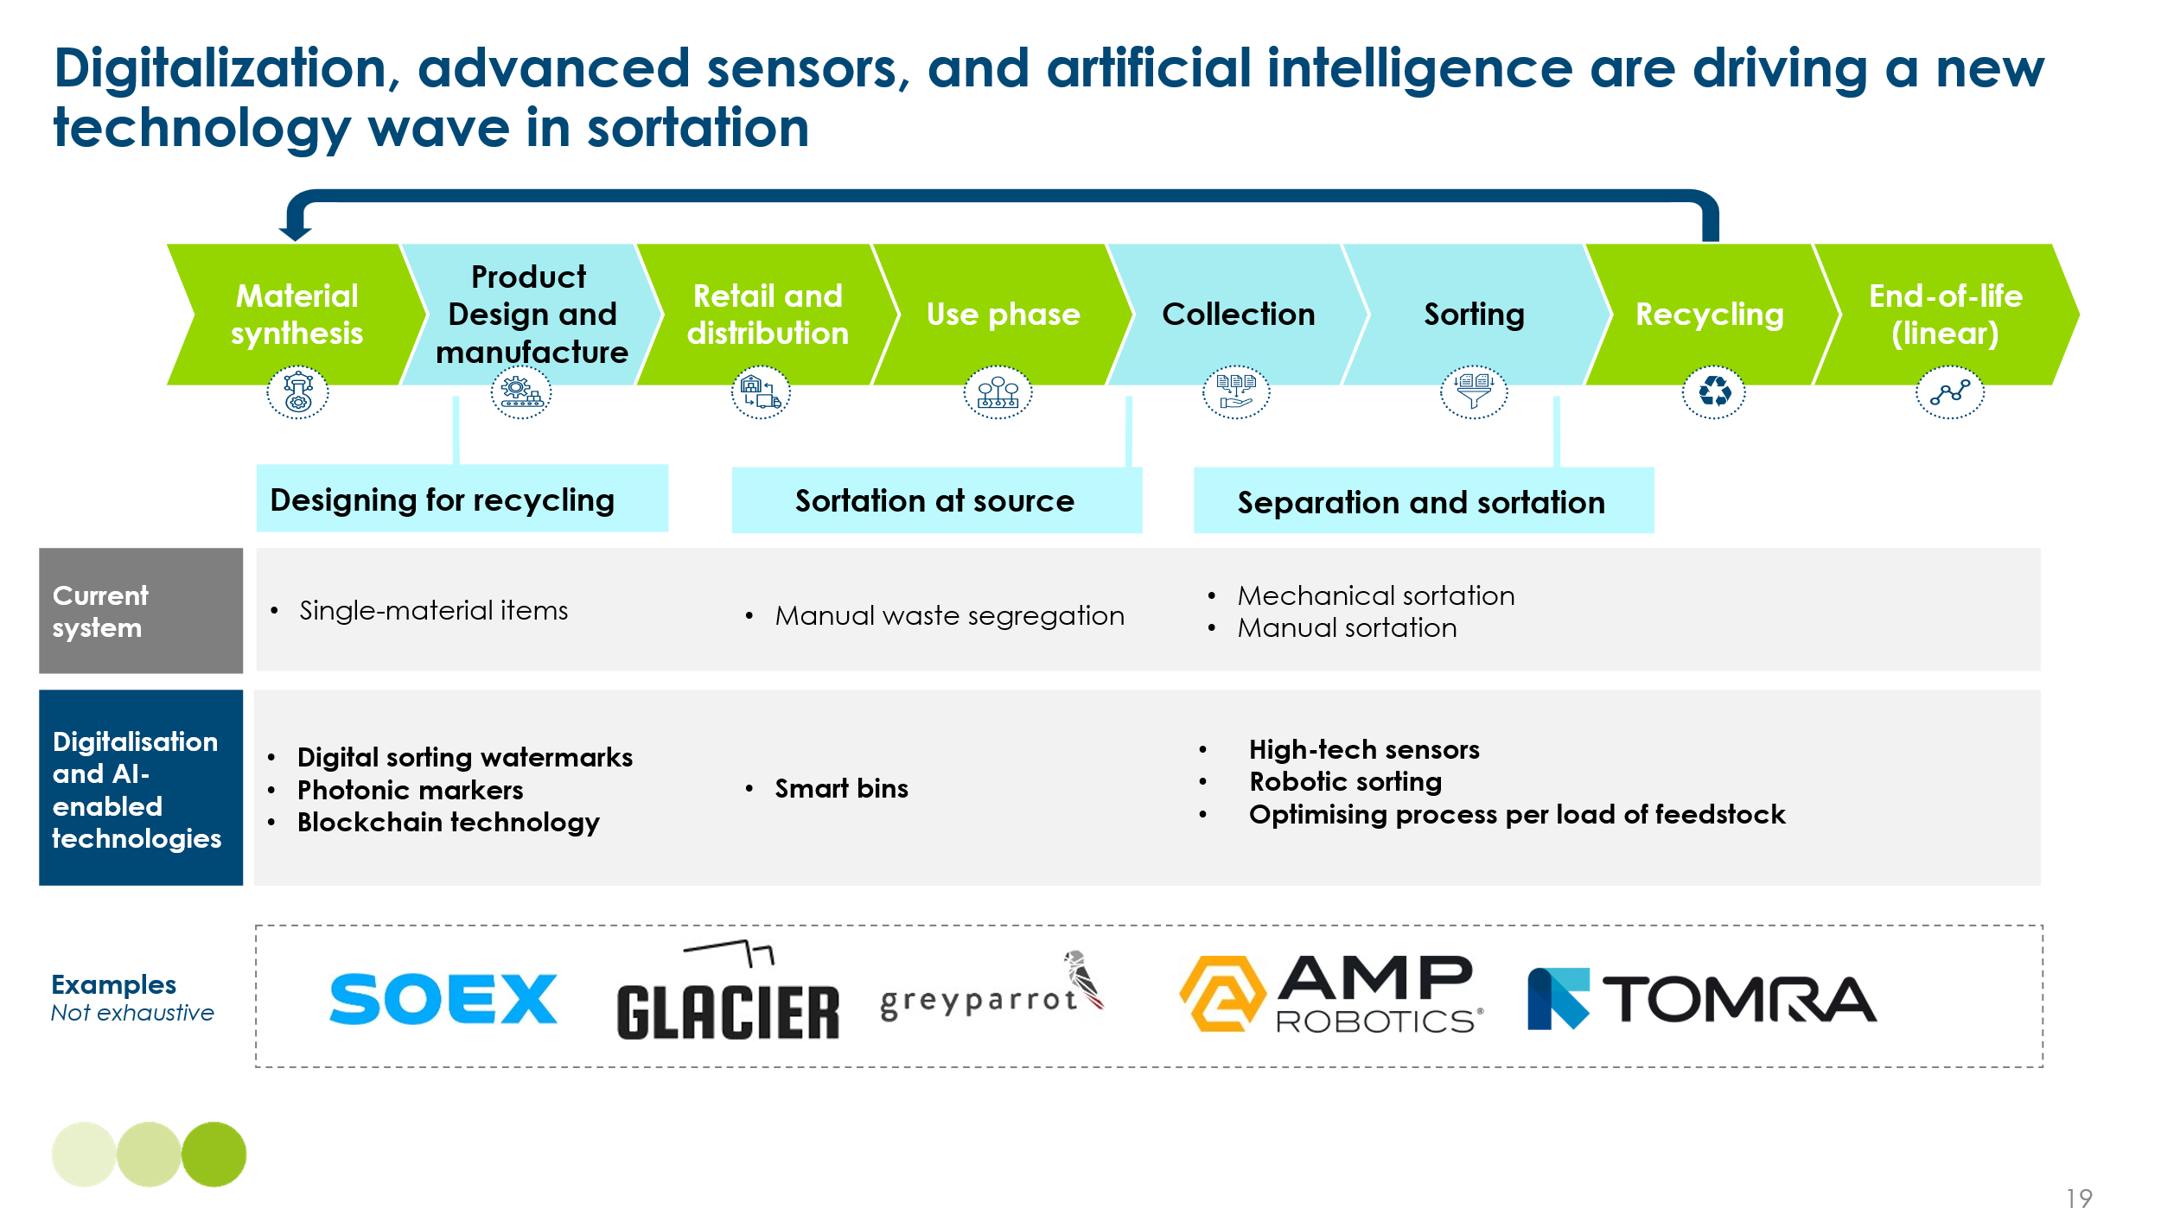

Costs and Impact
Reports show that final yield of recyclable product can increase by 25% in advanced facilities versus an average existing facility. This increase in yield applies only to waste that already reaches sortation facilities. In today’s system—where relatively low volumes are collected and sorted—this would increase global recycling rates from around 9% to 12% in the future.However, in a future system where downstream infrastructure is scaled and a greater share of waste reaches advanced sorting, the impact could be significantly larger—both in absolute terms and as a share of total plastic waste.
This hypothetical increase in yield is driven by a series of small improvements:
- Fewer losses of valuable materials due to advanced sensors and rapid sortation technology
- Better sortation of difficult plastics, including: coloured plastics, flexible plastics, contact-sensitive plastics
- Lower rates of contamination due to faster response rates (AI-enabled systems are capable of reaching speed of 140 picks/minute, 200% of current system speeds)
- Higher purity and therefore grade of recyclate bales. This limits need for further sortation at recycling plants and is the largest potential yield increase.
Potentially more important than the incremental improvements in efficiency and accuracy of sortation, advanced sortation may improve the economic viability of the sortation sector. Currently, sortation facilities operate most often at a loss. The sector is heavily subsidized, and MRFs are often running below capacity due to the combined pressures of high labour costs and the low, fluctuating value of recyclate. As Exhibit 3.8 shows, advanced sortation can improve the revenue of the sector with limited impact on costs. Although these technologies involve higher capital and energy expenditure, such costs can be offset by decreased labour requirements, improved efficiency, and savings on disposal fees. Additionally, improved recyclate quality and yield can generate higher revenues in the commodity market. While these improvements can significantly strengthen the business case for MRFs, some level of subsidy is likely to remain necessary elsewhere in the value chain ,such as during collection or recycling stages, as recognized in policies like Extended Producer Responsibility (EPR).
Exhibit 3.8
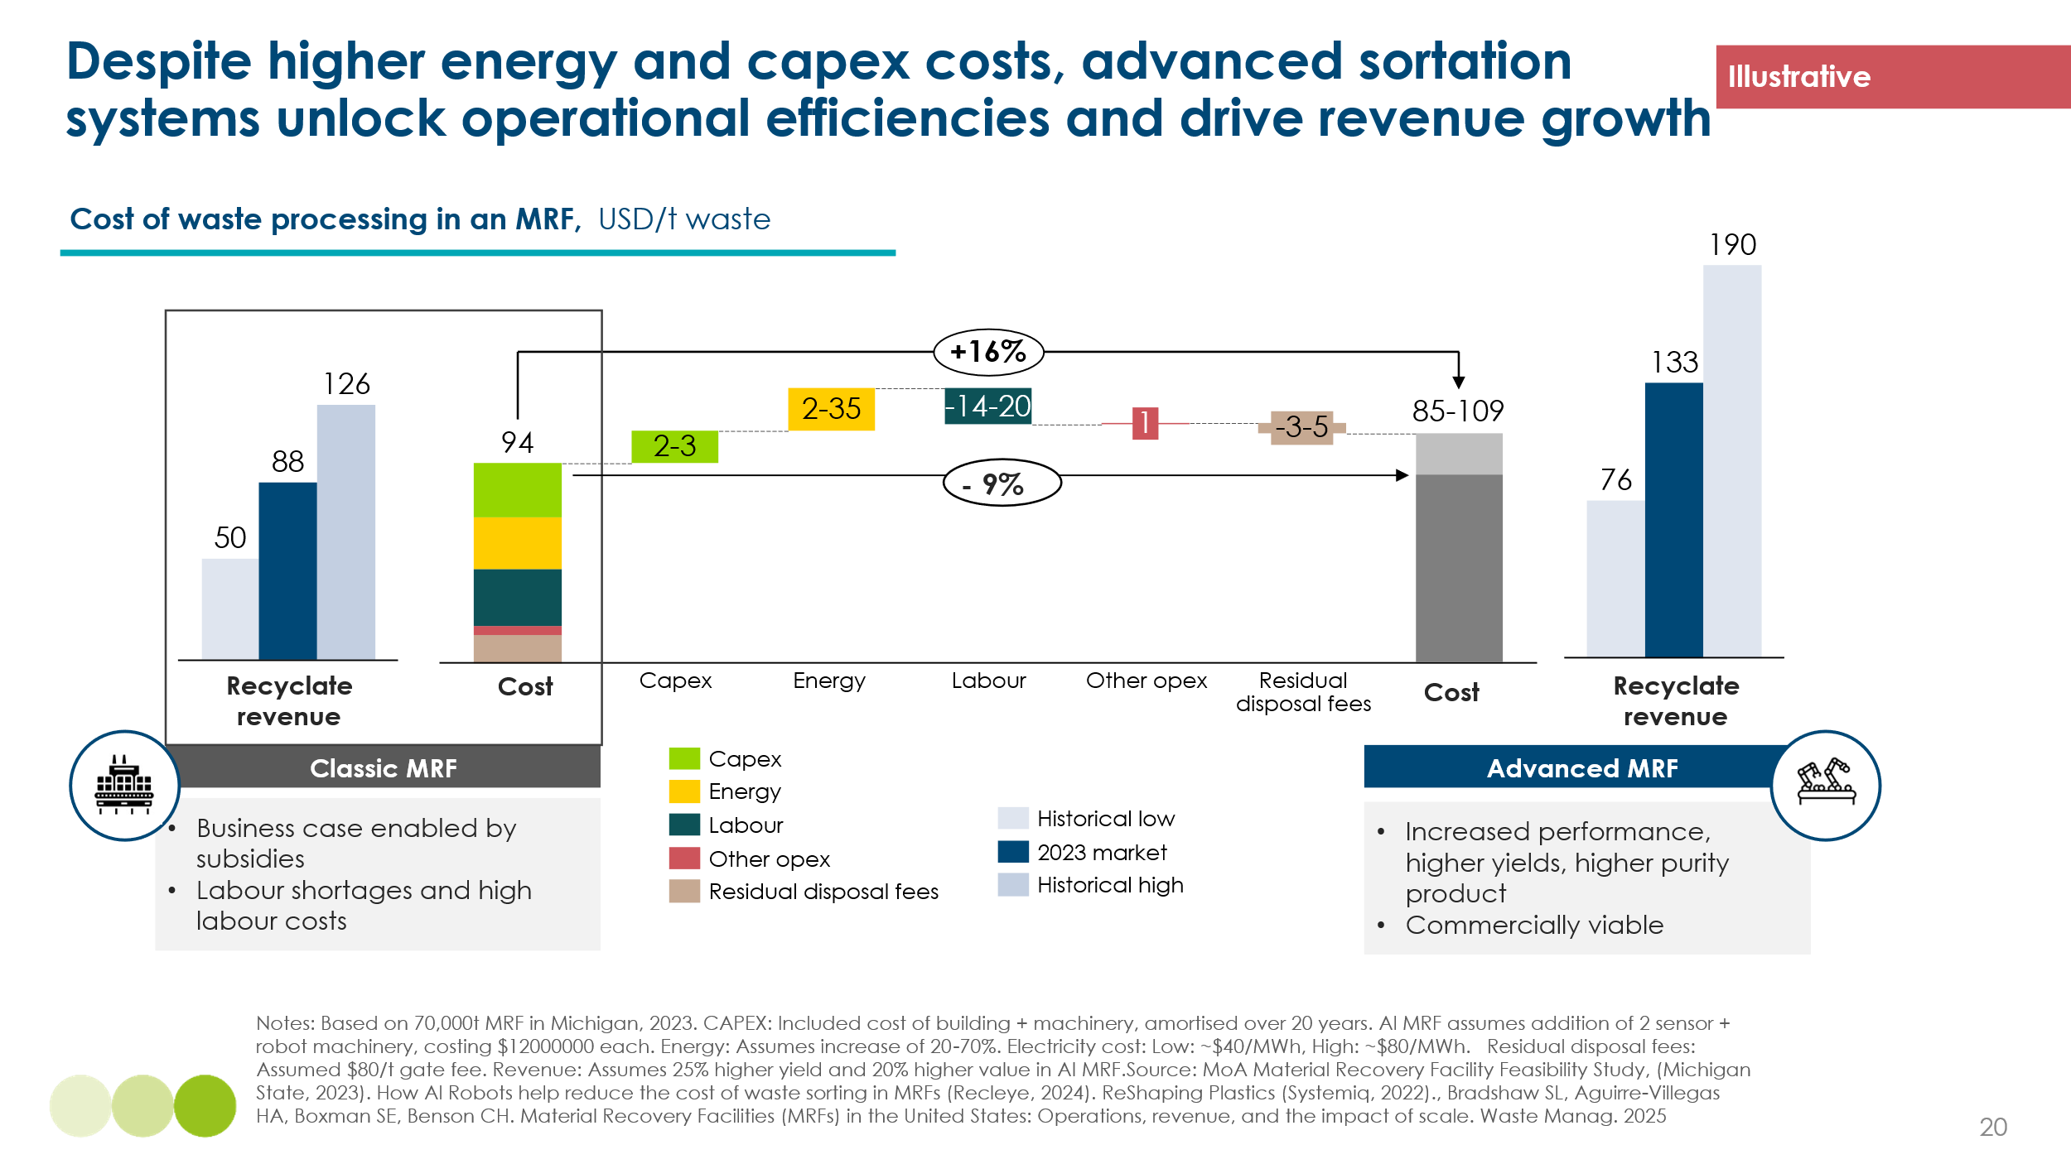

Barriers and Enablers
The main barrier to scaling advanced sortation is the widespread absence or underdevelopment of basic sortation infrastructure. In many regions, recyclable waste is collected through co-mingled systems and often sent directly to disposal. In these cases, there is limited value in applying advanced technologies when the foundational systems are missing or ineffective. Scaling sortation will require significant policy support, including direct investment in infrastructure and indirect measures such as mandates for separate collection and improved waste segregation.
These include:
  - Direct policy interventions – setting clear targets and subsidizing the sector, mandating separate collection streams (e.g., plastic vs. organic waste), and providing capital grants or tax credits for facility upgrades.
  - Indirect policy interventions to improve economics: Extended Producer Responsibility (EPR) – shifting financial and operational accountability for waste to producers, and carbon pricing mechanisms that internalize the climate cost of incineration and landfilling.
Advanced sortation may enable system change beyond costs as it fits into the broader waste management picture.
  - Provides greater system visibility – enabling better product design, infrastructure planning, and collection optimization.
  - Most importantly, supports policy and system changes needed to scale sortation in the first place.

3.3 Mechanical recycling

Overview
Physical and mechanical recycling encompasses two primary technologies: mechanical recycling and solvent-based recycling. Mechanical recycling involves physically processing waste materials into new products without altering their chemical structure. This process typically includes sorting, cleaning, shredding, and/or melting the materials. Solvent-based recycling, on the other hand, uses chemical solvents to dissolve and separate the components of waste materials, allowing for the recovery of pure polymers that can be reprocessed into high-quality products. One practical example of this is the recycling of end-of-life vehicles, where shredded material is treated with solvents to separate plastic fractions from complex residue streams. This approach allows for the extraction of relatively pure polymers from otherwise hard-to-sort mixtures. Mechanical recycling remains the most advanced technology in terms of maturity (see Exhibit 3.9), but only for a limited range of plastic feedstock types.
Exhibit 3.9
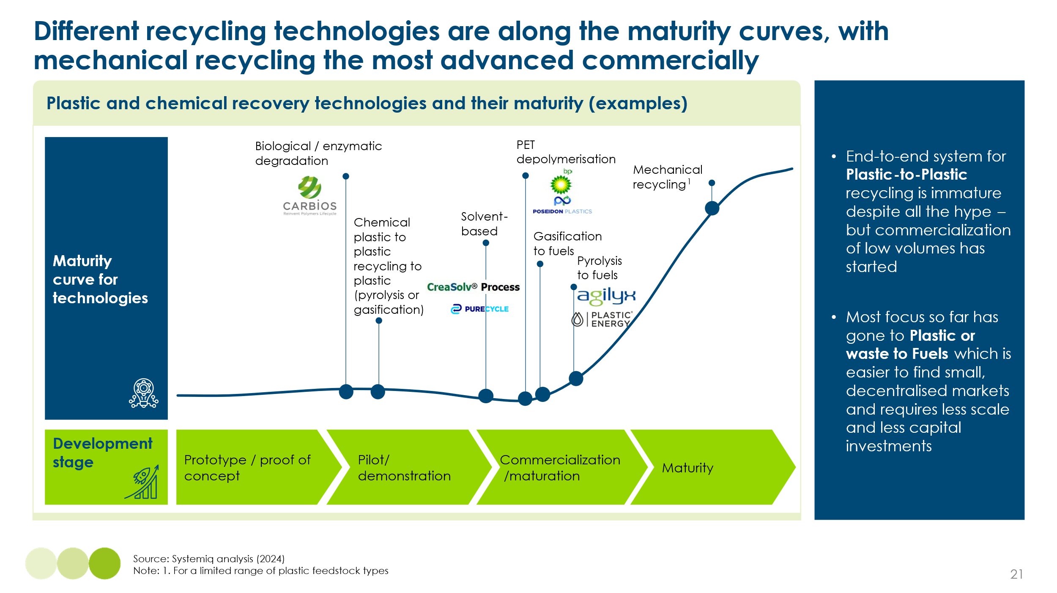

Barriers
Despite mechanical recycling being a well-established technology, it faces several challenges that limit its scalability. One major issue is the degradation of polymer properties due to heat, mechanical stress, and oxidation during the recycling process. This degradation can reduce material performance, making recycled plastic less suitable for certain applications. For food-grade mechanical recycling, the primary barrier is contamination risk rather than polymer degradation. This is typically managed through strict input controls, as seen in PET beverage bottle recycling. Additionally, since most mechanical recycling today involves only one cycle of previously virgin plastic, it remains uncertain how many times a material can be recycled before losing its essential properties in real-world conditions. In controlled laboratory settings, scientists have managed to recycle an HDPE bottle up to 10 times.
Another majority challenge for mechanical recycling centres around feedstock sensitivity. Mechanical recycling requires high levels of purity, and contaminated plastics either cannot be recycled or are recycled into lower-grade applications. Consequently, the output of what is mechanically recycled, is often converted into non-contact sensitive materials, such as polyester for textiles, plastics for furniture or the built environment, or strapping and packaging, in a process known as 'open-loop' recycling.
Several cycles of closed-loop recycling are technically feasible, but they require high levels of sorting and cleaning. Design for recycling will also play a crucial role in scaling mechanical recycling. Bottles and rigid packaging are more easily recycled in a closed loop than flexible or easily contaminated plastics, such as household goods and construction materials. Multi-layer multi-material (MLMM) products are virtually impossible to mechanically recycle, further complicating the process. Designing for recycling would play a crucial role in scaling closed-loop mechanical recycling. By shifting from complex, compound polymer designs, to simple mono-material, rigids with minimal additives, colourings and plasticisers, the quality of recyclate is increased.
Another significant barrier to mechanical recycling is the business case. While mechanical recycling provides environmental benefits, the economic viability can be challenging. The costs associated with sorting, cleaning, and processing plastics can be high, and the market value of recycled plastics is often lower than that of virgin plastics because of the abundance of low-cost naphtha fossil feedstock. However, in a market where fossil feedstock is scarce or its life-cycle carbon impact is priced appropriately, the business case for mechanical recycling could be far more compelling. This disparity can make it difficult for businesses to justify the investment in mechanical recycling infrastructure today. Some investments are being made today, but mostly in easier-to-recycle segments such as PET bottles. Additionally, fluctuations in the price of virgin plastics can impact the competitiveness of recycled plastics, further complicating the business case for mechanical recycling.

Enablers and potential impact
Mechanical recycling can be significantly enabled through a multifaceted approach that addresses the entire material lifecycle. Key enablers include investing and improving more waste collection and sorting systems and infrastructure to ensure material makes it to recycling facilities. Additionally, coordination among stakeholders in the value chain is needed to ensure best in class recycling infrastructure and policies that incentivize circularity. Key policies would include, but are not limited to:
Policies and targets:
- Reduce virgin plastic volumes
- Increase collection and recycling in developing countries
- Ban plastics designed for single use, and hard-to-recycle plastics
- Design rules for safe re-use, repair and recycling (e.g. the EU’s packaging and packaging wate directive include requirements for the design of packaging to facilitate re-use and recycling)
- Extended Producer Responsibilities schemes and/or unrecyclable plastic fees (e.g. EU plastics levy)
In a highly ambitious scenario by 2040, Plastic Treaty analysis undertaken by Systemiq estimates that mechanical recycling grow 5 times, from levels today of ~30 million tonnes to183 million tonnes (open and closed loop mechanical recycling) by 2040 (Exhibit 3.10).
Exhibit 3.10
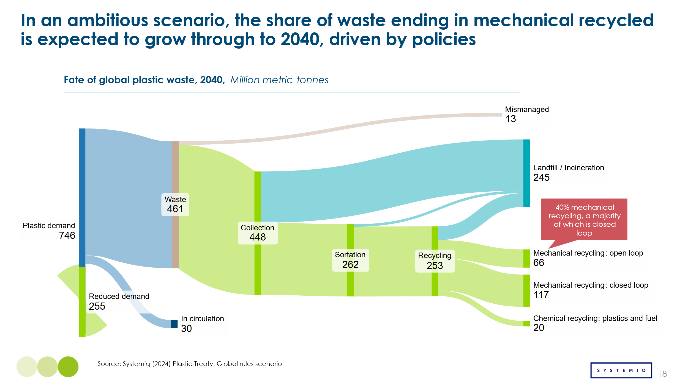

3.4 Chemical recycling and thermo conversion

Overview
Chemical recycling and thermo-conversion offer a pathway to reduce reliance on virgin fossil-based feedstocks by converting waste (especially plastic) into valuable chemical building blocks. Chemical recycling is where the material would be closed loop (i.e. material-to-material), whereas thermo-conversion describes the process where the feedstocks are used to create chemical outputs that are used for other uses, such as fuels (e.g. methanol production to shipping fuel). Unlike mechanical recycling, which degrades plastic quality over successive cycles, chemical recycling and thermo-conversion breaks down polymers into their fundamental components, enabling the production of high-quality recycled materials with properties equivalent to virgin plastics. Additionally, these technologies can process lower-purity materials that are unsuitable for mechanical recycling, making them complementary approaches in a circular economy.
There are some select emerging technologies for chemical recycling/thermo-conversion, however there are three fundamental approaches that dominate the current landscape: depolymerisation, pyrolysis and gasification. Each process yields different chemical products, as illustrated in Exhibit 3.11. In this analysis:
- Depolymerisation is assessed based on Polyethylene Terephthalate (PET) production. PET depolymerisation holds the highest market potential and is more mature application compared to the lower recycling volumes and more difficult processing of Polyurethane (PUR) and Polystyrene (PS).
- Gasification is evaluated based on methanol production via syngas formation.
- Pyrolysis is analysed in terms of High-Value Chemicals (HVC), specifically ethylene.
Exhibit 3.11
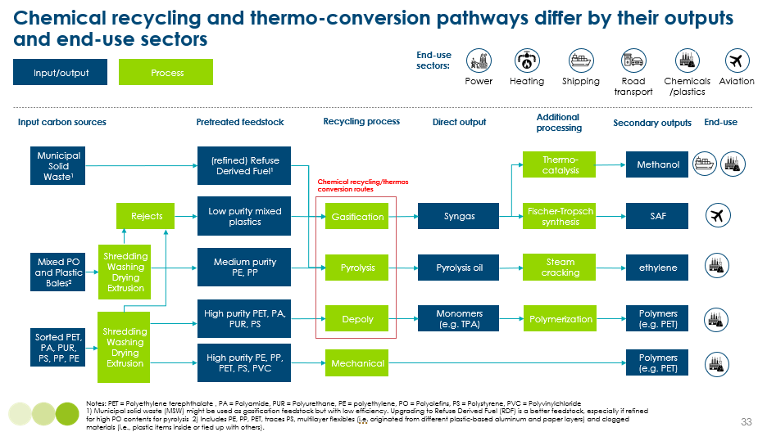
These technologies have the potential to complement mechanical recycling by processing contaminated and mixed plastic waste streams that would otherwise be incinerated or landfilled. The choice of an appropriate chemical recycling/thermo-conversion process depends primarily on the costs, the feedstock characteristics and the desired product. Exhibit 3.12 provides the different advantages and disadvantages of each technology. In practice, the limited availability of uncontaminated or sorted feedstocks, and the demand for recycled content with virgin-like quality, risks placing mechanical and chemical recycling pathways in competition rather than alignment. This dynamic may challenge the optimal allocation of waste streams and the scaling of both technologies simultaneously.
Exhibit 3.12

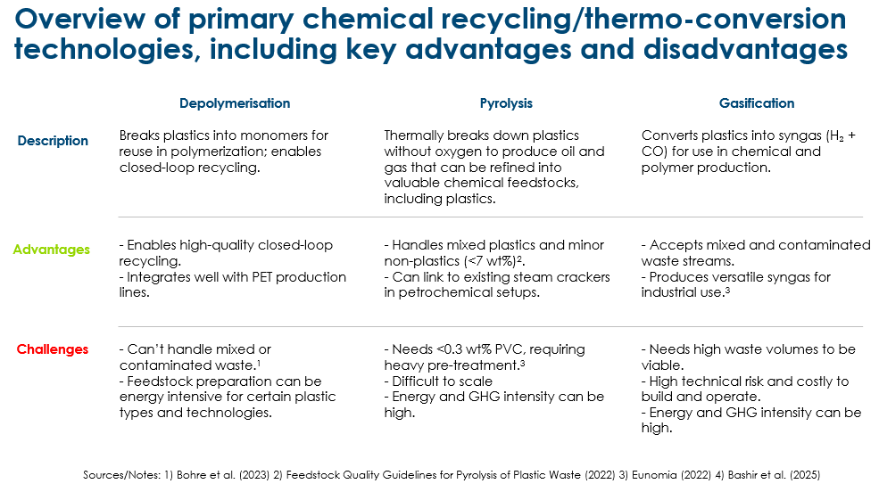

Costs
While the levelised cost of production for these technologies varies significantly, all face a significant premium when compared with their fossil based-alternative. Key cost drivers include capital and operational expenditures, feedstock and pre-treatment requirements, energy use, and the potential revenue from by-products. Exhibit 3.13 compares the levelised cost of production of each process with its fossil-based alternative.
Exhibit 3.13
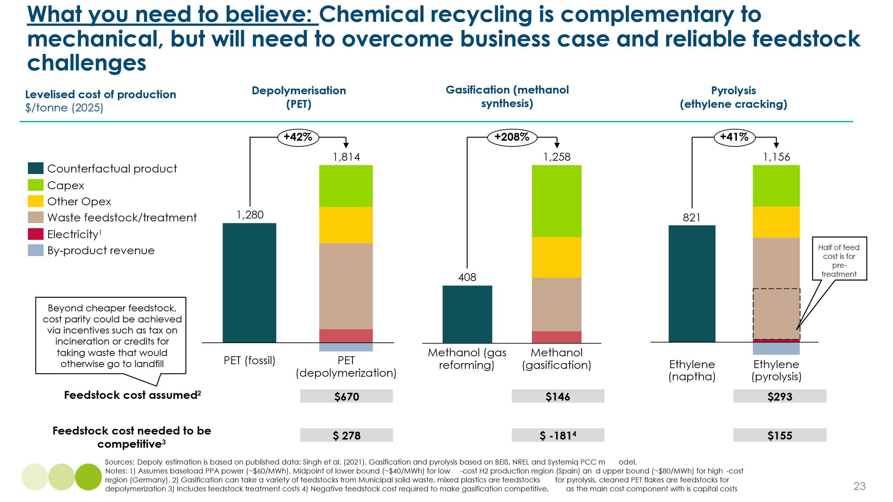
Feedstock costs are one of major cost drivers in chemical recycling and thermo-conversion, with significant differences between the three technologies. Depolymerisation has purity requirements for PET flakes, making it the most expensive, while gasification can process highly contaminated waste, leading to the lowest feedstock cost. However for gasification, its lower feedstock costs are offset by much higher capex and opex costs as a share of total costs. Pyrolysis feedstock costs falls in between, but pre-treatment significantly contributes about half of its total cost. In a scenario where regulations prohibit the burning of waste for energy recovery, the purchase cost of certain feedstocks could reduce due to lack of alternative disposal option. However, treatment costs, especially for pyrolysis and depolymerisation, are necessary to ensure high efficiency and proper operation.

Impact
The CO₂ emissions of chemical recycling and thermo-conversion processes are challenging to estimate due to the multiple process pathways that can influence emissions, efficiency, and overall economics. The most common pathways have been considered in the environmental footprint evaluation to provide a comparative assessment of different technologies. The CO₂ emissions of chemical recycling and thermo-conversion processes are challenging to estimate due to the multiple process pathways that can influence emissions, efficiency, and overall economics. The most common pathways have been considered in the environmental footprint evaluation to provide a comparative assessment of different technologies.
Gasification and pyrolysis currently emit more CO₂ than their fossil-based counterparts, methanol and ethylene for process emissions (Exhibit 3.14), when not accounting for avoided incineration credits. A potential improvement is hydrogen (H₂) injection, which could lower CO₂ emissions but would increase operational costs, reducing economic feasibility. Pyrolysis emissions could also be improved by electrification of the pyrolysis unit and/or the steam cracker, but this would require redirecting off-gases to alternative applications to maintain process efficiency. In contrast, chemical PET depolymerisation and mechanical recycling have lower CO₂ emissions than fossil PET production. Additionally, both of them could be fully electrified, as they primarily involve low-temperature operations, allowing for net-zero CO₂ emissions when powered by renewable energy.

Exhibit 3.14
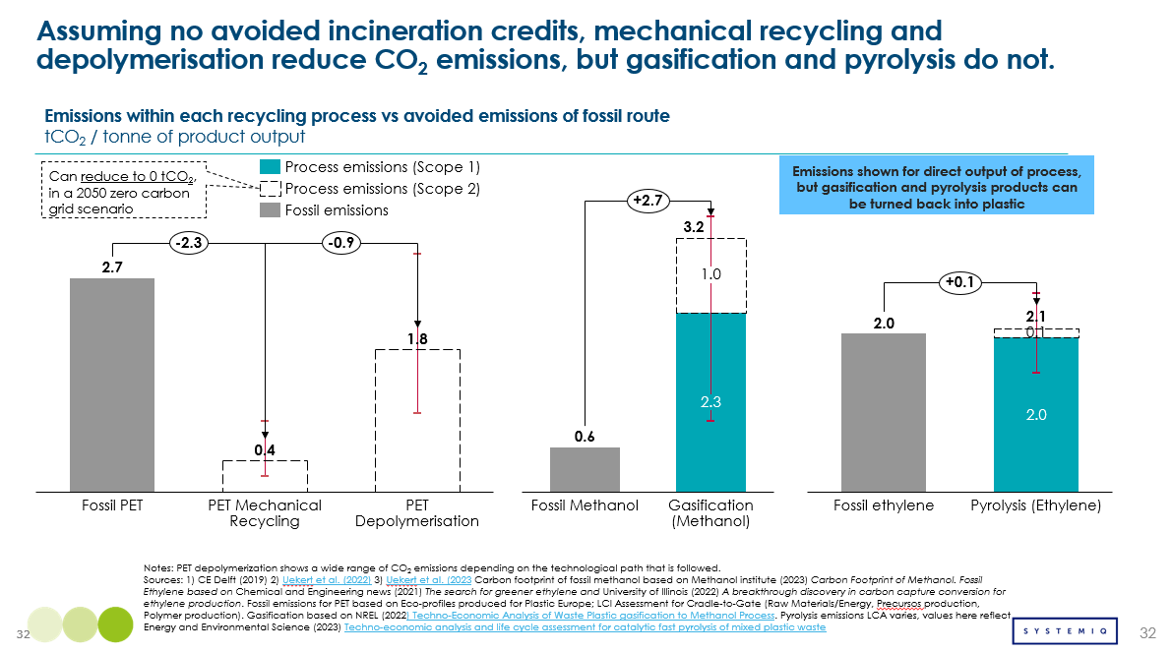
Across the different chemical recycling/thermo conversion technologies, yield from feedstocks varies and can be an important consideration when comparing emissions. The mass yield of waste plastic conversion into new chemical varies significantly across different recycling and thermochemical processes and also according to real world circumstances (e.g. optimizing yield and economics). Lower conversion rates imply that a greater share of the original plastic is not retained in the final material. However, they also lead to higher incineration emission savings per tonne of product, since more of the non-converted material is diverted from incineration. To accurately compare the net CO₂ impact of each process—factoring in the avoided emissions from incinerating waste plastic—it is preferable to normalize emissions data based on 1 tonne of plastic waste input. illustrates the overall CO₂ emission savings achieved by each process when processing 1 tonne of waste plastic.

Exhibit 3.15: Each of the recycling technologies results to negative CO2 emissions per ton of waste processed, because of the avoided incineration credits
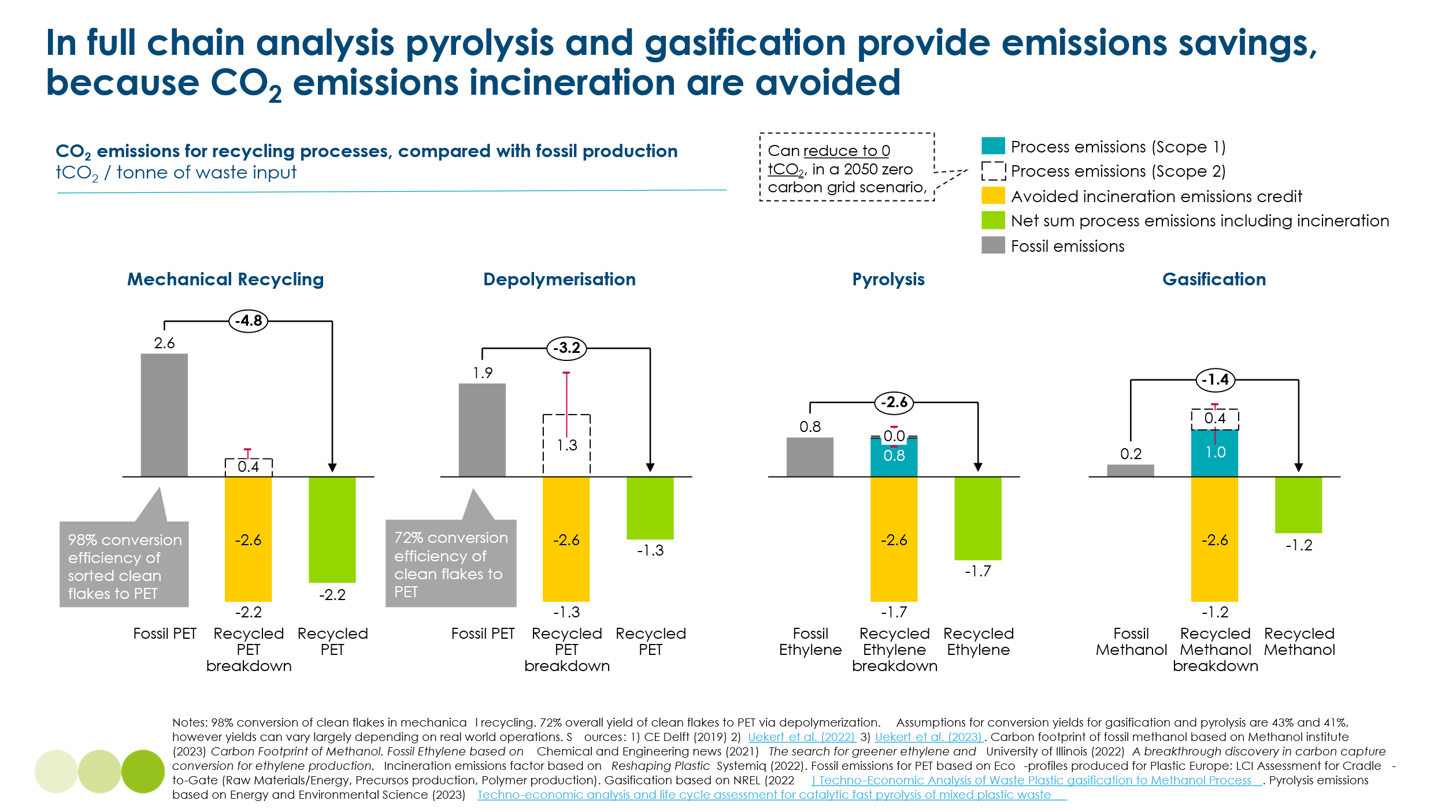
The main GHG impact of chemical recycling and thermo-conversion is from avoided alternative end of life emissions, like unabated incineration emissions. When accounting for incineration credits, all processes offer net CO₂ savings. Mechanical recycling delivers the highest reductions—up to 3.5x more than gasification—followed by depolymerisation, pyrolysis, and gasification in descending order. From both an economic and environmental perspective, the most effective approach to reducing carbon demand in the chemical sector follows a hierarchical strategy.
- Demand reduction and reuse should be prioritized, as they offer the highest carbon savings with minimal energy input.
- Mechanical recycling is the next best option, as it allows for the recovery of plastic waste with lower emissions than chemical recycling.
- Chemical recycling and thermo-conversion should be considered only for the plastic waste that cannot be processed by other means, given its higher energy consumption and economic constraints.
Applying this hierarchy, current global projections suggest that the majority of the waste will be managed via demand reduction, reuse and mechanical recycling (see Exhibit 3.16). A remaining 20% is estimated to be addressed by chemical recycling and thermo-conversion. Circularity solutions have the potential to reduce carbon demand in the chemicals sector by over two-thirds—an important consideration given the limited availability of truly sustainable carbon sources. Despite its limited role in volume, chemical recycling/thermo-conversion is essential to process hard-to-recycle waste and support the 2050 sustainability goals.

Exhibit 3.16: Stretch scenario: Primary carbon demand for plastic can be reduced by 71%, but requires system change, policy support and improved business cases
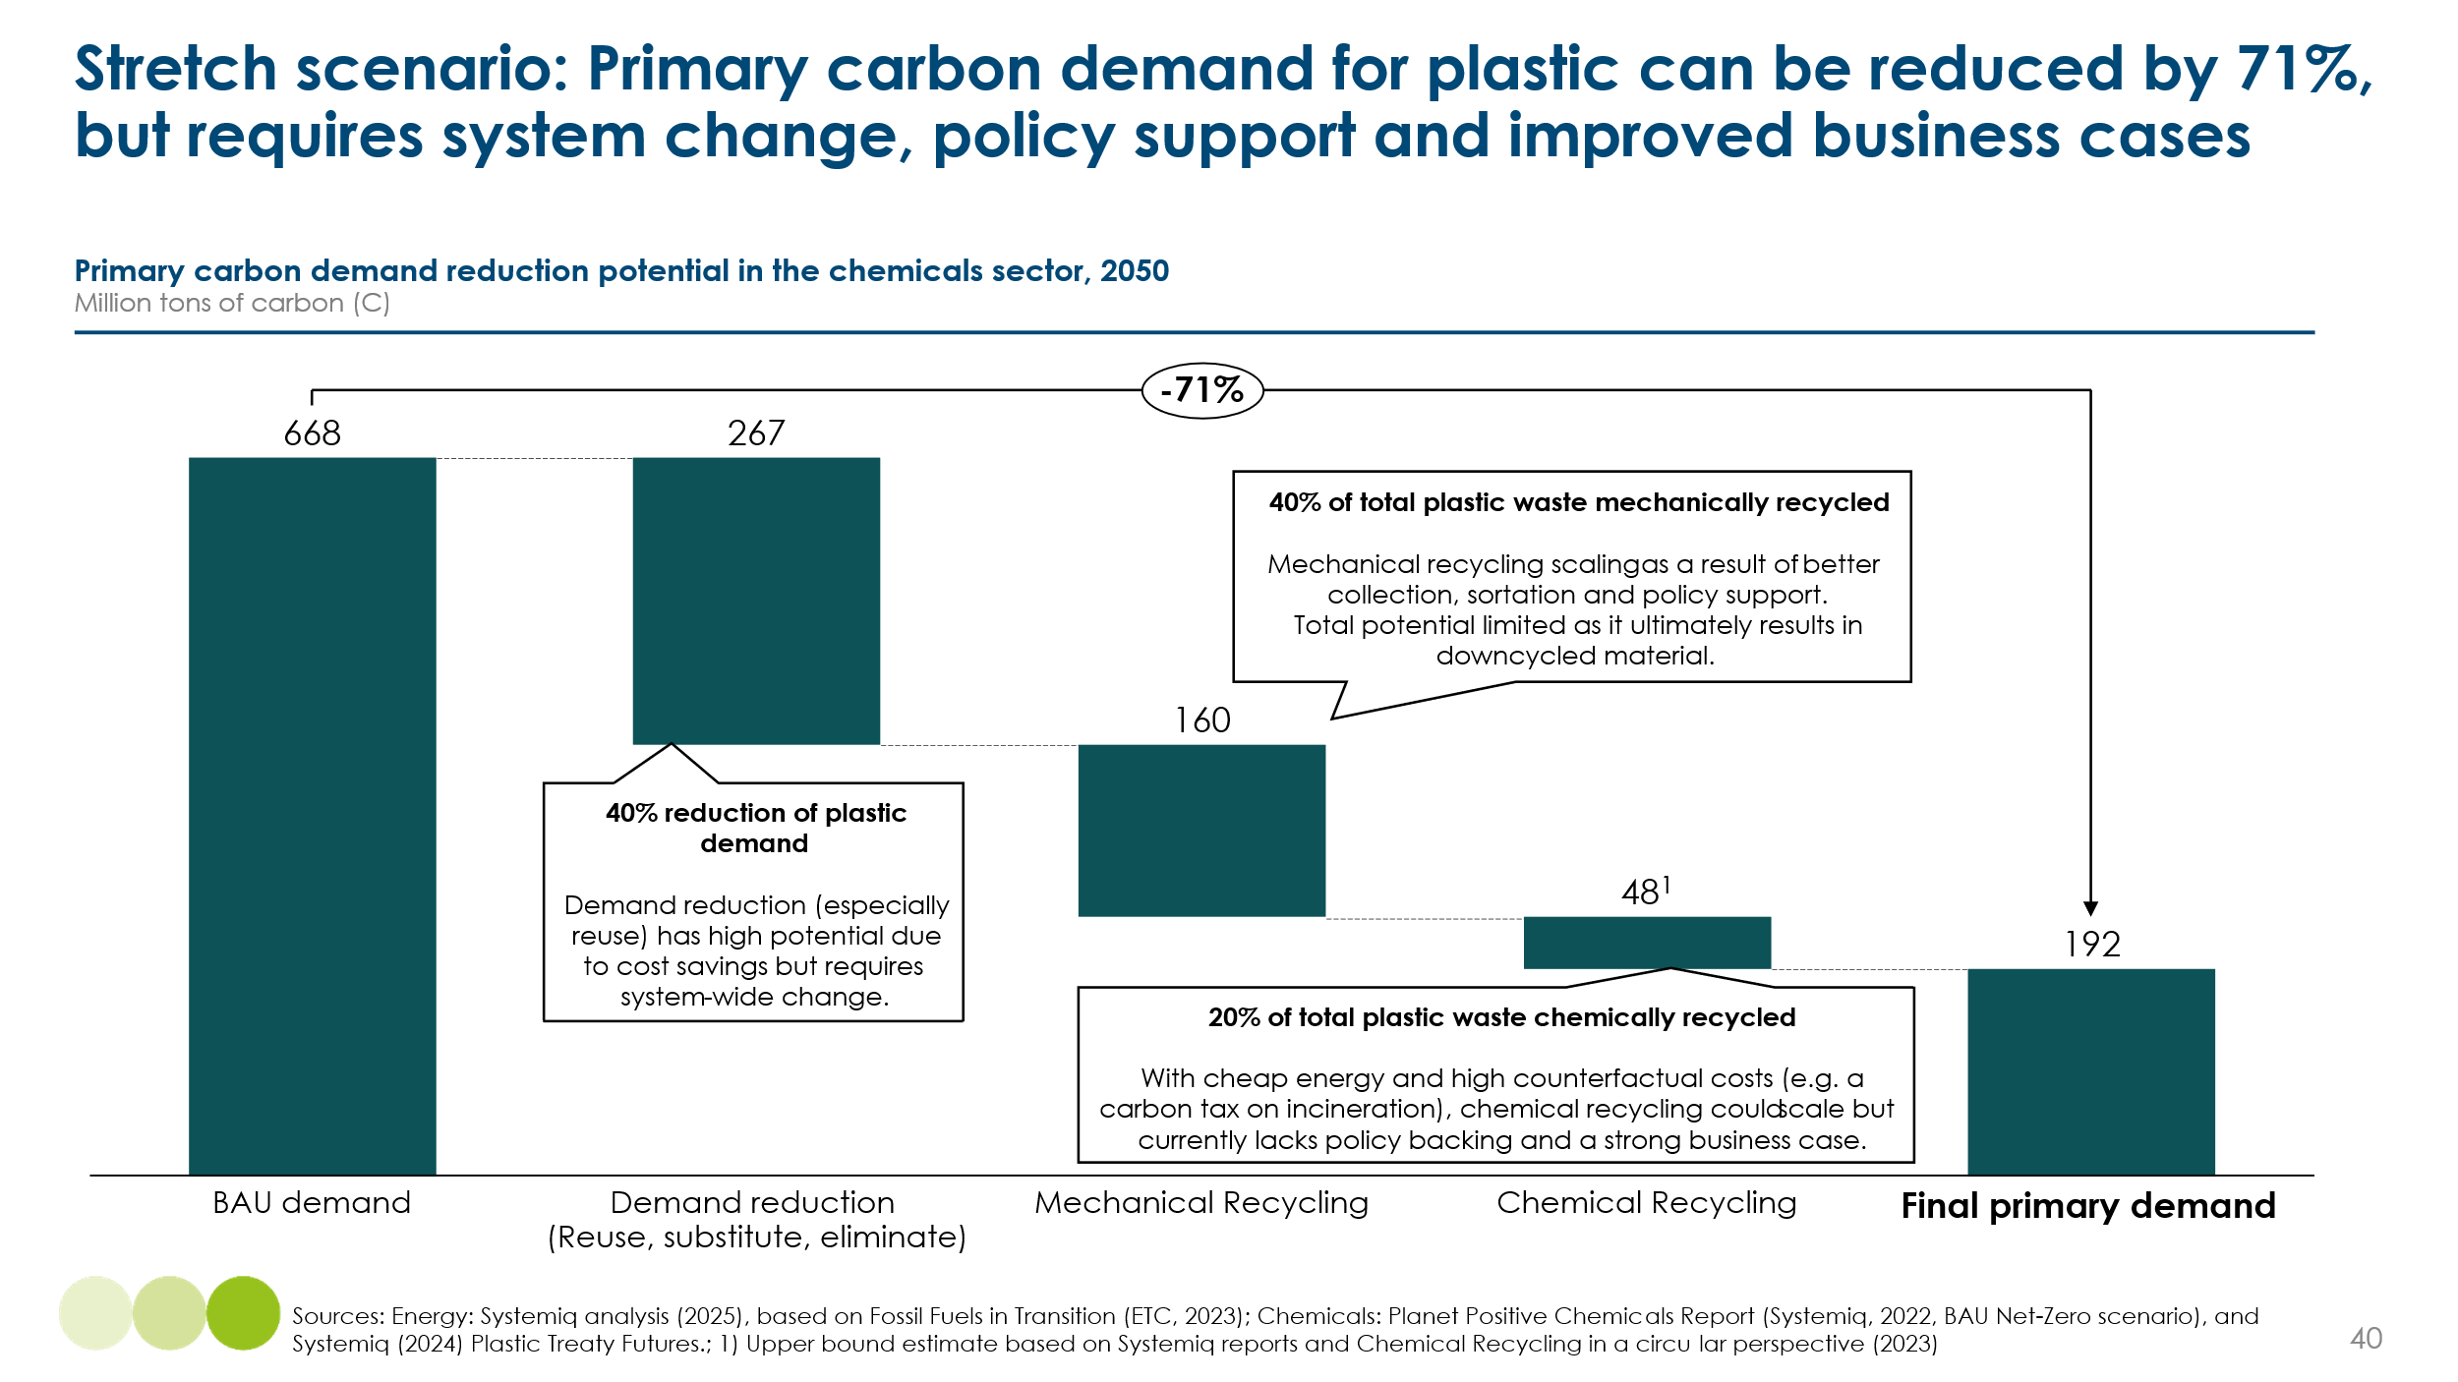

Barriers and Enablers
While chemical recycling and thermo-conversion has the potential to address plastic waste challenges, several barriers limit its widespread adoption. However, with strategic investments, supportive policies, and technological advancements, it could become a key component of a more sustainable plastic value chain. Key barriers and enablers are as follows:
Technology Maturity and Efficiency
Barriers: Chemical recycling and thermo-conversion technologies, while based on processes that have in some cases been used for decades, have not yet been proven at scale as end-to-end solutions within real-world waste management systems. Their integration into existing value chains remains limited, particularly when dealing with heterogeneous, contaminated waste streams. Scaling up will require improvements in conversion rates, energy efficiency, and overall process stability, all of which carry significant technological risk. Process efficiency remains a challenge, as highly variable feedstock makes it difficult to retain high-quality output production.
Enablers: Electrification and catalyst improvements could enhance efficiency but require further R&D and infrastructure investments.

Economic Competitiveness:
Barriers: Chemical recycling and thermo-conversion is currently more expensive than fossil-based plastic production and mechanical recycling due to:
- High capital expenditures (CAPEX) and pre-treatment costs.
- Lack of economies of scale, making it difficult to compete with established fossil-based processes.
Enablers: Financial mechanisms can improve the economic viability of chemical recycling and thermo-conversion. Extended Producer Responsibility (EPR) schemes place the burden of waste management on producers, incentivising the use of recyclable and recycled materials. Carbon pricing makes fossil-based inputs less attractive by internalising their environmental costs, while landfill taxes discourage the disposal of plastic waste that could be recovered. In addition, standardised policies on feedstock classification and product quality would reduce uncertainty, encouraging investment and supporting market growth.

Feedstock Availability and Quality:
Barriers: Chemical recycling and thermo-conversion requires a steady supply of suitable feedstock, but:
- Plastic collection and sorting systems remain inadequate, leading to inconsistent material streams.
- Contaminants such as PVC can cause operational challenges, increasing processing costs.
Enablers: Advanced sorting and pre-treatment technologies need to be scaled to ensure high-quality input materials. Improving waste management infrastructure is necessary to establish a more reliable feedstock supply.

Criticism on their circularity of chemical recycling:
Barrier: Although chemical recycling has the potential to support circularity by converting waste plastics back into monomers or polymers, stakeholder trust remains limited. Many fear that in practice, technologies marketed as chemical recycling may operate as material-to-fuel processes, prioritizing energy recovery over true circularity. This conflicts with the waste hierarchy, which favors prevention, reuse, and mechanical recycling. Additional concerns include greenhouse gas emissions, health impacts from large-scale facilities, and environmental justice for nearby communities. There is also broader unease that these technologies could enable continued growth in virgin plastic production without addressing systemic climate and sustainability goals
Enabler: Building broad stakeholder support will require clear evidence that chemical recycling delivers material-to-material outcomes, along with strong climate and health safeguards. Transparent standards and third-party verification will be essential to build trust and ensure alignment with circular economy principles.

3.5 Carbon capture and utilisation

Overview
As industries seek to decarbonize and transition to a circular economy, Carbon Capture and Utilisation (CCU) has emerged as a viable solution to reduce CO₂ emissions while generating valuable products. The Carbon Management Pathway consists of three key stages, as shown in Exhibit 3.17, capture, transport and end-of-life.
Exhibit 3.17
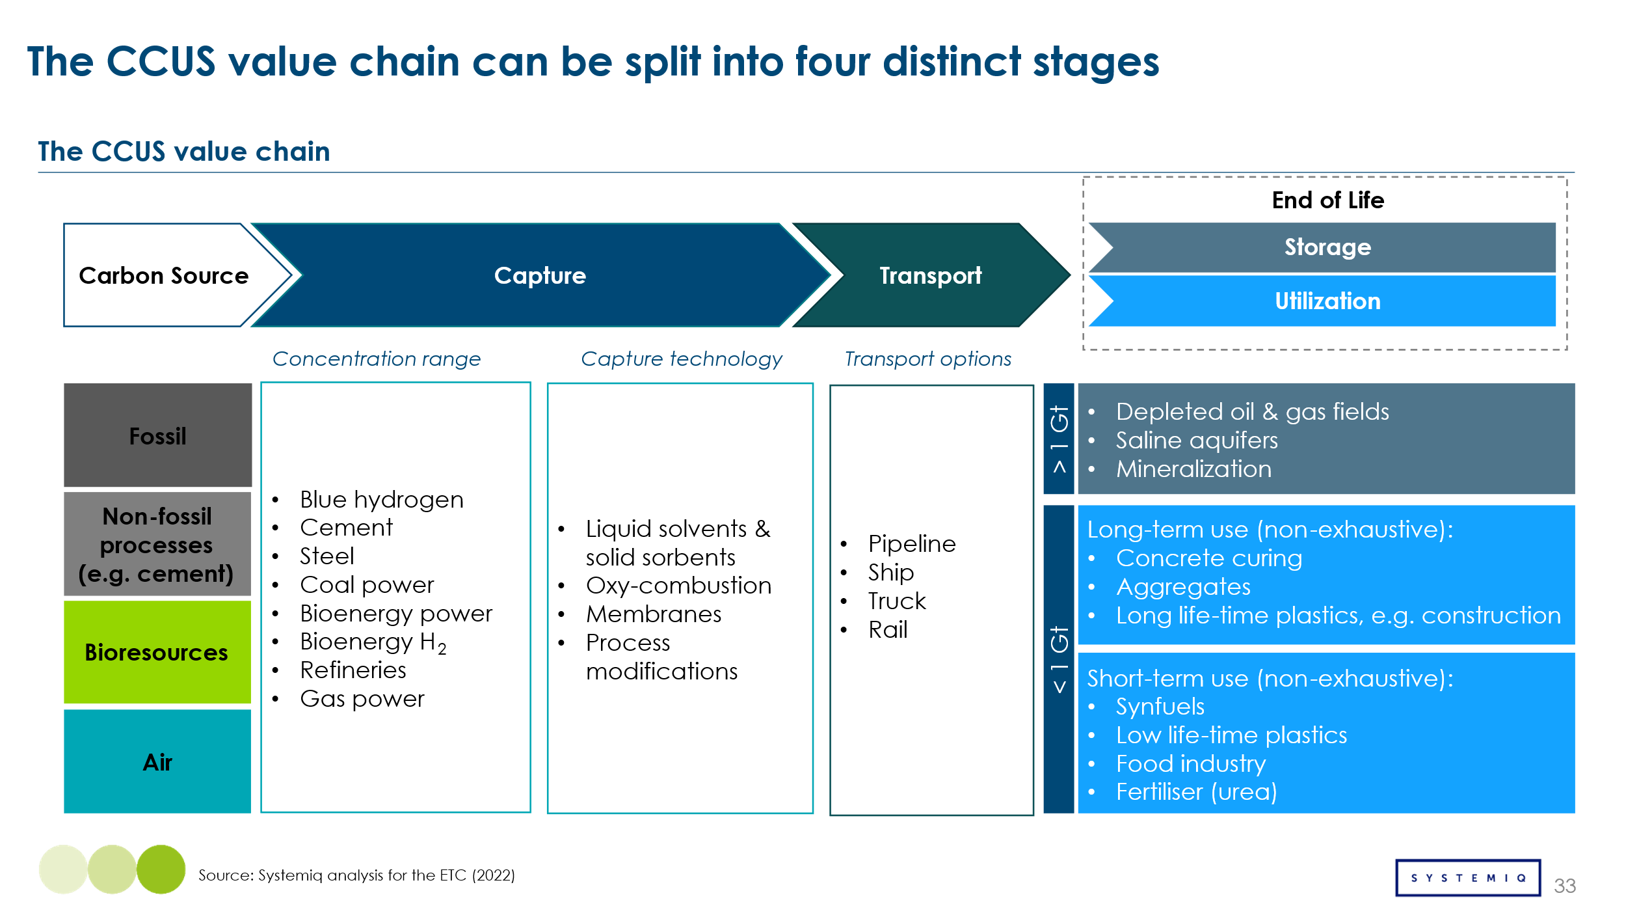
Unlike CCS, which focuses solely on sequestration, CCU repurposes CO₂ into chemicals, fuels, and materials, providing economic incentives for carbon reduction while supporting circular carbon cycles. This analysis focuses on four key CCU technologies that convert CO₂ into fuels and fuel precursors: Hydrogenation, Reverse Water-Gas Shift (RWGS), Electrochemical Reduction, and Biocatalysis. These technologies primarily produce e-methane, e-methanol, syngas, and ethanol, which can be further upgraded into sustainable aviation fuel (SAF) and chemical feedstocks. Exhibit 3.18 illustrates the CO₂ conversion pathways and their end uses.
Exhibit 3.18
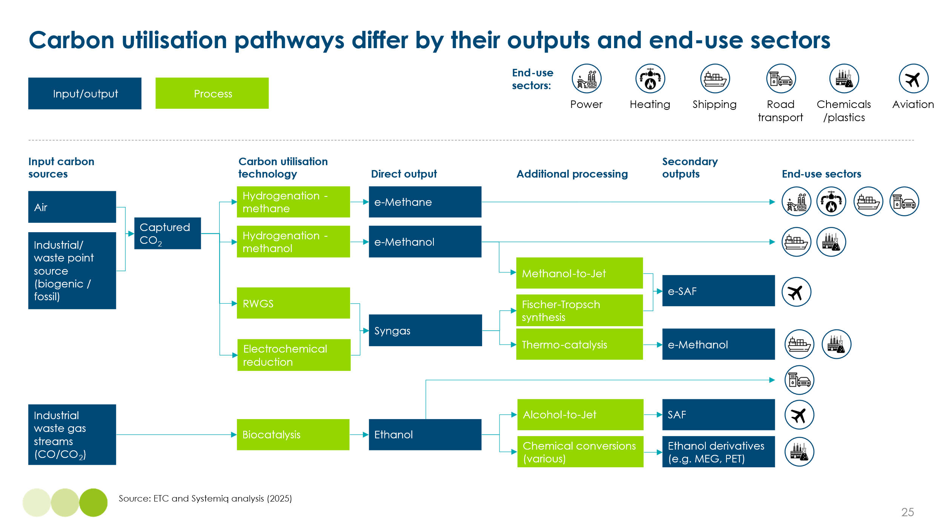

Hydrogenation combines CO₂ with green hydrogen to produce synthetic molecules such as e-methane or e-methanol; the latter can be further upgraded into fuels or chemicals. The Reverse Water-Gas Shift (RWGS) reaction transforms CO₂ into syngas (a mix of CO and H₂) and other carbon-based intermediates using heat or electricity. Similarly, electrochemical reduction uses renewable electricity to directly convert CO₂ into syngas or other reduced products at the electrode surface. Finally, biocatalysis leverages enzymes to convert CO or CO₂ and hydrogen into ethanol, which can be processed into downstream products such as derivatives or sustainable aviation fuel (SAF). Exhibit 3.19 presents the key advantages and disadvantages of these processes.
Exhibit 3.19
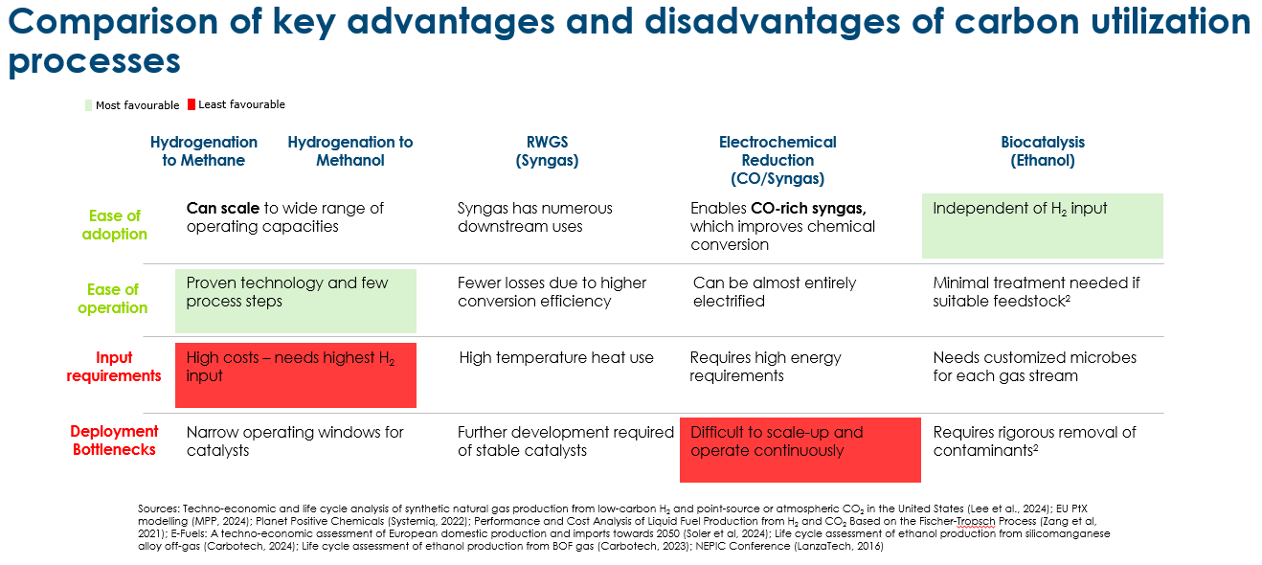

Costs
The Levelised cost of production for carbon utilisation technologies varies significantly depending on CAPEX, OPEX, H₂ costs, and energy consumption. To improve comparability between pathways, Reverse Water-Gas Shift (RWGS) and Electrochemical Reduction were modelled for syngas conversion to methanol, allowing for direct benchmarking against hydrogenation-based methanol production. The levelised cost of production of each route is compared to its fossil-based alternative, as shown in Exhibit 3.20.
Exhibit 3.20
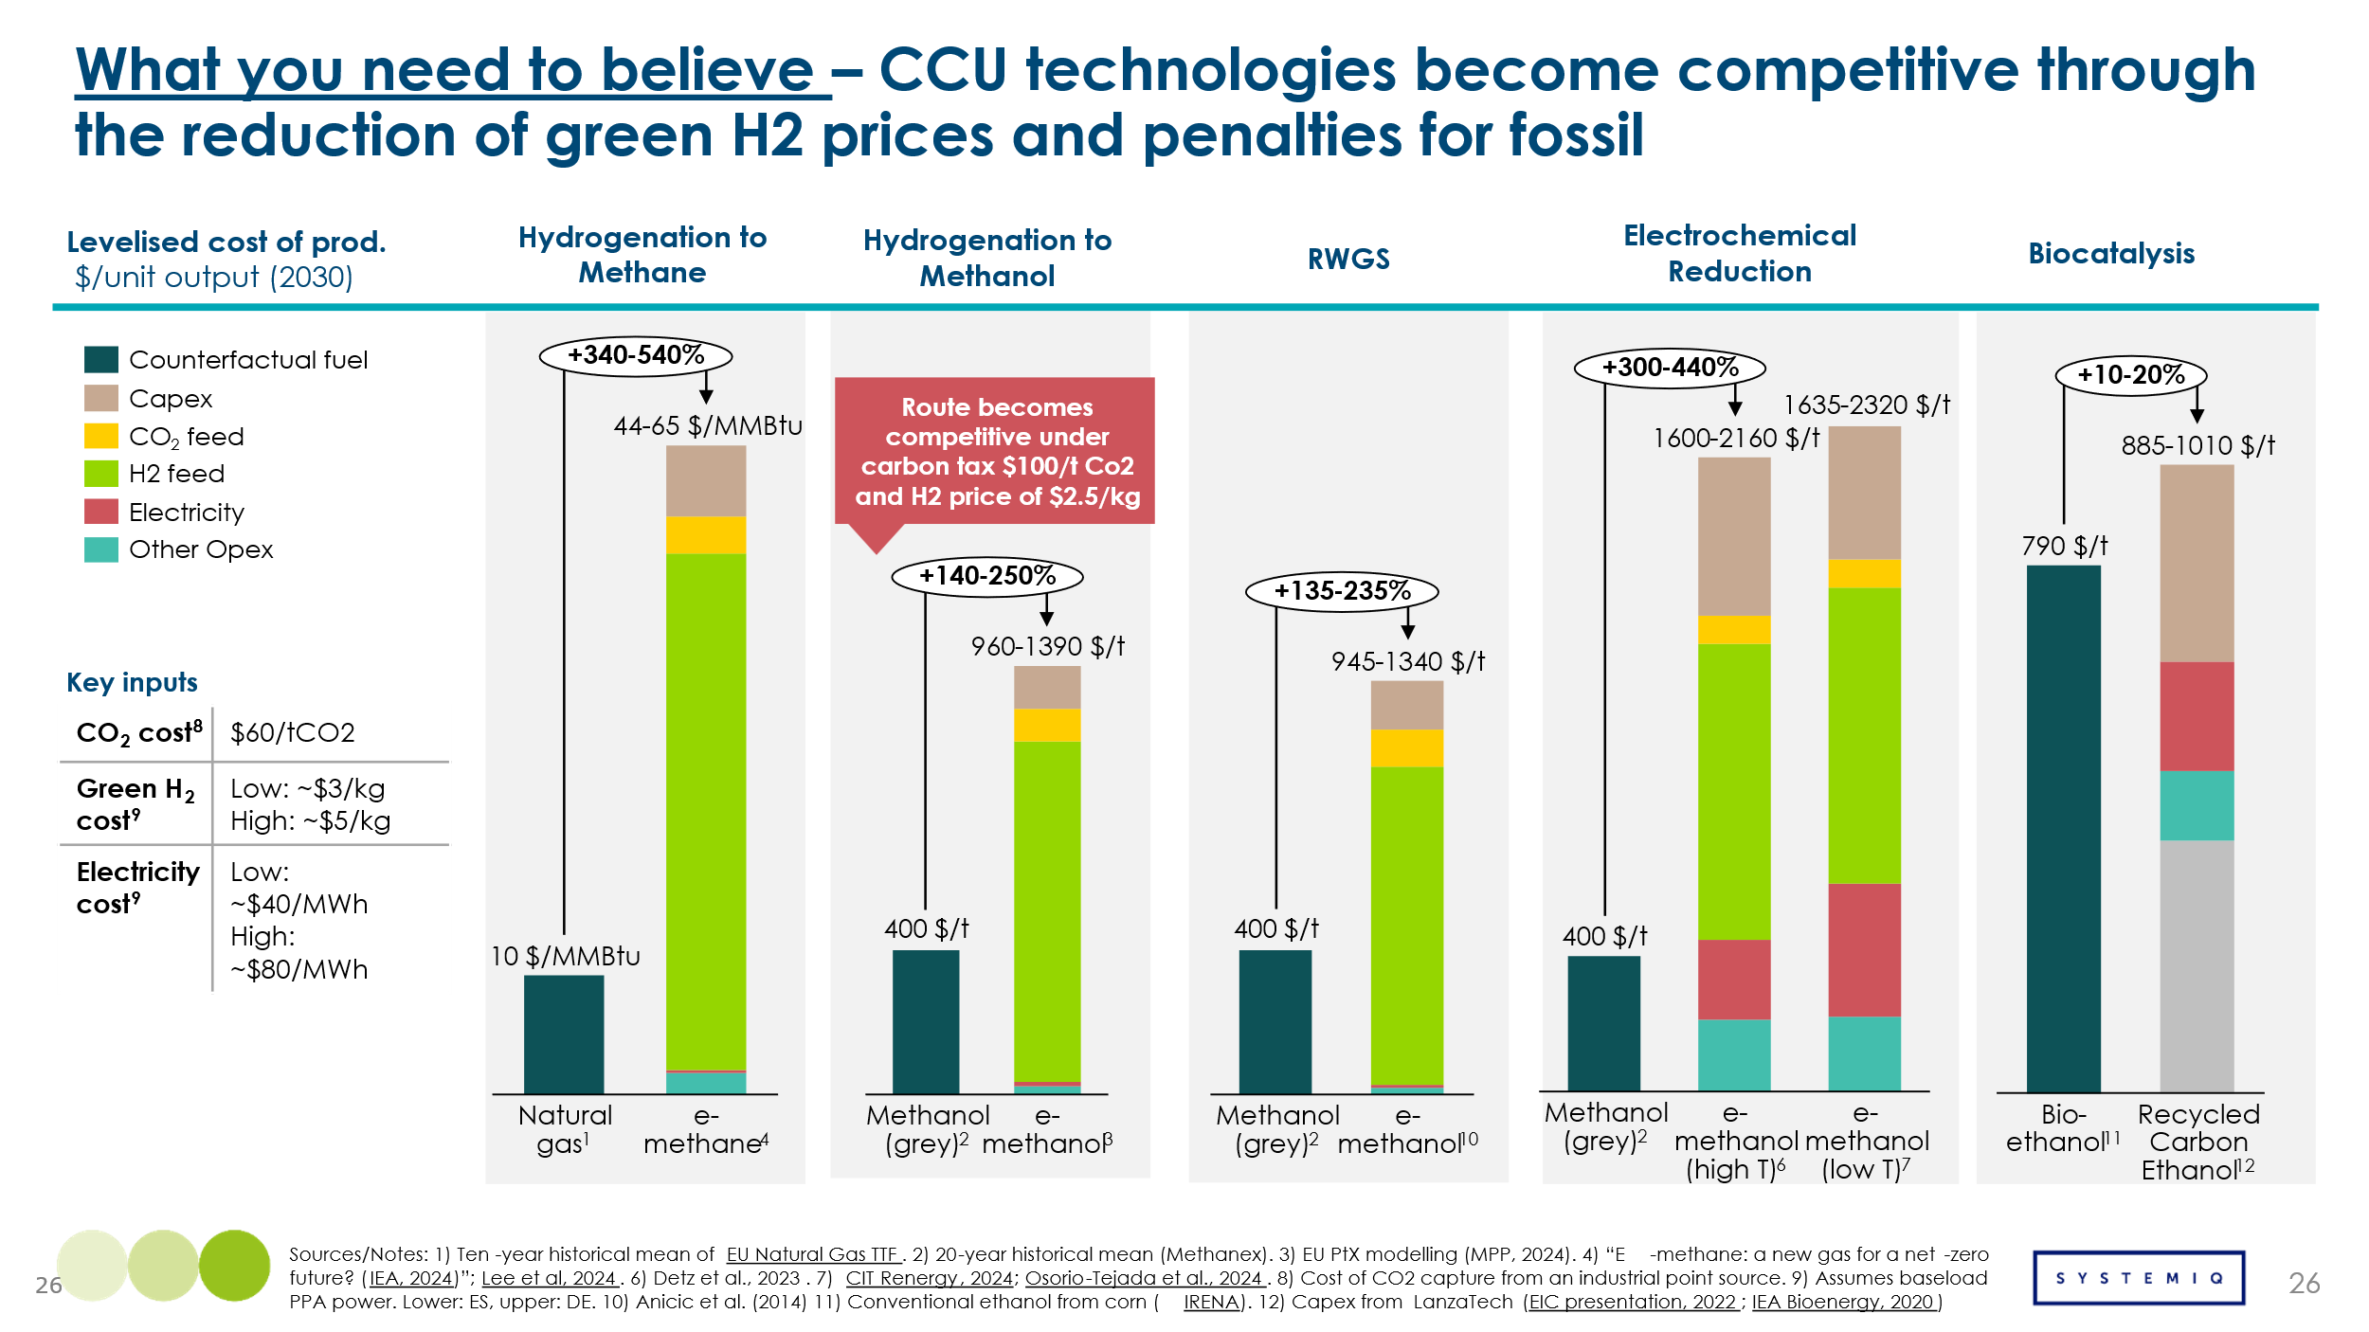
Across the board, most carbon utilisation pathways remain substantially more expensive than fossil-based alternatives—often by more than double. The only partial exception is biocatalysis, which has a comparatively modest cost premium. For hydrogenation-based technologies and RWGS, hydrogen feedstock accounts for 72–87% of production costs, making it the dominant cost driver. RWGS requires slightly less hydrogen than direct CO₂ hydrogenation due to more efficient CO-to-methanol conversion. Electrochemical reduction, while less reliant on external hydrogen, remains the least cost-competitive pathway. It produces CO-rich syngas, which reduces recycling during methanol synthesis, but high CAPEX and electricity demand drive up costs. Biocatalysis stands out as the most cost-competitive option, with a price premium of just 10–20% above bioethanol. Its independence from hydrogen feed makes it less sensitive to fluctuations in hydrogen pricing, supporting more stable production economics. However, long-term scalability may be limited by access to industrial CO streams, which are preferred but likely limited in a net-zero economy. Biocatalytic systems can also operate with CO₂ and H₂, though less efficiently. For a pathway like hydrogenation to methanol to become competitive with grey methanol, it would take green H2 prices to be in the range of $2.5/kg, couple with a carbon price of $100/t Co2 penalising the fossil alternative.

Impact
By 2050, CCU is projected to account for ~27% of captured CO₂, with the rest permanently stored via CCS and DACCS. According to ETC estimates, total CO₂ capture reaches ~8.5 Gt/year, of which 2.3 Gt is utilised—primarily for synthetic fuels and chemicals—while 6.2 Gt is sequestered. This reflects the consensus that CCU improves carbon efficiency (using CO₂ twice), but only permanent storage delivers net-zero outcomes.
The volume of CCU in the system will be dependent on the demand from key end-use sectors. In aviation, e-SAF can be produced via methanol-to-jet (from e-methanol) or RWGS + Fischer-Tropsch (from syngas). These drop-in fuels are well-suited for long-haul flights. The MPP Aviation Transition Strategy estimates e-SAF could meet 36% of 2050 demand. In shipping, e-methanol is expected to supply 28% of 2050 energy demand. Methanol-powered vessels are already in use, signalling traction. E-methane may play a smaller role, especially where LNG infrastructure is retained. In chemicals and plastics, e-methanol and e-ethanol offer fossil-free feedstocks. E-methanol could meet ~36% of high-value chemical demand, while ethanol-based derivatives (e.g. PET) may cover ~3% of 2050 needs. E-methane is expected to have limited use in power and industry, except in countries like Japan, which targets 90% city gas substitution by 2050. Other niche CCU applications—cement, aggregates, and EOR—face constraints from high costs, limited volumes, or lack of standards. Aggregates often lack market value, and CO₂ streams are inconsistent or uncertified.

Barriers and Enablers
Widespread adoption of CCU technologies faces both sector-specific barriers and broader system-level challenges.
Aviation
e-SAF faces high production costs and strong competition from biofuels, limiting large-scale deployment. Without substantial cost reductions or policy incentives, bio-SAF remains the preferred alternative, slowing the uptake of CCU-based fuels.
Shipping
e-Methanol presents a promising decarbonisation pathway, but higher costs compared to fossil fuels, supply chain constraints, and competition from ammonia and biofuels delay market growth. Although methanol-powered ships are increasing, ensuring affordable, scalable supply remains a key challenge.
Chemicals and Plastics
e-Methanol and e-ethanol could replace fossil-based feedstocks, but currently lack cost competitiveness. Without strong policy support, such as carbon pricing or incentives for low-carbon chemicals, fossil methanol continues to dominate the market.
Power and Industry
e-Methane struggles to compete with lower-cost electrification, making it a less viable large-scale option. Similarly, carbon-based materials like cement and aggregates face high infrastructure costs and limited market potential, constraining their role in CCU deployment.
Across all sectors, scaling CCU technologies will require both cost reduction and strong demand signals from the market. The economic viability of many pathways, particularly hydrogen-based routes, relies on access to low-cost green hydrogen and CO₂. On the demand side, strong policy support, including blending mandates and carbon pricing, will be essential to create viable markets. While biocatalysis offers a more cost-competitive entry point, its long-term scalability will be limited by the availability of suitable feedstocks.

3.6 A maximum circularity scenario

Exhibit 3.21 illustrates the maximum potential reduction in primary carbon demand achievable through circular economy strategies, as previously discussed.
The analysis suggests that primary carbon demand could be reduced from 4.9 Gt (adjusting for circularity levers already applied to the ACF scenario of ~0.2 Gt) to 3.4 Gt, through a combination of the following levers:
- Demand reduction through elimination, reuse and substitution which could reduce demands related to material use by ~140 million tonnes and energy demands 120 million tonnes. Substitution includes shifting from plastic to paper in packaging, which can reduce overall primary demand.
- Recycling of plastics enabled by improved citation which in total could cut primary carbon demand by around 420 million tonnes. Mechanical recycling (including plastic, but also wood, pulp and paper, which have relatively high recycling rates today) accounts for around 90% of this reduction, and will reduce both material demands and energy demands: chemical recycling will reduce material demands but not energy demands are not reduced, as no material differences are made from a primary production route.
- Various forms of CCU which could reduce primary carbon to meet energy demands by 490 million tonnes
In total, this would amount to a 30% reduction in primary carbon demand. However this is a maximum potential scenario which could only be achieved in practice with very strong supporting policies.
In the case of demand reductions and recycling these would need to involve
- Policies to require/encourage producers to eliminate unnecessary plastic packaging and facilitate reuse
- Regulations to require/encourage improved sortation
- Policies to reduce the role of end of life incineration, including via carbon pricing and regulatory constraints.
In the case of CCU, it would require blending mandates and carbon pricing, together with cost reduction achieved through scale, technological progress and the development of low cost hydrogen supply.
The optimal extent of demand reduction and circularity actually achieved will depend on the relative cost of options considered in this chapter versus the costs of sustainable primary carbon supply – which are considered in Chapter 4.
This balance cannot and does not need to be specified precisely in advance. But the analysis in this chapter shows that
- There is a very significant maximum potential for reuse and recycling – a 30% reduction. This indicates the potential prize if well designed policies plus technology developments can enable cost-effective implementation.
- Even this maximum potential reduction would leave a need for 3.4 Gt of sustainable primary carbon supply.
Exhibit 3.21
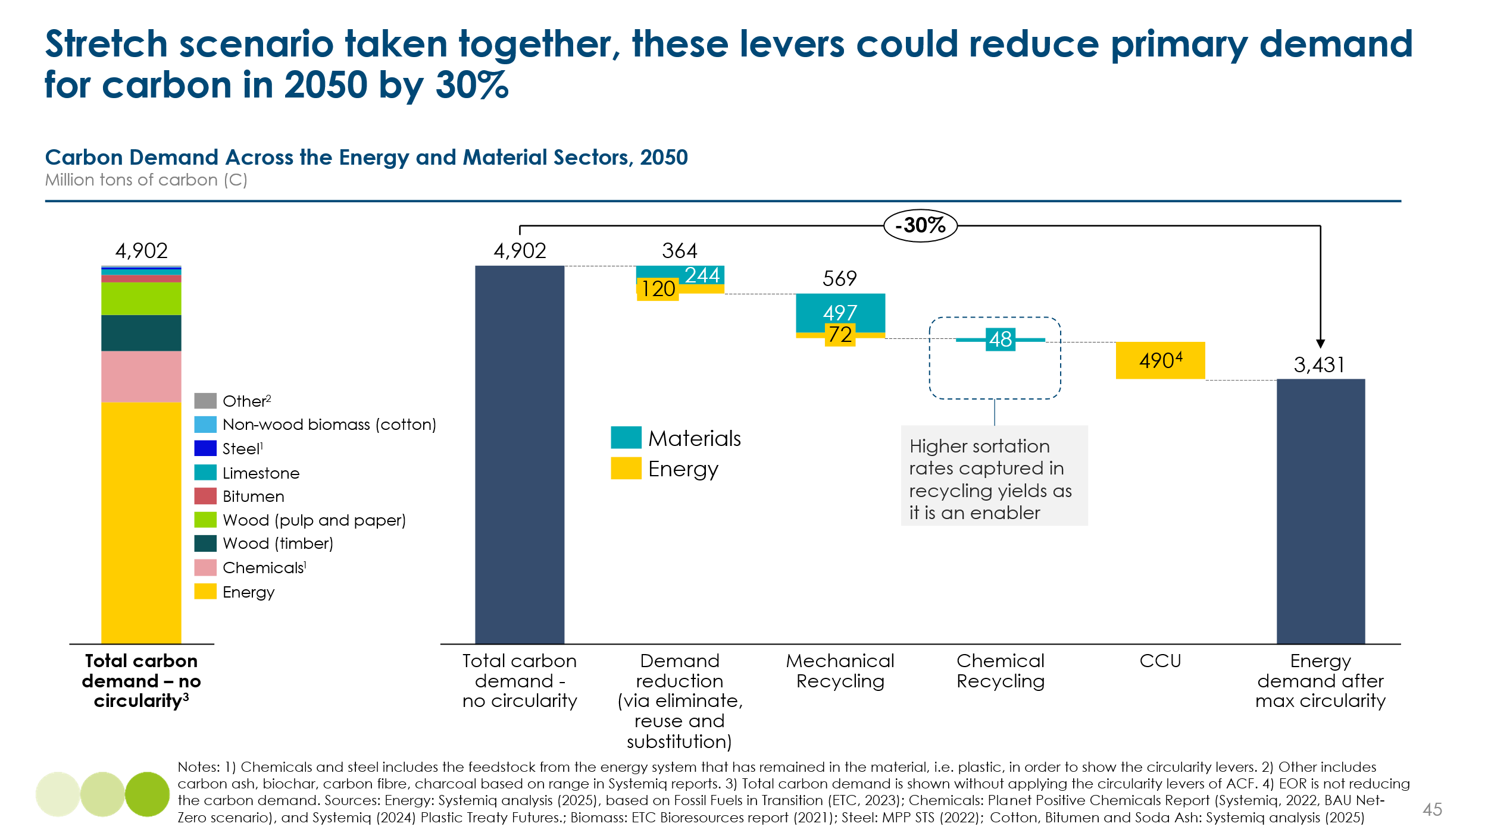

Sustainable sourcing of primary carbon
Primary carbon supplies could be sourced from the atmosphere, the ocean, the biomass or the ground (Exhibit 4.1). The challenges of ensuring sustainability differ by source.
- Sourcing carbon from the atmosphere or the ocean directly or indirectly reduces greenhouse gas concentrations and can be inherently sustainable. The key issues relate to cost-effectiveness.
- Biomass sources can be sustainable if the bio resource is extracted in ways that limit harmful land use change, protect biodiversity, and maintain carbon stocks.
- Using fossil for carbon from the ground is only sustainable if there is some combination of (i) capture and storage of any CO2 produced in combustion (ii) safe and clean in ground storage of solid products at end of life (iii) carbon removals elsewhere in the economy to offset any residual emissions.
This Chapter therefore considers
- Technologies for capturing carbon, including
  - Direct capture from the atmosphere or the ocean.
  - Point source carbon capture at the end of industrial processes

- Biomass related technologies including
  - Technologies to extract more biomass sustainably from land not currently devoted to food production
  - New technologies such as alternative proteins which could reduce the need for land for food production
  - Potential new sources of biomass – macro and microalgae
  - Technologies to improve biomass conversion efficiency.

- Conclusions on the possible and optimal balance between different sources of sustainable carbon supply.
Chapter 5 considers the storage technologies which will also be required to ensure that any use of fossil carbon is compatible with achieving net zero emissions.
Exhibit 4.1:
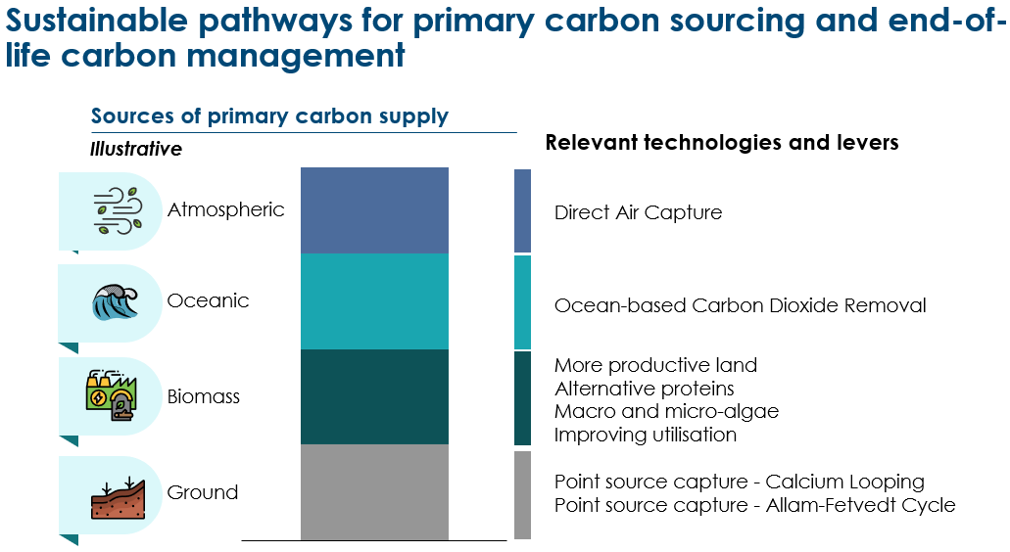

4.1 Categories of Carbon Capture Systems

Capturing carbon dioxide from different sources is central to both reducing emissions and creating a circular carbon supply. There are two principal capture pathways:
- Direct capture refers to the removal of CO₂ directly from the ambient environment, either from the air or the ocean.
- Point-source capture involves capturing CO₂ at the location of emission, such as industrial facilities or bioenergy plants.
As shown in Table 1, these technologies operate across different concentrations of CO₂ and serve different purposes. Point-source capture is focused on emission avoidance, while direct capture supports carbon removal. The technology landscape includes a range of systems tailored to specific concentrations, temperatures, and industrial settings.
Table 1: Overview of Carbon Capture Types
Capture Type | Application Example | Typical CO₂ Concentration (vol%)
Industrial point-source capture | Cement, steel, refineries | 5-30 %
Bioenergy point-source capture | Biomass combustion with CCS | 5-15 %
Direct air capture | Atmospheric removal | 0.04 %
Ocean-based capture | Electrochemical or alkalinity-based CDR | 0.01 %

Carbon capture systems are typically categorized by capture type (point-source or direct), system configuration (e.g. process-integrated, end-of-pipe, combustion stage), and separation technology (e.g. solvent-based absorption, membranes, adsorption, or electrochemical methods). Point-source capture accounts for the vast majority of global CCS capacity, though the specific breakdown between pre-combustion, post-combustion, and process separation routes varies by sector and geography (see Exhibit 4.2 for an indicative capacity distribution). While post-combustion systems constitute the largest single category by installed capacity, most operational projects today target high-purity CO₂ streams — such as those from natural gas processing, ammonia production or hydrogen reforming— where CO₂ is more concentrated and separation is less energy-intensive. Direct capture methods, such as air- or ocean-based systems, represent a growing class of distributed removal technologies, but still comprise a small share of total installed capacity.
Exhibit 4.2
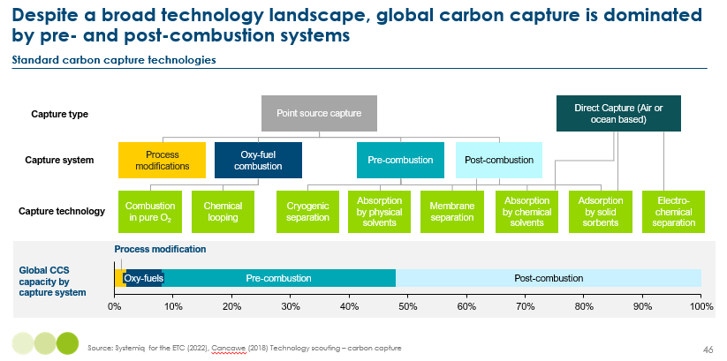

Each capture approach presents specific trade-offs in energy intensity, cost, selectivity, and ease of integration. Process modifications, such as the Allam-Fetvedt Cycle, achieve high capture rates with low operational energy penalties. However, these cycles require new-build infrastructure and carry high capital expenditure, limiting near-term scalability. Oxy-fuel combustion simplifies downstream capture by generating a nearly pure CO₂ stream, reducing mechanical complexity. Yet the need for oxygen supply systems and plant retrofitting introduces significant cost and engineering hurdles. Pre-combustion systems capture CO₂ before fuel is burned, typically through gasification or reforming processes, and are most effective in new, integrated facilities such as hydrogen or power production. Post-combustion systems include absorption with chemical solvents, which are well established and effective, but energy-intensive and vulnerable to degradation from impurities like SOx and NOx. Adsorption technologies operate at lower regeneration temperatures, enabling lower thermal energy demand. Their CO₂ purity is often reduced because of residual gases trapped in the sorbent bed, and they may also suffer performance degradation from acid gases, similarly to solvents. Membrane systems are modular and low-maintenance, but have poor capture efficiency at low partial pressures and may require gas recycling. Cryogenic separation achieves nearly complete CO₂ recovery but has high energy needs and risk of process blockage. Electrochemical methods, which are particularly promising for ocean-based capture, offer fully electrified, low-energy operation and high selectivity, but remain in early development and are difficult to scale. ,
Our analysis will focus on emerging technologies that can accelerate the development of carbon capture, as shown in Exhibit 4.3.
Exhibit 4.3
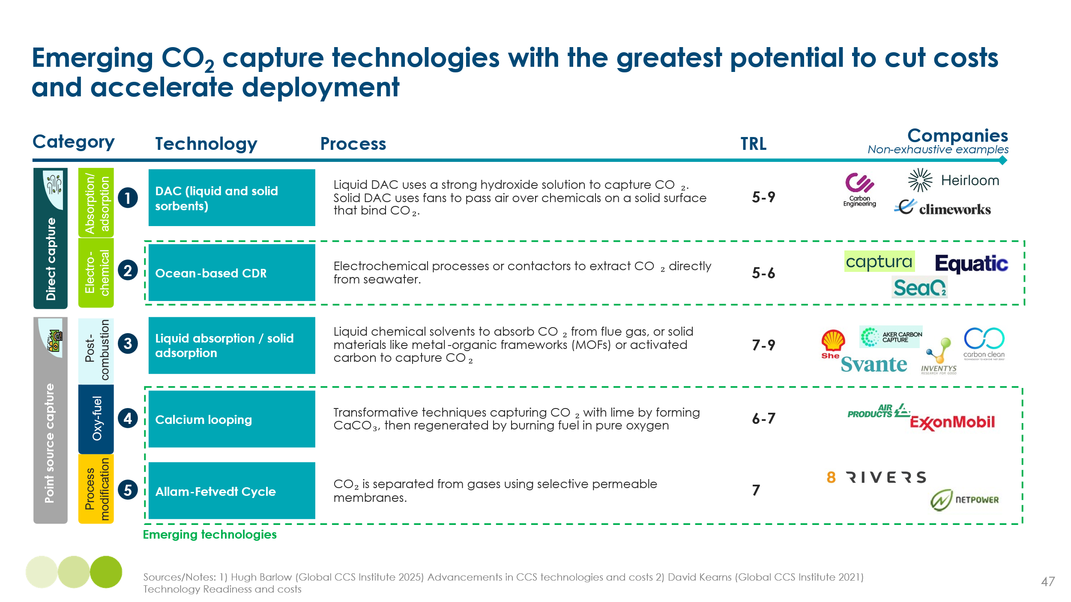

4.1.1 Direct Capture (Atmospheric and Oceanic)

Overview
As global attention turns to large-scale carbon dioxide removal, Direct Air Capture (DAC) stands out as a leading technology. Its ability to extract CO₂ directly from ambient air makes it vital for offsetting residual emissions and supporting carbon circularity in hard-to-abate sectors. However, DAC faces notable technical and economic hurdles. This chapter explores DAC configurations, cost trajectories, and the potential rise of ocean-based CDR (o-CDR) as a viable alternative.
DAC aims to capture CO₂ from the atmosphere, where concentrations are low and diffuse. These systems use engineered materials or chemical processes to extract CO₂ and then regenerate the capture medium. While conceptually simple, implementation is energy-intensive and requires careful optimization for cost and scale. DAC is commonly classified into three types: solid sorbent, liquid solvent, and electrochemical which differ in maturity and on-going developments, as shown in Exhibit 4.4 :
Exhibit 4.4
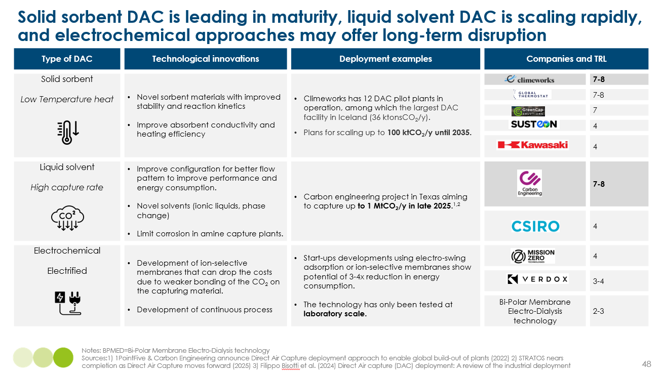
Initial DAC cost projections were highly optimistic driven by expectations around capital costs. The 2021 ETC outlook anticipated rapid cost reductions to $100–200 per tonne by mid-century. However, new data from early commercial projects prompted significant upward revisions which underlines the need for technology-specific data in cost models rather than generalized analogues. As DAC limitations become clearer, o-CDR is gaining attention as a complementary or alternative approach. As illustrated in Exhibit 4.5, these systems enhance the ocean’s carbon uptake using electrochemical processes that manipulate seawater chemistry.

Exhibit 4.5
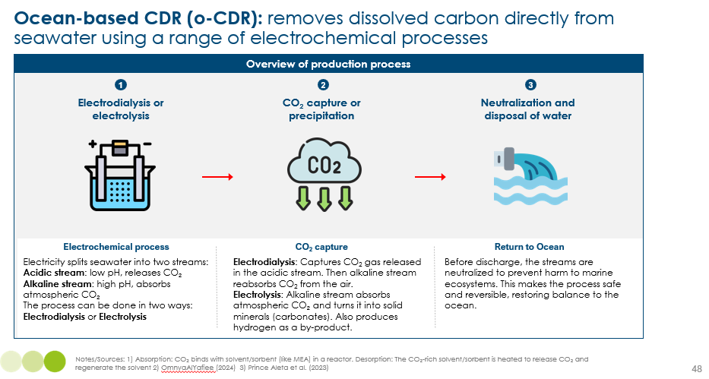
Ocean-based electrochemical carbon removal can involve one of two primary processes: electrodialysis or electrolysis, each resulting in a different carbon removal pathway and chemical outcome. In both approaches, seawater is split into two distinct streams — acidic and alkaline — through the application of electric current.
CO₂ removal is possible to occur in both streams, but the actual mechanism depends on the technology used:
- Electrodialysis-based systems: In this configuration, seawater is separated into an acidic stream and an alkaline stream. In the acidic stream, the reduction in pH shifts the carbonate equilibrium toward gaseous CO₂ release, as dissolved bicarbonate and carbonate ions convert back to CO₂ gas. This evolved CO₂ is captured, typically through vacuum stripping. The acidic and alkaline streams are subsequently recombined, yielding seawater with slightly higher pH and enhanced capacity to reabsorb atmospheric CO₂ upon discharge. Thus, the net removal occurs at the point of CO₂ gas evolution, with indirect drawdown from the atmosphere occurring as the ocean re-equilibrates over time.
- Electrolysis-based systems: In this configuration, water electrolysis produces an alkaline stream capable of absorbing CO₂ directly from the atmosphere. This absorbed CO₂ reacts with naturally occurring calcium (Ca²⁺) and magnesium (Mg²⁺) ions in seawater to form solid carbonate minerals (precipitation). This represents atmospheric CO₂ removal via mineralization, rather than extraction from seawater. In parallel, an acidic stream is also generated from the anode compartment and must be neutralized to avoid ecological harm, which typically involves adding alkaline minerals (ground rock).
The solid form of the captured CO₂ makes it unable to be utilised as a gas, but it could hold small value as a mineral making it a potential by-product. Additionally, H₂ is generated as a useful by-product.
Though o-CDR shares the objective of atmospheric CO₂ removal with DAC, it operates through a different medium and mechanism, skipping the air-capture step and reducing energy demand by up to 40% per tonne. Properly designed systems may also help combat ocean acidification. However, o-CDR remains early-stage, and key assumptions — especially that CO₂ removed from seawater will be fully replaced by atmospheric drawdown — are still under investigation. Re-equilibration rates vary by location and can take days to months, posing challenges for carbon accounting and certification. Its future success depends on site-specific deployment, access to clean electricity, and robust MRV frameworks. Until those are in place, o-CDR should be seen as a promising but emerging complement to more mature CO₂ removal pathways like DAC.
Table 2: Comparison of key characteristics of o-CDR and DAC
Parameter | o-CDR | DAC
CO₂ source medium | Seawater | Ambient air
Mechanism | Only desorption or precipitation | Absorption and desorption
Energy requirement | ~1.3–1.7 kWh/kg CO₂ | ~1.5–2.5 kWh/kg CO₂
Temperature | Ambient or low | 80–900°C
System type | Offshore or decentralized | Modular and scalable
By-product potential | Hydrogen (if electrolysis is used) | None

Costs
A major challenge in projecting DAC costs is the limited installed capacity and lack of historical deployment data. Most models rely on assumptions and analogies from mature sectors like solar PV or wind, which may not apply to DAC. Learning rate assumptions vary widely,,:
- Capital expenditure (CAPEX): Assumed learning rates range from 10% to 20%.
- Operational expenditure (OPEX): Learning rates range from 2% to 10%.
Moreover, many studies use single-component learning curves, which carry two critical limitations:
- They assume uniform learning across all system components, ignoring that many parts (e.g. compressors, heat exchangers) are already mature and will not benefit from deployment scale.
- Even for novel components, learning rates can vary from 11% to 27%, depending on design, integration and manufacturing scale, making simple curve-based extrapolations unreliable.
As shown in Exhibit 4.6, recent 2024 literature from ETH Zurich and MIT estimates DAC costs to be up to four times higher than those projected by the ETC in 2021. These studies derived their estimates using expert interviews to assess the cost of individual system components, multi-component learning curves, or a combination of both approaches.
Exhibit 4.6
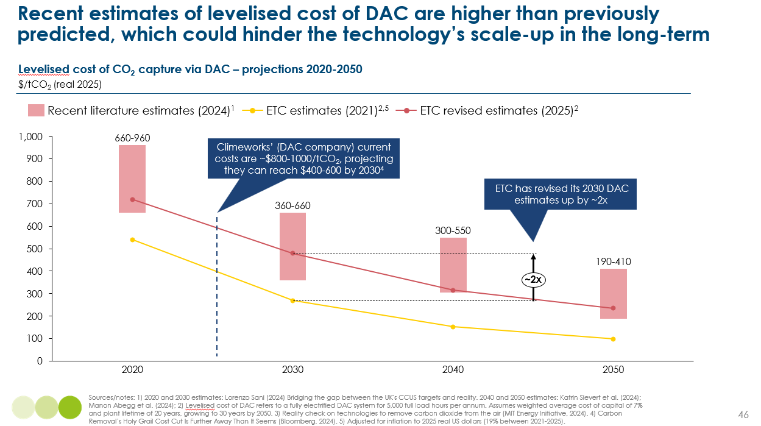
In light of updated data, the ETC has revised its internal projections for DAC costs in 2025 and beyond. These revisions are informed by actual project experience, notably from Climeworks’ plant in Iceland, and reflect a more grounded outlook on technology learning and system design.
Key updates include:
- CAPEX revision: Upward adjustment from $1470 to $2500 per tonne CO₂/year capacity, based on Climeworks’ recent deployment.
- Learning rate: Reduced from 12% to 6%, reflecting the slower-than-expected cost decline across major DAC components.
- Electricity consumption: Increased from 250 to 370 kWh/tCO₂, aligned with new research and more realistic system configurations.
- OPEX implications: Higher base costs and a flatter learning curve translate into more conservative future cost reductions.
These changes result in a projected cost of $478/tCO₂ in 2030, compared to earlier forecasts of around $270. Even under optimistic deployment scenarios, the new ETC trajectory forecasts costs falling to around $234/tCO₂ by 2050, about twice as expensive in the long run compare to than the $100–150 range envisioned in earlier literature. The revised estimates emphasize that while DAC remains a crucial tool for net-zero transitions, its scalability and economic viability depend heavily on continued innovation, policy support and the integration of low-cost, renewable energy infrastructure. A detailed breakdown of the updated levelized cost components is provided in the accompanying Exhibit 4.7.
Exhibit 4.7
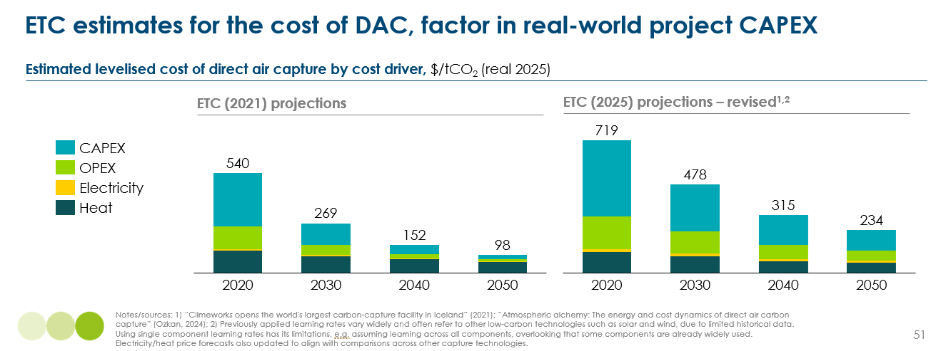

The Equatic process represents an ocean-based carbon removal pathway that relies on seawater electrolysis. Functioning similarly to an alkaline electrolyzer, the system uses ion-selective membranes to separate seawater into acidic and alkaline streams. Within this configuration, the alkaline stream absorbs atmospheric CO₂ and facilitates its precipitation into stable carbonate minerals, while the process simultaneously produces hydrogen gas as a valuable co-product. The acidic stream is subsequently neutralized using low-cost crushed rock, allowing for environmentally safe discharge back into the ocean.
Cost estimates for this system are anchored to benchmarks for alkaline electrolyzers, albeit adjusted slightly upward to account for the dual-function nature of the Equatic design. Mineral by-products, while generated during the process, are currently not monetized due to limited market maturity, although they may offer modest additional value in the future. A further cost advantage arises from the system’s ability to bypass desalination, significantly reducing overall operating expenses.
Equatic’s pilot project, scheduled for deployment in 2028, is designed to capture 36,000 tonnes of CO₂ annually while producing 3,600 tonnes of hydrogen,. In many cases, this hydrogen is valued at around $3 per kilogram, a price point that reflects expectations for future green hydrogen markets. At that price range, H₂ co-product substantially offsets system costs, reducing the net CO₂ removal cost to an estimated $150–250 per tonne. This is up to 68% lower than the updated ETC estimate for DAC, which places 2030 DAC costs around $478 per tonne. However, it is important to note that the DAC estimate reflects real-world project experience and commercial-scale learning, while the lower cost range projected for Equatic remains theoretical and subject to revision as the technology matures. A detailed breakdown of these cost components is shown in Exhibit 4.8.
Exhibit 4.8
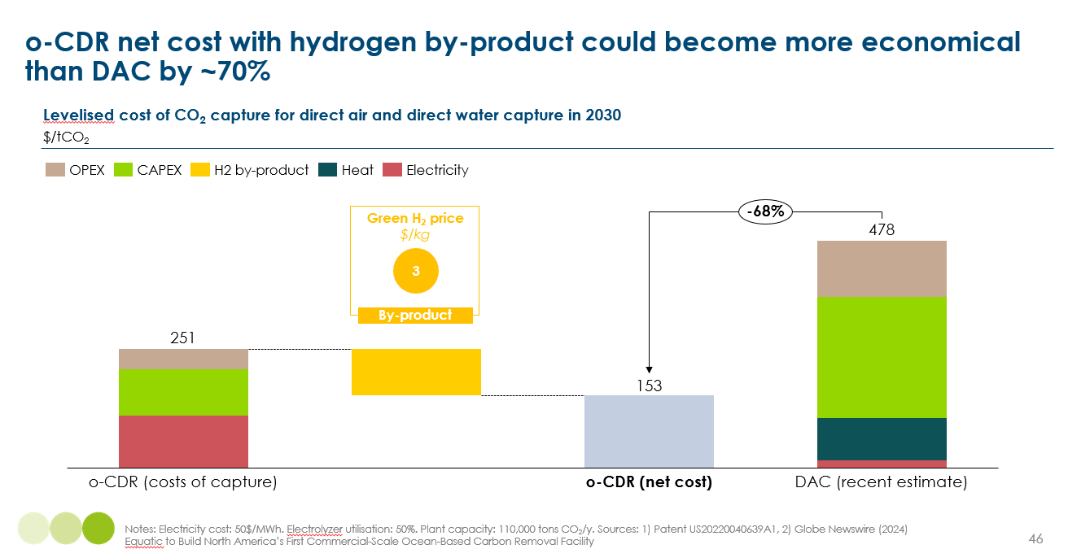
Equatic’s internal projections are even more ambitious, targeting costs below $100/tCO₂ by 2030 through continued process optimization and scale-up. If these targets are realized, ocean-based electrolysis could become one of the most competitive and scalable carbon removal solutions, particularly in coastal regions with abundant renewable energy infrastructure. However, this figure assumes ideal power conditions, including access to very low-cost, reliable electricity. With a production ratio of roughly 0.1 tonnes of H₂ per tonne of CO₂, the energy required exceeds 4 MWh per tonne of CO₂ — already pushing costs near $100 at typical power prices. In practice, cheap electricity and local hydrogen demand rarely coincide, and renewable intermittency may further inflate costs. As such, the <$100 estimate should be seen as an optimistic best case, not a near-term commercial benchmark.

Impact
If demonstrated successfully at scale, o-CDR could replace a substantial portion of projected DAC deployment. According to ETC estimates, achieving net-zero by 2050 may require up to 2.8 GtCO₂/year of removals from DAC, as shown in Exhibit 4.9. As o-CDR technologies advance and prove cost-effective, they could capture a meaningful share of this volume, offering a promising alternative pathway for atmospheric CO₂ removal.
Exhibit 4.9
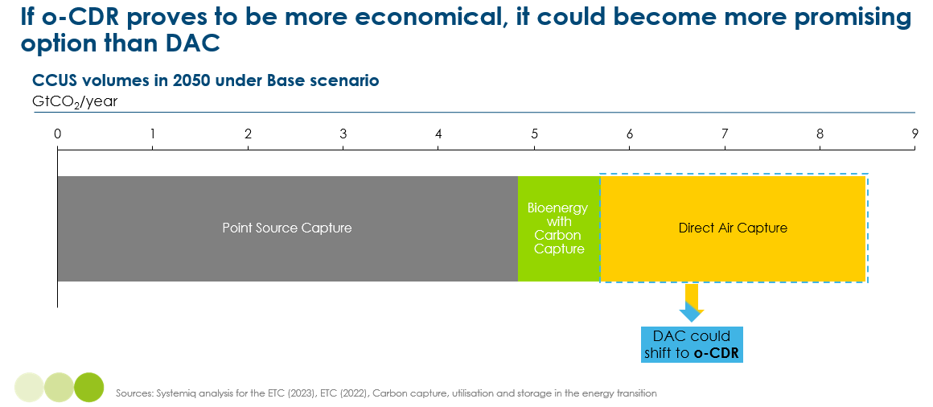
Potential:
- Rapidly scalable if economic and environmental barriers are addressed.
- Could help restore marine ecosystems and reduce ocean acidification.
Limitations:
- Operational complexity is significant, particularly around solids precipitation, fouling, and equipment maintenance. Exposing electrochemical systems to raw seawater introduces challenges that have proven demanding even in simpler processes like reverse osmosis.
- TRL remains low. Most systems are still at lab or small pilot scale.
- Risks to ocean chemistry and biodiversity must be carefully managed.
Direct Air Capture remains a critical carbon removal pathway, especially for hard-to-abate emissions, but faces persistent cost and energy barriers confirmed by recent data. Ocean-based capture has gained momentum as a complementary solution, with potential co-benefits such as hydrogen production and local ecosystem support. However, its success hinges not just on scalability, but on resolving major reliability and process engineering issues. In the near term, DAC may focus on modular, high-purity applications, while larger-scale removal could shift toward ocean-based or hybrid approaches—if these can meet environmental and operational performance thresholds.

Barriers and Enablers
For DAC and ocean-based carbon removal to contribute meaningfully to a net-zero future, key technical, economic, and policy milestones must be reached. Despite innovation, both remain limited by high costs, energy needs, and deployment complexity. The following enablers are critical for scaling these technologies:
• Technology development and system innovation: Continued progress in sorbents, solvents, membranes, and overall system architecture is essential. Modular platforms enhance deployment flexibility, while digital tools such as AI can accelerate material discovery. For ocean-based systems, improving the efficiency and stability of electrochemical processes and mineral precipitation will be particularly important.
• Access to low-cost, zero-carbon energy: The viability of both approaches is intrinsically tied to the availability of affordable, clean energy. While some pilots are already leveraging geothermal, nuclear and solar inputs, broader deployment will depend on stable access to renewable power at scale.
• Site-specific deployment strategies: Strategic siting near renewable energy hubs, CO₂ infrastructure, and suitable marine environments can reduce costs and simplify logistics. For DAC, proximity to storage or utilization sites is essential. o-CDR requires coastal access, permitting support, and local supplies of alkaline minerals (e.g. crushed rock) for neutralization. Sites must also enable disposal or reuse of mineralized CO₂, and ideally provide access to hydrogen markets to monetize co-produced H₂.
• Market frameworks and certification standards: Clear and credible rules for quantifying net CO₂ removals are foundational. Momentum is building through instruments such as the EU Carbon Removal Certification Framework (CRCF) and RED III. Full integration into compliance and voluntary markets will be critical for long-term investment and scalability. ,
• Environmental safeguards and public trust: Maintaining environmental integrity is a prerequisite for social license to operate. DAC systems must mitigate concerns related to solvent use, water consumption, and land impact. Ocean-based systems must be designed to avoid ecological disruption through careful pH management and trace metal monitoring. Early pilot projects suggest low environmental impact, but long-term monitoring and transparency are essential.
Key barriers to scale-up remain:
• Early technology readiness levels for ocean-based removal systems, with limited large-scale demonstrations
• High capital and operational costs, particularly for early-stage DAC and o-CDR systems
• Uncertain long-term revenue streams and limited integration due to the lack of liquid markets and reliable offtakers.
• Potential ecological trade-offs and public opposition in the absence of strong governance; environmental impacts still require further research and validation
• Operational risk under real-world conditions, including performance variability due to weather, air quality, and seawater composition, as seen in cases like Climeworks’ Orca plant, where output fell short of expectations.
While technology is advancing rapidly, large-scale deployment of DAC and o-CDR will depend on aligning system innovation, energy infrastructure, market incentives and regulatory safeguards. These systems are uniquely positioned to deliver durable, high-integrity removals if the enabling environment continues to mature in parallel with technical readiness.

4.1.2 Point-Source carbon capture

Overview
Point-source carbon capture is essential for reducing emissions from high-volume industrial emitters. Unlike direct capture methods that extract CO₂ from ambient air or water, point-source systems target emissions where they are most concentrated. This makes them well-suited for sectors such as power, cement, and heavy industry. However, viability depends on CO₂ concentration in the exhaust stream, thermal integration opportunities, and technology maturity.
Exhibit 4.10
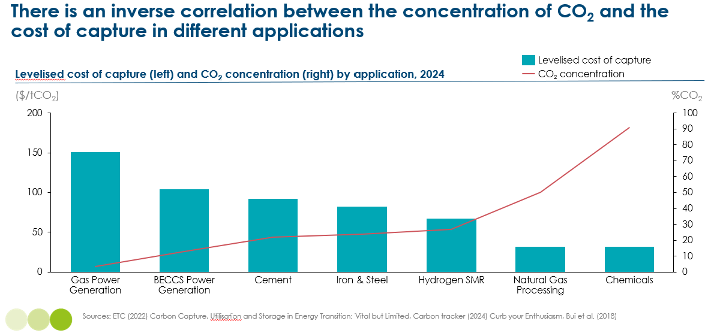
As shown in Exhibit 4.10, there is a strong inverse relationship between CO₂ concentration in flue gas and the cost of capture ,. The lower the concentration, the more energy and infrastructure is required to separate and purify the CO₂, leading to higher costs.
- Gas power generation is the most expensive application, with typical CO₂ concentrations around 3–4%, pushing capture costs above $150 per tonne.
- Cement and BECCS fall in the mid-range, with concentrations between 15–30%, and capture costs typically around $80–130 per tonne.
- Natural gas processing and chemical production offer the lowest capture costs, due to access to high-purity CO₂ streams, typically above 90% in chemical processes.
Sectors with dilute streams require more advanced, integrated technologies. Additionally, as shown in Exhibit 4.11, gas power and cement are also highly emission-intensive and challenging to decarbonize via electrification. These two sectors represent the highest projected CO₂ capture volumes by 2050. While BECCS, steel, and chemicals are important, they contribute less volume overall . DAC, though significant, is assessed separately. Given the scale and cost challenges, power and cement sectors demand targeted technological solutions.
Exhibit 4.11
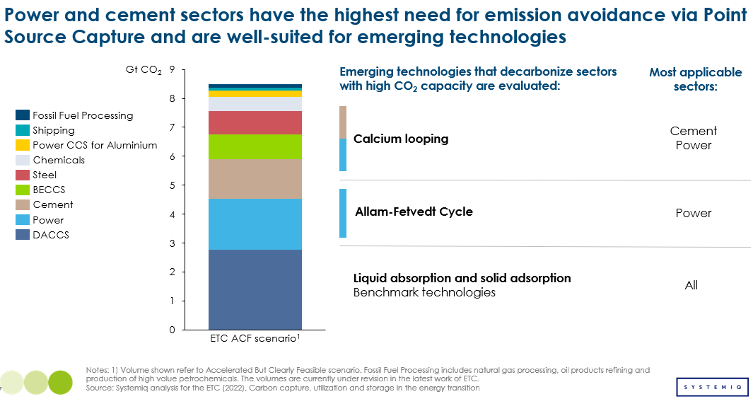
Benchmark point-source carbon capture technologies today are predominantly post-combustion systems, using either liquid absorption or solid adsorption. These methods remove CO₂ from flue gases after fossil fuel combustion and are already widely deployed at pilot and semi-industrial scales. The process involves two key steps:
- CO₂ Capture:
  - In liquid absorption, flue gas is passed through an absorber column where a liquid solvent (typically an amine-based chemical like MEA) binds with CO₂.
  - In solid adsorption, CO₂ molecules are captured on the surface of solid materials such as amine-functionalized sorbents, zeolites or metal-organic frameworks (MOFs).
- Regeneration:
  - For liquid systems, the solvent is heated in a stripper column to release high-purity CO₂ and regenerate the liquid for reuse.
  - For solids, CO₂ is desorbed via heating, pressure swing, or vacuum swing processes, after which the material is reused.
Advantages:
- Tail-end retrofits are possible with minimal plant modifications, enabling easier integration into existing infrastructure.
- Continuous innovation, especially in solvents (DMX) and sorbents (MOFs), is improving performance.
Disadvantages:
- Liquid systems are energy-intensive due to high heat demand for solvent regeneration.
- Both solvents and solid sorbents can degrade in the presence of flue gas impurities (SOx, Nox, dust), requiring pretreatment.
- Solid adsorbents may suffer reduced CO₂ capacity due to competition with water vapor, particularly for materials like zeolites, which are highly sensitive to humidity.

Two next-generation capture technologies are now emerging with potential to disrupt the post-combustion paradigm:
- Calcium Looping (CaL) for cement. It is the focus of CaLby2030, an EU-funded project with 18 partners working toward commercial deployment by 2030.
- Allam-Fetvedt Cycle (AFC) for power generation. It is now being scaled by NET Power, with a 300 MW commercial plant in Odessa, Texas, expected to begin operation by 2027.
These will be compared with post-combustion benchmarks in terms of energy efficiency, scalability, and integration potential.
Calcium Looping (CaL) is a promising carbon capture technology tailored for high-temperature industrial sectors such as cement. It operates through a closed-loop reaction between calcium oxide (CaO) and calcium carbonate (CaCO₃), using solid materials to chemically bind and release CO₂. As illustrated in Exhibit 4.12, the process includes three key stages: CO₂ capture in a carbonator, regeneration of the sorbent in a calciner, and continuous looping of the material. The calciner typically uses natural gas as a fuel in an oxy-fuel configuration, enabling the production of a concentrated CO₂ stream that can be efficiently captured and processed.
Exhibit 4.12
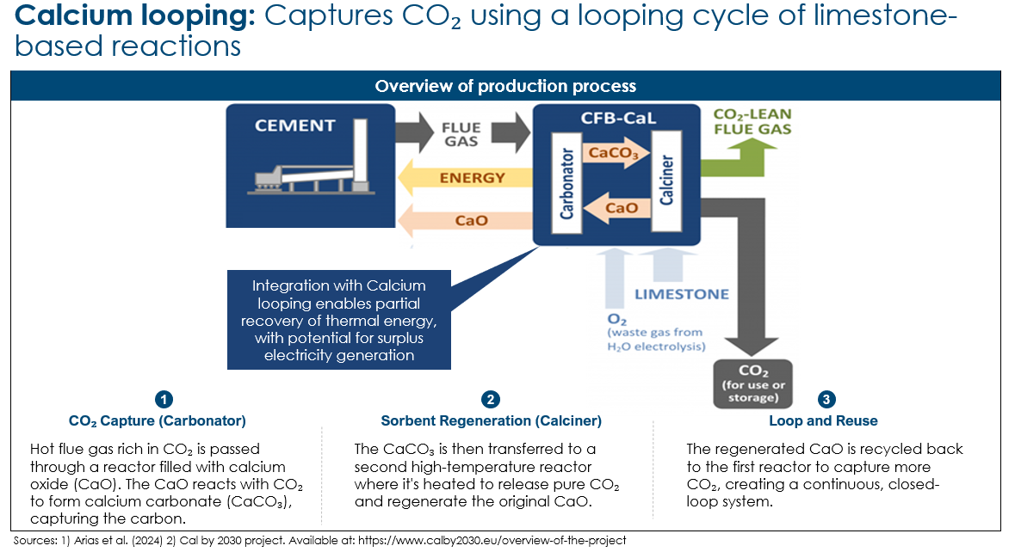
CaL is particularly compelling for cement industry integration, where calcination is already a core part of clinker production. While the CaL process requires a separate carbonator-calciner loop, opportunities exist to share infrastructure—raw materials, heat exchange networks, oxygen supply systems, and potentially even calciner design and footprint—with existing cement kiln operations. Projects like CLEANKER have demonstrated that partial integration is not only feasible but can offer capital efficiency and energy synergies, especially in new-build or deeply retrofitted facilities.
Advantages:
- High capture rate, typically around 90% and potentially up to 99%.
- Tolerant to flue gas impurities, eliminating the need for gas pretreatment.
- CaL can directly use the plant’s existing raw materials as the sorbent for CO₂, improving circularity.
- Electricity generation is enabled through heat integration, as waste heat from the exothermic carbonation reaction and high-temperature calciner can be partially recovered to generate surplus electricity.
Disadvantages:
- Requires high-temperature operation, making it less suitable for retrofits in low-temperature systems.
- Medium-to-high CAPEX, depending on the level of integration.
- Needs dedicated oxygen supply and careful material handling to manage solid sorbents, which can slow down deployment.
Overall, CaL presents a promising but technically demanding pathway for cement decarbonization. It offers opportunities for partial integration with existing plant infrastructure and energy efficiency gains through heat recovery, but its viability depends on careful system design, fuel and oxygen sourcing, and management of high-temperature solid flows.
Exhibit 4.13
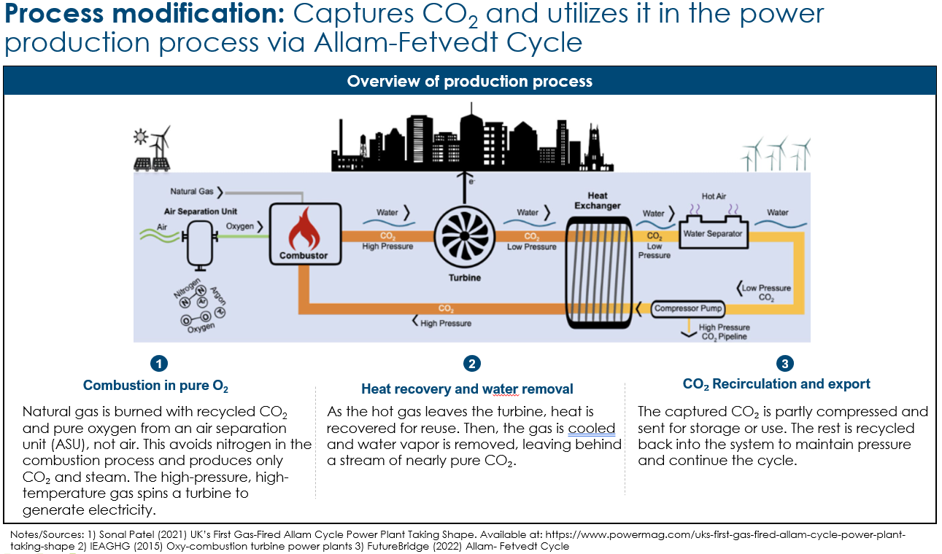
The Allam-Fetvedt Cycle (AFC) is a novel power generation system that fully integrates CO₂ capture within its core thermodynamic process (illustrated in Exhibit 4.13). Unlike conventional plants that bolt on capture units after combustion, AFC is designed as a greenfield solution where CO₂ is not a waste product, but a working fluid. As shown in the figure, the cycle begins by combusting natural gas with pure oxygen, eliminating nitrogen from the system and producing a high-pressure stream of CO₂ and water vapor. This gas powers a turbine to produce electricity. Downstream, heat is recovered and water is condensed, leaving a near-pure stream of CO₂. Part of this is sequestered or reused, while the rest is recycled to sustain system pressure.
Advantages:
- Near-total CO₂ capture (~99%) built into the core process.
- No need for chemical solvents like MEA, avoiding solvent degradation and emissions.
- As the working fluid is pure CO₂, non-condensable pollutants (NOₓ, SOₓ, particulates) are virtually eliminated.

Disadvantages:
- Requires a new plant build (greenfield project) — cannot be added onto existing infrastructure.
- High capital cost, driven by the need for oxygen production and CO₂ handling systems.
AFC provides an integrated, high-performance decarbonization route for power generation, albeit with significant upfront investment.

Costs
Exhibit 4.14 shows that among the evaluated technologies for cement decarbonization, CaL emerges as the most economical option, particularly when integrated directly into the production process. A major advantage is the production of electricity as a by-product, which significantly offsets operating costs and enhances overall system economics. In the configuration analyzed, the calciner is shared between the cement kiln and the carbon capture system, maximizing heat recovery and minimizing duplication of equipment. The calciner produces a H₂O/CO₂ stream and a CaO stream that is partly fed to the kiln for clinker production and partly to the carbonator for cyclic CO₂ capture. This configuration requires significant modifications to the existing kiln system and, hence, a high capital cost for retrofitting. Other integration models (e.g. tail-end or downstream) are technically possible and could reduce upfront costs, but may suffer from lower efficiency and higher operational expenditure. The case presented here reflects full integration and provides a representative average estimate of capture cost, at approximately $88/tCO₂ net.
Exhibit 4.14
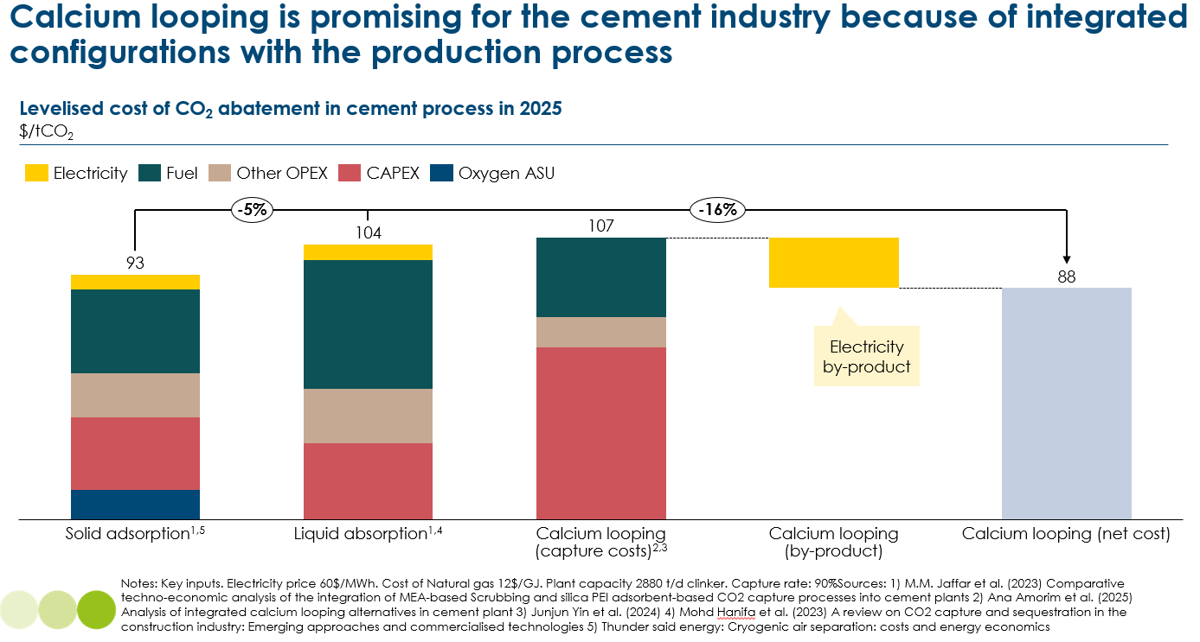
Liquid absorption and solid adsorption are also considered valid alternatives, with costs of 104 $/tCO₂ and $93/tCO₂ respectively. However, they face critical limitations in cement applications due to the dusty and chemically complex nature of cement flue gases. These off-gas streams can degrade solvents and adsorbents, requiring intensive pre-treatment or replacement. In contrast, CaL is well-suited to this environment, as it can tolerate impurities such as dust, SOx, NOx and trace metals, thereby reducing the need for costly pretreatment and ensuring greater process robustness. While liquid and solid capture systems may work in theory, their practical performance in cement applications remains less certain.
Solid adsorption has seen limited deployment, notably in China where it is paired with oxy-fuel combustion to enrich CO₂ concentration and improve capture efficiency. However, the financial and policy context of such deployments—including potential subsidies—is not fully transparent, making cross-comparison difficult. Overall, CaL stands out for its favorable economics, technical compatibility with cement plants, and integrated energy benefits.
Exhibit 4.15 shows that among evaluated technologies for power sector decarbonization, process modification via the AFC is the most cost-effective option, especially when assessed under a carbon price regime. The AFC achieves a CO₂ capture cost of $90/tCO₂, which means it would be fully competitive under a $90/tCO₂ carbon tax. Compared to the benchmark Natural Gas Combined Cycle (NGCC) plant with liquid absorption, AFC delivers 20% lower capital cost and 10% lower levelized cost of electricity (LCOE). This is enabled by its integrated high-pressure oxy-combustion and CO₂ recirculation, which avoids the need for post-combustion capture solvents and enables efficient carbon separation within the cycle itself.
Exhibit 4.15
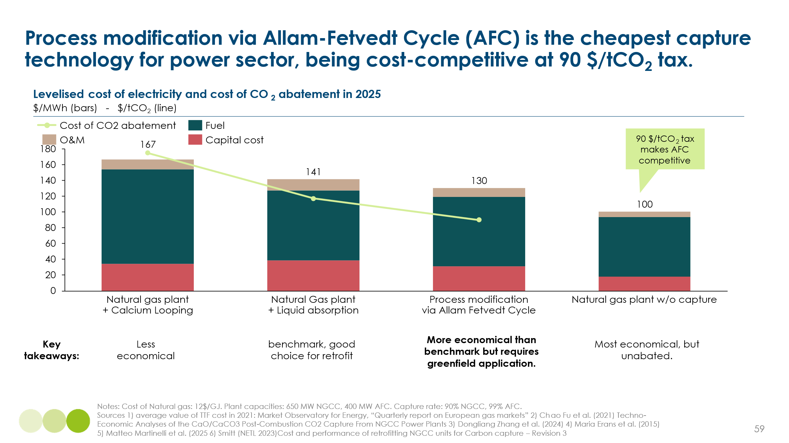
While NGCC coupled with liquid absorption or CaL offers valid alternatives, these configurations are less optimal in power applications. In particular, CaL does not benefit from the same process integration advantages seen in the cement sector, leading to higher capture costs ($175/tCO₂) due to standalone infrastructure requirements. Liquid absorption achieves moderate costs ($117/tCO₂), but it still relies on mature solvent-based systems with lower overall efficiencies.
The cost of natural gas is a key variable across all decarbonization pathways. Nevertheless, the thermal efficiencies of each capture configuration remain broadly comparable, which preserves the relative ranking of options. Despite its favorable performance potential, a key limitation of the Allam-Fetvedt Cycle (AFC) is its greenfield nature—it requires the construction of entirely new power plants rather than the retrofit of existing ones. This makes deployment more capital-intensive and slower, even if the system itself is efficient. Moreover, the AFC has not yet been deployed at commercial scale, and its cost estimates rely on engineering models and pilot-scale data. By contrast, NGCC retrofitted with liquid absorption is a proven, commercial technology with known performance under real-world conditions. The future competitiveness of AFC will depend on deployment learning, system reliability, and the availability of low-cost oxygen and CO₂ handling infrastructure.

Impact
While point-source carbon capture technologies can achieve capture efficiencies of around 90%, this figure applies only to the CO₂ generated at the point of combustion. A significant share of emissions remains unaddressed in the upstream and downstream segments of the fossil fuel value chain. These include:
- Upstream: Emissions from extraction, flaring, and field transport.
- Downstream: Processing, compression, and distribution.
Exhibit 4.16
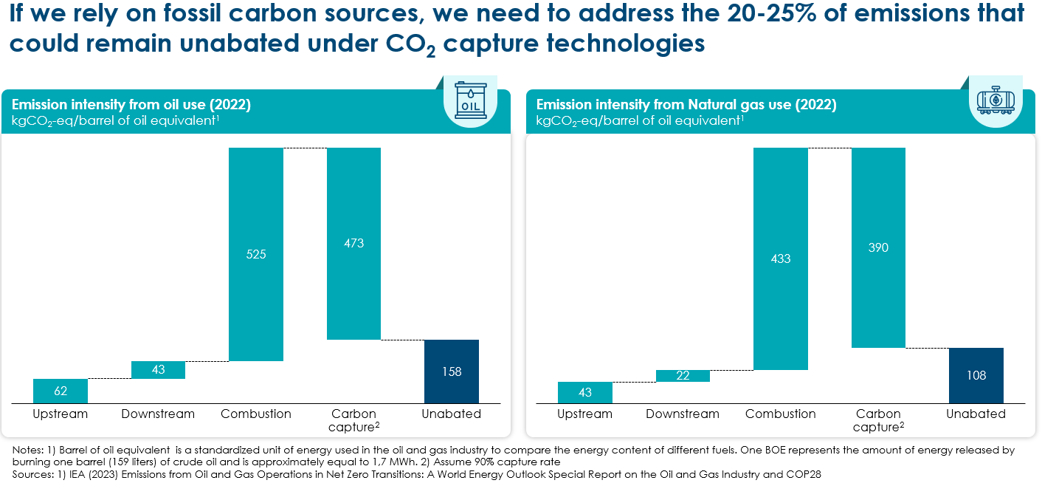
As shown in Exhibit 4.16, oil combustion results in 158 kgCO₂-eq of unabated emissions per barrel of oil, and natural gas yields 108 kgCO₂-eq, even after applying carbon capture ,. This corresponds to an overall emissions gap of 20–25%, which limits the full climate mitigation potential of fossil-based capture solutions.
Key levers to address this gap include:
- Reducing methane emissions from upstream oil and gas.
- Electrifying upstream facilities.
- Eliminating non-essential flaring.
- Expanding low-emission hydrogen integration and refining.
This limitation underscores the importance of targeting the full fossil value chain in parallel with capture solutions. While carbon capture plays a vital role, it must be deployed alongside broader systemic interventions to ensure a pathway to net-zero. Emerging technologies which demonstrate capture efficiencies close to 99% (e.g. AFC), can help reduce the residual emissions at the combustion stage. Although these technologies do not address upstream or downstream emissions, their higher capture rates can contribute to narrowing the overall mitigation gap.
Additionally, Decarbonizing the power sector could reduce reliance on biomass for electricity generation, allowing limited sustainable biomass resources to be redirected toward other high-impact uses, such as aviation fuels or industrial feedstocks, rather than being locked into BECCS for power.

Barriers and Enablers
Scaling point-source carbon capture to commercially viable levels across industrial and energy systems will require simultaneous progress in technology, infrastructure, policy, and financing. Key enablers include:
- Material and system innovation: Advances in solvents, sorbents, and capture system design are essential for improving efficiency and reducing energy demands. Next-generation materials such as phase-change solvents and metal-organic frameworks (MOFs) are currently undergoing pilot testing and show potential to significantly lower both capital and operational costs.
- Access to low-cost, zero-carbon energy: Many point-source capture systems, especially post-combustion, require significant heat or power. Using fossil-derived energy reduces climate benefits and raises costs, whereas renewable or waste heat sources improve efficiency.
- Process integration: Embedding capture systems within industrial sites like cement or steel plants can reduce costs by up to 50% compared to non-integrated configurations. For instance, CaL is highly compatible with cement kilns, allowing shared use of calciners, infrastructure, and sorbent material.
- Infrastructure development: CO₂ transport and storage infrastructure must expand in parallel to support large-scale deployment of capture systems.
- Policy and finance: Stable regulatory frameworks, clear carbon pricing, and dedicated incentives such as the US 45Q tax credit and EU Innovation Fund are critical to reduce investor risk and unlock new projects.
- Long-term monitoring: Proven MRV systems are necessary to ensure transparency and manage long- term liability, such as those demonstrated by Sleipner in Norway.
Key barriers to scale-up remain, particularly in the early stages of deployment. These are:
- High capital costs, which affect both retrofit projects and new-build systems like the AFC, especially where integration is complex or site-specific.
- Regulatory uncertainty in some regions, particularly regarding long-term storage liability and permitting, which delays investment.
- Limited access to CO₂ transport and storage infrastructure, especially outside a few well-characterized hubs such as the US Gulf Coast, restricts project siting and scale.
- Operational risks under real-world conditions, including equipment degradation, fluctuating feed conditions, and system downtime, remain poorly understood for emerging technologies.
- Technology-specific limitations constrain adoption:
  - Allam-Fetvedt Cycle, though highly efficient and capable of capturing ~99% of CO₂ without chemical solvents, can only be deployed in new-build (greenfield) plants. This makes it unsuitable for retrofits and limits relevance to regions where new fossil capacity is still being added—particularly in emerging markets that require dispatchable baseload power and lack full renewable penetration. In this context, AFC may serve as a tactical near-term solution, but it is unlikely to be a long-term decarbonization strategy in net-zero-aligned economies.
  - Calcium Looping is highly promising for cement decarbonization, thanks to its synergy with kiln infrastructure and tolerance to flue gas impurities. However, it requires high-temperature operation, making it less suitable for industries operating at lower process temperatures. It also entails medium-to-high capital costs and requires dedicated oxygen supply and sorbent handling systems, which can complicate integration in some settings.
While post-combustion and looping-based capture technologies are maturing rapidly, their widespread adoption will depend on technology-fit, cost trajectories, and the regional energy context. Solutions like CaL offer sector-specific integration advantages, while AFC presents a high-efficiency power solution for niche markets—provided the infrastructure and fossil feedstock remain aligned with local development needs. Unlocking full-scale deployment across all sectors will require coordinated action across technology, policy, and markets.

4.2 Biomass Carbon: Harnessing Biological Productivity
Biomass offers a natural carbon capture pathway through photosynthesis, which serves as a renewable and flexible carbon feedstock if sourced sustainably. It is already used in bioenergy, bioplastics, and a range of low-carbon products, but scaling its use must be managed carefully to avoid land-use conflict and ecological harm. Exhibit 4.17 lists the strict criteria necessary for biomass to be considered sustainable. These conditions ensure that biomass does not incur other environmental or social impacts, which may make it even more harmful than fossil resources.
Exhibit 4.17
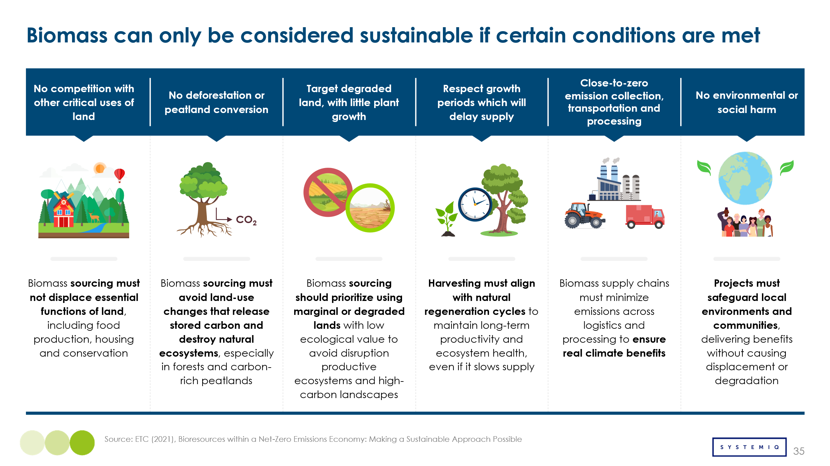
Based on these principles, the ETC has previously estimated that ~40 – 60 EJ of biomass could be sustainably supplied by 2050, as presented in Exhibit 4.18. Nonetheless, through radical changes, such as (1) use of more productive land, (2) more available land and (3) new sources, this estimate can be revised upwards. These changes are a result of a combination of factors, involving technological development, cultural change and robust, well-enforced legislation.
Exhibit 4.18
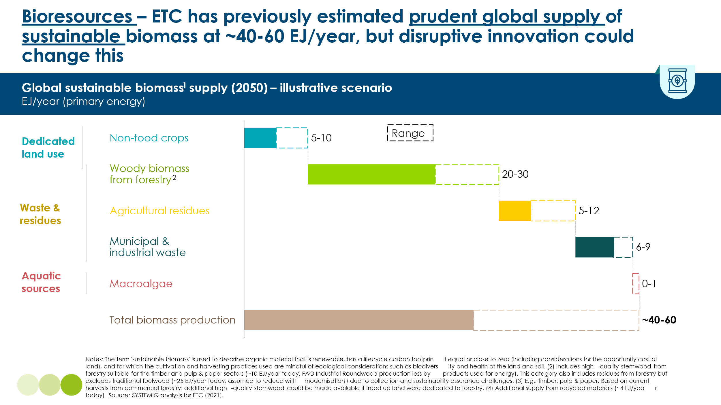

4.2.1 More Productive Land – Degraded land and more productive energy crops

Bioenergy crops could expand only on land that does not displace food production or critical ecosystem restoration. Two promising sources are (1) degraded land and (2) farmland that becomes available if diets shift away from animal-based protein. Degraded land, whether industrial sites contaminated with pollutants or farmland degraded by intensive agriculture, offers the larger global area, but its suitability differs by type. Industrial sites often need costly remediation to reduce contaminants before planting, whereas agricultural degradation is a continuum: lightly depleted soils may rebound quickly with organic amendments, cover crops and reduced tillage, while severely eroded or salinized fields demand more intensive restoration. Deploying energy crops on such land can boost productivity and generate revenue that offsets restoration costs, yet three caveats remain: potential competition with future food supply, loss of existing soil-carbon stocks during conversion, and the carbon-payback time, which ranges depending on crop, yield and prior land cover. Careful site assessment and lifecycle analysis are therefore essential before treating degraded land as a climate-positive bioenergy resource.
Energy-crop expansion must never jeopardise food security, whether the land involved is degraded or not. Exhibit 4.19 demonstrates that increased food demand is expected to cause the conversion of natural environments into pasture and cropland by 2050. This can be avoided by increased yield of food crops and decreased losses in the food supply chain. If this happens, converting unproductive food land for energy production will not contribute to disruptions in food supply. In regions with higher risk of food insecurity, shifting even low land areas from food to energy production may be very impactful and should be avoided, regardless of efficiency gains. For example, in some African countries, shifting land for energy production has already affected local prices.
Exhibit 4.19
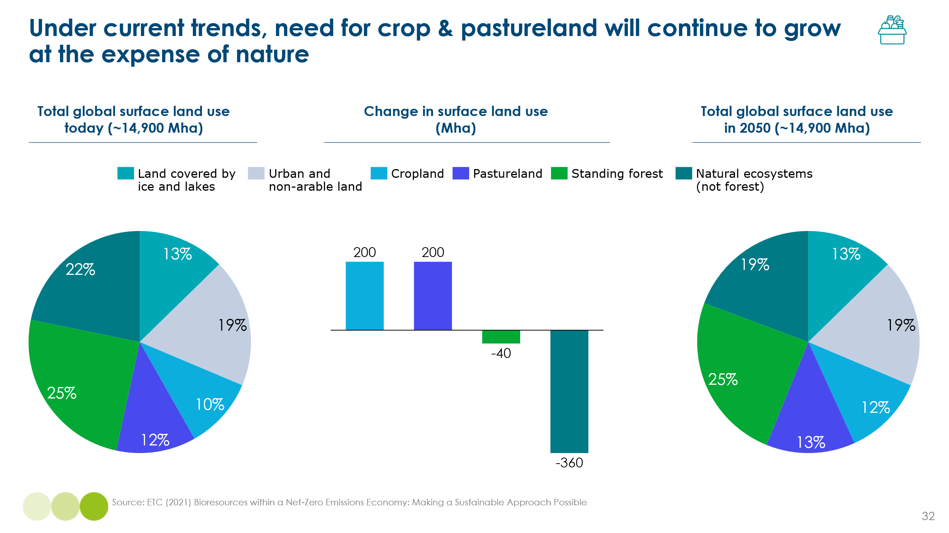

Natural carbon stocks should be factored into decisions about whether to repurpose degraded land for energy production or prioritise ecosystem restoration. Exhibit 4.20 shows that some vegetation types sequester considerably more carbon than others. In cold climates, slow microbial activity means biomass decomposes slowly, so a large share of carbon accumulates in the soil. By contrast, warm climates provide ample sunlight that fuels rapid plant growth and stores more carbon in living biomass. Moisture amplifies each trend: wetter cold sites slow decomposition even further, while wetter warm sites accelerate growth. Accordingly, when degraded land originally supported vegetation with high carbon-sequestration capacity, restoring that ecosystem should take precedence over energy production, as it is likely to deliver greater long-term carbon-sink benefits.
Exhibit 4.20
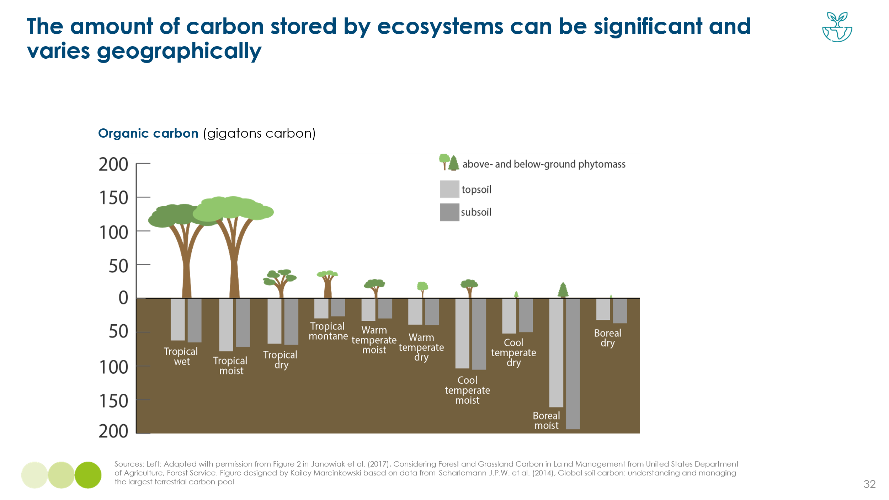
A final consideration is the time required for an energy crop to sequester as much carbon as the vegetation it replaces. Replacing natural ecosystems with energy crops generally involves long carbon-payback periods and should therefore be avoided, as demonstrated in Exhibit 4.21. However, certain biofuels can achieve relatively short carbon-payback periods when grown on abandoned cropland, degraded pasture, fallow land, grassland, or marginal cropland. This spectrum of land types highlights that agricultural degradation is a continuum: soils too depleted for efficient row-crop cultivation may still support low-intensity grazing. Selecting the right land–crop combination can thus enhance long-term carbon sequestration.
Exhibit 4.21
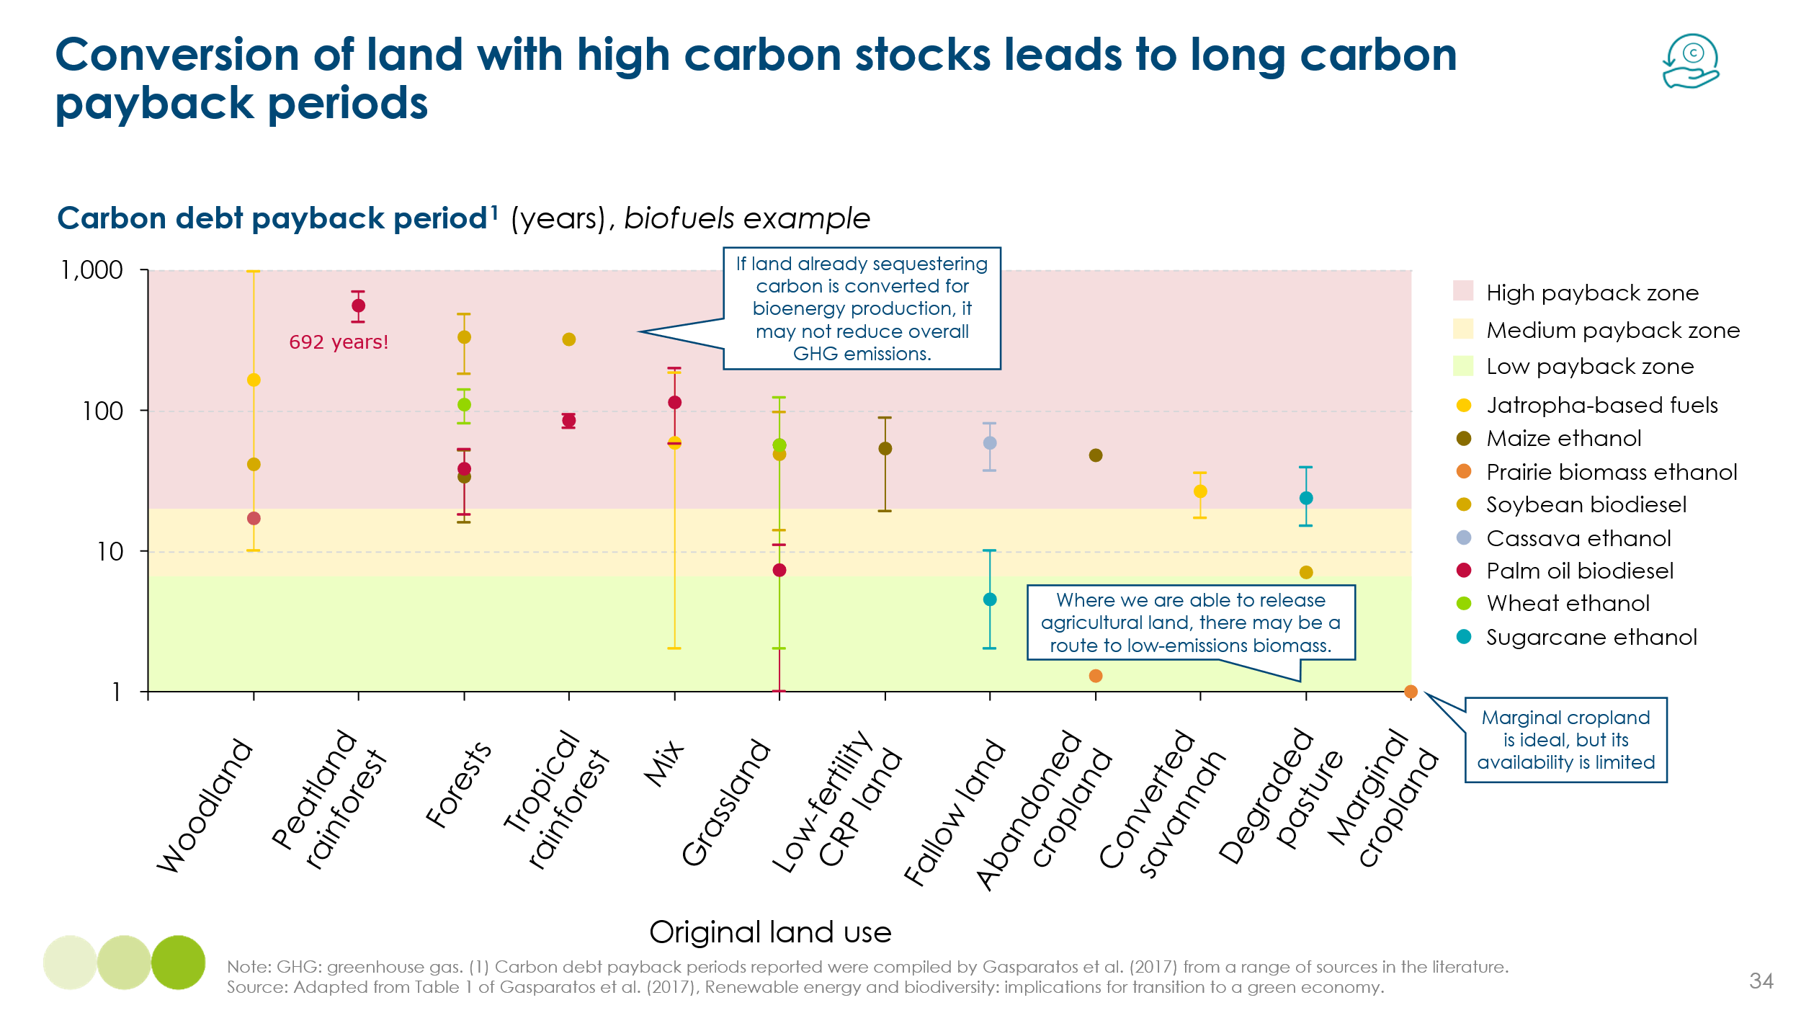
A review of studies on using degraded land for energy production indicates that the ETC’s 30 Mha estimate is conservative and reflects a prudent lower-bound scenario. Global degraded land estimates lie around 1,500 Mha, with sources estimating a range of 152 – 1,411 Mha used for energy production. The upper bound effectively assumes that every hectare of degraded land is converted, an unrealistic scenario that overlooks constraints such as urban degradation. The lower bound is 5x higher than the previous estimate from ETC, while the average of the lower bounds from the sources, which include IPPC and IIASA analysis, yield ~247 Mha. To ensure a conservative estimate, 200 Mha is now set as the potential maximum area available for energy production on degraded land. A summary of the reviewed literature is presented in Exhibit 4.22.
Exhibit 4.22
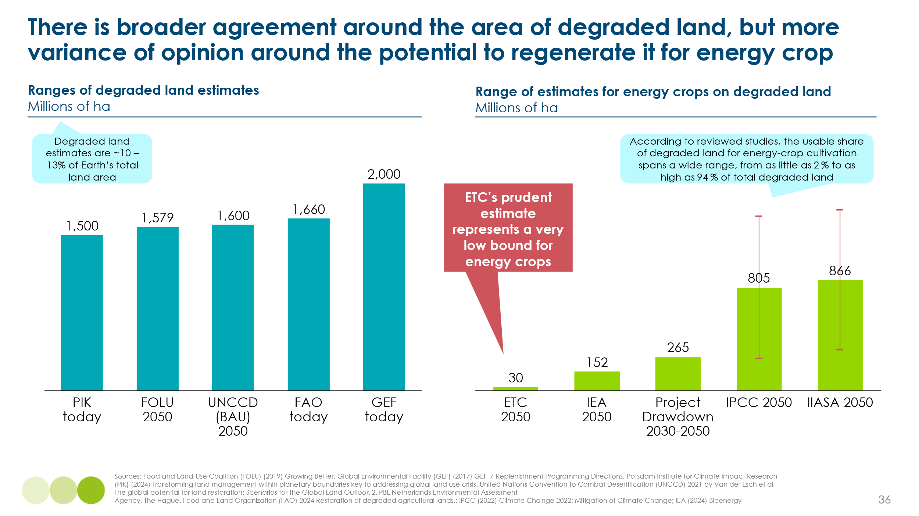
Using a standard reference crop such as switchgrass (~ 180 GJ/ha), that degraded land could supply up to 36 EJ of sustainable, non-food biomass. This accounts for a ~570% increase from ETC’s prudent estimate on Exhibit 4.23.
Literature review is valid for estimating a maximum potential of sustainable biomass growth in degraded land, but cannot account for regional factors. A more accurate assessment would:
    - map the global distribution of degraded land;
    - identify the areas where energy-crop cultivation generates the greatest net benefits;
    - match suitable energy crops to local soil and climate conditions;
    - determine a land restoration plan that specifies the timeframe and inputs required for soil recovery.
In addition to using more degraded land for energy production, introducing novel non-food energy crops could further boost the sustainable biomass supply. Although many of these crops can individually deliver higher yields, prosper on degraded or nutrient-poor soils, and act as both bioenergy feedstocks and carbon sinks, realising all three advantages at once often requires substantial synthetic inputs. Exhibit 4.24 summarises the options examined, with energy cane selected for detailed analysis.

Exhibit 4.23
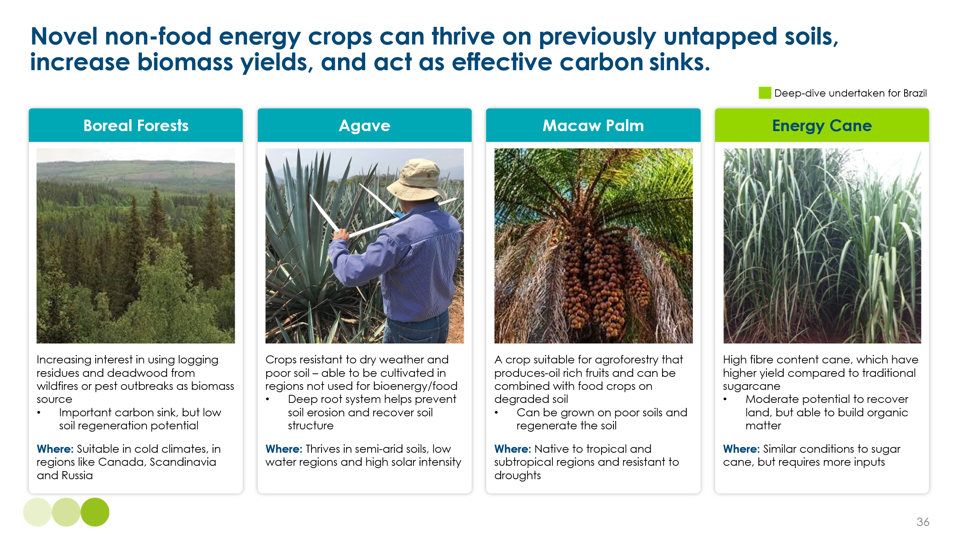
Energy cane is a high-yield variant of sugarcane bred for cellulosic biomass rather than sucrose production, making it an optimal feedstock for second generation biofuel. Exhibit 4.24 provides a detailed comparison of both strains. Thanks to its higher cellulosic content and superior yields, energy cane can raise the crop’s specific energy (energy per kilogram) by as much as 40 %. This advantage has attracted companies such as GranBio, which is evaluating the crop as a feedstock for bio-derived sustainable aviation fuel (bio-SAF).

Exhibit 4.24
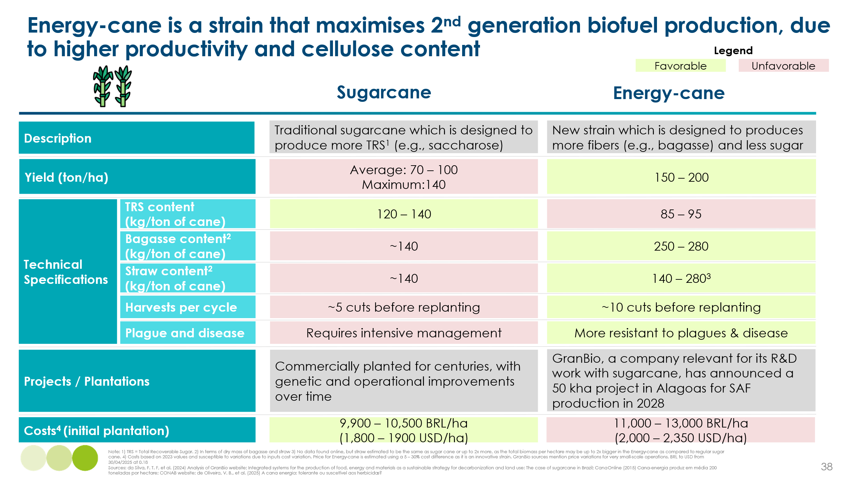
To illustrate the potential of novel energy crops in expanding sustainable biomass supply, an analysis has been conducted of energy-cane cultivation on degraded land in Brazil. The country possesses an estimated 112 Mha of degraded land, of which 66 Mha lie within regions already devoted to sugarcane production (Exhibit 4.25). Restricting energy-cane plantations to degraded land in these established sugarcane areas yields several advantages:
- Expansion into ecologically sensitive biomes—such as the Amazon—is avoided because commercial sugarcane is concentrated in the Centre-South.
- Proximity to existing logistics and processing infrastructure minimises additional capital expenditure.
- Displacement of food-producing land is prevented.
- Revenue from energy-cane cultivation provides a financial incentive that can offset the high cost of soil restoration.
- Degraded land elsewhere remains available for rehabilitation with food crops or native vegetation, supporting future food security and biodiversity recovery.
The analysis indicates a theoretical maximum of 65 EJ of additional biomass, demonstrating the significantly higher specific energy yield of energy cane relative to switchgrass. This estimate, using Brazil as a use case, more than doubles the prudent estimate, 50 – 60 EJ. The additional value corresponds to a total of ~1.6 Gt of carbon, showing that this use case alone could supply around 34% of the carbon demand in 2050. Although this estimate is more precise than the literature review, a more rigorous assessment of degraded-land suitability should be undertaken to identify the specific plots where energy-cane plantations are technically, environmentally, and economically feasible.

Exhibit 4.25
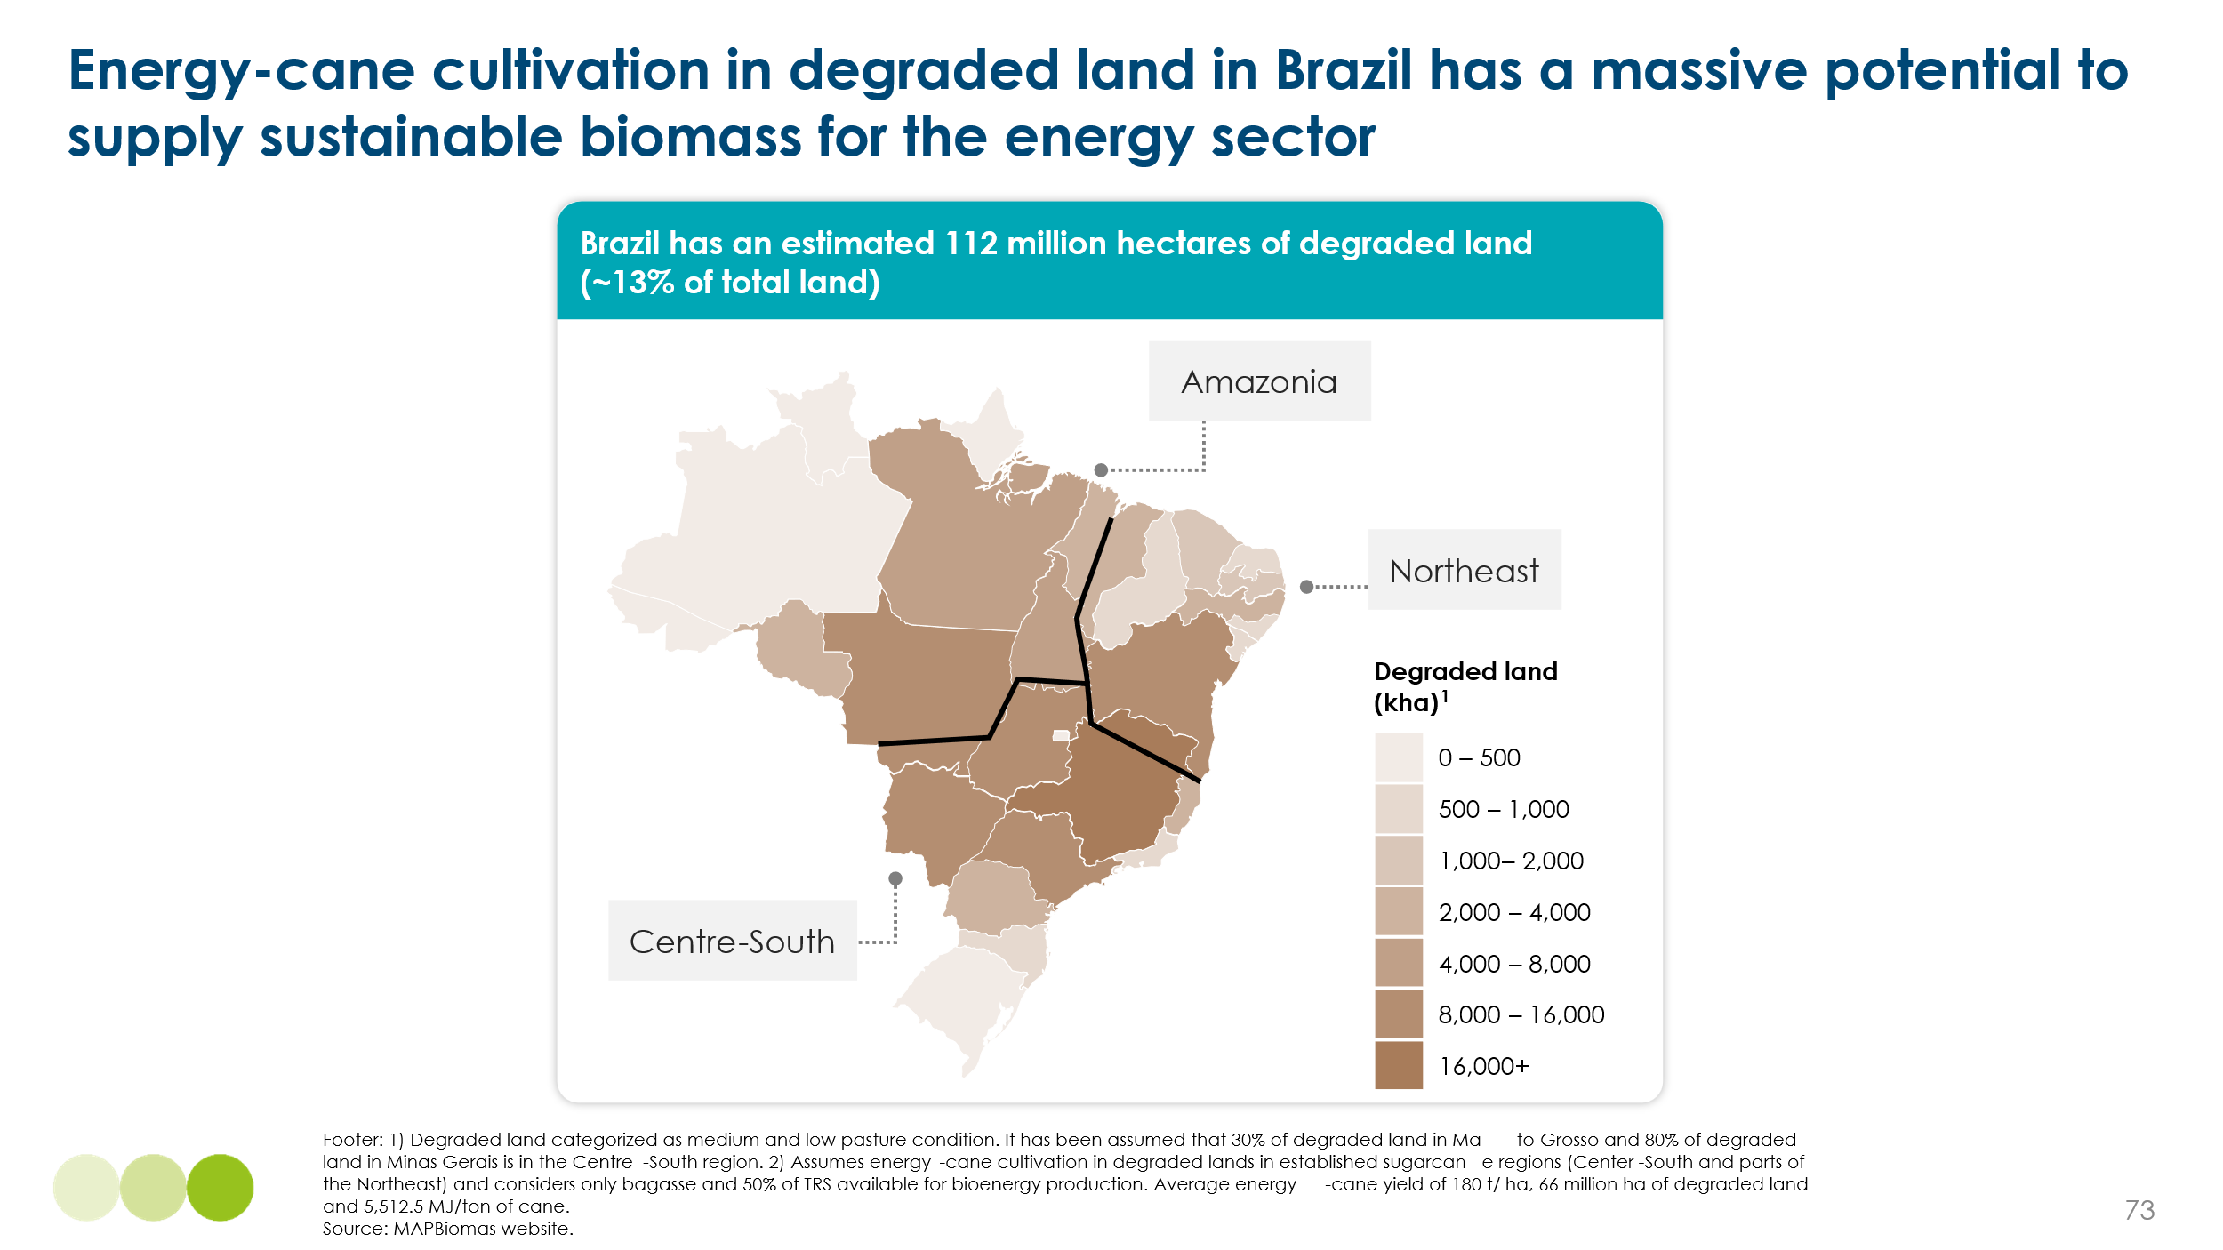
The principle of using degraded land for sustainable biofuel production could create perverse incentives. Greater flexibility in classifying such land may unintentionally reward actors who deliberately degrade it to secure sustainability certification for soil restoration or energy-crop cultivation. Existing regulations do not prohibit this practice; therefore, as sustainable biomass becomes more prominent, safeguards should be established to ensure that biofuel supply is not generated at the expense of deliberately degraded land. Exhibit 4.26 outlines five complementary actions that can be used to identify and monitor suitable degraded areas for sustainable biomass production, while discouraging further degradation. Adoption of such policies would enable soil recovery and sustainable carbon sourcing without additional environmental harm.
Exhibit 4.26
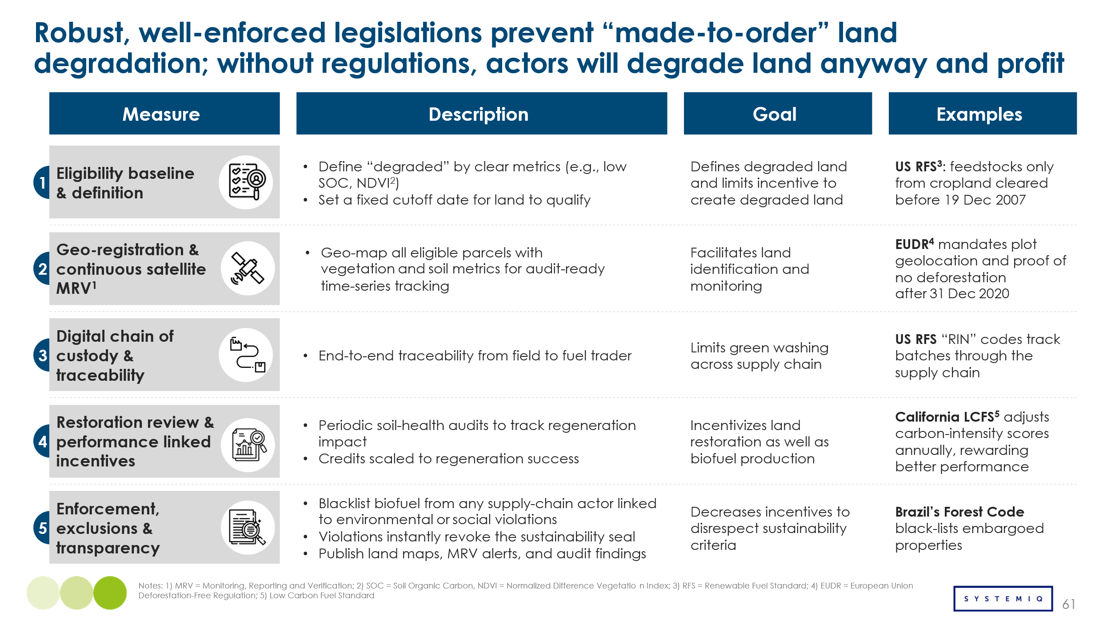

4.2.2 More Land – Alternative Proteins

Overview
Land needed for energy-crop cultivation can be freed by adopting alternative protein production methods. Alternative proteins refer to technology-based processes that re-route protein supply from animal sources to plant based, fermented and lab-grown products. Such methods require less water, land, and energy, achieve higher conversion efficiency, and shorten production cycles. A potential revolution in food sourcing is therefore offered, although significant technological, cultural, and consumer resistance must still be overcome.
Three innovations have been identified as having the greatest potential for land savings: biomass fermentation, precision fermentation, and cultivated meat. In general, these technologies involve three steps: (i) microbe selection or cell sourcing (for cultivated meat); (ii) microbe or cell growth in bioreactors; and (iii) product extraction. Exhibit 4.27 summarises the principal features of each technology and the leading industry participants.
Exhibit 4.27
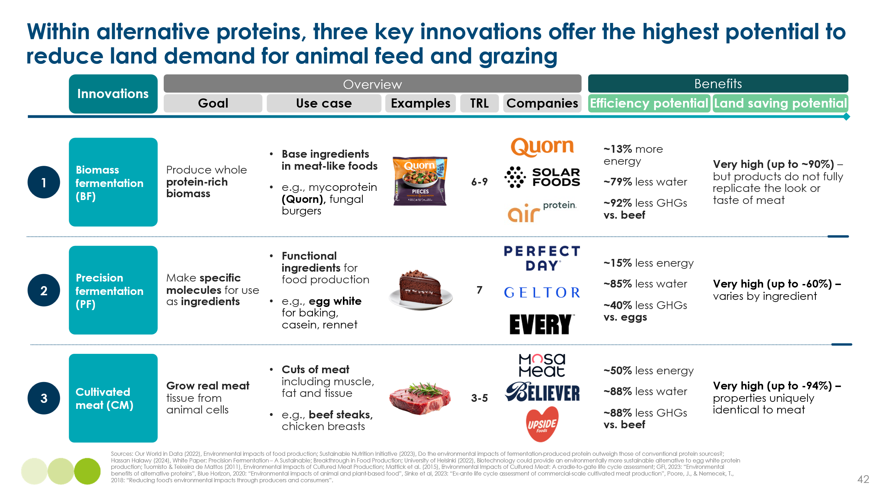

Costs
Cost competitiveness with animal-based protein has not yet been achieved by these innovations; however, parity could be reached by 2050, or even before, if critical cost-reduction levers are applied. An overview of current and projected costs is provided in Exhibit 4.28. At present, mass adoption is constrained by low technological maturity, limited output, and complex processing requirements. Targeted strain optimisation can trim operating costs by 10 – 50 %. Scaling production, through repurposing existing plants, streamlining processes, and adopting next-generation bioreactors, could then shrink CAPEX by more than 70 %. When these barriers are overcome, the production costs of alternative proteins could fall sufficiently to displace animal-based protein and free up land for other agricultural, biomass or ecological uses.

Exhibit 4.28
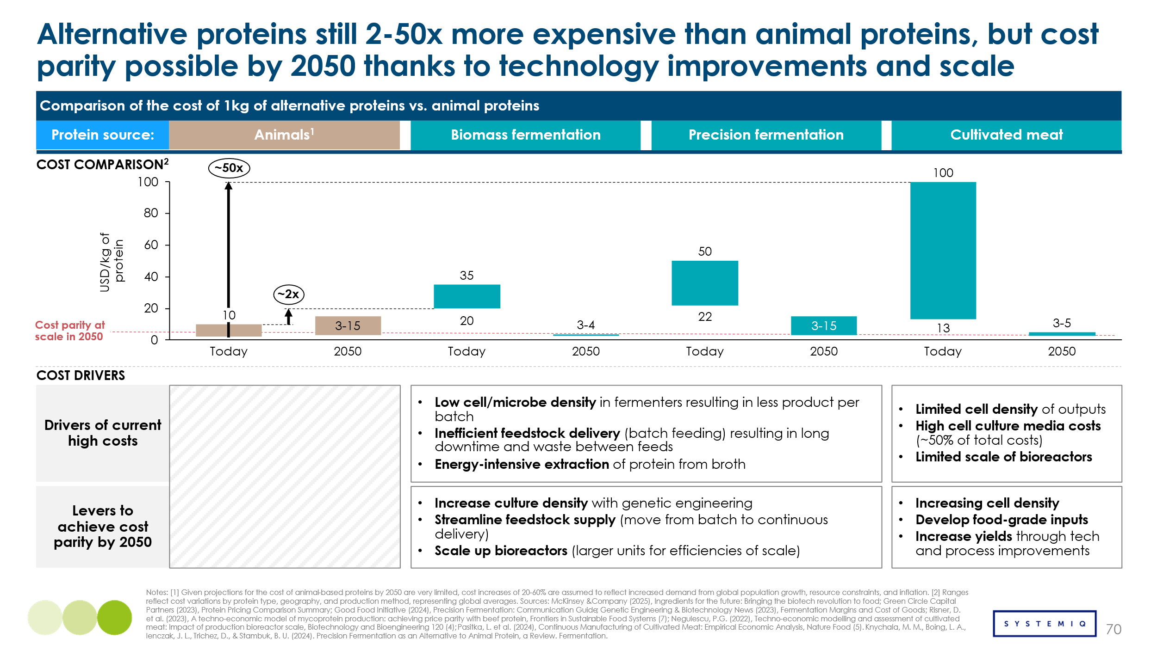

Impact
When cost parity is achieved, up to 400 Mt (million tonnes) of animal-based protein could be displaced by alternative proteins, freeing approximately 587 Mha of agricultural land. This represents 40 % of global projected 2050 protein demand (Exhibit 4.29), indicating a substantial shift in global protein production. Capturing this market share will require technological progress, supportive policy frameworks, and, most critically, increased consumer demand.
These figures were produced with a dedicated forecasting model that quantifies how quickly alternative proteins can gain market share and how much farmland their adoption could release. Annual growth rates for each protein category are projected from assumptions gathered through expert interviews and published studies. After production volumes are calculated, the model translates the resulting decline in animal-based protein demand into the equivalent area of agricultural land no longer required for livestock and feed production.

Exhibit 4.29
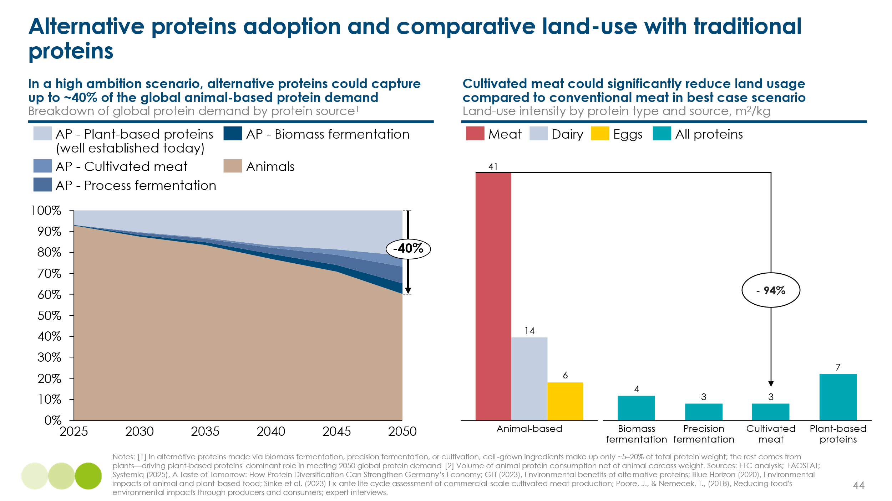
The freed land could be allocated to three primary uses: (i) biodiversity restoration; (ii) managed forestry; and (iii) energy-crop cultivation. Exhibit 4.30 illustrates the allocation approach for each use, aiming to maximise biodiversity restoration and, where feasible, generate sustainable biomass. Use-case selection is guided by region-specific land-use analyses that consider soil health, native vegetation, and other local factors. Under this scenario, an additional 27–28 EJ of sustainable biomass could be supplied.
Exhibit 4.30
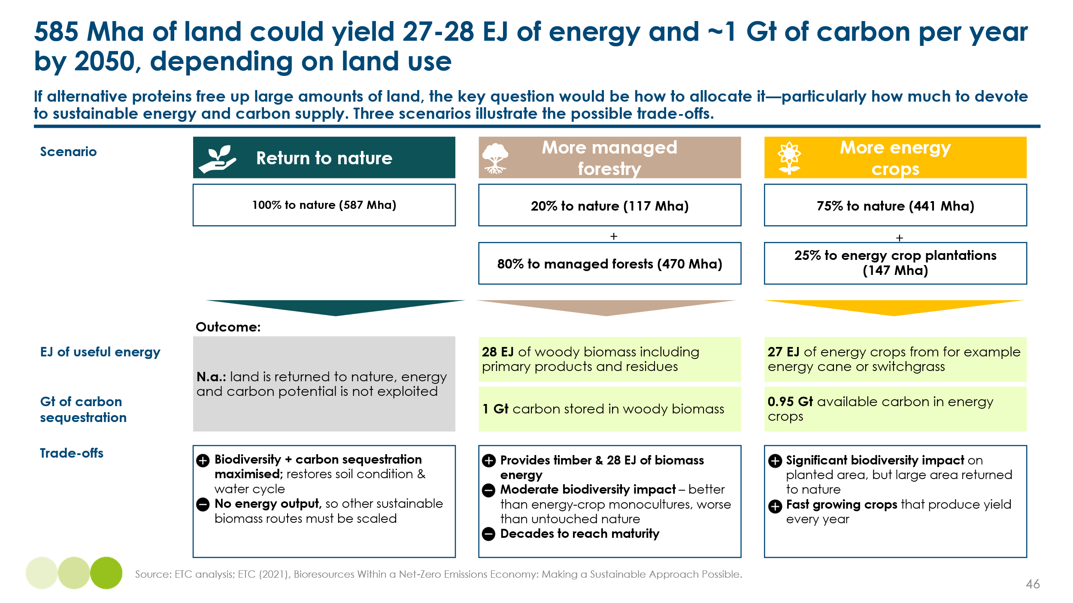

Barriers and Enablers
Alternative proteins will unlock their full land-saving and climate benefits only if consumers embrace them. To steer the scale-up and measure progress, five development criteria should be tracked:
- Affordability – price parity with conventional proteins (target: ≤ US $15 kg-¹ protein).
- Attractiveness – taste, texture, and nutrition at least equal to meat, enabling ~40 % market share.
- Accessibility – adequate scale-up finance and early adoption by public institutions, displacing up to 400 Mt of animal protein.
- Land liberation – the protein shift releases ~587 Mha of farmland.
- Land allocation – freed hectares are steered toward biodiversity recovery and biomass production, supplying an extra 27–28 EJ of sustainable biomass.
Among these metrics, attractiveness is pivotal: once consumers perceive alternative proteins as tasty and healthy, demand surges, investors deploy capital, production scales, costs fall, and all other targets become attainable. Without that consumer pull, progress on affordability or capacity alone will not deliver the desired impact.

4.2.3 New Sources of Biomass – Macro and Microalgae

Overview
A further measure for expanding land availability for sustainable biomass production involves shifting food supply from terrestrial to aquatic systems. In this context, macroalgae and microalgae have been identified as promising substitutes for land-based food and feed. Macroalgae are fast-growing photosynthetic organisms cultivated in coastal waters, whereas microalgae are microscopic photosynthetic organisms grown in open ponds or closed-reactor systems. Both groups can supply biomass for food or for third-generation biofuels.
Although significant potential exists for food and feed production from these sources, technological maturity remains low. Scaling efforts for macroalgae and microalgae are under way as companies seek optimal use cases. The innovation landscape and the land-saving potential of each technology are outlined in Exhibit 4.31.
Exhibit 4.31
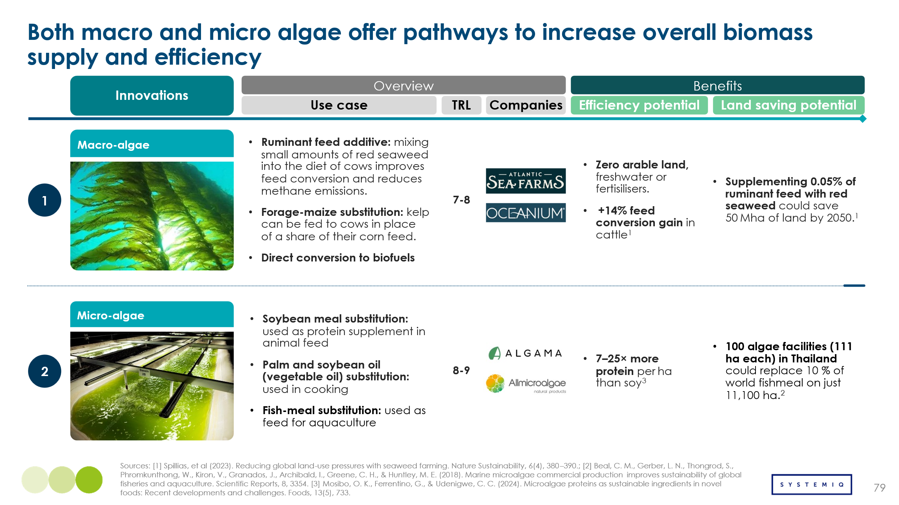
Costs
Macroalgae are viewed as a more promising substitute for corn than as a biofuel feedstock. Under favourable cultivation conditions, macroalgae can attain cost-competitiveness with corn for food and feed applications, whereas competition with high-yield energy crops such as energy cane remains unlikely. Exhibit 4.32 shows that corn is currently far less expensive than macroalgae; however, advances in process automation could reduce macroalgae production costs by up to 80 % by 2050. Automation is expected to cut labour and energy requirements while increasing yields, thereby strengthening overall process economics.

Exhibit 4.32
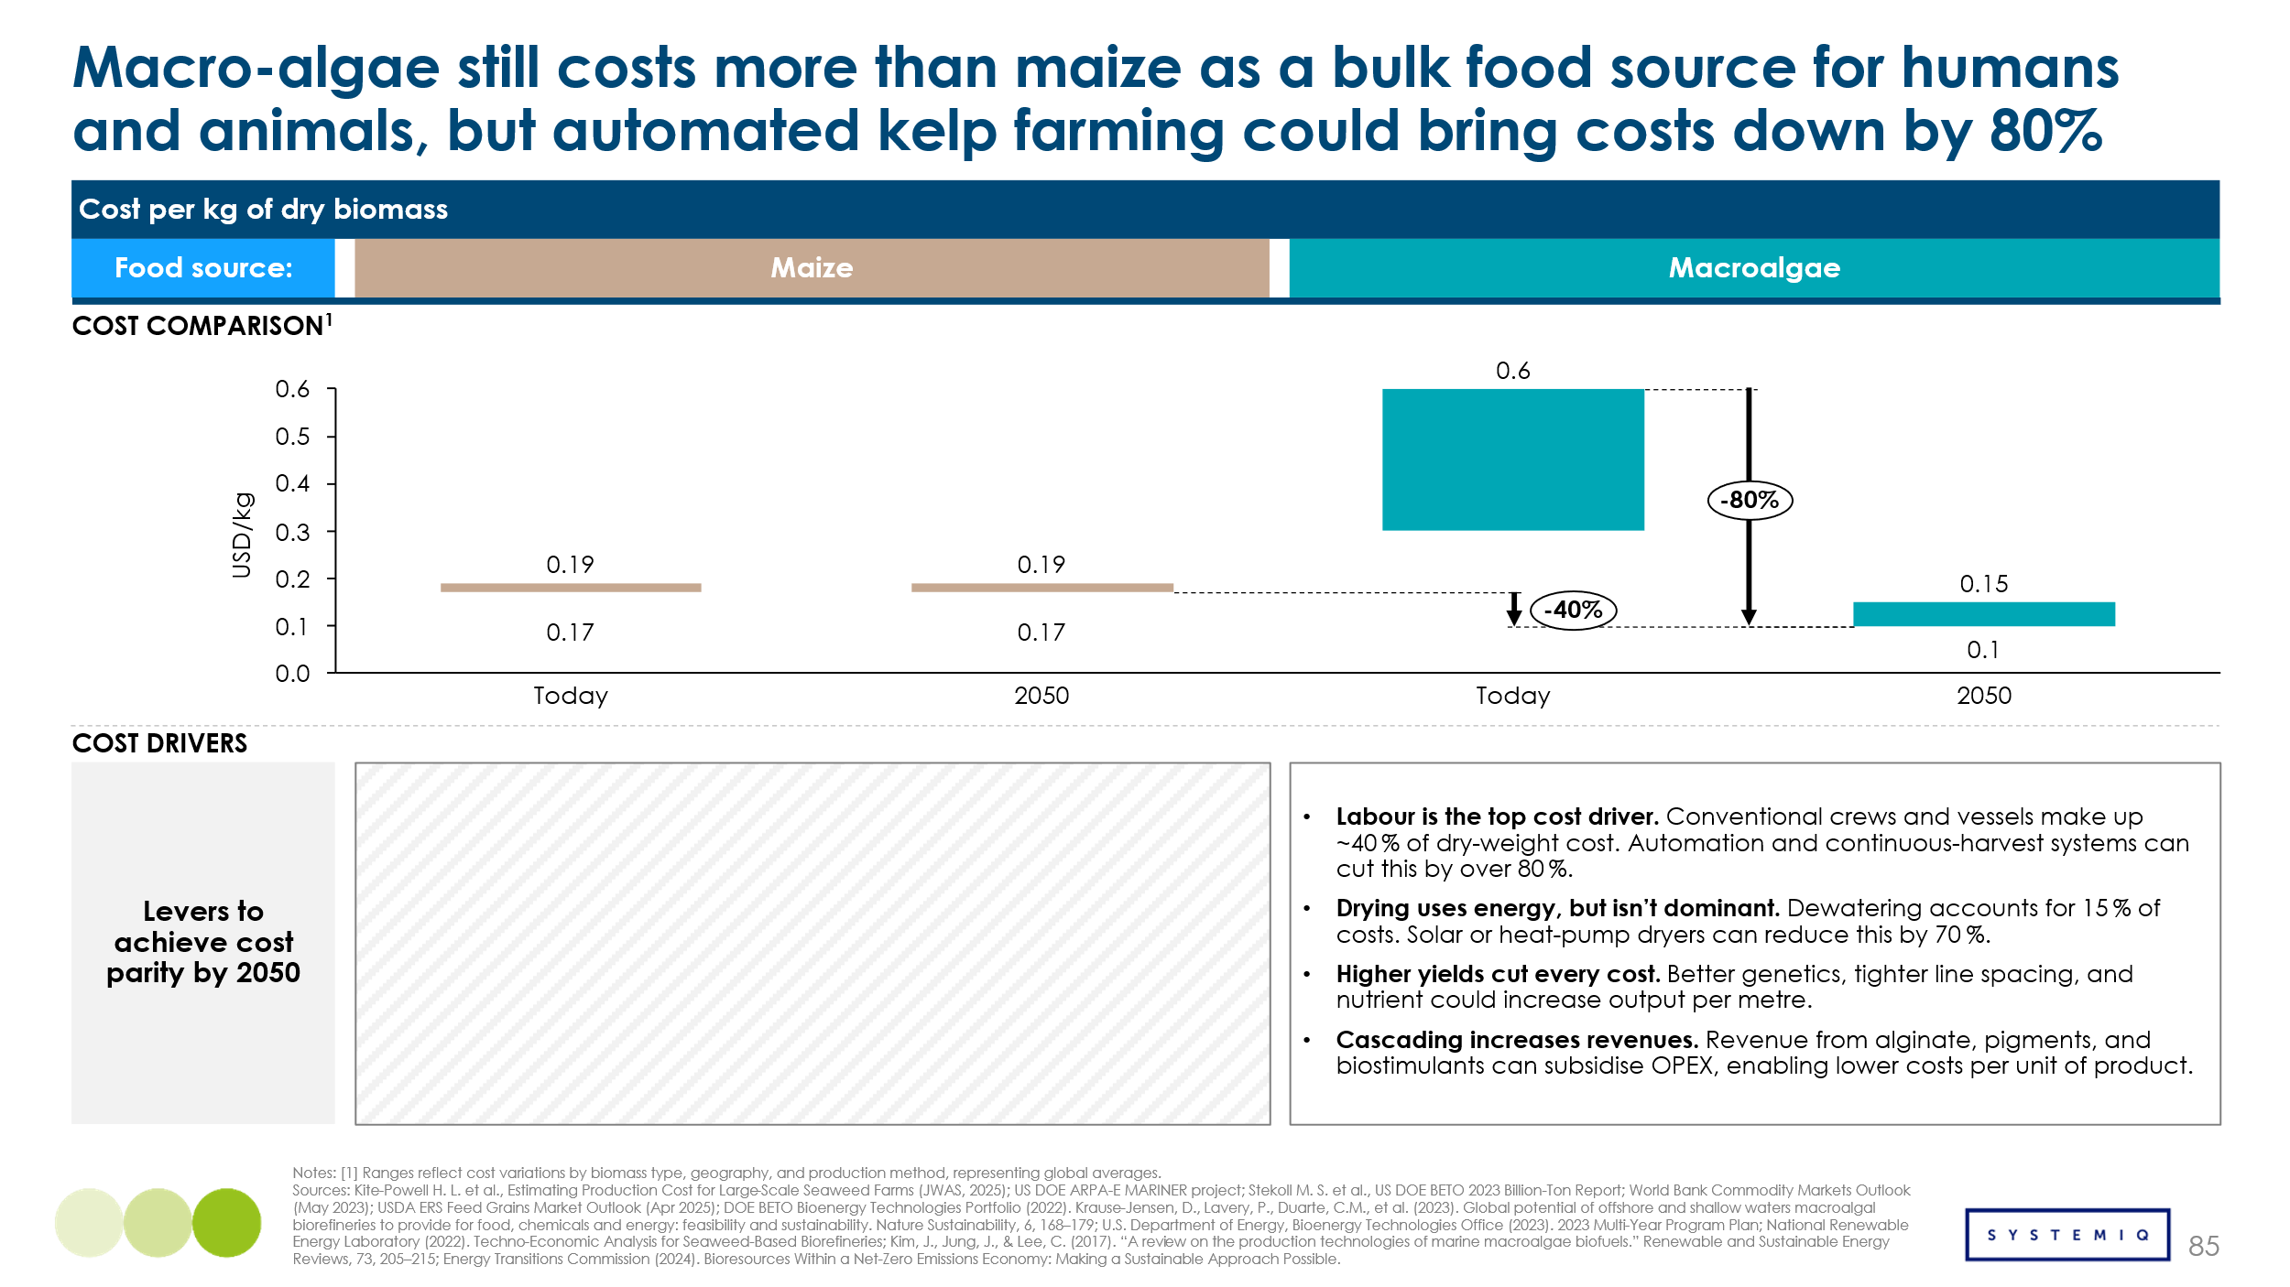
Microalgae are regarded as a potential feed substitute, particularly as a replacement for soy protein isolate. Production costs remain higher than those of soy and are likely to require policy or market incentives to reach cost parity. Scaling is hindered by the need for controlled-environment cultivation, like open ponds or closed photobioreactors, whose unit sizes are smaller than those employed for macroalgae. In addition, extensive strain engineering is required to increase cell density, protein concentration, and growth rates. Exhibit 4.33 indicates that, even under optimistic assumptions, microalgae are expected to achieve cost competitiveness with soy only in a best-case scenario; premium pricing may therefore be needed to offset the remaining cost differential.

Exhibit 4.33
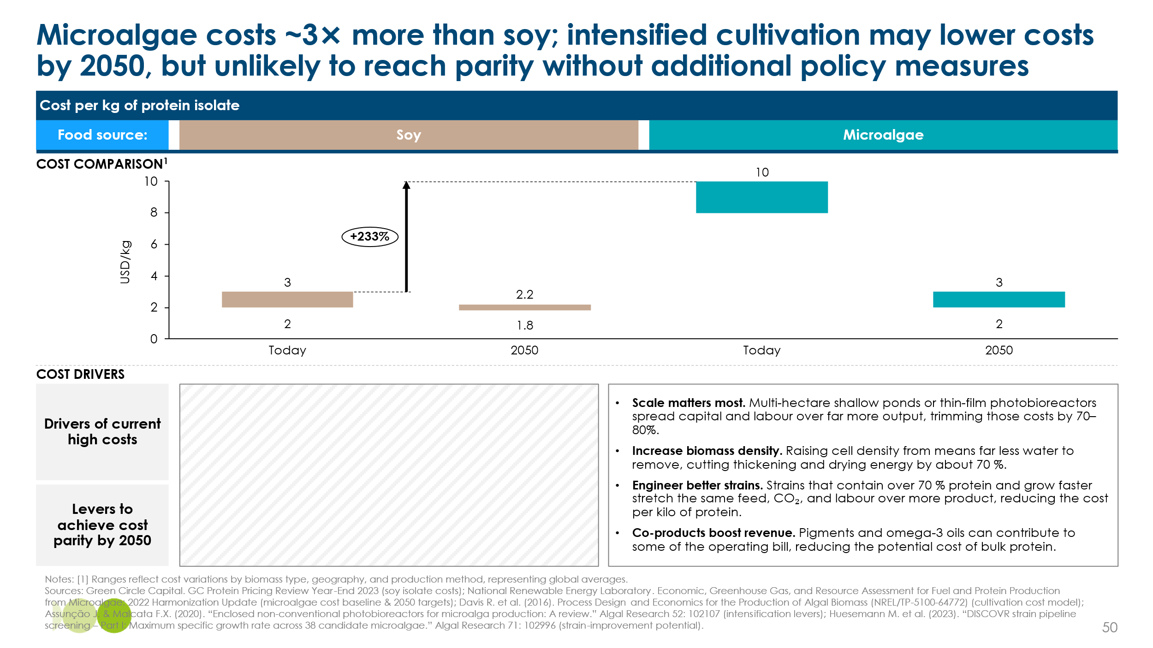

Impact
Estimating the true potential of these technologies is challenging. Should cost parity be achieved, a transformation of food and feed production could follow; at present, however, the technologies remain far from competing with incumbent feedstocks. A pragmatic estimate has therefore been prepared for their contribution as food and feed sources. Algal derivatives could supply approximately 2% of global food production and 8% of feed production by 2050, equivalent to 395 Mt. This output would release about 81 Mha of conventional agricultural land. Applying the framework used in Exhibit 4.30 an additional 10 EJ of sustainable biomass, which represents around 17% increase from the prudent estimate, could be generated while prioritising biodiversity restoration.
These results were produced with a forecasting model tailored to algal proteins, where growth projections are more uncertain because published estimates diverge. Multiple data sources were reviewed, and a deliberately conservative annual growth rate was adopted. After projected production volumes were established, the model translated the anticipated replacement of conventional food and feed into the corresponding area of farmland released.
Barriers and Enablers
Yield improvements and the facilitation of large-scale cultivation are regarded as essential, implying that financing and infrastructure development will be critical. Once these conditions are met, production costs are expected to fall, improving competitiveness with existing feedstocks. The same development criteria as for alternative protein are tracked to ensure impact and measure progress:
- Affordability – price parity with conventional feedstocks.
- Attractiveness – taste, texture, and nutrition match incumbent feedstocks, enabling algae to capture 1% of the food market and 8% of the feed market
- Accessibility – infrastructure is mobilised to allow for scale up of ponds and sea farms, displacing 395 Mt of terrestrial crops
- Land liberation – switch to algae-based products free up 81 Mha of agriculture land
- Land allocation – freed hectares are steered toward biodiversity recovery and biomass production, supplying an extra ~10 EJ of sustainable biomass.
Product “attractiveness” (taste, health profile, and sourcing perceptions) is considered less decisive than for alternative proteins because algal derivatives are also destined for feed markets and; therefore, face fewer sourcing biases.

4.2.4 Biomass Conversion: Improving Utilization of Bio-resources

Overview
In a de-fossilised economy, biomass serves as a feedstock for bio-based materials, such as wood and bioplastics, and for biofuels, including bio-SAF and biodiesel. The objective is to upgrade primary biomass, a carbon-neutral source, into more complex bio-based carbon molecules. Primary biomass is highly heterogeneous, originating from oily feedstocks, cellulosic residues, liquid biogenic waste, and other sources, which complicates categorisation. The resulting challenge is to devise processes that exploit the specific properties of each feedstock and convert them efficiently into useful products. Exhibit 4.34 maps the principal routes for primary-biomass conversion, demonstrating that, regardless of the input, products relevant to the same end-use sectors can be synthesized.
Exhibit 4.34
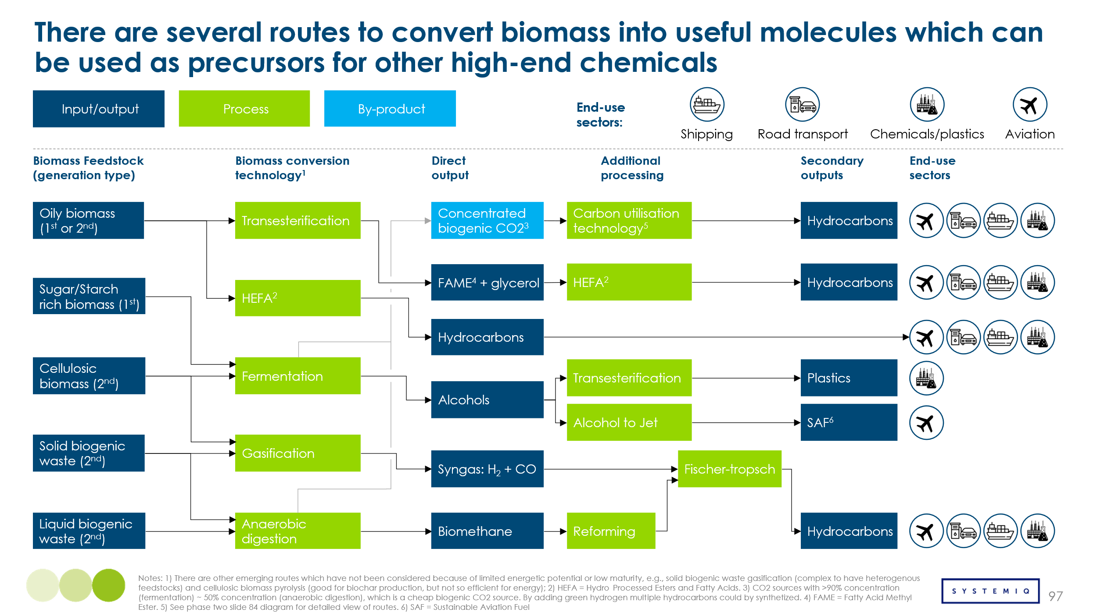
Conversion of primary biomass into useful products can be enhanced to reduce feedstock demand and improve process economics. Performance improvements may be achieved by adjusting operating conditions, such as temperature and pressure, or by adopting equipment innovations. Two equipment-based advances are particularly important: catalysts and specialised reactors. Catalysts are substances that accelerate reactions by lowering activation energy without being consumed, whereas reactors are vessels engineered to provide an optimal environment that maximises conversion efficiency. Exhibit 4.35 details how these innovations raise conversion efficiency and summarises their deployment in bioenergy projects across the industry.
Exhibit 4.35
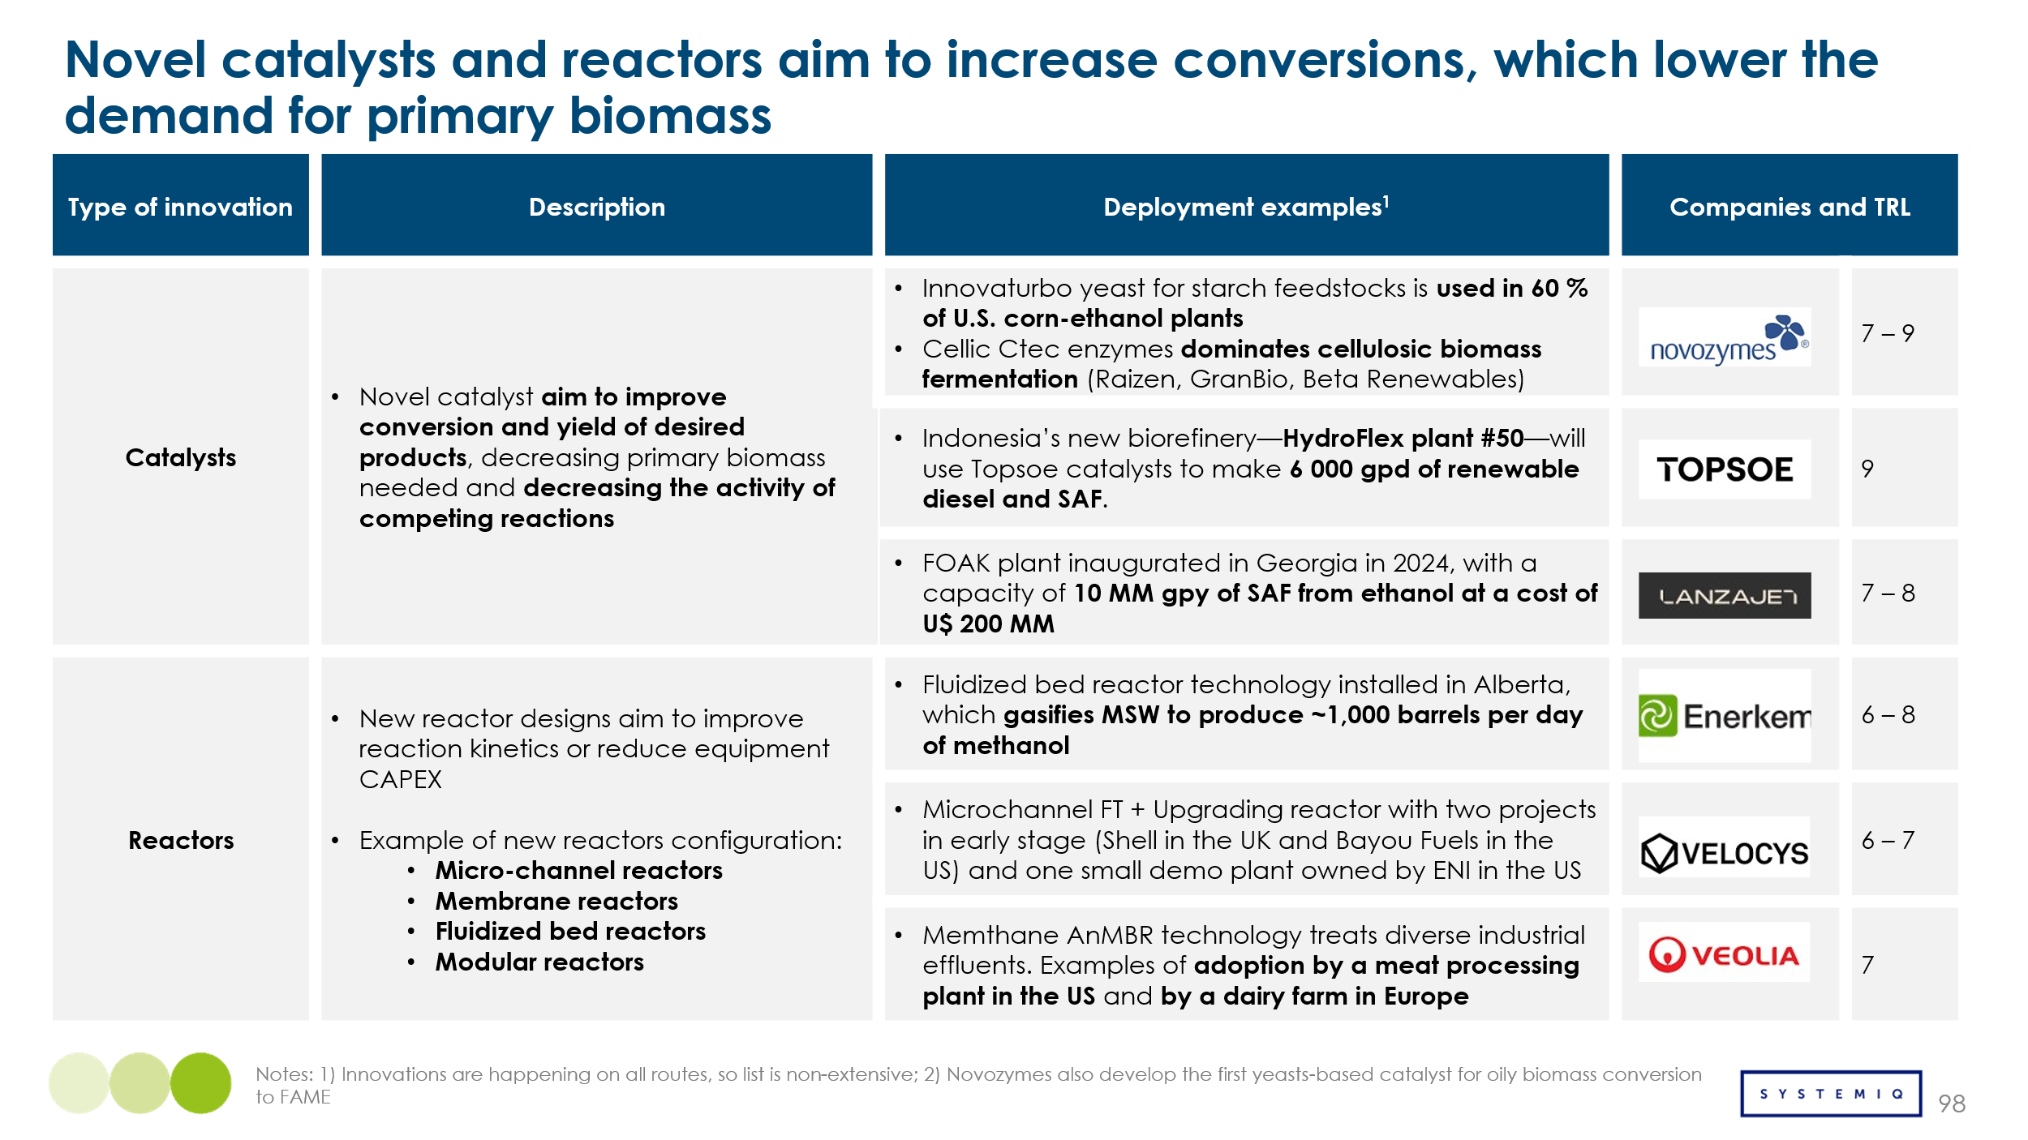
The two equipment innovations are intended to push reaction conversion toward the theoretical (stoichiometric) limit. For catalysts, research focuses on identifying optimal compositions and physical properties for the target reaction. For reactors, vessels are designed to maximise heat and mass transfer between reactants. The effects of these innovations are more pronounced in low-TRL processes than in mature ones; for example, bio-SAF production via the HEFA route already operates near its theoretical conversion limit, whereas Alcohol-to-Jet and Gasification–Fischer-Tropsch pathways remain further away, so larger conversion gains are still possible for the latter. The conversion gains are calculated for catalysts to range between 2% and 20% and for reactors between 8% and 20%.
Costs
Route-specific techno-economic assessments are constrained by limited access to proprietary catalyst and reactor data. To compensate for this data gap, cost reductions were estimated indirectly from the feedstock savings associated with higher conversion and product-yield factors along each biomass-conversion pathway. Capital-expenditure (CAPEX) effects were treated as neutral, on the premise that incremental yield gains do not justify an escalation in cost. Operating-expenditure (OPEX) impacts related to energy and utility demand were likewise excluded from the baseline calculation. The resulting analysis, summarised in Exhibit 4.36, indicates that feedstock-driven cost reductions that advanced catalysts and reactors could deliver are between the range of 4-8%. The reductions alone are insufficient to render bio-based pathways cost-competitive with their fossil counterparts, but could help enable bio-based products synthesis in locations with expensive feedstocks. Accordingly, additional market incentives (e.g., carbon-pricing mechanisms or green-premium contracts) will be required to bridge the residual cost gap during initial deployment phases.
Exhibit 4.36
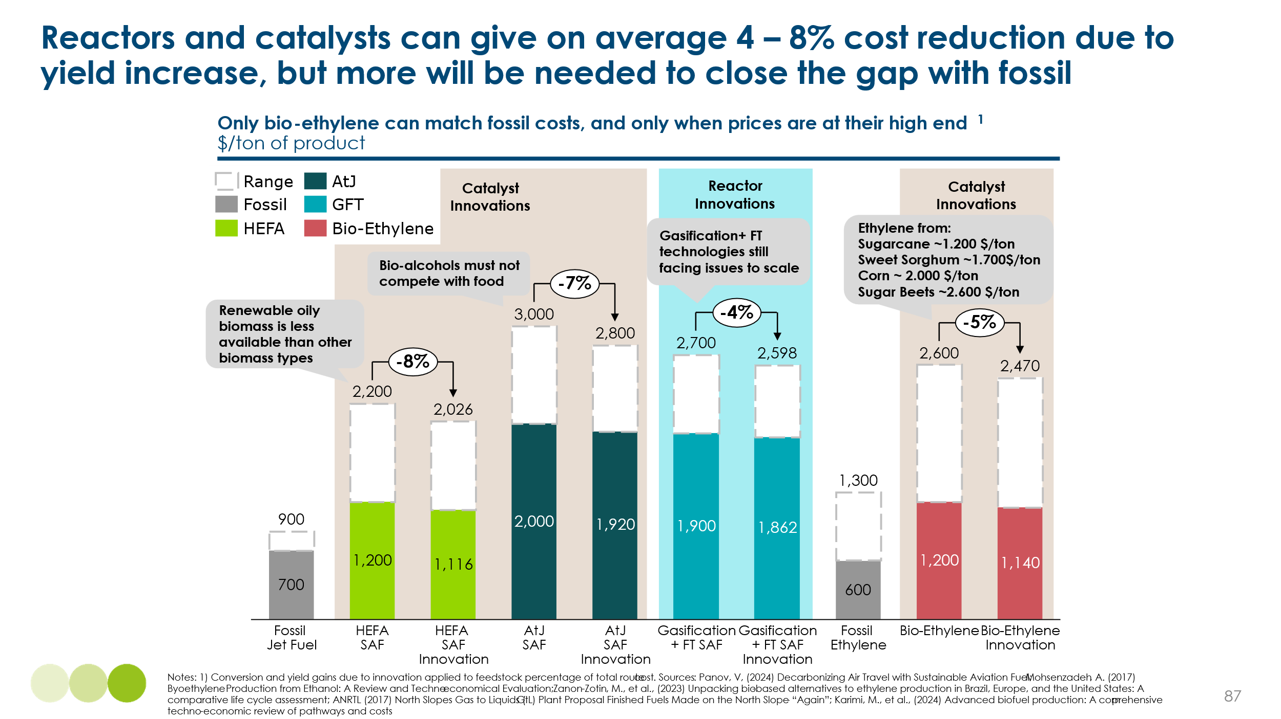

Impact
For the aviation sector, improvements in product yield are estimated to reduce primary-biomass demand by approximately 30 %. Exhibit 4.37 indicates that yield gains in the Alcohol-to-Jet (AtJ) and Gasification–Fischer-Tropsch (GFT) pathways contribute more to this reduction than gains in the Hydroprocessed Esters and Fatty Acids (HEFA) route. Two factors explain the difference: (i) AtJ and GFT are two-step, lower-TRL processes, so yield improvements have a larger relative impact; and (ii) these pathways are expected to supply a greater share of total bio-SAF output because availability of sustainable feedstock for HEFA is constrained. Whereas AtJ and GFT can use abundant lignocellulosic residues and other organic waste streams that can be purpose-grown or easily collected, the HEFA pathway relies on lipid-rich feedstocks. Today these lipids come mainly from relatively scarce waste oils and animal fats, so the limited supply of suitable oily biomass naturally limits how much SAF can be produced via HEFA.
Exhibit 4.37
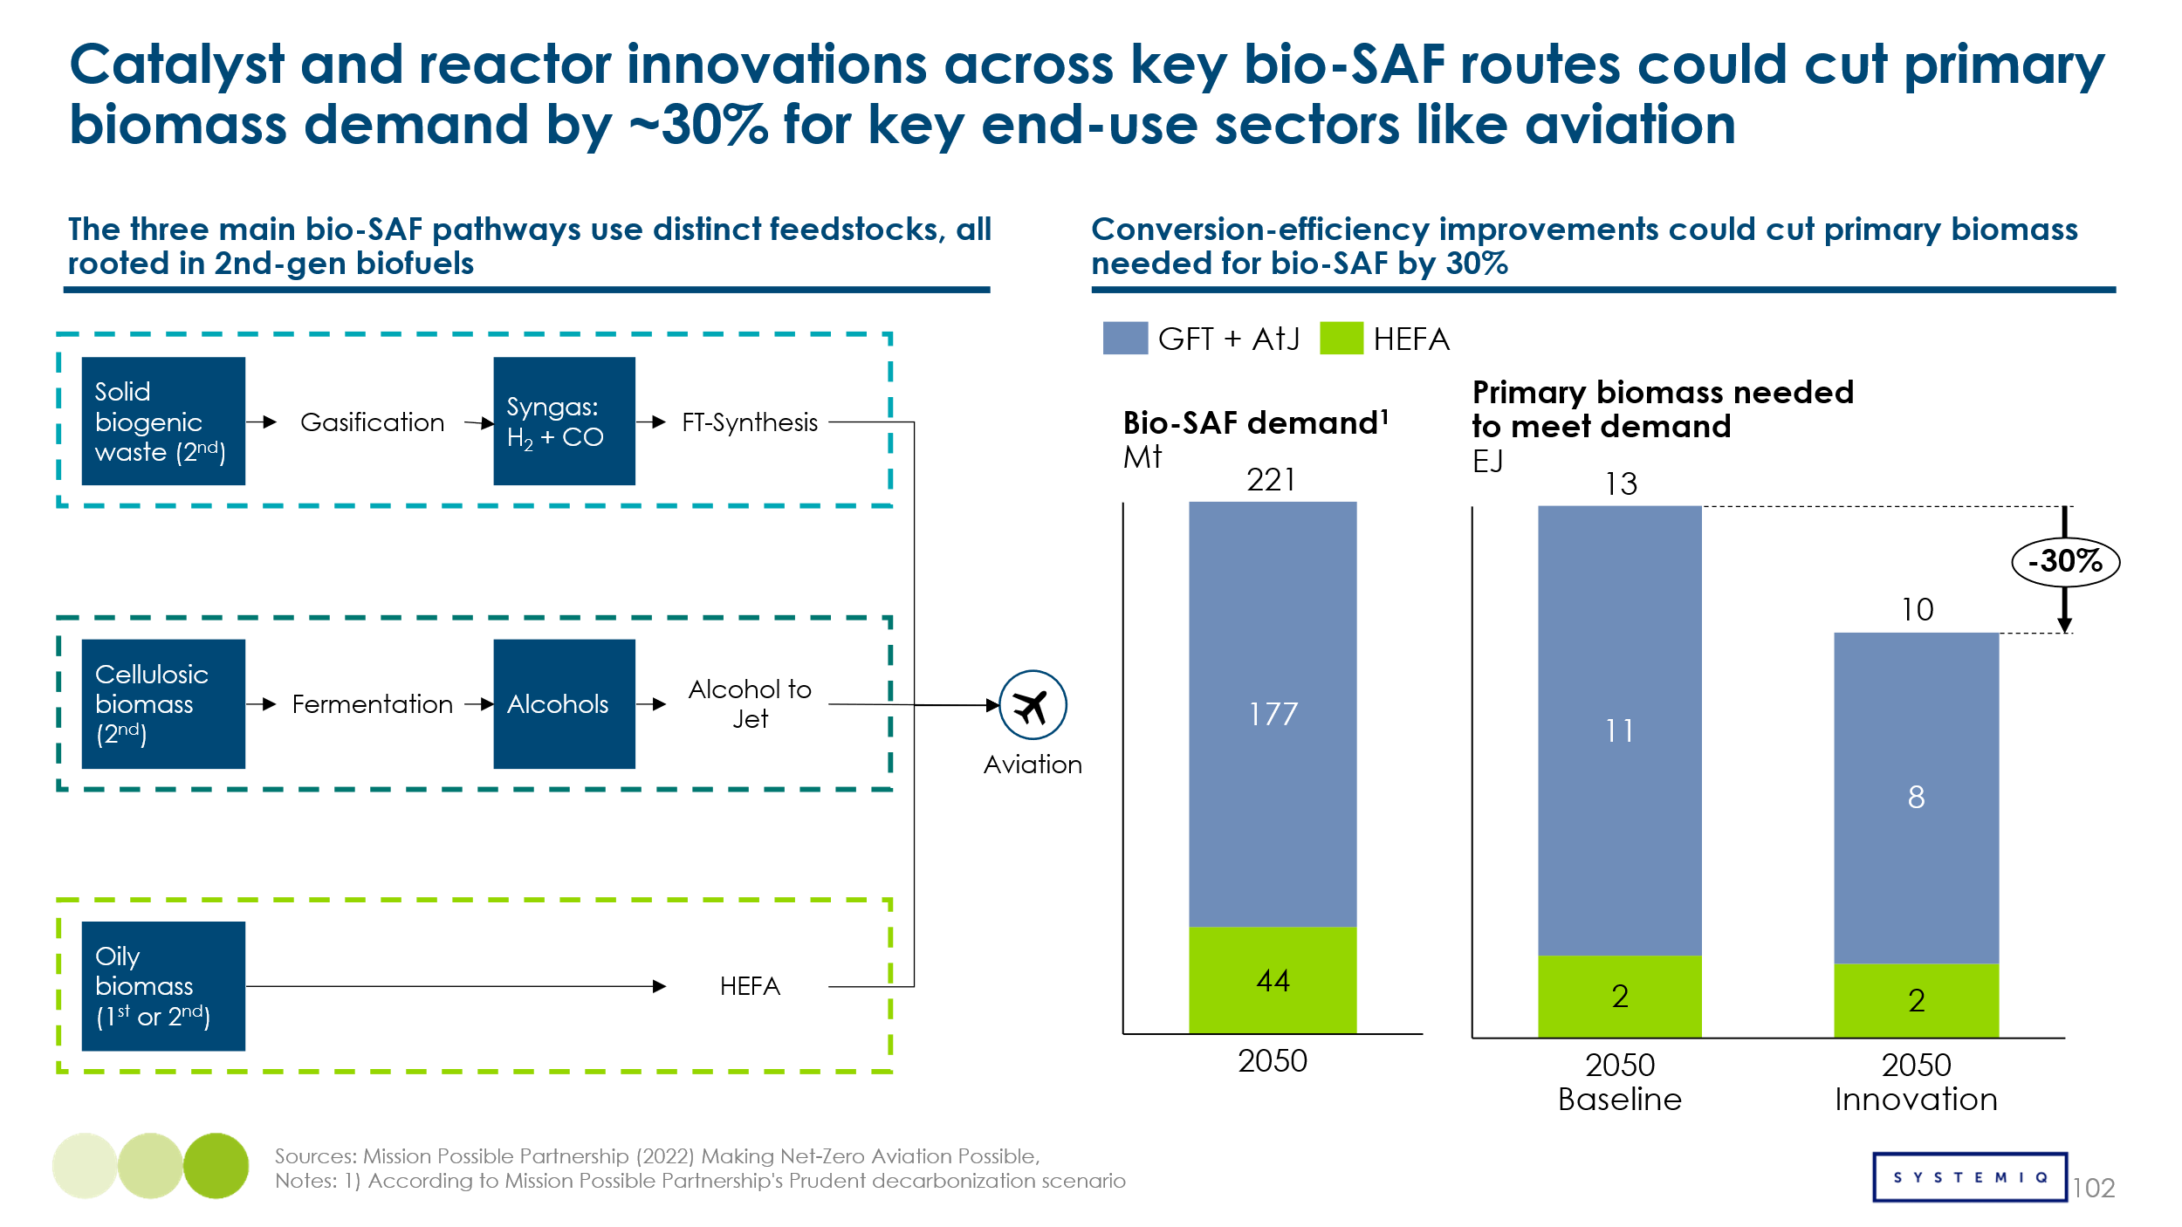

Barriers and Enablers
Commercial viability of bio-based carbon molecules depends on the continued development of integrated biorefinery systems for sector specific applications, like aviation. Two pillars require coordinated support: feedstock access and demand creation. For feedstock access, three criteria are key:
- Uniform biomass regulations that safeguard sustainability without excluding viable resources. This allows for maximisation of resource utilization and unification of legislations, avoiding regulatory mismatches
- Resource mapping coupled with local-infrastructure development. Maximizes resource availability and facilitates collection and processing of primary biomass into tradeable products
- Market mechanisms that promote tradability and commodity homogeneity. Creation of markets for specific bio-based carbon molecules (e.g., bio-methane, bio-ethanol, syngas, bio-oils), in order to facilitate molecule commercialization.
Demand creation focuses on accelerating deployment to drive cost reductions over time; two criteria are crucial:
- Demand-side incentives that facilitate long-term offtake agreements. Blending mandates and carbon taxes can push demand for bio-based carbon molecules, reducing commercial risks and enabling more plants to come online.
- Rapid scale-up to lower unit costs via economies of scale. Achieving cost parity with fossil fuels will require steep cost cuts driven by larger scale, learning rates, supply chain growth and product standardization, all of which require high-capacity facilities running for long, sustained periods.
Progress across all criteria will enable the bio-industry to grow organically and reach the scale needed to deliver meaningful impact in a net-zero economy.

4.3 Conclusions about sourcing of primary carbon
As described in this Chapter, there are multiple potential sources of primary carbon which could be used in a way compatible with net zero emissions. The optimal balance will be determined by future technological and cost development, and it is impossible and unnecessary to predict it in advance. Instead, the crucial priority is to introduce regulations and carbon pricing which will help achieve the most efficient solution.
But the key factors which will determine the optimal balance between the different sources are:
  - The cost of direct air capture and ocean based carbon removal. Initial estimates of DAC costs reaching below $100 by mid-century have recently been revised up, but further technological progress and cost reductions is possible. Ocean based CO2 removal seems to be emerging as a credible and potentially low-cost alternative. If either technology becomes cost-effective versus the alternatives, capture from the atmosphere or ocean could play a useful role both in (i) providing carbon atoms for end use applications and (ii) making it possible to offset emissions resulting from fossil fuel use; in the case of DAC this will also require the storage technologies described in Chapter 5.
- The technical feasibility and cost of point source carbon capture. Compared with expectations 10 to 15 years ago, the pace of cost reduction in point source capture, and the pace of deployment have been disappointing. This reflects complexities created by sector specific circumstances, the difficulty of applying carbon capture systems to already existing industrial plants, and the presence of impurities such as particulate matter, sulphur dioxide and nitrogen oxides. New technologies such as Calcium Looping or the Allam-Fetvedt Cycle (AFC) may help overcome these challenges.
The crucial policy priority to support development and optimal deployment is robust carbon pricing which needs to cover emissions from the production, processing and transport of fossil fuels as well as those which result from end use.
- The true sustainability of bioresource extraction. The ETC has previously published a prudent estimate that sustainable biomass extraction might be limited to 40 to 60 EJ (11,000-17,000 TWh) primarily deriving from agricultural and forestry rescues. ETC also indicated a maximum potential of 120 EJ (34,000 TWh) if agricultural productivity improvement, alternative proteins and diet change could free up land for buyer resource production.
Reflecting on new assessments in Section 6.2, we have now revised up our assessment of the maximum potential to 178EJ (49,000 TWh) (Exhibit 4.38). But is it important to see this as an absolute maximum potential which could only be achieved sustainably if:
- New technologies and/or changes in consumer behaviour make it possible to release land for bioresource production without reducing food production. The innovations discussed can radically improve output per hectare, yet they introduce unfamiliar production methods and dietary changes. Environmental risks, such as uncontrolled macroalgae proliferation, remain unquantified, and widespread adoption of alternative proteins hinges on consumer acceptance even if taste and texture match conventional products.
- Stronger regulations, as described in Exhibit 4.26, are in place to ensure that bioresource production does not compete with food production, and to prevent deliberate degradation of land which is subsequently used for bioresource production.
The uncertainties related to each of the possible primary carbon sources make it unhelpful to present one scenario for the future balance of supply. In Chapter 7 we therefore present a range of different scenarios which could result from future trends in technological feasibility, cost, and sustainability considerations.

Exhibit 4.38
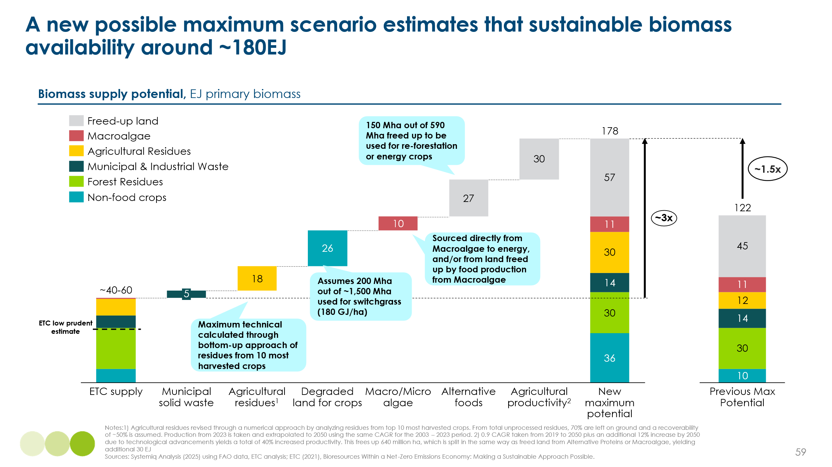

managing end of life carbon
Chapter 4 analysed potential sources of primary carbon supply which have different implications for gross and net CO2 emissions.
- Direct capture from the atmosphere or ocean will result in net zero emissions even if the use of the carbon (e.g. in aviation fuels) results in CO2 emissions.
- Similarly, the use of biomass can be zero carbon over the production and use cycle, with CO2 emissions in use balanced by CO2 absorbed during photosynthesis.
- But if fossil fuels are used, CO2 produced must be not only captured but also stored to deliver net zero emissions.
- And if carbon storage is applied to CO2 captured from the atmosphere or ocean, or at the end of an application using biomass, this can result in negative emissions, offsetting any residual emissions from unbated fossil fuel use.
This chapter therefore analyses the technologies available to store carbon at the end of life, considering in turn:
- Storage of gaseous CO2 whether via
  - Sedimentary storage in underground reservoirs or aquifers
  - In situ CO2 mineralisation
- Storage of solid carbon – in particular end of life plastics – considering both
  - Existing solid carbon management practices
  - Advanced landfill technologies
- Overall conclusions on the role of end of life carbon management
Exhibit 5.1
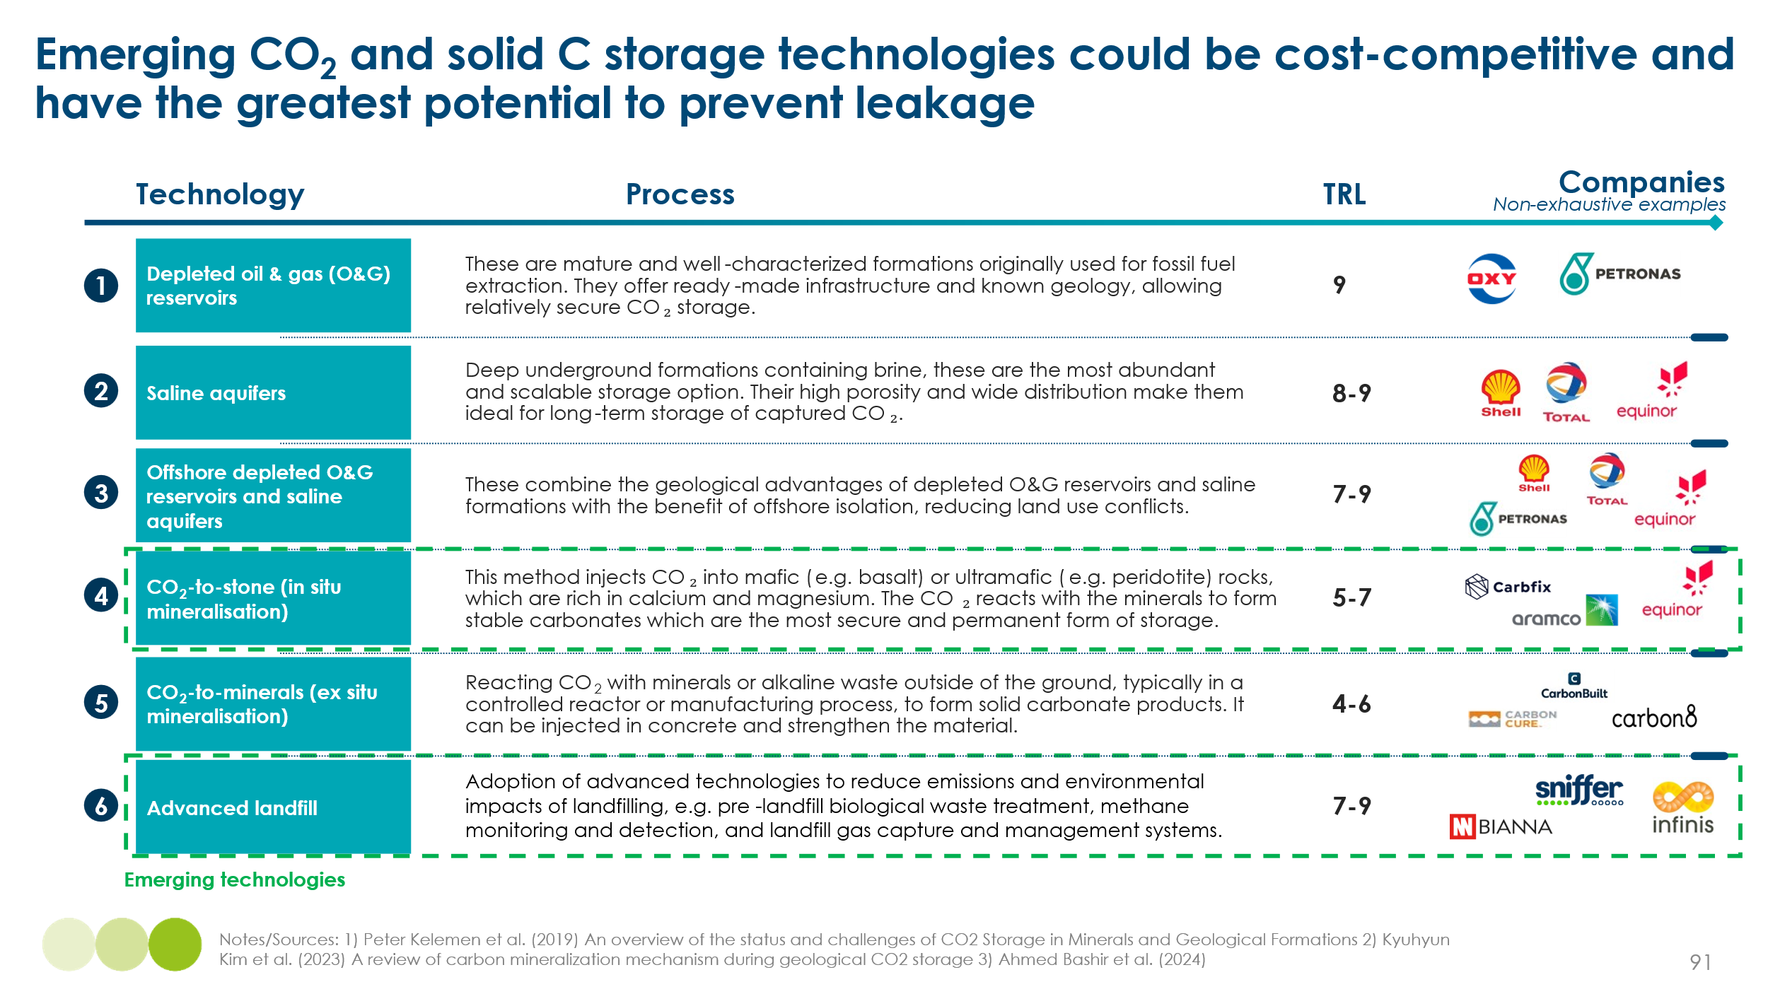

5.1 Managing and storing gaseous CO₂
Past ETC analysis has projected that large scale deployment of gaseous CO2 storage will be essential to achieve net zero emissions by mid-century. In our Fossil Fuels in Transition report (2023) our ACF scenario projected that 8.5GT per annum of CO2 would have be captured in 2050 (whether from point source applications or direct from the air), and that s 6.5GT of this will need to be stored. But today CO2 sequestration in sedimentary formations is currently only 50 million tonnes (0.05 Gt) p.a.
This section therefore assesses the potential for large scale up of sedimentary storage and the alternative strategy of in situ mineralisation.

5.1.1 Sedimentary CO₂ storage

Established sedimentary options for CO₂ storage have been the solution of focus to date, given their low cost and large theoretical capacities available. As shown on the left-hand side of Exhibit 5.2, global sedimentary CO₂ storage capacity is estimated at 51,000 GtCO₂, with regional capacities ranging from ~2,000-10,000 GtCO₂. Onshore CO₂ transport and storage networks offer the lowest cost potential (~$5-60/tCO₂ transported and stored) via pipeline transport and storage in depleted oil and gas reservoirs or saline aquifers. However, not all locations will have access to onshore CO₂ storage options or such locations may be politically unfavourable. An alternative is offshore CO₂ transport and storage, although these typically have higher cost requirements (upwards of $60/tCO₂ for transport and storage), owing to more complex infrastructure requirements (e.g. CO₂ liquefaction and shipping).
Exhibit 5.2
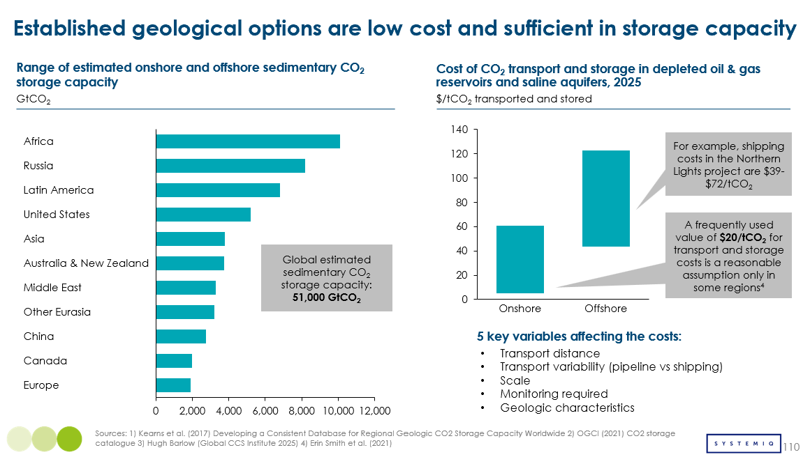

Depleted oil and gas reservoirs, along with deep saline aquifers, represent the most mature and well-understood geological options for long-term CO₂ storage. These formations benefit from decades of characterisation through hydrocarbon exploration and production, offering established pathways for injection. However, despite their technical readiness, multiple factors may constrain their ability to scale in line with climate targets. Exhibit 5.3 outlines four key limitations that could hamper the expansion of these conventional CO₂ storage solutions.
Exhibit 5.3
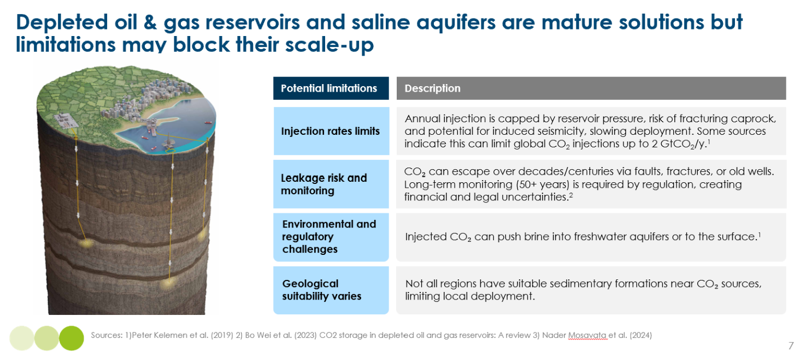
One major constraint is the limit on injection rates, which are governed by reservoir pressure, caprock integrity, and the risk of induced seismicity. These physical and geological barriers restrict how quickly CO₂ can be injected. This bottleneck highlights a fundamental tension between geological potential and operational feasibility, emphasizing potential limitations of global CO₂ injection rates.
Another important consideration is the perceived risk of CO₂ leakage and the burden of long-term monitoring. While well-selected geological formations, such as deep saline aquifers and depleted oil and gas reservoirs, have been shown to provide robust long-term containment, public concern often lingers around the potential for CO₂ to migrate through legacy wells, faults, or fractures over very long timescales. To manage this, regulatory frameworks typically require monitoring and liability coverage for several decades post-injection (often cited as 50 years), which can introduce financial and legal uncertainties. This makes rigorous site selection, well integrity assurance, and transparent monitoring essential not only for technical performance, but also to maintain public trust and support for project deployment.
Environmental and regulatory concerns may also present barriers to deployment. One commonly cited theoretical risk is that injected CO₂ could displace deep saline brines, which might migrate upward and contaminate overlying freshwater aquifers under certain geological conditions. , While such events have not been observed in commercial-scale projects, they are taken seriously by regulators and have been extensively modelled in academic literature. These perceived risks can trigger regulatory scrutiny and community opposition, particularly in regions with limited experience in subsurface resource management. In addition, regulatory regimes vary significantly across jurisdictions, contributing to uncertainty in permitting timelines and lowering investment confidence.
Lastly, geological suitability is not evenly distributed, with many CO₂ point sources located far from viable storage formations, creating logistical and cost challenges for pipeline or ship transport. This spatial mismatch reduces the economic viability of CCS in key industrial regions and further supports the case for exploring alternative or complementary storage pathways. Emerging CO₂ storage technologies could be critical to bridge this gap and ensure that global CCS infrastructure can meet 2050 capacity targets.

5.1.2 Innovation: in-situ CO₂ mineralisation

Overview
A promising alternative to sedimentary CO₂ storage, in-situ CO₂ mineralisation (TRL 5-7) offers the potential to permanently store carbon into reactive rock formations. In situ CO₂ mineralisation is a geological carbon storage technique that involves the underground injection of CO₂ into basaltic or ultramafic rocks, where it chemically reacts with naturally occurring minerals to form stable carbonates. Once injected, CO₂ dissolves in formation water and forms carbonic acid (H₂CO₃). This acidic solution reacts with silicate minerals rich in magnesium, calcium, and iron, releasing metal cations (e.g., Mg²⁺, Ca²⁺, Fe²⁺) that subsequently bond with carbonate ions (CO₃²⁻). The result is the formation of solid carbonate minerals such as calcite or magnesite, which permanently lock CO₂ in an immobile and inert form underground.
In situ mineralisation is being actively pursued by several pioneering companies worldwide. Notably, Carbfix in Iceland has demonstrated the viability of in situ mineralisation at scale (~36,000 tons of CO₂ per year), using the country’s abundant basaltic rock and renewable geothermal energy to inject and mineralise CO₂. In Canada, Deep Sky is undertaking feasibility studies for similar in situ storage by injecting CO₂ into reactive mafic and ultramafic rocks in Québec. In Kenya, Octavia Carbon is piloting ~1,000 tons of CO₂ storage per year via the integration of direct air capture with CO₂ injection into volcanic basalts in the East African Rift, targeting rapid and verifiable mineral storage. These efforts highlight growing momentum behind in situ mineralisation as a commercial CO₂ storage pathway.

Costs
Despite higher current costs, some mineralisation pathways are approaching cost competitiveness with conventional storage options. As shown in Exhibit 5.4, the least complex pathway (onland basalt) is estimated to currently cost only 50% greater than storage of CO₂ in conventional onshore sedimentary reservoirs. Conversely, more complex pathways such as seafloor basalt incur significantly higher costs, driven by logistical and technical challenges. Opportunities to deploy mineralisation close to emission sources or captured CO₂ could reduce transportation costs and offset some of the cost differential, particularly in regions with suitable geology.
In situ CO₂ mineralisation could offer significantly higher long-term storage potential than traditional sedimentary reservoirs. While formations such as depleted oil and gas fields and saline aquifers are estimated to provide a global maximum capacity of approximately 51,000 GtCO₂, some mineralisation pathways may offer an order of magnitude more. For example, onshore basalt formations, which represent the most cost-effective mineralisation option to date, are estimated to hold up to 250,000 GtCO₂.These formations are often found in different geophysical regions than sedimentary basins, including extensive onland basalt provinces in India, Siberia, and the Pacific Northwest of the United States, as well as along seafloor basalt formations such as those in East Africa and the mid-ocean ridges. This geographic distinction means that mineralisation and sedimentary storage can complement each other, expanding the global storage footprint in a regionally additive way. Together, these pathways form a portfolio of CO₂ storage options that improves overall scalability, resilience, and availability across diverse geographies.
Exhibit 5.4
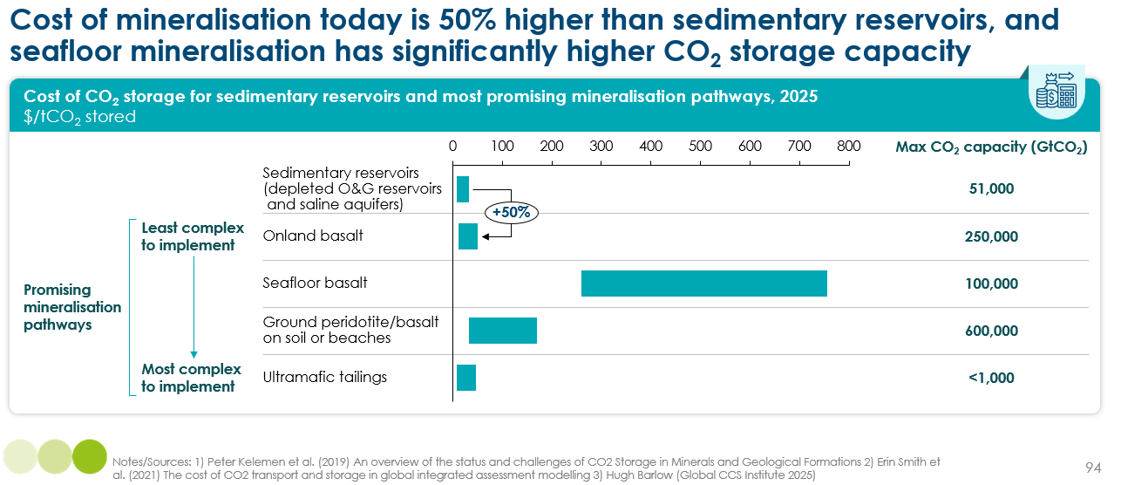

Impact
One of in situ mineralisation’s most significant advantages lies in its permanence: unlike storage in sedimentary reservoirs, mineralised CO₂ becomes chemically stable and immobile within the host rock. This eliminates the risk of long-term leakage and may reduce or remove the need for multi-decade post-injection monitoring and liability management. This level of containment may appeal to industries, regulators, and the public alike, helping build trust in the long-term security of CO₂ storage.
In addition, in situ mineralisation presents no intrinsic environmental limitation on injection rates, making it a potentially high-throughput solution in geologically suitable locations. By contrast, sedimentary storage systems such as saline aquifers or depleted oil and gas fields are constrained by pressure build-up, caprock integrity limits, and induced seismicity risks. These factors require complex reservoir modelling and pressure management strategies to avoid leakage or damage. Mineralisation avoids these issues: the CO₂ reacts rapidly with host rock, forming stable carbonates and eliminating pressure buildup, which allows for more continuous and potentially higher injection rates.
However, in situ mineralisation is currently more expensive than sedimentary storage, in part due to limited infrastructure maturity, site development costs, and the need for CO₂ pre-conditioning (such as pressurization or transport to remote basaltic regions). That said, costs may come down over time through process integration with industrial emitters, co-location with renewable energy, and scaling of successful demonstration projects. In the longer term, mineralisation’s appeal may lie less in near-term cost competitiveness and more in its potential to simplify long-term monitoring, increase geographic storage options, and address public acceptance barriers in jurisdictions where traditional storage faces opposition or regulatory inertia.

Barriers and Enablers
The most significant barrier to widespread deployment faced by in situ CO2 mineralisation is its geological constraint. Suitable rock types are not uniformly distributed across all regions and are often located far from major industrial emission sources. This geographical mismatch raises infrastructure and transport challenges, potentially limiting the number of viable project sites and increasing overall CO₂ transport costs.
Another barrier is the lack of existing infrastructure and regulatory frameworks. Unlike conventional CO₂ storage in depleted oil and gas reservoirs, mineralisation lacks a mature network of pipelines, wells, and monitoring systems. Moreover, permitting pathways and standards for this emerging approach are still being defined in many jurisdictions, which may slow project development and final investment decisions. However, there is growing momentum in some regions such as Europe. In 2025, the first permit for large-scale onshore CO₂ mineralisation was awarded to Carbfix under the EU’s CCS Directive. While the permitted storage volume is modest (approximately 106 ktCO₂ per year, totalling 3.2 MtCO₂ over three decades) the project represents a significant regulatory milestone. It establishes a permitting pathway for in situ mineralisation in the EU and may pave the way for larger-scale deployments in the future.
Despite these challenges, an important enabler that could accelerate deployment of in situ mineralisation is the growing emphasis on CO₂ storage durability and permanence. Governments and regulators are increasingly embedding long-term durability as a criterion in carbon removal schemes. For instance, the UK is considering integrating carbon removals into its Emissions Trading Scheme, provided permanence of carbon storage can be verifiably measured. Similarly, the Integrity Council for the Voluntary Carbon Market has launched a work programme focused on permanence, proposing industry-wide liability mechanisms to ensure removal permanence over decades. These policy and market shifts may lend preference to CO₂ storage technologies such as in situ mineralisation given its demonstrable permanence of CO₂ in solid form.
Another key enabler could be the co-location of DAC systems with on-land CO₂ mineralisation geological formations. Placing DAC units near basalt or ultramafic rock allows for modular, scalable systems without reliance on offshore infrastructure. However, this model depends not only on suitable geology but also on abundant, low-cost renewable energy, given DAC’s high energy requirements. Emerging strategies should focus on coastal locations where onland basalt formations coincide with strong renewable resources. This setup may offer a pathway to low-cost, permanent carbon removal, particularly as o-CDR frameworks evolve. The Carbfix–Climeworks project in Iceland illustrates this model, combining geothermal-powered DAC with nearby basalt storage.

5.2 Managing solid carbon

For the solid carbon contained in physical products, notably plastics, recycling technologies alone will be unable to manage carbon at end-of-life. Exhibit 5.5 showcases a balanced scenario for the end-of-life management of plastic waste in 2040, incorporating circular economy solutions (e.g. reduced demand, recycling) and linear waste management practices (i.e. landfill or incineration). Under this scenario, a significant amount, i.e. 40% of global plastic waste (181 million tonnes), could still be sent to landfill by 2040.
Exhibit 5.5
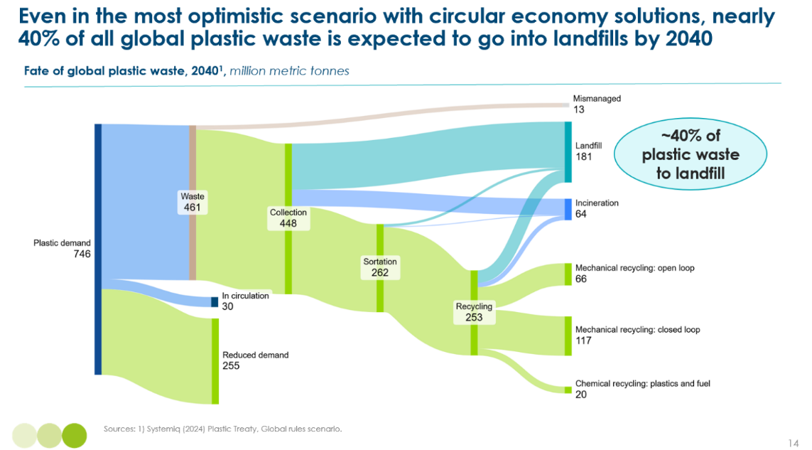

5.2.1 Existing solid carbon management practices

Landfill and incineration are the dominant commercial technologies for managing plastic waste and broader municipal solid waste (MSW) streams that are not recycled. In developed regions, managed landfills are typically designed with multiple engineered protections to prevent leakage to the environment, such as bottom liners and cover materials or containment and treatment systems for waste by-products (e.g. leachate). However, landfill quality varies widely across the globe. In many low- and middle-income countries, waste is still disposed of in open dumps or poorly managed landfills, which often lack containment and are vulnerable to geological instability, flooding, or coastal erosion, leading to significant environmental risks. At the same time, waste incineration is a well-established and mature industry, particularly in industrialised countries. Many facilities operate under long-term public service contracts and are integrated with waste-to-energy (WtE) systems that recover energy from combustion, typically as electricity, heat, or both.
Both landfilling and incineration of plastic waste are significant drivers of climate change, together currently emitting approximately 1.2 GtCO₂eq per year,. Emissions from landfill are primarily driven by the anaerobic decomposition of organic components of MSW (e.g. food waste) which produces landfill gas, a mixture of methane and CO₂. Given the significant global warming potential of methane, management of landfill gas is becoming an increasing priority for site operators. On the other hand, waste incineration plants emit primarily CO₂ from the combustion of fossil-derived materials such as plastics. Mitigating these emissions will require improved waste management practices, such as the adoption of advanced landfilling technologies or application of CCS on incinerators.

5.2.2 Innovation: advanced landfill technologies

Overview
Adoption of advanced landfill technologies will be critical to manage and reduce the GHG emissions of future landfill sites. As shown in Exhibit 5.6, such technologies include:
- Pre-landfill material recovery and biological treatment (MRBT): This technology involves stabilising biogenic MSW through aerobic decomposition before it is landfilled. The aim is to reduce the mass of the input waste by approximately 25–30%, significantly lowering its methane-generating potential once buried. By biologically treating the waste in advance (typically through controlled aerobic composting), the organic content that would typically decompose anaerobically in landfills (and release methane) is largely neutralised. This method is a proactive approach aimed at minimising future emissions at the source, whilst aligning with circular economy principles by enabling the recovery of materials prior to disposal.
- Comprehensive methane monitoring and detection: This category includes advanced systems designed to detect and measure methane leakage from landfills. Tools employed can include aerial infrared imaging, drone-mounted sensors, and continuous ground-based analysers. These systems enhance the accuracy and frequency of monitoring, making it easier to detect leaks promptly and take corrective action (e.g. capping leaks). Monitoring technologies can play a vital role in identifying fugitive emissions that are otherwise hard to track and ensuring that landfills mitigate GHG emissions more effectively.
- Landfill gas capture and management systems: These systems focus on capturing landfill gas (methane and CO₂) generated during waste decomposition. The gas is collected at designated wells and routed via pipelines, where it can be processed and upgraded for use as an energy source or fuel. As landfill gas benefits from its biogenic CO₂ content, it is expected to become increasingly marketable in low-carbon energy markets. Additionally, biocover materials may be used on the landfill surface to trap gases and enhance microbial methane oxidation. Together, these systems can help reduce the release of GHG emissions from landfills.
Exhibit 5.6
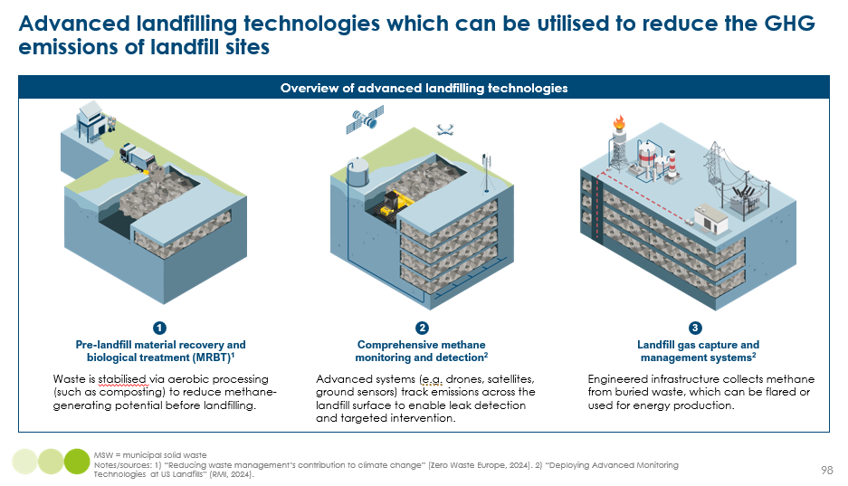
Costs
Advanced landfilling with MRBT could be implemented at only a marginally higher cost than conventional managed landfills. As shown in Exhibit 5.7, the cost of a managed landfill typically ranges from $30–120 per tonne of waste, influenced by factors such as land and labour costs or landfill system designs. In comparison, advanced landfill systems incorporating MRBT could have a relatively minor incremental cost of roughly $30/tonne. Given this small cost increase, adopting advanced landfill systems could offer a cost-effective way to reduce GHG emissions from landfills.
Compared to incineration with CCS, advanced landfilling with MRBT is significantly more cost-competitive and technologically mature. Exhibit 5.7 highlights that incineration with CCS entails a much higher cost between $260–310 per tonne of waste, equating to approximately 2 to 3 times the cost of advanced landfilling. Incineration without CCS also remains more expensive, at $130–180 per tonne. This positions advanced landfilling as a highly attractive solution, especially for jurisdictions seeking to balance emissions reductions with financial feasibility. Additionally, advanced landfill technologies are at a higher technology readiness level (TRL 8–9) than incineration with CCS (TRL 7), making them an immediately deployable solution. While managed/advanced landfilling could offer a more cost-effective and market-ready solution, there are other pragmatic considerations (e.g. land use, environmental trade-offs) that influence regional decision-making on waste management strategies and regulations.
Exhibit 5.7
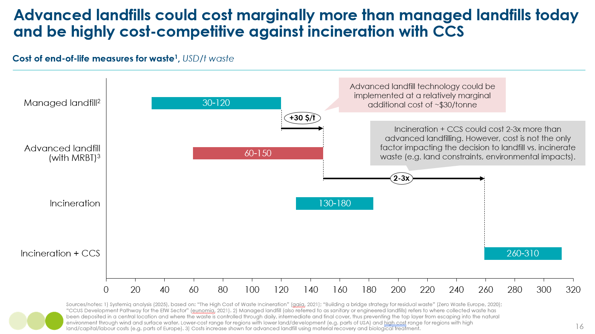

Considering project cost and revenue structures, advanced landfill technologies such as MRBT could potentially achieve breakeven with only marginal additional revenue. Exhibit 5.8 (left-hand side) illustrates this cost and revenue structure for the US, a country with greater reliance on landfilling. Due to relatively low baseline landfill costs and the ability to recover revenue (e.g., through waste collection gate fees), the net additional revenue required to breakeven with MRBT is modestly around $10/tonne. This suggests advanced landfilling could be a financially viable investment in regions that rely heavily on landfill disposal, particularly where regulatory incentives can support cost recovery.
By contrast, the addition of CCS to incineration could significantly increase project costs, particularly in incineration-dependent markets. As shown Exhibit 5.8 (right-hand side), incineration with CCS in the UK could require a steep additional cost of approximately $130/tonne, translating to an extra $60/tonne in revenue required to breakeven. Even with electricity and heat revenues factored in, the financial gap is substantial, posing a challenge for widespread CCS deployment without substantial public subsidies or higher gate fees. This contrast underscores the relatively lower economic hurdle associated with scaling advanced landfilling technologies, which may offer a more pragmatic path for emission reduction in certain geographies.
Exhibit 5.8
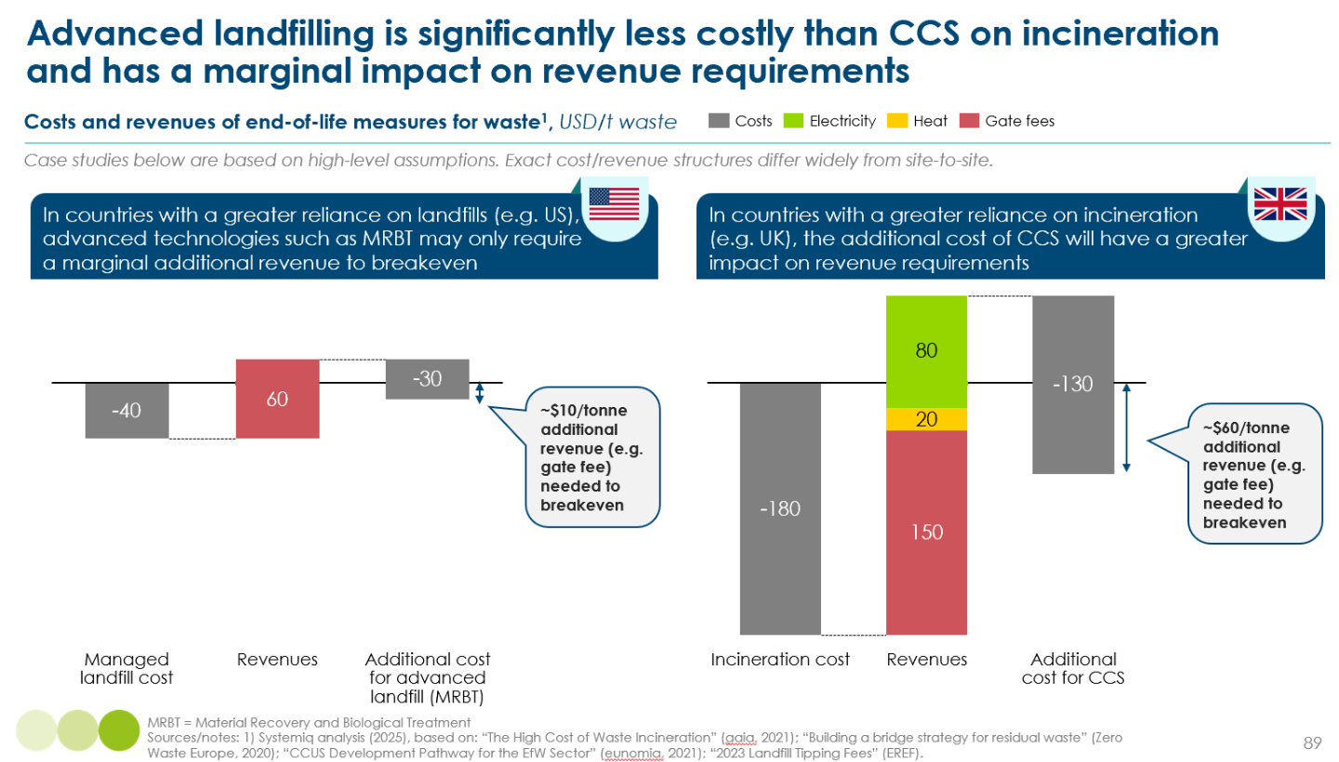

Impact
Advanced landfilling of MSW can reduce GHG emissions by up to 92% compared to managed landfilling, achieving emissions levels comparable to incineration with CCS. As shown in Exhibit 5.9, combining MRBT with gas capture systems can reduce emissions by a factor of ~10, from 2.1 tCO₂e/t waste (for conventional managed landfills) down to 0.2 tCO₂e/t. This is on par with the emissions from incineration with CCS, which also achieves 0.1–0.2 tCO₂e/t waste. Pure plastic waste emits less (0.1 tCO₂e/t) than MSW (2.1 tCO₂e/t), since plastics do not generate methane in anaerobic conditions. MRBT contributes significantly to this reduction by biologically stabilising organic waste and minimising methane generation. When paired with gas capture infrastructure, the remaining landfill gas emissions can be further contained, delivering significant GHG mitigation potential. As methane represents ~90% of landfill GHG emissions, abatement is particularly important given methane’s high global warming potential over a 20-year horizon, where its impact is over 80 times that of CO₂.
Exhibit 5.9
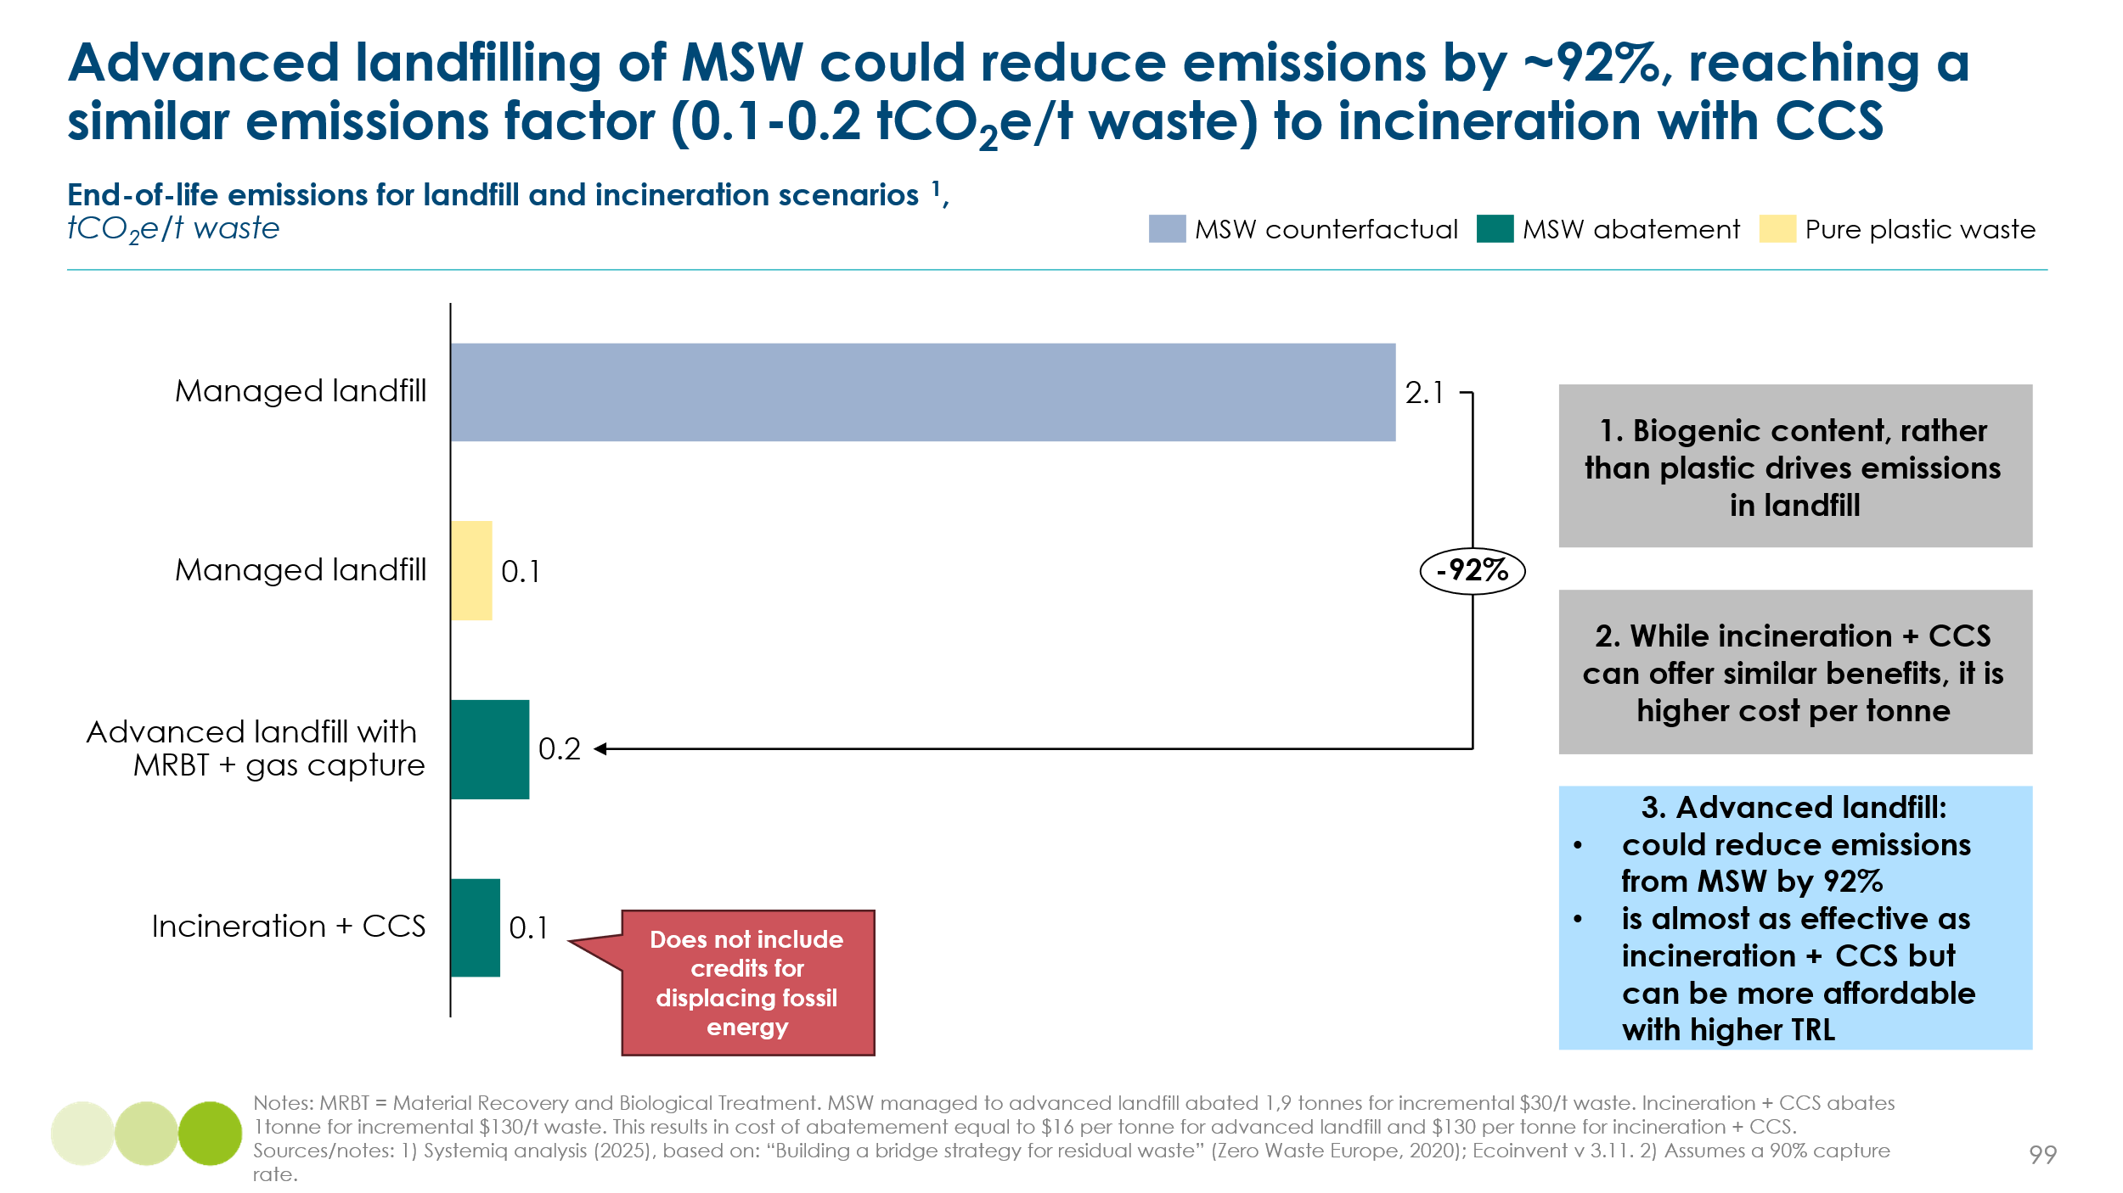

Barriers and enablers

One of the primary barriers to advanced landfilling is the lack of upfront capital and operational funding, especially in low- and middle-income regions. Technologies such as MRBT, comprehensive methane detection, and landfill gas capture systems require significant investment in infrastructure and equipment, along with the development of a skilled workforce. Many municipalities still operate under budget-constrained waste management systems, with unsanitary landfills or open dumpsites common in low-income countries. Investments may therefore be difficult to justify without guaranteed returns or proper revenue mechanisms (e.g. sufficient gate fees for waste collection), limiting their attractiveness to both public and private investors.

Another major barrier is access to land. In densely populated or rapidly urbanising areas, securing adequate space for landfill sites is increasingly difficult. Land near population centres is highly competitive, and new landfill proposals often face strong local opposition due to concerns about odour, traffic, health impacts, and land value. This spatial constraint can push policymakers toward waste-to-energy incineration, which requires less land and can be co-located with industrial facilities. However, this shift often comes at the cost of higher emissions and lower material recovery. Despite these pressures, the cumulative land required for landfilling all plastic waste generated between now and 2040 is projected to remain minimal, constituting less than 0.001% of Earth’s total land area.

A further barrier lies in the lack of strong policy frameworks supporting the adoption of advanced landfilling technologies. In many countries, regulations governing landfilling practices are either outdated or insufficiently enforced, allowing continued reliance on low-cost, high-emission landfill operations. Without clear mandates to reduce biodegradable waste or control methane emissions, there is little regulatory pressure to modernise landfills. Additionally, fragmented jurisdiction between national and local governments can lead to inconsistent implementation (e.g. national government regulations on GHG emissions versus local government management of waste), further hindering technology deployment. In high-income countries, another critical challenge is the existence of long-term waste incineration contracts between municipalities and private operators, creating a strong lock-in effect. These agreements can be expensive to exit and discourage the consideration of alternative solutions such as advanced landfilling. In parallel, incineration of waste to produce power continues to benefit from favourable carbon accounting (e.g. grid electricity emissions offsetting), despite being one of the most carbon-intensive ways to generate electricity.

Social acceptability and broader environmental considerations pose additional barriers to scaling advanced landfilling. Public perception of landfills are often negative, given their association with land degradation, environmental contamination risks, and unfavourable odours/sights. Hence, local communities are not typically in favour of nearby landfill sites. Investing in well-managed and state-of-the-art facilities can help build trust and shift social acceptability around modern landfilling. While critics may argue that advanced landfilling could reduce momentum for upstream waste prevention, it is important to recognise their climate benefits. Advanced (methane-mitigated) landfills represent a substantially lower-emission alternative to unabated incineration and offer a pragmatic near-term strategy in landfill-dependent regions.

Policy mandates and regulatory requirements are critical enablers for scaling advanced landfill technologies by creating binding obligations to reduce emissions. The EU Landfill Directive, for example, requires Member States to cut the volume of biodegradable waste sent to landfills by 35% relative to 1995 levels. Complementing this, the EU Waste Framework Directive has mandated the separate recycling and collection of biowaste since end of 2023. These mechanisms pressure municipalities to adopt upstream treatment such as MRBT or invest in biowaste collection and recycling systems. In addition, mandates provide long-term clarity and direction, enabling better planning and investment decisions in waste management infrastructure. Similar regulatory measures can also drive the installation of gas capture systems by requiring landfills above a certain capacity to control and report their methane emissions.

Public and private financial incentives can play a powerful role in accelerating technology deployment, especially when aligned with energy or carbon markets. For example, the US offers corporate tax credits of up to 1.5 cents/kWh for electricity generated from landfill gas, creating a market signal that supports gas capture and utilisation projects. Commercial power purchase agreements (PPAs) for renewable electricity sourced from landfill gas can offer another revenue stream, reducing the payback period for investment. Emerging carbon markets also present a growing opportunity to monetise methane abatement from unmanaged landfills in developing countries. For example, projects can access revenues through Verra’s Verified Carbon Standard, with methodologies enabling credits from landfill gas capture or energy use. Overall, a range of incentives can be considered to overcome cost barriers and derisk projects for developers and municipalities.

5.3 Conclusions on end-of-life carbon management
The analysis presented above shows that
- Both CO2 storage in geological formations (e.g. reservoirs and aquifers ) and in-situ mineralisation, can provide safe and permanent sequestration of gaseous CO2.
- Storage in solid carbon form can also be made safe and permanent. Strategies for decarbonising the plastic life-cycle should not therefore exclude the possibility of high-quality in ground storage.
But it is important to recognise the risks that poorly regulated and monitored storage could be unsafe and impermanent, and that extensive reliance on end of life storage maintains a major role for fossil fuel extraction, and processing, which in itself is a major source of CO2 and methane emissions. It is therefore essential that:
- Both gas and solid carbon storage is subject to tight regulations and monitoring.
- Carbon and methane pricing and regulation is applied to upstream fossil fuel production, processing and distribution.

technology trade-offs
Chapters 1 to 5 have assessed multiple currently available or emerging technologies which could make it possible to achieve net zero emissions by mid-century. These technologies make it possible to either (i) provide energy services without any carbon molecule input (ii) reuse or recycle carbon molecules (iii) extract primary carbon supply from non-fossil fuel sources (iv) offset emissions with carbon capture and storage.
The optimal balance over time between these different technologies will reflect technological readiness, costs or tonne of CO2 reduction, energy input costs now and in the future, and natural resource demands. These will all evolve over time, but current comparisons suggest the following broad conclusions.
Technological readiness. In terms of technological readiness (measured by TRL) there is no pattern suggesting that particular categories of technology are likely to dominate (Exhibit 6.1). Across all of the seven broad categories of possible solutions, there are in most cases multiple technologies in the 5 to 9 TRL range (Exhibit 6.1). The major exceptions are
- Electro winning and metal oxide electrolysis (MOE) are still assessed to be at a TRL of 4 to 5, and significant technological advancement and fine-tuning is therefore required before commercial rollout.
- Geological hydrogen extraction remains at low technological readiness due to technical challenges (limited field demonstrations, uncertain resources, immature extraction methods, and hydrogen purity issues), economic barriers (unproven costs and uncertain yields), regulatory gaps (lack of frameworks and dedicated infrastructure), and environmental concerns (risks of gas leakage, groundwater contamination, and seismicity). However, investors in this industry are confident that these hurdles will be overcome in the coming decades.
- In situ mineralisation of CO₂ remains at a relatively low technological readiness due to technical and cost hurdles including slow reaction rates, subsurface and feedstock uncertainties, high energy and infrastructure requirements, and the need for robust monitoring techniques. These factors have kept costs high and have limited large-scale deployment to date, but some commercial-scale deployment is expected within the next decade.
- Synthetic/cultured meat production is still at a very early stage of technological and commercial deployment. As a result, the feasibility of the large upside for sustainable bioresource extraction, shown on Exhibit 4.30, remains unproven.
Cost per ton of CO2 abated. Exhibit 6.2 presents a summary of multiple estimates of the cost of abatement for the different technologies in 2030/2035. There are significant degrees of uncertainty around each specific estimate, but the very wide dispersion between the different technologies suggests some broad conclusions.
- In principle reuse of materials and material recycling of plastics should be able to reduce primary carbon demand at negative cost of abatement. They crucially depend however on the introduction and social acceptance of more disciplined end of life recovery and sortation
- Several direct electrification technologies – in particular electro winning, MOE, and e-cracking, seem likely in principle to be low cost options if and when they progress to a higher TRL level
- Several point source CCS solutions seem likely to be among the more economic options, but estimates of DACCS for 2030 make it still a very expensive option at that time
- The several carbon capture and use options seem very expensive, and will need to achieve significant cost reductions to play a major role
Energy costs now and in the future. One key determinant of the 2030/2035 abatement costs shown in Exhibit 6.2 is the energy intensity of the different processes and the costs of energy inputs. For instance both DACCS and chemical recycling via gasification have high cost because they are very energy intensive processes; and the high cost of the CCU options are to a significant extent driven by the assumed cost of green hydrogen inputs, which in turn depend on the cost of electricity.
As a result these technologies would become more competitive if the cost of zero carbon electricity declined significantly, either globally or in specific regions. As the ETC‘s recent report on Power Systems Transformation sets out, this is likely to occur over the medium term in “global sunbelt“ countries which enjoy very large solar or wind resources In specific locations therefore some of the technologies – and in particular DACCS – are likely to play a more significant role than their position on Exhibit 6.2 suggests.
Natural resource and local environmental effects. Securing primary carbon supply from either fossil or bio resources will inevitably have a significant local environmental impact: these arise from the mining, drilling, transport and refining involved in fossil fuel supply, and from the biodiversity losses which may result from biomass extraction. Circularity via reuse or recycling of materials is the most effective lever to reduce this input.
Bio energy by resource supply creates the greatest demand for land: other technology options e.g., for gaseous or solid carbon storage, are trivial by comparison. For example, landfilling all of the world’s municipal solid waste (including plastic) from now until 2040 would theoretically occupy 0.85 million hectares, where the freeing up of land via alternative proteins could generate 28EJ using 585 million hectares (see Exhibit 4.30). Regulation to minimise the adverse effects on biodiversity, and to avoid bad incentives for land degradation (e.g. as shown on Exhibit 4.26) are therefore essential.
Exhibit 6.1
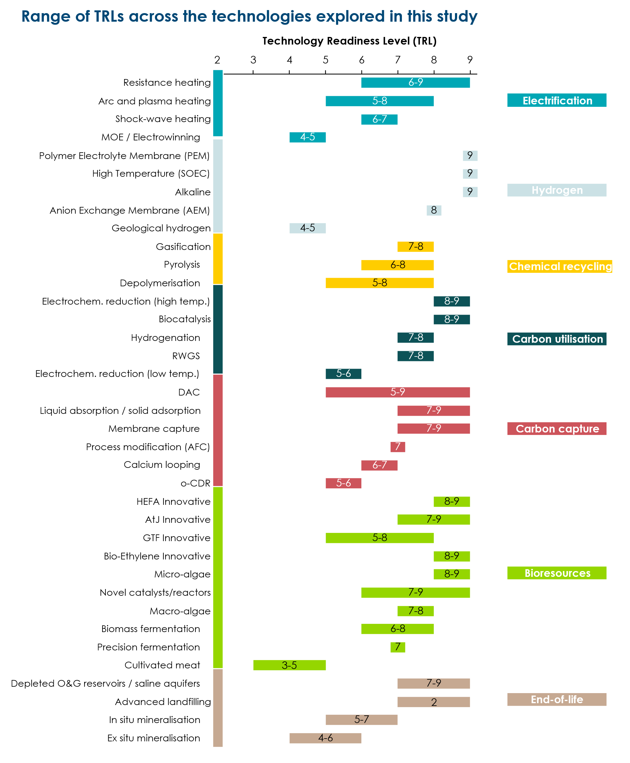

Exhibit 6.2
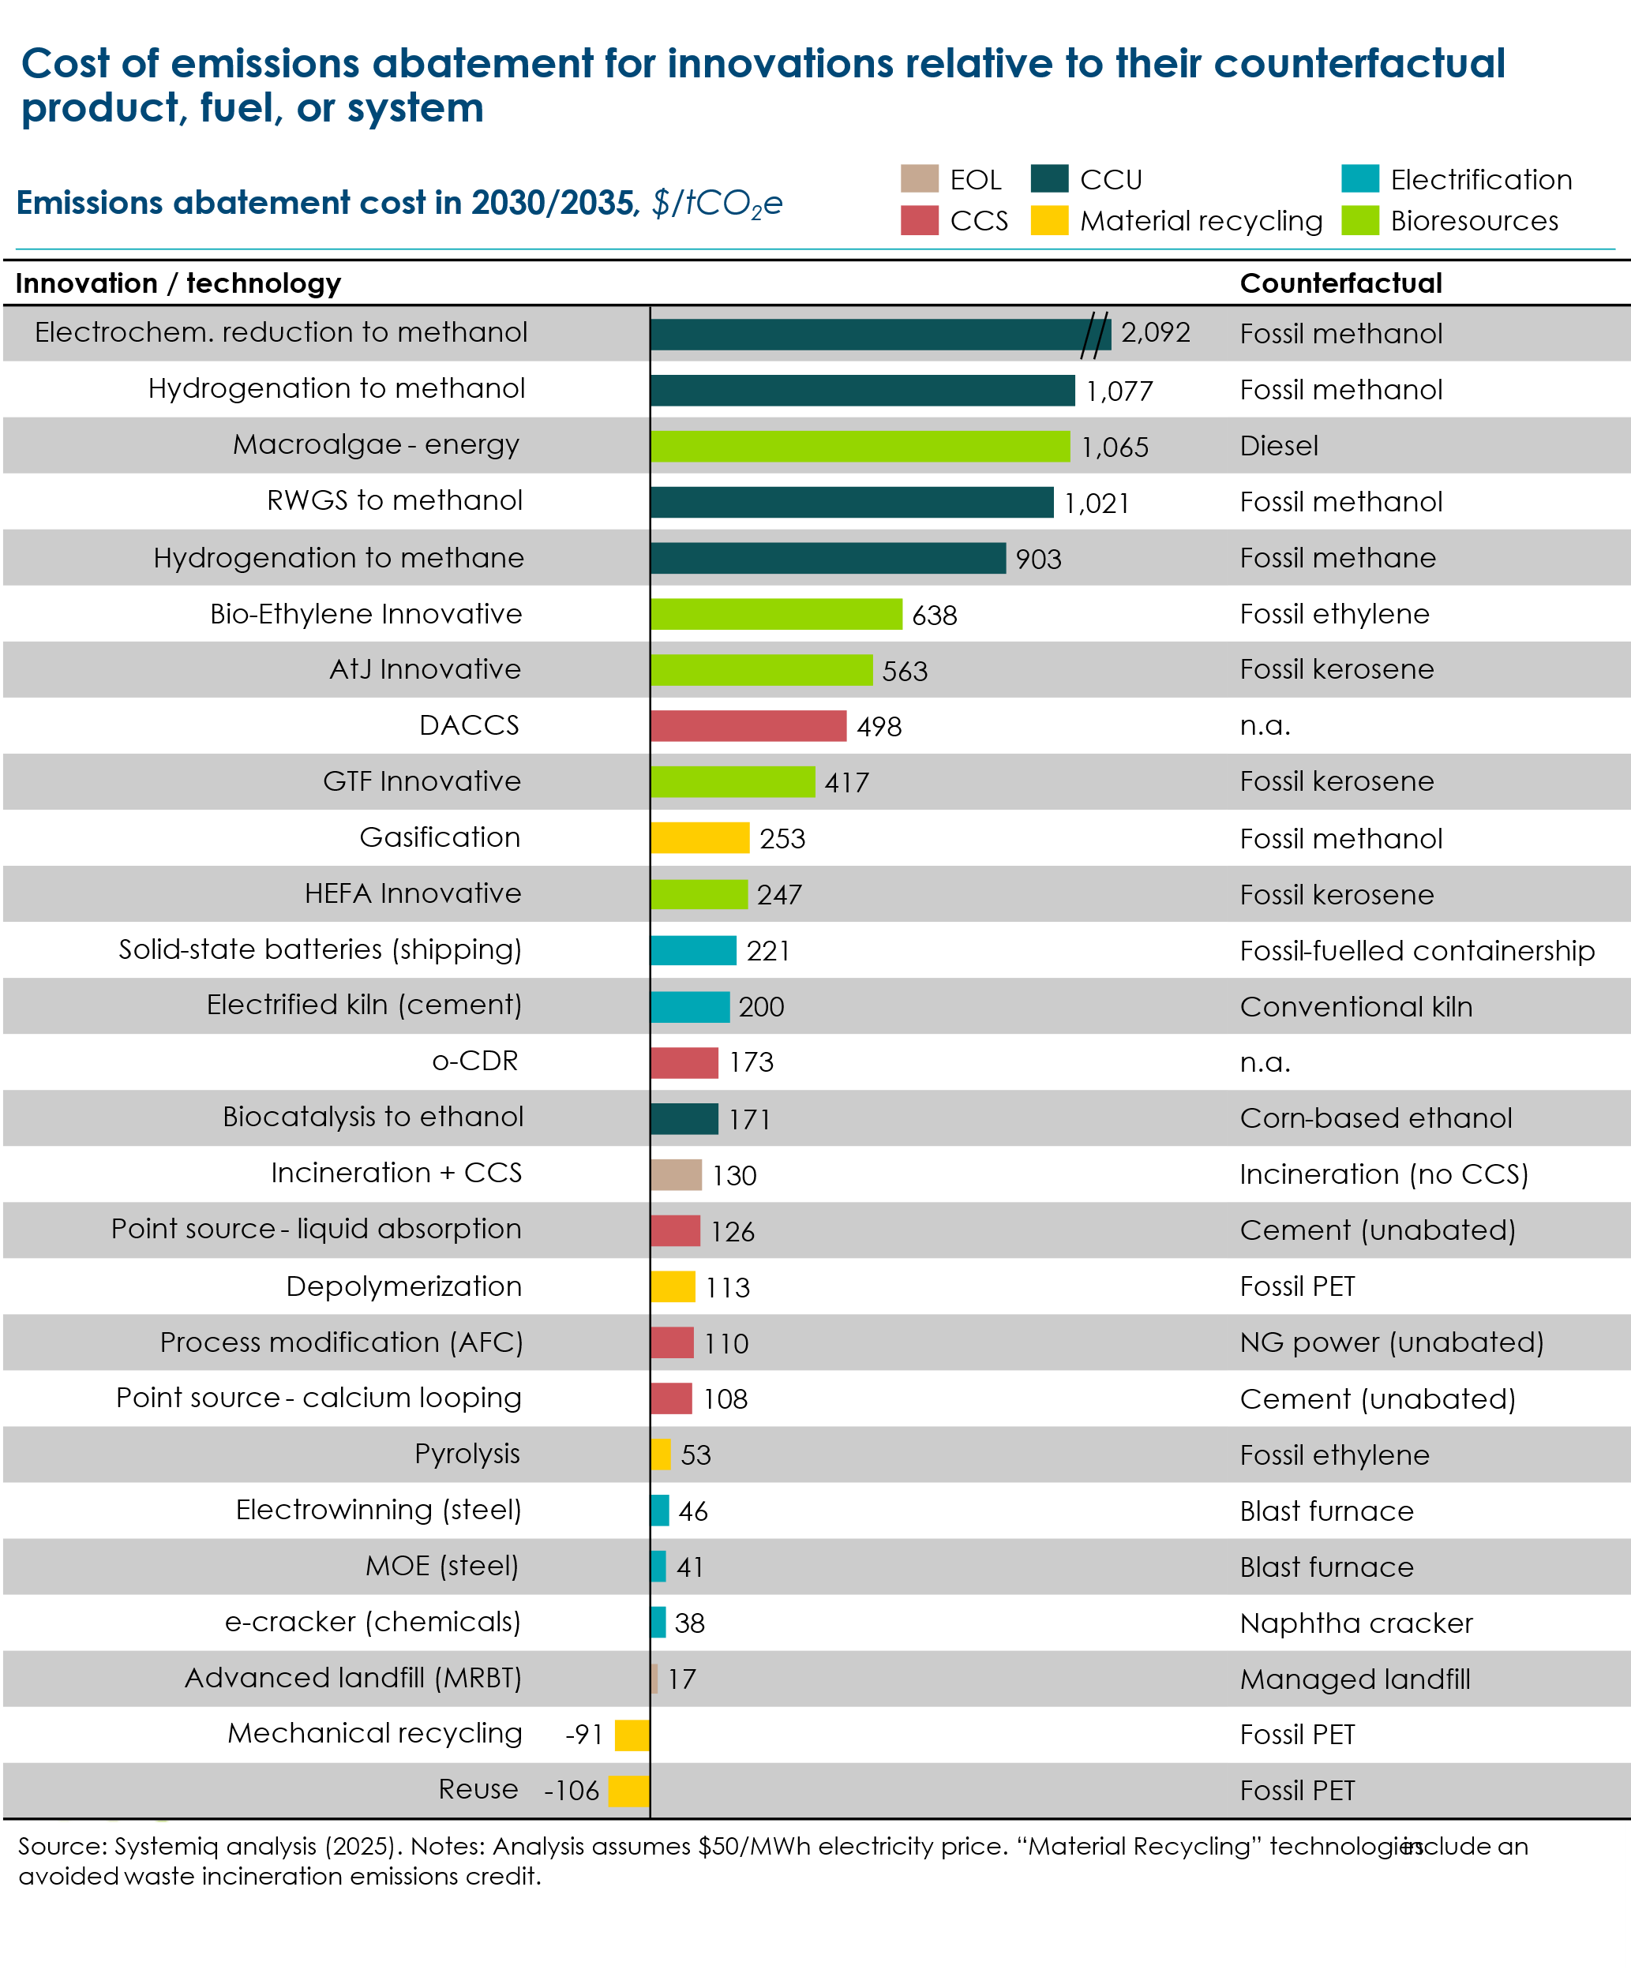

technology scenarios 2050
Exhibit 0.1 in the introduction set out the current pattern of carbon supply, use and end destination in today’s energy and material system. In this system, total carbon usage amounts to 11.5 Gt C: 85% of this is derived from the ground, and 88% results in emissions to the atmosphere.
The technologies discussed in this report could be combined in multiple different ways to deliver net zero emissions to the atmosphere. We have therefore developed four scenarios which represent different ways in which this objective could be achieved. Table 3 explains key features of each scenario, Exhibits 7.1-7.4 show the resulting pattern of supply, use and demand; and Table 4 shows the quantities of carbon usage and end destination in millions of tons.
In all four cases the total quantity of carbon used in the global energy and material system is dramatically reduced from today 11.5 Gt to between 3.2 Gt to 4.7 Gt depending on scenario. This reflects the impact of electrification which, as Exhibit 0.2 showed, is certain to produce a major reduction in the use of carbon based molecules even before considering the options for increased electrification which were considered in Chapter 1.
But the balance between different sources and destinations for carbon differs significantly between the four scenarios.
- In our Base case scenario (Exhibit 7.1) which broadly reflects the ETC‘s Accelerated but clearly feasible (ACF) scenario from our Fossil Fuels in Transition report, recycling and reuse has grown from today’s 2% of carbon supply to 13% by 2050: but 57% of carbon supply still derives from fossil fuels extracted from the ground, with 30% deriving from bio resource. Meanwhile at the end of life, 21% of carbon inputs remain in use, 55% of end of life carbon is stored in gaseous or solid form, while 10% is still emitted to the atmosphere. This residual atmospheric emission is however compatible with net zero because of the offsetting impact of CO2 sequestration via photosynthesis in the production of biomass.

- The Minimum primary carbon scenario (Exhibit 7.2) explores the potential impact of maximum progress towards the electrification options considered in Chapter 1, and the reuse/recycling options examined in Chapter 3. In this scenario total demand for carbon is reduced to 3.2 Gt of which a greatly increased 29% is provided via recycling or reuse. Bio resource supply falls to 1.4 Gt versus 1.5 Gt in the Base Case, while fossil carbon supply falls dramatically from 2.7 Gt to 1Gt. Meanwhile at end of life, 60% of all carbon used is reused, recycled or stays in use, while the need for gaseous storage falls from 2.2Gt to 0.8 Gt of carbon (or from 8.0 Gt to 2.9 Gt of CO2).The feasibility of this scenario depends on the abundant supply of low-cost green power, faster market penetration of electric technologies, and large investments in collection, recycling and carbon utilisation systems.

- The Minimum Fossil Carbon scenario (Exhibit 7.3) maintains the ambitious electrification assumption, and therefore also has a low total carbon demand at 3.5 Gt. But it illustrates how far fossil fuel demand could be reduced if total sustainable biomass supply reached 90EJ which is half of the absolute maximum discussed in section 5.3 (Exhibit 4.38). Under this assumption, total carbon supply from fossil sources would be reduced to just 560 million tons, 16% of the 2050 total, and a 94% reduction from today’s 9.7 Gt. In this scenario the need for end of life gaseous would be dramatically reduced to around 410 million tonnes (about 2Gt of CO2) since bio energy can be a zero carbon energy source even if CCS is not deployed.

- Finally in the Fossil fuel in Perpetuity scenario, (Exhibit 7.4) we explore the implications of accepting a large continuing role for fossil fuels – though one still much reduced from today, with total fossil fuel use of 3.4 Gt C versus 9.7 Gt C today. This scenario inevitably maximises the need for carbon storage, with a gaseous storage need at about 2.6 Gt of carbon or 10Gt of CO2. This would require a massive and rapid buildup from today’s minimal level of CCS deployment.

Across all scenarios, deep dependency on different technologies shapes both risks and opportunities. The Fossil-in-Perpetuity pathway, where roughly 70% of carbon is stored underground, hinges on large-scale deployment of carbon capture and storage (CCS) and direct air capture (DACC)—technologies that remain expensive and largely unscaled. In contrast, the Minimise-Fossil-Carbon scenario leans on abundant biomass, supported by complementary levers such as biotechnology-driven dietary shifts, high-yield energy crops, and utilisation of agricultural and forestry residues. Yet biomass-based strategies face critical constraints, from land availability to competing demands for food production and biodiversity. Meanwhile, electrification consistently offers the steepest near-term reduction in fossil demand across all scenarios, but cannot fully displace the need for carbon-based molecules. Successfully balancing those molecules with net zero targets requires active monitoring of technology progress and strategic, diversified investment—avoiding over-reliance on any single pathway and ensuring flexibility to adapt as conditions change

Table 3 Description of Scenarios developed for carbon flows for materials and energy, 2050
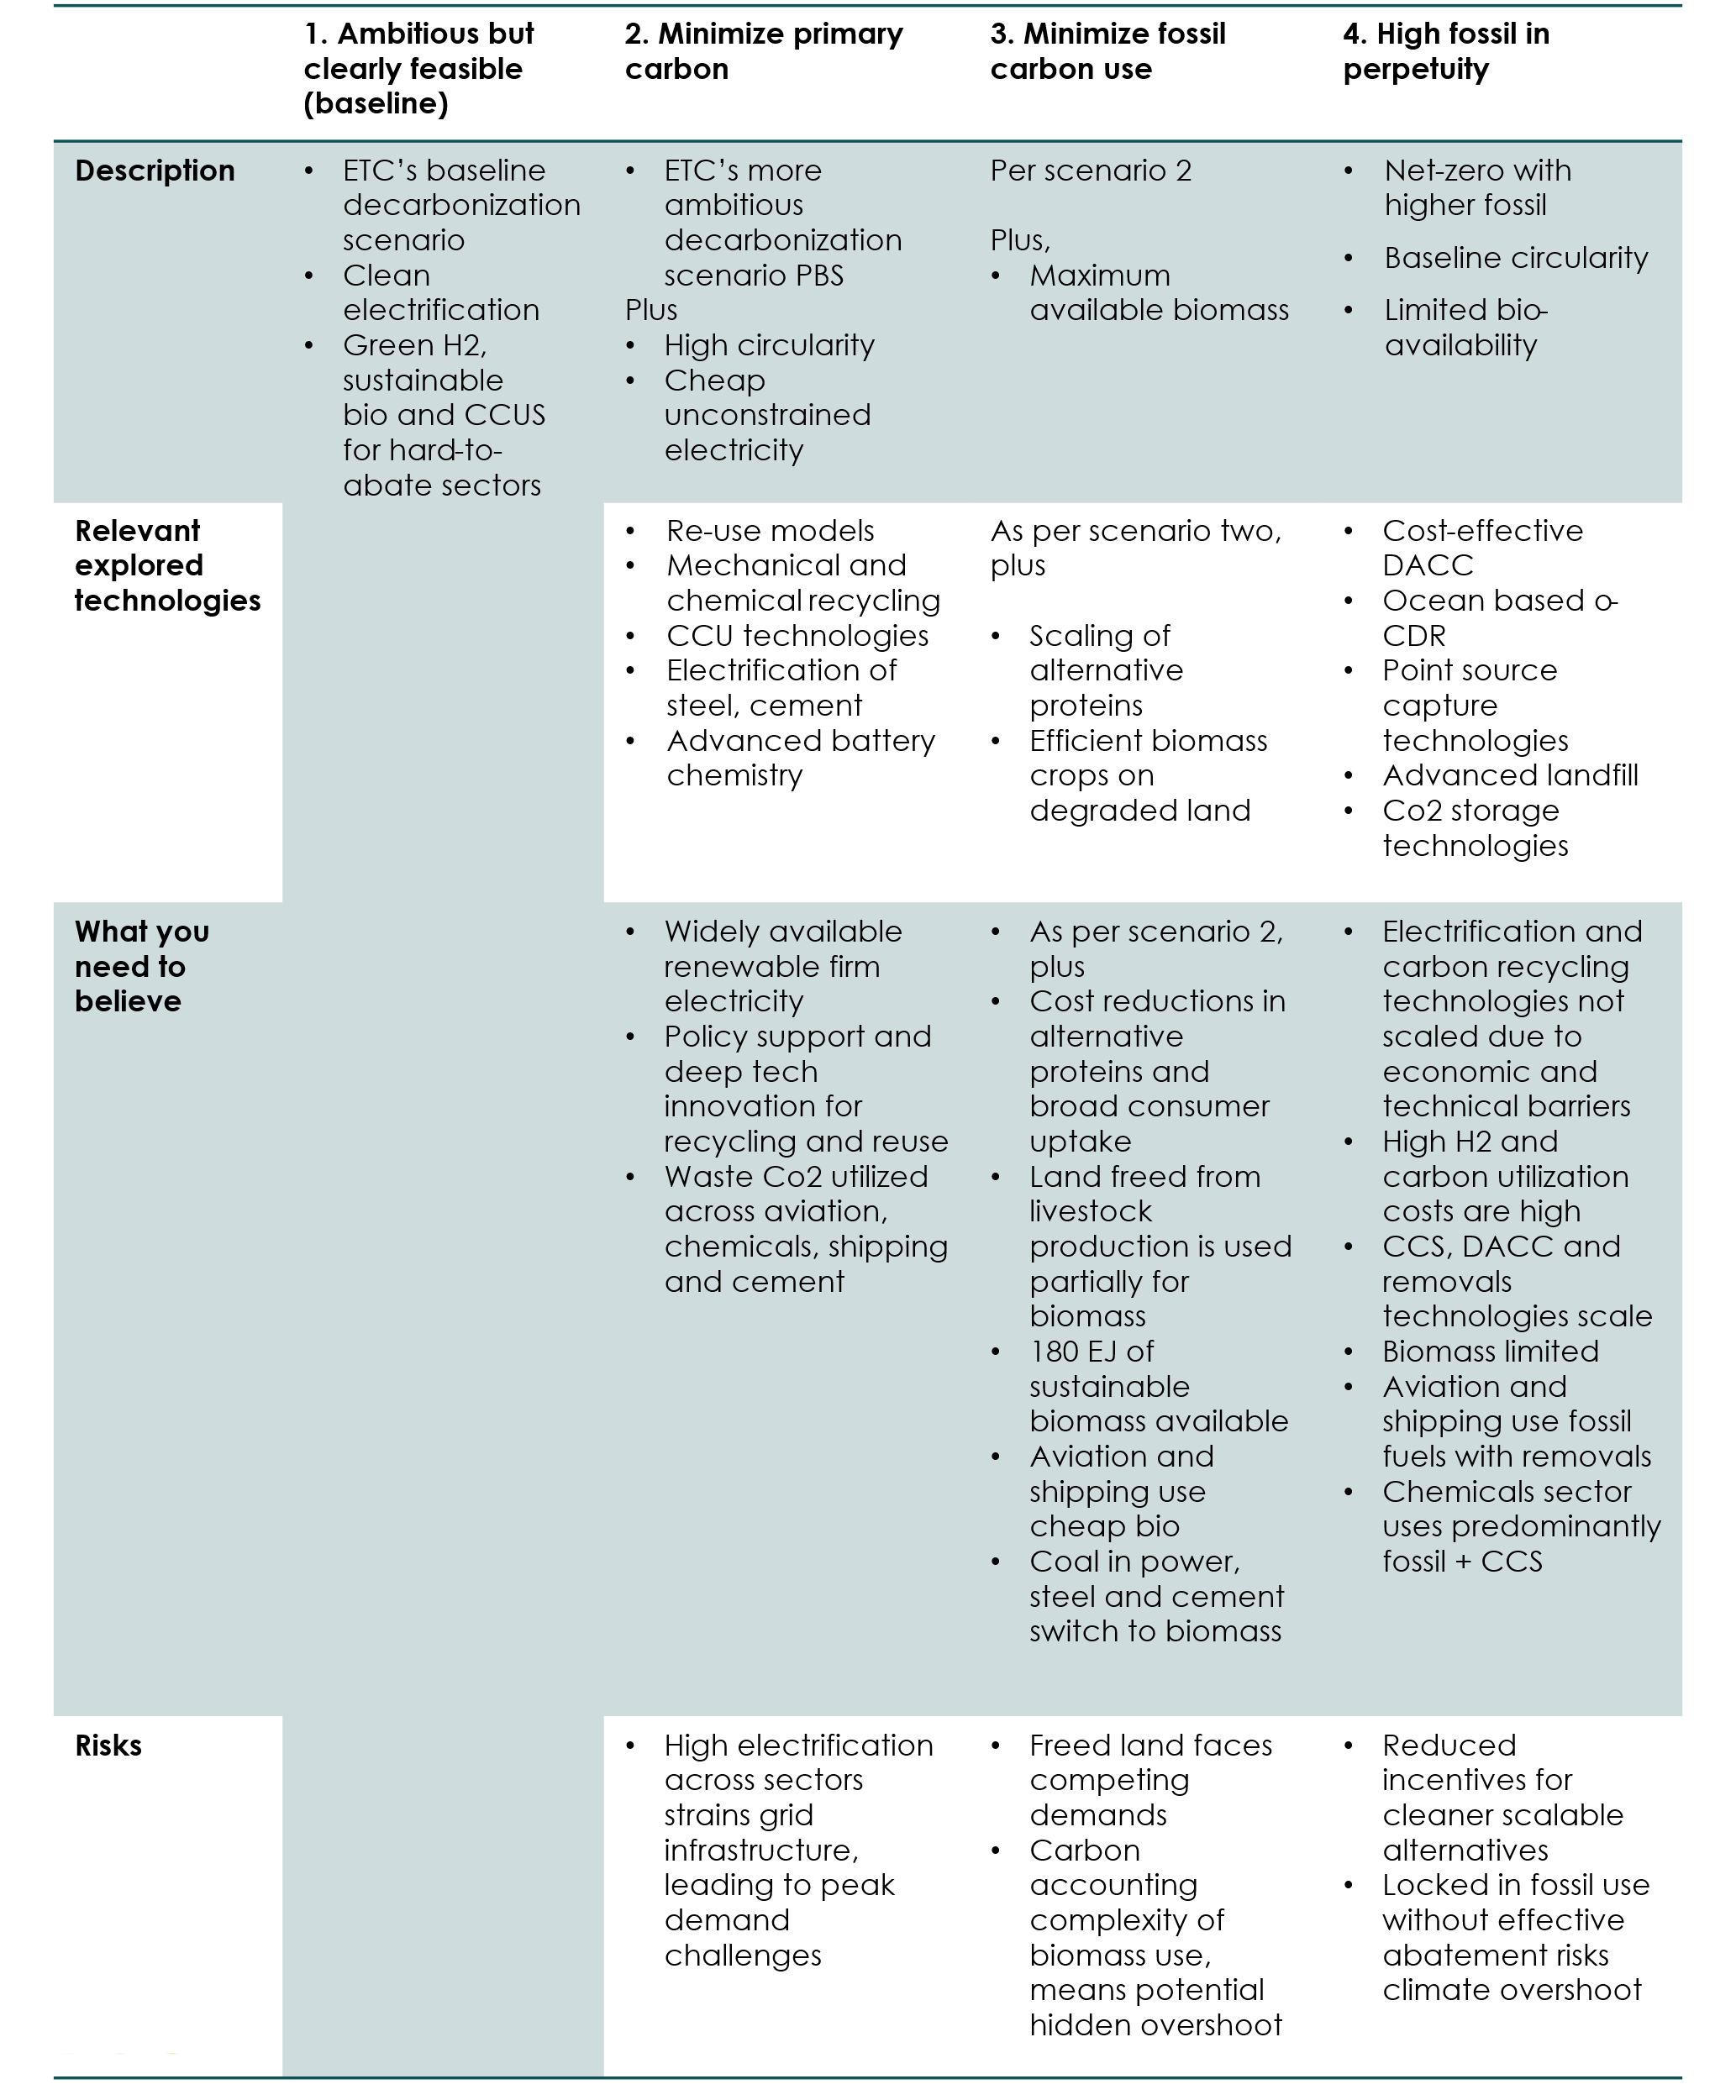

Exhibit 7.1 ACF mid-century, Carbon Source and destination for the energy and materials sectors, Mt C
Exhibit 7.2 Minimize primary carbon use, Carbon Source and destination for the energy and materials sectors, Mt C
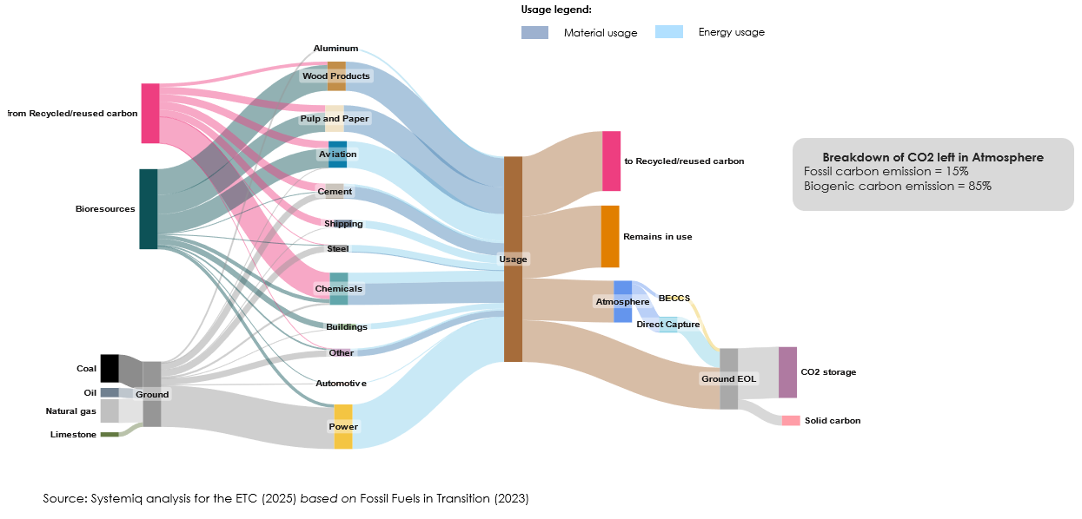
Exhibit 7.3 Minimize fossil carbon use, Carbon Source and destination for the energy and materials, Mt C
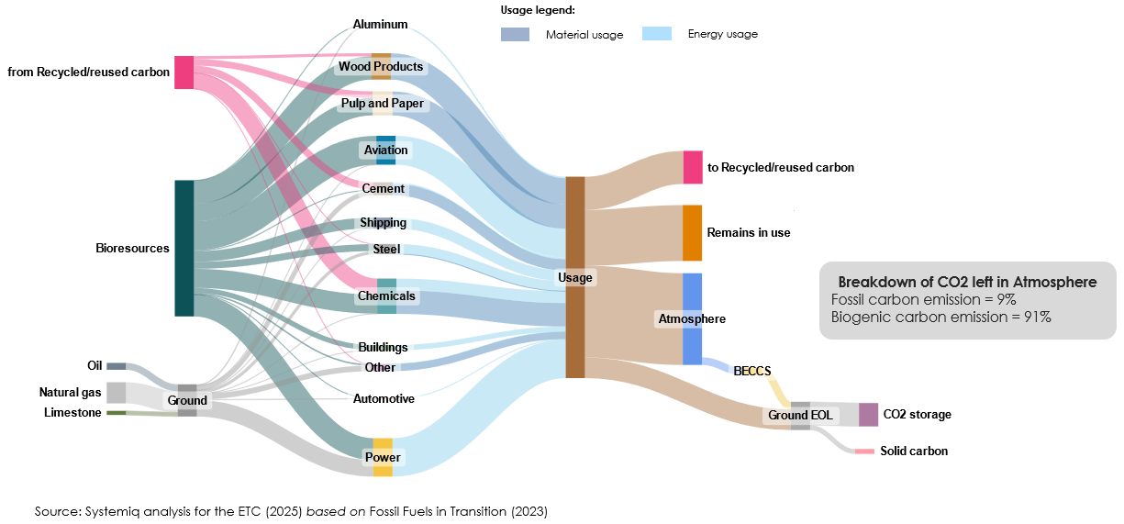
Exhibit 7.4 Fossil in perpetuity, Carbon Source and destination for the energy and materials sectors, Mt C
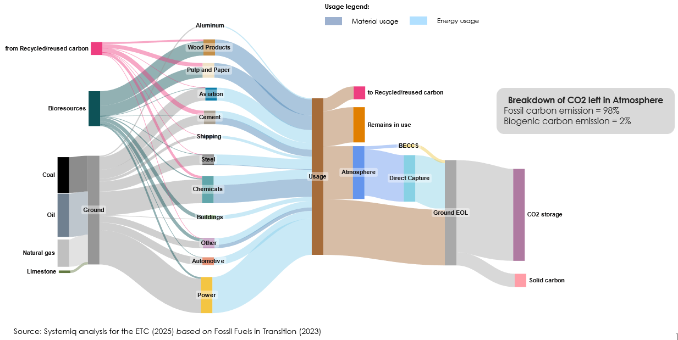

Table 4 Volume and share of source per scenario
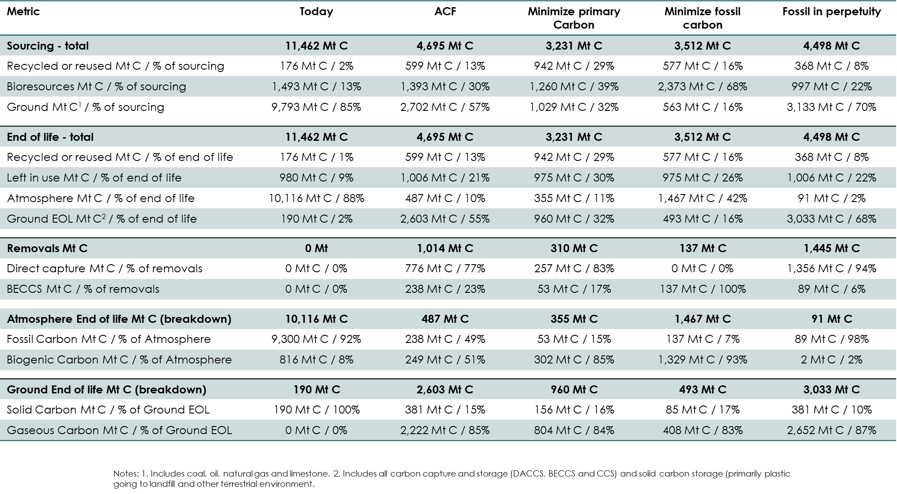
Table 5 Change in carbon volume flows from today's system
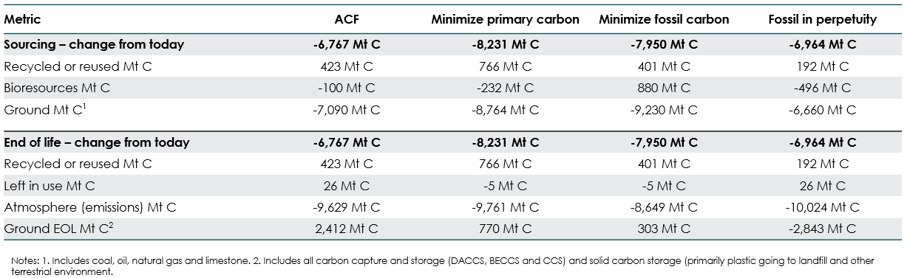

key conclusions and recommendations
A net-zero world will still be a carbon world. Even in the most ambitious decarbonisation scenarios, carbon molecules remain essential, embedded in the fuels that power long-haul aviation, the feedstocks that underpin chemical production, and other materials. The challenge is no longer just about reducing carbon use, but about managing the carbon that remains: where it comes from, how it circulates through the economy, and what happens to it at end-of-life.
1. Carbon demand will persist even to mid-century—it must be actively planned for and managed
The transition to net-zero is not a journey to zero carbon use, but to zero carbon emissions. In sectors like aviation, steel, and chemicals, carbon is difficult to substitute due to fundamental constraints like energy density and process chemistry. Planning must therefore focus not only on reducing emissions, but also on building a sustainable system for the carbon that stays.
2. Electrification and re-use are the most effective tools for reducing carbon usage in the energy and materials sectors
Direct electrification, powered by clean, firm electricity, is the most efficient decarbonisation route in many sectors. Technologies such as high-temperature electric heating, molten oxide electrolysis, and advanced battery chemistries are already displacing fossil carbon and could go further if scaled. Reuse also offers a relatively mature and cost-effective upstream measure to reduce carbon use. Together, these technologies are on the frontier of carbon displacement.
3. Circularity offers a path to reducing primary carbon demand, but would require significant intervention.
Upstream interventions, elimination, reuse, and substitution, can reduce demand before materials requiring carbon are developed. Mechanical recycling, particularly in sectors like pulp, paper, and rigid plastics, is already proven and scalable. However, circularity is not a silver bullet: even in the most circular scenario only about a third of carbon can be made circular. Just over half of this circular carbon can come from materials, the remaining from waste carbon utilisation. Achieving meaningful impact requires coordination across product design, policy, and consumer behaviour. Without this, even the best technologies will fall short.
4. Linear end-of-life solutions will play a role, especially where circularity solutions are challenged
Not all carbon can be reused or recycled. In these cases, linear solutions like geological storage and advanced landfilling provide necessary backstops. Technologies such as in-situ CO₂ mineralisation offer high permanence with fewer leakage risks, while methane-stabilising landfill systems can reduce emissions from residual waste. These are not ideal outcomes but they are pragmatic ones, especially in the near term.
5. Sustainable primary carbon is constrained (biomass) or sourcing technology is still emerging (DAC, oCDR), while fossil is abundant. If ways of sourcing our sustainable biomass do not scale, we need to be strategic about fossil usage and offsets
Biomass, DAC, and ocean-based carbon removal represent the most viable sources of sustainable primary carbon. Each comes with trade-offs. Biomass is land-constrained and must be carefully governed to avoid food security and biodiversity risks. DAC is scalable but expensive, while ocean-based removal offers promise at lower cost but remains early-stage. These sources must be prioritised based on availability, permanence, and system fit—not just marginal cost. Fossil carbon is abundant and cheap, but incompatible with long-term climate goals unless paired with durable removals. Strategic planning is needed to balance availability, permanence, and system fit.
6. Deep technology innovation is essential to close the gap—promising technologies are still at early stage and there is uncertainty around costs
Many of the most promising technologies such as high-temperature industrial heat, CO₂ conversion, and ocean-based carbon removal, are still early-stage or costly. Yet they offer potential solutions to the most challenging parts of the carbon problem. Their success will depend on access to clean energy, supportive policy, and a willingness to invest in long-term system value over short-term efficiency. In areas like chemical recycling, where current business cases are weak and GHG performance is critical, breakthrough innovation is needed to enable end-to-end disruption.
7. We need to be open minded about the full set of solutions. There are trade-offs across the different technologies and the likely ‘optimal’ mix will vary by geography, sector and time horizon.
No single technology solves the carbon challenge. Mechanical recycling is cost-effective today but limited by feedstock quality and system integration. DACCS offers scalable, durable carbon removal but is energy-intensive and expensive. E-methanol via CCU can decarbonise hard-to-electrify sectors like aviation, yet hinges on access to cheap green hydrogen. Electrification methods such as molten oxide electrolysis show promise for industry but face infrastructure and deployment barriers.
These differences reflect not just technical maturity, but varying dependencies on energy, land, and materials. While a spectrum of viable technologies exists, their high costs create a gap between theoretical solutions and market willingness to pay. This leaves room for breakthrough deep tech innovation to accelerate the transition. Market forces will help determine which technologies scale, but this must occur within robust regulatory, standardisation, and certification frameworks to protect natural and social capital, not just commercial returns.
The optimal technology mix will vary by region, shaped by energy access, land use, industrial structure, and policy. What works in one context may not in another. Rather than chasing a single best solution, decision-makers should build diverse, adaptive portfolios that balance cost, readiness, and resource efficiency, while staying responsive to evolving constraints and opportunities. This demands openness to both near-term deployment and long-term innovation.
8. For a majority of technologies, policy will determine what scales and how fast. Carbon pricing a critical lever but part of a broader architecture
Carbon pricing is a critical lever, but it must be part of a broader policy architecture. Mandates, extended producer responsibility, design standards, and public procurement can stimulate demand for low-carbon fuels and materials. Infrastructure investment, tax incentives, and certification systems are essential to support emerging technologies and safeguard environmental integrity. Without agile, responsive policy, even the most promising innovations risk stalling at pilot scale.
Some technologies have breakthrough potential and viable business models independent of policy. Others do not, and for these, we must be pragmatic, deploying lower-performing but available solutions now, especially given the urgency of scaling. Policy must help identify:
i) Technologies with the highest abatement potential—both direct and through cross-sector halo effects—and the greatest likelihood of cost reduction to parity
ii) Technologies facing systemic inertia that require early incentives to begin moving along the transition curve
Ultimately, policy must not only enable innovation but also guide strategic deployment, balancing ambition with realism to accelerate the path to net zero.

Future Cleantech architects (2024) Decarbonizing High-Temperature Heat in Industry
Some energy is lost to surrounding materials, equipment, or the environment via radiation and convection.
Based on shockwave technology compared against conventional gas burners for e-crackers BloombergNEF (2022), Decarbonising petrochemicals. Center for Global Commons & Systemiq (2022), Planet Positive Chemicals.
Future Clean Architects (2024) Decarbonizing high-temperature heat in industry
Burman T and Engvall J (2021) Evaluation of usage of plasma torches in cement production
Tatič Miroslav, Lukáč Ladislav, Kizek Ján: New Generation of Refractories for Rotary Cement Kiln, Advance in Thermal Processes and Energy Transformation Volume 5, No.4 (2022), p. 69-77, ISSN 2585-9102.
Wiencke, J. et al., Electrolysis of iron in a molten oxide electrolyte, Journal of Applied Electrochemistry, 2018
ETC analysis based on IEA (2024), Global EV Outlook 2024, and BNEF (2024) China Already Makes as Many Batteries as the Entire World Wants.
Exhibit 2.5 based on RMI. (2023). X-Change: Batteries. The Battery Domino Effect. Available online.
Wang et al. (2023) Advances in solid-state batteries: Materials, interfaces, characterizations, and devices. MRS Bulletin 48.
Based on historical learning rates
Goldman Sachs (2024) Electric vehicle battery prices are expected to fall almost 50% by 2026, based on company data, Wood Mackenzie, SNE Research, Goldman Sachs; BNEF (2024) 2023 Lithium-Ion Battery Price survey, BNEF (2024) New Energy Outlook; Fraunhofer ISI (2024) Solid-state batteries roadmap 2035+, Alkahidli et al. (2024) Solid-state batteries, their future in the energy storage and electric vehicles market
Kersey et al. (2022)
Segal, S (2021) The viability of electric aircraft
Clements K (2025) Electrifying Flight: Electric Aircraft Technology Takes Off—And Lands, and Garay, E (2022) Electric Planes Are Coming Sooner Than You Think
Patel, P (2024) Sodium-Ion Batteries Poised to Pick Off Large-Scale Lithium-Ion Applications
CATL (2025) Naxtra Battery Breakthrough & Dual-Power Architecture: CATL Pioneers the Multi-Power Era
Vaalma, C., et al (2018) A cost and resource analysis of sodium-ion batteries
Yao, A, et, al (2024) Critically assessing sodium-ion technology roadmaps and scenarios for techno-economic competitiveness against lithium-ion batteries
IEA (2024) World Energy Investment 2024.
Black, G. A., et al., (2019) Economic Viability of Light Water Small Modular Nuclear Reactors: General Methodology and Vendor Data
Future Power Technology (2023) The future of nuclear: France’s nuclear dreams or nightmares?
IES (2023) Literature Review of Advanced Reactor Costs Estimates
IEA (2023), World Energy Outlook 2023; IEA (2021), World Energy Outlook 2021; Hydrogen insights (2024), 'Getting to net zero will need nearly a quarter less clean hydrogen than we initially predicted': BNEF; Hydrogen insights (2023), Half of all clean hydrogen produced globally could be transported long-distance by 2030, says Hydrogen Council
https://www.science.org/doi/10.1126/sciadv.ado0955 Geoffrey Ellis and Sarah Gelman , Model predictions of global geological hydrogen resources
Hydrogen insight (2023) US offers $20m in funding for technology to improve natural-hydrogen exploration and extraction
Hydrogen insight (2024) A new gold rush | There are now 40 companies searching for natural hydrogen deposits — up from ten in 2020
IEA (2024) ETP Clean Energy Technology Guide
Hydrogen Council (2023) Hydrogen Insights December 2023
, 27 Clean Air Task Force (2023) Solide Oxide Electrolysis: A Technology Status Assessment
Systemiq (2022) Planet Positive Chemicals
Thredup (2023) Resale Market and Consumer Trend Report
Ellen MacArthur Foundation (2023) Unlocking a reuse revolution
Ellen MacArthur (2019) Reuse – Rethinking Packaging
Systemiq (2024) Plastic Treaty Futures
TOMRA (2022) Breaking the bottlenecks of recycled plastic content
Recycleye (2024) How AI robots reduce costs of waste sorting, Eunomia (2024) Advanced Sortation for Circularity
Systemiq analysis.
AMP robotics (2022) AMP Robotics Achieves Data Milestones and Recycling Automation Breakthrough
PWC (2022) Plastic Pathways
Recycleye (2024) How AI robots reduce costs of waste sorting
Plastics today (2018) Scientific tests prove HDPE can be recycled at least 10 times
Non-contact sensitive means materials that are not intended to come into direct contact with products that require high safety and hygiene standards, such as food, beverages, cosmetics, and medical products.
Systemiq (2023) Circularity of PET/polyester packaging and textiles in Europe
AMTOP (2024) Difference between virgin plastic and recycled plastic
IEEF (2024) Impact on Virgin vs Recycled plastics prices and implications for a production cap
Systemiq (2024) Plastic Treaty Futures
Ragaert et al (2023) Clarifying European terminology in plastics recycling
Yadav et al. (2023) Natural fiber reinforced rPET/polyester composites: a review on development, mechanical performance, and sustainable management
(OECD, 2024)
Anicic et al (2014) Comparison between two method of methanol production from carbon dioxide
Systemiq analysis for the ETC (2025)
ETC (2023) Fossil Fuels in Transition
Systemiq and Center for Global Commons (2022) Planet positive chemicals
Carbon tracker (2024) Curb your Enthusiasm
Leung, et al. (2014) An overview of current status of carbon dioxide capture and storage technologies
Global CCS Institute (2025) Advancements in CCS technologies and costs
Wang, X. , Song, C. (2020) Carbon capture from flue gas and the atmosphere: A perspective
Bisotti, Filippo, et al. "Direct Air capture (DAC) deployment: A review of the industrial deployment." Chemical Engineering Science 283 (2024): 119416.
Prince Aleta (2024) Direct ocean capture: the emergence of electrochemical processes for oceanic carbon removal
The process of Captura is used as a reference for electrodialysis-based systems. The process of Equatic is used as reference for electrolysis-based systems.
Sievert, Katrin, Tobias S. Schmidt, and Bjarne Steffen. "Considering technology characteristics to project future costs of direct air capture." Joule 8.4 (2024): 979-999.
Abegg, Manon, et al. "Expert insights into future trajectories: assessing cost reductions and scalability of carbon dioxide removal technologies." Frontiers in Climate 6 (2024): 1331901.
Nancy W. Stauffer (November 2024) Reality check on technologies to remove carbon dioxide from the air. Available at: https://news.mit.edu/2024/reality-check-tech-to-remove-carbon-dioxide-from-air-1120
Equatic announcement (2024) Equatic to build North America’s first commercial-scale ocean-based carbon removal facility. Available at: https://www.equatic.tech/articles/equatic-to-build-north-americas-first-commercial-scale-ocean-based-carbon-removal-facility
According to Equatic’s patent: US20220040639A1
Zentou, Hamid, et al. "Recent advances and challenges in solid sorbents for CO2 capture." Carbon Capture Science & Technology (2025): 100386.
Fossil-free Plastics: Driving Clean Industrial Leadership in Europe (Systemiq, 2025)
Carbon Removal Certification Framework (CRCF) EU/2024/3012
ETC (2022) Carbon Capture, Utilisation and Storage in Energy Transition: Vital but Limited
Carbon tracker (2024) Curb Your Enthusiasm: Bridging the gap between the UK’s CCUS targets and reality. Available at: https://carbontracker.org/reports/curb-your-enthusiasm/
Volume shown refer to Accelerated But Clearly Feasible scenario. Fossil Fuel Processing includes natural gas processing, oil products refining and production of high value petrochemicals. The volumes are currently under revision in the latest work of ETC.
Martina Fantini et al. (2021) Calcium Looping Technology Demonstration in Industrial Environment: Status of the CLEANKER Pilot Plant
Cal by 2030 project. Available at: https://www.calby2030.eu/overview-of-the-project
Jon Yin et al. (CSIRO 2020) Retrofitting calcium carbonate looping to an existing cement plant for CO2 capture: a techno-economic feasibility study
Fu, Chao, et al. "Techno-economic analyses of the CaO/CaCO3 post-combustion CO2 capture from NGCC power plants." Frontiers in Chemical Engineering 2 (2021): 596417.
Barrel of oil equivalent is a standardized unit of energy used in the oil and gas industry to compare the energy content of different fuels. One BOE represents the amount of energy released by burning one barrel (159 liters) of crude oil and is approximately equal to 1,7 MWh.
IEA (2023) Emissions from Oil and Gas Operations in Net Zero Transitions: A World Energy Outlook Special Report on the Oil and Gas Industry and COP28.
Waghmode, V. (2024) Cassava Prices Soaring in Nigeria Due to Increased Demand from Ethanol Producers
GFI, Driving down costs, unpublished
GFI (2023) Manufacturing capacity landscape and scaling strategies for fermentation-derived proteins; BCG & Synonym (2024) Breaking the Cost Barrier on Biomanufacturing
Systemiq (2025) A Taste of Tomorrow
[1] Van Oort (2023) Can seaweeds feed the world? Modelling world offshore seaweed production potential; [2] Greene, C.H. & Scott-Buechler, C.M. (2022). Algal solutions: Transforming marine aquaculture from the bottom up for a sustainable future; [3] Caporgno & Mathys (2018) – Frontiers in Nutrition; [4] Stice C. and Basu A. (2015) The Great Protein Shift: Re-Thinking One of the Fundamental Building Blocks of the Human Diet; [5] Makkar et al., 2016 –Seaweeds for livestock diets: A review; [6] Park S. et al. (2024) Production of safe cyanobacterial biomass for animal feed using wastewater and drinking-water-treatment residuals
Huerta-Rosas, Brenda, et al., (2024) Design and optimization of an intensified sustainable plant to produce biojet fuel using the ATJ process
This has been observed in the Calumet project, where the novel micro-channel Fischer-Tropsch reactor costed 15% less than the incumbent technology
ETC (2021) Bioresources within a Net-Zero Emissions Economy: Making a Sustainable Approach Possible. Note that these estimates are for supply at the “primary energy” level, before conversion losses: energy delivered at the “final energy level” would be significant less
ETC (2023), Accelerated but Clearly Feasible Scenario from the Fossil Fuels in Transition report
IEA (2024), Annual CO₂ capture capacity vs CO₂ storage capacity, current and planned, 2022-2030.
Lena Walter et al. (2012) Brine migration resulting from CO2 injection into saline aquifers – An approach to risk estimation including various levels of uncertainty
Raoof Gholami et al. (2021) Leakage risk assessment of a CO2 storage site: A review
Climeworks, Mammoth: our newest facility. Available at: https://climeworks.com/plant-mammoth. [Accessed June 2025].
Octavia Carbon, Accelerating The Path to Net Zero. Available at: https://www.octaviacarbon.com/technology. [Accessed June 2025].
Carbfix (2025), Carbfix Secures Europe’s First Storage Permit for Onshore Geological Storage of CO₂. Available at https://www.carbfix.com/newsmedia/carbfix-secures-europes-first-storage-permit-for-o. [Accessed June 2025].
UK Government (May 2024), Integrating greenhouse gas removals in the UK Emissions Trading Scheme. Available at: https://www.gov.uk/government/consultations/integrating-greenhouse-gas-removals-in-the-uk-emissions-trading-scheme. [Accessed June 2025].
Integrity Council for the Voluntary Carbon Market (May 2022), Integrity Council Releases First Continuous Improvement Work Program Report, Focused on Permanence. Available at: https://icvcm.org/ciwp-report-on-permanence/. [Accessed June 2025].
Also commonly referred to as engineered or sanitary landfills.
Landfill global emissions estimate at ~0.8 GtCO₂eq: Pericarbon (2025), The Methane Crisis: Uncovering the Climate Impact of Landfills. Available at: https://www.pericarbon.org/post/the-methane-crisis-uncovering-the-climate-impact-of-landfills. [Accessed June 2025].
Incineration global emissions estimate at ~0.4 GtCO₂eq: Zero Waste Europe (2019), The impact of Waste-to-Energy incineration on climate. Available at: https://zerowasteeurope.eu/wp-content/uploads/edd/2019/09/ZWE_Policy-briefing_The-impact-of-Waste-to-Energy-incineration-on-Climate.pdf. [Accessed June 2025].
IEA (2021), Methane and climate change. Available at: https://www.iea.org/reports/methane-tracker-2021/methane-and-climate-change. [Accessed June 2025].
Global cumulative plastic waste landfilled (2025-2040) estimated at 3.6 Gt. Based on Systemiq (2024) Plastic Treaty, Global rules scenario. Assumes landfill depth of 30m and height of 10m.
European Commission, Biodegradable waste. Available at: https://environment.ec.europa.eu/topics/waste-and-recycling/biodegradable-waste_en. [Accessed May 2025].
European Parliament, Resource efficiency and the circular economy. Available at: https://www.europarl.europa.eu/factsheets/en/sheet/76/waste-management-policy. [Accessed June 2025].
US EPA (Dec 2024), Renewable Electricity Production Tax Credit Information. Available at: https://www.epa.gov/lmop/renewable-electricity-production-tax-credit-information. [Accessed May 2025].
Catalytic Finance Foundation (June 2025), Whitepaper on Carbon Finance for Municipal Solid Waste in Developing Countries. Available at: https://www.catalyticfinance.org/news/whitepaper-on-carbon-finance-for-municipal-solid-waste-in-developing-countries. [Accessed June 2025].
Hydrogen Science Coalition (2024), Everything you need to know about natural or geologic hydrogen
US Department of Energy (2023), Pathways to Commercial Liftoff: Carbon Management
https://www.energy-transitions.org/publications/power-systems-transformation/
These effects can also be reduced by improvements in energy productivity which make it possible to supply useful energy services while reducing final and primary energy demand. See forthcoming ETC Energy Productivity report
Systemiq analysis (2025), assuming 41.5Gt of MSW waste generated between 2025-2040 and compacted landfill depth of 30m and height of 10m

