Buildings decarbonisation report

Note for ETC Representatives:
- This report presents the emerging analysis and conclusions from our 2024 buildings decarbonisation workstream. These insights were presented in the Representative’s meeting on the 19th September, where we had a fantastic and very engaged discussion. Please note that all of your feedback has been noted and will be reflected in the final draft, but the text and exhibits in this draft have not yet been edited to take into account this discussion.
- We would particularly value your feedback on:
  - The narrative, framing and our view on recommendations
  - The language used and whether this speaks to those in the buildings sector
  - Technical details and key modelling assumptions
  - Opportunities to streamline and simplify
- We recognise that this is a very long report and we do not expect a line by line review in its entirety – please use the contents page to guide where you are best placed to provide feedback.
- There are some areas of the report that we are still working on, but would welcome your suggestions:
  - Case studies: throughout the report, we have placeholders for case studies we would like to add to bring the story to life – if you have any suggestions from your organisations or others, please do flag this in your feedback.
  - Summary of actions for policy and industry: we are still working on a full write up of this concluding chapter, but have outlined our initial thinking for your consideration.
- The deadline for comments is Monday 14th October. Please do flag if there are any issues with this and also if you would like to discuss your comments in more detail on a call with the team.
- Please treat this text as confidential and not to be circulated beyond your organisation at this stage.
- Please send your feedback to pmo@energy-transitions.org and hannah.audino@systemiq.earth
Thank you very much for your continued support and engagement on this workstream.

Contents
Introduction: coverage, report structure and summary conclusions 4
Structure of this report 5
Summary conclusions 7
1. The building decarbonisation challenge 11
Operational emissions 12
Embodied emissions 14
Global building stock 15
The energy transition for buildings – key aspects and implementation challenges 17
Section A: The net zero transition for operational energy use 19
2. Heating 20
2.1 The starting point: large fossil fuel use primarily in developed countries 21
2.2 Clean heating technologies – multiple heat pumps as the dominant solution 24
2.3 Passive heating techniques 38
2.4 Optimal combinations of heating technologies and improved insulation 42
2.5 Implications for the heating transition and fossil fuels 48
2.6 Actions for policy and industry 51
3. Cooling 57
3.1 Active cooling technologies 59
3.2 Managing growing demand for cooling 60
3.3 Implications for energy demand 66
4. Cooking 67
4.1 The transition to clean cooking technologies 68
4.2 Implications for the cooking energy transition 69
5. Appliances 71
5.1 Energy efficiency of appliances 73
5.2 Policies to realise efficiency improvements 74
6. Lighting 76
7. The net zero transition for operational energy in commercial buildings 80
7.1 Understanding commercial building energy use 80
7.2 Clean heating and cooling technologies in commercial buildings 83
7.3 Passive heating and cooling in commercial buildings 85
7.4 Actions for policy and industry 87
8. The importance of drastically reducing refrigerant leakage and venting 90
9. Managing electricity demand: efficient and flexible buildings are vital 94
9.1 Aligning buildings electricity demand with renewable supply 94
9.2 Technical efficiency improvements 98
9.3 Reducing energy needs and losses 99
9.4 Solving the peak demand challenge: Demand-side efficiency and flexibility 104
9.5 Implications for energy demand 110
Section B: The opportunity to reduce the embodied carbon from the next generation of new buildings 114
10. Understanding emissions across the building lifecycle 114
11. The huge potential to mitigate upfront embodied carbon 116
11.1 Decarbonising material production 118
11.2 Demand efficiency levers: material efficiency, substitution and building less 123
11.3 Implications for embodied carbon from new construction 132
12. Use phase and end-of-life embodied carbon 133
12.1 Embodied carbon of retrofits 133
12.2 Retrofitting or rebuilding at end of life 135
13. Actions to bring embodied carbon to the fore 136
13.1 Actions for policymakers and industry 137
Section C: Actions for policymakers and industry 140
Key actions / strategic priorities 140

Introduction: coverage, report structure and summary conclusions
At COP21 in Paris, and again at COP26 in Glasgow, the vast majority of the world’s nations agreed that it is essential to limit global warming to well below 2°C, and ideally to 1.5°C, with limited overshoot. Since then, 99 countries have committed to such targets, with another 60 countries currently in talks to make these commitments.¹ Recent extreme weather events across the world have illustrated the vital importance of meeting those objectives. But we are running out of time to achieve such targets.
To achieve a net zero-carbon economy by mid-century, the world must ensure that by then all energy use vastly reduces its CO₂ or other greenhouse gas (GHG) emissions. This will require primarily switching to the use of non-fossil fuel energy sources, together with a limited but vital role for carbon capture and storage (CCUS) in offsetting the small residual use of fossil fuels. Much of the work of the Energy Transitions Commission (ETC) has therefore been devoted to identifying how to achieve this decarbonisation of energy supply. The ETC, through the work of the Mission Possible Partnership has also looked at decarbonising key heavy emitting sectors, such as steel, aluminium and aviation.
This report, for the first time, looks in depth at the global buildings sector, which makes up a third of global emissions, and 10% of direct fossil fuel energy use. It considers heating, cooling, cooking, lighting, appliances across residential and commercial buildings and the energy required to construct new residential and commercial buildings between now and 2050.
This report builds upon our existing work, and contributes to the wider literature in five main ways:
- This report considers all buildings energy use - both operational energy (i.e. the energy used, and the carbon generated, to heat, cool and power cooking, lighting and appliances) and embodied carbon (i.e. the emissions generated from producing building materials and constructing, maintaining and demolishing buildings).
- It considers how actions at a building/household level impact the wider energy system, particularly the electricity system, including how flexible buildings can play a key role in managing electricity demand as heating and cooking electrifies, as demand for cooling and appliances grows, and as we decarbonise our power system with variable renewables.
- It outlines the clear technical and economic feasibility of clean heating technologies, including challenging the notion that deep insulation is a pre-requisite to installing a heat pump, and – while recognising that every building is different and there is no one-size-fits-all solution – identifies what technologies will likely be used across different types of buildings to guide policy decisions.
- It treats energy productivity as a core part of the solution set, recognising that by using energy more efficiently, we can significantly reduce emissions and the scale (and costs) of the clean power system we need to build for a net-zero economy. This work will form part of a wider series of reports the ETC is doing on energy productivity (see Box 1).
- It provides a robust evidence base for how, with the right policies, the buildings energy transition can go hand in hand with lower energy bills, higher living standards and greater social equity.

Structure of this report
Analysing and describing transition pathways for the global building stock is challenging, given the heterogeneity in building stock and given the interaction between clean technologies and energy productivity in reducing emissions.
This report will discuss operational energy (Chapters 2-9) and embodied carbon (Chapter 10-12) separately. Within operational energy, it will step through technologies and solutions for each end-use for new and existing residential buildings, and then for commercial; this will lead to some duplication, for example the discussion of building envelope and design solutions which apply to both heating and cooling. Chapters 9 will bring everything together to discuss the implications for energy and actions required.
This report will cover:
- Chapter 1 will introduce the building decarbonisation challenge, including emissions and energy use.
- Section A: the net-zero transition for operational energy
- Chapters 2-6 will cover residential buildings, exploring both the active and passive heating and cooling technologies and the potential for greater efficiency in cooling, lighting and appliances.
- Chapter 7 will explore operational energy use in commercial buildings.
- Chapter 8 will explain how to manage refrigerant leakage and venting from heat pumps and ACs.
- Chapter 9 will explore the system-wide implications of electrified buildings and how to create efficient and flexible buildings which can play a key role in managing electricity demand in a renewable energy system.
- Section B: the opportunity to reduce embodied carbon in the next generation of new buildings
- Chapter 10 will outline the importance of reducing embodied carbon.
- Chapter 11 will set out how steel, cement and concrete can be decarbonised, drawing on the Mission Possible Partnership transition strategies.
- Chapter 12 will explore how strategies to use low-carbon and less material.
- Section C: actions required from policymakers, industry, financial institutions, and households.
Throughout this report, one key issue which we address is the relative importance of decarbonising energy supply to the building sector (via the combination of electrification and the decarbonisation of power systems) versus reducing energy use while still meeting increasing human welfare (via for instance building insulation and equipment technical efficiency improvements). Our conclusions on the latter opportunity will feed into ETC‘s wider report on the role of “energy productivity” improvements in achieving a zero carbon economy, which will cover all sectors of the economy. Box 1 describes that work and the three different forms of energy productivity improvement which we will assess both in this report and for other sectors.
Box 1
The ETC’s wider work on energy productivity
To achieve a net zero-carbon economy by mid-century, the world must ensure that by then all energy use vastly reduces its CO₂ or other greenhouse gas (GHG) emissions. This will require primarily switching to the use of non-fossil fuel energy sources, but also the offsetting of a small residual use of fossil fuels by carbon capture and storage. Much of the work of the Energy Transitions Commission has therefore been devoted to identifying how to achieve this decarbonisation of energy supply.
Emissions could also be reduced by using energy more efficiently. Even if all energy supply is decarbonised, greater energy efficiency, would still play a critical role by reducing the total cost of energy inputs required. Improving overall "energy productivity," i.e., reducing energy intensity, or the amount of energy required to generate a dollar of GDP, is therefore an important objective. Over the last 10 years, global primary energy productivity improvements have increased by 1.7% per annum. However, with global GDP growing at 2.7%, overall energy demand has continued to grow. But at COP28, nations agreed to double energy productivity improvements, achieving a global average of 4.1% per annum by 2030.
The ETC believes that to identify how this could be achieved , and to assess the long-term potential for energy efficiency improvement beyond 2030, it is essential to take a detailed sector-by-sector approach. During 2024, we are therefore conducting an analysis of productivity improvement potential in each major sector (road transport, buildings, and key industries) and identifying policies required to seize this potential. We will then aggregate the sectoral opportunities into an assessment of the total economic-wide opportunity, publishing a final report in 2025. This report sets out our analysis of energy productivity improvement in the road transport sector.
In addition to identifying energy productivity potential by sector, it is also vital to consider the several different types of improvement that could together deliver improved energy productivity. Exhibit 1 sets out the framework we will use in all our energy productivity reports, with improved energy productivity (i.e., reduced kWh of energy input per $ of GDP) potentially resulting from improvements in:
- Energy process efficiency, delivering a given quantity of a specific service with less energy input (e.g., fewer litres of jet fuel per aviation passenger km).
- Service efficiency, which enable people to enjoy the same standard of living but using less energy-intensive services or products (e.g., reduced road or air passenger km but increased rail). It is divided in two subcategories: demand efficiency and product efficiency.
- Material efficiency, delivering a given quantity of products with reduced material inputs (e.g., fewer kg of steel or plastics per passenger road vehicle).
Our final report on overall energy productivity will assess the combined potential across all of these categories of improvement, and will be published in Q1 2025.
Exhibit 1
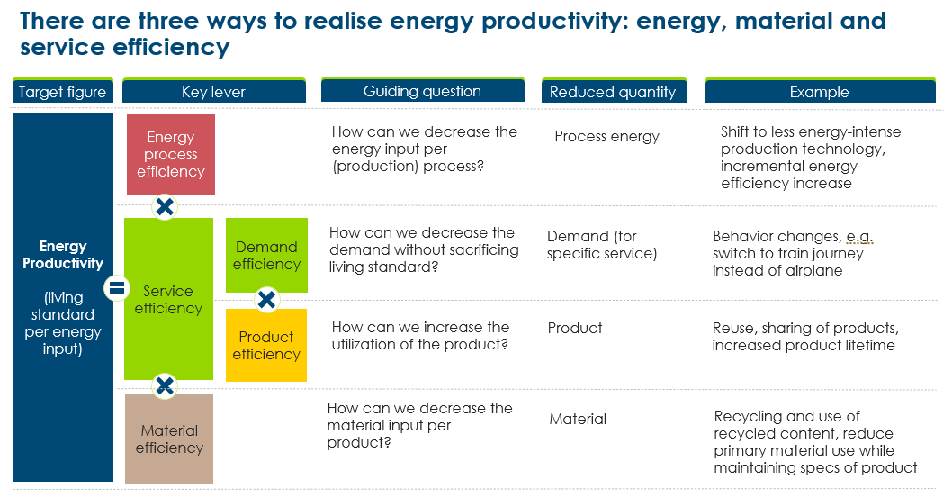

Summary conclusions
Each chapter of this report sets out the conclusions on the specific challenges considered and the implications for overall energy productivity, electricity demand and fossil fuel use. In Section C, we bring together all the conclusions, and assess the relative impact of different actions.

Our key conclusions related to operational energy use are:
- The solution to decarbonising residential and commercial heating will be predominately electric and predominately heat pumps, but there is no one-size-fits-all technology, with a range used depending on building characteristics and household preferences. Heat networks (e.g., networked ground source heat pumps and district heating solutions) should be deployed where possible, since these can deliver significant efficiency gains and overcome slow individual decision-making.
- The idea that heat pumps only work well in existing buildings if accompanied by very high insulation standards, has been overstated: this challenges the need to always apply a “fabric first” approach. In most cases, radiator upsizing and/or light insulation will provide sufficient comfort at a reasonable cost. The “fabric first” approach should always be the default in new buildings – where reducing operational energy per m² beyond current regulated standards by 25% may only add 1-5% to construction costs – and in the least efficient properties, which should be a government priority.
- Hydrogen should not be an option to replace gas and oil heating in existing buildings. It is much less efficient (e.g., green hydrogen for heating would require 5-6 more electricity than heat pumps), would still require substantial retrofit to boilers and the gas network, and would not be scalable until the mid-2030s.
- Demand for cooling is set to more than double by 2050 as a result of rising incomes and climate change. Demand could, however, be even greater if rising incomes drives significant behaviour change in parts of the world which are currently more conservative in their use. This will have significant benefits for health, wellbeing and productivity, but will create huge demands for electricity requirements that need to be managed.
- Deploying passive cooling techniques in buildings could reduce global demand for cooling by around 25%, with even greater benefits for the 40% of the global population living in hot countries that may still not have access to air conditioning in 2050. Many of these are low-cost, such as external shading and painting roofs white, and can reduce cooling energy demand in individual buildings by up to 50%.
- The risk of emissions relating to refrigerant leakage and venting from ACs and heat pumps is very large but can be managed. Emissions from refrigerant leakage and venting in 2050 could be equivalent to 15% of today’s total building emissions, but could be cut in half with regulations and incentives for proper disposal of refrigerant at end of life, skills certifications to improve the quality of installations and maintenance, and with a faster transition to lower-GWP refrigerants.
- For cooking, it is essential to phase out the traditional use of biomass (TUOB) as rapidly as possible, eliminating its extremely harmful health effects and emissions. Intermediate fuels such as liquid petroleum gas (LPG) will play a role during transition but the eventual solution should see cooking electrified across the world. Achieving this, however, requires significant education and awareness and financial support to shift how households cook, especially in lower-income countries.
- Final demand for buildings could increase from 36,600 TWh to 57,500 TWh under business as usual. But it could be limited to ~23,200 TWh via a combination of:
  - Electrification, which directly reduces final energy consumption because heat pumps are 3-4 times more efficient than fossil fuel boilers and electric cooking can be over 5 times more efficient than the traditional use of biomass.
  - Technical efficiency improvements in heating (e.g., from a COP of 3 to 4-5), cooking (e.g., moving to induction hobs), cooling equipment (where the average AC sold today is far less efficient than best available technology), household appliances, and moving all lighting to LED bulbs. These improvements could reduce required energy supply by around 25%.
  - Building new buildings to higher standards and incorporating passive heating and cooling techniques, and retrofitting the least efficient existing buildings.
  - Improving demand efficiency through the installation of smart systems which can reduce unnecessary energy use (e.g., sensors in commercial buildings, controlling thermostats remotely), and encouraging behaviour change (e.g., turning cooling thermostats up).
- Electrification is efficiency, but we are moving from an energy system where energy for buildings is supplied by a variety of fuels, to a system in which it is virtually exclusively electric (e.g., even district heat networks need to be electrified). Annual electricity requirements for buildings in 2050 could be 2.5-3 times higher than today, from 12,800 TWh to around 35,000 TWh; but this could be lowered to around 18,500 TWh with strong action on energy productivity [Exhibit 2]. Crucially, the supply of clean zero-carbon electricity needs to keep pace with rising demand to limit adverse impacts on emissions.
- Electricity demand for buildings will create peaky demand for grids, but there is huge untapped potential for demand-side flexibility. Insulation can have a significant impact on a building’s thermal inertia and peak heating needs – this doesn’t need to be to passive house standards, but 2-4 hours flexibility will have a big impact. Water storage tanks are a low-cost, no regrets solution for households with sufficient space, to shift water heating outside of peak times. Smart systems are also a no-regrets solution, which can also support gradual behaviour change. Solar panels and batteries would be a huge benefit to the grid in countries with a big cooling need, but rely on costs continuing to come down. Time of use tariffs are critical to incentivising this demand-side flexibility.
- It is technically and economically feasible to almost entirely eliminate the direct use of gas and oil in buildings by 2050, with falls of around 15-20% possible by 2030. Coal use can be entirely eliminated by 2040 [Exhibit 3].
Our key conclusions related to embodied carbon are:
- Global floor area is set to expand by ~50% by 2050, which at today’s embodied carbon intensity, could produce ~75GtCO₂, equivalent to 40% of the estimated remaining carbon budget for a 50% chance of limiting warming to 1.5ºC. As demonstrated by the MPP’s sector transition strategies, the potential to decarbonise the production of steel and cement is greater than previously thought; various technologies could lead to a 50% reduction in potential cumulative embodied carbon from new buildings, to ~40GtCO₂. However, significant emission reductions from these solutions will not occur until the mid-2030s onwards and they will not be sufficient to reach net zero by 2050.
- Material efficiency and substitution solutions have the potential to reduce baseline embodied carbon by a further 10%, taking the total potential reduction in cumulative emissions to 60%. These include changing building design to use less material input and using lower-carbon materials such as timber, which can have negative emissions if dealt with correctly at end-of-life. Overall, the share of the remaining 1.5ºC carbon budget to 2050 that could be used up from the construction of new buildings could fall from 40% to 15%, without any reduction in floor space built.
Key policy, industry and finance actions for the next decade:
- Set out a clear national vision for the building energy transition with targets for heat pump deployment and clear bans on fossil fuel heating and cooking, supported by local street-by-street delivery plans.
- Underpin incentives for, and trust in, clean, electric technologies by creating early demand for low-carbon technologies, rebalancing gas and electricity prices, and providing time-limited subsidies.
- Create strong frameworks and standards for measuring and reducing whole-life carbon of new buildings, particularly around embodied carbon.
- Manage new and peaky electricity demand with flexible and efficient buildings with time of use tariffs, minimum energy performance standards and labelling regulations, and financial incentives for insulation, smart systems, rooftop solar PV and batteries.
- Deliver a fair and just transition for households with targeted support for low-income households, investment in social housing, clear regulations on the energy efficiency of rented properties, and education and awareness of low-cost passive heating and insulation improvements.
Exhibit 2
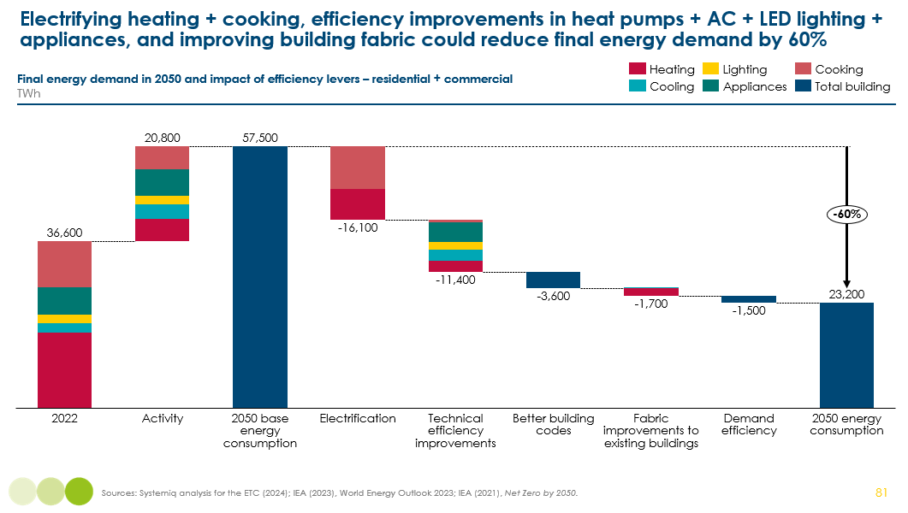

Exhibit 3
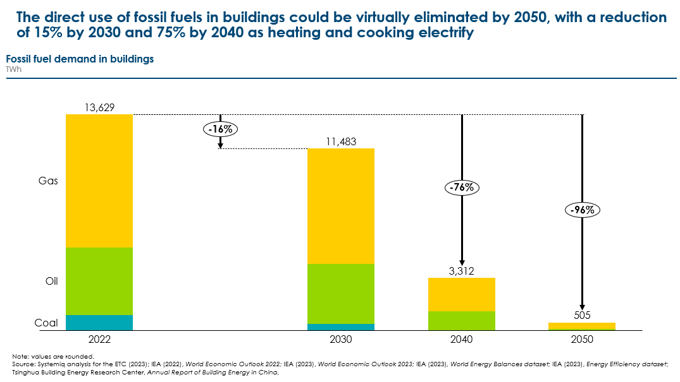

- The building decarbonisation challenge
Buildings account for around a third of global annual emissions, or 12.3 GtCO₂ [Exhibit 4], and 10% of direct fossil fuel use. This arises from:
- Emissions from the operation of buildings, which account for 26% of global emissions, or 9.8 GtCO₂. The direct use of fossil fuels accounts for 3 GtCO₂ (8%), predominately the use of gas and oil for heating. The indirect use of fossil fuels for electricity used in buildings accounts for 6.8 GtCO₂ (18%). Operational emissions are produced by the world’s total stock of buildings, around 250bn sqm, which is less than 0.5% of the world’s habitable land.,
- Emissions from the construction of new buildings, which account for 7% of global emissions, or 2.5 GtCO₂. These emissions are referred to as embodied carbon, and arise from the production of materials - predominantly steel, cement and concrete - and the use of fossil fuels in transportation and construction. Embodied emissions relate to the additions to the global building stock in a given year, around 5bn sqm.
A further 6% of annual emissions are the embodied carbon from new infrastructure, such as roads and bridges, railways, industrial facilities, ports, and pipelines. Together with buildings, this makes up the world’s ‘built environment’. This report will predominantly focus on buildings – both residential and commercial – but will, at a high level, discuss the embodied carbon of infrastructure in Section B.
Exhibit 4
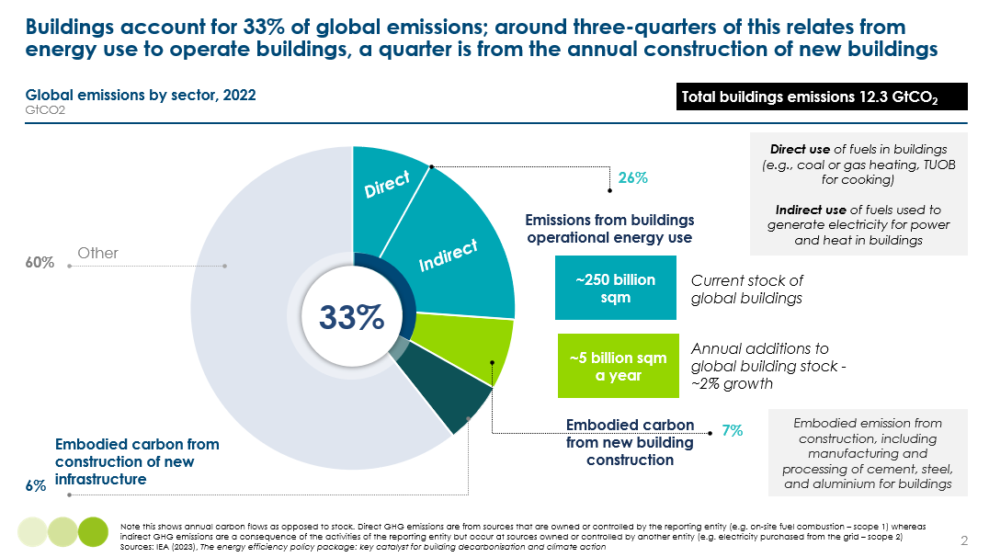

Operational emissions
Energy is used in buildings for five end uses: heating, cooling, cooking, lighting and powering appliances (e.g., refrigerators, TVs, and dishwashers) [Exhibit 6].
- Heating is the biggest source of operational emissions (11% of global emissions), accounting for 45% of final energy use in buildings and 80% of direct fossil fuel use [Exhibit 5].
- Cooking accounts for a further 15% of direct fossil fuel use, but is largely fuelled by the traditional use of biomass (TUOB) in lower-income countries. TUOB is incredibly inefficient (as little as 10% of energy used is converted to useful heat), meaning cooking is the second largest component of final energy demand (~30%).
- Cooling, lighting and appliances are over 95% electrified, with emissions resulting from the indirect use of fossil fuels to generate electricity. Appliances account for ~15% of final energy demand, but is the second largest source of operational emissions (8% of global emissions). Cooling and lighting each account for ~5% of final energy demand and 2-3% of global emissions; however, as we will explore in this report, cooling is set to the be the fastest growing source of buildings energy demand over the coming decades, with implications for emissions if clean electrification does not keep pace and if refrigerant leakage is not managed.
These global averages mask significant variation across countries; some parts of the world such as Africa have no or very little heating needs, while others, such as parts of Canada and the Nordic countries will have very low heating needs. Many countries, including China, the US and parts of Europe, have both seasonal heating and cooling needs.
Exhibit 5
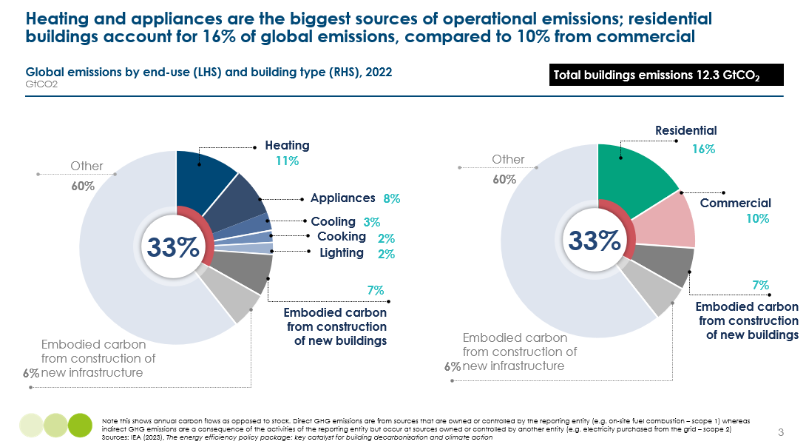

Residential buildings account for 60% of operational emissions, despite comprising 80% of global floor space [Exhibit 9]. In comparison, commercial buildings make up 20% of global floor space but produce 40% of operational emissions. Commercial buildings are a very diverse group of buildings, including offices, hotels, restaurants, hospitals and schools.
Exhibit 6
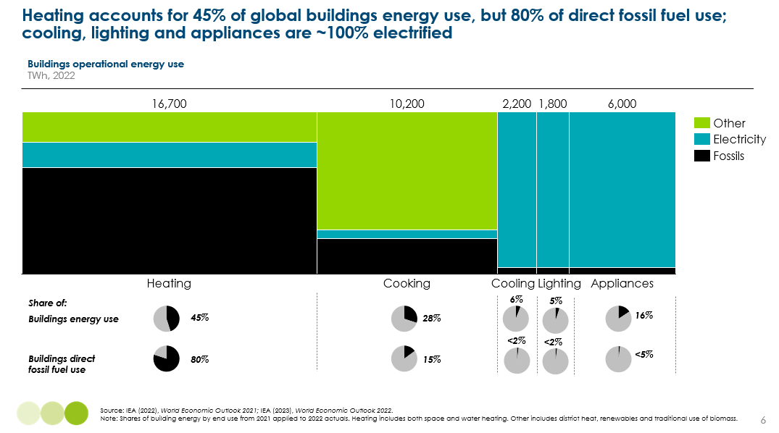
Overall, as Exhibit 6 shows, 35% of total buildings energy use is already electrified. This means that as the power sector is decarbonised, operational emissions will fall in turn [Exhibit 7].
Exhibit 7
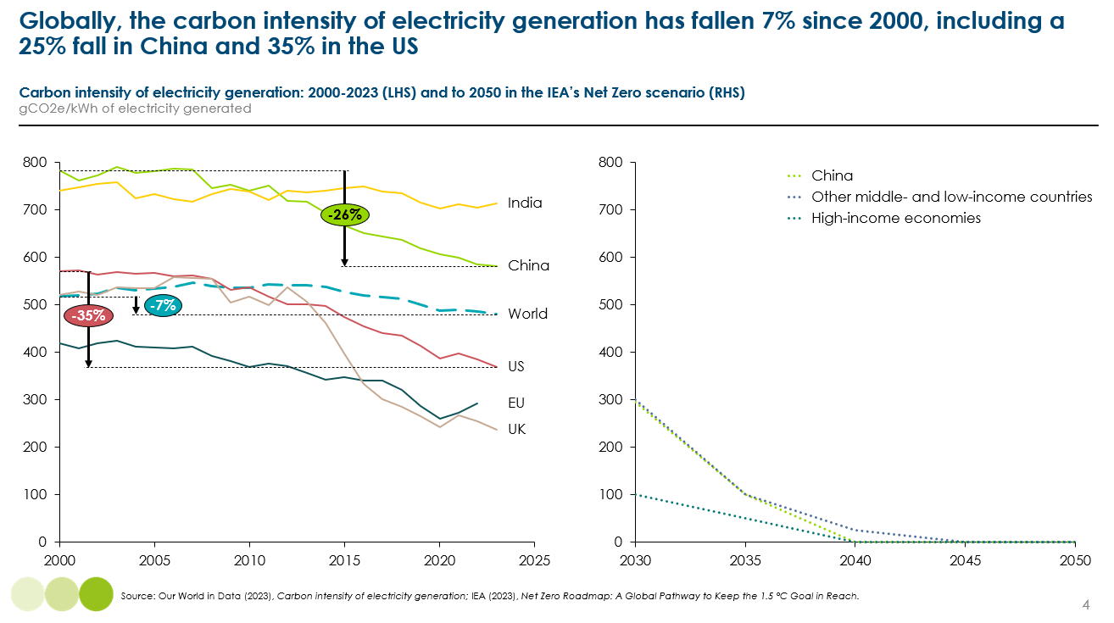

Embodied emissions
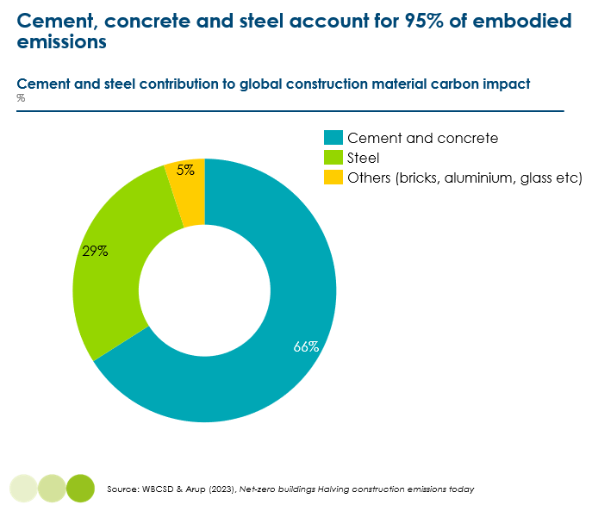
Embodied emissions arise from a wide variety of processes, materials and machinery used to construct buildings. In comparison to operational emissions, where robust data on household energy use and the emissions intensity of different fuels exists, collecting global data on embodied emissions is much more challenging. This reflects the huge variation in the way buildings are built, the materials used, and the lack of a consistent measurement framework.
Exhibit 8
We do know that steel, cement and concrete account are overwhelmingly the main sources of emissions relating from material production for construction [Exhibit 8].
Global floor area is set to increase 55% by 2050, from 250bn sqm to 390bn sqm, which will drive significant demand for steel, cement and concrete.
As we explore in Chapter 10, constructing an additional 140bn sqm would generate 75 GtCO₂, holding today’s global average embodied carbon per m² constant (0.5 GtCO₂/bn m²).
Exhibit 9
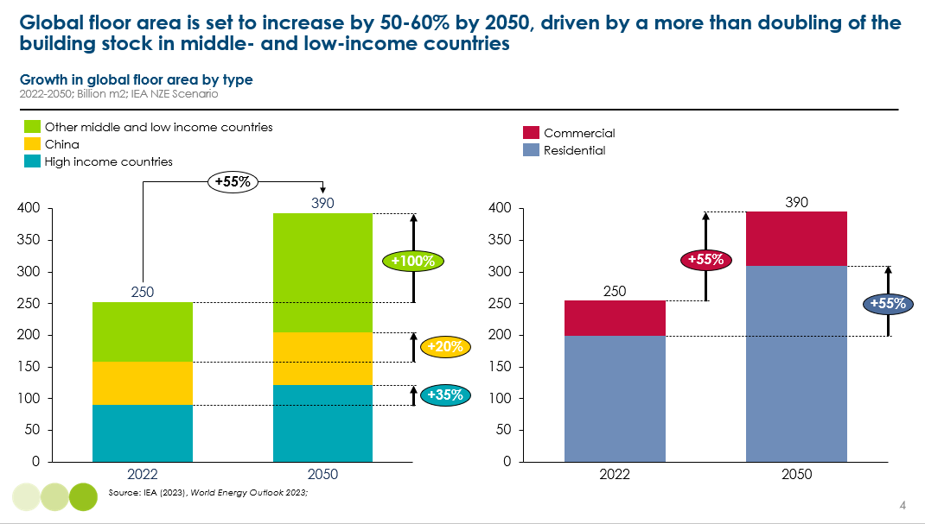

Global building stock
One of the biggest challenges to the net-zero transition is that all buildings are different, both within and across countries. The type and size of a building, its ownership, and its location have huge implications for the applicability of clean heating technologies, for the potential to improve energy efficiency, and for the actions to lower embodied carbon in new buildings. A conclusion that will be repeated throughout this report is that there is no one-size-fits-all solution to decarbonising buildings. However, this report recognises the need for stronger national strategic vision to deliver the transition and so seeks to identify the technologies and solutions which will likely dominate.

Residential buildings
Drawing on data from OECD countries, key differences in residential buildings across countries include:
- Building archetype: 60% of all buildings across OECD countries are houses, with 40% being flats and apartments [Exhibit 10]. This varies massively across countries, with flats accounting for 65-75% of building stock in Spain and Korea, compared to 15-20% in Australia and the UK. In cities like Shanghai, flats account for 90% of floor space.
- Size: average floor space per person varies from over 65m² in the US, to around 45m² in France and Germany, to below 30m² in many Eastern European countries.
- Ownership: Around 75% of buildings are privately owned in Europe and the US, but again this varies massively at 45% in Germany, 65-70% in the UK and US, and over 90% in Hungary and Romania [Exhibit 10]. On average, 15% of buildings are privately rented and 10% are social housing.
- Degree of urbanisation: 40% of people across the Europe and the US live in cities, 30% live in towns and suburbs, and 30% in rural areas. These proportions will vary hugely across other continents.
Exhibit 10
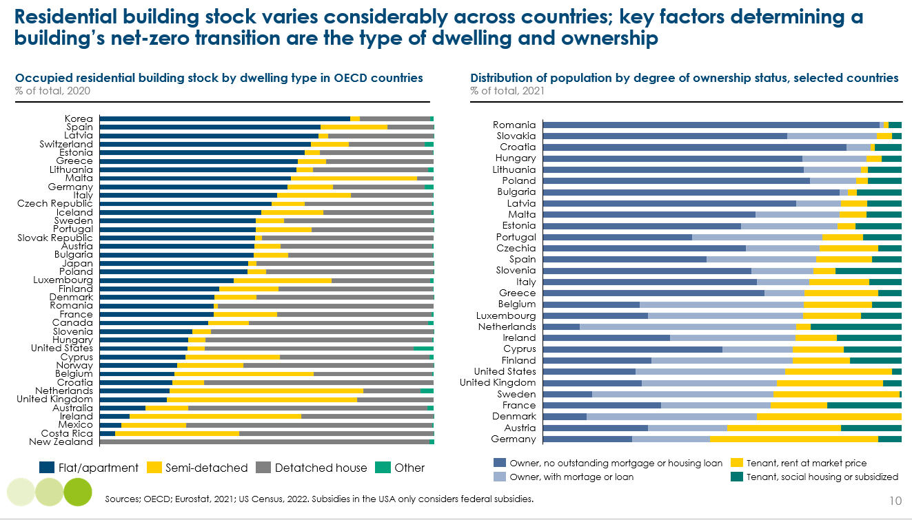

Commercial buildings
Globally, commercial buildings make up 20% of floor space, but this varies across countries [Exhibit 11]. In Germany for example, commercial buildings account for a third. The term “commercial building” refers to a very large and heterogeneous stock of buildings across different sectors. In Europe and the US, offices account for 25-30%, compared to almost 40% in China. Education and wholesale/retail buildings are typically the second and third largest, at around 15-25% respectively. Other sectors include warehouses, hotels and restaurants, hospitals and sports facilities (see Chapter 7).
Exhibit 11
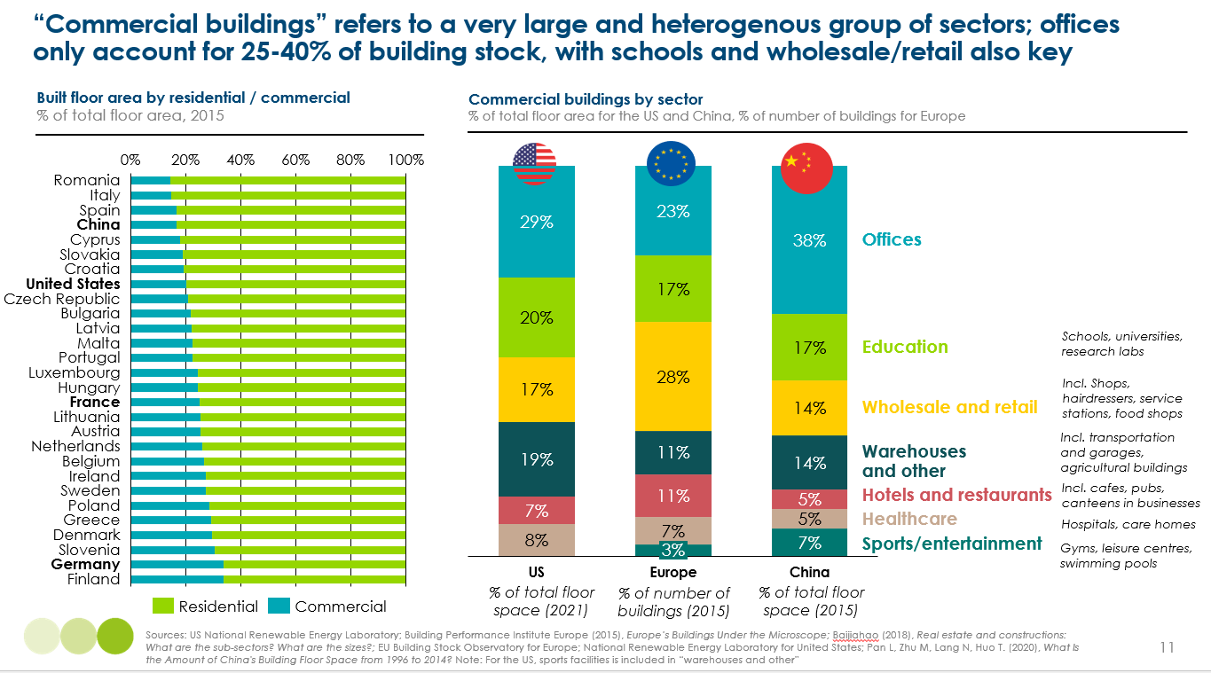

The significant heterogeneity in commercial buildings – more so than for residential – means determining transition pathways is even more challenging. This report will step through the transition for residential buildings in detail, followed by a discussion of where the transition for commercial buildings may be different, or have particular nuances.

The energy transition for buildings – key aspects and implementation challenges
The energy transition is imperative not just to reduce emissions, but also to deliver upon critical social and economic development goals. The quality of building stock varies massively across and within countries, with lower incomes, energy poverty, and poor living standards and health being closely linked. As we outline in this report, with the right policies, decarbonising buildings and improving social outcomes can go hand in hand.
Electric heating and cooking technologies will significantly improve air quality and are inherently more efficient with lower running costs, and building more efficient and flexible homes will improve standards of living and further lower energy bills.
There are two core strands to this transition. The first is transitioning to clean technologies and clean electricity. For operational energy, this means transitioning fossil fuel heating and cooking technologies used in buildings to clean technologies. This will overwhelmingly be a transition to electric heating and cooking. For embodied emissions, this means decarbonising steel and cement production and electrifying transport and construction. This must be underpinned by a rapid decarbonisation of the power system to ensure that the electricity increasingly used in buildings is low and eventually zero carbon.
The second strand is improved energy productivity. This means using less energy for the same standard of living and can be achieved through energy efficiency (i.e. using less energy to deliver the same output), material efficiency (i.e. using less material for the same product/service), and service efficiency (i.e. better utilisation of products/services without sacrificing living standards).
Energy productivity will play a critical role both in getting the sector to net-zero and in reducing emissions during the transition, which is key to limiting warming to 1.5ºC. For operational energy, reducing energy use will lower high-carbon energy use while it is still directly or indirectly generated using fossil fuels. For embodied carbon, it will reduce high-carbon material use in construction during the transition.
Energy productivity also has a wide range of other economic, social and environmental benefits:
- It will reduce the scale of the challenge in building a clean power system, including reducing investment costs for renewables, grid upgrades, and storage.
- It will help to ease balancing challenges for the electricity grid, especially at peak times, helping to create a resilient and flexible energy system.
- It will have significant social benefits, lowering energy bills for households, improving living standards, and health and equality.
- It will lead to lower negative impacts on planetary boundaries, including less demand for materials, minerals and land.
Achieving these benefits via building decarbonisation poses some distinct implementation challenges not found in other sectors:

- In power generation, industry and non-road transport, almost all the investment decisions required to drive decarbonisation will be made by professional managers in businesses rather than by individual consumers. And while there will in some cases be a green cost premium to be faced (with for instance, a higher steel price per tonne and higher shipping freight rates) at the level of the products purchased by individual consumers, the cost impact is very small.

- In passenger road transport, meanwhile, individual consumers will need to make decisions about car purchase, but within a number of years EVs will be cheaper to buy upfront than ICEVs (indeed in China that point has already been reached) and comparing the cost and performance characteristics of EV and ICEs is relatively straightforward.

- In the residential building sector by contrast, individual households will need to decide between multiple possible clean technologies both “active” (e.g., heating and cooling systems) and “passive” (e.g., improved insulation) - the installation of which will entail some disruption within their homes. And while clean heating technologies (in particular heat pumps) can deliver lower operating costs, it is likely that those which reduce operating costs will require higher upfront investment. But the availability and cost of finance varies greatly between low and high income households. More generally indeed, feasible and optimal solutions vary greatly by specific household circumstances, such as the availability of space and current quality of insulation.

Public policies must therefore be designed to address these distinctive implementation challenges and distributional effects. But despite those challenges, the actions required to decarbonise building energy use will ultimately lead to improved outcomes for society, through lower and more stable energy bills, and improved housing quality and living standards.
This report sets out the actions required by government and the private sector to minimise the financial and distributional impacts on households, to ensure a fair and just transition, and to rapidly reduce emissions.

Section A: The net zero transition for operational energy use

Total global energy use in buildings amounts to 37,000 TWh or 130 EJ today; this is around a third of total final energy consumption across the economy. Direct use of fossil fuels account for 35-40% of this, providing 13,800 TWh in 2022. Within this, gas accounts for 60%, oil for 30%, and coal for almost 10%.
Electricity drives a further 35% (12,800 TWh), with three-quarters of this powering cooling, lighting and appliances. Today, just 15% of heating is electrified. The decarbonisation of the power sector will therefore drive the decarbonisation of a large share of building operational emissions.
The traditional use of biomass (TUOB) in cooking accounts for ~20% of total energy use (7,000 TWh), and the final 5-10% is renewables (e.g., solar thermal water heating and geothermal) and district heating – although it is important to note that 90% of district heating, which involves generating heat in a centralised location and then distributing it to individual buildings, is generated by fossil fuels.
This section will step through each energy end use in turn, focusing on residential buildings in Chapters 2-6. Chapter 7 will then explore where conclusions for commercial buildings are different. Chapter 8 will discuss the refrigerant leakage and venting challenge in both residential and commercial buildings. Chapter 9 will then bring the whole story on operational energy use together, discussing the system-wide implications of electrified buildings.
Exhibit 12
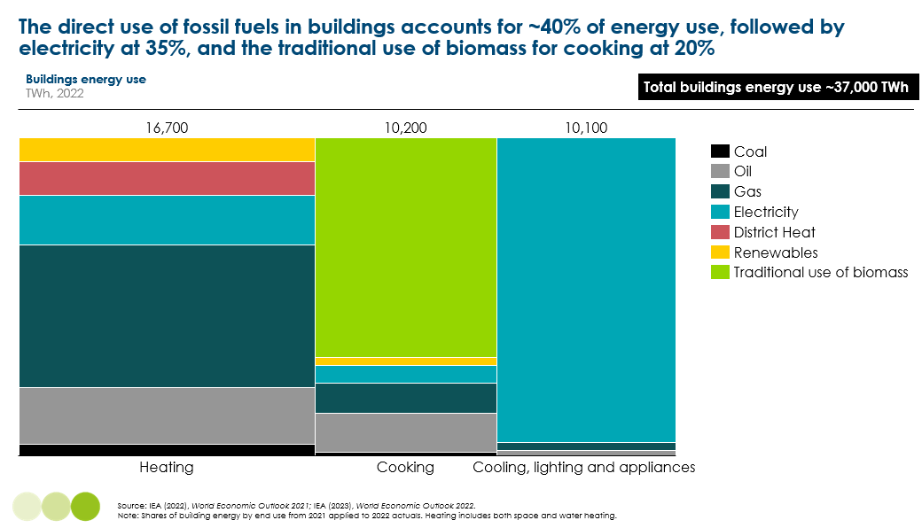
- Heating
Heating building space and water counts accounts for 45% of total energy use in buildings across the world, but for 80% of direct fossil fuel use, and thus for the vast majority of today’s emissions which would not be eliminated by the decarbonisation of electricity supply alone. Decarbonising heating is therefore the most important challenge in the buildings sector. This chapter describes and assesses the technologies available to achieve decarbonisation and the implications within the residential sector. Chapter 7 considers the specific challenges related to commercial buildings.
The key conclusions are that:
- Building heating can and should be almost entirely electrified, primarily with heat pumps, either in individual homes or within heat networks which deliver a major technology development. There is, however, no one-size-fits-all solution; a range of technologies will be used to solve the challenges of specific building types and climates.
- Hydrogen is not a viable alternative to replace gas heating; it is much less efficient (e.g., green hydrogen would requiring 5-6 more electricity than heat pumps), would still require substantial retrofit to boilers and the gas network, and would not be scalable until the mid-2030s.
- A holistic, whole-building approach is required to create net-zero ready buildings. This involves consideration and optimisation across three types of technology: 1) installation of electric technologies which can be powered by clean electricity, 2) improvements to the building envelope, and 3) consideration of a suite of smart and flexible technologies (e.g., smart system, solar and batteries).
- However, the idea that heat pumps can only work well in existing buildings if accompanied by very high insulation standards, has been overstated, slowing down home heating electrification rates. In most cases, radiator upsizing and/or light insulation will provide sufficient comfort at a reasonable cost. This means heat pump deployment should not be held back by an overly rigid commitment to a fabric first approach.
- While not a pre-requisite for heat pumps, there is a suite of passive heating retrofits, many of which are relatively low-cost(e.g., DIY draught proofing) which can greatly improve living standards, reduce energy bills and ease peak energy demand.
- Deployment of heat pumps and improved insulation could halve 2050 final energy demand for residential heating compared to a BAU scenario that maintains existing fossil fuel use, through superior efficiency.
  - However even in this case, electricity used to heat buildings could still grow from 2,600 TWh today to 4,000-5,000 TWh in 2050. Without strong action on technical efficiency and insulation, it could be 10,000 TWh.
  - This will enable the almost complete elimination of all fossil fuel use for residential building heating by 2050.
The sections below set out the analysis which supports these conclusions, covering in turn:
- The starting point: a large role for fossil fuels in residential heating, primarily in developed countries.
- Technologies available to solve the problem and relative costs: multiple variants of heat pumps as the primary solution.
- Passive heating: improved insulation in new and existing buildings.
- Combining different approaches in new and existing buildings: indicative overall mix.
- Implications for energy productivity, electricity and fossil fuel use.
- Actions required from government, business, and consumers
The implications of heating decarbonisation, including on peak electricity demand, will then be explored in Chapter 9.
  - The starting point: large scale use of fossil fuels for heating primarily in northern latitude countries
Heating is the biggest decarbonisation challenge, accounting for 45% of final energy use in buildings and 80% of direct fossil fuel use. Of the 11,000 TWh of fossil energy used directly to provide on-site heat, 67% or 7,400 TWh is gas, 27% or 2,900 TWh is oil, and the remaining amount is coal. Coal is also dominant in some district heating systems, particularly those in northern China.
Fossil-based heating is concentrated in northern latitude countries with relatively cold winters [Exhibit 13]. Around 75% of total fossil fuel use for heating buildings, and over 60% of total gas use in buildings, is in the US and Canada, Europe, and China. Russia and Iran are also major users of gas in buildings, accounting for 10% and 7%, respectively, of total gas use.
Exhibit 13
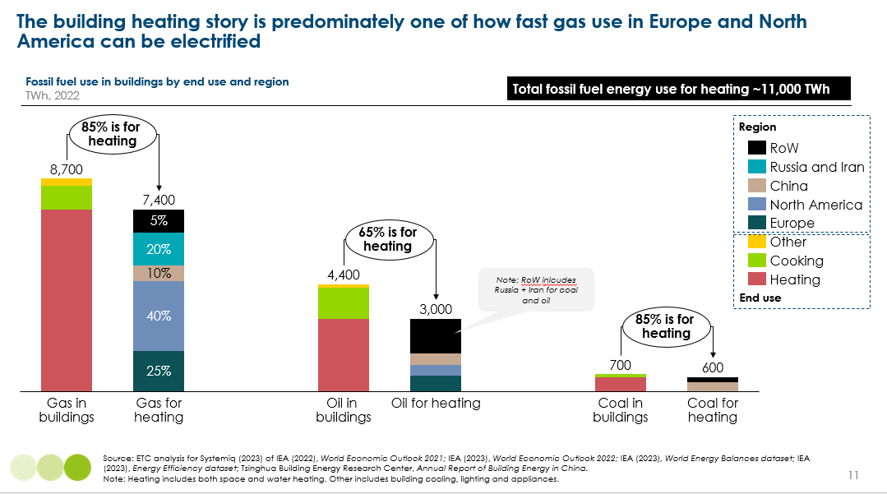
Three-quarters of global heating energy is for space heating, and a quarter is used to heat water [Exhibit 14]. This is despite space heating only being required in around 40% of households across the world.
By contrast, water heating is required by all households; however, energy needs are comparatively smaller and a large share of hot water needs in lower-income countries are unmet. The fuels used for water heating largely mirror those used for space heating, although with larger shares for electricity and for non-electric renewables (e.g., solar thermal where the heat of the sun is used to direct heat water).
There are an estimated ~720m gas and oil boilers supplying 10,400 TWh of energy for heating today, including 240 gas boilers in the US and Canada, 150m in Russia and Iran, and 140m across Europe [Exhibit 15]. In addition, there is 600 TWh of coal heating existing buildings, predominately in China. The key question for the transition is how fast these boilers can be replaced with clean heating technologies.
Exhibit 14
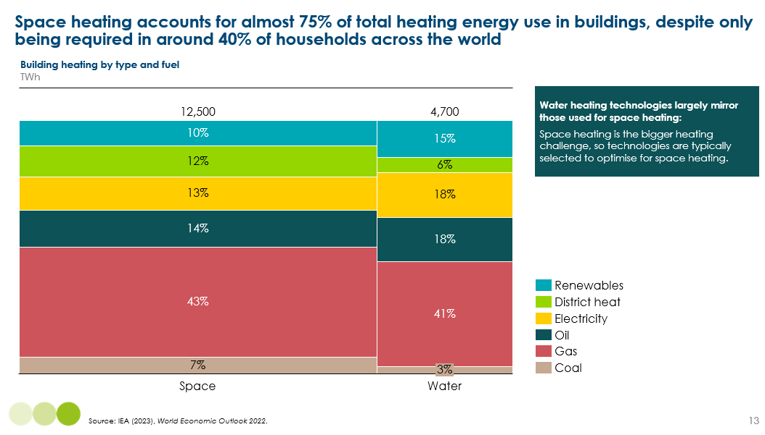
Exhibit 15
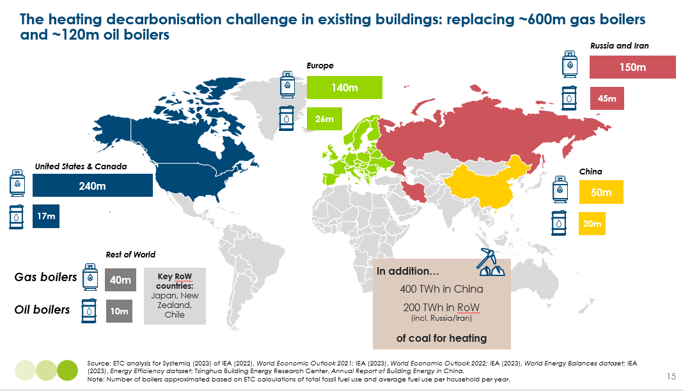
The direct and indirect use of fossil fuels to heat buildings produces about 4.1GtCO₂. To reduce and eventually eliminate these emissions it is essential to replace the direct use of fossil fuels in buildings with clean heating technologies, primarily electric. Electrification will create “net-zero ready” buildings and therefore must be combined with large-scale decarbonisation of the electricity grid, which is critical economy-wide and not just for residential heating. Section 2.1 describes the technologies available to achieve this decarbonisation.
However, to create fully “net-zero ready” buildings, it is important to take a holistic and whole-buildings approach to decarbonisation which considers a full suite of potential technology options and the role of buildings in a zero-carbon electricity system. It is therefore important to simultaneously consider opportunities to [Exhibit 16]:
- Reduce household and commercial demand for heat consumption via building design and envelope choices (i.e. improved insulation) – sometimes called “passive heating” technologies. This will reduce the emissions from electricity during the transition to zero carbon electricity production, and reduce required electricity inputs in the long term. Section 2.3 assesses these options.
- Reduce electricity input from the grid, instead generating electricity at a building or community level, via the installation of rooftop solar PV. These opportunities are considered in Chapter 9.
- Reducing in particular peak load energy requirements, which impose high costs if electricity is the energy source. This can be achieved either via the improved insulation actions discussed in Section 2.3, or via energy storage solutions at building level (whether in heat or electricity form), combined with smart systems. These opportunities are discussed in chapter 9.
Exhibit 16
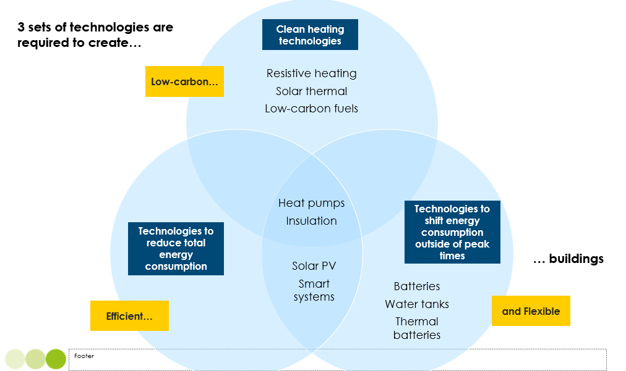

  - Clean heating technologies – multiple heat pump variants as the dominant solution
Multiple technologies could be deployed to decarbonise building heating and different solutions will be most appropriate in different circumstances. But heat pump technology should play the dominant role given its inherent efficiency advantage; concerns about the effectiveness of heat pump are largely misplaced and technology improvement will make them even less valid. Heat networks, some of which will use heat pump technology, will often be cost effective.
    - Alternative clean heating technologies
There are four main types of potentially zero carbon heating technology which could be used to provide either space or water heating in both residential and commercial buildings [Exhibit 17]:
- Electricity-based solutions via either:
  - Electric heat pumps which use the same compression technology as air-conditioners but working in the reverse direction. As Exhibit 18 shows, there are several types of heat pump, and different variants will be most appropriate in different solutions. But their common and distinctive feature is that that they can deliver several kilowatt hours of heat for each kilowatt hour of electricity input, with “coefficients of performance”(COP) in the 300-500% range. Annex 1 provides more details on heat pump technology.
  - Electric resistive heating, which generates heat by passing an electric current through a resistor. The main technology for electric resistive space heating is the convection heater, while electric water heating can be delivered via immersion heaters or immediate heaters. All applications are close to 100% efficient in turning electrical energy into heat.
- Zero-carbon heat sources:
  - Solar thermal systems use the radiated heat of the sun to directly heat water in panels, which is then stored in a hot water cylinder. They are used almost entirely for water rather than space heating but are an efficient and cost effective solution in locations with strong solar radiation.
  - Geothermal heat can also be used a heat source for district heating.
- Low-carbon fuels used in boilers.
- Biomass boilers burning wood chips, which must be produced in a sustainable fashion. These are bulkier than gas boilers, with space also required to store biomass. Burning biomass has adverse local air quality effects via particulate matter and nitrogen dioxide, and are therefore subject to increasingly tight regulation which will limit their application to particular locations.
- Bio-methane burnt in existing gas boilers and distributed via the existing gas grid.
- Hydrogen burnt in variants of gas boiler and also distributed via the existing gas grid. This has been proposed as a solution in a number of countries, but for the reason set out in Box 3 is unlikely to be an optimal solution in individual homes. It may, however, play a role in district heating systems.
- Secondary heat sources: district heating systems can also utilise existing heat sources, such as urban waste heat (e.g., sewage water, data centres, metro systems), and industrial waste heat.
Among these technologies, reversible heat pumps can be used in reverse to also provide cooling, but all the other technologies can only provide heating. The technologies also differ in relation to whether and how they can provide water heating [Exhibit 19]:

- Air-to-air heat pumps cannot provide water heating, but “wet” heat pump systems (air-to-water, ground-to-water, and water-to-water)can, but will typically require water cylinders which impose space requirements. The cost effective solution may often be to combine heat pump warming of water to a moderate temperature, with electric resistive heating to reach a high temperature for hot water needs.
- Gas boiler base technologies can also can provide instantaneous hot water via a “combi boiler”, but can also be used in combination with a hot water cylinder.
- Electric resistive heating can work either via an immersion heater inside a cylinder or via an immediate heater which requires much less space. The immersion heater/cylinder combination has the advantage that it can enable the use of off-peak electricity, reducing consumer costs and peak electricity requirements in the grid.
These different technologies can either be deployed in individual homes or at centralised locations, with hot water then distributed to individual homes. This is known as a “heat network”, and ranges from community heating (e.g., one block of flats or a street), to larger-scale district heating (e.g., cities and towns) [Exhibit 18]. Heat networks are generally much more efficient than individual technologies, with the ability to reach much higher temperatures and minimal losses through highly-insulated pipes.
Networked ground source heat pumps sit somewhere in the middle of this spectrum using shared ground arrays which circulate low-temperature heat (e.g., around 20ºC) to individual heat pumps in homes, which then upgrade the heat to around 50-65ºC [see Box 2].
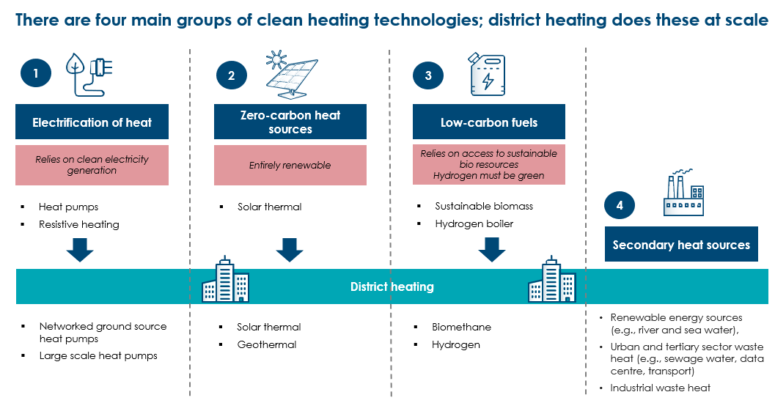
Exhibit 17

Exhibit 18
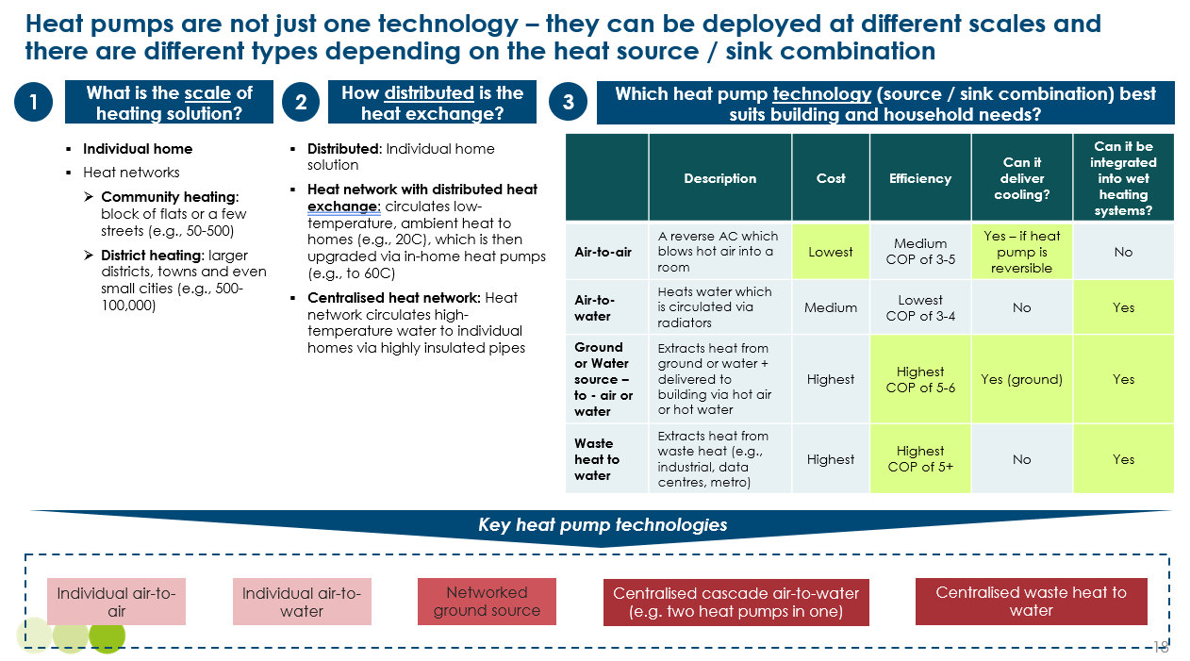

Exhibit 19
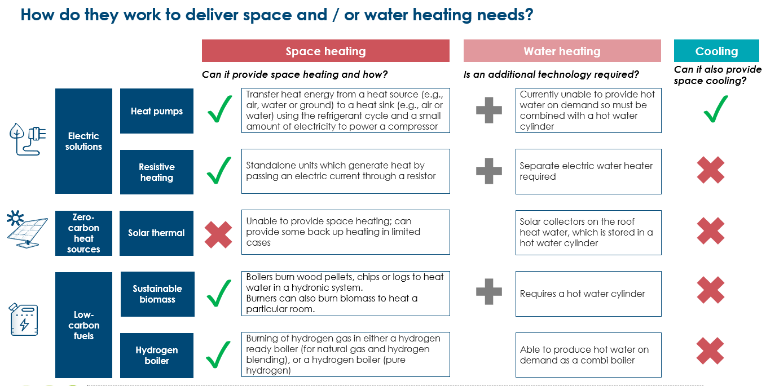

Box 2
To add: case study on Kensa networked ground source heat pumps
- Social housing tower blocks in Thurrock, Essex
- Impact on energy poverty and bills
- Financing approach

Box 3
Hydrogen: potential role in district heating but not individual homes
In countries with large natural gas networks, a number of governments and industries have been considering the use of hydrogen gas, most notably the UK and Germany [Exhibit 32]. Hydrogen has been presented as a “drop-in” replacement of natural gas that can utilise existing pipelines and infrastructure. However, we believe that hydrogen should be ruled out as an option to replace existing fossil fuel boilers for the following reasons:
- Hydrogen is not a “drop-in” replacement: households will still need new boilers which can deal with either a gas/hydrogen blend 100% hydrogen, excess flow values in meters and upstream, and in some homes additional ventilation and pipe replacement will be needed. In addition, significant retrofit – or even rebuilding - to the gas network will be required, given the fact that hydrogen and natural gas have very different physical properties (e.g., molecule size, flame and chemical properties).
- Using green hydrogen would require 5-6 times more electricity than heat pumps: as illustrated in Exhibit 20, the process of producing green hydrogen (i.e. using renewable electricity) and converting this to heat in a boiler has an overall of 50-55%. This compares to 300%+ for heat pumps.
- System costs could be 25% higher compared to electrification: this reflects higher electricity generation requirements (although some costs would be offset by the fact hydrogen can be produced with curtailed electricity), and the cost of developing hydrogen pipelines and storage infrastructure.
- Consumer costs could be 85% higher compared to electrification: even though the cost of a hydrogen boiler is likely 3-4 times cheaper than an air-to-water heat pump, overall costs are expected to be much higher. This is because hydrogen is much less efficient, with higher running costs, and many households will actually have to replace their boiler twice (e.g., in the transition from hydrogen-blend and then 100% hydrogen).
- Using clean hydrogen for home heating would delay the decarbonisation of buildings until at least the mid-2030s: there is huge uncertainty over the pace of clean hydrogen supply pipelines, especially in light of recent high electrolyser prices.
As we argued in our 2021 Making the Hydrogen Economy Possible report, using hydrogen should be prioritised in sectors where electric technologies are neither technically or economically feasible at scale. This is not the case for buildings, where the competitiveness of, and incentives for, clean electrification have rapidly increased in recent years.
Indeed, in recent years the IEA has consistently revised down its forecast for hydrogen use in buildings, from meeting 12% of global heating demand in 2050 in a forecast made in 2021, to 3% in its 2023 forecast. In the UK, a third trial of hydrogen heating was shelved in early 2024, in response to public opposition.
Beyond direct use in homes, hydrogen will still play an important role in the net-zero transition of buildings:
- It is a key technology to store large amounts of energy over time, providing seasonal grid balancing in a renewables-dominated energy system.
- Hydrogen could also play both a direct role in district heat networks, for example in locations close to industrial clusters with high hydrogen use/production, and an indirect role, where waste heat from industry powered by hydrogen can be utilised.
Exhibit 20
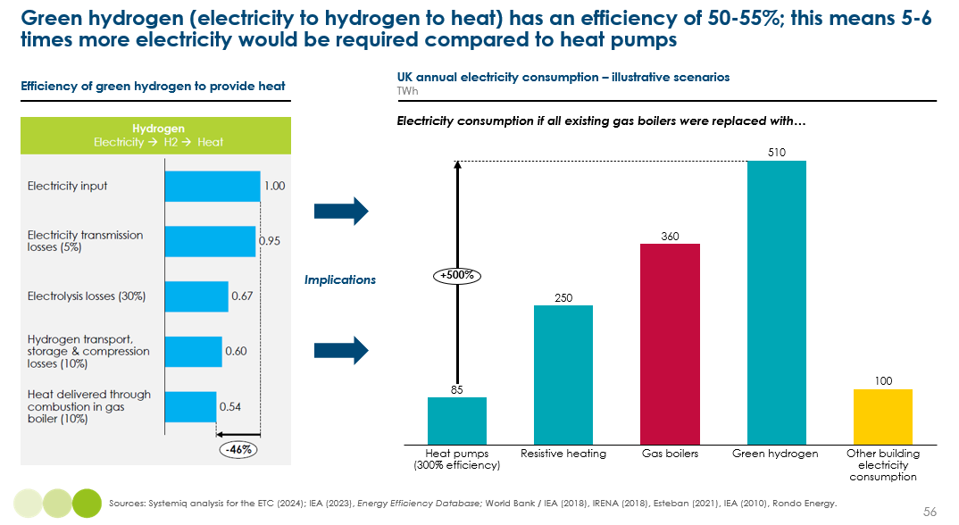

    - Relative costs of different technologies.
The relative cost efficiency of these alternative technologies depends both on upfront costs and running costs; and running costs in turn depend on both the efficiency of the different technologies and the cost per kWh of the different energy sources, and in particular the relative cost of electricity and gas. This relativity varies greatly by region of the world, and by specific country within Europe [Box 4].
In this section we therefore compare typical costs for an average household in Europe, while recognising that actual experience will differ significantly in line with specific circumstances. For a typical European household living in a 2 to 3 bedroom house, the cost of a boiler would be about $3000, and running cost to provide 10,500 kWh of kilowatt of heat per annum would be €1250 to €1500 at the average gas price of €0.12 per kWh which applied in 2023. We assume a current electricity to gas price ratio of 2.5 for this “average” customer.
Box 4
Factors determining the relative costs of heating technologies
The total cost of ownership (TCO) of alternative heating technologies depends on 3 factors:
Upfront cost: these vary significantly by heating technology and also between countries since installation costs vary with the cost of labour. This section presents typical upfront costs for the different technologies for a 2-3 bedroom house in Europe. It compares the clean technology costs with those for a new gas or oil boiler, which could cost between €1,500-4,500 depending on size and property characteristics; we assume an average of €3,000.
Efficiency and energy input required. Here heat pumps have a major advantage against all other technologies since they can deliver multiple kWh of heat per unit of electricity input.
The cost of energy inputs, and in particular the relative cost of electricity versus gas, which varies greatly between countries. For example, in the UK, electricity costs 4 times more than gas, versus 2-3 times more in the US and France, but below 1.5 times in Norway and Sweden. One reason for this is the generation mix, with electricity prices lower in Scandinavia because of abundant hydro resources, and in France because of nuclear generation. But another is that levies and taxes applied to electricity are often much higher than those applied to gas. In Spain and Germany, for example, levies and taxes on electricity are around €0.2/kWh, compared to €0.02/kWh for gas.
Absolute fuel costs also vary greatly across countries, with electricity costing an average of €0.29/kWh in Europe in 2023, compared to €0.11/kWh in the US.
Efficiency and the cost of energy together determine running costs, which together with upfront costs determine the TCO, taking into account differences in the cost of capital (i.e. the financing cost). These financing costs vary greatly between households of different income and wealth levels.

Compared with these typical gas heating costs:
- Upfront capital costs are higher for heat pumps and biomass boilers but lower for resistive heating [Exhibit 21].
- Heat pump capital cost vary significantly by type of heat pump, with air-to-air around €5,000, air-to-water in a range of €8,000 to €15,000, while ground-source systems can cost €15,000 but less if deployed on a network basis. All of these costs should fall with technology development and scale growth.
- Electric resistive heaters are the cheapest technology upfront, with a cost of around €1,500-€2,000.
- Bio mass boilers are somewhat more expensive than gas boilers costing about €15,000.
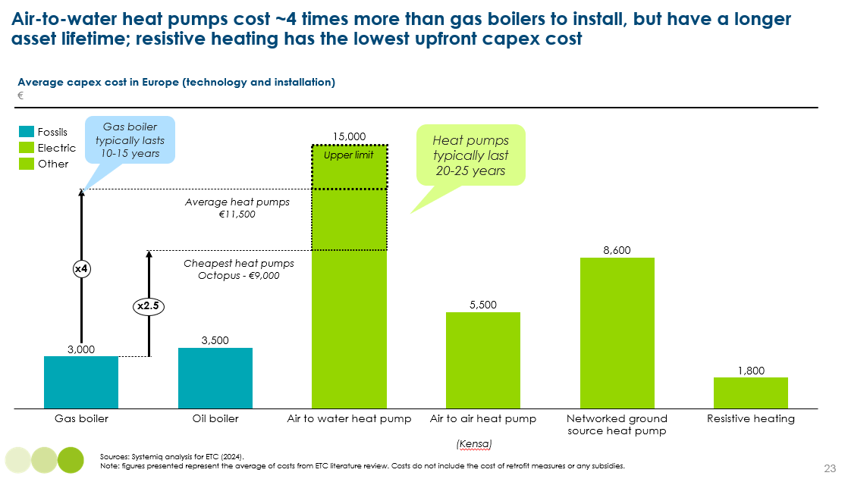
Exhibit 21

- Heat pumps are far more efficient than all of the other technologies, delivering around 300% efficiency today and with further significant improvement likely in future. Resistive heating is around 100% efficient in both space and water heating applications, while biomass boilers are typically slightly less efficient than gas boilers [Exhibit 22].
  - Given the inherent efficiency superiority of heat pumps, operating costs would be around one third to one fifth of gas boilers if electricity prices were the same per kilowatt hour as those for gas; but this efficiency benefit is offset by the higher cost of electricity relative to gas.
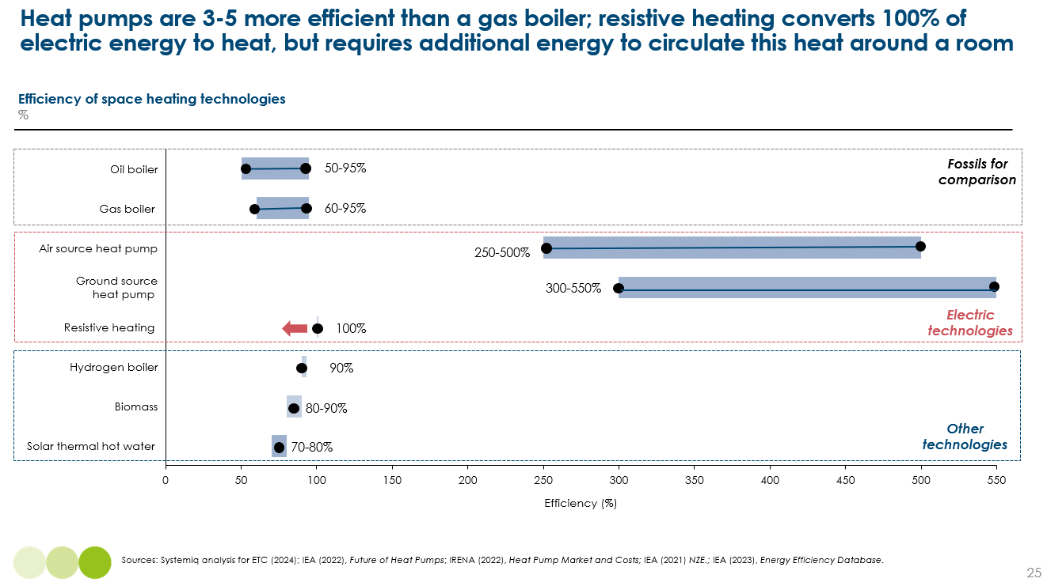
Exhibit 22
- The relative the total cost of ownership (TCO) between technologies therefore depends on the precise heat pump efficiency and the precise electricity/gas ratio assumed. Exhibit 23 shows the result for a heat pump at 300% efficiency and an electricity to gas price ratio of 2.5. This implies that for the average EU household, the TCO of heat pumps is similar to gas boilers. However, this is not the case in all counties, with the key factor being the relative difference between electricity and gas prices; in the UK for example, where electricity costs around 4 times more than gas, heat pumps need to be over 500% efficient to reach cost competitiveness [Exhibit 24].
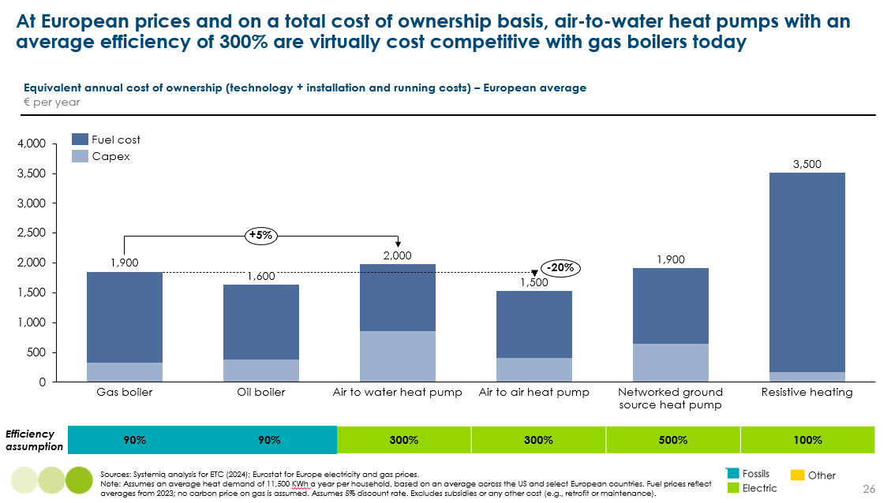
Exhibit 23

This relative position of heat pumps is likely to improve over time as capital upfront costs decline, efficiencies improve and the electricity/gas price ratio declines as electricity prices are decoupled from their current link to gas wholesale prices (the policies required to achieve this decoupling are described in Section 2.6). The increasing cost competitiveness of heat pumps on a TCO basis implies a shift in government policy from subsidies to the provision of low-cost finance.
Exhibit 24
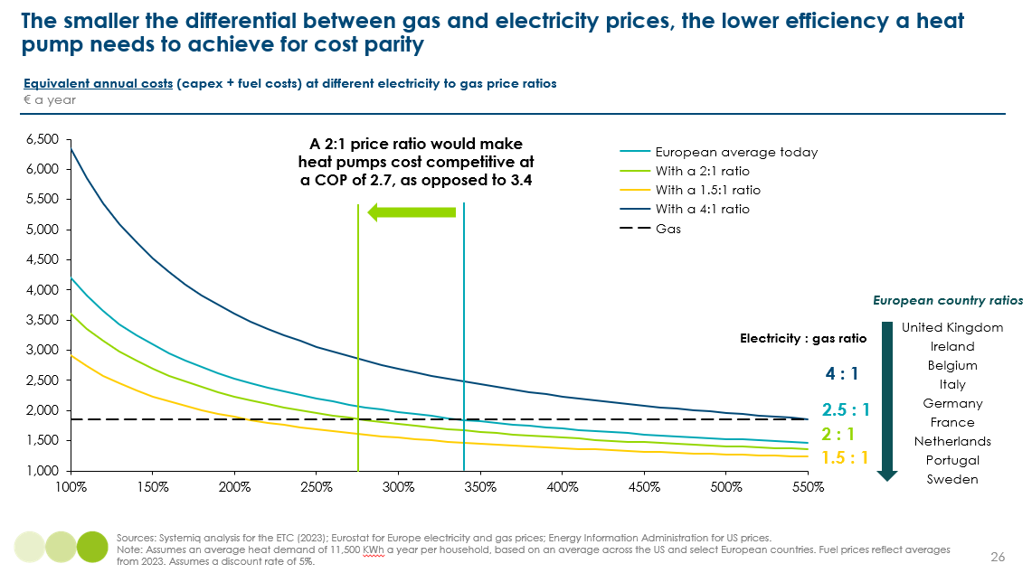

It is important to recognise, however, that individual circumstances will differ significantly from this average, with for instance:
- Lower income households tending to face a higher financing cost, which increases the impact of higher upfront equipment costs.
- Major differences between households in terms of space availability to house different units of equipment [Exhibit 25]. For tightly space constrained households, heat pumps may not be feasible and electric resistive heating a more feasible solution, but with higher operating costs as a result.
It is therefore essential that strong overall public policy support for heat pump developments is combined with policies which address the significant distributional issues, including appropriate subsidy support for lower income households. These policies are described further in Section 2.6.
Those complexities do not however undermine the overall conclusion that heat pumps will and should play a dominant role in the decarbonisation of both residential and commercial building heating.

Exhibit 25
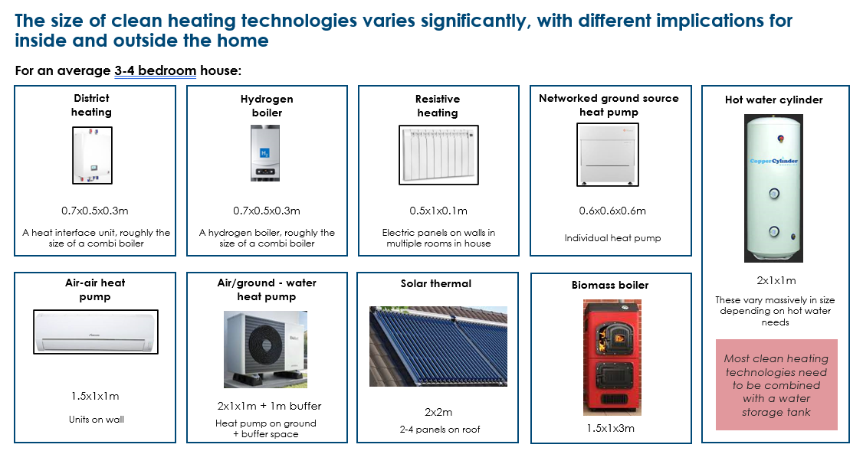
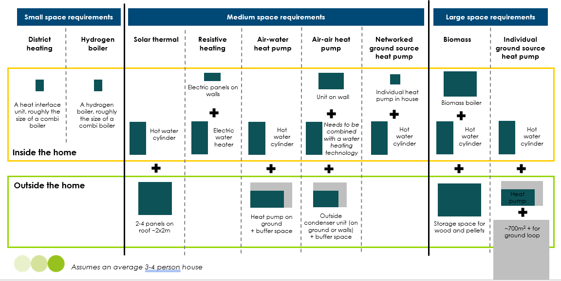
    - Heat pump myths, realities and technological progress
Despite the strong general case for heat pumps, there continues to be scepticism about their effectiveness, and significant opposition to their deployment. This reflects a number of myths which are unfounded even today and which will become even less valid as heat pump technology improves and costs reduce.

Heat pump myths versus valid concerns
- “Heat pumps cannot deliver the same heat as gas boilers”: Air-to-water heat pumps typically operate with lower flow temperatures compared to gas boilers (i.e. the water which runs through central heating systems is 35-50ºC, compared to 60-80ºC for gas boilers). But this is not an issue as long as heat pumps are sized and installed correctly. Many existing buildings will require radiators to be replaced and upsized, enabling more heat to be transferred into the room. In comparison to gas boilers which are able to quickly provide heat on demand, heat pumps work by being turned on for longer but at lower temperatures. This does not mean heat pumps are less effective, just that they require a change in how they are operated. Surveys consistently report very high levels of satisfaction with space and water heating provided by heat pumps.
- “Heat pumps don’t work in cold climates”: It is true that the efficiency of air-to-air or air-to-water heat pumps will decline as the air temperature declines, but the impact at all but the most extreme temperatures is sufficiently small that it does not undermine the case for air-based heat pumps in almost all climates. Refrigerants are liquid at very low temperatures (e.g., below -30°C) and ground source heat pumps work in all climates. As a result Norway and Finland – which have average January temperatures of around -8ºC – have the highest number of heat pumps per 100 households in the world, at more than 40.
- Heat pumps won’t work in old buildings without very extensive expensive retrofit: Given the lower temperatures at which heat pumps typically operate, it is often asserted that they cannot deliver sufficient warm to offset rapid heat loss from badly insulated buildings. But as argued in section 2.3.2 below, this argument has been hugely overstated. In addition, high-temperature heat pumps which can reach temperatures of around 65ºC are increasingly available on the market, reducing the need for radiator upsizing or insulation; these operate at a lower efficiency than standard heat pumps but are still significantly more efficient than gas boilers.
Rather than these three issues, the crucial challenges relating to heat pumps are those mentioned above:
- The high upfront costs and the implications for affordability, especially for low income household facing high financing costs.
- The space availability to install a heat pump plus a hot water cylinder if the heat pump is to be used for hot water supply as well as space heating.

Innovations in heat pump technology
Heat pump technology has been used in homes for over 50 years, but currently only meets around 10% of global heating needs in buildings. As heat pump markets continue to scale, innovation is rapidly improving the technology and addressing many of the key concerns about their performance:
- Efficiency: heat pump technology is becoming more efficient due to, a) variable speed motors which enable a heat pump to operate a different speeds rather than simply on and off, and b) improvements in inverter technology which prevents a fall in performance at lower outdoor temperatures. Average efficiency is expected to gradually improve to around 400-500% to 2050. As a result, the operating cost advantage of heat pumps versus gas boilers will steadily increase.
- Flow temperatures: developments in high-temperature heat pumps are increasingly making it possible to use them to heat poorly insulated houses. Initially these involved a “cascade system” – effectively two heat pumps in one, resulting in lower efficiency – but now can use different refrigerants which can reach higher temperatures for the same amount of compression (e.g., around 60ºC compared to 40ºC).
- Hot water: because they work to lower flow temperatures, heat pumps can’t deliver hot water on demand like a ‘combi boiler’. This means they require a hot water cylinder, which gradually heats and stores hot water over time. This is an issue for installing heat pumps in smaller properties. The hot water challenge has not currently been solved by any products on the market today, but the combination of high temperature heat pumps and innovation in heat exchanger technology is expected to reduce the size of, or eventually the need for, hot water cylinders. Technologies which combine preheating of water in moderately sized cylinders, plus resistive heating boosters to deliver water at the desired temperature are also possible.
- Size: heat pumps are generally getting smaller in size. Today an air-to-air heat pump inside unit is around 1.5m² and an air-to-water heat pump is around 2m². An issue today is the tendency of installers to oversize heat pumps, but as installers gain experience they will be able to right-size heat pumps.

Potential for heat pump cost reduction
Alongside these innovations to drive improved heat pump performance and usability, there is also significant potential for cost reduction, which will result from economies of scale and learning curve effects as the market for heat pumps grows massively. It is striking for instance, that air-to-air heat pumps are today significantly more expensive than air-conditioner units, despite the fact that the core items of equipment are identical.

Reversible air-to-air heat pumps
The fact that heat pumps and air conditioners are essentially the same means that units which have a valve to reverse the flow of refrigerant can provide both space heating and cooling. This is will be a huge driver of adoption, as cooling needs grow (see Chapter 3), with around a third of the global population requiring both heating and cooling over the course of a year. In these countries, reversible heat pumps/air conditioners are likely to be significantly less costly than combining air to water heat pumps plus separate air-conditioning units. [Exhibit 26].
Exhibit 26
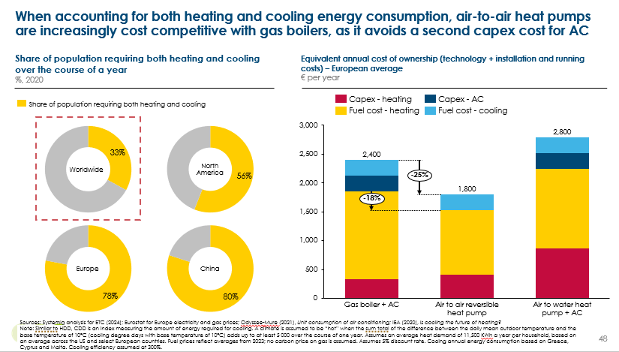

    - Heat networks
The technologies described above can be deployed at the individual house level, but can also be deployed in various forms of networked or district heating solutions.
In data on buildings energy use [see for example, Exhibit 12], ‘district heating’ is its own fuel category; but in reality there is a huge variety of fuels and technologies covered by this term.
Currently, 90% of energy delivered heat networks, 1,600 TWh, is supplied by fossil fuels (predominately coal and gas), as shown in Exhibit 27. This means there is additional challenge of decarbonising these networks, which are common in China, Russia and, to a lesser extent, Europe. In China in particular, district heat networks have a very high carbon intensity, 25% above the global average.
Exhibit 27
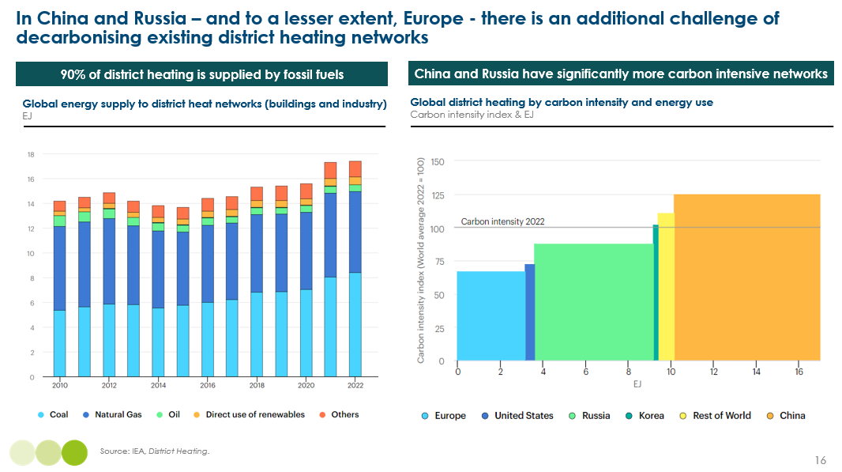
There is a large variety of technologies which can be deployed both in new heat networks and to decarbonise existing high-carbon networks. Indeed, the last few years have seen momentum for heat networks pick up, driven for example in Europe by energy security concerns. Key examples include Denmark and Finland growing their geothermal heat networks, Canada exploiting wastewater waste heat with heat pumps, and China utilising waste heat from nuclear power plants.
The suitability of different technologies is highly situation-specific, depending on space availability, the number of buildings connected and their distribution, and access to heat sources. However, it is possible to draw the following conclusions:
- Heat networks provide efficient and often lower-cost clean heating at scale. They can overcome slow individual action, enabling street-by-street decarbonisation. Therefore, understanding the potential to deploy these across countries through national heat plans and zoning should be a top priority.
- There are significant untapped secondary heat sources such as metro tunnels, data centres and industry; the energy transition will also lead to growing waste heat opportunities from carbon capture and power-to-X processes. These also offer innovative opportunities for financing their development, with the removal of waste heat providing huge benefit to businesses (e.g., data centres).
- Continued improvements in the size and scale of heat pumps mean these will be a core solution to decarbonising existing heat networks. Heat pumps can also be combined with secondary heat pumps to achieve much higher efficiencies.
- Many countries, such as the Nordic countries and the US, have considerable renewable heat sources such as geothermal; these offer significant low-cost potential which should be maximised.
- Low-carbon fuels such as biomethane and hydrogen may play a role in the decarbonisation of existing heat networks, where reliable supply may exist (e.g., close to industrial sites).
  - Passive heating techniques
As described above there is a wide range of “active” technologies which could be used to decarbonise the supply of heat to homes or commercial buildings, with multiple variants of heat pump technology likely to play a major role whether in individual buildings or in networked solutions.
But it is also possible to rely on natural elements such as the sun and a building’s envelope to maintain a comfortable indoor temperature and therefore reduce the need for a mechanical heating system. These so called “passive” techniques can play a critical role in developing a clean, efficient and high quality building stock.
By reducing energy requirements from active heating they:
- Help reduce emissions while electricity is still generated using high-carbon sources, and while heating is still directly fuelled by fossils.
- Reduce the scale of clean power and network upgrades required.
- Significantly improve outcomes for households, leading to more comfortable and higher quality homes and lower energy bills.
Passive heating techniques focus on capturing and retaining heat inside a building by optimising:
- Orientation to maximise solar exposure during the winter months (e.g., in the northern hemisphere, windows and living areas facing south).
- Thermal mass in the building fabric: materials such as stone, brick and concrete are able to slowly absorb and store ambient heat during the day and then radiate this at night. This helps to avoid sudden spikes in indoor temperatures.
- Minimising heat loss in the building envelope: materials and design choices are important to create a barrier between hot and cold temperatures. Key solutions include:
  - Insulation: materials with high thermal resistance, therefore resisting heat transfer, include fibre glass, mineral wool and foam. Insultation should be appropriately applied to walls, floors and roofs.
  - Windows: amount of glazing (e.g., double or triple) and coatings (e.g., low-emissivity glass which reflects heat back into a room).
  - Airtightness: high-quality construction and effective use of seals around windows and doors can help reduce air leakage. While this is very important to prevent draughts, it is also critical to ensure a building has sufficient ventilation and air quality.
As we will explore further in Chapter 9, high thermal mass and a low heat loss rate are key to a building’s flexibility and ability to reduce and time-shift its peak heating needs.
Designed for northern hemisphere countries (e.g., with a focus more on heating), the Passive House Standard is the gold standard for energy efficient new buildings, incorporating passive building techniques to lower energy consumption by 70-90% compared to typical buildings. As Chapter 9 explains, the costs of building to Passive House standards can be prohibitive (especially for existing buildings), but there are many low-cost and high-impact things that can be done.
    - The huge opportunity for passive heating in new buildings
It is significantly cheaper and easier to ensure buildings are constructed with passive heating techniques compared to retrofitting at a later date. The impact on energy consumption will vary massively across techniques and buildings; however Exhibit 28 shows that heating demand can be reduced by 15-30% on average.
Similarly, the additional cost to developers will vary depending on material and labour costs, and know-how. Exhibit 28 sets out rough estimates of cost to developers; it is important to note that these are not necessarily additional costs, with regulation in many countries already requiring a focus on these.
From an economy-wide perspective, these techniques have very strong returns, up to 30% for insulation. The challenge is that the costs are borne by developers but the returns accrue to households via lower energy bills. Chapter 9 will discuss the role of regulation and private sector action in ensuring new builds are built to maximise efficiency and comfort.
Exhibit 28
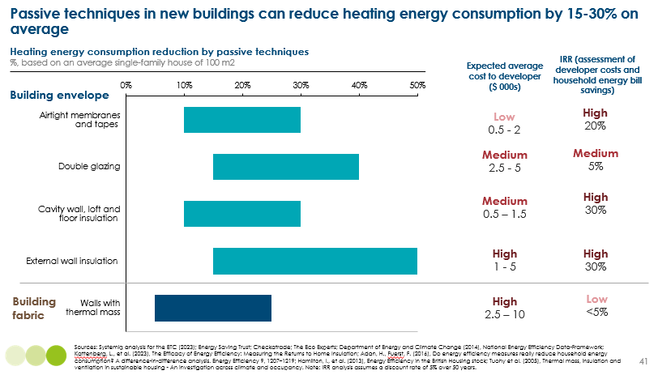
    - The potential to retrofit buildings for passive heating
In existing buildings, the main passive heating techniques that can be retrofitted are improvements to the building envelope. There are a variety of improvements that can be made, ranging from:
- Low-cost, light insulation measures (~5% reduction in energy consumption): including draught proofing (which can often be DIY using self-adhesive foam strips around window frames, brushes at the bottom of doors and letterboxes, and sealing cracks), and loft insulation using boards or rolls of mineral wool, fibreglass or cellulose.
- Medium insulation measures (~10-20% reduction in energy consumption): including insulating cavity walls with polystyrene beads, mineral wool or polyurethane foam, and adding insulating boards underneath floorboards.
- Deep insulation measures (~25-50% reduction in energy consumption): these involve more structural changes to the building fabric, including replacing windows with double or triple glazing, or insulating external solid walls.
As detailed in section 2.4, the vast majority of households should be able to install a heat pump without additional insulation, provided the heat pump is sized and installed correctly with appropriate radiator replacement.
However, there are significant wider benefits to improving insulation in existing homes, including living standards, lower energy bills, and health and social equality. As we outline in Chapter 9, reducing heat loss within homes is also core to enabling households to shift the timing of their heat demand , use electricity at lower off peak prices, and reduce the challenges and costs created by high peak electricity demand in renewable dominated power systems.
The challenge is that some insulation measures have high upfront costs and it is very hard for households to estimate how much this investment will reduce annual energy bills. Exhibit 29 sets out some illustrative scenarios for costs and energy savings, comparing the paybacks in inefficient and average buildings. Key points, focusing just on the financial incentives, are as follows:
- The incentive to insulation decreases with higher heat pump efficiencies.
- Even without government support, many households in inefficient properties have an incentive to do light and medium insulation.
- Without government support, it is unlikely that most households living in average efficiency buildings will invest in insulation. However, households may still have a strong willingness to pay for insulation to improve comfort and building value.
- For households that have a winter heating and summer cooling need (e.g., many parts of the US and Southern Europe), the returns will improve when considering that improving insulation will reduce both heat loss and AC energy loss.
Exhibit 29
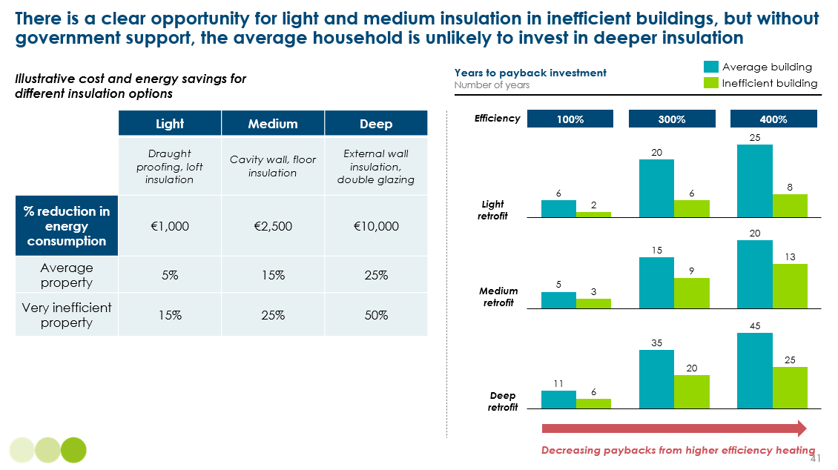
This suggests the following policy priorities:
- Improving the energy efficiency of the least efficient properties should be a critical priority this decade, with very strong economic and social paybacks. Government should allocate sufficient grants and subsidies, with low income households tending to live in poorer quality homes.
- For the average property, governments should provide low-cost or zero-interest finance, overcoming lower paybacks for the average household.
- Providing clear guidance on low-cost insulation measures that can often be DIY, and offering free advisors to assess the most cost-effective measures for individual properties.
  - Optimal combinations of heating technologies and improved insulation
Given both the clean heating technologies described in section 2.2 and the passive heating technologies described in section 2.3, optimal approaches to building heat decarbonisation will entail multiple different combinations of actions, varying by region and by specific building. But broad conclusions on the predominant technologies and most important policies can be reached.
    - New buildings
Strategies to ensure that new buildings are zero carbon should combine very high standards for building design plus regulation to require the installation of a zero carbon heating technology which in the vast majority of situations will be electric.
This implies the need for:
- Regulation to prohibit the installation of fossil fuel boilers in new builds from 2025 in high-income countries and from 2030-35 in middle-income countries.
- More ambitious building codes with more stringent minimum requirements for energy intensity (i.e. the typical kwh/m² a building can consume); this will tend to limit the installation of resistive heating for primary space heating needs and encourage heat pump solutions,
- Guidance and training of the real estate sector to better inform prospective buyers about their heating system, future bans on fossil fuel heating, and running cost implications of resistive heating vs heat pumps.
- Collaboration of developers with wider industry stakeholders (e.g., utility companies, heat pump companies, financial institutions) to finance new heat networks.
This combination of policies is likely to drive very widespread deployment of heat pump based solutions, but with the particular type of system varying by building type and location:
- Networked ground source heat pumps will be the economic solution in many large scale developments of apartment blocks and housing estates, and will deliver households the highest possible efficiency and lowest operating costs.
- Air-to-air heat pumps will be particularly attractive in regions which have cooling as well as heating needs. They will need to be accompanied by electric resistive or solar thermal water heating.
- Air-to-water heat pumps will be the cost effective solution for many detached properties which do not have cooling as well as heating need, and which have the space for hot water cylinders. It is therefore important to ensure that householders are well informed about future operating costs as well as upfront costs, to avoid the danger that developers focus solely on minimising the latter.
Exhibit 30
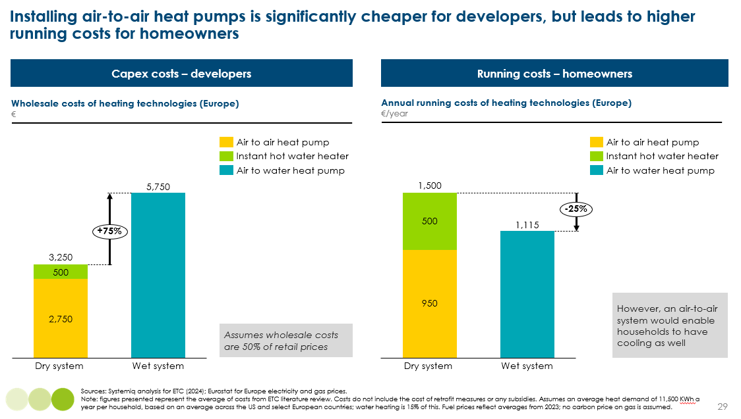
    - Existing buildings
The crucial question is the extent to which fabric improvements are required. Past policies and guidance household have often been based on a “fabric first” approach, in which building electrification is only pursued after very extensive improvements in building insulation, aiming for standards close to those which might be achieved in new builds. In part, this reflected a concern that “premature electrification” could drive up electricity demand before electricity generation has been decarbonised.
However there is a growing recognition that this should no longer be the default for the average existing building [Exhibit 31]. This is partly because power system decarbonisation means that in many countries switching from gas to an electric solution will deliver significant emissions reductions even if electric resistive heating is used. But also because of a reassessment of the feasibility and economics of heat pump deployment in imperfectly insulated houses.

Exhibit 31
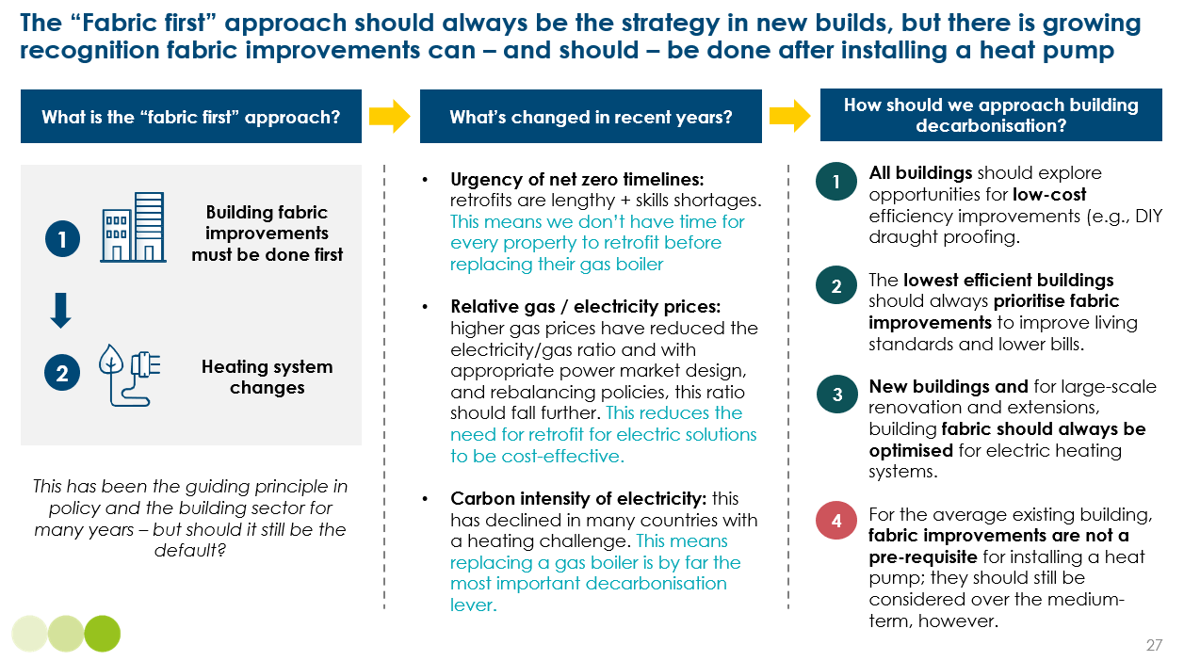

Past policy has sometimes been guided by the belief that fabric improvements are necessary either to provide sufficient comfort or to improve the economics of heat pumps. However, these can both now be challenged, since:
- In most cases, a very high insulation standard is not necessary for a heat pump to provide sufficient comfort. It is important to understand that insulation does not directly impact a heat pump’s technical performance, which is determined by the temperature differential between the heat source and sink (see Annex 1). But air-to-water heat pumps operate at lower flow temperatures to gas boilers, which can lead to a decrease in comfort if a heat pump system is not properly sized or installed. There are two ways to mitigate against lower temperatures:
  - Increase how much heat is emitted into a room by upsizing radiators – this is generally a lower-cost and easier approach; it can often be done in a day and in many cases, radiators are suboptimal for new gas boilers as well (e.g., age or quality) and should be replaced in any case.
  - Reduce how much heat is lost out of a room – as we outlines in Section 2.3, there is a whole spectrum of improvements that can be made to building fabric in existing buildings from low-cost draught proofing, loft insulation, to double glazing and external wall insulation. In many cases the lower cost options will be sufficient to ensure that heat pumps can deliver the desired level of comfort
- Heat pumps already have comparable running costs to gas boilers. As outlined above, for heat pumps operating at 300% efficiency (which is the typical average today), annual running costs are already 25% lower even with electricity costing 2-3 times more than gas.
There is a growing body of literature confirming that the need for building fabric improvements before installing a heat pump has been overstated. Analysis of a UK council’s building stock suggests that only 6% of buildings need major fabric modifications and 24% need moderate modifications before installing a heat pump (e.g., cavity wall insulation); 60% require radiator improvements and/or minor fabric improvements (e.g., draft proofing, loft insulation), and 10% are heat-pump ready.
Our key conclusions are therefore:
- The need for large-scale deep retrofits before heat pump installation has been overstated, and countries should now commit to large scale heat pump deployment.
- For most households , heat pump installation will deliver lower TCO, and adequate comfort can be ensured if the system is sized and installed correctly, including appropriate sizing and quality of radiators.
- Heat pump installation should in many homes be accompanied by light to medium retrofits, such as draught proofing and loft / cavity wall insulation. Such measures will often deliver a positive return and will help reduce peak electricity demands as discussed in Chapter 9. Such improvements can, however, be made after a heat pump has been installed.
- More extensive retrofits will be needed in the currently least energy efficient buildings, where they would save costs and deliver higher comfort levels even if households were continuing to use gas boilers or other fossil fuel technologies
    - Implications for the balance of different technologies
There is no one-size-fits-all solution to clean heating, but it is clear that the technology will be overwhelmingly electric and predominantly heat pumps.
The deployment of specific technologies will vary depending on a building’s current heating solution [Exhibit 32], building type and size, and building ownership. The key technologies and their typical applicability are:
- Air-to-air heat pumps in countries with cooling needs, those with ducted heating systems, and in new buildings.
- Air-to-water in existing buildings in countries with wet heating systems (i.e. countries that currently rely on natural gas).
- Networked ground source heat pumps in blocks of flats and terrace housing, including new builds and social housing where decision-making and financing is easier.
- District heating in dense, urban areas and in locations close to a secondary heat source, and in countries that have existing heat networks (e.g., existing expertise and skills).
- Resistive heating where heat pumps are unsuitable or unfinanceable, or where higher-income households would prefer higher energy bills over the changes to their home that installing a heat pump may incur.
- Electric water heating to accompany air-to-air heat pump installations, and air-to-water heat pumps where households do not have the space for a water tank.
Exhibit 32
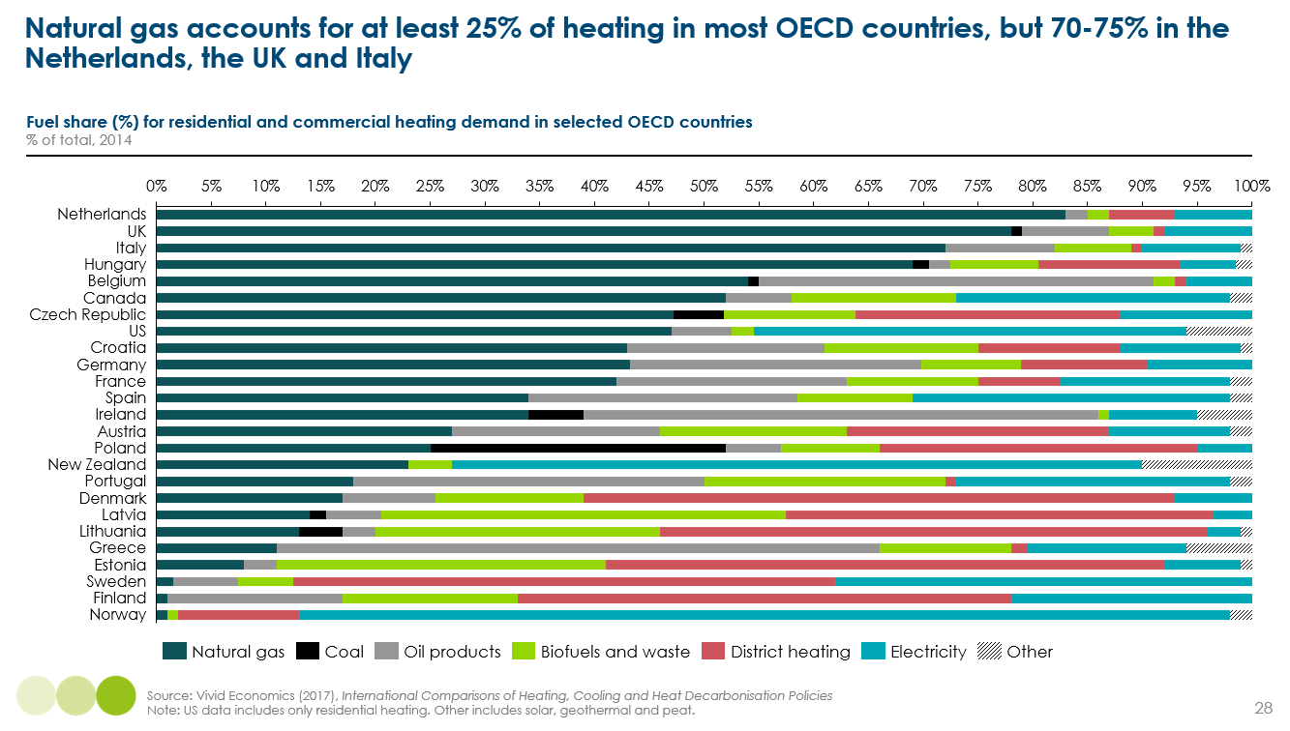
Given the huge variety of individual circumstance, and the potential for future changes in technological possibility and cost, it is not possible - nor necessary - to predict the precise future mix of technologies which will be used to decarbonise building heating. But it is still useful for national strategies to define a broad sense of direction, including an indication of which technologies are most likely to prove optimal in the specific national context. Such a vision can help ensure the sufficiently rapid development of clean technology supply chains to meet future, and inform householder choices.
Exhibit 33 therefore indicates for France and the UK, the technologies which seem most likely to dominate in particular categories of the building stock. Key differences are likely to include:
- Air-to-water heat pumps will be more common in the UK, as it has more properties with existing wet heating systems, while air-to-air heat pumps will be more common in France with its greater cooling needs.
- Networked ground source heat pumps could be prevalent in both countries, while France has a large share of existing district heat networks, meaning the private sector has the skills and capabilities to scale up new heat networks.
- In both countries, strong policy and regulation is required to ensure that rental properties and social housing are not installed with resistive heating, which has far higher running costs than heat pumps and would have adverse distributional impacts on lower-income households.
Exhibit 33
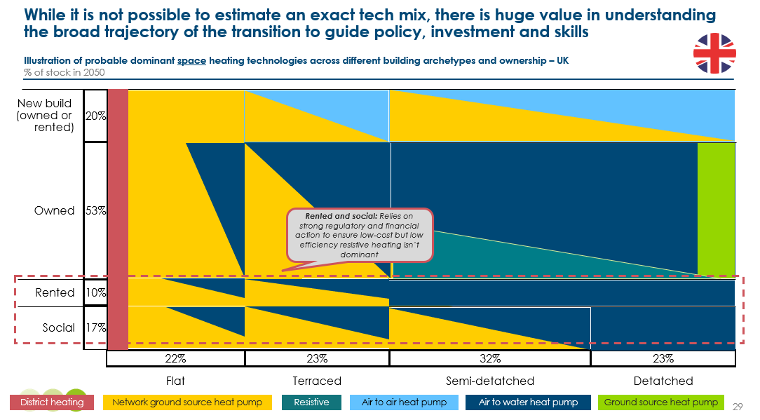
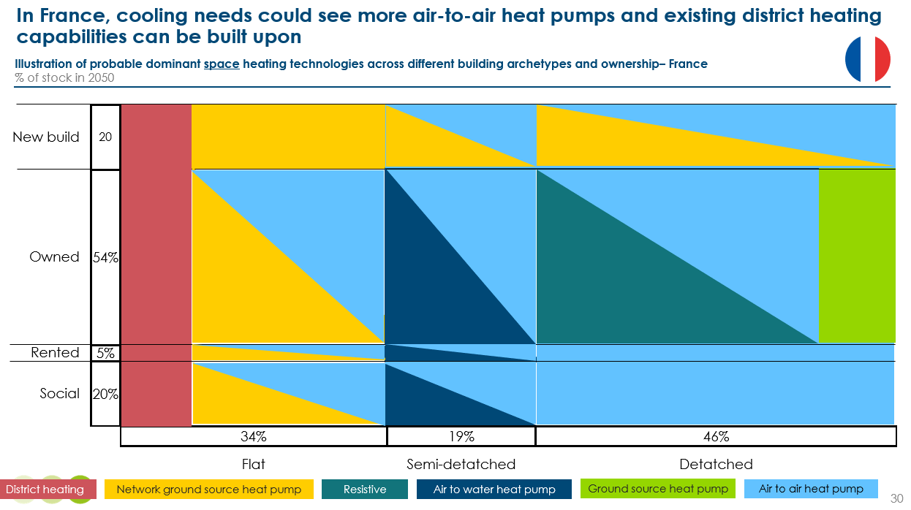

  - Implications for the heating transition and fossil fuels
There will be three key stages to the heating energy transition:
- Preventing new builds from installing fossil fuel boilers. The EU is the furthest along, with the revised Energy Performance Buildings Directive (EPBD) requiring all new public buildings to be zero-emission from 2026 and all new buildings from 2028. There are no national timelines in China or the US, although New York has banned fossil heating in new builds from 2026.
- Preventing existing buildings from installing fossil fuel boilers. The extension to the EU’s Emissions Trading Scheme to buildings in 2025 will drive action, but no firm bans on the sale of fossil fuel boilers have successfully been implemented yet.
- Preventing buildings from running a fossil fuel boiler. The EU’s revised EPBD sets a target for all fossil fuel heating to be phased out by 2040, but with the exception of Denmark (which aims to convert all remaining gas boilers to heat pumps or district heating), no specific national timelines for when the domestic gas grid could be switched off. Box 5 discusses the key questions that countries should begin thinking about to prepare for this.
In our Fossil Fuels in Transition report, we outlined an ambitious scenario for how rapidly the stock of fossil fuel boilers could go electric in Europe and North America [Exhibit 34]. In other countries the transition is likely to occur later. This results in the scenarios for the decline in fossil fuel use for heating shown in Exhibit 36. Note that these pathways also include commercial buildings (discussed in Chapter 7). Key points are as follows:
- Gas use falls 75-90% by 2050, but falls of only 10-15% by 2030 are feasible by 2030.
- Oil demand falls 90-95% by 2050, with falls of 20-35% possible by 2030.
- Coal use is entirely eliminated by 2040.
As heating is electrified, final energy consumption for heating will fall by 10-15%, due to the superior efficiency of heat pumps. This will, however, result in a potential quadrupling of electricity demand for heating, from 2,600 TWh to over 10,000 TWh. With strong action on energy productivity, including heat pumps increasing in efficiency from 300% to 400-500% and with improvements to building fabric, electricity demand could be reduced to 4,600 TWh [Exhibit 35].
Exhibit 34
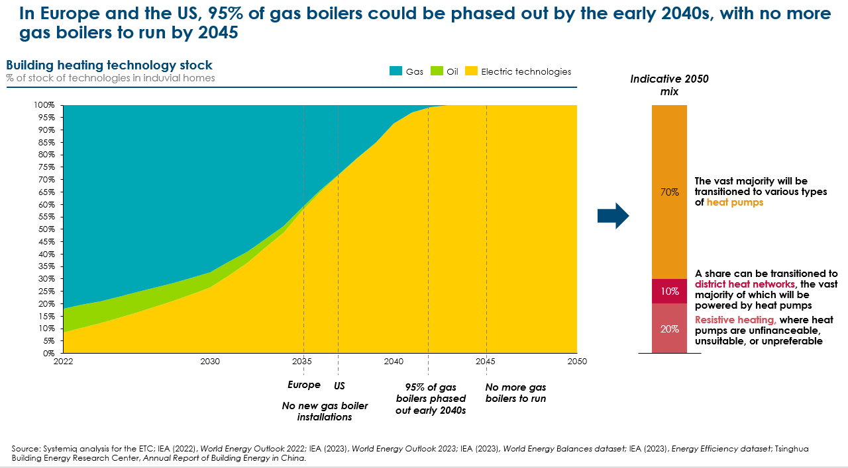
Exhibit 35
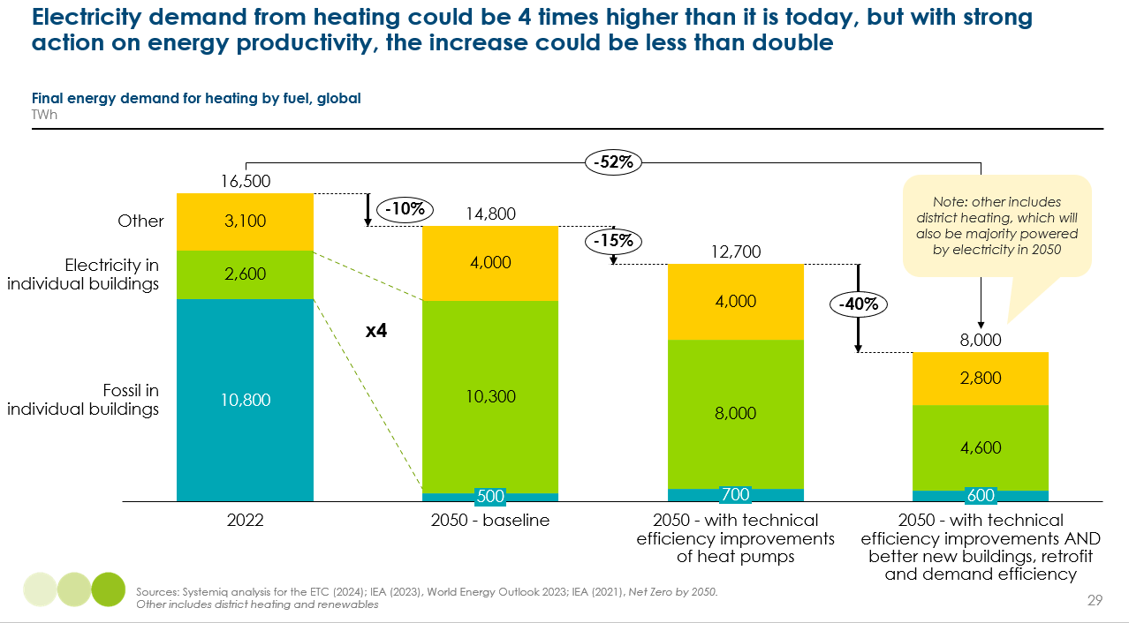
Exhibit 36
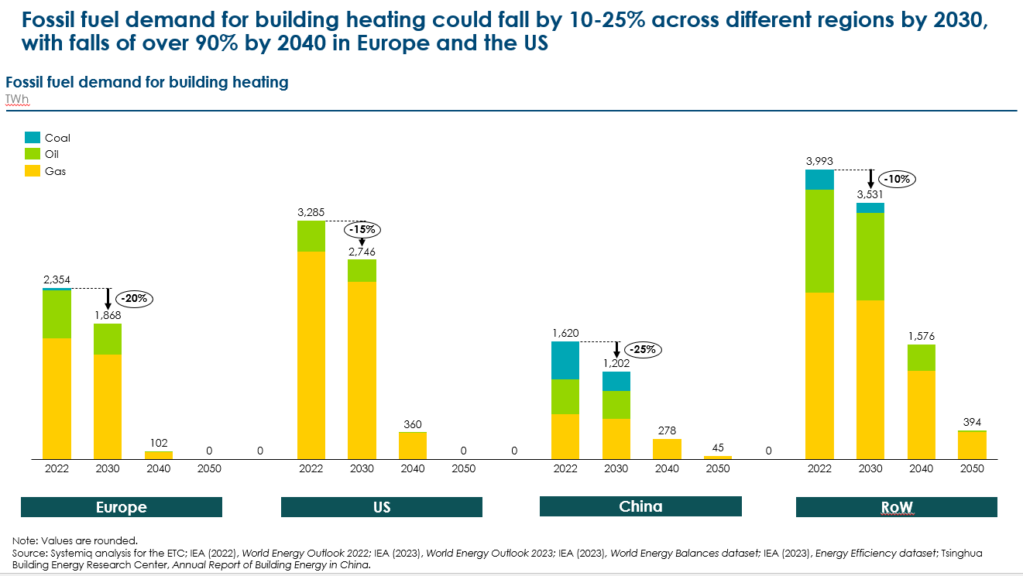
Box 5
Future of the gas grid
Phasing out gas boilers leaves big questions about what happens to the existing gas network. As we evidenced in Box 3, a hydrogen home heating system would be higher cost, inefficient and significantly delay the transition. This means, while the transmission network could be used for hydrogen (e.g., for industrial purposes) or transporting captured carbon, the distribution network of pipes which deliver gas to homes will need to be largely decommissioned – unless they were developed into heat networks.
This poses big questions around how this is done and who pays:
- Safety: Unused pipes must be made safe. With many running under roads and buildings, they need to be filled with concrete or repurposed (e.g., for electricity cables).
- Who pays: Gas networks in most counties (e.g., the UK) are privately owned assets, with the cost of maintaining and upgrading the network recouped through energy bills. The challenge is that as more households electrify, these costs will be shared across a smaller customer base; at the same time, the gas grid must be maintained and kept safe until the last building is disconnected.
- Equity: This is further compounded by the fact that lower-income households may be the last to electrify, unless governments support their transition with subsidies and low cost finance.
- Coordination: Street-by-street electrification strategies will be key to prevent situations where there are only a few buildings on a local distribution network and it becomes economically unviable to keep the gas grid going for them.
Analysis of the UK suggests that decommissioning the gas grid could cost up to £25 bn. Leaving the private sector to bear these costs would lead to adverse equity impacts, meaning costs will undoubtedly need to be partially publicly financed, either with the government directly financing decommissioning or by providing financial support to lower-income households faced with higher bills.
It is critical that policymakers and network operators begin planning for how to cost-effectively decommission the grid. Key next steps should be:
- Setting a clear policy direction that hydrogen will not be used in homes.
- Developing local street-by-street strategies to phase out fossil fuel heating.
- Setting national targets for the phase out of fossil fuel boilers and when the gas network for buildings could be switched off.
- Working with grid owners to understand how granular the gas grid could be switched off.

  - Actions for policy and industry
While it is technically and economically feasible to electrify building heating using predominantly heat pumps, realising this potential will require a comprehensive set of well-designed policies and private sector action.

Upfront cost reduction and manufacturing capacity
Even though heat pumps are already becoming cost competitive with gas boilers on a total cost of ownership basis, affording the upfront costs is a critical challenge. Air-to-water heat pumps can cost €5,000-10,000 more than a gas boiler to purchase and install, and air-to-air ones can cost around €2,000-3,000 more. It is interesting to note that air conditioners, which are virtually the same technology, cost 2-3 times less than an air-to-air heat pump. This implies that there must be significant potential for cost reduction:
- Capex costs, which typically account for ~40% of total consumer costs, will tend to come down as market scale increases and competition grows. Given the mechanical complexity of heat pumps, we are unlikely to see the dramatic cost reductions achieved in solar PV and batteries, but a price fall of 25% by 2030 is feasible.
- Labour costs, which typically account for ~60% of costs, could be slower to come down unless skills development can keep pace with rising demand. With every building being different, there is a limit to which heat pump installations can be standardised. There is also evidence that subsidies in some countries may be dampening potential falls in labour costs, with installers having less incentive to compete on price.
- On the supply side, currently announced production capacity plans for heat pump manufacture fall 35% short of 2030 demand forecasts. However, this largely reflects demand and policy uncertainty as opposed to any material manufacturing constraints. Scaling up heat pump manufacturing has relatively short lead times of 1-3 years – so with the right policies, potential constraints should ease quickly.
Governments can help encourage cost reductions and ensure that adequate supply chains are in place by:
- Giving manufacturers and installers confidence in the pace of heating electrification with clear targets and a national strategy.
- Setting rising quotas on manufacturers for heat pumps as a share of all heating system sales, for example the UK’s Clean Heat Market Mechanism. This could be combined with incentives to develop local manufacturing, with strategies to ensure sufficient supply of critical materials, such as the EU’s Critical Raw Minerals Act. Over the medium-term, it will also be important to increase the recovery and recycling of materials through end‐of‐life management regulations, such as the EU’s Waste Electrical and Electronic Equipment Directive.
- Driving early demand by decarbonising social housing and public buildings.
- Stimulating household demand with financial support, but ensuring that any subsidies are time-limited and targeted to lower-income households to ensure that they don’t dampen the impact of competition on potential cost reductions.
- Providing financial incentives for research and innovation in the technology.
- Regulation to prohibit the installation of fossil fuel boilers in new buildings.
In addition, there are various financial solutions which can help households afford the upfront costs [Box 6].
Box 6
How to share the upfront costs of heat pumps with households?
It is not feasible for low income households to bear all of the costs of installing heat pumps, and it would be too expensive for governments to meet a significant share of costs for all households. Subsidy support packages must therefore be focussed on lower income groups, using a mix of public and private delivery channels, including:
- Governments: which can provide both grants and low or zero-interest finance.
- Green investment banks: investing in decarbonising social housing should be a top priority. They can also pool investments in local areas, overcoming high individual transaction costs for financial institutions.
- Financial institutions: there is room for significant innovation in terms of “mortgage top-ups” and offering favourable green interest rates for heat pumps and energy efficiency retrofits. With residential real estate accounting for a very large share of many banks portfolios, product innovation will be key to meeting financed emission commitments. Governments can encourage this by securing more favourable rates (e.g., on first loss terms).
- Private sector: if mandated to sell a certain share of heat pumps, the private sector may essentially share costs with households by lowering prices, or also offering low-cost finance. Utility and other energy companies should finance shared ground arrays for networked heat pumps, which are repaid by a standing charge.

Electricity costing more than gas
In the US and across most Europe, heat pumps already cost 25-30% less a year to run at 300% efficiency. But in some countries, such as the UK, the difference in annual running costs is much less. The key determinant is how much more expensive a kWh of electricity costs, relative to a kWh of gas.
There is a clear relationship between heat pump adoption and a lower ratio between gas and electricity prices. The UK has the lowest heat pumps per household in Europe, with electricity costing over 4 times as much as gas [Exhibit 37].
Exhibit 37
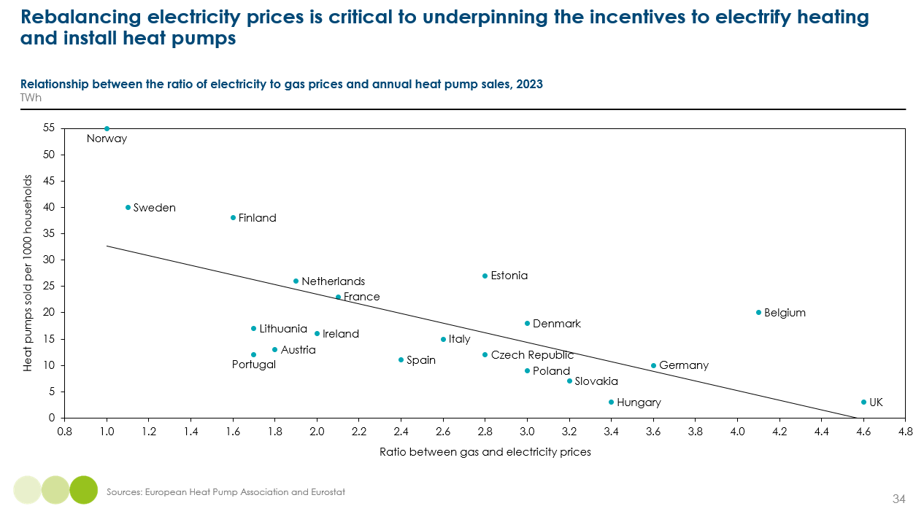
Actions which could achieve a rebalancing of electricity and gas prices are therefore a priority. Exhibit 24 shows the huge impact that a smaller differential has on the efficiency a heat pump needs to achieve for TCO parity. In Europe, with electricity costing 2.5 times more than gas today, an air-to-water heat pump needs to average 340% efficiency over a year to be cost competitive; this would fall to 270% if electricity only cost 2 times as much.
There are a number of ways governments can pursue rebalancing:
- Removing environmental levies which are currently disproportionately placed on electricity (a legacy from when electricity was generated from higher-carbon sources such as coal) and shifting them either to general taxation or onto gas. This rebalancing should be done gradually, in line with rising heat pump adoption, and combined with targeted support for lower-income households still using gas. It is important to remember that all households, even those still using gas for heating, will benefit from lower prices for their other electricity consumption.
- Governments could also take a more targeted approach by offering relief on electricity used for space heating. Since 2021, Denmark has applied a lower tax rate to electricity used for heating, with taxes on existing electricity consumption remaining the same.
- Carbon pricing for fossil fuel consumption.
- This should be underpinned by appropriate power market design, to ensure wholesale and retail prices better reflect lower cost renewables (e.g., reducing the frequency of gas setting marginal prices).

Regulation and policy
In many countries, poorly designed policies are holding back progress. In recent years, a number of regulations and timelines for the phase out of fossil fuel heating have been weakened or rolled back on, for example in the UK and Germany. This uncertainty drags on private sector and household investment. It is therefore essential to set out ear timelines for the phase out of fossil fuel boilers (see Box 7).
In addition, planning restrictions are in some cases restricting heat pump uptake. In the UK for example, heat pumps are not allowed to be placed on walls (therefore preventing uptake in flats) and must have a 1m boundary around outside units, creating issues for terrace housing. Restrictions on changes that can be made to listed or protected buildings (e.g., for historical or aesthetic reasons) also restricts uptake. Governments should therefore review whether existing regulations are unnecessarily restrictive, or whether their objectives could be achieved via other means, for example standards for maximum noise levels.
Regulation should undoubtedly set clear building codes and standards for new builds (see Chapter 9). This will also support change in existing buildings by scaling up supply chains and setting a clear direction of travel.
Box 7
EU sets out clear regulation to phase out fossil fuel heating by 2040
In 2024, the EU revised is Energy Performance of Buildings Directive, setting out a clear and ambitious timeline for both new and existing buildings.
New buildings: all new residential and non-residential buildings must have zero on-site emissions from fossil fuels by 2030 and must be “solar-ready” (fit to host solar installations).
Existing buildings: member states must:
- Set out measures for to achieve a complete phaseout of fossil fuels boilers by 2040
- Adopt a national trajectory to reduce primary energy use 16% by 2030, and 20-22% by 2035 for residential buildings
- Commercial buildings are required to progress faster – they must renovate the 16% worst-performing buildings by 2030 and the 26% worst-performing buildings by 2033.

Consumer awareness
Until governments ban the sale of fossil fuel boilers, the transition over the next decade relies on households choosing to purchase a heat pump. The challenge in many countries is that awareness of heat pumps and accurate information is very low. In the UK, 60% of households have no interest in installing a heat pump, and 85% are unaware of the climate benefits.
Key actions required include:
- Information and awareness campaigns to debunk misconceptions and explain the benefits to energy bills. Governments should lead by example, installing heat pumps in prominent and older public buildings.
- Community initiatives, such as local pilots, demonstrations and forums where households can see successful installations in similar properties can bolster trust in the technology and enable the sharing of lessons learned and benefits.
- ‘One-stop shop’ advice services can guide households through complicated energy efficiency retrofit and technology decisions.
- Third-party energy audits can help consumers make informed decisions about their property, for example via requirements for energy performance certificates.

Landlord and tenant split incentives
Around 15-30% of households live in privately rented accommodation across the OECD. The challenge is that landlords have an incentive to install the cheapest clean heating technology (e.g., resistive heating), but this leads to sub-optimal outcomes for tenants and electricity grids:
- Resistive heating has 3-4 times higher running costs.
- Resistive heating requires 3-4 times more electricity than heat pumps, and if installed in a high share of the housing stock, would impose high peak electricity requirements unless time of use tariffs and investment in insulation and household level storage resulted in a significant demand shift away from peak hours.
Ensuring that, as much as possible, landlords install heat pumps should therefore be a government priority. Key policies include:
- Minimum energy performance standards for private rental properties, set such that resistive heating in poorly insulated properties would be infeasible
- Provision of low-cost finance that can be repaid directly through rental income.
- Scaling up district / networked solutions which reduce the need for individual landlord decision-making.

Coordination and planning
Delivering the replacement of fossil fuel boilers at scale will be a significant coordination challenge:
- Coordinating the electrification of heating with scaling up renewables and grid upgrades.
- Coordinating investments in local infrastructure and skills.
- Planning for the future of the gas grid as more and more households disconnect [Box 5].
Street by street approaches will need to play a key role. These place more responsibility on local authorities to identify areas suitable for coordinated switching via heat networks, networked heat pumps, or mass heat pump adoption. This requires local policymakers to:
- Develop a deep understanding of their housing stock and households, undertaking surveys to assess likely solutions, attitudes and plans to replacing boilers.
- Setting local targets, with financial incentives from national governments.
- Host community groups to better understand barriers and drive consumer awareness.
Heat networks and networked heat pumps are, in themselves, a key solution to overcoming coordination challenges. These have the benefit of overcoming slow or uneven household decision-making, as the government and private sector drive investments. This requires:
- Zoning to understand potential in local areas, including the availability of waste heat and the feasible distance this can be moved and infrastructure feasibility.
- Explore financing strategies and sources, with a wide number of private sector companies Investment in ground arrays:
  - Coordinating investment from utility companies, government, heat pump companies, and financial institutions for laying shared ground arrays.
  - Exploring new sources of finance from the private sector for secondary waste heat (e.g., data centres investing in heat being taken away)

Local grid upgrades
In addition to upgrades to national transmission networks, an often overlooked issue is the upgrades required to the local distribution network. In most countries, especially those which rely heavily on gas, the local grid has not been designed to deal with large peaks from electrified heating and so must be upgraded to support greater loads. This means secondary substations, which lower the voltage so it can enter homes, will need significant reinforcements. In addition, many properties will need fuse and service cable reinforcements; the latter of which can involve disruption to roads.
One challenge is that in many countries, there is a concerning lack of data on existing infrastructure and how many areas will be affected. Critical actions include:
- Network system operators must begin a large-scale data collection exercise to understand current capacity and expected constraints.
- National planning for priority distribution network upgrades, which should be carefully reflected in regulator's price controls and investment allowances.
- Reform of the regulatory price control process to drive a focus on anticipatory and long-term investment.

Skills availability
The more pressing supply-side challenge is skills. The number of heat pump installers needs to increase by at least a third in the US and Europe by 2040, but will be even higher in countries that don’t have a strong AC installer base either. In the UK, a more than 8-times increase in installers is needed by 2030.
Retraining existing boiler engineers is generally a more straightforward process, but still requires significant retraining to safely work with electricity. Non-technical skills such as communication and interpersonal skills are also key to help overcome household concerns.
Poor quality installations risks serious setbacks to consumer acceptance in the transition and will add to energy bills. There is a tendency today for installers to oversize heat pumps to ensure they meet comfort expectations; this increases both capex and running costs.
Priority policies include:
- For new entrants, coordination across the education and private sector is required to design clean training and career routes, including apprenticeships and hands-on experience.
- For existing engineers, policymakers should provide financial incentives to companies and trainees, underpinned by a national awareness and skills campaign.
- Skills campaigns for architects, developers and builders to promote the installation of heat pumps in new builds.
- This needs to be underpinned by an improvement in the quality of training, including sharing learnings, best practice and incentives for continued professional development. Certification schemes, such as the US’ Energy Star programme, should be developed, ensuring installers meet very high standards and can give consumers confidence.
- Cooling
Key messages:
- Demand for cooling is set to more than double by 2050 from 2,000 TWh to 5,000 TWh, but current projections may actually be underestimating the potential increase
- Air conditioning will be by far the dominant cooling technology, but we are potentially at the start of innovation in space cooling technologies, for example evaporative cooling and the combination of dehumidifiers.
- Passive cooling and better urban planning can reduce a building’s cooling energy needs by 25-40%. Many of these are low-cost, such as external shading by planting trees and painting roofs white. Getting this right in new buildings is critical; better building codes could reduce global electricity needs for cooling by around 20%.
- The single most effective lever to reducing electricity needs for cooling is to improve the efficiency of the stock of ACs, with the market average sold today being far below the best available technology. Combined with behaviour change (e.g., turning thermostats up to reasonable levels), this could more than offset the increase in demand.

Cooling accounts for 3% of global energy-related emissions and 6% of operational energy use – around 1 GtCO₂ and 2,200 TWh. It is already virtually 100% electrified, meaning there is no technology transition required. However, there are three important issues relating to the net-zero transition for cooling:
- Cooling is the fastest growing component of operational energy use, with demand growing all over the world. Exhibit 38 shows how cooling energy consumption is set to more than double by 2050 without strong action on energy efficiency and behaviour change. Cooled floor area today is 2/3 the size of heated floor area; by 2050, it will be 25% bigger. The challenge is how to ensure clean electrification keeps pace with rising demand.
- Despite growing access, more than 40% of people living in hot climates will not have access to cooling by 2050, either because they cannot afford it or they don’t have access to electricity. Expanding access to cooling is a health and equality imperative. Often overlooked is the relationship between temperature and humidity; above a certain combination of heat and humidity (known as the “wet-bulb temperature”), humans are unable to regulate their temperature by sweating, creating severe risks to human health. The challenge is how to continue improving access to cooling, using a combination of air conditioning, dehumidification (where appropriate) and fans, and ensuring this is as efficient as possible.
- Air conditioning contains refrigerants which, if leaked or released into the atmosphere, contribute to global warming. This issue is explored in more detail, looking across both AC and heat pumps, in Chapter 8. The challenge is how to ensure AC is installed and maintained properly, and refrigerant is properly disposed of at end of life.
Exhibit 38
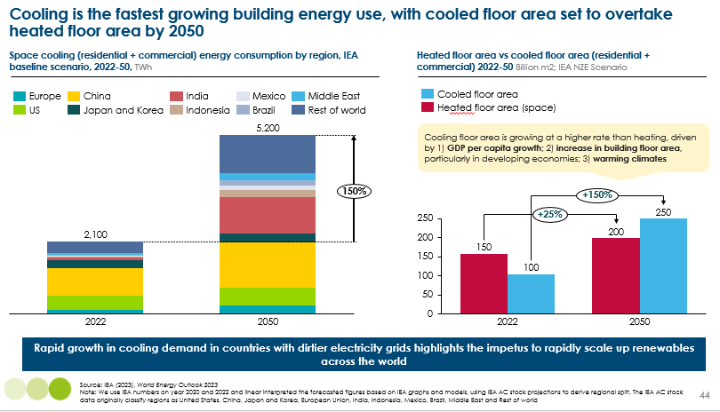
Exhibit 39
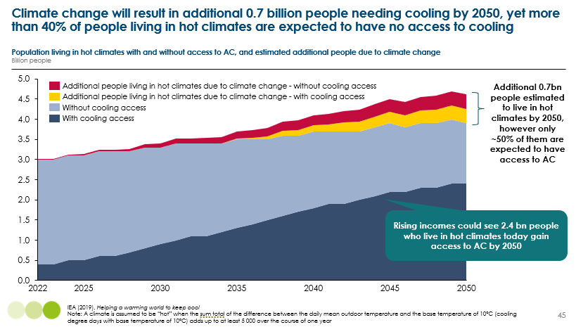
  - Active cooling technologies
Two things are important when thinking about cooling: reducing the temperature of the room, and improving overall comfort through fans and reduced humidity.
There are just two main technologies which are able to lower the temperature of a room:
- Air conditioning: ACs move heat from inside a room and expel this outside. They work just like a refrigerator, or a heat pump in reverse. They are by far the most common cooling technology, with around 2 bn units in operation across residential and commercial buildings. AC can be relatively cheap, with portable units at ~$500 and typical split systems units (i.e. one outdoor and indoor unit) serving one room costing ~$1,500, but costs can increase to $2,500-5,000 for multi-split systems serving multiple rooms. They are incredibly efficient, typically over 400% (see section 2.2.3).
  - Reversible heat pumps have a valve which switches the direction of flow of the refrigerant, enabling it to provide both heating (heat pump) and cooling (AC).
- Evaporative cooling forces hot air in the room through wet cooling pads, which cause the water to evaporate, absorbing heat in the process. Cold air is then circulated back into the room. Because they contribute to humidity, they are only suitable in dry climates. Evaporative coolers have many advantages – they are typically more accessible and are a cost-effective solution to AC, with portable coolers costing anywhere between $50-250. Larger and roof-mounted coolers typically cost $1,000-3000. They also have very low running costs, with a similar wattage to an electric fan. There are a few limitations, including the need for a constant supply of water and fresh air, regular maintenance, and are less effective at air filtering.
Where these space cooling technologies are unaffordable, there are a number of cooling appliances that can help people to deal with the impacts of hot climates, including humidity:
- Electric fans are a very cheap (anything from $10-100) solution that cost very little to run (wattage is around 30x lower than an AC). There are currently double the number of fans than ACs in operation today. By 2050, however, there could be a similar number of fans and ACs in operation in residential buildings (around 3.5-4 bn units each).
- Dehumidifiers are a solution in humid climates to remove excess moisture from the air, either using absorbent material to extract water from the air, or condensing water over cold coils. Costs vary across countries and based on size, but can be as cheap as $50-100, or upwards to $500.
From an energy demand perspective, the extent to which demand for AC increases is the most important question.
  - Managing growing demand for cooling
45% of the global population live in hot climates requiring cooling and a further 50% require cooling intermittently, for example in certain seasons [Exhibit 40]. However, these proportions differ hugely across regions. Despite cooling being required in virtually all parts of the world at some points in a year, it only accounts for 6% of operational energy use. This is partly because air conditioning is so efficient, but also because a significant share of cooling needs are unmet [Exhibit 39].
Exhibit 40 shows that despite 55% of its population living in hot climates, Africa only accounts for less than 5% of global cooling energy demand. This compares to North America accounting for 30%, from just 10% of their population living in hot climates.
Exhibit 40
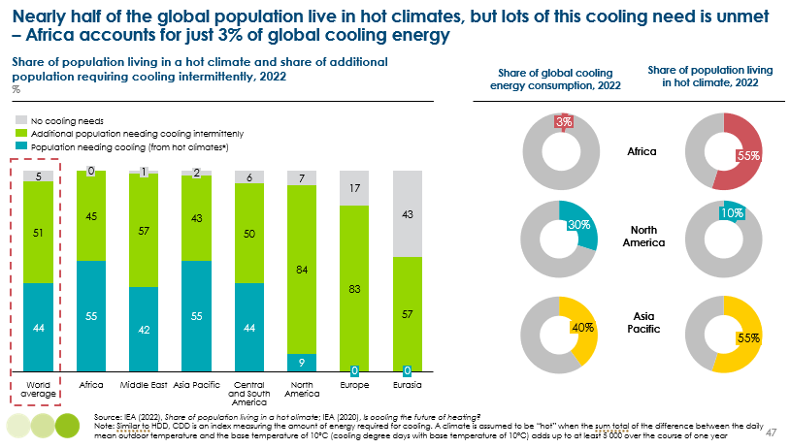
The IEA expects the global stock of air conditioners to increase from around 2 bn today, to 5-6 bn by 2050; the residential sector accounts for around 70% of this. There are three main drivers:
- GDP per capita: AC ownership tends to be much higher in richer countries, for example 80% of households have an AC in North America compared to around 5% of households in Africa. As incomes increase, an additional 2.4 bn people living in hot climates could gain access to AC by 2050 [Exhibit 39].
- Floor area growth: floor area in hot climates is set to expand by 150% by 2050, from 100 bn m² to 250 bn m² [Exhibit 38], driven by population growth and urbanisation.
- Warming climates: climate change could result in an additional 0.7 bn people living in hot climates over the next 25 years [Exhibit 39]. For those already living in hot climates, it will exacerbate cooling needs, requiring ACs for longer and set to lower thermostats.
Without action on energy efficiency and behaviour change (explored in the following sections), cooling energy demand could increase from 2,200 TWh today, to over 5,000 TWh by 2050. Cooling demand could be 15-20% of forecasted electricity supply in Indonesia and India – a huge increase from 5-10% today.
It is possible that cooling energy needs will increase more than current projections suggest, with three key uncertainties:
- The pace and extent to which emissions are reduced globally, and the implications for warming climates.
- The feedback loop between AC use and higher outdoor temperatures. Estimates suggest that waste heat emitted from ACs could increase the mean air temperature by more than 1°C in urban locations in the evening. This could exacerbate “urban heat island effects” which result from dense concentrations of concrete and buildings which absorb and retain heat. This could have severe consequences for homeless people, as well as driving even greater use of air conditioning.
- Around 40% of heat pump sales over the coming decades could be reversible ones which can provide heating and cooling. This could drive additional cooling demand than would otherwise have occurred, for example in parts of Europe where cooling needs may not warrant purchasing a separate air conditioner, but having access to a technology than can also provide cooling leads to incremental demand.
It is, however, possible to limit the increase in energy demand for cooling without impacting living standards (i.e. without reducing the extent to which cooling needs are met). This section outlines the opportunities to:
- Increase the efficiency of air conditioning.
- Encourage behaviour change (e.g., through increasing thermostats).
- Reduce cooling needs through passive cooling techniques in buildings.
    - Opportunities to improve energy efficiency
Just like a heat pump, ACs are able to produce more useful output for the electricity put in. Similarly, their efficiency is determined by the temperature differential between the source and sink; because the required temperature differential for ACs tends to be lower than for heat pumps (e.g., going from 35ºC to 25ºC, compared to going from 0ºC to 20ºC), air conditioners on the market today can achieve efficiencies of 400-800%, compared to around 300-400% for heat pumps.
There is a huge variation in the efficiency of ACs on the market today, both within and across countries, meaning there is significant potential to realise efficiency gains just through better policies such as minimum efficiency standards and labelling [Exhibit 41]:
- In Europe and the US, the market average efficiency is around 2-3 times lower than the best available technology.
- In other high-income countries such as Canada and Australia, both market average and best available efficiencies are much lower than in Europe and the US.
- The key challenge is countries with weaker regulatory capacity but very high cooling needs, such as India and Thailand where average efficiencies are low.
Exhibit 41
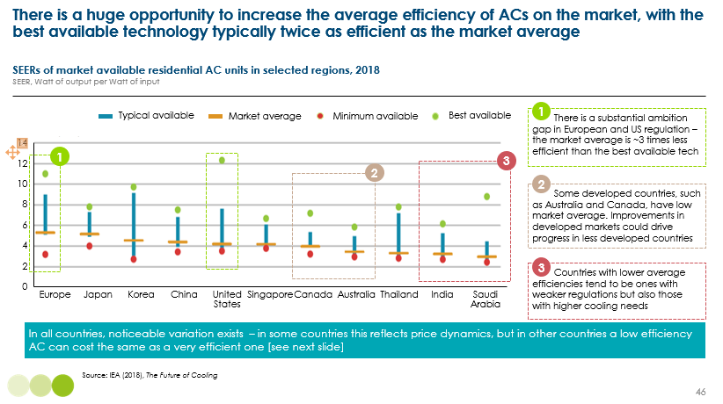
In the US and EU, Minimum Energy Performance Standards (MEPS) and labels have helped more than halve AC energy consumption since policies were introduced. In China, a tightening of minimum energy performance standards in 2019 saw the most efficient ACs growing their market share from 20% to 55% in two years. The key question is whether there is a cost premium to purchasing a more efficient AC:
- In some countries, such as Thailand, an AC with an efficiency of over 600% can cost the same as one with an efficiency of less than 400%. This means better energy labelling is key.
- In some countries, such as Vietnam, there is a clear price premium to more efficient AC. This means minimum energy performance standards are key, even if they increase cost.
In addition, continued technological advancements will drive further improvements. Key opportunities include variable speed motors which allow an AC to scale up and down (rather than just on and off), and a transition to refrigerants which are able to transfer more heat for the same electrical input (see Chapter 8).
Driving up the average efficiency of the AC stock is the single most effective solution to reducing the cooling energy demand challenge. For example, if average AC efficiency was able to reach 700%, annual electricity requirements for cooling in 2050 could be 70% lower in India, 40% lower in China and 50% lower in the US, compared to holding current efficiencies constant. The impact on total electricity demand could be savings of 500-1,000 TWh per year.
    - Opportunities for behaviour change
Currently, there are huge differences in annual household energy consumption for cooling across countries. Though in many instances cooling is essential to human health, it is often used excessively, particularly in high income countries. It will also be important to limit the excessive use of AC:
- In Texas, US, 95% of households own an AC, with average annual energy consumption of 4,000 kWh. Thermostats are typically set very low (~22ºC) and are often left on all day.
- In Guangzhou, China and Hyderabad, India, 75-85% of households own an AC, with average annual energy consumption of ~700 kWh. Thermostats are typically set at around 24-26ºC and are used for around 5 hours a day.
In richer countries such as the US and parts of the Middle East, perverse heating and cooling behaviours persist where thermostats in the summer are set lower than thermostats in the winter. This suggests cooling energy consumption far above true need.
There is a risk that, as incomes grow in lower-income countries such as India, AC consumption could begin to exceed need. To illustrate the importance of limiting such behaviour, our analysis suggests that if households in India used their AC as much as those in Texas, electricity requirements for cooling could be 6 times higher in 2050, from ~400TWh to 2,700TWh.
Policy can play a key role in encouraging or mandating behaviour change:
- Temperature limits in buildings: in Belgium, public buildings have a heating limit of 19°C and an AC limit of 27°C. Beijing’s "energy-saving police” check that AC in commercial buildings (e.g., offices, hotels, malls) is not set below 26°C.
- Penalties: Italy introduced fines of €500–3,000 for industrial buildings that set space cooling temperatures below 25°C.
- Encouragement: The Japanese ‘Cool Biz’ (cool to 28˚C) and ‘Warm Biz’ (heat to 20˚C) programmes gave social permission for professionals to adopt dress codes that match varying office temperatures.
    - Passive cooling techniques
Just as with heating, there are many passive cooling techniques that can reduce the need for active cooling. The health and wellbeing imperative of passive cooling is huge, especially for households which are unable to afford AC.
Passive cooling focuses on minimising heat gain and maximising natural ventilation:
- Orientation of a building's longest sides against the direction of the sun to minimise solar gain.
- Material and colour choice: painting roofs and walls white to reduce how much heat is absorbed, using bright and reflective coatings to reflect sunlight and reduce solar gain, and using ceramics and tiles which have a high thermal resistance.
- Building envelope and design: a low window-to-wall ratio (as windows lead to more solar gain) and using shading structures such as awnings, trellises and porticos. Optimising for natural ventilation is also key, including vents, solar chimneys, and optimising building shape to maximise natural airflow.
Differences in climate will require different techniques:
- In humid climates, ventilation is key. This means high ceilings and many openings for constant air flow, allowing warm air to drift to the ceiling.
- In dry climates, with huge differences between day and night temperatures, heavy exterior walls and roofs can help keep the temperature constant for longer, creating a natural barrier between inside and outside temperatures.

The huge opportunity for passive cooling in new buildings
Passive cooling techniques can reduce cooling energy needs by 25-40%, but reductions can be as big as 75% [Exhibit 42]. It is, however, much harder to assess costs and impacts, with huge variation depending on climate, labour and material costs, and the extent of technique deployed (e.g., external shading can range from trees and retractable awnings to concrete structures).
What is clear, is that many of these choices are low cost, low effort and can have a very big impact on how hot a building gets. For example, in one case study, painting the roof of a factory in Indonesia white led to a 10ºC reduction in indoor temperatures.
The challenge is a lack of knowhow and awareness among developers, weak regulation, and the fact that the benefits to passive cooling techniques accrue to households, not developers. Exhibit 43 highlights the cost-effectiveness of different passive cooling techniques and shows the difference in the US, where annual energy bills for cooling are high, compared to China. In the US, these techniques have very strong returns of around 5-10%; note these are lower than for passive heating because cooling energy bills are lower.
In other parts of the world, it is more challenging to make an economic case; however, the health and social imperatives are huge. This highlights the critical importance of more ambitious building codes (see Chapter 9) and training and awareness of developers of low-hanging fruit opportunities.
Exhibit 42
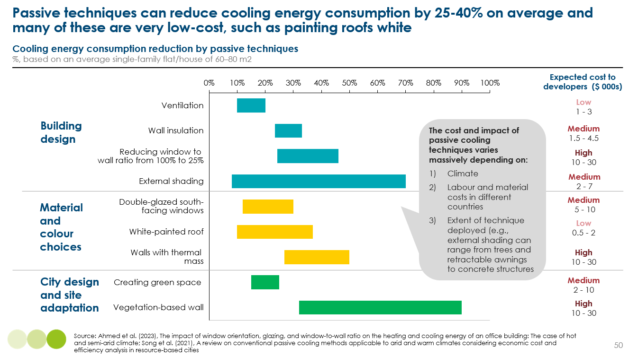
Exhibit 43
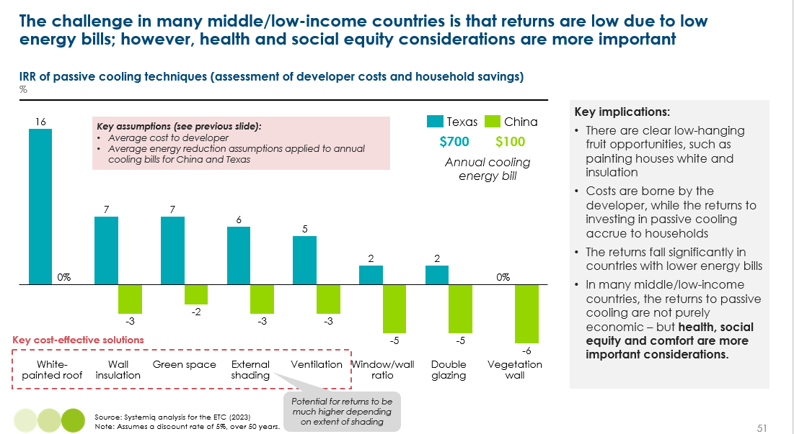
The other crucial aspect with new builds is to consider how better urban design can reduce heat island effects. In humid climates, large distances between buildings is important for air circulation; in dry climates, dense and narrow streets can help provide shade. Simple things such as planting trees along streets and preserving nature can have a huge impact on creating cooler streets and wellbeing.

The potential to retrofit buildings for passive cooling
Many of the passive cooling techniques discussed above can be fairly easily done to existing buildings, for example painting roofs white, adding trees for shading, and some forms of insulation. Other techniques such as redesigning for natural ventilation or selecting materials which do not absorb heat are much harder to retrofit. This highlights the importance of getting it right the first time around, with better building codes (see Chapter 9).
Another challenge is that household energy bills for cooling are generally lower than typical heating bills. With key exceptions in rich, hot regions such as Texas – where AC energy use is as high as typical heating energy use in Europe and the US – annual kWh consumed for cooling in middle-income countries are around a quarter of what is typically needed for a heat pump. As set out in Section 2.2.4, this reflects differences in household income, use and thermostat settings. It might also reflect the fact that the temperature differential required in colder countries (e.g., going from 0ºC to 20ºC) is higher than in hot countries (e.g., going from 35ºC to 25ºC).
Combined with often lower electricity prices in lower-income countries, AC energy bills in some parts of India and China could be less than $100 a year. While this may be a relatively high share of annual disposable income for some households, it makes the economic paybacks to investing in retrofitting challenging. This highlights the importance of policies and the provision of low-cost finance to ensure households can reap the health and comfort benefits of passive cooling.
  - Implications for energy demand
Rising demand could see electricity demand from cooling increase 2.5 fold by 2050, from 2,100 TWh to over 5,000 TWh. However, energy efficiency improvements to air conditioners and to new and existing buildings from passive cooling techniques could more than offset this increase in demand. Exhibit 44 shows that electricity consumption from cooling could be lower than it is today, at 1,200 TWh.

Exhibit 44
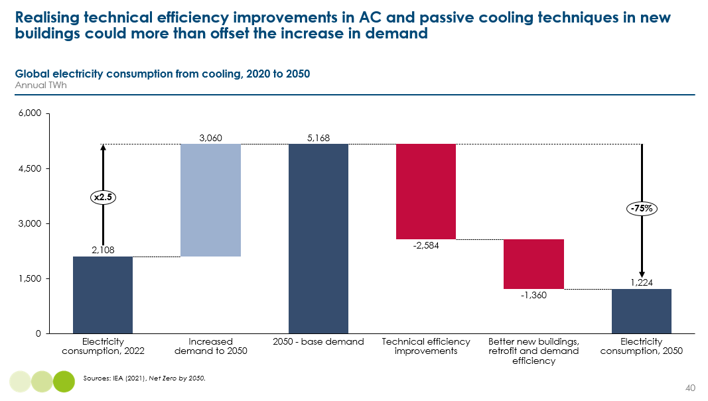
- Cooking
Key messages:
- High-income countries should entirely electrify cooking by 2040, and China by 2050; electric cooking is healthier, far more efficient and it can be cost competitive with gas/LPG.
- The imperative is to eliminate the use of traditional use of biomass, which has adverse health impacts and is also incredibly inefficient
  - A crucial interim solution in the 2030s is to install improved cookstoves and then transition to clean cooking fuels.
  - Liquefied Petroleum Gas (LPG) will be the dominant transition fuel, with electric cooking and modern forms of bioenergy being too expensive.
- By 2050, higher incomes and improved access to electricity should enable the vast majority of the world’s population to transition away from fossil fuel cooking.

Cooking drives 3% of global emissions and 15% of direct fossil fuel use in buildings. But fossil fuels actually only account for 20% of cooking energy use. Instead, from a final energy consumption perspective, it is 70% fuelled by the traditional use of biomass (TUOB) in lower-income countries. TUOB refers to the use of solid biomass (e.g., wood, wood waste, and charcoal) with basic technologies (e.g., open fires and basic stoves). TUOB is incredibly inefficient (as little as 10% of energy used is converted to useful heat), meaning cooking is the second largest component of final energy demand (~30%).
The energy transition for cooking is not just about transitioning to technologies which do not run on fossil fuels, but to ones that are clean from an air quality, health and safety perspective. Currently around 1/3 of the global population, or 2.3bn people, still cook their meals on open fires or basic stoves which TUOB. This has significant consequences:
- It contributes to 3.7m premature deaths a year.
- Households can spend around 5 hours a day collecting fuel and cooking, resulting in lost education and economic opportunities, especially for women and children.
- It contributes to deforestation.
  - The transition to clean cooking technologies
Electric cooking meets both definitions of “clean” and is already an important energy source for cooking in high-income countries. In most countries, electric cookers do not cost materially more than a gas cooker (e.g., ~€500 for a 4-hob cooker), although there is typically a price premium of ~€200-400 for an induction hob. Electric cookers have other advantages including higher efficiency [Exhibit 45], more even heat distribution, and being easier to clean. For many households, with the right policies and incentives, electrifying cooking can be a natural step along with electrifying heating, allowing them to disconnect from the gas grid.
Exhibit 45
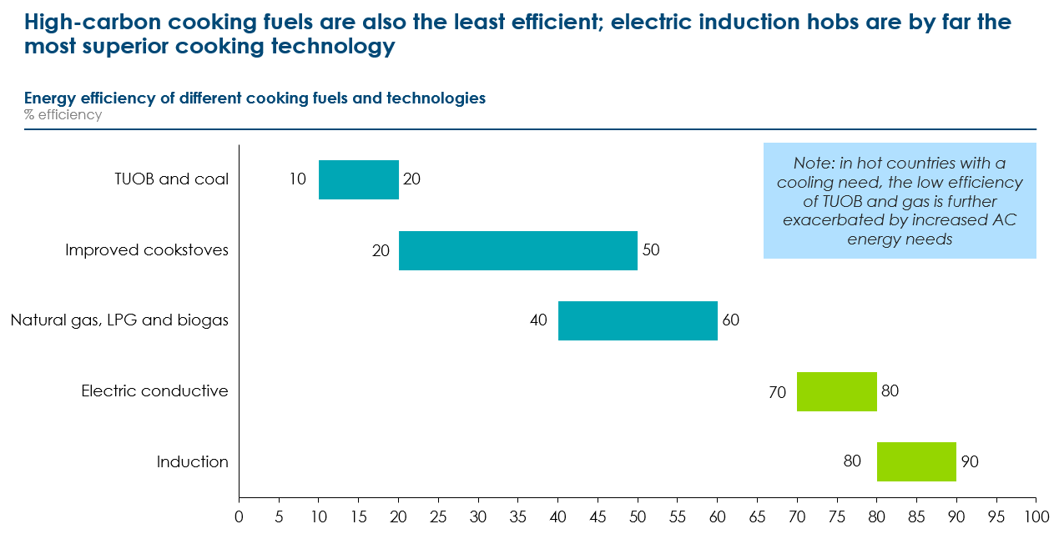
But progress towards electrification will be much slower in lower-income countries, given the higher cost of electricity relative to other fuel sources, and in some cases a lack of electricity supply and reliable grid infrastructure. Around 75% of the population in Sub-Saharan Africa currently lack any access to electricity, and while decentralised small-scale solar systems can provide adequate power for lighting, many appliances and refrigeration, they are often insufficient to support cooking applications as well.,
In these countries and where cooking currently depends primarily on coal or TUOB, the transition will likely follow several stages:
- A crucial interim solution in the 2030s is to install improved cookstoves. These are much more efficient and safer, and emit less emissions. For example, having an insulated combustion chamber above and around the fire which reduces heat loss and chimneys which prevent indoor pollution. Policy to tackle cost and a lack of awareness are key.
- By 2040, strong policy will be required to ensure a transition to cleaner cooking fuels. Liquefied Petroleum Gas (LPG), is likely to be by far the dominant fuel, despite still having emissions of 0.2-0.25 kgCO₂/kWh. This is because the cost of electric cooking will be prohibitive in most lower-income countries, as well as unreliable access to electricity. In addition, while natural gas is typically delivered to households via distribution pipelines, LPG can be distributed in large pressurised cylinders. In the last decade, 70% of those who gained access did so through LPG. In China and India, policies such as providing free stoves and subsidised canisters have been critical.
- Alternatively, modern forms of bioenergy such as bioethanol and biomethane can be used. If produced sustainably, these also contribute to reducing emissions. However, purchasing biogas stoves can cost up to six times the monthly income for low-income households in Sub-Saharan Africa, and guaranteeing sustainable supply that does not contribute to detrimental land-use is uncertain.
- By 2050, higher incomes and improved access to electricity should enable the vast majority of the world’s population to transition away from fossil fuel cooking.
  - Implications for the cooking energy transition
As a result, while fossil fuel use for cooking in high-income countries and China should rapidly decline towards zero by 2040, oil use (i.e. LPG) in cooking will actually increase slightly in the rest of the world in the 2030s [Exhibit 47]. This will, however, be more than offset by declining oil use in buildings for heating, and also by reduced coal use for cooking.
Overall, Exhibit 46 shows how the fuel mix for cooking might change to 2050, with a halving of final energy consumption but a seven-fold increase in electricity.
Exhibit 46
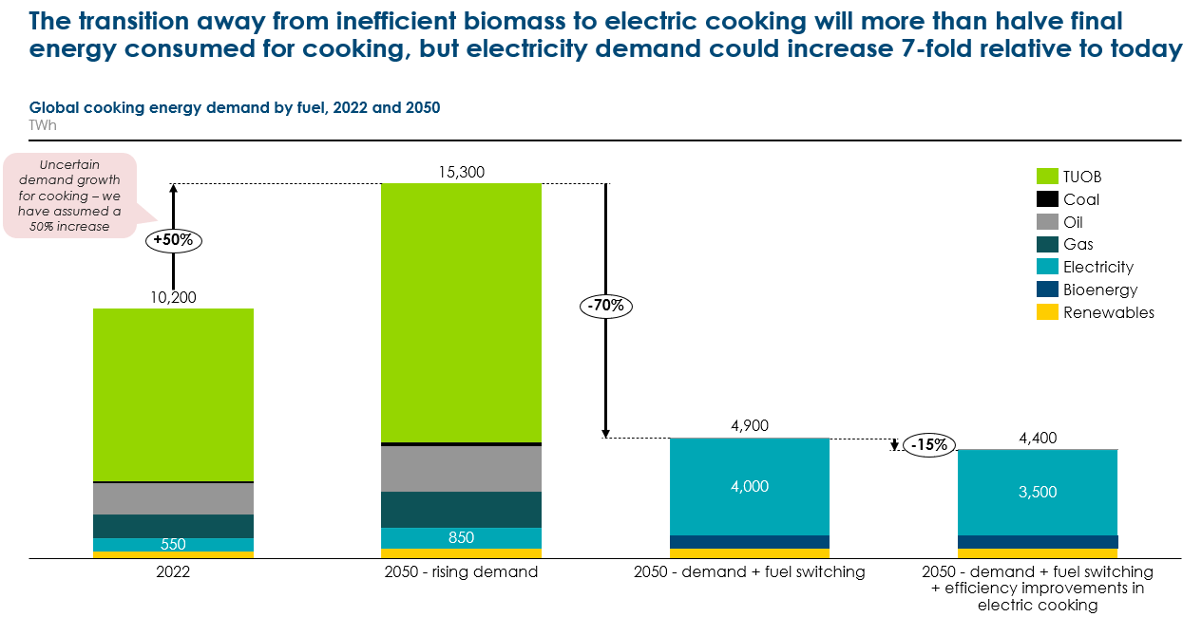
Although low-carbon solutions to cooking to exist, often at comparative cost and with many benefits compared to fossil fuels, uptake is unlikely to accelerate at the required pace without additional action on policy, finance and education:
- Education and awareness campaigns are crucial, as the transition relies on widespread changes to social and cultural norms. For example, challenging beliefs that cooking with woks can be done without a naked flame. Key actions include community advocacy groups, training households and salespeople, and cooking classes to demonstrate new technologies. Education of young people, including social media, is key to changing norms in the next generation.
- Governments should set clear targets for expanding clean cooking access.
- Regulation to ensure minimum standards of improved cookstoves.
- Subsidies, grants and low-cost finance, with international development finance playing a key role. Financial support should be focused both on the upfront costs and ongoing fuel costs while markets and supply are scaled up.
Exhibit 47
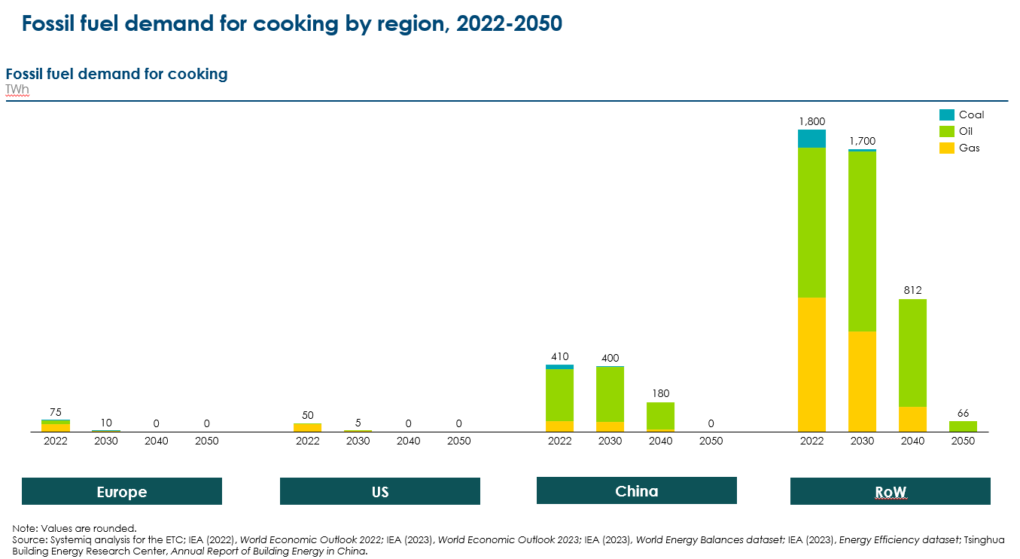
- Appliances
Key messages:
- Without any action to improve efficiency, electricity demand for household appliances could double, from ~6,000 TWh, to almost 12,000 TWh.
- However, improving the technical efficiency of appliances through minimum energy performance standards and labelling could offset 70% of the increase in electricity demand.
- Realising efficiency gains in hot countries is critical, as appliances produce heat which then lead to greater AC use.
- Accelerating the stock turnover of older, less efficient appliances through financial incentives should be targeted at large, energy-consuming white goods, especially fridges and freezers which have high GWP refrigerant. This must be accompanied by investment in recycling and reuse facilities, with retailers obliged to offer trade-in schemes.

Appliances refer to anything that households plug into electrical sockets, including kitchen appliances (e.g., fridges microwaves, kettles, and rice cookers), household appliances (e.g., dishwashers, washing machines, vacuum cleaners) and digital equipment (e.g., laptops, TVs, mobile phones). Exhibit 48 sets out some of the key differences in appliance energy use between UK and Indian households.
Appliances account for 8% of global emissions and are already 100% electrified, meaning there is no technology transition required. It is important to note that appliances account for almost the same share of global emissions as heating (11%) when it uses a third less energy. This is because the carbon intensity of natural gas which is used for 50% of heating has a lower carbon intensity (~200gCO2/kWh) than the global average carbon intensity of electricity (~440gCO2/kWh), as coal still accounts for 35% of production. This highlights the importance of rapid power sector decarbonisation to drive emission reductions.
The use of these appliances accounts for 15% of buildings operational energy use, around 6,000 TWh of electricity. A combination of rising incomes and falling consumer costs are enabling more households to afford appliances, which will deliver significant social outcomes in terms of comfort, access to information, health and productivity. Currently, 20% of the global population do not have access to refrigerators, 15% don’t own a TV and 25% don’t have a mobile phone. At the same time, energy demand will also increase from households:
- Owning more appliances – the IEA expects there to be 1.4 TVs per household by 2030, up from 0.9 in 2000.
- Using appliances more frequently (e.g., using a washing machine more than once a week).
- Choosing larger or more sophisticated models (e.g., bigger TVs with smart controls that use more energy). In addition to higher wattage, smart appliances also have additional associated electricity requirements to power the data centres which store their data; this will be explored in an upcoming ETC short on future power demand.
Without action to improve efficiency this could increase electricity needs by 85% to over 11,000 TWh by 2050. Offsetting this demand increase with more efficient appliances will be key to managing electricity demand without limiting improvements in living standards.

Exhibit 48
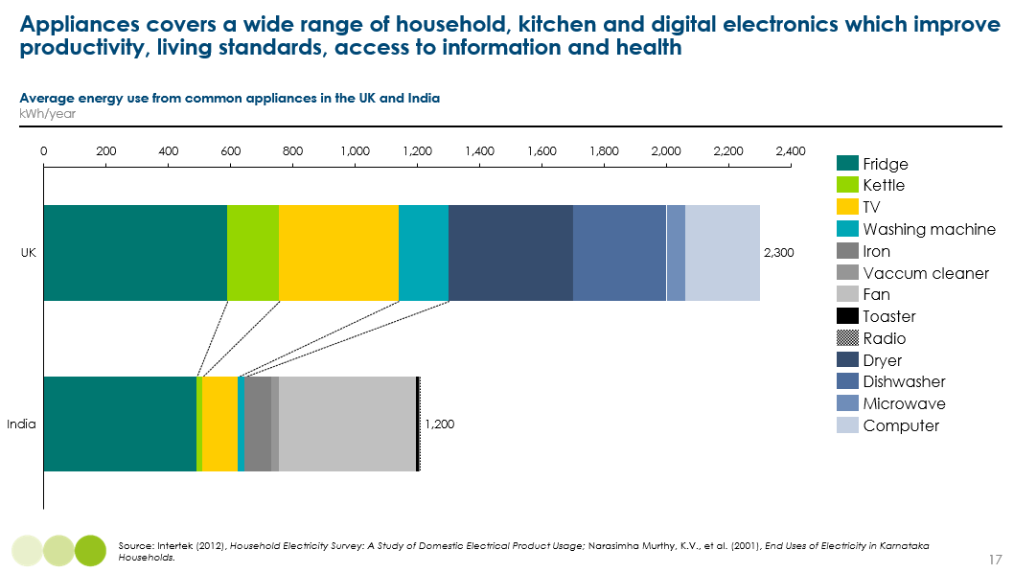

  - Energy efficiency of appliances
The efficiency of appliances and technologies tends to increase over time as manufacturers innovate, compete on quality and look to cut their own costs. Key improvements in appliances to date have been reducing excess heat production, increasing motor efficiency, improving the insulation of fridge freezers, and load sensing technology in washing machines to adjust water and energy use accordingly.
However, there is significant potential to realise much faster improvements with policies and regulation. This reflects the fact there are large differences in the average efficiency of new appliances across countries [Exhibit 49] and within countries [Exhibit 41], with the market average being far below best available options.
Regulation has been crucial to accelerated improvements in energy efficiency. Specifically, minimum energy performance standards (MEPS) which set a clear floor for efficiency, and regulation on energy labelling. Analysis of global MEPS and labelling regulations suggests that they have increased the underlying rate of technological improvement 2-3 times, resulting in energy savings of 10-30% over 15 to 20 years in most countries. In countries with the tightest regulations, energy savings have been over 50%. While it is not always the case that more efficient appliances cost more, MEPS are key to reducing possible prime premia.
Policies and R&D can improve the efficiency of new appliances, but the existing stock can take 5-20 years to be replaced; a key question is therefore how much this stock turnover should be accelerated? Policies can incentivise households to turn in their older appliances, or restrict second hand markets but these policies need to be carefully designed to prevent adverse impacts on:
- Embodied carbon: as the grid decarbonises, it will take longer for energy savings to offset the carbon generated in manufacturing new appliances.
- Waste generation: stock turnover needs to be carefully managed with circular approaches and investment in recycling.
- Affordability and social equity: restricting second hand markets could prevent lower-income households being able to afford appliances.
Lessons can be learned from Ghana’s 2013 import ban on second hand fridges and ACs, which had very poor energy efficiency and used Ozone-depleting refrigerants (see Chapter 8). Rebates were offered to replace old appliances and the average annual electricity consumption of fridges fell 70%, from 1,200kWh/year in 2013 to 400kWh/year in 2019, realising lower energy bills for households.
Exhibit 49
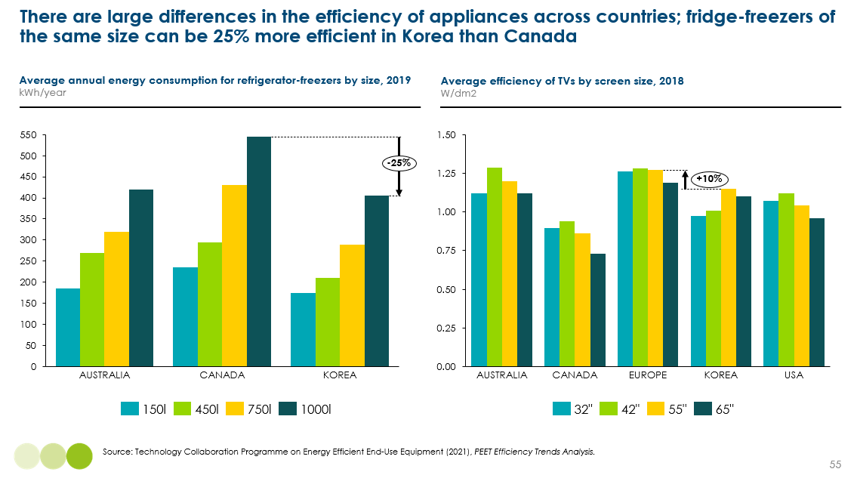
  - Policies to realise efficiency improvements
The IEA estimates that electricity demand for appliances could be 40% lower in 2050 with energy efficiency improvements, offsetting 70% of the increase in demand [Exhibit 50]. Realising these gains requires a combination of regulation, education and financial incentives to:
- Set a minimum efficiency floor. Over 110 countries now have MEPS in place for new appliances, but these vary in terms of stringency. A critical priority is increasing the ambition and breadth of MEPS.
- Grow the market for efficient appliances, using a variety of policies and incentives:
  - Energy performance labelling, including translating energy efficiency into layman’s terms (e.g., impact on running costs). Making it clear how far above regulated minimum standards an appliance is would be a very helpful tool.
  - Policymakers can actively shape purchase decisions and overcome potential cost barriers with low-cost finance, subsidies or rebates for more efficient models. This will also push manufacturers towards this level, increasing innovation and driving down costs.
  - Bulk procurement can also play a big role in lowering consumer prices, with competitive bidding at scale to lower costs. Box 8 in the following section on lighting explores how the Indian government’s bulk procurement of LED light bulbs grew the market 130-fold in just five years.
  - Education campaigns which get households thinking about running costs as well as upfront costs, and provide comparisons across different models.
  - International collaboration to stop dumping, including regional harmonisation of standards and voluntary commitments from the private sector.
- Drive further improvements in efficiency with targeted R&D support (e.g., financial incentives, prizes), focusing for example on developing smart appliances which work effectively within smart building systems to provide demand-side flexibility (e.g., Bluetooth enabled devices).
This must be underpinned by gradual behaviour change, which focuses on encouraging households to turn off appliances when they are not in use and washing at lower temperatures.
Exhibit 50
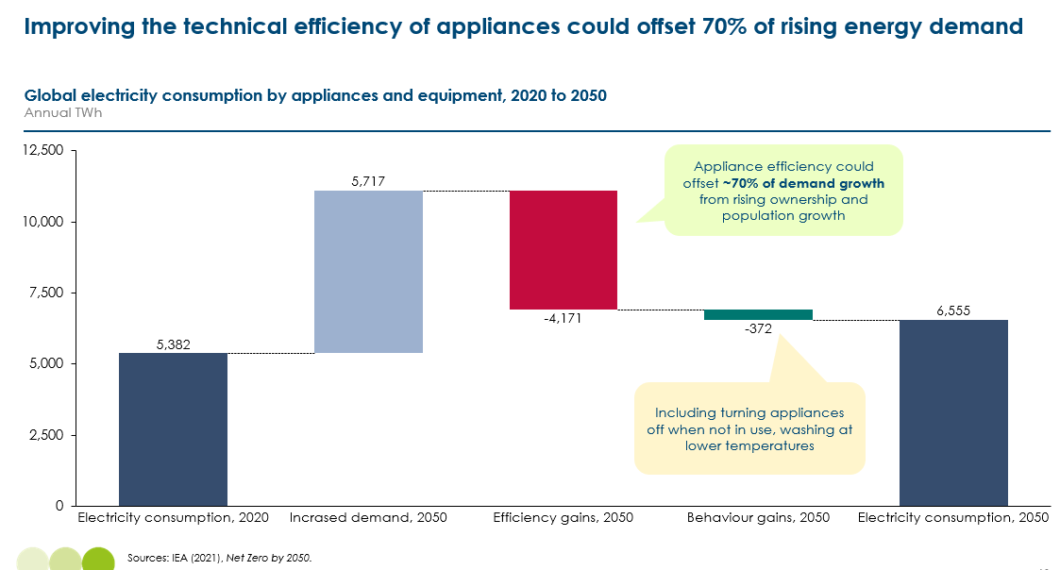
- Lighting
Key messages:
- Without action on energy efficiency, electricity demand for lighting could double, from 1,800 TWh to 3,600 TWh in 2050.
- If all lighting demand could be delivered with LED light bulbs, electricity requirements could be even lower than they are today, at 1,600 TWh in 2050. LED light bulbs are over 80% more efficient than incandescent lighting, they run for 30-50 times longer, and have significantly lower lifetime costs.
- Government bulk procurement has proven to be very successful at rapidly growing the market for LEDs and lowering retail costs (e.g., in India).

Lighting is arguably the easiest aspect of the building energy transition. It accounts for 2% of global emissions and is virtually 100% electrified. This means for the vast majority of households, there is no technology transition required and as electricity generation is decarbonised, emissions will fall.
However, almost 10% of the world’s population do not currently have access to lighting and many rural households in low-income countries still rely on kerosene lamps due to a lack of access to electricity. Expanding access to safe, electric lighting is therefore also critical.
Lighting accounts for the smallest share of operational energy use, 5%, or around 1,800 TWh. Importantly, global electricity consumption for lighting has remained constant over the past 10 years, as efficiency improvements have offset rising demand.
Arguably the biggest low-hanging fruit opportunity for energy efficiency across the buildings sector is the move to LED lighting, which is not only much more efficient but also has significantly lower running costs and longer lifetimes, therefore also reducing waste.
There are three main types of light bulbs:
- Light emitting diodes (LED): an electrical light source that can produce light without heat. They are able to emit light in a specific direction, reducing the need for reflectors and diffusers which trap light. These features allow them to be over 80% more efficient than typical incandescent lighting, with expectations of a further 30% improvement this decade [Exhibit 51]. The cost of LED lights has fallen dramatically, with a 95% decline in the US from $70 per bulb in 2010, to below $10 in 2016. They are now virtually cost competitive with incandescent bulbs in most countries. They also last much longer, for 30,000-50,000 hours.
- Fluorescent: these are glass tubes filled with a mixture of argon and mercury vapour which use electricity to ionise the gas and emit ultraviolet radiation. However, they can release as much as 80% of their energy as heat, making them much less efficient. They last for around 15,000 hours.
- Incandescent: these have a filament (e.g., halogen gas) which is heated until it glows. This means around 90% of their energy is released as heat. Given their low efficiency, they have higher running costs and also only last for around 1,000-2,000 hours.
Today, around 50% of new lighting sales are LED. With well-designed policies, it is possible for LEDs to account for 100% of the market by 2030. This is key to offsetting the huge increase in demand for lighting expected over the coming decades. Exhibit 52 shows that rising demand from population, income and floor space growth could lead to a doubling of electricity requirements for lighting, holding today’s average light bulb efficiency constant.
This doubling could, however, be more than offset if all lighting was LED and with expected increases in the efficiency of LED lighting from 110 lumens/watt to 140. Under these assumptions, annual electricity consumption in 2050 could be lower than it is today.
Exhibit 51
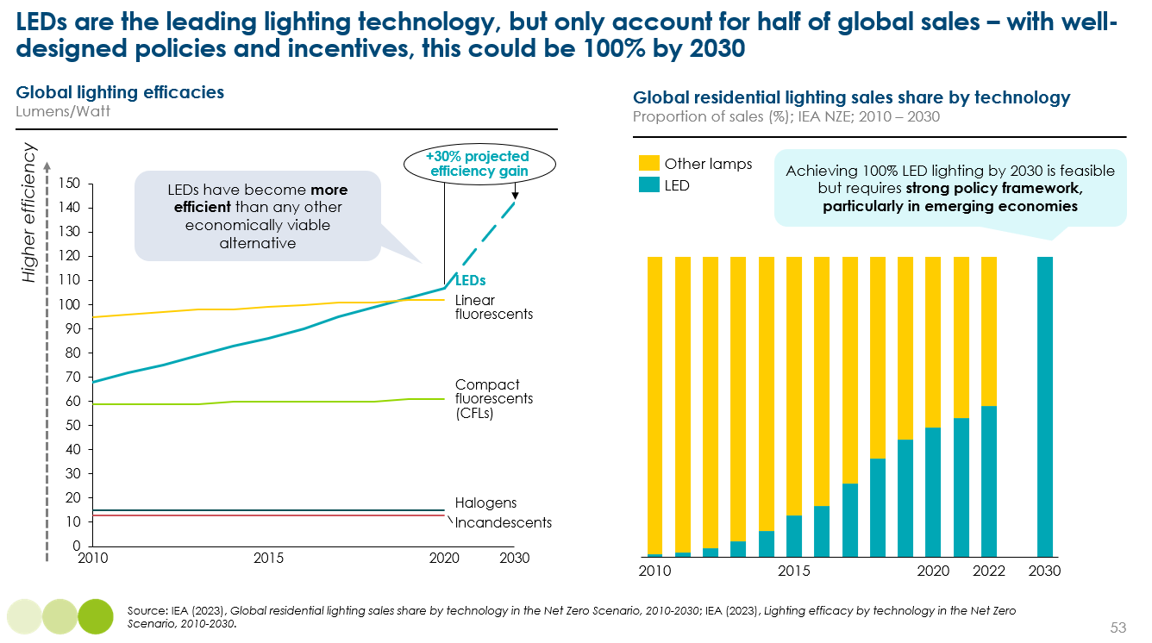
Exhibit 52
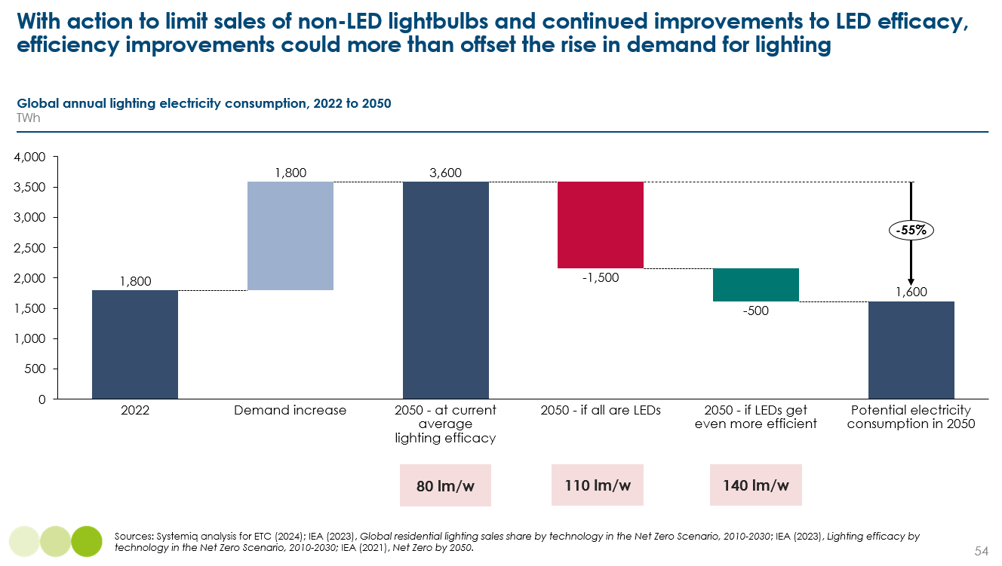
Realising this potential reduction in electricity needs requires the following actions:
- More ambitious minimum energy performance standards (MEPS): these have been critical to the growth of LEDs, but could go much further given how much LED costs have fallen. In 2023, the UK announced the most stringent MEPS in the world, to 120 lm/w in 2023 and 140 lm/w in 2027. At the right level, MEPS would effectively ban the sale of inefficient fluorescent and incandescent light bulbs. Around a quarter of global residential lighting energy demand is not covered by MEPS, so efforts to expand regulation across the world is key. Regulation should also focus on driving minimum standards in commercial and public buildings.
- Improved labelling: only half of the world’s lighting electricity consumption is covered by mandatory labelling. These need to focus on explaining the significantly lower running costs for LED lighting and longer lifetimes, enabling consumers to make informed decisions about lifetime costs.
- Market-based solutions: governments can use public procurement to help drive demand. In China, LED lighting is compulsory in government procurements. Governments should ensure all public buildings and street lamps are installed with LEDs. In India, bulk procurement programmes have helped to massively drive down costs [Box 8].

Box 8
India’s LED bulk buying programme
In 2015, India launched a bulk procurement scheme of LED light bulbs at competitive prices, much lower than those in local markets. These were then distributed to households subsidy-free via a replacement scheme.
The initiative resulted in:
- As of January 2022, the program had distributed over 360m LED bulbs, saving over 47TWh and avoiding 37 MtCO2 a year.
- Between 2014 and 2017, LED bulb retail costs fell 75-80%, from INR 300-350 per bulb in 2014, to INR 70-80 per bulb in 2017.
- India’s LED lighting market grew 130-fold in just five years, from annual sales of 5m bulbs per year in 2014, to about 670m in 2018.
The scheme, however, was not accompanied with enforcement of quality standards and as a result of fierce competition focused on cost, the efficiency and lifetimes of LED bulbs has worsened in India.

To do: add a case study bringing all of these end uses together
    - What does a fully clean and efficient home look like?
    - Combined impact of all of these technologies and passive solutions
    - Bring the chapter to life

- The net zero transition for operational energy in commercial buildings

Key messages:
- In commercial buildings, electrification and heat pumps will also win out – but there is even less of a one-size-fits-all solution
- Commercial buildings can be installed with more sophisticated HVAC systems, which are able to simultaneously heat and cool different parts of a building, with huge efficiency gains.
- Installing heat pumps and retrofitting existing commercial buildings is generally easier to finance compared to residential buildings but can be practically challenging due to the need to dismantle existing systems often with tenants in the building. However, installing a building management system is a no-regrets solution which can reduce energy consumption by 10-20% (e.g., sensors and predictive AI to flex energy consumption according to occupancy, the weather and energy prices).
- Given stronger market signals for energy efficient buildings, there is a strong case for setting much earlier targets for the transition away from fossil fuel heating in commercial buildings, including immediate bans on the installation of new boilers in both new and existing commercial buildings in high-income countries.

Commercial buildings account for 20% of global building stock and operating them accounts for 10% of global emissions (see Chapter 1). It includes a huge variety of types of buildings [Exhibit 11], including offices, schools, hospitals, hotels, restaurants and warehouses; and these shares differ hugely across countries. For example, offices account for almost 40% of commercial building floor space in China, compared to 30% in the US. Data on commercial building energy use is less readily available than residential, so this section relies heavily on data from the US and Europe.
  - Understanding commercial building energy use
There are key differences in energy needs, on average across commercial buildings, compared to residential buildings [Exhibit 53]:
- Lighting and appliance energy needs are much higher in commercial buildings, given higher floor space and energy consuming appliances such as computers. This means that electricity is already a much more important fuel, providing 35-50% of commercial building energy in the US and EU, compared to around 25% in residential buildings.
- Space and water heating needs are significantly less important, accounting for around 30-40% of energy compared to over 60% in residential buildings. It is important to note that heating and cooling needs in commercial buildings refer to creating comfortable room temperatures for human occupants, it does not refer to any needs for commercial purposes (e.g., heat for manufacturing processes, cooling for data centres).
- In general, commercial buildings have higher cooling needs than residential buildings; however, in the US, where household AC use is very high, cooling accounts for a similar percentage of total energy.
This aggregate picture, however, varies significantly across different commercial buildings [Exhibit 54].
Exhibit 53
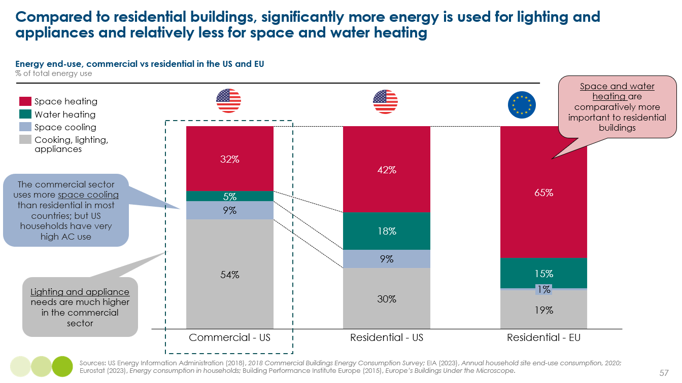
Exhibit 54
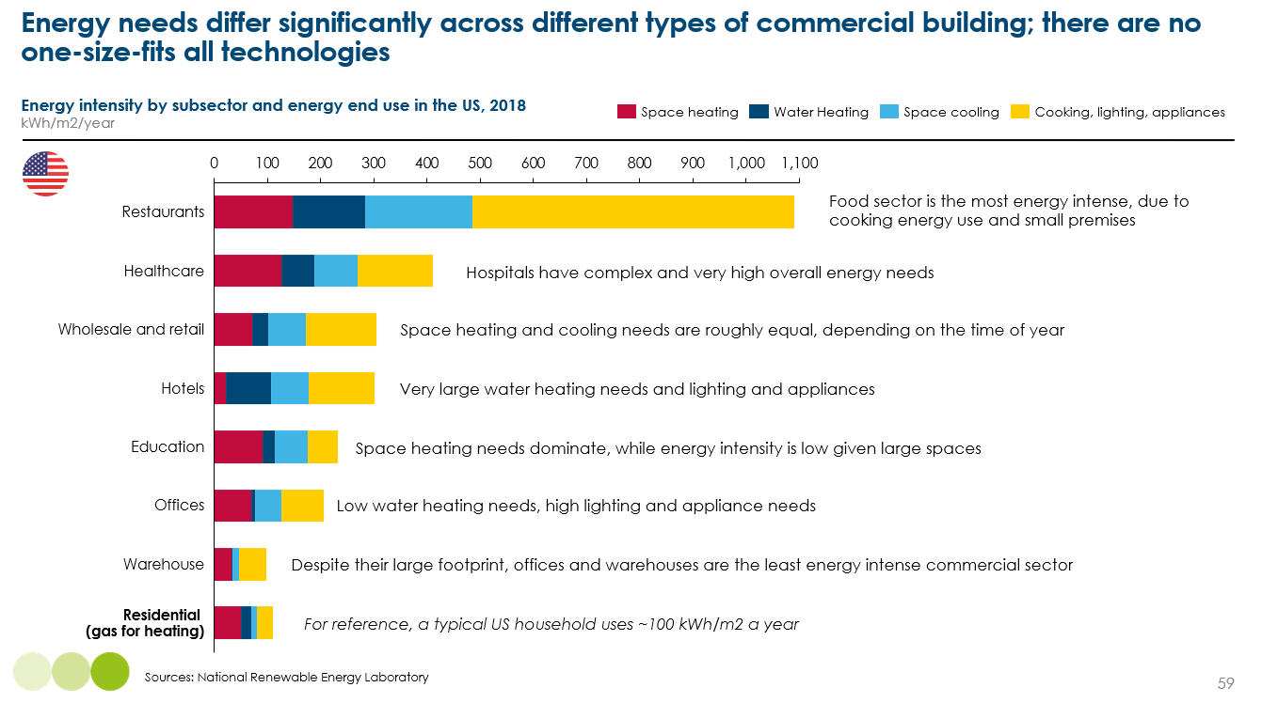
Breaking appliance energy needs down further, Exhibit 55 shows that ventilation is one of the most important energy uses – this is especially the case post-COVID. In fact, heating, ventilation and air conditioning (HVAC) in total accounts for ~60% of total energy consumption on average.
A key challenge to managing commercial energy use (explored in more detail in Chapter 7), is that ~25% of energy use is unable to be controlled by building managers (e.g., in the same way that heating and cooling thermostats can be). These so called “unregulated” plug loads include office equipment and computing, refrigeration, and other miscellaneous equipment such as motors that is installed by tenants.
Exhibit 55
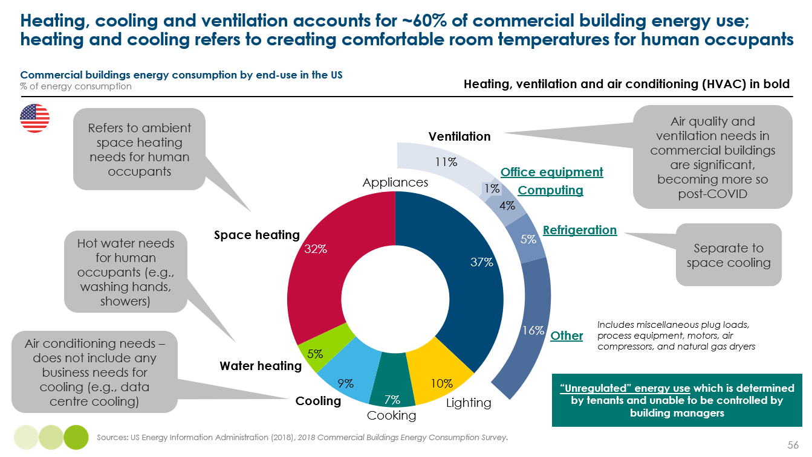

  - Clean heating and cooling technologies in commercial buildings
As we evidenced in Chapter 2, there are many clean heating technologies, but there will be no one-size-fits-all solution. This is arguably even more the case for commercial buildings, given the huge variation in energy needs. For the key clean heating technologies, key nuances in commercial buildings include:
- Air to air heat pumps: these will likely be the dominant in many commercial buildings, being able to deliver space heating and cooling and work effectively in ducted systems, along with ventilation.
- Networked ground source heat pumps: these could be a very effective solution for large and new commercial buildings with sufficient scale to make financing the shared ground arrays easier.
- Air to water heat pumps: as with residential, these will be used in existing buildings that have a wet heating system. In new buildings, these are unlikely to be prominent due to higher capex costs.
- Resistive heating: with larger and more open spaces in many commercial buildings, resistive heaters would be even less efficient and have much higher running costs. They could play a role for some buildings that have very minimal heating needs. Tighter commercial building regulations are also expected to make the installation of relatively inefficient heating less feasible. Resistive water heating, however, will play a key role alongside air to air heat pumps.
Traditionally, commercial HVAC systems have been developed in silo and even involve different fuels, for example gas-based heating combined with ACs, single-zone heat pumps or ACs, or multi-split systems which deliver heating and cooling via separate ducts. There is, however, a huge opportunity to shift to combined heating and cooling systems which are able to simultaneously heat and cool different areas of a building. Variable refrigerant flow (VRF) systems involve multiple indoor units connected to on outdoor unit and a variable speed compressor, which enables system to operate continuously but at varying speeds to match demand. They are essentially very smart heat pumps which are able to make the most of temperature differentials and waste heat.
Crucially, they are able to extract residual heat from a cooling zone and redirect it to a zone requiring heat. When heating demand is greater than cooling, the heat pump works hard to transfer additional heat. When cooling demand is greater than heating, excess heat is ejected into the atmosphere. This utilisation of waste heat enables them to be much more efficient, the potential to reduce energy consumption by 30-40%.
Despite the potential for energy savings, the upfront capex cost remains a challenge:
- In new buildings, as with residential buildings, there is likely to be a cost premium to installing heat pumps and VRF systems compared to fossil-based systems. These cost premiums could be larger than in residential buildings, due to larger and complex systems, and to meet health and safety standards. However, these are expected to be manageable in general. For large commercial buildings, there is typically a very competitive tender process for architects and construction. With the potential for huge running cost savings, tenants could be willing to pay more (see section 3.4). It is also important to remember that new builds charge a premium anyway. As with residential, there is no reason why regulation should not mandate the installation of clean heating technologies in new commercial buildings in developed countries from 2025.
- In existing buildings, the paybacks to installing heat pumps and VRF systems are still challenging. Exhibit 56 presents example analysis for a UK hotel and shows that it can take 15-25 years for investments to be paid back via energy savings. However, carbon savings can accrue after just 4 years. The financing solutions and regulation outlined in section 2.1.4 is therefore key.

Exhibit 56
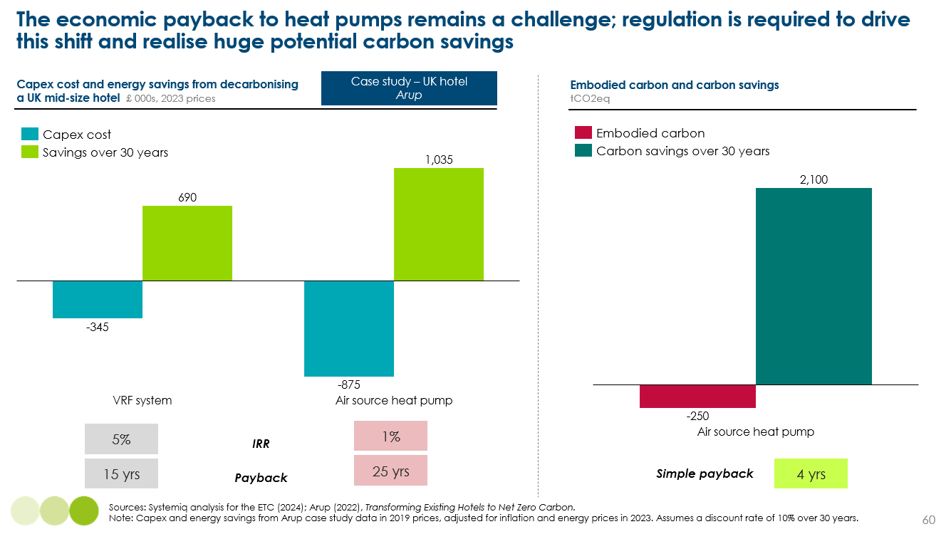
  - Passive heating and cooling in commercial buildings
Sections 2.1.2 and 2.2.3 outlined the building design techniques that can reduce heating and cooling energy consumption by 15-40% in new residential buildings. Similar impacts can be achieved in commercial buildings, but there are some key nuances:
- Roof insulation has a much smaller impact in multistorey buildings, but is key for warehouses.
- Wall insulation is also critical in warehouses, hospitals and hotels, but will play a smaller role in buildings with glass façades.
- Natural ventilation can play a very important role in offsetting mechanical ventilation.
- Painting buildings white might be less applicable to commercial buildings that have aesthetic requirements.
- In commercial buildings, shading structures can be much more innovative and have significant impacts on energy consumption, for example green façades around data centres which also play a key role in reducing heat island effects.
Windows are a critical part of building façades for many offices, hotels, schools and retail. Various glass technologies exist to aid in passive heating and cooling:
- Low-emissivity glass minimises the amount of infrared and ultraviolet light that comes through glass without minimising the amount of light. It uses a coating of silver which is a poor radiator of heat, reflecting heat back inside for a consistent indoor temperature.
- Electrochemical glass, also known as “smart glass” allows buildings to control the amount of light and solar radiation that enters a building through variable glazing. It works by ionising particles within a conductive coating; when electricity is applied, the metal ions within the coatings are attracted to one face of the coating. This build up provides tinting within a double or triple glazed unit. Smart glass works best as part of a smart system, with predictive and real-time inputs (e.g., weather, location, cloud cover).
Commercial buildings face a different set of considerations and trade-offs when it comes to building design and incorporating these techniques:
- Aesthetics: certain design features can increase heating or cooling needs.
- Natural lighting vs cooling/heating needs: more windows can greatly reduce lighting requirements but can increase heating/cooling needs.
- Air quality: natural ventilation can come at the expense of heating/cooling energy loss, whereas glass facades require more mechanical ventilation.
- Other considerations include safety and fire risk, accessibility requirements, and noise and acoustics.
With commercial floor space set to grow 55% by 2050, regulation and awareness of passive heating and cooling techniques in commercial buildings will be critical (see Chapter 9).

To add: case study on a net-zero commercial building

    - The potential to retrofit commercial buildings for passive heating and cooling
As we argued in Chapter 2, the fabric first approach should no longer be the default for most buildings. This is also the case for commercial buildings, where similar upgrades to pipework, radiators and light energy efficiency improvements can be sufficient in most cases before installing a heat pump.
Retrofitting existing commercial buildings can also be significantly more challenging:
- Practical challenges of fabric upgrades with tenants in building; vacating tenants can have significant cost implications. Differing contract lengths for different tenants also poses challenges.
- Energy costs of heating and cooling relative to lighting and appliances, which means the potential payback from building fabric changes can often be lower than investing in other energy efficiency improvements, such as smart energy management systems (see Chapter 9). Research by Schneider Electric shows that these systems lead to a 20% reduction in energy use on average, repaying their investment in 2-4 years. In Europe, commercial buildings with an EPC rating of D would instantly move up to c or D by installing a smart system.
- Significant embodied carbon of building fabric changes given the size of commercial buildings.
However, there is a huge opportunity to unlock better investment. Today, many commercial buildings undergo retrofit for non-energy efficiency reasons. In Europe, only 5% of renovations currently deliver more than 3% in energy savings. As commercial building are owned by companies and institutions with the capacity to invest for the long-term, making a stronger joined up business case for energy efficient retrofits is key.
  - Actions for policy and industry
In residential buildings, we concluded that regulation will be the most critical driver; while still very important for commercial buildings, there is also the potential for a much stronger market demand signal. This is because:
- There are cost savings and revenue streams associated with more efficient and flexible buildings.
- Commercial building owners need to de-risk their assets against future carbon and energy regulation.
- Commercial businesses, investors and building owners will have their own net-zero and financed emissions commitments.
A well-functioning low-carbon commercial building market needs strong demand signals from lenders, tenants, investors and fund managers, with a clear link between energy efficiency and value. This requires transparency on building performance, based on actual energy use data and clear benchmarks of what “good” energy intensity is.
Building certifications can help make this link, by rating buildings for going above and beyond regulations. The challenge is that major certifications and ratings tools today do not provide transparency on carbon and energy performance and do not have clear targets that are broadly 1.5°C-aligned or better. For example, Exhibit 57 shows that there is no correlation between certifications and energy performance. Box 9 sets out what is required to create a well-functioning certification market.
Exhibit 57
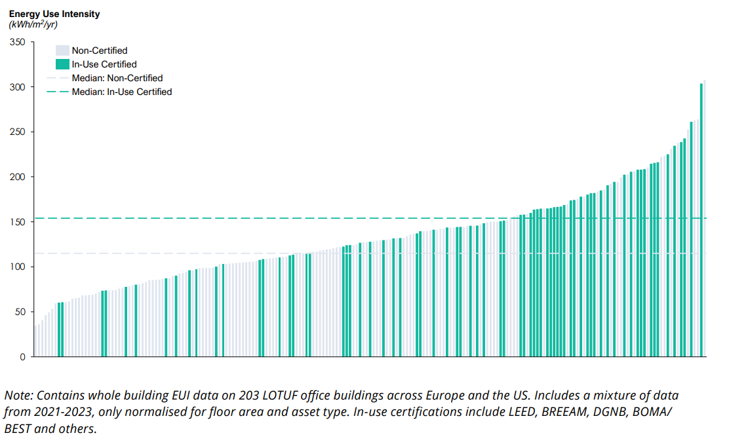
Box 9
What does a well-functioning building certification market look like?
Certifications can create a strong demand signal if they:
- Cover whole building emissions, including operational and embodied.
- Set out clear minimum requirements for energy use intensity.
- Set ambitious goals for 1.5 degree alignment against science-backed pathways.
- Measure performance using actual carbon and energy data.
- Provide transparency through publicly available targets, metrics and assessments.

Crucially, net-zero commitments from the private sector depend upon well-functioning building certification. In turn, voluntary commitments will accelerate the development of data, benchmarks and transparency. The private sector must:
- The real estate and construction sectors must set science-based targets to reduce whole life carbon emissions in new and retrofit buildings, and invest in collecting data, skills and knowledge sharing.
- Businesses with large scope 1 and 2 emissions (e.g., major hotel, restaurant and retail chains, professional services) should commit to reduce energy use intensity and emissions in their buildings from:
- Financial institutions must focus on developing a clear understanding of how to price and assess value and risk. Lenders should develop clear lending criteria tied to minimum EPC standards and offer favourable rates for better performance. Investors and fund managers should set out clear plans to reduce financed emissions.
- Cities and governments should collect data on public buildings, offer policy incentives (e.g., fast tracked permitting), and provide education and awareness of best practice.
This must be underpinned by strong regulation which sets a clear minimum floor for building design, energy use and the efficiency of installed technology. Developing commercial building codes is inherently harder than in the residential sector, given the huge heterogeneity across commercial building types and the lack of data on actual building performance meaning there is no clear starting point.
However, there is a clear opportunity for more ambitious and better designed regulation. Indeed, there is a strong case for setting much earlier targets for the transition away from fossil fuel heating in commercial buildings, including:
- Set ambitious targets for reductions in energy use intensity, and identify the priority lowest-performing buildings to renovate. The EU’s revised EPBD has committed to renovate 26% of the lowest-performing commercial properties by 2033.
- Create a more effective energy performance certificates system by:
  - Differentiating criteria by commercial building type and ensuring there is a strong correlation between criteria and energy performance.
  - Mandate that these must be updated at least every 5 years, or after any substantial retrofit.
  - Create effective enforcement and monitoring mechanisms.
  - Ensuring data is reported to national authorities, so EPC certificate can then include comparisons to the average.
- Regulate that rented buildings must have a minimum EPC rating. For example, the UK will require a minimum EPC rating of C from 2028 (up from E today), and B by 2030.
- In countries without established building codes, regulation needs to move gradually and begin with being prescriptive (e.g., specifying passive techniques) and move to performance based over time (e.g., kWh/m2).
- The importance of drastically reducing refrigerant leakage and venting
Key messages:
- Refrigerants can have a high global warming potential (GWP) relative to CO₂ if they leak or are intentionally released (vented) into the atmosphere. Currently, around 2-5% of refrigerant in heat pumps and air conditioners leaks every year, and 90% is vented at end of life.
- Emissions from refrigerant leakage and venting could be almost 1 GtCO₂ in 2030, rising to 2 GtCO₂ in 2050; this is equivalent to 15% of today’s annual emissions from buildings.
- Emissions could be halved in 2050 with regulations and incentives for proper disposal of refrigerant at end of life, skills certifications to improve the quality of installations and maintenance, and with a faster transition to lower-GWP refrigerants.
- International agreements and national regulation are already driving an industry transition towards natural refrigerants, such as propane, but action needs to accelerate.

Air conditioners and heat pumps contain refrigerants, which contribute to global warming if they are released into the atmosphere. Refrigerants are fluids which have very low boiling points and therefore change state between a liquid and gas at low temperatures. In other words, they are able to absorb and let go of heat energy really quickly. There are many different types of refrigerants, which work differently at different pressures and temperatures.
Refrigerants have different global warming potentials (GWP). This assesses a refrigerant’s global warming impact relative to the same quantity of carbon dioxide over a 100 year period. Exhibit 58 shows the spectrum of GWP, from hydrofluorocarbons (HFCs) which can be 1,000-2,000 times more detrimental than CO₂, down to natural refrigerants such as propane which are 3 times more detrimental to warming. Note also that refrigerants have a lower atmospheric lifetime than CO₂ and the amounts in the atmosphere are significantly less.
The Kigali Amendment to the Montreal Protocol in 2016 was an international agreement to phase out the use of HFCs – which are used not just in AC and heat pumps, but also aerosols and foams – in high-income countries by 2036 and in the rest of the world by 2047. It is estimated that without Kigali, surface temperatures might be 0.3-0.5ºC higher by the end of the century.
Kigali is driving an industry transition towards using natural refrigerants, such as propane, which have a much lower GWP. In 2024, the EU passed new regulations to phase out HFCs in line with Kigali targets, including setting quotas for the import of HFCs and banning trade in HFCs with any countries which have not signed Kigali.
Crucially, these refrigerants are also beneficial for efficiency, with propane for example, able to absorb and let go of heat rapidly. This transition is also not expected to lead to any long-term cost penalties, although in the short-term there will likely be some impact as manufacturers learn how to use these safely (e.g., propane is very flammable).
Transitioning to lower GWP refrigerants lowers the impact on global warming from refrigerant which is released into the atmosphere. But the other way to address the challenge is to reduce how much refrigerant is actually released into the atmosphere. This can happen from:
- Leakage: refrigerant can escape from air conditioners and heat pump systems through leaks or improper handling. It is estimated that, on average, around 2-5% of refrigerant is leaked every year, varying depending on equipment size, age and condition, the quality of installation, and amount of maintenance.
- Venting: refrigerants are often intentionally released into the atmosphere during servicing, maintenance, or at end of life. Key risk factors include improper servicing practice, a lack of awareness of technicians, and weak regulations for proper disposal. Today, estimates suggest that close to 90% of ACs at end-of-life are vented in the US. In the developing world, the number is likely even larger.
Exhibit 58
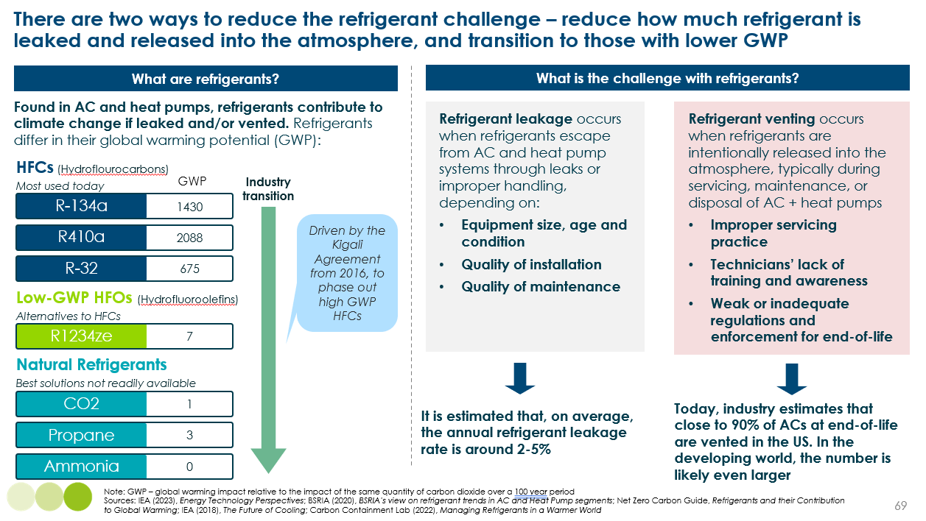
  - Estimates of emissions from leakage and venting
There is relatively little research estimating refrigerant-linked emissions from ACs and heat pumps. Using estimates of leakage and venting rates from the literature, and assuming there is on average of 10lb of refrigerant in a typical unit and assets last 15 years, we have estimated potential annual emissions in 2030 and 2050 [Exhibit 59]. Key points are:
- Emissions in 2030 could be almost 1Gt, which is equivalent to ~5% of today’s total emissions from building operational energy use (12.3 GtCO2). ACs account for around 90% of this, given existing stock is so much higher.
- With projected increases in AC and heat pump installation, but combined with a gradual transition to lower GWP refrigerants, emissions in 2050 could be more than double, around 2 GtCO2. Despite increasing uptake of heat pumps, the global stock could still be ~5 times lower than ACs (around 1bn compared to almost 5.5-6 bn ACs). In addition, emissions from heat pump venting in 2050 will be significantly smaller than for ACs, as the stock reaching end of life (i.e. from 2035) is even smaller.
- The most crucial action is to reduce venting. Exhibit 59 shows the impact of lowering venting rates to 50%, but there is no reason that tighter regulations on installers, household education, and financial incentives cannot reduce this even further.
- While it is also important to lower leakage rates as well, for example from 3.5% a year to 1.5%, without even stronger action to cut venting rates, this has no impact on lowering emissions as the refrigerant which is prevented from leaking is simply released into the atmosphere at end of life.
- For the refrigerant that is released into the atmosphere, it is crucial to transition towards low-GWP refrigerants. With reasonable assumptions about how the share of different refrigerants in the global stock of ACs and heat pumps will change and a faster transition to lower-GWP refrigerants, annual emissions in 2050 could be a further 5% lower; it will take time for low-GWP refrigerant in the total stock of existing ACs and heat pumps to increase.
- Annual emissions in 2050 could be equivalent to 10-15% of operational building emissions today, but as operational emissions are decarbonised with clean electrification, this share will actually increase, bringing the refrigerant challenge to the fore.
It is also important to keep in mind that any emissions relating from refrigerants are an order of magnitude lower than if gas boiler use continued.
Exhibit 59
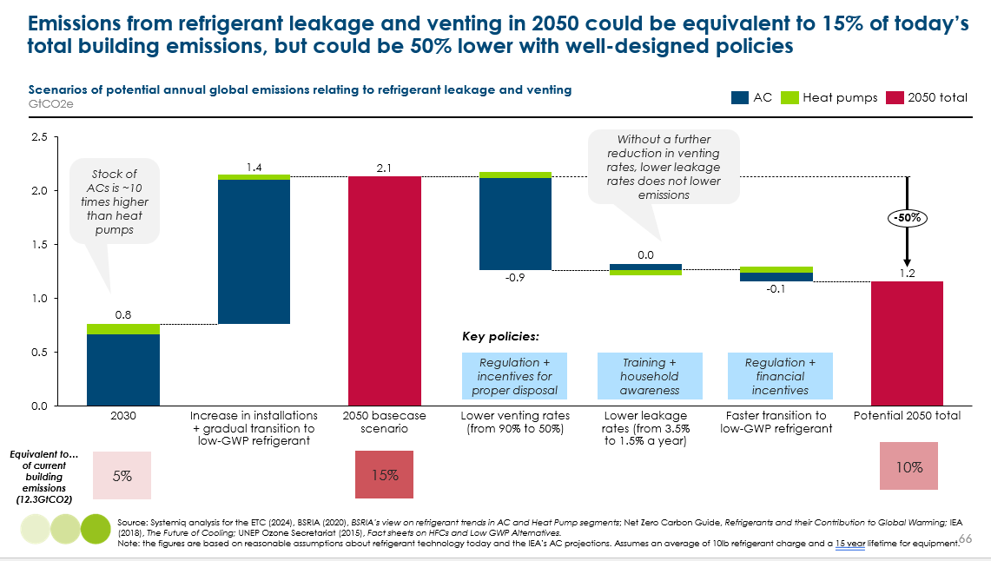

  - Actions to manage the refrigerant challenge
As an overlooked issue, policymakers and industry must develop coherent strategies to ensure that the heating technology transition and greater access to AC is not impeded by emissions which are entirely manageable with the right policies and regulation:

Policymakers
- Accelerate the transition to lower-GWP refrigerant with stronger regulation that has clear timelines and enforcement mechanisms. Policymakers should support R&D to rapidly lower the costs of using alternative refrigerants safely.
- Develop accreditation schemes for skilled installers and provide sufficient funding for high-quality training.
- Regulate installation and maintenance companies to properly deal with refrigerant during maintenance and disposal, including fines for improper disposal and incentives for higher collection rates.
- Run consumer awareness campaigns to spot leaks, the importance of regular maintenance, and how to properly dispose of units. Incentives should be offered for taking a unit for recycling.
- Tighter regulation for professionally managed residential and commercial buildings, with legal maintenance requirements.

Private sector
- Manufacturing companies to issue clear labelling on the type of refrigerant used, regular maintenance guidelines, and instructions for end of life disposal.
- Installers should offer discounts for regular maintenance checks and ensure they always collect old units when installing new ones.

Households and consumers
- Ensure they understand how heat pumps and ACs work, how to spot for leaks, and the importance of proper maintenance and disposal.
- Consider the type of refrigerant in a heat pump and AC when purchasing.
- Managing electricity demand: efficient and flexible buildings are vital

The previous chapters have evidenced the technical and economic feasibility of transitioning to clean and more efficient electric technologies. Combined with improved access to cooling, lighting and appliances across the world, the buildings energy transition will – with the right policies – fundamentally improve living standards, air quality, health and lower energy bills, while making vital contributions to reducing emissions.
However, it will create significant demand for electricity that must be carefully managed in a renewables-dominated energy system. This chapter will describe the importance of creating efficient and flexible buildings to ease final and peak energy demand challenges.
  - Aligning buildings electricity demand with renewable supply
    - Final energy demand
Holding today’s fuel and technology mix constant, final energy demand for heating, cooling, cooking, lighting and appliances could increase by 60%, from ~36,600 TWh today to ~57,500 TWh in 2050, as populations, incomes and urbanisation increase.,
Electrification, however, is efficiency. The near 100% electrification of heating and cooking by 2050 will reduce final energy demand by 30%, driven by heat pumps which are 3-4 times more efficient than gas boilers and the transition away from very inefficient biomass for cooking, where as little as 10% of energy is converted to useful heat.
While final energy demand will fall relative to continuing a fossil-fuel based heating system, the challenge is that we are moving from a system in which a variety of fuels supply buildings energy, to a system in which energy supply is predominately electric. This means that electrification and rising demand could lead to a 2-3 times increase in global electricity demand for building operations.
Today, around 12,800 TWh of electricity is consumed by the world’s buildings. In a baseline scenario without additional action to realise energy productivity opportunities, this could increase to around 35,500 TWh. Household electricity demand will be further increased by the need to charge EVs. This has huge implications for the extent and pace at which countries need to build a resilient clean power system.

    - Peak energy demand
The fundamental challenge with a renewables-dominated electricity system is that the availability of solar and wind varies across days, months and years. This means renewable generation, storage solutions, and any necessary higher-carbon back up generation must be sufficiently sized to:
- Meet the highest possible demand at a given moment in time, for example hourly demand during a cold snap.
- Meet sustained high demand over months, for example a particularly hot summer followed by a particularly cold winter
Ensuring peak electricity demand is met therefore has huge implications for the cost of building a clean energy system, emissions, and, in some cases, security of supply.
Building electricity needs powered by a renewables-dominated system faces three balancing challenges:
Daily balancing to manage demand fluctuations over the day and night when the sun doesn’t shine or the wind isn’t blowing. Heating needs tend to peak in the morning and evening [Exhibit 60], while cooling needs tend to peak in the middle of the day and into the night. In comparison, the sun shines most during the middle of the day but solar generation will be non-existent at night.
It is important to understand that, from a final energy demand perspective, the transition to heat pumps will more than halve the energy required at peak times compared to gas [Exhibit 60]. It will also create smoother peaks as heat pumps operate at lower temperatures for longer, compared to gas boilers which are turned on and off in response to demand. But shifting to an electric system will lead to a 4-6 times increase in household electricity needs.
There are many cost effective solutions to solve daily balancing challenges at the grid level; lithium-ion batteries will be the dominant technology in most countries, supported by pumped hydro, flow batteries and compressed air energy storage.
And as we outline in this section, there are also many solutions that can be deployed at the building level to balance demand and supply across hours and days, including insulation, solar PV, water storage, and smart energy systems.
Exhibit 60
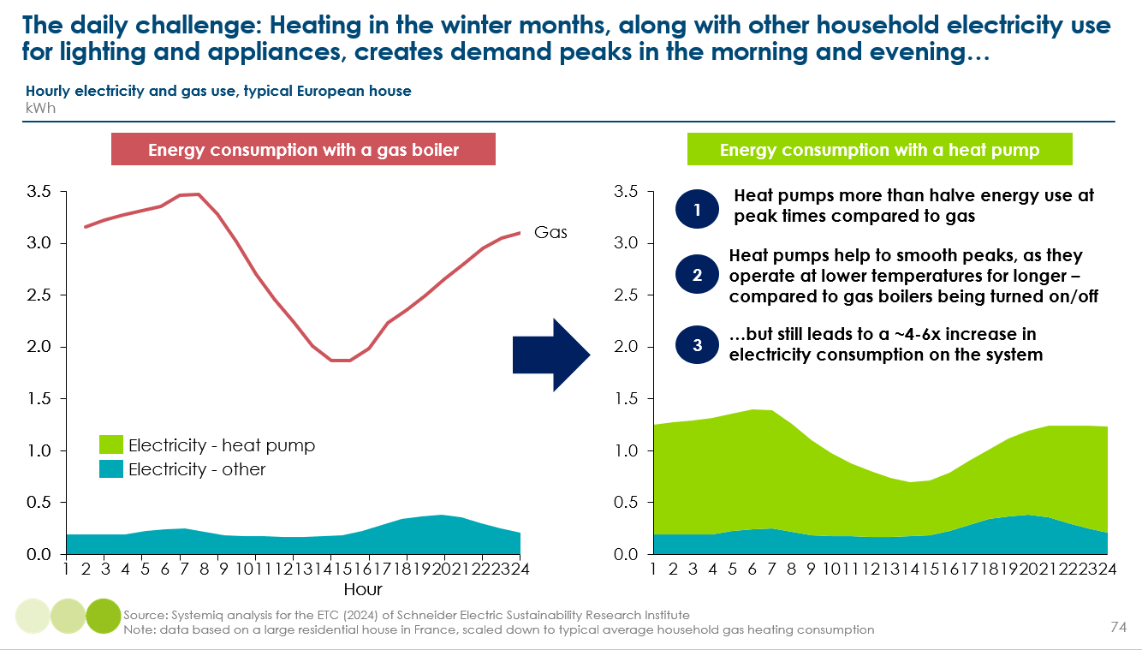

Seasonal balancing to manage predictable month-by-month cycles in demand and supply. In Northern latitude countries, heating needs peak in the winter months of October to March, when wind supply is typically higher but solar generation is reduced; cooling needs in these countries peak in the summer months where wind output can be lower [Exhibit 61]. In other parts of the world, cooling needs and renewable generation can vary across dry and wet seasons.
Unpredictable week-by-week variations that cannot be forecast well in advance and vary in importance each year, for example, extended weeks of ‘wind droughts’/anticyclones which reduce renewable generation, or extreme heatwaves which increase demand.
The big challenge with seasonal and unpredictable variations is when increases in demand coincide with decreases in renewable generation. For example, unpredictable reductions in supply may coincide with spikes in demand (e.g., anti-cyclone induced wind droughts during a cold snap). In 2023, China’s worst heatwave and drought in six decades hit hydroelectricity, the nation’s second biggest source of power; in response, coal output was boosted to generate electricity to meet increased cooling demand.
Managing seasonal and unpredictable variations is much more challenging, but solvable with a range of solutions that the ETC are exploring in depth in our upcoming Grids and balancing workstream: These include:
- Long-term energy storage (e.g., batteries, power-to-X, pumped hydro, hydrogen)
- Dispatchable generation (e.g., gas-fired turbines with CCS or burning hydrogen rather than methane).
- Interconnectors to import electricity from other countries.
- Overbuilding renewables relative to average daily demand levels in order to be able to meet peak demand on some occasions. This will produce a surplus of power supply at some times, which may be useable to produce green hydrogen.
While building-level solutions cannot bridge supply gaps beyond weeks and months, any reductions to overall electricity use over the course of a year can help preserve storage capacity and so aid in seasonal balancing.
Exhibit 61
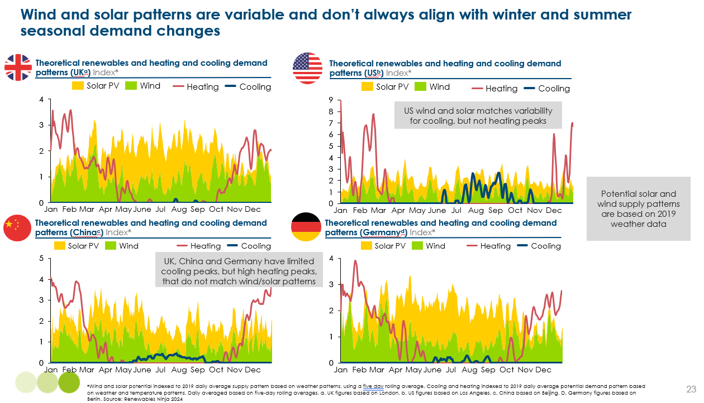
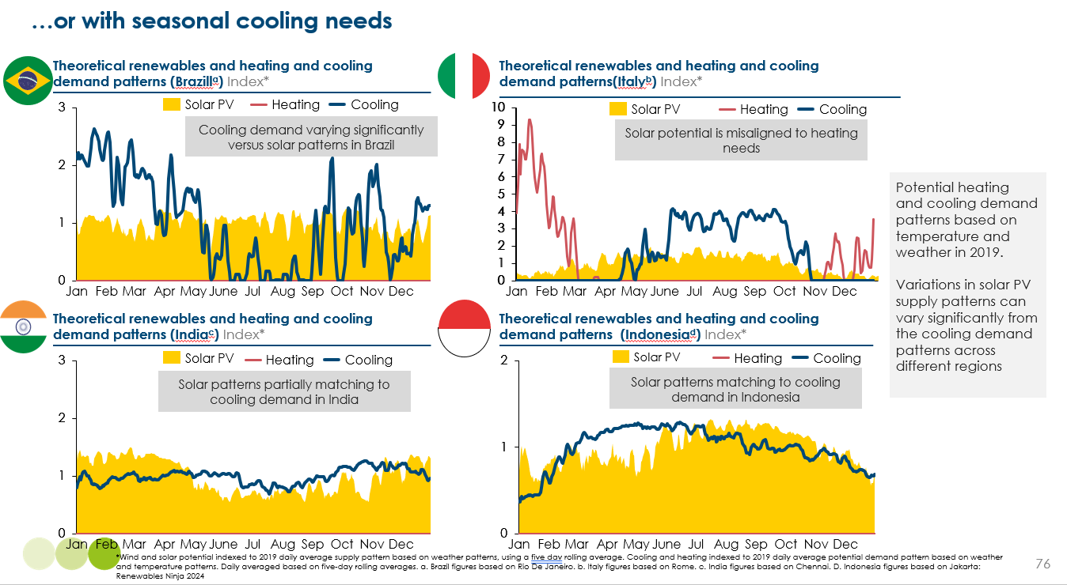

    - Opportunities for energy productivity and flexibility
Beyond electrification (which is, in itself, efficiency), there are three main areas of opportunity to reduce final and peak electricity needs while at the same time lowering energy bills and improving comfort [Exhibit 62]:
- Realising technical efficiency improvements in key technologies.
- Reducing energy needs and losses through better building design and envelopes.
- Encouraging demand-side efficiency (e.g., load shedding) and flexibility (e.g., load shifting) to enable building demand to respond to a change in the supply of clean electricity.
Thees actions will reduce the scale of the clean power system we need to build and reduce the frequency at which more expensive fossil fuel generation is required to fill gaps in supply. In this way, it will further help lower energy bills and emissions. These solutions therefore need to be a core part of policymakers and network system operator’s toolkits.
Exhibit 62
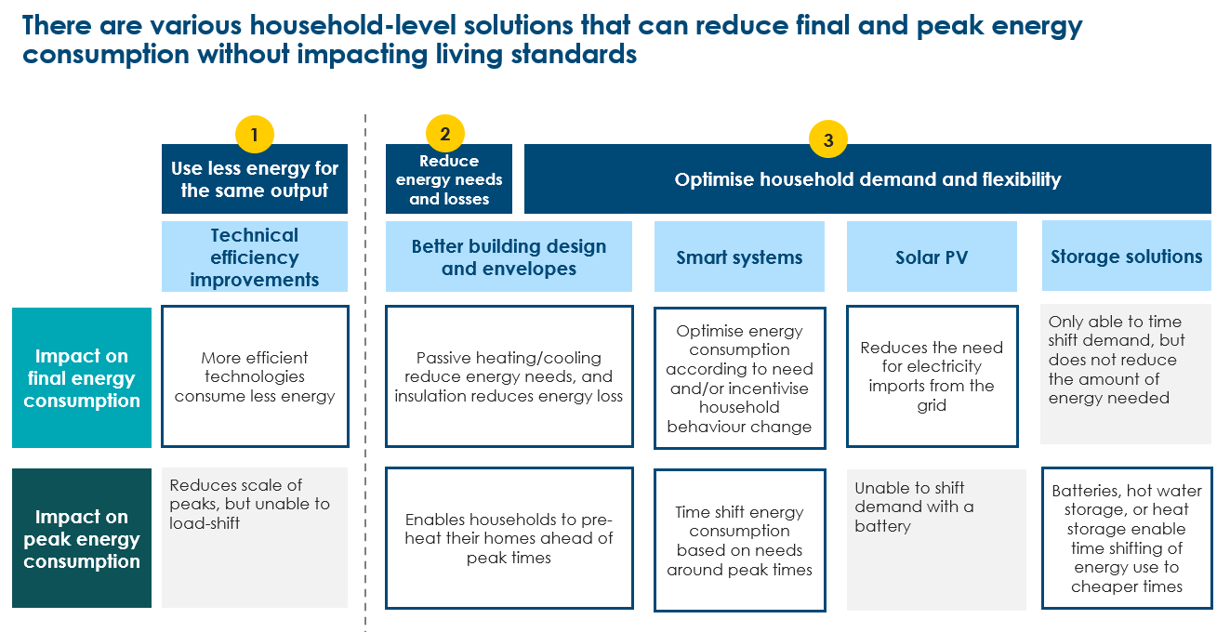
  - Technical efficiency improvements
The single most effective solution to the buildings electricity demand challenge is installing more efficient technologies. This can often be done at a minimal, or even zero, cost premium and can significantly lower bills without any action or disruption to households.
Throughout Chapters 2-6, we outlined the significant potential for technical efficiency improvements across all technologies:
- Heat pumps are expected to see gradual improvements in average efficiency to 400-500% over the next 25 years., This reflects improvements to the technology (e.g., variable speed motors and improvements in inverter technology which prevents a fall in performance at lower outdoor temperatures), and right-sizing of systems as skills and experience of installers improves.
- There are already air conditioners on the market that can achieve a seasonal energy efficiency rating (SEER) of over 10., Yet the average AC sold only achieves a SEER of 3-6. Even without further innovation, improved minimum energy performance standards (MEPS) and labelling should be able to realise at least a 50% improvement in the efficiency of the AC stock by 2050.
- Moving towards induction hobs, which are around 80-90% efficient, compared to 70-80% for electric convection hobs.
- Similarly, improving the efficiency the average household appliances sold with stronger MEPS and labelling could lead to a 40% reduction in electricity demand in 2050.
- LED lighting is already 80% more efficient than incandescent lighting, and is expected to get at least 30% more efficient from today’s levels. If all lighting was LED in 2050, electricity needs would be almost 60% lower versus a scenario in which LED lighting continues to make up only half of global sales.
Looking across all technologies, technical efficiency improvements could lower electricity requirements in 2050 by 30%.
This doesn’t take into account the risk of rebound effects, where households use a technology more because it costs less to use; however, in most cases this applies to lower-income households whose demand is less than their true need; this implies that some rebound effect is positive for human welfare.

  - Reducing energy needs and losses
    - Building more efficient new buildings
Global floor area is set to increase 50-60% by 2050, from 250bn sqm to 390bn sqm.
Exhibit 9 and Exhibit 38. show that the key areas of growth will be:
- In middle- and low-income countries (excluding China), where floor space is set to double, compared to a 20-35% increase in China and high-income countries.
- In hot countries requiring cooling. On a global level, cooled floor area is set to increase 150%, compared to a 25% increase in heated floor area.
- Focused on residential buildings (+110bn sqm), compared to commercial (+30bn sqm).
- Likely focused on apartment blocks to a large extent, given these are more common in rapidly urbanising emerging markets; however, the exact mix of building archetypes is very uncertain.
As outlined in Chapters 2 and 3, there are significant opportunities to incorporate passive heating and cooling techniques in building design and envelopes to both:
- Reduce the need for mechanical heating and cooling in the first place (e.g., orientation to reduce solar gain, using materials with high thermal mass).
- Reduce energy loss from mechanical heating and cooling (e.g., better insulation, air tight and high quality construction).
These techniques can reduce energy consumption by 15-40% in new residential buildings, with significant benefits for energy bills, living standards and for managing electricity demand.
Once a building is built, it will likely be around for 60-100 years and making changes is significantly more costly and disruptive. It is therefore crucial to ensure the next generation of new buildings is built to higher standards, incorporates passive techniques, and maximises efficiency and flexibility.

The opportunity to create better new buildings
In many countries, new buildings are subject to building codes which outline minimum construction and energy efficiency criteria. These regulations set a minimum floor which all construction must meet; unless developers believe they can charge a premium, there is little incentive to go above this.
In recent years, building certification schemes have emerged to incentivise stronger performance, by awarding those which meet stronger energy efficiency criteria (as well as other environmental and health factors such as air quality). These typically apply to the top 5-10% of the market. Going beyond this, the Passive House standard is the gold standard for energy efficient buildings, with criteria which effectively sets the frontier of what is currently possible. Exhibit 63 shows that certified buildings typically consume 20% less energy per m² than one built to regulated standards, while a Passive House building consumes at least 50% less.
The key question, of course, is how much does it cost to build to these higher standards. Understanding the incremental cost is challenging as there is no consistent baseline or definition of an energy efficient or green building. Based on a literature review of construction in high/middle income countries, we have drawn the following conclusions:
- The cost premium of moving from current standards to typical certification levels and achieving at least a 20% reduction in kwh/m² is typically very manageable (1-5%).
- Achieving a further 30%+ reduction in energy intensity has a larger additional cost premium of 2.5-17.5%.
Exhibit 63
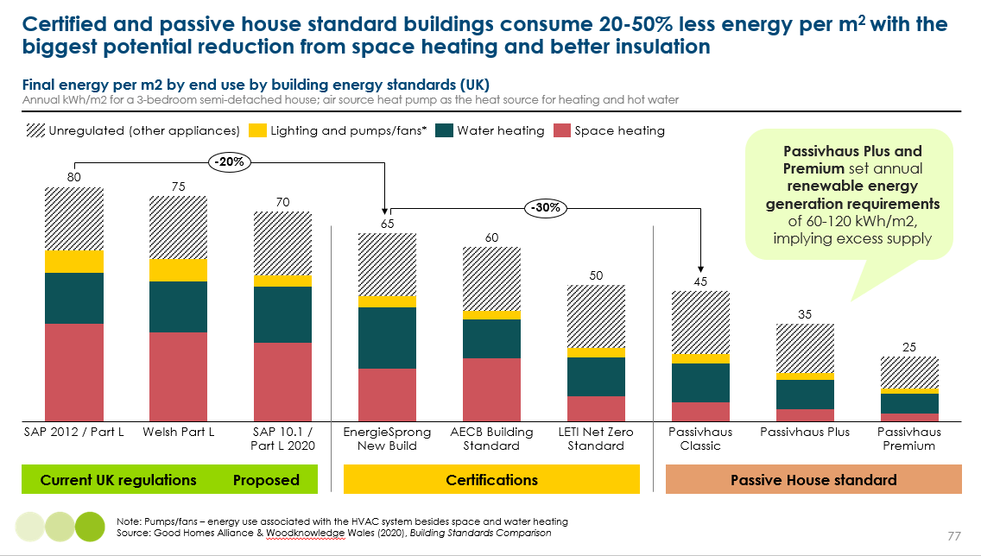
This suggests that, in countries with established building codes, regulations should move towards certification standards over time, with a manageable and gradual additional cost [Exhibit 64]. In turn, certifications should continue to increase in ambition, pushing the industry frontier.
The bigger challenge is in countries without established regulations, including large parts of Asia, most of Africa and South America, where most of the growth in new floor space will occur. Note, however, that even some US and Canadian states don’t have mandatory building codes. In these countries, regulation must be gradually phased in and tightened over time to ensure manageable costs and compliance.
Exhibit 64
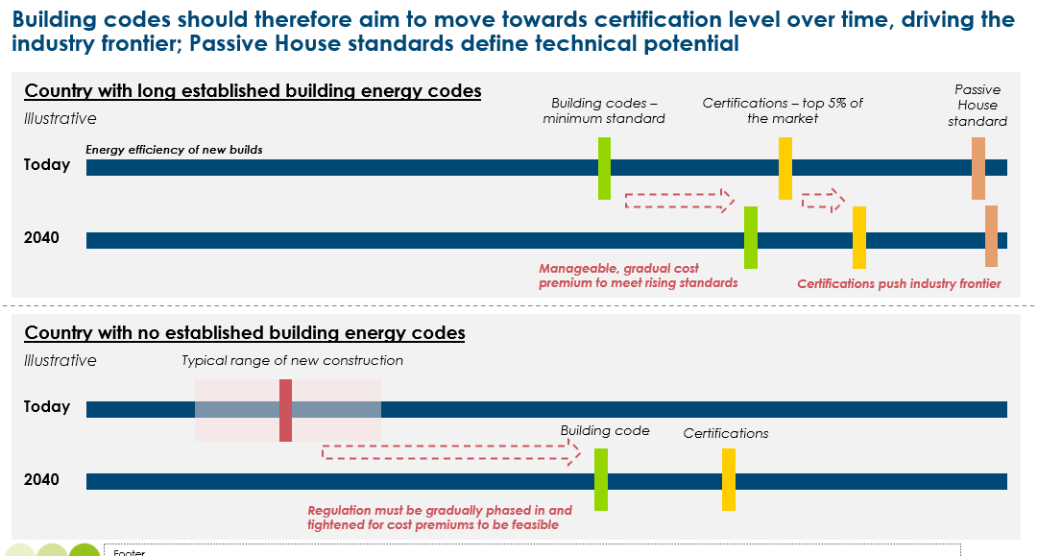

Size of the prize
Reasonable assumptions about the extent and pace that different parts of the world could tighten building codes suggest that cumulative energy consumption from the stock of new residential buildings to 2050 could be around 20% lower. But this could be significantly greater if much faster action were taken. Tightening building codes will be a gradual process, highlighting the critical importance of action this decade to drive continued and accelerated improvements.
Exhibit 65
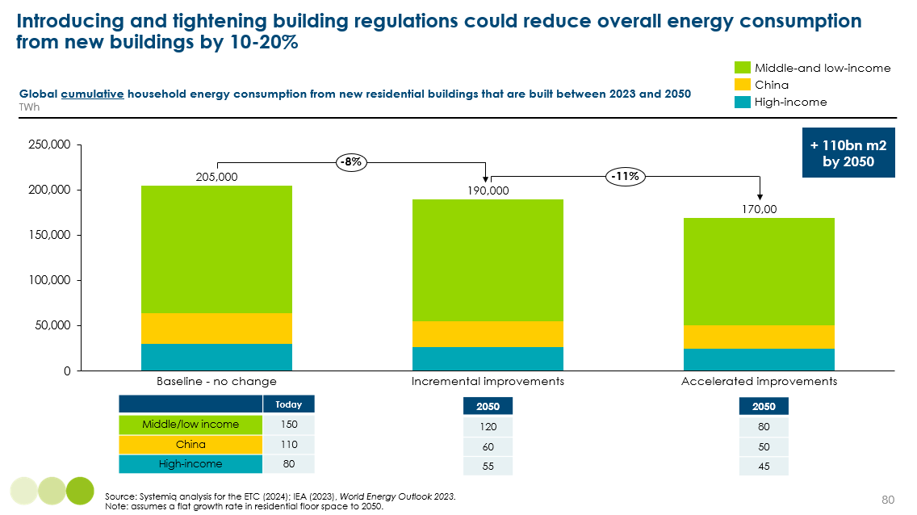

Realising this potential prize requires a mix of regulation, market/voluntary actions, and wider policies and incentives.
Regulation will be the most important driver of change, but to be effective requires regulators and policymakers to:
- Increase the ambition of minimum standards, gradually tightening criteria every ~5 years and setting out a long-term roadmap to provide 5-10 years foresight of changes. In high-income countries and China, regulations should clearly set a target and timeline to reach certification level standards.
- Implement prescriptive regulations in countries without codes today, which specify design choices, materials and technologies. Regulation should take on an educative role initially, but crucially must learn from other countries to enable lower-income countries to effective “leapfrog” towards higher standards.
- Develop enforcement and monitoring schemes, including fines for noncompliance and refusal of planning permission.
- Develop clear measurement approaches, frameworks and open source databases.
Market and voluntary actions can play a supporting role in driving change, including:
- Net-zero commitments from developers may drive investment in energy efficient new building.
- Financial institutions, as part of their own net-zero commitments, may send a demand signal to developers for energy efficient construction, for example through favourable interest rates.
- Buyers may also be willing to pay a premium for energy efficient buildings, but with many other factors at play in deciding whether to buy a property these signals are very weak and likely only apply to the very top of the market and the commercial sector.
Realising the potential of these demand signals requires improvements to the transparency and credibility of building certifications to create a strong link between energy efficiency and value (see Chapter 7).
Policies and incentives can also play an important role:
- Improving education and awareness of passive techniques and quality construction through pilots and demonstration projects, continued professional development for existing architects and developers, and sharing learnings across countries.
- Incentivising stronger action through fast-track approvals and permitting advantages (e.g., greater floor space) for energy efficient projects.
- Financial incentives, such as tax credits and subsidies and favourable lending rates.

    - Retrofit for energy efficiency
In Chapter 2, we evidenced that:
- Insulating existing homes to a very high standard is not a pre-requisite for installing a heat pump in most homes, as long as radiators and systems are appropriately sized; although will likely still be important in the least energy efficient properties.
- There are many low-cost and low-effort ways that existing buildings can be insulated (e.g., DIY draught proofing, loft insulation), which can reduce energy consumption by ~5-15% and should be actively encouraged by policymakers.
- Insulation and living standards are closely linked and so retrofitting the least efficient properties should be a priority for policymakers.
The extent to which existing buildings will require retrofitting will vary massively across and within countries and estimating a global number is challenging. A reasonable assumption is that up to 75% of heated floor space could see some improvement to their levels of insulation, while it is likely that a much small share of cooled floor area will be retrofitted, given a large share of this is in middle- and low-income countries with new buildings and where affordability will be an even greater challenge.

  - Solving the peak demand challenge: Demand-side efficiency and flexibility

In today’s fossil-dominated electricity system, supply is able to respond very quickly to a change in demand (e.g., firing up more gas turbines). In tomorrow’s renewable energy system based on variable sun and wind, there is a limit to how far electricity supply can rapidly respond to demand. There is, however, significant untapped potential for demand instead to flex in response to changes in supply, without major changes in behaviour change or a reduction in living standards.
As set out in Exhibit 62, there are four main building-level solutions that can help to optimise household energy use and improve flexibility: better building envelopes (e.g., insulation and thermal mass), smart systems, solar PV, and storage. The incentives to invest in these will depend on:
- Ratio of electricity prices to gas: higher electricity prices will create a stronger payback. This is at odds with the rebalancing required to incentivise the electrification of heating and cooking.
- Time of use tariffs: flexible tariffs which better reflect the marginal cost of electricity generation at different times of day can create an incentive to time-shift demand.
- Sellback price: compensation for exporting excess electricity generation back to the grid creates an additional incentive to invest in solar PV.

Box 10
To add: case study on Octopus’ dynamic tariffs
- Impact on energy savings
- Consumer satisfaction with tariffs and demand size flex
- Implications for potential for UK demand flex size of the prize

    - Better building envelopes
The previous section explored the importance of insulation and thermal mass from the perspective of lowering overall energy needs and losses. But crucially, this can also play a critical role in reducing peak energy demand, by enabling households to pre-heat or cool their homes ahead of peak times. Exhibit 66 shows how a building’s “hours of flexibility” can vary across select countries, with the UK’s older and poorly insulated housing stock performing poorly. It suggests that homes in the UK require 2-3 times more energy at peak times compared to Germany and Norway to prevent temperatures dropping by more than 1ºC.
Exhibit 66
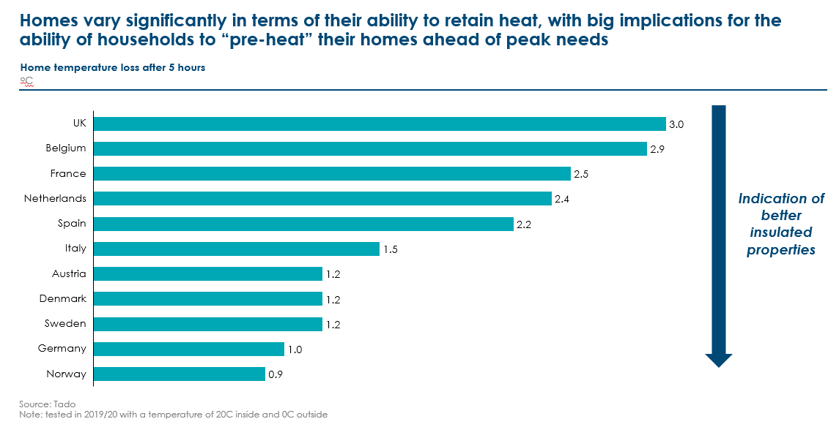
Today, there are some utility companies targeting climate-savvy consumers with dynamic tariffs that offer different peak and off-peak hourly or daily prices. For example, peak hour prices in Octopus Energy’s Agile tariff averaged €0.18/kWh in April 2024, compared to €0.08/kWh for off-peak hours. In February 2024, EDF’s Tempo tariff averaged €0.75/kWh on high demand days and €0.13/kWh on low demand days.
If there is a sufficient differential, these flexible tariffs can create an additional financial incentive for households to invest in insulation. Time of use tariffs are currently in their infancy and rely on innovation in retail markets and smart meter adoption, but are generally expected to become a more popular offering over time.
However, as more and more people adopt time of use tariffs, the spread between peak and off-peak prices is likely to narrow, though not disappear entirely – there will always be some energy use that cannot be shifted to off-peak times. Combined with the high costs of medium- to deep-retrofits, this means time of use tariffs are unlikely to fundamentally change the investment case for households at scale, especially given the uncertainty in how prices will evolve.
This underscores the importance of:
- Governments, regulators, network operations and electricity providers recognising the importance of insulation in addressing balancing challenges.
- As a result, optimal policies will involve governments offering financial support to households to afford the upfront costs.
    - Smart systems
Smart systems, or building energy management systems, use automated processes and data to control and optimise the operation of installed technologies, for example:
- Controlling heating/cooling remotely and only heating/cooling certain rooms – this helps to reduce unnecessary energy use.
- Tacking and monitoring energy use and costs, enabling households to adjust their behaviour according to their budgets.
- Responding to price signals from energy providers or the grid.
Commercial building systems are typically much more sophisticated, including sensors (e.g., turning lights off automatically, sensing where office spaces are less occupied), connecting HVAC technologies together, and using analytics and AI respond to real time changes in weather, use of a building and the grid. There are a wide range of these provided in the market - Box 11 illustrates one particular extreme case for how to bring everything together. The crucial consideration for smart systems is that the energy they save must be more than the energy that the data centres that power then consume.
Box 11
Brainbox AI
This building management system uses information on weather, occupants and grid mix/prices to autonomously control individual pieces of HVAC equipment, making adjustments every 5 minutes. Crucially, it uses AI to learn behaviours and patterns and predict energy needs over time. For example:
- If the weather is expected to be warmer than normal, it can automatically reduce pre-heating overnight
- If the grid is especially fossils-dominated or if peak prices spike, it can reduce heating/cooling to within minimum acceptable temperature bounds and maximise pre-heating/cooling
- If the building is especially busy, it can anticipate that it might be warmer and increase cooling
Commercial building which have adopted BrainboxAI have typically experienced a 10-20% reduction in HVAC energy consumption and a 5-10% reduction in total energy consumption.

We expect strong uptake of smart systems across both residential and commercial properties in high-income countries and China, even without strong policy frameworks in place. They can be fairly low-cost (e.g., ~€100 for a smart thermostat, up to €500-1,000 to connect all relevant technologies in a residential house), and can have a big impact on reducing overall energy consumption and therefore energy bills [Exhibit 67]. In addition, they will play a really important educational role as we transition to a renewable energy system, helping people better understand how energy supply varies over time and the impact on prices.
Exhibit 67
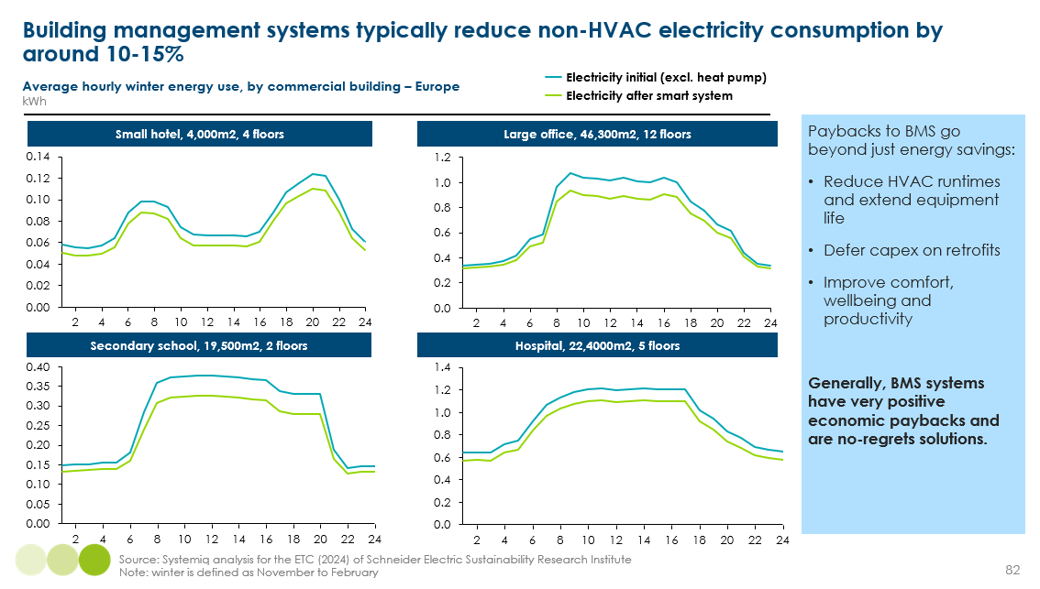
    - Rooftop Solar PV
Rooftop solar PV does not reduce final energy consumption from an economy-wide perspective, but it does reduce the amount of electricity households import from the grid. This lowers bills and the scale of grid upgrades and storage required at a national level, especially if excess generation is sold back to the grid.
The LCOE of solar PV has fallen 90% over the past decade [Exhibit 68], although the cost of rooftop solar is higher than utility-scale. In the US, the capital cost of rooftop solar was $2,000-4,000/kW, compared to $700-1,400 for utility scale. Still lower costs are being achieved in China and India, however, with module capital costs down to $100-150/KW, and capital cost for equipment (but not including land and grid connection costs) at $300/KW.
There is already a strong investment case to installing rooftop solar PV in most high-income countries. As more buildings electrify heating and as the costs of solar PV fall further, many households are likely to install rooftop solar without being incentivised to do so. However, as with heat pumps, affording the upfront costs is a barrier for many, meaning the provision of low-cost finance should be a key policy priority.
Particularly strong uptake is expected from higher-income households in middle- and low-income countries that have high cooling needs, given AC use coincides with when the sun is shining. Unreliable grids will provide an additional incentive in some cases.
Exhibit 68
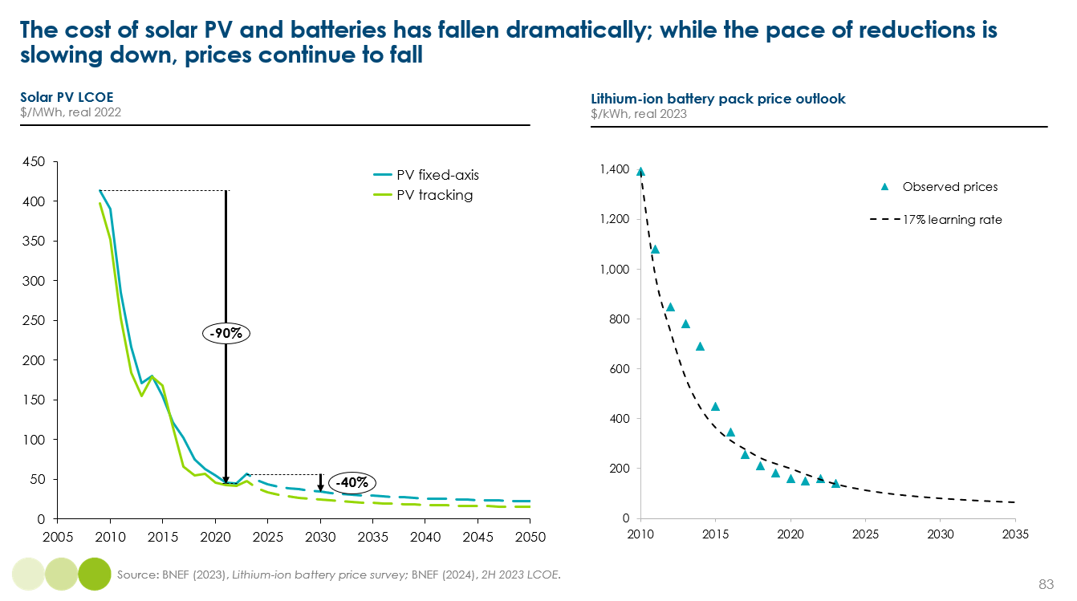
For commercial buildings, the incentive to invest heavily depends on available roof space; warehouses for example have a very high roof to floor ratio, while multi-story offices do not. Exhibit 69 shows how the share of total energy needs that solar generation can meet varies hugely across different commercial buildings. For those with large flat roofs, such as warehouses, this implies the need for strong regulation which requires all new large flat roof commercial buildings to have rooftop solar PV.
For those with minimal roof space (i.e. the 12 floor large office illustrated), this underscores the importance and potential impact of improved insulation and smart systems. For large commercial buildings, solar panels can also be integrated into facades [to add case study].
Box 12
To add: case study of building integrated PV
    - Impact on energy consumption (e.g., insulation, light)
    - Cost and feasibility of installation

Exhibit 69
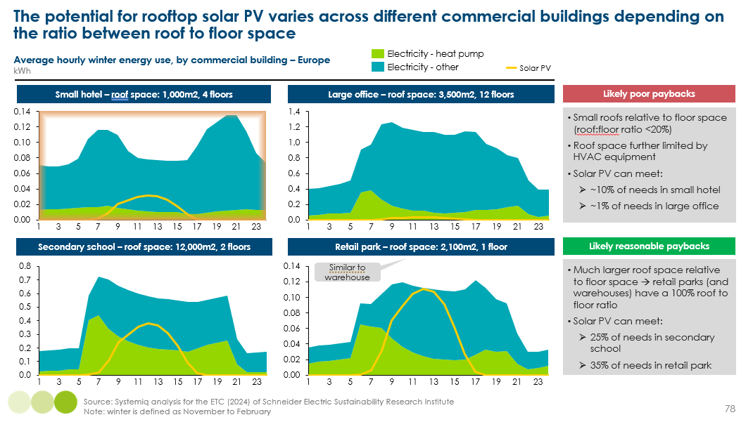
    - Storage technologies
Buildings can store hot water, power or heat at times when renewable power is in abundance and cheap, for use at peak times. There are three main technologies:
- Hot water cylinders: Domestic hot water can be heated and stored in a well-insulated tank. The technology will play a critical role in the rollout of air-to-water heat pumps which require water to be gradually heated over time and stored. They are fairly low-cost, at around €500-1,500 for a 2-4 bedroom house. The main drawback, however, is large space requirements of around 2-3m².
- Batteries: These are typically combined with solar PV to store excess or off-peak electricity generated for later use. They could also be used in isolation to charge from grid at off-peak times and enable households to avoid peak energy consumption from the grid. They can provide power for either electric space or water heating. As Exhibit 68 shows, the cost of producing batteries has fallen dramatically; but this is currently not feeding fully through to retail prices. As markets scale, consumer prices should fall too.
- Thermal batteries: There are a range of technologies which can also store heat, from bricks which have a high thermal capacity, to those which exploit the high thermal potential of phase change materials. These can be heated up at off-peak times, and water is then passed over when heat is required. They are currently used for domestic hot water needs, but could also be used to deliver space heating in a wet heating system. In residential properties, they can be around half the size of a hot water cylinder and our initial engagement with providers suggests they could cost around 50% more than a hot water cylinder. It is also possible to store cooling too, for example in the form of ice.
Unless incentivised by policy, however, household uptake rests upon time of use tariffs and a sufficient differential (e.g., at least 30%) between peak and off-peak prices. In the absence of such retail energy market developments , governments and network system operators should actively encourage the uptake of hot water cylinders as the lowest-cost solution, for example through low-cost finance. With water heating accounting for around 20% of total heating energy needs, mass uptake of water storage can have a significant impact on reducing peak electricity demand.

  - Implications for energy demand
    - Reducing final electricity demand
The combination of electrification of heating and the energy productivity solutions discussed above could in theory lower annual energy demand in 2050 by 60% [Exhibit 70].
- The electrification of heating and cooking will reduce final energy consumption by around 30%, but heating final consumption by a third.
- Technical efficiency improvements has the potential to lower final energy consumption by around 20%.
- Improving the building fabric of new and existing buildings could, together, lower 2050 consumption by 10% - this could be even higher with much greater ambition to improve building codes and with financial support households.
- Demand efficiency, for example from the use of smart systems or behaviour change (e.g., policies to limit thermostats in public buildings) could reduce consumption by ~5%, but again this could be much higher with stronger policies and education.
Given the size of the prize, public policy should focus on seizing this potential wherever it is cost-effective to do so; but crucially, governments should at the same time remain committed to building a clean energy system as fast as possible. Planning and investment in renewable generation, networks and storage should be guided by the upper bound of estimates, recognising that the full potential of these energy productivity improvements is unlikely.
Exhibit 70
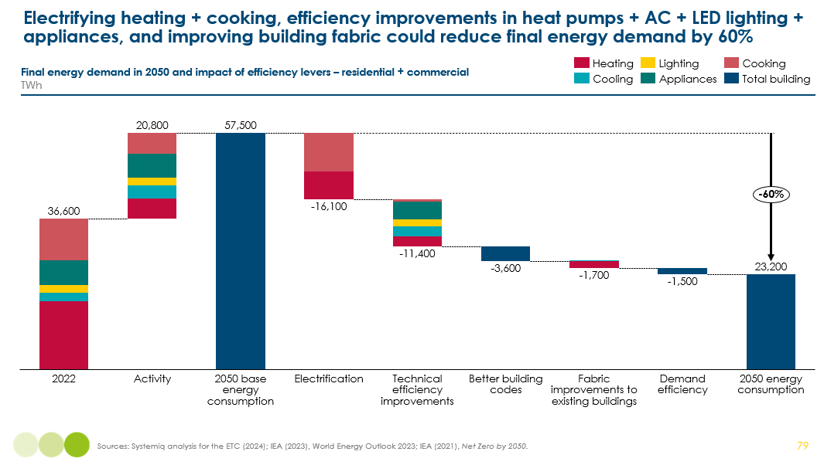

ASSUMPTIONS FOR MEMBERS TO REVIEW - PLEASE NOTE THIS TABLE WILL NOT BE DIRECTLY INCLUDED IN THE REPORT
Lever | Approach / assumptions
Electrification | - 75% of fossil fuel heating is heat pumps, COP of 3  - 20% of fossil heating is resistive  - 5% remains fossil
Tech efficiency | - Heat pumps COP 3 à 4  - Cooling: COP 4 à 6  - Cooking: 75% to 85%  - Lighting: 45% improvement  - Appliances: 40% improvement
Better building codes – new buildings
  kWh/m2 of building codes | Today | 2050 – incremental improvements | 2050 – accelerated improvements
  Middle/low income | 150 | 120 | 80
  China | 110 | 60 | 50
  High-income | 80 | 55 | 45
Fabric improvements in existing buildings | - Heating: 50% of existing buildings insulated, 20% reduction in energy consumption  - Cooling: 20% of existing buildings insulated, 20% reduction in energy consumption
Demand efficiency (e.g., smart systems) | - 5% reduction in total consumption

    - Reducing peak electricity demand
Overall, flexibility of energy use in buildings can play an important role to address the peak challenge -as the consumption of electricity undergoes a change from an old system which was based primarily on “one-way” flows of consumption, to one of “two-way flows” where demand can more proactively play a part to match the variability in supply. The ETC estimates that around 20% of total buildings electricity demand in 2050 could be realistically time-shifted with demand-side response including via distributed storage, with significant opportunities across heating and cooling, and some more limited potential in lighting & appliances. Overall, commercial buildings could offer greater potential, given aggregation possibilities via building management systems. However, as discussed, this will require unlocking key regulatory enablers, such as time of use pricing.
It is important to note that the solutions discussed in this section will only help to solve the daily balancing challenge; they cannot address seasonal balancing. The level of insulation required would be too extreme to be feasible, rooftop solar generation faces the same challenges at grid-level solar, and storage solutions don’t have sufficient capacity beyond a day. Seasonal balancing challenges therefore need to be solved by investments within the power system rather than at building level.
    - The phase out of fossil fuel demand
Combining the projections for heating and cooking (see sections 2.5 and 4.5), results in the following implications for the phaseout of fossil fuels [Exhibit 71]:
- Coal use is entirely eliminated by 2040 in both scenarios.
- Gas use also is almost entirely eliminated by 2050 but falls only 15–25% by 2030.
- Oil use in heating declines rapidly, but initially grows for cooking (in the form of LPG); however, since oil use for heating is currently around 2.5 times larger than for cooking, a material decline of 15–25% can still be achieved globally by 2030.
Exhibit 71
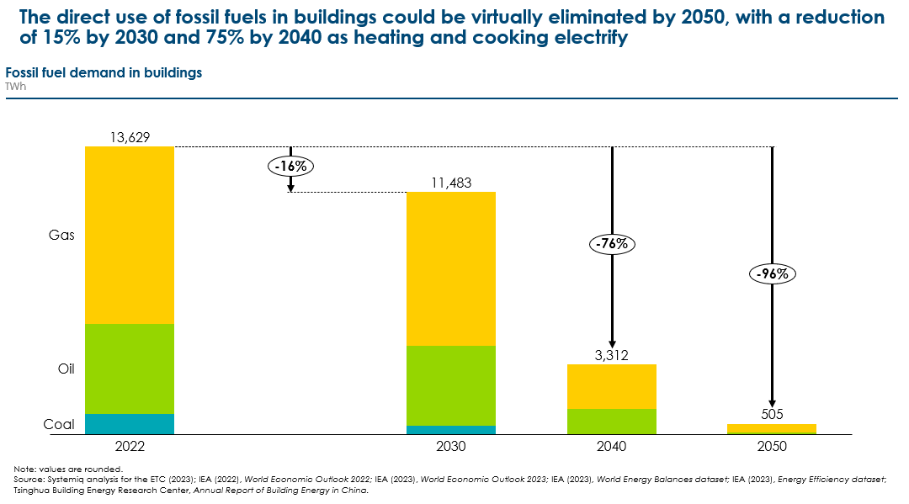

Section B: The opportunity to reduce the embodied carbon from the next generation of new buildings

- Understanding emissions across the building lifecycle
This report has so far focused on energy used – and the resulting direct and indirect emissions (80% of total buildings emissions) - to operate buildings. However, 20% of annual emissions relating to buildings (2.6 GtCO₂) arise from the energy and materials used to construct new buildings, maintain existing ones, and demolish those at end of life. In total, annual embodied emissions from the built environment – including both buildings and wider infrastructure - account for 13% of emissions (4.8 GtCO₂) [Exhibit 4 in Chapter 1]:
- 2.6 GtCO₂, or 7% of global emissions, from residential and commercial buildings.
- 2.2 GtCO₂, or 6% of global emissions, from infrastructure, including the construction of roads, bridges, airports, pipelines, railways and ports.
This section will predominately focus on buildings, but will discuss the wider built environment where relevant.
Focusing on buildings, Exhibit 72 shows how operational and embodied emissions arise over a building’s lifecycle. Of the three stages, operational emissions only relate from a building’s use phase, whereas embodied emissions occur in the upfront, use and end-of-life phases. There are fundamental differences between operational and embodied emissions:
- Embodied emissions are one-off occurrences at a few points in a building’s lifecycle [Exhibit 72], while operational emissions recur every year over the long-term.
- There are a huge variety of sources of embodied emissions, from the production of different building materials such as steel and cement, to the transport and machinery used in construction and demolition. In comparison, understanding household energy consumption and associated carbon intensity is relatively easier.
- This means there is a significant lack of data on embodied carbon and as a result, no consensus on what a typical building’s embodied emissions are.
Exhibit 73 presents data from case studies in Europe, suggesting that, over 60 years, embodied and operational emissions each account for 50% of total lifecycle emissions. Of embodied emissions, two-thirds occur before a building is even in use, while end-of-life emissions account for less than 5%. The ratio between a building’s operational and embodied emissions will, however, vary massively across countries and buildings depending on:
- The materials and construction techniques used.
- The building archetype (e.g., flats have a higher embodied carbon per m² because of the need for greater foundations and structures).
- The carbon intensity of electricity generation and the technologies used for heating and cooking.
- A building’s lifetime.
This section will step through the sources and mitigation potential for upfront, use and end of life embodied carbon.
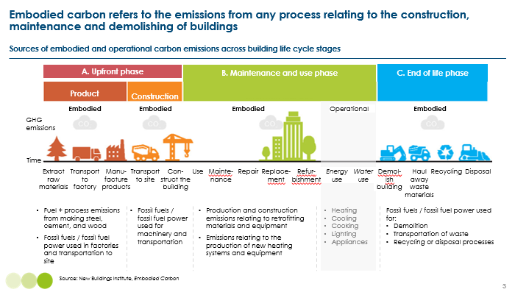
Exhibit 72
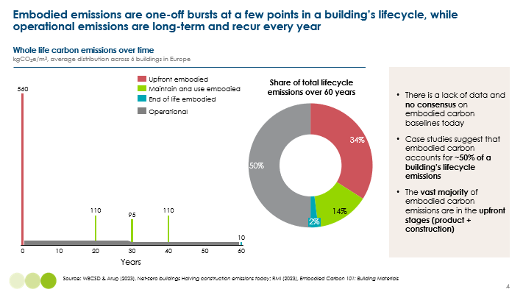
Exhibit 73

- The huge potential to mitigate upfront embodied carbon
Key messages:
- Embodied carbon is often overlooked, but can account for up to half of a building’s lifecycle emissions. As heating is electrified and electricity grids are decarbonised, embodied carbon will become an even bigger share of emissions.
- With global floor area set to more than double by 2050, action to reduce embodied carbon during the transition is critical; new construction could release 75GtCO2, or 40% of the remaining carbon budget for 1.5C
- By far the biggest source of embodied carbon is from the production of material inputs to construction, namely cement, concrete and steel
- The Mission Possible Partnership’s sector transition strategies have challenged the belief that it was not possible to fully decarbonise the so-called “hard to abate” sectors by 2050, setting out the suite of technologies available today
- But to reach net zero by 2050, material efficiency and substitution is required, involving innovative building design strategies, using alternative materials such as timber, and better urban planning

Upfront embodied carbon arises from the production and transportation of materials and the construction of new buildings. A building can be thought of as having 5 main layers:
- Structure: a building’s skeleton and overall shape, including its substructure (e.g., foundations and retaining walls) and superstructure (e.g., upper floors, roof and stairs).
- Skin: the outside layers, such as the façade, windows, surface material and insulation.
- Space plan: walls, doors and raised floors/suspended ceilings used to for compartmentalisation.
- Services: HVAC and lighting that supports a building’s operation.
- Stuff: all other items of furniture and appliances that are installed. This report focuses on the four above layers, and does not consider the embodied carbon in producing these items.
A building’s structure accounts for over half of its embodied emissions, due to steel, cement and concrete, which is also required across the other three layers [Exhibit 74]. As Exhibit 75 shows, producing many of these materials is currently highly carbon intensive.
Exhibit 74
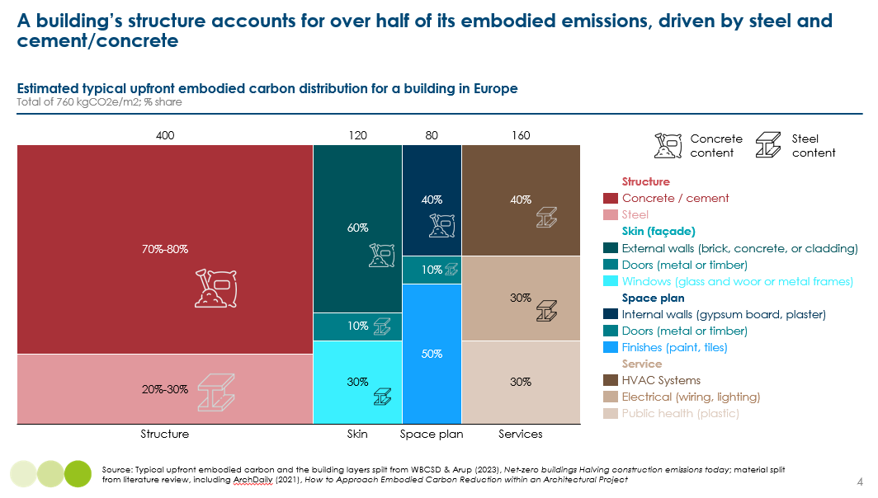

Exhibit 75
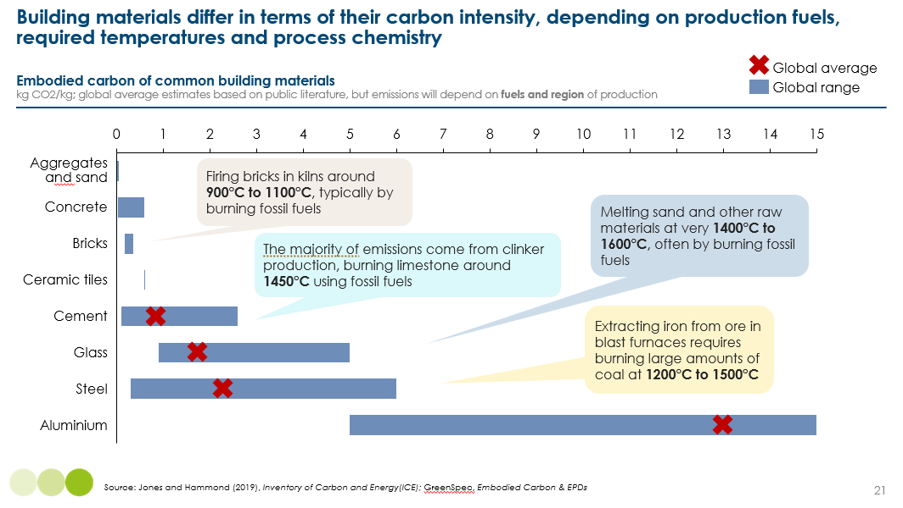
Reducing the carbon required to build new buildings is the biggest embodied carbon challenge as global floor area is set to increase 55% by 2050, from 250bn sqm to 390bn sqm. Today, around 4.5bn m² of new floor space is built every year, which results in 2.6GtCO₂ of annual embodied carbon emissions. Holding today’s global average embodied carbon per m² constant (0.5 GtCO₂/bn m²), constructing this additional 140bn sqm would generate 75 GtCO₂ by 2050. Exhibit 76 shows that this would use up 40% of the remaining carbon budget that scientists estimate gives the world a 50% chance of limiting warming to 1.5ºC.
Exhibit 76
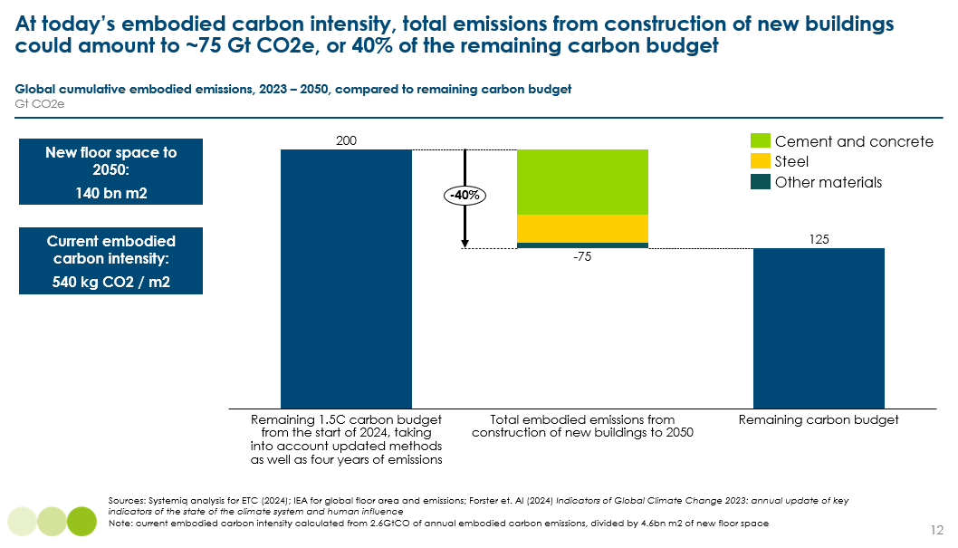
Finding ways to construct lower-carbon buildings is therefore imperative. Broadly, there are two main ways of doing this:
- Decarbonise the production of building material inputs (e.g., cement, concrete, steel, bricks, glass, aluminium) – discussed in 11.1.
- Reduce demand for high-carbon material inputs, by using materials more efficiently or substituting for lower-carbon materials – discussed in 11.2.
  - Decarbonising material production
In recent years, the Mission Possible Partnership have developed sector transition strategies for the heavy industrial sectors, outlining the suite of technologies that exist today to decarbonise the production of steel, cement, concrete and aluminium. These strategies have challenged the belief that it is not possible to fully decarbonise steel, cement and concrete by 2050, outlining industry-backed technically and economically feasible pathways using technologies available today.
The MPP strategies show that, while reducing demand is important, addressing process and production emissions is entirely possible and will have by far the biggest impact on mitigating emissions on the way to net zero. Exhibit 77 shows that decarbonising production accounts for 75-80% of total mitigation potential for cement, concrete and steel to 2050.
This section will outline some of the main insights from the MPP transition strategies for key materials.
Exhibit 77
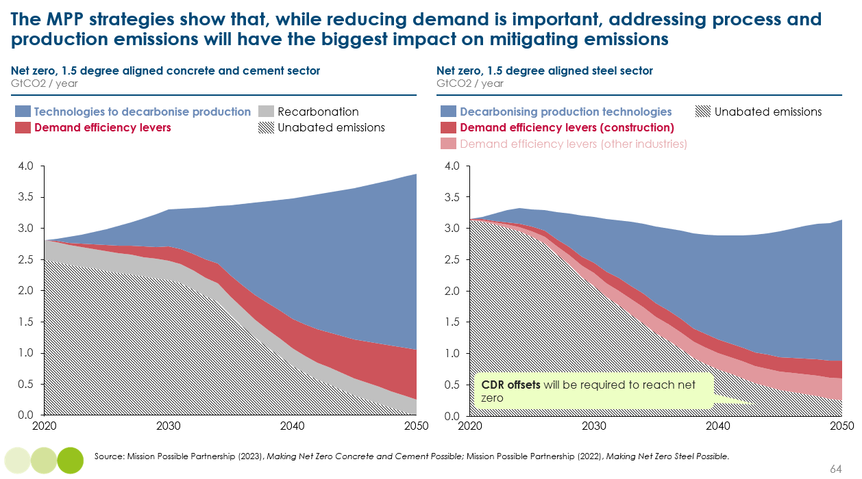
    - Cement and concrete
Cement is used in buildings because of its binding properties, and can be combined with gravel, sand, aggregates and crushed rock to form concrete. Around 85% of cement and concrete is used in buildings, and 15% in wider infrastructure. Across the entire built environment, the cement and concrete sectors account for around 7-8% of global CO₂ emissions. Despite energy efficiency improvements, in the absence of any further action, emissions are expected to grow by about 40% by 2050, driven by increases in demand.
The conventional concrete production cycle starts with the manufacturing of clinker, which is an intermediary product produced out of extracted limestone and clay. This raw material mix is then heated at very high temperatures to ensure it hardens with the addition of water (a key cement-inherent characteristic). This produces CO₂ emissions in two ways:
- Process emissions: CO₂ is generated by the calcination of limestone (CaCO3) into lime (CaO) and CO₂. This accounts 53% of the total emissions in the concrete-making process.
- Production emissions: CO₂ is also generated by burning fossil fuels to reach the 900°C required for calcination and 1,450°C required for clinkerisation. This accounts for 35% of the emissions in the concrete-making process. The predominant fuels currently used in clinkerisation are coal and petroleum coke (petcoke) (82%). Other fuels include natural gas (9%), industrial wastes (6%), and biogenic waste (3%).
Other emissions (around 12%) come from direct and indirect fossil fuel use to power machinery and transport. Cement, however, does also reabsorb some CO₂ from the air over its lifetime, offsetting some of the carbon emissions from its production. Across all types of concrete, a conservative estimate is that 10% reduction in total concrete emissions are reabsorbed. Overall, producing a tonne of cement produces around 0.6 tCO₂ and concrete produces an additional 0.1 tCO_{2.}
The concrete and cement sector is often labelled as ‘hard to abate’ for three key reasons:
- Process emissions: Because CO₂ is released through a chemical reaction, it cannot be eliminated by increasing efficiency or changing fuel – without using carbon capture (CCUS) this process cannot currently be decarbonised.
- High kiln temperature: To date is has been technically challenging to fully decarbonise high-temperature heating processes with alternative fuels.
- Highly localised markets: Concrete and cement are bulky, low-value products, rarely economical to transport over long distances. Because they are usually produced close to their use (less than 50 km for concrete and 250 km for cement), decarbonisation depends on local resources and infrastructure, with limited significant relocation of industrial sites. Region-specific decarbonisation pathways are therefore critical.
However, the MPP strategies evidence that decarbonisation is feasible with technologies which are available today. Exhibit 78 shows that there are three main areas of action, each involving a range of technologies (e.g., CCUS, less emission-intensive supplementary cementitious materials such as limestone, fly ash or slag from new green steel production, and alternative chemistries), underpinned by clean electrification. Decarbonising material production by addressing process and production emissions can deliver 80% of the emissions mitigation potential, but will not be sufficient to reach net zero by 2050. Doing so requires a suite of actions to reduce demand through material efficiency and substitution, which we explore in detail in Section 11.2.
Exhibit 78
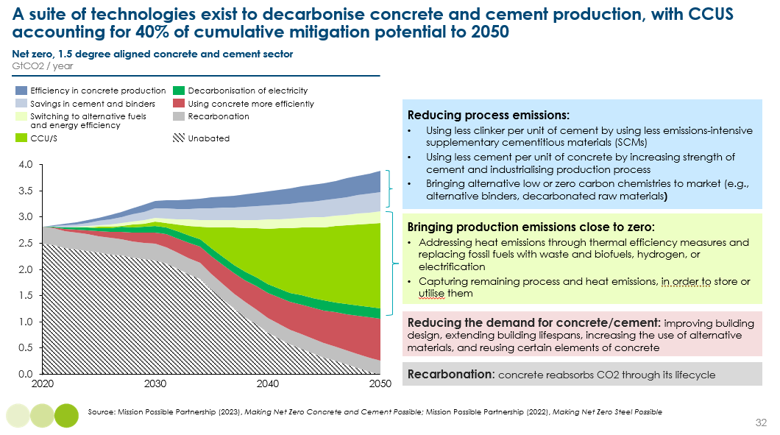

    - Steel
Globally and across all sectors, the production of primary and secondary steel accounts for around 7% of global emissions, or 3.1 GtCO₂e. The built environment drives around 50% of steel use by mass, but is also used widely across other sectors including automotives, electrical and mechanical equipment, and will play a critical role in producing wind turbines and EVs for the energy transition. Different types of steel satisfy these different uses; rebar – reinforced steel used in concrete - is the most common steel used in buildings, and has an embodied carbon intensity of ~2 kgCO₂/kg.,
Today, nearly all the world’s steel is made through one of three main production routes:
- Blast furnace–basic oxygen furnace (BF-BOF): Iron ore is reduced in the blast furnace to molten iron, which is subsequently refined to crude steel in the basic oxygen furnace. The reduction reactions and refining process require temperatures in the range of 1,100°C to 1,600°C, currently achieved with fossil fuels. About 70% of the world’s steel was produced via this process in 2020, which emits an average of 2.1 tonnes of CO₂ per tonne of crude steel (t CO₂/t CS).
- Electric arc furnace (EAF): The EAF route, accounting for 25% of global production in 2020, uses electricity to melt scrap steel. Depending on scrap availability and plant configuration, other sources of metallic iron such as direct reduced iron (DRI) or hot metal can also be used. Emissions are highly dependent on the carbon intensity of the electricity supply but are on average 0.5 t CO₂/t CS.
- Direct reduced iron–electric arc furnace (DRI-EAF): the process of reducing iron ore without melting it, using a reducing gas (typically a blend of hydrogen and carbon monoxide derived from natural gas). The solid product, iron, is mainly used as feedstock in an EAF to produce steel. About 5% of the world’s steel is produced via this process, which emits 1.2 t CO₂/t CS on average when using natural gas.
The steel sector can decarbonise by reducing demand for primary steel and by changing the way steel is made. A portfolio of solutions is needed to decarbonise steelmaking because different technologies will be cost-competitive in different locations. Exhibit 79 shows the MPP estimates of the relative global importance of different technologies; note this is an average for all types of steel.
The next chapter will discuss demand efficiency levers in more detail, but it is important to note that material recirculation (i.e. using scrap steel) will play an important role both by reducing demand for primary steel (see chapter 11.2) and as in input to primary steel making which can lower the carbon intensity of production by reducing the need for iron ore and energy inputs [Exhibit 79].
Avoiding production emissions is centred on utilising zero-carbon electricity to power electrolyser and electrowinning ironmaking technologies, and green hydrogen as a clean feedstock for producing DRI. Steelmaking technologies can also be near-zero emissions using CCUS technologies affixed to fossil fuel power generation assets that supply energy to steel plants, as well as to emissive process equipment such as natural gas DRI plants and coal-fed blast furnaces.
As with cement, realising significant emissions mitigation this decade will be challenging for the following reasons:
- The cost of near-zero-emissions primary steelmaking facilities could be up to 90% higher than conventional plants over the next decade. The steel industry operates in a highly globalised and commoditised wholesale market, meaning even small increases in the costs faced by steelmakers can weaken their market competitiveness.
- While technologies are known and technically proven, they are still on the cusp of reaching commercial scale. However, industry leaders such as SSAB are committing to bringing fossil-free steel to the market by 2027.
- Lengthy asset lifetimes of 20-40 years meant that not all steel plants will be eligible for a low-carbon refurbishment in the coming decade (and those plants that are eligible risk being locked into carbon-intensive pathways if alternative technologies are not available in time).
This highlights the importance of maximising the potential to reduce demand for steel in the first place (see chapter 11.2), as well as strong policy support towards steel decarbonisation.
Exhibit 79
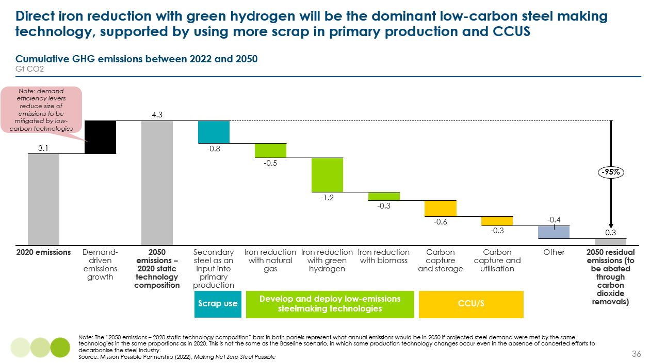

    - Aluminium, bricks and glass
Cement, concrete and steel account for 95% of embodied emissions from construction; the remaining 5% is driven mainly by aluminium, glass and bricks. In these sectors, clean electrification is the biggest lever to decarbonising material production. For aluminium, low-carbon power means 70% of emissions can be mitigated by 2035. For glass, fuel switching to electricity and grid decarbonisation could account for 85% of emission mitigation. However, achieving net-zero aluminium by 2050 still will not be possible without demand efficiency levers.

  - Demand efficiency levers: material efficiency, substitution and building less
The previous section evidenced that technologies to decarbonise the production of key building materials that exist today can account for 75-80% of total mitigation potential to 2050. However:
- It will not be economically feasible to reach net-zero with low-carbon production technologies alone by 2050.
- Many of these technologies, while technologically proven, are still on the cusp of reaching commercial scale and so will not achieve significant emissions mitigation until the mid-2030s.
Given the crucial need to reduce global emissions by XXXX% by 2030 for a 50% chance of limiting warming to 1.5ºC, and the need to reduce locked in carbon from new construction, reducing the demand of material inputs will need to play a critical role in the construction sector’s transition.
Exhibit 80 shows that the biggest opportunity to reduce embodied carbon is in the design stage, with decisions about whether to build at all. Without restricting living standards, this could be achieved by re-using or extending the lifetimes of existing buildings, by better urban planning to reduce overall built environment construction (e.g., roads and other public infrastructure), or by optimising the use of buildings (e.g., shared working spaces). However, solutions to build less are much harder to implement and Exhibit 81 shows that, on aggregate, “building less” will have a smaller overall impact on reducing material demand.
For buildings which are constructed, this chapter will discuss the suite of solutions to “building clever” which will play a significant role in decarbonising construction by reducing material intensity and substituting high-carbon materials. It will also explore efficient construction methods and circularity approaches which can streamline the actual construction process and reduce waste (“build efficient”).
Altogether, these demand efficiency strategies have the potential to reduce cumulative demand for cement, concrete and steel by 30-35% by 2050.
Exhibit 80
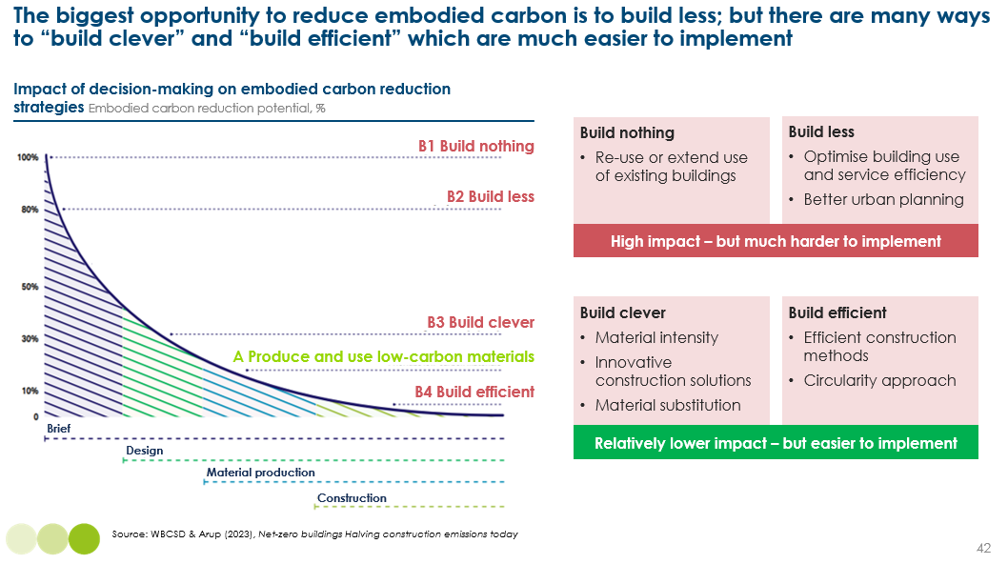
Exhibit 81
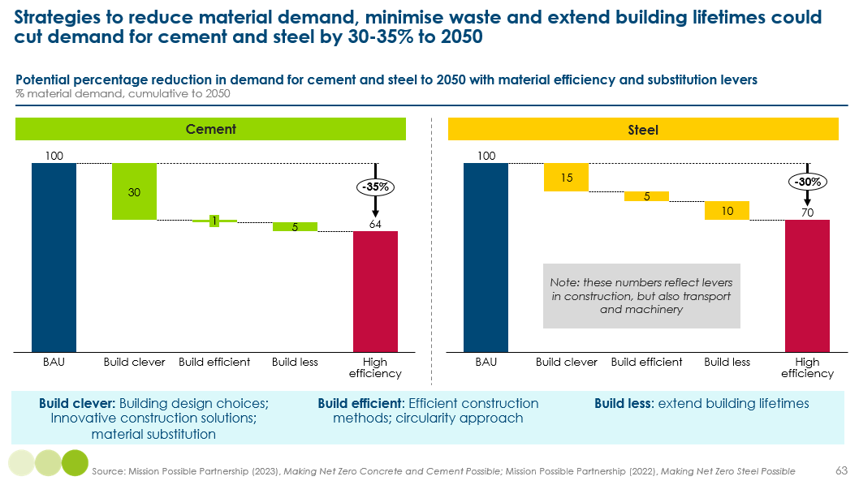

    - Build clever: material intensity and substitution
Reducing material intensity through different building design choices and innovative construction techniques, and substituting for lower-carbon materials can reduce cumulative cement and concrete demand by 15-30% and steel demand by 15% to 2050. The suite of options available to a particular development will vary significantly depending on the nature of the building, know-how and awareness, regulation and cost.
Drawing heavily on research by the World Green Buildings Council and Arup, this section details some of the key considerations for architects, developers and builders:
- In the brief stage, the embodied carbon of different building archetypes should be a key decision factor, with taller multi-story buildings typically having a much higher carbon intensity as they require more material for structural support [Exhibit 82]. Similarly, siting buildings in areas where ground elevation and soil conditions require relatively smaller foundations can reduce embodied emissions.
- In the design stage, architects should look to maximise floor efficiency (i.e. how much of gross construction area is useable by tenants) and minimise the wall-to-floor ratio [Exhibit 82].
- Architects and tenants should work together to optimise the use of buildings to enable lower embodied carbon, for example locating heavy equipment on ground floors to reduce material required to develop suitable upper floors (e.g., heavy hospital equipment such as MRI machines on ground floors).
- With the majority of embodied carbon often in the floor systems, architects should explore different ratios of steel, concrete and timber that can reduce high-carbon material use. Different construction techniques, such as tree-column floor systems, can also reduce embodied carbon relative to standard floorplate systems by 15-20%.
- Maximise the incorporation of passive heating and cooling techniques (see Chapters 2 and 3) which have a minimal impact on embodied carbon, such as orientation, airtight construction and low-carbon material insulation (e.g., natural fibres).
Exhibit 82
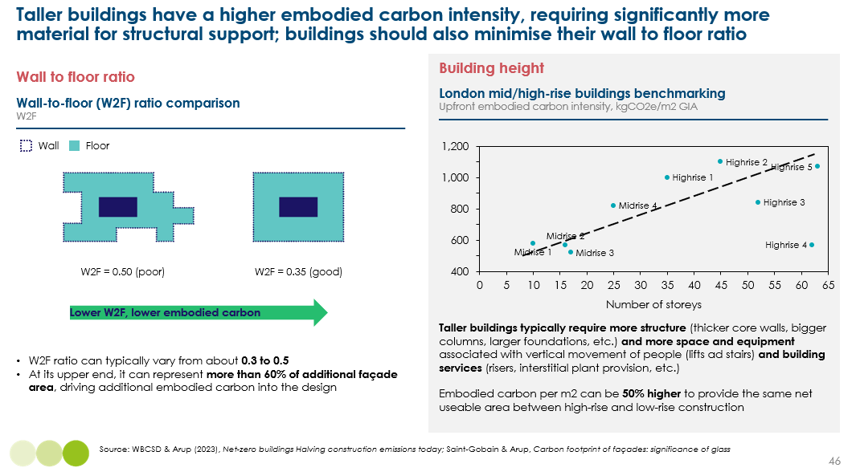
There is also a big opportunity to substitute the use of high-carbon steel, cement and concrete for lower-carbon alternative materials [Exhibit 83]. In addition to having a much lower carbon intensity, bio-based materials such as timber, bamboo and hempcrete are able to sequester carbon and store this during their use in buildings, meaning they have the potential to be carbon neutral or even carbon negative – as long as they are dealt with properly at end of life [Box 13].
These materials cannot be used in all cases or construction projects (e.g., timber is only suitable for low- to mid-rise buildings), but where applicable can typically offer similar stability, safety and durability. It is important to ensure bio-based materials are properly treated to prevent issues of moisture and insect infestation, and ensure that supply is sustainably sourced, without contributing to additional land use change and deforestation.
In general, the lifetime costs of using bio-based materials is lower, as they as associated with lower maintenance and energy costs. The construction costs of building with bio-based materials have also been reported as 10-15% lower compared to a house built with concrete, but others report a 10-25% increase (although this is not solely due to materials but also the cost of implementing additional design considerations).
For these reasons, hybrid construction where, for example, timber is used to substitute a portion of steel, cement and concrete use is the biggest area of opportunity.
Exhibit 83 – note we are still checking the numbers in this exhibit – any feedback would be greatly appreciated
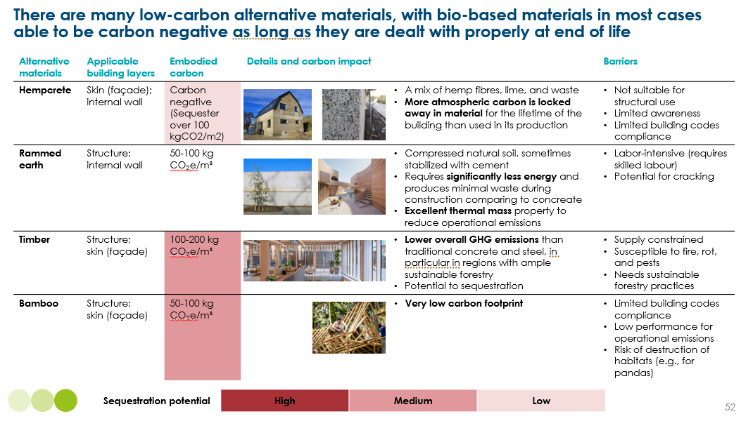
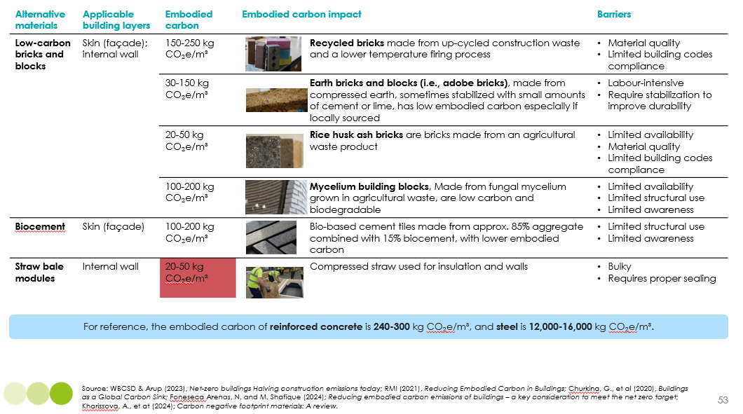

Box 13
The debate around the use of timber in construction
Mass timber refers to engineered wood products made from lumber, veneer, or wooden strands that are laminated together into massive structural elements such as panels, columns, and beams. Timber can offer the same structural, safety and durability as steel and cement in certain applications, but it is only a viable substitute in certain building archetypes (e.g., low- and mid-rise buildings), or around 40% of future construction.
It is important to note that the supply of sustainable timber is very limited due to competing demands for land, long lead times and growing demand for sustainable biomass across sectors. Currently, only 11% of timber today is certified as sustainably harvested and 85% of this is from Europe, North Asia and North America. As we explored in our Bioresources report, the demand for sustainable biomass in a net-zero economy will greatly exceed scenarios of maximum supply. It is crucial to prioritise use across sectors where it can be used as a material, in aviation, and in applications where it can be combined with CCS.
Where sustainable supply can be guaranteed, timber has a number of benefits, including:
- Prefabrication is easier for timber, leading to lower waste.
- Timber aesthetics mean that less additional material is needed (e.g., plaster, paint, drywall), saving on material and labour costs.
- Mass timber has high insulating capabilities, meaning less insulation material is needed.
- These features contribute to lower net construction costs; despite additional costs of sustainable sourcing (~5%) cost savings of up to 15% have been reported.
In general, timber has a lower carbon intensity than traditional steel and cement, but the exact carbon savings are heavily contested and depend on a range of factors. For example, lifetime carbon savings from substituting concrete by cross-laminated timber range from 10-15% to 60%. Exhibit 84 shows that the boundary between desirable and undesirable timber substitution is very complex and depends on various factors:
- The actual embodied carbon in timber can be up to five times higher when accounting for carbon in the tree that cannot be used for timber (bark, branches) and which is burned or left to rot.
- While timber has a high sequestration potential, replanted trees will take decades to re-sequester the emitted carbon.
- It is crucial to ensure trees are cut down at the right time in their life; cutting them down before end of life significantly cuts a tree’s sequestration potential.
- Without strict guidance, replacing concrete and steel with mass timber could become a net GHG-emitter.
Overall, timber should be explored as a material substitute to some high-carbon steel and cement use where negative lifecycle carbon emissions and sustainable supply can be guaranteed. Hybrid construction which offsets some steel and cement use with timber could play an important role in low-rise construction in certain regions with well-regulated sustainable timber industries. This requires the industry to develop a stronger consensus around how to measure and account for the carbon of timber and regulations about when to cut down trees and safety and durability.
Exhibit 84
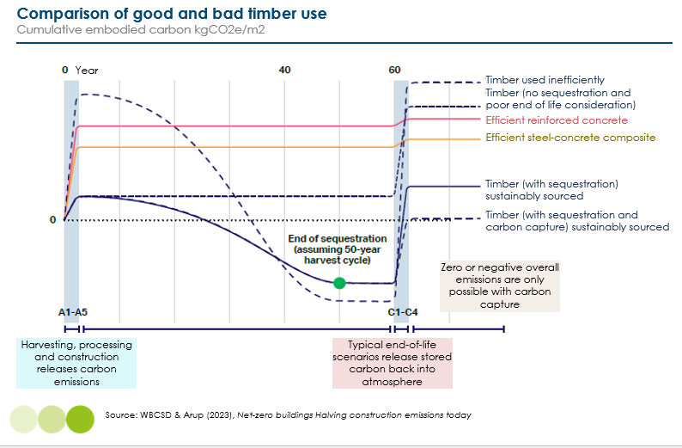

    - Build efficient: modular construction
A combination of efficient and circular construction has the potential to reduce global cumulative demand for cement and concrete by 1% by 2050, and by 5% for steel. However, impacts for individual construction projects can be significant. Key actions include:
- Modular construction, where parts of a building are made in a factory, shipped to site, and put together like big building blocks. This has the potential to reduce on-site waste by up to 90%, cut material consumption by 20%, and double the speed of construction. It also cuts transport related emissions, with fewer raw materials being bought to site.
- Digital tools to reduce waste in the design of buildings, including digital twinning, building information modelling systems, and 3D printing.
- Using robotics and drones to handle materials.
- On-site waste management to maximise the recovery of materials for recycling and re-use.
    - Build less: better urban planning
Extending building lifetimes and better urban planning have the potential to reduce global cumulative demand for cement and concrete by 5% by 2050, and by 10% for steel.
Building lifetimes vary massively across regions, from over 100 years in Europe, 50-60 years in the US, 30-40 years in Japan, and just 25 years in China. The potential to extend lifetimes is therefore heavily region specific. Extending building lifetimes should be a priority in parts of Asia, where poor urban planning during rapid urbanisation resulted in inadequate and inflexible buildings – and high demolition rates. Frequent demolition in Asia is often not due to poor construction quality, but due to evolving urban planning and land policies. This suggests a huge opportunity to get this right first time around. For poor quality housing with high operational energy requirements, there is less of an opportunity. Planning and investment should ensure building is designed with future uses in mind and material durability.
As outlined in Chapter 10, around half of global embodied carbon comes from constructing new infrastructure, such as roads, pipes and utilities. Better urban and spatial planning can therefore have a huge impact on reducing the need for additional public infrastructure and transport. The IPCC estimates that 25% of urban emissions could be saved by 2050, by making urban areas compact.
The key opportunity rests upon the concept of the ’15 minute city’, where all key public services should be accessible within 15 minutes. Capitalising on the potential to “infill” new building in existing settlements and promoting multi-unit dwellings is estimated to avoid 40% of emissions a year from new building in the EU. Multi-unit dwellings also use half as much heating energy as single-unit houses.
Policymakers and planners need to explore how to reach a sweet spot in efficiency and balance for a high quality of life, ensuring there is sufficient green space, investing sufficiently in public transport to prevent overcrowding, and promoting access to cooling to offset urban island heat effects.
    - Build nothing: making better use of existing buildings
As Exhibit 80 shows, the biggest opportunity to reduce embodied carbon comes from deciding not to build at all. However, it is crucial to ensure that policies to limit building do not also limit living standards; for example, ensuring that people in lower-income countries are able to experience an increase in sqm per capita. However, there are many strategies to reduce future construction without compromising wellbeing.
Exhibit 85 presents an ambitious scenario for reducing global floor space in 2050 by 15% by:
- Reducing residential floor space per capita in North America and Europe, given these regions have shrinking populations and high second home ownership.
- Tackling high vacancy rates in China (20% of buildings in most cities are not occupied) and high second-home ownerships (40% of Chinese urban households own two or more apartments). In many cases, new buildings in China will never be occupied and urban infrastructure in many third and fourth-tier cities massively exceeds future requirements.
- Making better use of space, for example through shared working spaces which recognise the increase in telecommuting post-COVID.
Realising this potential is, however, very challenging as it relies on fundamental lifestyle and behaviour changes. There is also very limited potential to reduce m2/capita in developing countries, as levels remain far below Europe/N America average.
Exhibit 85
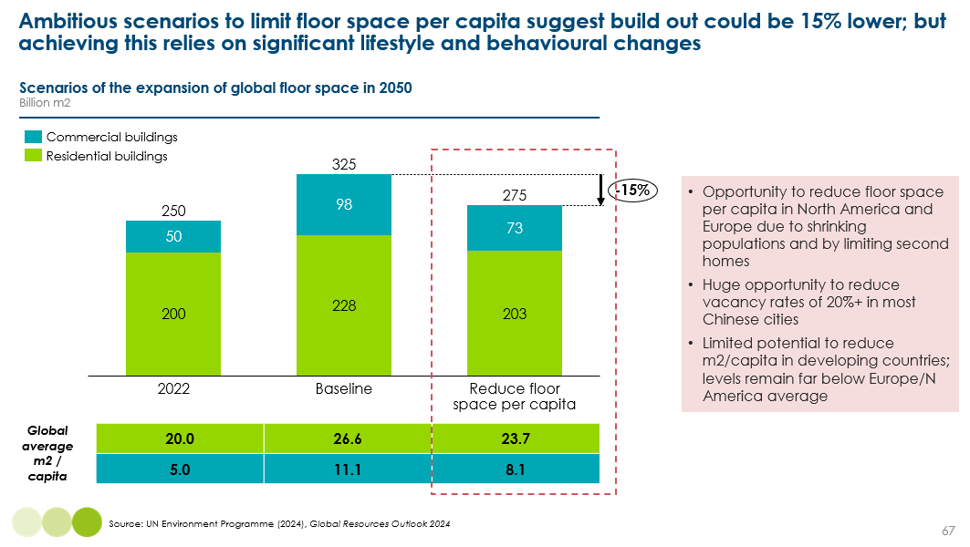

  - Implications for embodied carbon from new construction
Putting pathways to decarbonise material inputs and opportunities to reduce demand for materials together suggests that the total embodied carbon from the construction of new buildings to 2050 could be 60% lower with ambitious action [Exhibit 86]. Around 30 GtCO₂ could be produced, compared to 75 GtCO_{2.} This would use up 15% of the world’s remaining carbon budget to limit warming to 1.5ºC, compared to 40%. This is a huge saving, which highlights the critical importance of policy and industry action this decade to accelerate action (Chapter 13).
The estimates for reducing demand for materials include the potential to build clever, build efficient and build less. As outlined in 11.2.4, embodied carbon from new construction could be even lower with ambitious action to actually build less in the first place; although this is much more challenging to achieve in practice.
Exhibit 86
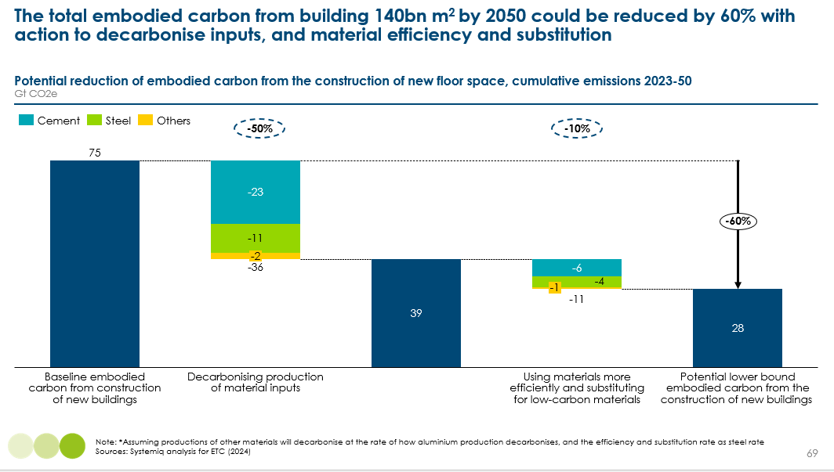

- Use phase and end-of-life embodied carbon
Key messages:
- From a whole-life carbon perspective, it is crucial that retrofits lead to an improvement in energy performance; currently in the EU, only 5% of commercial building retrofits lead to energy savings of more than 3%.
- As the grid decarbonises, it will take longer for embodied carbon to be offset by operational emissions over time, creating a more challenging carbon case for retrofitting. However, there is still a very strong social business case for improving the quality of housing and living standards.
- Energy efficiency improvements to the least efficient buildings should be prioritised this decade, realising greater emission savings of high-carbon electricity use, and improving living standards.
- While the embodied carbon associated with extending buildings is far lower than rebuilding, where rebuilding is done to very high design and material standards, maximising opportunities to use low-carbon materials and incorporate passive heating/cooling, it can be preferable from a lifecycle emissions perspective.

Buildings will be retrofitted with new materials and technologies over time, resulting in additional embodied emissions over its use. Of the building layers, the structure of a building will typically last over 60 years, while its skin will need replacing or updating every 30-35 years, services every 20-30 years, and space plan every 10-30 years. This chapter explores the embodied carbon of retrofitting buildings, and what to do with buildings at end of life. As a reminder, these account for about 25% of total embodied emissions over a building’s lifetime [Exhibit 73].
  - Embodied carbon of retrofits
Buildings can be retrofitted to improve comfort, aesthetics and energy efficiency. However, currently in the EU, only 5% of commercial building retrofits lead to energy savings of more than 3%. From a whole-life carbon perspective, it is crucial that retrofits lead to an improvement in energy performance, ensuring that embodied carbon is offset by avoided operational emissions [Exhibit 87]. The challenge is that, as the grid decarbonises, it will take longer for embodied carbon to be offset by operational emissions over time, creating a more challenging carbon case for retrofitting. As discussed throughout this report, however, there is still a very strong social business case for improving the quality of housing and living standards.
Exhibit 87
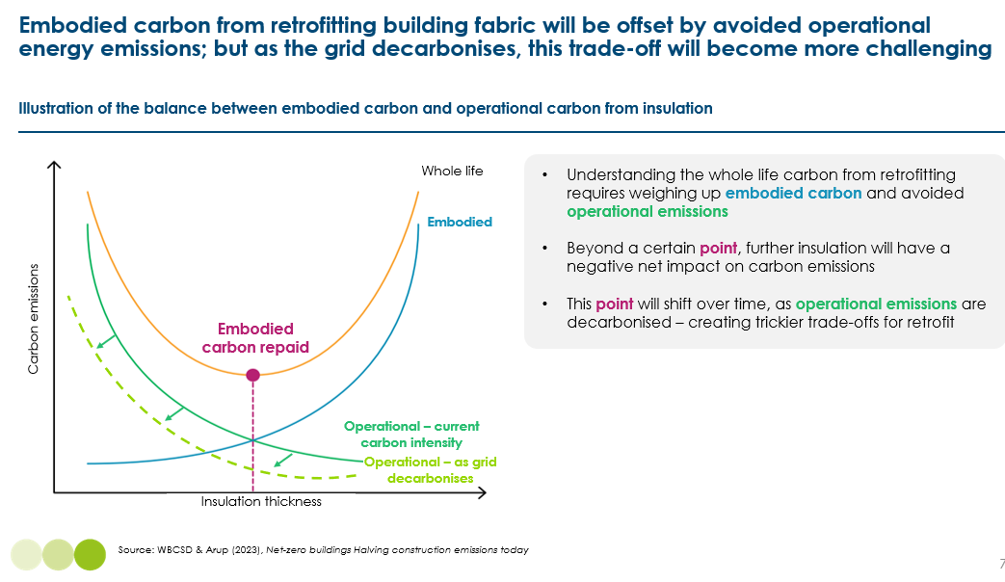
Exhibit 88 presents some illustrative examples of how many years it takes the embodied carbon of different retrofits to be paid back in avoided emissions from lower electricity use. At today’s current grid carbon intensities of 300-600 gCO₂/kWh (i.e. US, Germany, China), even deep retrofits will repay their embodied carbon in under 5 years, or 10-15 years in countries like France and Finland with grid intensity at 75 gCO₂/kWh. However, as grids decarbonise, for example to 10 gCO₂/kWh, it will take 50-100 years to repay the embodied carbon.
This does not mean that retrofits should be deprioritised as we decarbonise electricity. Instead, it suggests the following policy priorities:
- Prioritise energy efficiency improvements to the least efficient buildings this decade, realising greater emission savings of high-carbon electricity use, and improving living standards.
- Prioritise lower-carbon materials (e.g., natural fibres). There are a wide variety of different materials which can be used for insulation, from woodwool boards and glass fibre, which have a carbon intensity of around 1-1.5 kgCO₂/kg, to polystyrene and polyurethane, which are more carbon intensive at 2.5-3.5 kgCO₂/kg.
- Use materials with recycled content and select materials for durability, which last longer and reduce the frequency of retrofit.
Exhibit 88
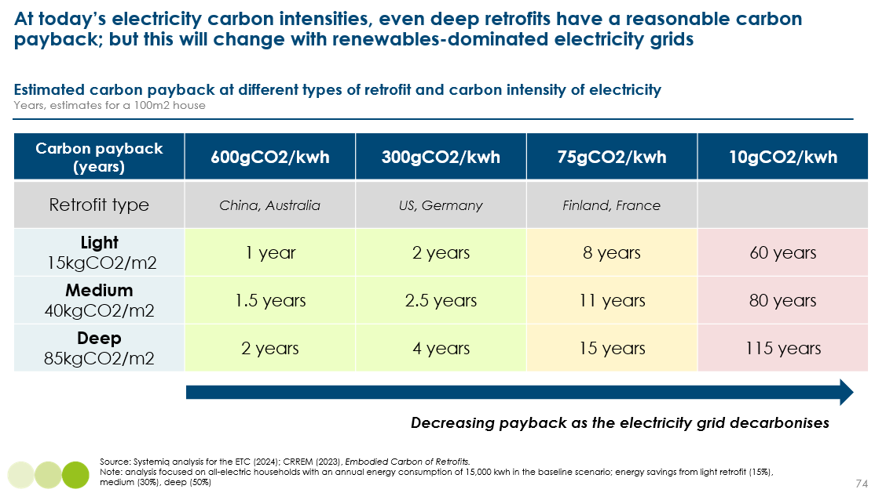
  - Retrofitting or rebuilding at end of life
Embodied emissions relating to the end of a building’s life account for the smallest share of its total lifecycle emissions, less than 5%. These emissions relate from various sources, including the energy used to power demolition machinery, to transport debris, to recycle materials, and from the waste processing. These emissions can be reduced with the electrification of transport and industry, and with careful waste management strategies to properly deal with timber and other bio-based materials at end of time, preventing them being burned or decomposing and releasing sequestered carbon.
The key question relating to buildings at end of life is whether is it better, from a carbon perspective, to extend a building’s lifetime by retrofitting or to rebuild to much higher embodied and operational carbon standards. There will be no one-size-fits-all answer to this question and heavily depends on the standards to which a building is built.
Exhibit 89 shows that, in some cases, lifecycle emissions from rebuilding can be the same as retrofitting. While the embodied carbon associated with extending buildings is far lower than rebuilding, where rebuilding is done to very high design and material standards, maximising opportunities to use low-carbon materials and incorporate passive heating/cooling, it can be preferable from a lifecycle emissions perspective. This case study highlights the importance of considering and measuring lifecycle emissions (see Chapter 13).
Exhibit 89
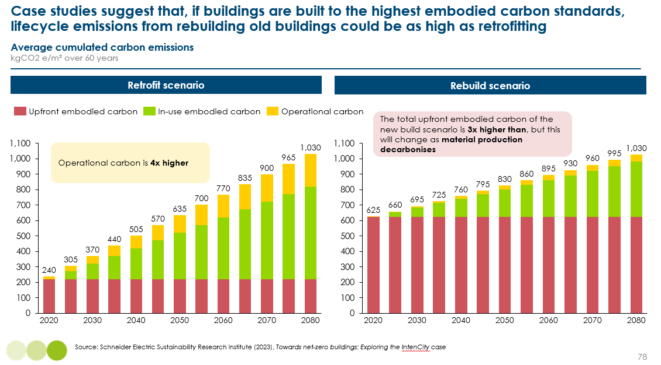

- Actions to bring embodied carbon to the fore
Embodied carbon is often overlooked by policymakers, developers, investors, builders and tenants. Chapters 10-12 have outlined the significant opportunity to reduce locked in embodied carbon from the 55% increase in global floor area to 2050. Realising this potential, however, currently faces a number of barriers:
- Embodied carbon is not very well understood, with lifecycle emissions traditionally not being assessed, measured or tracked. There is currently no consensus on what good embodied carbon benchmarks are across regions and building archetypes. Key challenges include the lack of a standardised assessment approach and challenges tracing and verifying the emissions associated with materials from global supply chains.
- This means transparency and market demand signals for low-embodied carbon buildings are weak. There is little evidence today that good performance on embodied carbon translates to higher asset value, attracts a lower cost of capital, or that tenants are willing to pay more for it.
- There is a lack of awareness of and skills to deploy the various demand-side strategies that can reduce material demand and costs, and of the potential pathways to decarbonise steel, cement and steel.
- Embodied carbon receives relatively little policy and regulatory focus to date and it is currently challenging to make a strong business case for action with high perceived and, in some cases, actual material and labour costs.
The cost of low-carbon steel, cement and concrete are expected to be 100%, 40-120%, and 15-40% higher, respectively, without strong policy support. However, it is important to understand that these higher material costs will only add 1.5-3% to the cost of construction. To some extent, this cost premium of low-carbon material inputs will incentivise developers to explore the suite of strategies to lower their demand for materials (Chapter 11.2). However, these strategies also come with their own cost barriers, as they are more complex and labour-intensive.
Embodied carbon is rising up the policy agenda. At COP28, the Buildings Breakthrough was launched, as part of the Breakthrough Agenda at COP26. 28 governments, including China and the US set commitments to reduce embodied carbon in new construction projects by at least 40% by 2030. Industry groups are also beginning to set voluntary commitments to reduce embodied carbon. The World Green Buildings Council’s Net Zero Carbon Buildings Commitment to reduce embodied carbon from new buildings and major renovations by 40% by 2030 has 176 signatories of ~$400 bn annual turnover. The Better Buildings Partnership has 37 asset managers and investors, which have committed to publishing their net zero transition plans, including embodied carbon, which will be supported by the development of new buildings sector science-based targets guidance.
Concerted action by policymakers and industry is needed to achieve and go beyond these targets. This chapter will focus on the actions needed to drive awareness and consideration of embodied carbon; it will not detail the full suite of actions needed to accelerate the decarbonisation of steel, cement and concrete, which are described in detail in the MPP’s sector transition strategies.
  - Actions for policymakers and industry
The most crucial action to underpin both regulation and voluntary commitments is greater transparency and data on embodied carbon. It is critical that developers, policymakers, and financial institutions begin developing robust databases of embodied carbon across new construction projects this decade:
- The first step is for regulation to require all new construction and large renovations to complete lifecycle carbon assessments, with data collected by national authorities as part of planning permission. In London, this regulation has completed transformed transparency in the sector, with favourable finance rates already being attached to lower embodied carbon projects in just a few years [Box 14].
- Industry and policymakers should work together to develop clear guidance and frameworks to measure embodied carbon. Given the absence of a clear approach today, there is a huge opportunity for international collaboration to ensure harmonisation and comparability across countries.
- Ideally, collected data should be open source, enabling the industry to develop a much clearer idea of what good looks like and set targets accordingly.
Having clearer benchmarks for ambitious levels of embodied carbon will enable:
- Voluntary commitments from large developers and from commercial businesses who’s buildings account for a large share of their scope 1 and 2 emissions (e.g., hotel and retail chains, professional services) to build ambitious low-embodied carbon new buildings.
- Green building certifications, which are currently dominated by a focus on operational carbon, to develop clear criteria and benchmarks for embodied carbon and lifecycle emissions.
- Regulation to begin setting minimum requirements for lifecycle emissions, being careful to sufficiently differentiate across different building types [Exhibit 90].
While regulation needs to play a role, setting minimum standards will be much harder than for operational carbon, where clearer benchmarks and measurement exist. For embodied carbon, there are many complex trade-offs (e.g., with safety, operational energy, durability) and regulation needs to ensure it does not create unintended consequences. If regulation is too specific, it can be a barrier to innovation. Rather than being too prescriptive, it should focus on mandating carbon intensities for material inputs, including minimum recycled content for material inputs, and requiring all new buildings undertake whole lifecycle emission assessments.
Box 14
TO ADD CASE STUDY:
- Embodied carbon assessment regulation in London
- Potential for rapid change and progress to be made
- Transparency and data crucial to transform market
- Seeing green finance begin to attach a value to embodied carbon

Exhibit 90
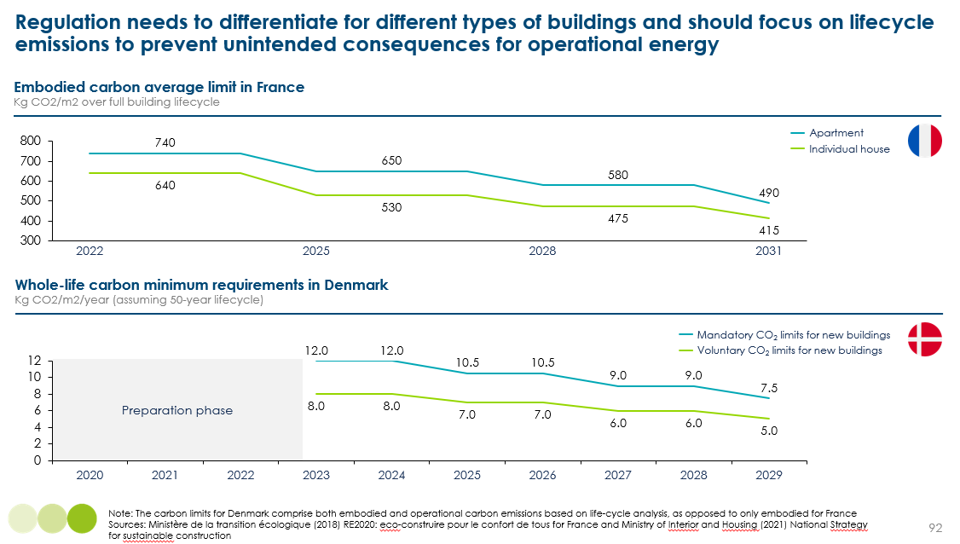

Section C: Actions for policymakers and industry

Note: this section is still being drafted, but please see below for an outline of our high-level thinking.

Key actions / strategic priorities
- Set out a clear national vision for the building energy transition, supported by local street-by-street delivery plans
- Underpin incentives for, and trust in, clean, electric technologies
- Create strong frameworks and standards for measuring and reducing whole-life carbon of new buildings
- Manage new and peaky electricity demand with flexible and efficient buildings
- Deliver a fair and just transition for households

Set out a clear national vision for the building energy transition, supported by local street-by-street delivery plans
Policymakers
  - Targets for heat pump deployment + training
  - Clear bans on fossil fuel heating and cooking
    - Bans in new buildings – 2025 in high-income countries
    - Bans on the sale of new fossil fuel boilers – 2035 in high-income countries
    - Timeline to switch off sections of the gas grid over time and reduce levels
  - Street-by-street decarbonisation strategies
    - Zoning for district heating and networked heat pumps
    - Local and regional planning needs to be in sync with national level policy
  - Timelines for the increasing scope and stringency of building codes
Industry
  - Voluntary commitments to
    - Reduce financed emissions from buildings
    - Reduce embodied carbon of new builds
    - Build new builds to much higher efficiency standards
    - Decarbonise building stock and invest in energy efficiency (e.g., hotel chains and professional services companies)
Underpin incentives for, and trust in, clean, electric technologies
Policymakers
  - Create demand for low carbon technologies
    - Quantitative mandates
    - Green procurement
  - Rebalance gas and electricity prices – shift levies to gas or general taxation
  - Power market design to drive electrification and enable consumers to benefit from low-cost renewables (e.g., time of use tariffs)
  - Time limited subsidies for heat pumps, clean cooking and energy efficiency improvements
  - Education and awareness of the benefits
  - Local demonstrations of heat pumps and electric cooking
Industry:
  - Voluntary commitments to increase sales of heat pumps and capitalise on opportunities to for early demand from energy-savvy and conscious consumers
  - Invest in quality training of heat pump installers, for example collaborating with governments in specific training courses and schools
  - Financial institutions to design products to increase access to finance (e.g., mortgage top ups for heat pumps and insulation, or models which provide loans against future bill savings)
  - Industry collaboration to fund networked heat pumps
  - Innovation to reduce heat pump capex costs
  - Scale up low-carbon material markets

Create strong frameworks and standards for measuring and reducing whole-life carbon of new buildings
Policymakers
  - Improve the ambition and enforcement of building codes (e.g., increase kWh/m2 requirements towards the level of green building certifications over time)
  - Regulation to play an education role in lower income countries (e.g., prescriptive building designs and considerations)
  - Integrate whole-life carbon assessment into building codes and regulation
    - Develop frameworks to define and measure embodied carbon
    - Harmonisation of these across countries
Industry:
  - Improve the transparency of green building certifications
    - Publicly available targets and assessments
    - Measure performance using actual, not modelled, data
    - Science-based targets

Manage new and peaky electricity demand with flexible and efficient buildings
Policymakers
- Power market design and regulation (e.g. time of use pricing)
- Investment and incentives for insulation, rooftop solar and batteries, storage, smart systems – though many likely to have positive paybacks
- Minimum energy performance standards and regulations on labelling for appliances, lighting and heating/cooling technologies
Industry
- Scale up the provision of time of use pricing and deployment of smart meters
- Promote education and behaviour change
- Improved energy efficiency labelling

Deliver a fair and just transition for households
Policymakers
- Targeted financial support for low-income households (e.g. for heat pumps, insulation)
- Investment in social housing energy efficiency improvements
- Better urban planning to reduce urban island heat effects
- Forward planning for any gas grid shut off
- Minimum energy performance standards for rental properties
- Education and awareness of low-cost and DIY passive heating and cooling, and of cleaner cooking fuels
Industry
- Industry engagement and forward planning for any gas grid shutoff
- Utility companies to support vulnerable customers with financial support and advice on energy efficiency upgrades

Annex 1: Heat pumps
To be drafted
- Technical explanations of how heat pumps work
- Explanation of efficiency and COP

ETC (2024), Fossil Fuels in Transition: Committing to the phase-down of all fossil fuels
Systemiq analysis for the ETC; BNEF (2023), New Energy Outlook 2022; IEA, World Energy Outlook 2022.
We have previously evidenced the potential to electrify building heating in our 2021 Making Clean Electrification Possible report, the global investment required to decarbonise buildings in our 2023 Financing the Transition report, and developed scenarios for the decline of direct fossil fuel use in buildings in our 2023 Fossil Fuels in Transition report. The Mission Possible Partnership (MPP) has also developed detailed sector transition strategies to decarbonise cement and concrete, steel and aluminium. While buildings is a key source of demand for these materials, these strategies are broader than just the buildings sector.
Active heating/cooling systems refer to the use of mechanical equipment regulate indoor temperatures (e.g., heat pumps, AC). Passive solutions rely on natural elements such as the sun and a building’s envelope to maintain a comfortable indoor temperature.
ETC (2024), Fossil Fuels in Transition: Committing to the phase-down of all fossil fuels
COP28 UEA, Global Renewables and Energy Efficiency Pledge
Half of the world’s habitable land is used for agriculture - Our World in Data
IEA (2023), World Energy Outlook 2023.
TUOB refers to the use of solid biomass (e.g., wood, wood waste, and charcoal) with basic technologies (e.g., open fires and basic stoves).
IEA (2023), World Energy Outlook 2023.
Systemiq analysis for the ETC (2024).
OECD database
Wenyi Zhang (2024), Composition of residential buildings in Shanghai 2022, by type.
European Commission; Directorate-General for Energy for Europe; NREL.
Eurostat, 2021 for Europe. US Census, 2022 for US.
Eurostat; US Department of Housing and Urban Development.
Systemiq analysis for the ETC (2024), based on average fuel use per household per year.
Jan Rosenow (2024), A meta-review of 54 studies on hydrogen heating.
Ibid
IEA (2021), Global Hydrogen Review 2021; IEA (2023), Global Hydrogen Review 2023.
Third pilot of household hydrogen heating shelved by UK government | Hydrogen power | The Guardian
Regulatory Assistance Project (2022), A policy toolkit for global mass heat pump deployment.
Ibid.
Carbon Brief (2024), 18 misleading myths about heat pumps.
IEA, Heat Pumps Overview, Available at: https://www.iea.org/energy-system/buildings/heat-pumps. [Accessed 29/07/2024]
Based on ETC interviews with experts across the technology and buildings landscape.
The main innovation has been working out how to safely use propane (known as R290).
District Heating - Energy System - IEA
Buildpass (2020), The 5 fundamental principles of passive house.
Wholesale costs for clean technologies are very uncertain; we have assumed 50% of retail prices.
For example, see Eyre, N., et al. (2023), Fabric First: Is this still the right approach?
For example, see Passivhaus Trust (2024), The right time for heat pumps: decarbonising home heating in a staged retrofit; Pehnt, M., et al. (2023), Lowering flow temperatures is key in the switch to efficient clean heat; Nesta (2024), Insulation impact: how much do UK houses really need?
Cornwall Council and Etude (2024), Cornwall Housing Decarbonisation Strategy.
Arup (2023), Report for the National Infrastructure Commission and Ofgem: Future of Great Britain’s Gas Networks.
IEA (2023), Energy Technology Perspective 2023. Figures as of August 2023.
With home electricity meters being unable to separate electricity use for heating vs other appliances, the tax rate is lowered for electricity use above 4,000 kWh.
Mitsubishi Electric (2023), The Future of Residential Heating in Britain.
Regen (2024), Electrification: The local grid challenge.
Systemiq analysis for the ETC (2023), IEA (2022), The Future of Heat Pumps.
Nesta (2022), How to scale a highly skilled heat pump industry.
The 1GtCO₂ emissions relates just to fossil fuel use to generate electricity. As we explore in Chapter 8, refrigerant leakage and venting from AC also contributes to global warming and is an overlooked issue.
IEA (2019), Helping a warming world to keep cool.
IEA (2018), The Future of Cooling.
Note that dehumidifiers actually increase the temperature of a room as they produce hot air to operate; however, the benefits of lower humidity outweigh the increase in temperature.
Cooling - IEA
IEA (2019), Helping a Warming World to Keep Cool.
ibid
IEA (2023), World Energy Outlook 2023.
Systemiq analysis for the ETC (2024); IEA (2023), World Energy Outlook 2023; BNEF (2023), New Energy Outlook 2022.
Salamanca, et al. (2014), Anthropogenic heating of the urban environment due to AC.
IEA (2018), The Future of Cooling.
ibid
ibid
CLASP (2023), China’s MEPS Lead to Major AC Market Transformation.
IEA (2023), Keeping cooling in a hotter world.
UE EIA (2020), Residential Energy Consumption Survey; Odyssee-mure (2023), Sectoral profile – households; Lawrence Berkeley National Laboratory (2004), A Tale of Five Cities: The China Residential Energy Consumption Survey; Guo et al. (2022), Extreme temperatures and residential electricity consumption: Evidence from Chinese households; Energy Informatics (2022), Investigation on air conditioning load patterns and electricity consumption of typical residential buildings in tropical wet and dry climate in India.
National Renewable Energy Laboratory (2017), Residential Indoor Temperature Study.
The IEA’s Net Zero Scenario assumes a temperature limit of 24ºC on AC.
Cool Coalition (2023), Indonesia’s Cool Roofs Champion.
IEA (2023), A Vision for Clean Cooking Access for All.
An induction hob is a type of electric hob that uses electromagnetic energy to directly heat cookware, as opposed to the entire hob; this makes them more efficient.
IEA (2023), SDG7: Access to electricity.
Lighting, appliances, and refrigerators require steady amounts of electricity over time whereas cooking requires high amounts of energy for limited amounts of time.
LPG is produced during oil refining or extracted from oil and gas reservoirs.
IEA (2023), A Vision for Clean Cooking Access for All.
Ibid
IEA (2023), World Energy Outlook 2023.
Our World in Data (2023), Carbon intensity of electricity generation.
CLASP (2024), Net Zero Heroes: Scaling Efficient Appliances for Climate Change Mitigation, Adaptation & Resilience.
IEA (2023), World Energy Outlook 2023.
IEA (2021), Net Zero by 2050.
IEA/4E TCP (2021), Annual energy reduction in new-product energy consumption from EES&L programmes.
Durand et al. (2024), Environmental assessment of used refrigerating appliances: Why does an import ban make sense and what could other countries learn from Ghana?
IEA (2021), Net Zero by 2050.
CLASP (2024), Net Zero Heroes: Scaling Efficient Appliances for Climate Change Mitigation, Adaptation & Resilience.
IEA (2016), Energy Efficiency Market Report 2016.
LED Lighting | Department of Energy
ibid
IEA (2023), Global residential lighting sales share by technology in the Net Zero Scenario, 2010-2030.
Calculated as 80 lumens/watt, based on 50% of lighting being LED (at 100 lumens/watt) and 50% being 50 lumens/watt on average. Note these estimates are based on residential and commercial buildings.
Lighting - IEA
Ibid
India Ministry of Power (2022), Salient Features of UJALA and SLNP Programmes.
Guest post: How energy-efficient LED bulbs lit up India in just five years (carbonbrief.org)
US National Renewable Energy Laboratory; Baijiahao (2018), Real estate and constructions: What are the sub-sectors? What are the sizes?
US Energy Information Administration (2018), 2018 Commercial Buildings Energy Consumption Survey; EIA (2023), Annual household site end-use consumption, 2020; Eurostat (2023), Energy consumption in households; Building Performance Institute Europe (2015), Europe’s Buildings Under the Microscope.
Trane Technologies, Electrifying buildings with VRF technology.
For example, see UK Green Building Council (2024), Retrofitting Office Buildings.
Schneider Electric, Non-residential buildings: high efficiency potential, low-retrofit cost.
Leaders of the Urban Future (LOTUF) in partnership with Systemiq (2024), Seeing is believing: Unlocking the low-carbon real estate market.
Leaders of the Urban Future (LOTUF) in partnership with Systemiq (2024), Seeing is believing: Unlocking the low-carbon real estate market.
In the UK for example, OakNorth, a commercial lender, have committed to ensuring all new property financing deals have a path to achieving at least an EPC B rating by 2030.
For example, commercial building regulations tend to treat airport arrivals/departure lounges as “lobbies”, but frequent open doors and large spaces mean that maintaining regulated lobby temperatures requires a significant amount of energy. A study found that increasing HVAC thermostats in one airport from 25C to 27C reduced energy consumption 25% during the hot months. See Sayed Hassan Abdallah, A. et al (2021), Energy audit and evaluation of indoor environment conditions inside Assiut International Airport terminal building, Egypt.
Most HFCs have an atmospheric lifetime of 5-30 years. CO₂ does not have a specific lifetime because it is continuously cycled between the atmosphere, oceans and land biosphere and its net removal from the atmosphere involves a range of processes with different time scales. However, it is clear that some CO₂ will stay in the atmosphere for many thousands of years, so that emissions lead to a very long commitment to climate change. See IPPC (2007), Technical Summary. In: Climate Change 2007: The Physical Science Basis. Contribution of Working Group I to the Fourth Assessment Report of the Intergovernmental Panel on Climate Change.
Kigali Amendment - Fluorocarbons
BSRIA (2020), BSRIA’s view on refrigerant trends in AC and Heat Pump segments.
Carbon Containment Lab (2022), Managing Refrigerants in a Warmer World.
The amount of refrigerant in heat pumps and air conditioners varies massively depending on the size of the unit. Typical residential systems have around 5-10lb, with units in commercial buildings typically a bit higher (e.g., 15lb), but units in very large commercial buildings can be as much as 50-75lb.
Systemiq analysis for the ETC (2024); IEA (2018), The Future of Cooling.
At 0.22kgCO₂/kWh and assuming annual gas consumption of 12,000 kWh, a gas boiler will emit ~2,500 kgCO₂ a year. A residential heat pump with 2kg of R1234ze refrigerant (which has a GWP of 675) would produce ~1,400 kgCO₂ if this was all released into the atmosphere; averaged over a 20 year lifetime, this equates to less than 70 kgCO₂ a year.
Final energy refers to energy supplied to the final consumer for all energy uses and across all fuels and technologies.
Systemiq analysis for the ETC (2024); IEA (2021), Net Zero by 2050.
IEA (2023), World Energy Outlook 2023.
ETC (2021), Making Clean Electrification Possible.
Forthcoming Q1 2025. See also ETC (2021), Making clean electrification possible.
Based on ETC interviews with experts across the technology and buildings landscape.
Note that air-to-air heat pumps can generally achieve higher efficiencies than air-to-water heat pumps because the water in radiators needs to be heated to higher temperatures than the air to achieve the same room temperature.
SEER is measured by the cooling output during a typical cooling-season divided by the total electric energy input during the same period. IEA (2018), The Future of Cooling.
Despite being fundamentally the same technology, air conditioners are typically more efficient than heat pumps because the required temperature differential for ACs tends to be lower than for heat pumps (e.g., going from 35ºC to 25ºC, compared to going from 0ºC to 20ºC). See Annex 1.
IEA (2023), World Energy Outlook 2023.
However, if
Example certifications include LEED Buildings, Energy Star labelling, NABERS.
Buildpass (2021), What is PassivHaus retrofit?; Checkatrade (2023), What is a Passive House and how much does passivehaus certification cost?; Statista (2024), Average construction cost of completed buildings per square meter in China in 2022, by region; Chen (2020), Evaluating the economic feasibility of the Passive House in China; WSP (2019), Green Building Strategies Cost Analysis; UK Green Building Council (2020), Building the case for net zero: A feasibility study into the design, delivery and cost of new net zero carbon buildings; Davis Langdon (2004), Costing Green: A comprehensive cost database and methodology; TERI (2015), Energy efficient buildings – a business case for India?
ETC analysis based on reasonable assumptions about how fast and to what level building codes could be introduced and tightened.
Agile Portal (octopushome.net)
Lazard (2023), 2023 Levelized Cost Of Energy+.
Based on ETC interviews with local manufacturers and generators.
Our analysis of the financial returns of rooftop solar PV in Europe and the US based on 2023 energy prices suggest investments are paid within 10 years.
WBCSD & Arup (2023), Net-zero buildings Halving construction emissions today.
IEA (2023), World Energy Outlook 2023.
Systemiq analysis for the ETC (2024).
Mission Possible Partnership (2023), Making Net Zero Concrete and Cement Possible; Mission Possible Partnership (2022), Making Net Zero Steel Possible; Mission Possible Partnership (2022), Making Net Zero Aluminium Possible.
Mission Possible Partnership (2023), Making Net Zero Concrete and Cement Possible.
Mission Possible Partnership (2023), Making Net Zero Concrete and Cement Possible. Based on the lower bound of the tier 1 CO2 uptake model for concrete published by IVL, the Swedish Environmental Research Institute.
Mission Possible Partnership (2023), Making Net Zero Concrete and Cement Possible; IEA Cement - IEA
World Steel Association (2024), World Steel in Figures 2024.
Other key types of steel include plate (a flat steel sheet used in pipes and shipbuilding), tinplate (used in food cans and industrial packaging), electro-galvanised steel (used in cars and wall/roofing elements), and welded pipe (used to transport gases and water).
Jones and Hammond (2019), Inventory of Carbon and Energy (ICE).
Mission Possible Partnership (2022), Making Net Zero Steel Possible.
Fossil free steel – The future is fossil free! - SSAB
WBCSD & Arup (2023), Net-zero buildings Halving construction emissions today.
British Glass, Glass sector Net zero strategy 2050.
WBCSD & Arup (2023), Net-zero buildings Halving construction emissions today.
Ibid. Tree column floor systems involve branching arms from columns to support upper floors. They reduce embodied carbon by shortening the spans of main beams required, reducing depth and weight.
Dams, B., et al. (2023), Upscaling bio-based construction: challenges and opportunities; Kransy, E., et a. (2017), Analysis and comparison of environmental impacts and costs of bio-based house versus concrete house.
ETC (2021), Bioresources within a net-zero emissions economy.
Röck M e.a. (2022), Towards EU embodied carbon benchmarks for buildings – Setting the baseline: A bottom-up approach.
Zhuocheng Duan, Qiong Huang et al., Comparative life cycle assessment of a reinforced concrete residential building with equivalent cross laminated timber alternatives in China, Journal of Building Engineering, Volume 62, 105357; The BioComposites Centre (2019), Wood in Construction in the UK: An Analysis of Carbon Abatement Potential.
Modular Building Institute, Building Green, Living Clean: How Modular Construction Paves the Way for Zero-Waste and Eco-Efficiency.
IPCC. “Sixth Assessment Report - Climate Change 2021: The Physical Science Basis,” 2021
Systemiq (2022), Efficient and balanced space use: shaping vibrant neighbourhoods and boosting climate progress in Europe.
ETC and RMI (2020), Achieving a green recovery for China.
WBCSD & Arup (2023), Net-zero buildings Halving construction emissions today.
European Commission (2020), A Renovation Wave for Europe - greening our buildings, creating jobs, improving lives.
GreenSpec, Embodied Carbon & EPDs.
Mission Possible Partnership (2023), Making Net Zero Concrete and Cement Possible; Mission Possible Partnership (2022), Making Net Zero Steel Possible.
WGBC (2023), The Commitment; BBP (2023), Member Climate Commitment; SBTI (2023), Buildings Sector Science Based Targets Guidance.
Key policies include carbon pricing, mandates for low-carbon production, offtake agreements and green procurement, industry consortia to share risks and learnings, and the development of enabling infrastructure and clean electricity generation.

